Psychotherapy

Shabnam Ara¹

Sr.nursing Officer (Msc mental health Nursing & psychology )

currently working as tutor college of Nursing ,GMC Srinagar

shabnamrashid24@gmail.com

Yasmeen Akhter²

Sr.nursing Officer (Msc medical surgical Nursing)

currently working as tutor college of Nursing ,GMC Srinagar.

Rais Ahmad³

Tutor (Msc community Health nursing)

College of Nursing, GMC Srinagar.

ABSTRACT:
In present chapter we have discussed on different psychological therapies based on various psychological theories. Objectives of this chapter is to understand various types, techniques and goals of psychotherapy .How psychotherapy helps to improve in signs and symptoms of mental illness .It is non pharmacological intervention used to treat victimized thoughts or behavior of a client. According to the American Psychological Association, about 75% of people are benefited by psychotherapy it also reveals that psychotherapy causes change in their brain as that of same as observed in clients taking medication (Karlsson, 2011).From all studies related to psychotherapy, mental illness are recovered and help the client to improve in their thought, impulses and behavior.
Key words: psychotherapy, psychological therapies, signs and symptoms, thought
Introduction
Psychotherapy is the non pharmacological intervention used to treat mental illness with the application of verbal and psychological techniques. Psychotherapy is also known as talk therapy, counseling, psychosocial therapy. There are various types of psychotherapies, based on different psychological theories. All therapies require therapeutic relationship, communication, and working to overcome victimized thoughts or behaviors of an individual.
.

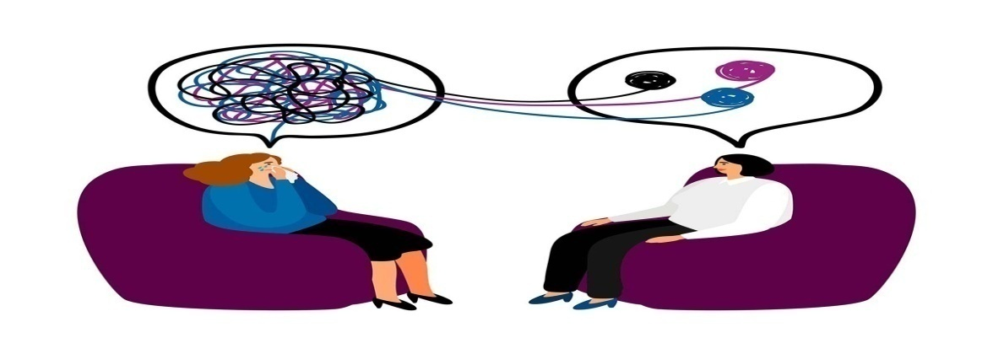
Professionals who can provide psychotherapy include clinical psychologists, psychiatric nurse’s psychotherapists, psychiatrists, counselors, social workers, and mental health counselors. The trained professional help the client to overcome with the specific or general problems, like examination stress, family problems etc. Psychotherapy is a collaborative intervention based on the relationship between the client and a therapist, within a supportive environment that allow the client to talk openly without judging them. Psychotherapy helps to understand &learn about one’s moods, feelings, thoughts, and behaviors. Client learn skills to tackle their challenging situations with healthy coping strategies and can enjoy their life happily, healthy, productive & equipped to face new challenges in the present and the future.
Indication of psychotherapy
Anxiety disorders | Obsessive-Compulsive Disorder (Ocd),Phobias, Panic Disorder,  Posttraumatic Stress Disorder (Ptsd), Social Anxiety Disorder,  Generalized Anxiety Disorder (Gad).
Mood disorders | Depression ,bipolar disorder.
Eating disorders | anorexia or bulimia
Addictions | substance-use disorder or compulsive gambling, smart addiction
Personality disorders | Personality Disorder Or Dependent Personality Disorder.  Schizophrenia Or Other Disorders
Others | Divorce, psychosocial stressor, financial problems ,death of loved ones

Types of Psychotherapy

There are different types of psychotherapy depends on patients condition and need of the client
Individual therapy  Couples therapy | It is most common involves one-on-one session with the therapist in a safe, caring, and confidential environment. It encourages in-depth discussions between client and therapist. This is best for people who do not like group environments and feel they can be more open and honest one-on-one. Individual therapy allows the therapist and client to focus on each other, build a strong rapport, and work together to solve the client’s issues.  Couples therapy involves interaction between therapist and couple as to improve their relationship and function .Here the couples explore their issues with the therapist and resolve conflict.
Family therapy | Family therapy centers on improving the family dynamic include multiple individuals within a family unit. The therapist may provide premarital counseling, child counseling, and separation and divorce counseling. Family therapy may help the clients to develop new interpersonal communication skills, help the family members to understand each other , change negative behaviors, resolve conflicts, and create a better-functioning home environment.
Group therapy | Group therapy involves a small group of individuals who usually share a common goal. This allows members of the group to practice new skills and behaviors within a supportive group. It may be homogenous or heterogeneous group with a definite goal. It includes 6-12 members lasting for one hour twice in a week. Group therapy help the client to develop communication skills, learn to express their issues, and accept criticism from others

Techniques of Psychotherapy
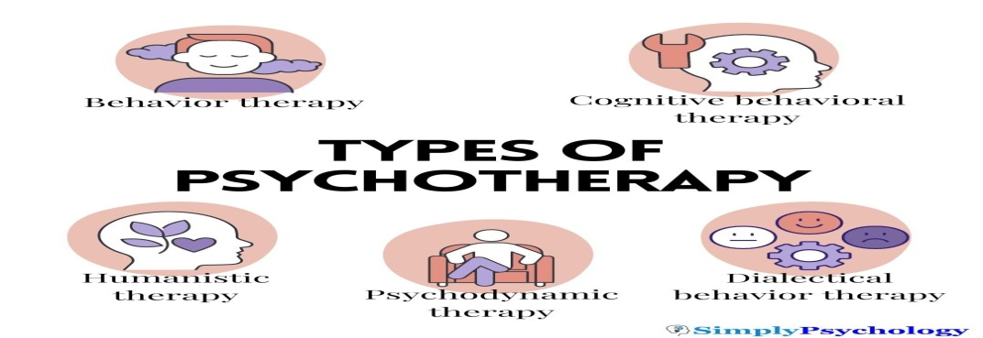

Behavior therapy :It is an umbrella term used for many techniques based on behaviorist theories such as classical conditioning, operant conditioning, and social learning theory. This helps to identify & seek change in self-destructive or unhealthy behaviors. Behavior therapy emphasizes on the idea that all behaviors are learned, and can be modified for healthy functioning Exposure therapy is a type of behavior therapy where client is exposure of their fear, incorporating relaxation strategies among them. Another type of behavior therapy, called systematic desensitization, involves learning ways to relax (e.g., through visualization or progressive muscle relaxation), then making a list of fears and ranking them based on intensity. After this, the therapist encourages the individual to start exposing themselves to these fears in stages so that they get increasingly more comfortable dealing with them..

Cognitive behavioral therapy (CBT) . Its aim is to correct cognition along behavior of a client. In CBT, client set goals that they want to work on, problem-solve, and practice new skills with the therapist. Rational emotive behavior therapy (REBT) is a type of CBT that focuses on identifying negative or destructive thoughts and feelings. Here the client actively challenge their thought and replace them with more rational, realistic ones. Another type of CBT is mindfulness-based cognitive therapy which combines CBT with meditation. This type of therapy helps to cultivate a non-judgmental, approach .

Dialectical behavior therapy (DBT) It is intended to treat borderline personality disorder and other conditions who have difficulty with emotional regulation or exhibit self-destructive behaviors such as eating disorders or substance-use disorders..DBT focuses to teach people how to develop healthy coping, regulate their emotions, and improve relationships with others. This therapy emphasizes on mindfulness, distress tolerance, and interpersonal effectiveness.

Humanistic therapy : This emphasizes on the principle that everyone has their own unique philosophy of life & world that impacts choices and actions of a client/individual. The humanist psychologist Carl Rogers developed an approach known as client-centered therapy. According to this therapy people absorb criticism or disapproval from others that distorts once thought ,blocking personal growth, ultimately leads mental distress. This therapy helps the client to know themselves in order to maximize their potential and stresses the importance of self-exploration, free will, and self-actualization

Psychodynamic therapy: Based on Sigmund Freud’s theory of psychoanalysis, it explores how the unconscious mind influences our thoughts, feelings, and behaviors. This therapy examines how a person’s experiences from childhood to old age .Freud believed that there are unconscious influences that results to psychological distress.

Some techniques of psychoanalysts include:
DREAM INTERPRETATION
FREE ASSOCIATION
TRANSFERENCE

Goals of Psychotherapy

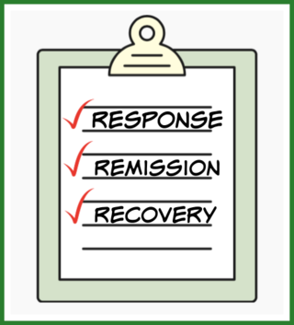
1. Response
2. Remission
3. Recovery
Response is defined as an improvement in illness after psychotherapy begins.eg client feels better after few sessions of psychotherapy.
Remission is defined as the experience of being symptom-free from illness. When a client gains optimism, self-confidence and a returns to healthy state of living...
Recovery is defined as the absence of symptoms for at least 4 months following the onset of remission .It presents with periods of improvement and growth as well as with setbacks and stumbling blocks.
Evidences on psychotherapies
Karlsson, 2011 conducted a study that identified that there is change in brain of clients with mental health disorders (including depression, panic disorder, PTSD, etc.) after psychotherapy similar to that of pharmacological treatment.
Hofmann et al., 2012; NIDA, 2018 conducted meta-analyses that psychotherapy is effective in improving the symptoms of client with anxiety-related disorders, including OCD and PTSD, as well as in anger problems, drug abuse, and general stress.
Oud et al., 2019 reveals that CBT is effective in treating symptoms of depression and anxiety among children and an adolescent.
Elliott, 2002 states that a review of 86 studies finds humanistic therapies are effective in client improvement in mental health issue .In 2016 Elliott suggests that client-centered approaches are helpful for trauma, relationship difficulties, psychosis, and coping with chronic health issues.
Abbass et al., 2021 has reviewed studies related to psychoanalytic therapy emphasized on improvements in somatic symptoms, depressive symptoms, and anxiety symptoms.
Conclusion: psychotherapies are effective intervention as evidenced by various studies with the help of different techniques and application of psychological theories

References:
- KAPLAN & SADOCK”S Synopsis of psychiatry 11th edition updated with DSM-5
- P.Prakash ,Text book of Mental Health & Psychiatric Nursing ,
- American Psychological Association. (2020, July 31). Understanding psychotherapy and how it works. https://www.apa.org/topics/psychotherapy/understanding
- Elliott, R. (2002). The effectiveness of humanistic therapies: A meta-analysis.
- Elliott, R. (2016). Research on person-centred/experiential psychotherapy and counselling: summary of the main findings.
- Hofmann, S. G., Asnaani, A., Vonk, I. J., Sawyer, A. T., & Fang, A. (2012). The efficacy of cognitive behavioral therapy: A review of meta-analyses. Cognitive therapy and research, 36(5), 427-440.
- Karlsson, 2011, How psychotherapy changes the brain: Understanding the mechanisms, August 2011 ,Psychiatric Times 28(8):21-23

