Value Addition of Berries and Cherries

Archana V. Mahida*,
Ph.D. Scholar,
Department of Horticulture,
School of Life Sciences,
Central University of Tamil Nadu,
Neelakudi, Thiruvarur- 610 005
Tamil Nadu

Dr. K. Rama Krishna (Ph.D, IARI)
Assistant Professor (Specialization: Postharvest Technology)
Department of Horticulture,
School of Life Sciences,
Central University of Tamil Nadu (CUTN),
Neelakudi, Thiruvarur- 610 005,
Tamil Nadu

A.Krishnamoorthi
Ph.D. Scholar,
ICAR-NBPGR Pusa Campus
IARI, New Delhi-110012

*Corresponding author: mahidaarchana24@gmail.com
ABSTRACT
A variety of berries and cherry fruits can be grown in this country due to the variable climatic conditions. These fruits are plentiful and available throughout the year. These fruits can meet the needs of consumers who are health-conscious because they are also valued for their medicinal and nutritional properties. Because of their acidity and astringent flavour, several of these cherry fruits cannot be sold fresh in the market. Consumers are constantly looking for fresh, mouthwatering, wholesome, and eye-catching food products. Value-added berries and cherries can fill this desire. Therefore, research efforts to diversify and popularise these underutilized berry and cherry fruit crops must be prioritized. In order to do this, it is necessary to increase the demand for these fruit crops on both domestic and international markets, promote their exportation, and improve their nutritional and socioeconomic status.

Keywords: Consumer demand, Nutritious, Diversification, Export and Socio-economic status

- INTRODUCTION
The agroecological zones and elevations of India are home to some of the most valuable plants in the world. The country's variable climatic conditions offer an ideal location for cultivating a variety of berries and cherries. There is a demand for many cherry and berry species, many of which have the potential to be commercially exploited but have not yet been fully utilized. This can be partially accomplished by creating appropriate processing for these underutilized fruits.
Berries and Cherries are known for their rich flavour, vibrant colours and potential health benefits Value addition of berries and Cherries involves transforming them into various products or enhancing their qualities to increase their market value
- Glimpse of Value Addition of Berries:
- Mulberry:

The mulberry belongs to the family Moraceae. Mulberry is believed to originated on the lower slope of Himalayas and a native of either India or China. The mulberry flower occurs during late winter or the beginning of spring. The fruits are sorosis. The fruits have attractive purple-to-black colour and pleasing flavour. Mulberry is a quick-growing deciduous plant that is widely dispersed from temperate to subtropical regions and may be found in a wide range of climatic, topographical, and soil conditions. It has also good medicinal properties and can be used for debility symptoms when used with other restoratives [4]. Mulberry leaves provide significant levels of calcium, vitamin C, beta-carotene, and protein. It is easily cultivable in several regions of India, which means that it can assist in meeting the recommended dietary requirement for a variety of micronutrients and enhancing the health of vulnerable people [7]. Mulberry can be used to create a variety of goods, including marmalade, fondant jams, jellies, cakes, breads, parathas, fruit teas, fruit drink pulp, fruit wine, fruit sauce, fruit powder and chocolate.

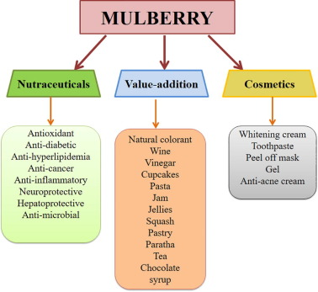
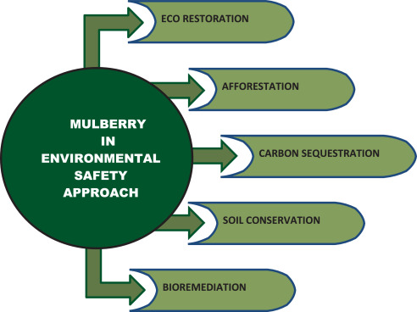

Source:- https://www.sciencedirect.com/science/article/pii/S266671932030011X
Mulberry Jelly:-
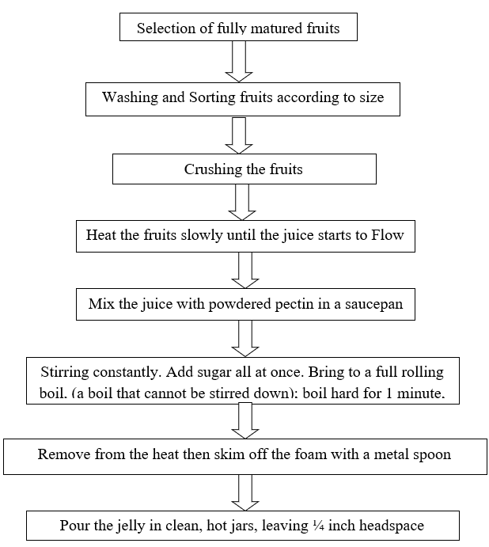

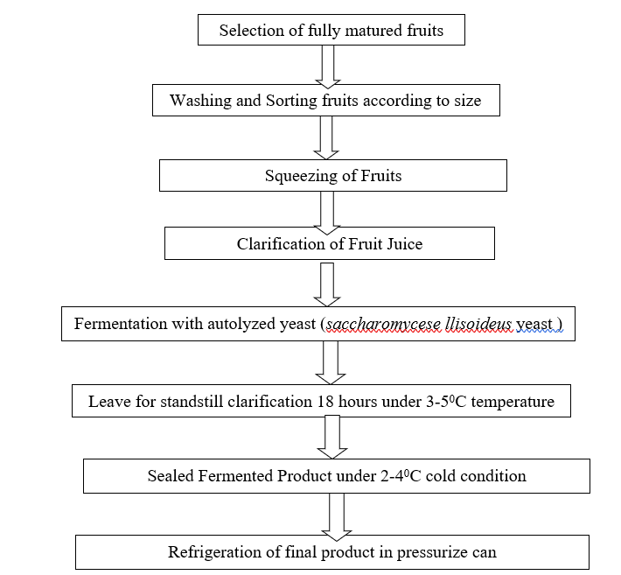
Mulberry Sparkling Wine

Mulberry Jam:-
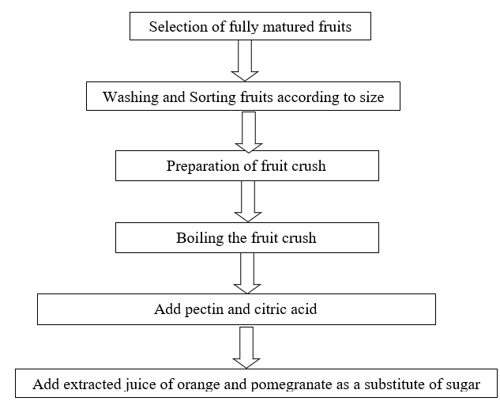

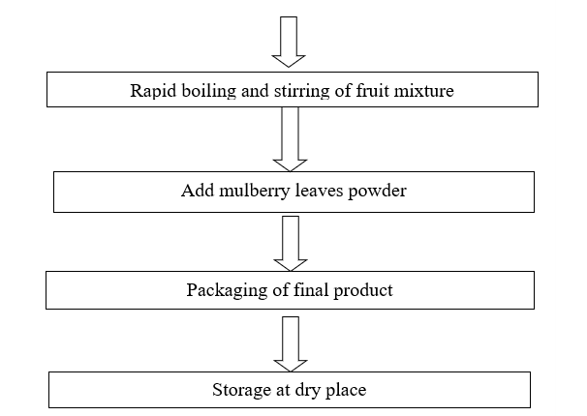

Clarification of mulberry juice:
- Adjusting the range of total acid in mulberry juice up to 4-6 g/L
- During the fermentation step add residual sugar of 16-20 g/L
- After adding the residual sugar change the jar and carry out interior scaled fermentation of the jar from the dissolubility yeast.

- Raspberries:
Raspbeeries (Rubus idaeus) is an aggregated fruit belong to the family of rosaceae. Plants in the Rubus genus have prickles like roses and are often called brambles. Raspberries are grown for both the fresh fruit market and processing sector in to frozen product, puree, juice or dried fruits. Raspbeeries are rich in fiber, vitamin C and antioxidants [2].

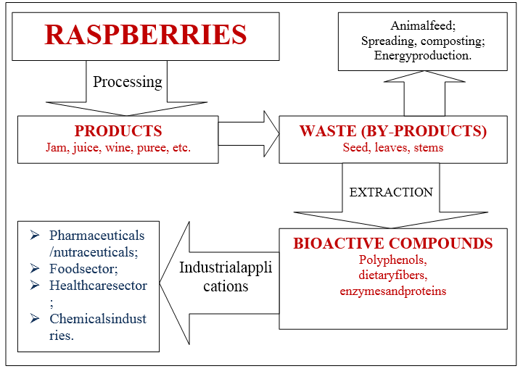
Source: https://kosmospublishers.com/valorisation-of-raspberries-by-products-for-food-and-pharmaceutical-industries/
Encapsulated Raspberry Powder
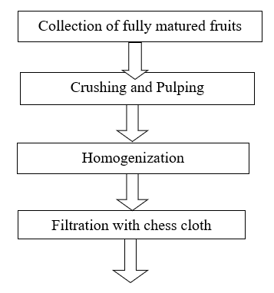
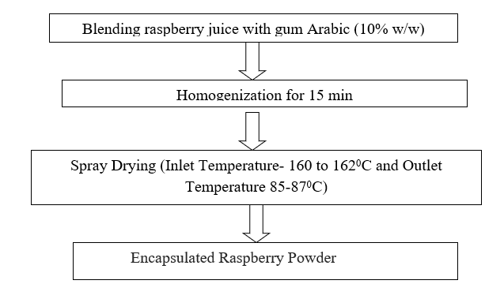

Waste Utilization of Raspberry
Waste and by-products generated from the processing of raspberries can be used in different cosmetic and pharmaceutical industries and these waste products are also used in eco-friendly applications like animal feed, bio-energy production [12]
Seeds extracted from these berries are a rich source of antioxidants and it may be used to prevent different human diseases i.e. cardiovascular, diabetes and different type of cancer.
- Strawberry
It is important crop grown in temperate and sub-tropical areas of India. It is an aggregated fruit and it is widely grown as a hybrid species of fragaria×ananassa. The first strawberry species was cultivated in the early 17th century. This fruit's unusual aroma, vivid red colour, and juicy texture are its main selling points.Strawberry is a very good source of magnesium, potassium and vitamin C. [5]. strawberries have a low glycemic index and are fat-free. Additionally, the fibre in strawberries slows down the absorption of raw sugar. Having a diet high in strawberries can help lower your chance of developing serious illnesses including cancer, diabetes, heart disease, and stroke. Strawberries are also a good source of antioxidants like vitamin C. Strawberry is consumed in large quality either fresh or after processing and prepared product like jam, Juice, Powder and Milkshake.

Strawberry Crush
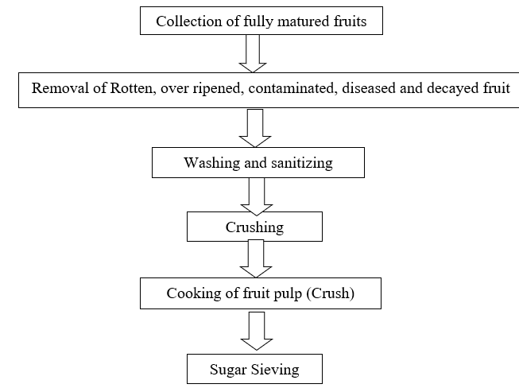

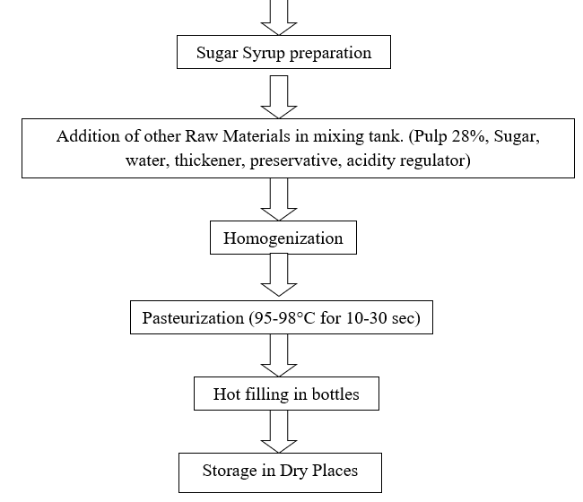

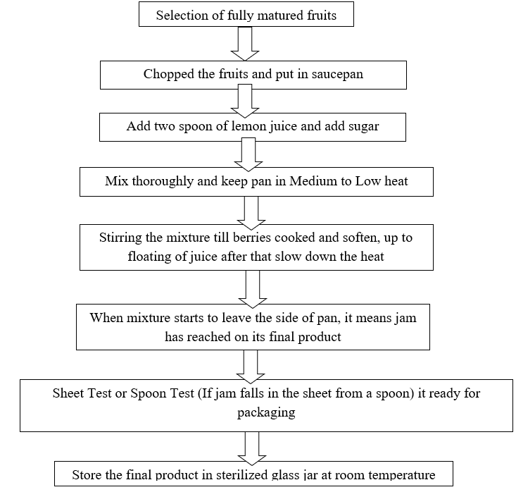
Strawberry Jam:

- Blue berry
Blueberry (Vaccinium cyanococcus) is a low bush berry, It is belong to family of Ericaceae. It is considered as a super fruit due to abundant polyphenolic compound. It I beneficial for reducing the oxidative stress and it also plays the important role in preventing bloodsugar. Blueberries are rich in anthocynin and antioxidants [1].It is also recognized as a king of world fruit. The world's largest producer of blueberries is the United States. It is processed as IQF (Individually Quick Frozen), Puree, Jam, Jelly, Pie, Cookies and Muffins, etc.
Product prepared from Blue Berry:
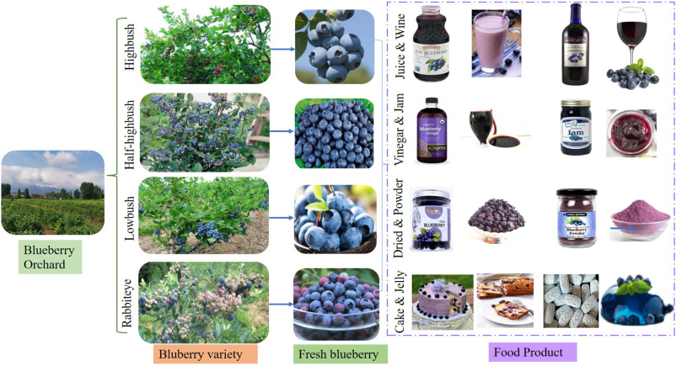
Source: https://www.sciencedirect.com/science/article/abs/pii/S0168160522003622
Blueberry Juice
Blueberry Juice is a popular product in the United States. It is a healthy beverage due to its higher phytochemical content and for canning of this juice maintain the temperature between 93-95 ⁰C for 25-30 min.
Blueberry wine
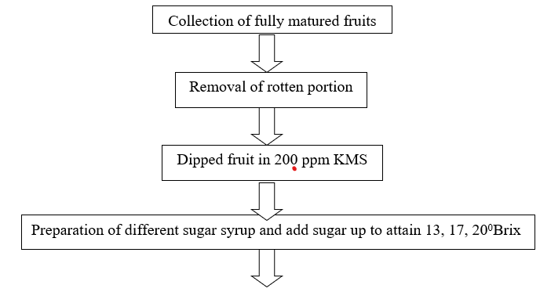

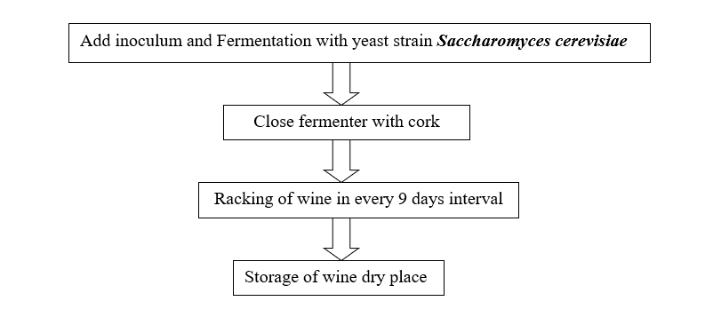

III.Glimpse of Value Addition of Cherries:
A.Tart Cherry
Tart Cherry is Known as Prunus Cerasus, It is commonly cultivated in the U.S. Tart cherries are rich in antioxidants like proanthocyanins, anthocyanins, and flavanols and it is also rich in vitamins and melatonin. It is beneficial for cardiovascular diseases and Blood Pressure. Chemicals in tart cherry fruit may function as antioxidants and prevent edoema [11]. Even though up to 97% of tart cherries grown are used in cooking and baking, some tart cherry products are marketed for specific health benefits. It is processed as a concentrate, Jelly, Jam, and wine [9].
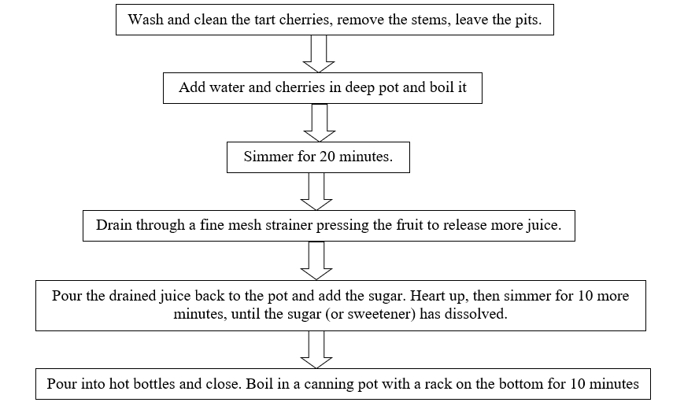
Tart Cherry Concentrate:

B. Rainier Cherry
A premium variety of cherry is the Rainier Cherry. It was given Mount Rainier's name. It was created by Harold Fogle in 1952 at Washington State University. Mazzard Cherry is the typical rootstock utilized for rainier cherries. The huge, yellow Rainier cherry has a scarlet flush and very firm, yellow-white flesh. Fruit will be produced in three to five years. It is among the most cold-resistant delicious cherries. Washington produced best quality Rainier Cherry. The flavour of Rainier cherries is remarkably sweet and low in acid with a caramel-like finish on the palate. Due to their low glycemic index, rainier cherries can control blood sugar levels and stave off diabetes. [3]. Various value-added products are prepared from Rainier Cherry like dried cherries, Cherry Jam, Cherry Pie, Cherry Juice, and Cherry sauces. Value-added products provide additional opportunities for farmers to diversify their contributions and surge revenue
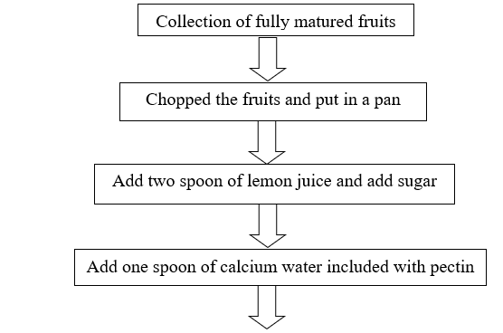
Rainier Cherry Jam

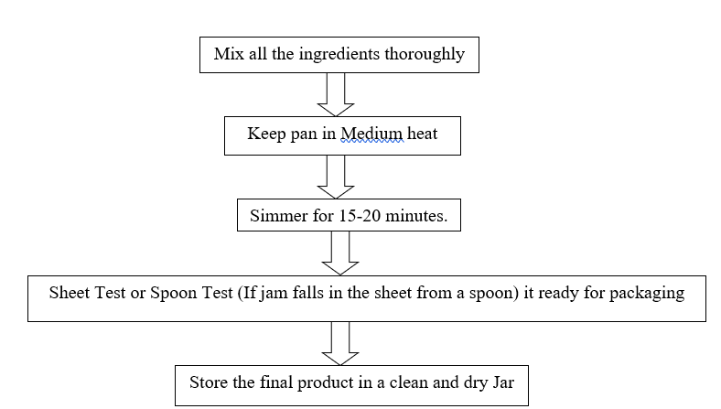

C. Barbados cherry
Malpighia emarginata (Barbados cherry), a tropical and subtropical shrub, is a member of the Malpighiaceae family.. It is also called West Indian Cherry. It is well renowned for having a huge amount of vitamin C. Along with the vital nutrients carotenoids and bioflavonoids, M. emarginata also includes vitamins A, B1, B2, and B3. The fruit exhibits significant antioxidant capacity as well as a variety of fascinating bio-functional qualities, including the ability to whiten skin, to slow the ageing process, and to reverse drug resistance [6]. Due to its high vitamin C content, Barbados Cherry can prevent gout, strengthen the immune system, lower oxidative stress, and benefit collagen synthesis. Currently, Tamil Nadu, Kerala, Maharashtra, and Karnataka are the states where the fruit is planted as a garden tree. A few plant varieties that did well in the Andaman and Nicobar Islands' tropical and humid climate were introduced there in 1995–1996 [10].
The exotic fruit acerola (Barbados cherry) has tremendous agro-industrial potential and offers enticing commercial opportunities. The crop has not yet become popular among Indian farmers due to a lack of knowledge about its nutritional worth and cultivation, and it still remains a lesser-known and underutilized fruit [8]. The fruit's pulp can be used to make juice, jam, jelly, preserves, syrup, etc., or it can be eaten fresh. West Indian cherries are a fruit that is incredibly underused and have the potential to be used to create a variety of products. In times of abundance, this fruit's high vitamin C content is not fully utilized.
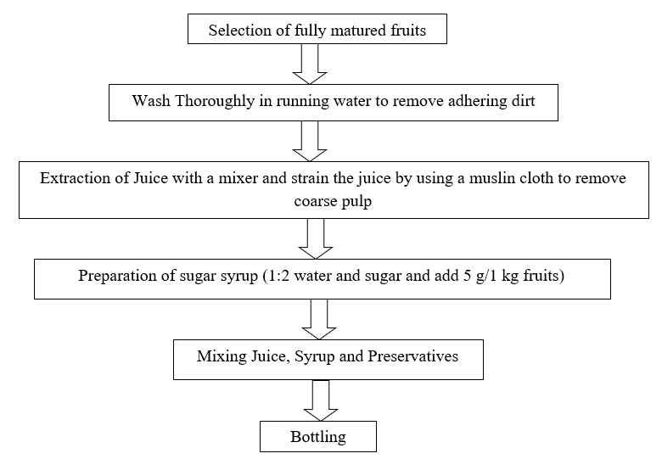
West Indian Cherry Squash

West Indian Cherry Sauce
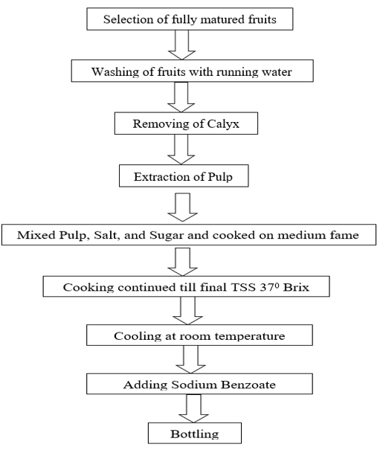

IV. Conclusion
India, a diverse nation with a large variety of fruits, may play a significant role by offering processed goods with distinctive flavours. It is past time for our nation to prioritize utilizing these local fruits and marketing the processed goods globally so that we may both profit the nation and give nutritious items with little effort. It won't just have a big economic impact. a rivalry in international trade. Unexploited fruits should be viewed as a supplement to traditional fruits, not as a replacement.
V. References
- Duan, Yumin, Ayon Tarafdar, Deepshi Chaurasia, Anuradha Singh, Preeti Chaturvedi Bhargava, Jianfeng Yang, Zelin Li et al. (2022) "Blueberry fruit valorization and valuable constituents: A review." International Journal of Food Microbiology: 109890.
- Ispiryan, A. and Viškelis, J. (2019). Valorization of raspberries by-products for food and pharmaceutical industries. Adv. Agric. Harti. Ento. AAHE-102.
- Kelley, D. S., Adkins, Y. and Laugero, K. D. (2018). A review of the health benefits of cherries. Nutrients, 10(3), 368.
- Krishna, H., Singh, D., Singh, R. S., Kumar, L., Sharma, B. D. and Saroj, P. L. (2020). Morphological and antioxidant characteristics of mulberry (Morus spp.) genotypes. Journal of the Saudi Society of Agricultural Sciences, 19(2), 136-145
- Kumar, S., Kumar, J., Tripathi, J., Gupta, S. and Gautam, S. (2022). Secondary product from strawberry (Fragaria ananassa) fruit for extended preservation and value addition. Journal of Food Science and Technology, 59(4):1598-1609.
- Mezadri, T., Villaño, D., Fernández-Pachón, M. S., García-Parrilla, M. C. and Troncoso, A. M. (2008). Antioxidant compounds and antioxidant activity in acerola (Malpighia emarginata DC.) fruits and derivatives. Journal of Food Composition and analysis, 21(4), 282-290
- Ramya, V. S. and Chandrashekar, S. (2020). Development of value-added products from mulberry leaves. International Journal of Current Microbiology and Applied Sciences, 9(3), 2319-7706
- Rani, R. N., Kukanoor, L., Karadiguddi, M., Srinivas, N., Nataraja, K. H. and Koulagi, S. (2019). Standardization of Protocol for West Indian Cherry (Malpighia glabra L.) Squash. Int. J. Curr. Microbiol. App. Sci, 8(9):1322-1327.
- Siddiq, M., Iezzoni, A., Khan, A., Breen, P., Sebolt, A. M., Dolan, K. D., & Ravi, R. (2011). Characterization of new tart cherry (Prunus cerasus L.): selections based on fruit quality, total anthocyanins, and antioxidant capacity. International Journal of Food Properties, 14(2), 471-480
- Singh, D. R. (2006). West Indian Cherry–A lesser-known fruit for nutritional security. Natural Product Radiance. 5(5):366-368
- Vitale, K. C., Hueglin, S., and Broad, E. (2017). Tart cherry juice in athletes: a literature review and commentary. Current sports medicine reports, 16(4): 230-239.
- Zhao, Y. (Ed.). (2007). Berry fruit: value-added products for health promotion. CRC press

