Introduction, Scope and Application of Nanotechnology
Tejaswini Pagarª
ªDepartment of Chemistry, Mahatma Gandhi Vidyamandirs Loknete Vyankatrao Hiray Arts, Science and Commerce College Panchavati, Nashik 422 003, India (Affiliated to Savitribai Phule Pune University, Pune.)
Introduction:
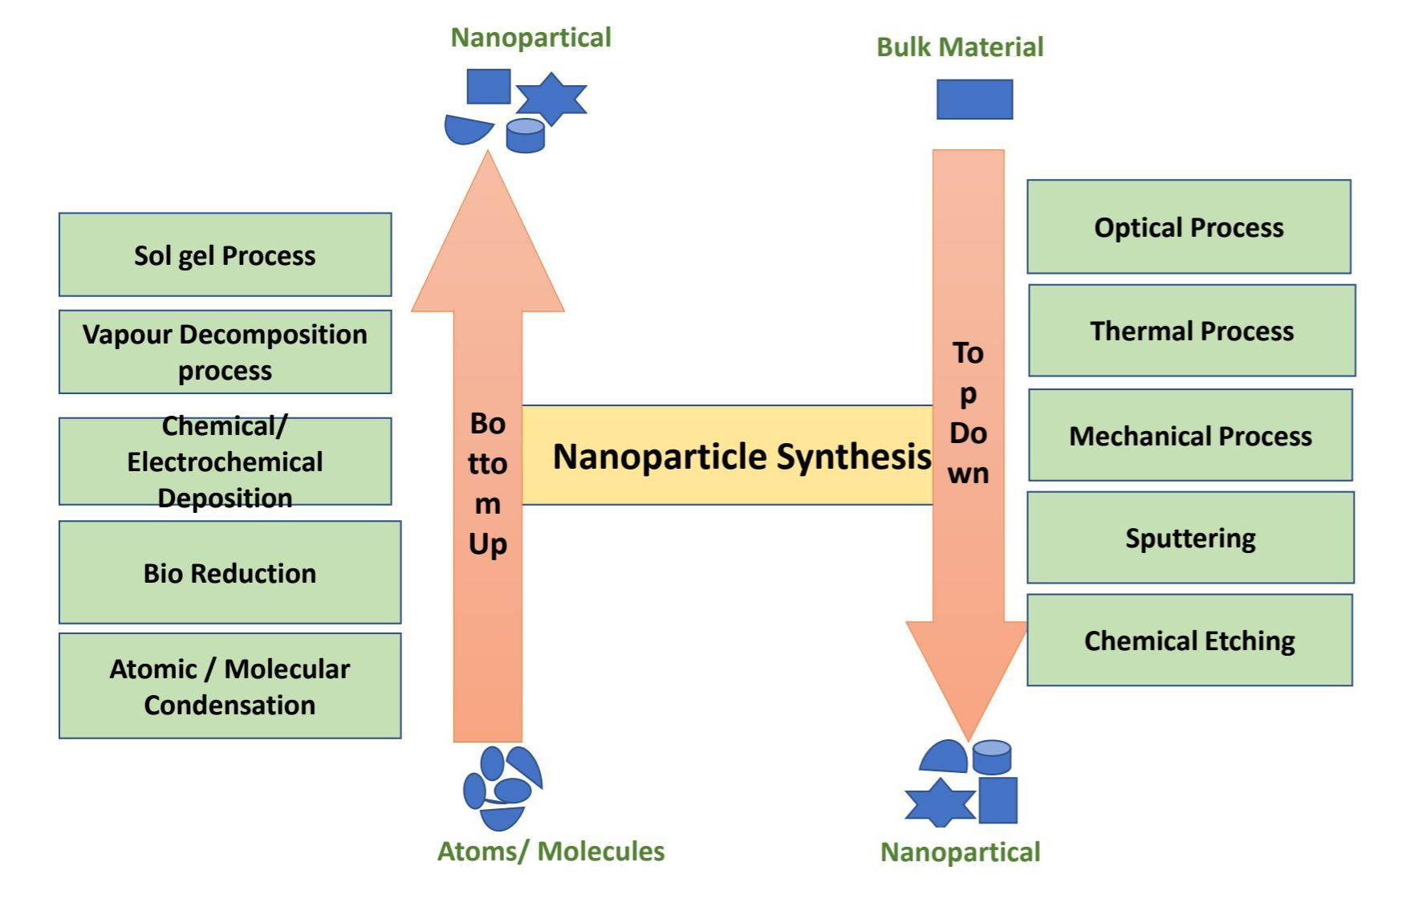
Demonstrated in 1959, Nobel prize-winning American physicist Richard Feynman first proposed the idea of nanotechnology. Feynman gave a talk titled “There’s Plenty of Room at the Bottom” at the California Institute of Technology (Caltech) during the American Physical Society’s annual meeting. In this lecture, Feynman posed the question, “Why can’t we write the entire 24 volumes of the Encyclopaedia Britannica on the head of a pin?” and sketched a future in which machines would be used to build smaller machines, all the way down to molecules [1]. This new idea demonstrates that Feynman’s hypotheses have been proven correct and demonstrates that, for this reason, he is considered the father of modern nanotechnology. After fifteen years, Norio Taniguchi, a Japanese scientist, was the first to use and define the term “Nanotechnology” in 1974. “Nanotechnology mainly consists of the processing of separation, consolidation, and deformation of material by one atom or one molecule” [2]. Two approaches have been created to describe the various options for the synthesis of nanostructures since Feynman's discovery of this new idea of study. These manufacturing strategies can be divided into two groups: “Top-down and Bottom-Up” with varying degrees of quality, speed and cost. Using the Top-down method, the bulk material is essentially broken down to create nanoparticles. Utilizing cutting-edge methods developed and improved by industry over the past few decades, such as precision engineering and lithography, this can be achieved. The majority of the microelectronics business is based on precision engineering to help with all aspects of production and a combination of advancements can result in excellent performance. Among these are sensors for size control, advanced nanostructure based on diamond or cubic boron nitride and numerical control and servo-drive technology. In lithography, a surface is patterned by being exposed to ions, electrons and light and material is then deposited onto that surface to create the desired material. The term “bottom-up approach” refers to the process of building up nanostructures from the bottom up, atom by atom or molecule by molecule, applying physical and chemical techniques in the nanoscale (1 nm to 100 nm) range. Chemical synthesis is a technique for creating raw materials that can be used either as the foundation for more complex ordered materials or directly in products in their bulk-disordered form. When atoms or molecules interact chemically and physically to form created nanostructures, self-assembly is a bottom-up method used to achieve this. Positional assembly is the sole method that allows for the independent placement of individual atoms, molecules, or clusters [3]. (Figure 1) summarises the general top-down and bottom-up concepts as well as the various approaches used to create nanoparticles utilizing these techniques.
Figure.1: Bottom up and Top down method.
The first book on nanotechnology, “Engines of Creation: The Coming Era of Nanotechnology,” was released in 1986 by K. Eric Drexler, which contributed to the growing acceptance of the “molecular engineering” hypothesis [4]. Drexler explained how to construct intricate machines out of individual atoms that are capable of independently manipulating molecules and atoms to create self-assembling nanostructures. Later, in 1991, Drexler, Peterson, and Pergamit published another book titled “Unbounding the Future: The Nanotechnology Revolution,” in which they refer to “nanobots” or “assemblers” for nano processes used in medical applications. It was then that the renowned term “Nanomedicine” was first used [5].
Definitions:
The prefix “nano” is a Greek word that means “dwarf” or “very small” and it represents a thousand millionth of a meter (10-9m ). It is important to distinguish between nanotechnology and Nano science.
The study of molecules and structures on the nanometer scale is known as nanoscience. Nanotechnology is the use of materials with a size between 1 and 100 nm in every object like devices and other objects [6].
The basic definition of nanotechnology is “technology at the nanoscale”. Various definitions of nanotechnology have since developed. It is necessary to expand this first description, for example, by defining what is meant by the term “nanoscale” as a result, without first defining “nanoscale”, or scale that ranges from 1 to 100 nm, we cannot properly define nanotechnology. Nanotechnology can be described in the terms “atomically precise technology” or “engineering with atomic precision” [7].
Systems and materials that use nanoscale components and structures to represent innovative, greatly enhanced chemical, physical and biological capabilities, processes and phenomena are related to nanotechnology.
According to the dictionary, nanotechnology is “The design, characterization, manufacture, shape, and size-controlled application matter in the nanoscale” [8].
Nanotechnology is a field of study that consists of the study of phenomena and is a sub-classification of technology in the fields of colloidal science, chemistry, physics, biology and other sciences on the nanoscales [9].
A catalyst’s performance is significantly impacted by the size and distribution of its particles. The advantages of NPs as catalysts are due to their chemical characteristics, which include their high surface-to-volume ratio, surface shape and electronic properties, all of which are related to particle size [9,10]. There have been significant advancements in the disciplines that support the production and deep knowledge of the nature (particle size, content and structure) and function of NPs as catalysts for the enhanced performance of chemical reactions [11]. According to this definition, there are two conditions needed for nanotechnology. First, there are the scale problems: Nanotechnology focuses on exploiting structures by manipulating their size and shape at the nanoscale. The second difficulty is one of the novelties: due to their nanoscales, nanotechnology must deal with small objects in a way that makes use of certain qualities [12].
The first book on nanotechnology, “Engines of Creation: The Coming Era of Nanotechnology,” was released in 1986 by K. Eric Drexler, which contributed to the growing acceptance of the “molecular engineering” hypothesis [4]. Drexler explained how to construct intricate machines out of individual atoms that are capable of independently manipulating molecules and atoms to create self-assembling nanostructures. Later, in 1991, Drexler, Peterson, and Pergamit published another book titled “Unbounding the Future: The Nanotechnology Revolution,” in which they refer to “nanobots” or “assemblers” for nano processes used in medical applications. It was then that the renowned term “Nano medicine” was first used [5].
Definitions:
The prefix “nano” is a Greek word that means “dwarf” or “very small” and it represents a thousand millionth of a meter (10⁻⁹m ). It is important to distinguish between nanotechnology and Nano science.
- The study of molecules and structures on the nanometer scale is known as nanoscience. Nanotechnology is the use of materials with a size between 1 and 100 nm in every object like devices and other objects [6].
- The basic definition of nanotechnology is “technology at the nanoscale”. Various definitions of nanotechnology have since developed. It is necessary to expand this first description, for example, by defining what is meant by the term “nanoscale” As a result, without first defining “nanoscale”, or scale that ranges from 1 to 100 nm, we cannot properly define nanotechnology. Nanotechnology can be described in the terms “atomically precise technology” or “engineering with atomic precision” [7].
- Systems and materials that use nanoscale components and structure to represent innovative, greatly enhanced chemical, physical and biological capabilities, processes and phenomena are related to nanotechnology.
- According to the dictionary, nanotechnology is “ the design, characterization, manufacture, shape, and size controlled application matter in the nanoscale”[8].
- Nanotechnology is a field of study that consists of the study of phenomena and is a sub-classification of technology in the fields of colloidal science, chemistry, physics, biology and other sciences on the nanoscales [9].
A catalyst’s performance is significantly impacted by the size and distribution of its particles. The advantages of NPs as catalysts are due to their chemical characteristics, which include their high surface-to-volume ratio, surface shape and electronic properties, all of which are related to particle size [9,10]. There have been significant advancements in the disciplines that support the production and deep knowledge of the nature (particle size, content and structure) and function of NPs as catalysts for the enhanced performance of chemical reactions [11]. According to this definition, there are two conditions needed for nanotechnology. First, there are the scale problems: Nanotechnology focuses on exploiting structures by manipulating their size and shape at the nanoscale. The second difficulty is one of the novelty: due to their nanoscales, nanotechnology must deal with small objects in a way that makes use of certain qualities [12].
History:
One of the most intriguing examples of nanotechnology in the ancient world can be found in the fourth century AD, when the Romans employed nanoparticles and structures. One of the most remarkable achievements in the field of ancient glass is the Lycurgus Cup, which is the part of British Museum collection. It is the first well known instant of dichroic glass. Dichroic glass describes two different types of glass, which change colour in certain lighting conditions. This means That the cup has two different colours: the glass appears green in direct light and res-purple when light shines through the glass (Figure 2) [13].
Figure 2: The cup of Lycurgus, (A) the glass appears green , and in light
(B) , it appear red-purple[13].

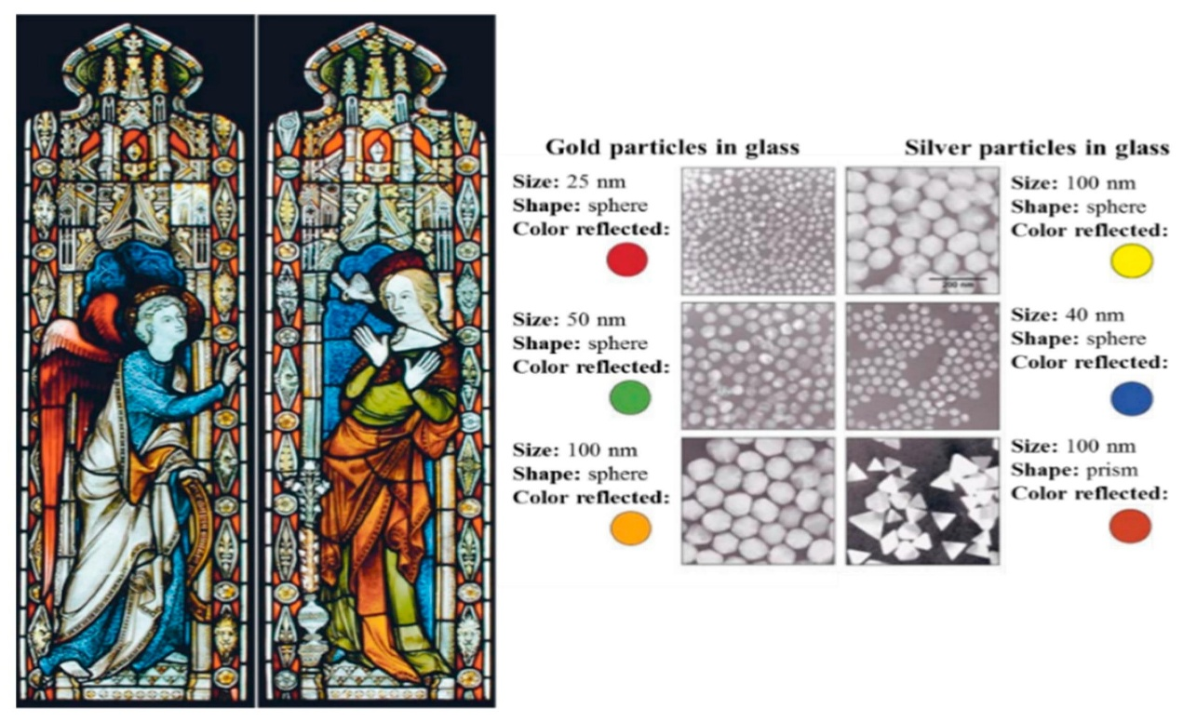
To understand the dichroism phenomena, scientists studied the cup in 1990 using a transmission electron microscope (TEM) [14]. Due to the presence of 50-100 nm diameter nanoparticles, dichroism (two colours) has been detected. According to X-ray examination, these nanoparticles are silver gold (Ag-Au) alloys with an approximate 7:3 ratio of Ag to Au and contain an additional 10% of copper (Cu) scattered in the glass matrix [15,16]. The Au nanoparticles produce a red colour as a result of light absorption (~520 nm). The red-purple colour is due to the absorption by the bigger particles while the green colour is attributed to the light scattering by colloidal dispersion of Ag nanoparticles with a size of 40nm. The Lycurgus cup is recognized as one of the oldest synthetic nanomaterials [6]. The fusion of Au and Ag nanoparticle into glass produces a similar effect in late-medieval church windows, which shine dazzling red and yellow colours. The stained glass windows in (Figure: 3) are an illustration of how these nanoparticles of various size affect them [17].
Figure 3: Nanoparticle impact on stained-glass windows coloration [17]

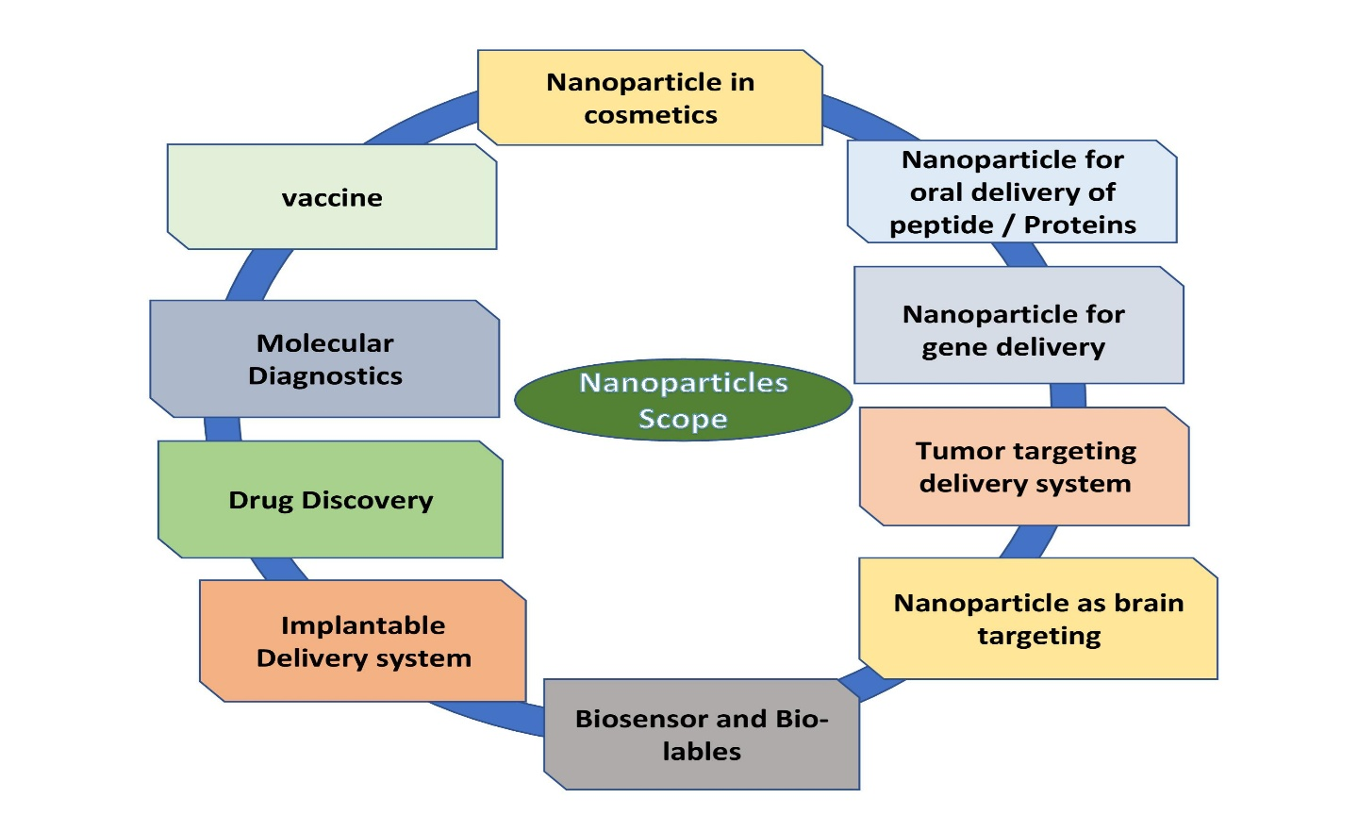
Scope of Nanotechnology:

Figure 4: Scope of Nanotechnology
- Nanomaterials have been developed for numerous uses in a variety of industries, including medicine, medication delivery, electronics, fuel cells, food and space, among others. The use of nanoparticles in catalysis to speed up chemical reactions is growing.
- Nanoparticles are used increasingly in catalysis to boost chemical reactions.
- This helps some money and cut down on pollution by lowering the number of catalytic materials required to achieve desired outcomes. Petroleum refinement and catalytic converters for automobiles are two significant applications.
- Application for nanotechnology can be found in engineering, biological and medical fields as well as chemical, materials and physical research. Material that demonstrates its transformational power includes carbon, silica, gold, polydimethylsiloxane, cadmium selenide and iron oxide.
- Nanotechnology for brain drug delivery.
- Nanotechnology, which has the potential to completely revolutionize industries like manufacturing, agriculture, electronics, pharmaceuticals and military is one of the topics that is developing the fastest.
- Nanomaterials are used widely in food and agriculture systems as intelligent carriers of agrochemicals, Nano formulations, Nano biosensors, for precise farming and food packing, Nano bioremediations, Nano fibres, for genetic engineering etc.
- In the future, nanotechnology might also make it possible for items to gather energy from their surroundings.
- New nanomaterials and ideas are being right now that have the ability to produce every from motion, light, temperature changes, glucose and other sources with high conversion efficiency.
Types of Nanotechnology:
- Nano-particles:
Nanomaterials are substances that have undergone nanoscale engineering or manipulation to produce novel properties or behaviours not present in their bulk equivalents. Carbon nanotubes, nanoparticles and quantum dots are a few examples of nanomaterials. The extraordinary strength and conductivity of carbon nanotubes, for instance, make them helpful in a variety of applications, including electronics, energy storage and material sciences. Nanoparticles, which have at least one dimension on the nanomaterial scales, can be made of a variety of substances including metal, oxides, and polymer and they have special features that make them useful in a variety of industries including the medical, cosmetics and environmental ones. Quantum dots are tiny semiconductor particles that can be employed in displays, solar cells and medical imaging.
- Nano-medicine:
Nanomedicine is the use of nanotechnology in the medicinal industry. It includes the use of small components and nanoscale medical equipment to detect and treat diseases. Diagnostics nanoparticles and targeted drug delivery systems are two examples. Targeted drug delivery systems use nanoparticles to deliver the drug directly to particular cells or tissues, minimizing negative effects and boosting treatment effectiveness. In fact, resolution images of the inside of the human body can be captured using diagnostics nanoparticles to identify disorders early on. Targeted drugs are delivered directly to targeted cells or tissues using nanoparticles.
- Nano-electronics:
To produce electrical devices that are quicker and more effective, nanoelectronics uses small transistors and another electronic components at the nanoscales. Nanoscale transistors and memory components are a few examples. Smaller, more energy-efficient electronic devices that process and store more data than conventional electronic devices are made possible by this tiny transistor and other components.
- Nano-composite:
Nanocomposites are composites that contain a phase with nanoscale morphology, such as nanoparticles, nanotubes, or lamellar nanostructures. They are multiphase materials because they have many phases and at least one of those phases should have diameters between 10 and 100nm.
- Nano-lithography:
This expanding are of nanotechnology techniques focuses on the creation of nanometre-scale structures on a variety of materials. The modern phrase related to the design of structures made at a scale between 10⁻⁹ to 10⁻⁶ m (nanometre scales)
- Nano-biotechnology:
Nanobiotechnology is the study of the tiniest biological components (1-100nm) to develop systems and devices in the same size range that can be used for novel applications. It is a brand new branch of study that provides unique physicochemical and biological characteristics of nanostructures and their uses in a variety of fields, including agriculture and medicine. Metal nanoparticles are the main chemicals impacting fungi that cause disease in both plants and people.
- Microscopy, Spectroscopy, Nano-robotics, Wet nanotechnology, Nano-fluidics, Nano-electromechanical relay, Nano-photonics, Optoelectronics etc.

Nanoparticle Synthesis:
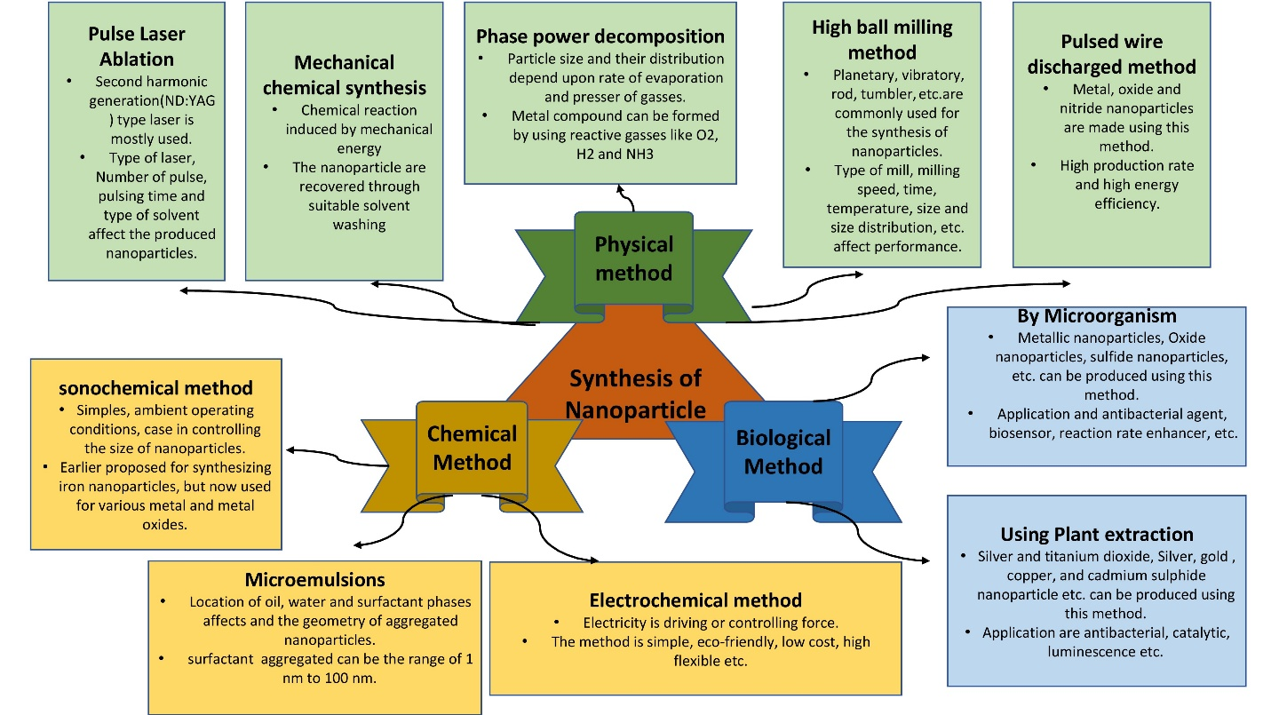
Figure 5: A different technique for creating nanoparticles.
Particles, colloids, thin films, tubes, rods, clusters, wires, powders and more can all be used to make various types of nanomaterial. As shown in (Figure 5), these processes can be divided into three primary categories for producing Nanomaterials. Quantum dots (QDs), nanowires, Nanorods and nanoplates are examples of the several types of nanostructures that can be used in an approach.
Application:
- Medical Science: Cancer Treatment, Drug Delivery, Imaging Tools and Equipment, Tissue Engineering, Gene Therapy, Treating Wound Injuries.
- Textiles: Making anti-bacterial, stain-resistant, wrinkle and fuzz-resistant textiles.
- Devices: Glucose, Sensors, Lithium-Ion Batteries, Thin Film, Solar Panels, High-Efficiency Sensors.
- Material Science: Flexible Materials, Lightweight Armours, Stealth Materials, Wear-Resistant Coatings, Anti-Corrosive Paints, Masks.
- Environment Conservation: Water and Air Purification Membranes, Detection of Harmful Chemicals Oil Spills.
- Nano-composites: Nanoparticles and nanotubes have an important role to play in composites. Carbon fibres and bundles of multi-walled CNTs are used in polymers to enhance and control connectivity.
- Nano lubricants: The inorganic materials of nano-spheres are used as lubricants. They are more durable as compared to conventional solid lubricants.
- Nanocoating and Nanostructured Surfaces: Coatings with thickness at nano or atomic scales are in active production.
Reference:
- Feynman R.P. There’s plenty of room at the bottom. Eng. Sci. 1960;23:22–36. [Google Scholar].
- Taniguchi N., Arakawa C., Kobayashi T. On the basic concept of nano-technology; Proceedings of the International Conference on Production Engineering; Tokyo, Japan. 26–29 August 1974.
- Iqbal P., Preece J.A., Mendes P.M. Supramolecular Chemistry. John Wiley & Sons, Ltd.; Chichester, UK: 2012. Nanotechnology: The “Top-Down” and “Bottom-Up” Approaches.
- Drexler E.K. Engines of Creation: The Coming Era of Nanotechnology. Anchor Press; Garden City, NY, USA: 1986. [Google Scholar].
- Drexler E.K., Peterson C., Pergamit G. Unbounding the Future: The Nanotechnology Revolution. William Morrow and Company, Inc.; New York, NY, USA: 1991. [CrossRef]
- Mansoori, G.; Fauzi Soelaiman, T. Nanotechnology—An Introduction for the Standards Community. J. ASTM Int. 2005, 2, 1–22.
- National nanotechnology initiative: leading to the next industrial revolution. Washington, DC: National Science and Technology Council; 2000.
- Abad E. Nano dictionary. Basel: Collegium Basilca; 2005
- Mansoori GA, Soelaiman TAF. Nanotechnology introduction for the standards community. J ASTM Int 2005;2(6):17–38.
- Mansoori GA, Mohazzabi P, McCormack P, Jabbari S. Nanotechnology in cancer prevention, detection and treatment: bright future lies ahead. World Rev Sci Technol Sustain Dev 2007;4(2–3):226–57.
- Mansoori GA, Vakili-Nezhaad GR, Ashrafi AR. Some mathematical concepts are applicable in Nanothermodynamics. Int J Pure Appl Math Sci 2005;2:58–61.
- Allhoff, F. On the Autonomy and Justification of Nanoethics. Nanoethics 2007, 1, 185–210. [CrossRef]
- The British Museum. Available online: www. britishmuseum.org /research/ collection _ online/collection_ Object_details.aspx?objobjec=61219&partId=1
- Barber, D.J.; Freestone, I.C. An investigation of the origin of the color of the Lycurgus Cup by analytical Transmission electron microscopy. Archaeometry 1990, 32, 33–45. [CrossRef].
- Freestone, I.; Meeks, N.; Sax, M.; Higgitt, C. The Lycurgus Cup—A Roman nanotechnology. Gold Bull. 2007, 40, 270–277. [CrossRef]
- Wagner, F.E.; Haslbeck, S.; Stievano, L.; Calogero, S.; Pankhurst, Q.A.; Martinek, K.-P. Before striking gold in gold-ruby glass. Nature 2000, 407, 691–692. [CrossRef].
- The New York Times. Available online: www.nytimes.com/imagepages/ 2005/ 02/ 21/ science/20050222_ NANO1_GRAPHIC.html

