Edited by
Patil Sachin Sambhajirao, Waghmode Ahilya vitthal and Patil Manasi Shirish
Department of Food Science
S. G. M. College Karad
E.Mail : sachinpatilfoodtech@gmail.com
waghmode.algae@gmail.com

WHEAT BREAD

Content
- Introduction
- Definitions
- Functional ingredients
- Role of each Major and minor ingredient
- Methods of bread making
- Faults in bread with their remedies
- Quality checking of dough rheology for quality wheat bread

Introduction
Wheat belongs to the genus Triticum of the grass family Gramineae. Wheat is the third cereal grain after maize & rice as a staple food. India ranks IInd in wheat production (112.74 MT) during 2022 – 23. Uttar Pradesh is the largest wheat producing state in India. China is the Ist world’s largest producer of wheat (134.33 MT).There are more than 30,000 species & varieties. It is cultivated from prehistoric times (5000 B.C.).The average length of wheat grain is about 8mm.Average weight of single wheat kernel is 35mg.It is ovoid in shape with the germ or embryo at one end & a bundle of hair at another end, along one side there is a furrow like part. Wheat grain have either a dark orange brown appearance or a light yellowish color. Bread is one of the spongy, porous food item. It can be variable from different grain flour for providing a lot of nutrients.
Definition of Bread
A staple food in western country which is made by baking dough made with flour & water & additional ingredients.
Definition of Baking
A technique of prolonged cooking of foods by dry heat through convection normally in oven under controlled condition.
Functional Ingredients used in bread making
- Structure builders
It forms structure during fermentation and baking of bread mould. Flour is the best example for having desirable structure of bread.
- Tenderizers
Ingredient of bread industry that leads to soften the bread loaf. The examples are butter, vegetable oil etc.
- Leaveners
Ingredient is used to allow the fermentation process and allowing to leave CO₂. Yeast is the best ingredient used as a leavener.
- Moisteners
It provides moisture & keeping quality. Milk, water, eggs & syrup are examples of moistener.
- Driers
It absorbs & retain moisture & provide the body of the product. Milk solids & starches
- Flavors
- Provide natural flavor
- Cocoa, chocolate, butter,& other natural flavor bearing ingredients.
The different ingredients used in bakery are:
- Flour
- Sugar
- Shortenings
- Leavening agents
- Eggs
- Water
- Salt
- Milk and milk derivatives
- Minor ingredients
- Flour
Wheat flour is the basic ingredient used in bread making. It gives better structure to bread because of gluten content it forms when flour comes in contact with moisture. It has extensibility, elasticity. Gradually it becomes capable of holding gas & It form spongy structure on baking in oven.
There are two types of Wheat 1. Hard wheat 2.Soft wheat.
But among these Hard wheat flour is the best source of gluten so used to make quality bread.
Hard wheat – Mostly desirable in bread production. High in good quality protein. Hard wheat dough has high water absorptive capacity, excellent gas holding properties & will yield bread with good volume, grain & texture.
Colour – The fresh flour has creamy white color.
Strength – It leads to produce a bold, big , well risen loaf.
Tolerance – It can be strong to have baking quality in the final product.
Water absorption – 60 to 65 %
Uniformity – Uniform flour to obtain good quality & product
pH – The pH of flour must be at the ranges from 5.5 to 6.5. If the pH is at below this desirable range can produce poor result n bread making. Composition – Major components of flour are starch (70%), protein (11.5%), water (14%) & minor components are such Ash(4%), sugar (1%) & fat (1%). Gluten protein (glutenin & gliadin) is insoluble in water or dilute solution.
2. Sugar
It gives sweet taste to bread. It acts as a tenderizer. It gives brown color to crust on caramelization. It gives flavor too. It gives flavor too. Sucrose is the best sweetener to improve acceptability of bread. Sugar adds calorific value in bread. Crust becomes darker if there is more sugar content. High concentration of sugar interferes with gluten formation. As sugar percentage is increased, the crust becomes darker i.e. results in more reddish brown crust. High concentration of sugar interferes with gluten formation.
Uses of Sugar
- Gives the necessary sweetness in cakes.
- Serves as a form of food for the yeast in fermentation
- It is used in the preparation of variety of icings.
- Assists in the creaming & whipping process of mixing .
- Provides good grain texture in the product.
- Aids in the retention of moisture & prolongs freshness.
- Promotes a good crust colour.
- Adds nutritional values to the product.
- It increases gas production.
- Shortenings
- Fat lubricates the structure of a baked product.
- Lard, butter & some vegetable oils.
- It has tenderizing effect on flour proteins & makes the product tender.
- It is fat part of the mixture which holds large number of air cells incorporated during creaming.
- Vegetable oil is used for brushing over crust for shininess after baking.
- It also makes the bread crust soft.
Use of Shortenings
- Impart shortness, richness & tenderness to the product
- Improve the eating qualities of the product
- Provide aeration
- Contribute to flavor, particularly special fats such as butter
- Promote a desirable grain & texture.
- Develop flakiness in product
- Lubricate the gluten for development of yeast raised dough.
- Act as emulsifiers for holding of liquids.
Properties Of Shortening
It should have
- Bland flavor
- White appearance
- Good plasticity
- Flavor & oxidative stability
Butter
- It is the best of all baking shortenings .
- It imparts desirable flavor to the finished baked products.
- It is widely used for specially breads, sweet goods, cookies & pastries.
Lard
- Margarine is prepared by blending lard & shortening.
- It is also used to soften the bread.
4. Leavening agents
Biological agents – Yeast
Yeast
- Baker yeast is one celled, colorless microorganism called as Saccharomyces cerevisiae.
- Characters of Yeast
- Yeast exists & is active in air as well as in absence of air.
- In presence of air it grows rapidly & forms little alcohol.
- In absence of air it grows slowly but alcohol formation increases.
Yeast is a microorganism that can grow in moist dough and consume carbohydrate and then produce more CO₂ and less alcohol in aerobic condition.
Disadvantage
It is difficult to control & fermentation flavor can be undesirable.
It is also more expensive than chemical agents.
- Eggs
It adds moisture, structure and color to crust of bread. It adds nutrients too in bread. Proteins of eggs are of particular importance. Coagulation of protein during baking contributes to the structure of finished product & reduces tenderness.
Function of Eggs
- Binding action
- Leavening action
- Emulsifying action
- Flavor
- Colour
- Nutritive value
Egg white
- Although it reduces the shelf life It adds part of protein in bread.
- Albumin having pH 6.5 to 9.5 has greatest foaming power.
- The pH of egg white is 7.6.
Egg Yolk
Yolk is not commonly employed as a foaming agent with the exception of a yellow sponge type baked product. It has emulsifying property (oil water air emulsion). It increases viscosity where air gets incorporated. It is mostly used in manufacture of mayonnaise & salad dressings. pH of egg yolk is 6.0.
Following actions should be kept in mind while using egg as ingredients:
- Weight of sugar should exceed the weight of flour
- Weight of total liquid should equal or slightly exceed the weight of sugar
- In pound cake / layer cake , the weight of Egg solids should approximately 1/4th of the weight of shortening
- In white cake the weight of egg white solids should exceed 1/10th of the weight of shortening.
6. Water
- In its pure form, water is a tasteless, odorless & colorless liquid.
- It leads to form gluten after wheat flour comes in contact with it.
Functions of water in Bakery
- It leads to form gluten by adding moisture in wheat flour.
- Actually gluten is not present in wheat it forms after wheat flour comes in contact with water.
- In presence of water there is better enzyme activity.
- It dissolves salts, sugar & suspends other material in dough.
- Salt
- Common salt is used in bread making.
Functions of Salt
- It increases gluten stability
- Controls fermentation
- Develops flavor
- Retains water
- Contributes to the crust & crumb formation
Common salt should have the following characteristics:
- It should be completely soluble in water
- It should be free from lumps
- It should be pure
- It should be free from a bitter or biting taste
- Milk & Milk derivatives
- Role in structure formation in cakes.
- It contributes to the crust browning because of protein & sugar content.
- Improves flavor, richness also.
- Improved nutritional value.
- Minor Ingredients
- Flour improver / Dough improver
Definition
It is defined as an optional ingredient is added in wheat flour to raise the dough while fermentation.
Example: Potassium bromate
Now a days it is banned because it can cause cancer after using higher percent in bread making.
- Bread improvers improves the tolerance during manufacturing stages as well.
- They simplify production by giving spongy, lightweight, attractive final product.
- Bread improvers can also act on the following properties of dough:
- It improves the dough rheological properties like strength, extensibility, elasticity.
- It also improves the yeast fermentation by yeast activity and by increasing the gas retention power in the dough.
- Flour bleaching agent
It is a food additive added to flour to make the flour whiter and it oxidizes the flour surfaces and help for developing of gluten in dough.
Major flour bleaching agents are:
- benzoyl peroxide
Benzoyl peroxide and hydrogen peroxide are used as bleaching agents.
- Calcium peroxide
It is also used as a bleaching agent in flour.

- Oxidizing Agent
- Oxidizing agent is added in flour that it helps with gluten performance in dough stability.
- It leads to create a stronger dough.
Oxidizing agents are as follows:
- Pottassium bromated
- Potassium iodate
- Ascorbic acid
- Flour reducing agent
It reduces the mixing time, proofing time and improves machine ability.
Examples : Fumaric acid, sodium bisulfite.

Different methods of bread making is based on the type of process
- All in one / Straight method
- Sponge Method
- Delayed salt Method
- No time dough Method
- Ferment & dough Method

- All in one / Straight method
- As per standard recipe all ingredients mix together at one time.
Flow Sheet
Scaling → Mixing →Fermentation →Punching →Scaling →Rounding →Benching →Panning →Proofing→ Baking → Cooling
Explanation
- Scaling
- Four basic ingredients Flour, Yeast, Salt & Water. Optional ingredients are sugar , fat & milk. These ingredients are weighed as per the standard recipe.
- Mixing
- Sifted flour is taken into the vat of dough mixer and water is piped into that at desired temperature to mix properly. Flour start to absorb liquid & start to form a dough.
- Check the dough for proper hydration by falling the dough.
- The mixer rotates at speed 35 to 75 rpm. & mixing for 12 min.
Baker must be experienced to check the consistency of the dough.
- Fermentation
- Fermentation is the process in which complex nutrients especially carbohydrate & protein is converted in to simple nutrients.
- Starch → Sugar → CO₂ + alcohol As dough ferment, acidity get develop & leads to stretch the dough.
- Fermentation is carried out by different ways
- High speed machinery – extreme forces the yeast cells to multiply rapidly.
- Fermentation by addition of L – Cystein & Vit – C.
- Dough is kept for fermentation in a trough & stored in temperature controlled room 25ºC to 26ºC RH – 70%. Dough should be covered with wet cloth. Yeast is more active at 43.33ºC.
- Making a ferment separately
- Punching
- After fermentation dough is punched to expel gas & to redistribute food for yeast.
- It is also called as Knock back stage.
- Scaling
- Using bench knife portion of dough is cut & take a weight.
- Rounding
- Round to restretched the gluten & also make balls / rounds.
- Benching
- Baker then benches the dough before final shaping.
- Panning
- Place the dough on to baking pans.
- Proofing
- Place in proofing unit where 35ºC temperature & relative humidity 85 to 90%.
Main functions
- To relax the dough
- Helps in production & retention of gas during fermentation.
- To improve strength of gluten & to improve extensibility.
- To give higher volume to the dough.
- Baking
- Baker then slides the dough into the hot oven directly on the hearth.
- The temperature should be 218.33ºC for 25 to 30 min.
Changes during baking
- Increased temperature causes CO₂ of dough to expand & increases the size.
- Moisture loss surface ultimately causes caramelization of sugar.
- Enzymatic & yeast action are stopped.
- Right amount of moisture is lost & loaf holds it shape.
- Cooling of baked loaf
- It should not too dry or warm environment for cooling.
- Sponge dough Method
- Here part of flour, water , yeast , sugar mixed together.
- In this method two mixing periods & fermentation periods are used.
Advantage – Fermentation in 2 stages so better control on speed of fermentation.
Disadvantages – More space requirement

Flow sheet
Scaling (Weighing of ingredients)

Mixing

Add fermented dough (mix previous ferment sponge)

Kneading in a trough

Fermentation of dough

Punching and Scaling (Punching – To escape excess gas from loaf)

Rounding ( Make the surface of loaf smooth and round)

Benching

Panning (Arrange buns in a pan) / Moulding

Proofing (Resting time for raising extra volume)

Baking (220ºC Temp. for 25 to 30min)

Cooling (at Room Temperature)
- Delayed Salt Method
- Here steps for bread making are followed as previous methods.
- Avoid using salt at the beginning of process.
- Speed of fermentation faster (salt less)
- Salt added at Knock back stage
- Salt used in different ways
- Sifted dry on dough & mixed
- Creamed with fat & then mixed
- Some four & water in mixed, then salt is added
- No time Method
- Dough is not fermented after mixing.
- Allowed to rest only for 30 min.
- Quantity of yeast is increased 2 to 3 times more than in other method.
Disadvantage – poor keeping quality & lack in aroma.
- Ferment & dough method
Ferment making separately & then mixed it to make a dough

Bread faults, causes and remedies

1. Under volume  a) Used weak flour (less protein)  b) More salt  c) Less use of butter/ oil/ fat  d) Use of hot water for yeast  e) More quantity taken in a dough kneader  f) less time mixing was performed  g) Mixing for more time  h) Mixing with hand that not proper  i) Stored sour dough  k) Long time proofing  l) Incomplete proofing  m) High heat in oven at beginning  n) Without preheated oven  2. Big loaf volume of bread  a) Less percent salt in recipe  b) Use of Extra hard wheat flour  c) Dough over aged (stale)  d) Too much dough stuck to the pan  e) More time for proofing  f) No more heat in onen.  3. Too dark color on crust  a) More sugar used  b) High percent milk in recipe  c) Aged dough  d) Too hot oven during baking  e) More time for baking  4. Very light brown colored crust  a) Not standardized recipe for bread making  b) Improper fermentation  c) Excessive mineral yeast food for fermentation  d)Aged dough is mixed  e) Insufficient humidity in proof box is used  f) not hot oven  g) Not sufficient time for baking | 5. small bubbles under crust  a) More fermentation  b) Improper temperature in proof box  c) More time for proofing  d) Improper handling  6. Crust too thick  a) Less use of shortening agent  b) Minimum use of sugar  c) Aged dough  d) Less moisture in proof box  e) More steam in proof box  f) Cool oven during baking  g) Over baking of bread  7. Shell tops of bread  a) New flour for bread making  b) Stiff dough is prepared  c) Dough too young and fresh  d) Not sufficient moisture in proof box  e) Less pan proofing  f) Excess heat on top  8. Lack of break and shred on bread  a) Weak flour having less protein  b) Excess amount of mineral yeast used  c) Young dough  d) Extremely old dough  e) Excessive proof  9. Crumb is grey in color  a) More quantity malt is used  b) Old grain dough  c) Excess proofing time  d) Pans big in size for amount of dough  10. Streaked crumb of bread  a) Improper addition of ingredients  b) Sponge or dough crusted  c) Improper breaking of sponge  d) Excessive greasing of trough

11. Coarse grain of crumb  a) Flour used having less protein  b) Improper mixing  c) Slack dough while making  d) Use of fresh dough  e) Use of aged dough  f) Improper moulding  g) More time for proofing  h) Rough handling at oven in bread making  i) Oven become cool  12. Poor Texture  a) Flour having less gluten.  b) No more shortening  c) Improper mixing  d) low quality dough while making bread  e) More oil for greasing  f) Use of fresh dough for bread making  g) Aged dough is used.  h) Excess oil is used for dough divider.  i) Excess flour spreading on platform  j) Low baking temperature was preferred | 13. Poor keeping qualities of bread  a) Improper formula for bread making  b) Low cost ingredients in bread making  c) Not proper storage of ingredients  d) Aged dough was used  e) Dough become Stiff before baking  f) More time for proofing  g) cool oven was used  h) More time for cooling  14. Holes in Bread  a) Unbalanced formula for bread making  b) Too strong flour was used.  c) Not proper addition of ingredients  d) Under mixing of dough  e) Over mixing of dough  f) Excess trough greasing  g) Young dough was used  h) Old dough  l) Excessive use of divider oil  m) Excess dusting flour on platform  i) Too much machine punishment  j) Proof box too hot than baking  k) Over proofing was used

Measurement of Dough rheological properties
Rheological tests are used to predict baking performance and behavior of the dough during processing before baking.
These measure the following mechanical properties of dough with the help of Farinograph, mixograph, extensograph, alveograph and amylograp etc.
- Farinograph
- Alveograph
- Mixograph
- Amylograph
- Extensiograph

- Farinograph
- Among all It is the most commonly used flour quality test. It is used to find out the quantity of water required to make dough.
- It is to evaluate effects of used ingredients.
- It evaluates the flour blending requirements. It is used to predict finished product.
- It resists the dough from strengthening .
a. Absorption of water
The amount of water is absorbed that leads to make the center of farinograph curve. It is of 500BU (Brabender Unit). It is important to measure the water level for reaching to the end product. Finally, the absorption in percentage.
- Peak time
It shows the dough development time. At the beginning of procedure amount of water is added till it reaches desired consistency of dough. It gives an indication to get optimum mixing time. It is expressed in minutes.
- Arrival time
It is the time at which the curve touches 500 BU line. It means the rate of flour hydration. Arrival time is measured in minutes.
- Departure time
It is the time where the curve leaves the 500BU in the graph.
It begins the dough to break down. It is measured in minues.
- Stability time
It means the difference between arrival & departure time. Has a maximum consistency & really it indicates dough strength. This Stability time is measured in minutes.
- Mixing Tolerance Index
It means the gap in between peak time and value at top of 5minutes after the peak period. It shows the degree of softness. It is expressed in min. Here in this the Weak gluten flour has a lower water absorption & shorter stability time than strong gluten flour.

Method
- Take 300gm flour sample of 14% moisture and put into the farinograph mixing bowl for testing.
- Secondly Water is taken from a burette to the flour & mixed to form a dough.
- The farinograph curve is showing as water absorbed by flour.
- Less quantity of water increases dough consistency & moves the curve upward is showed on the graph.
- Curve is formed at the value of 500 BU.

Strong Gluten Flour
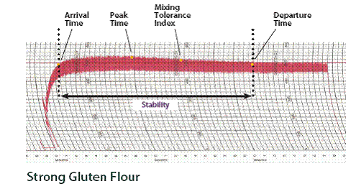

- Weak Gluten Flour
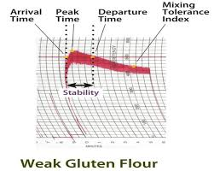
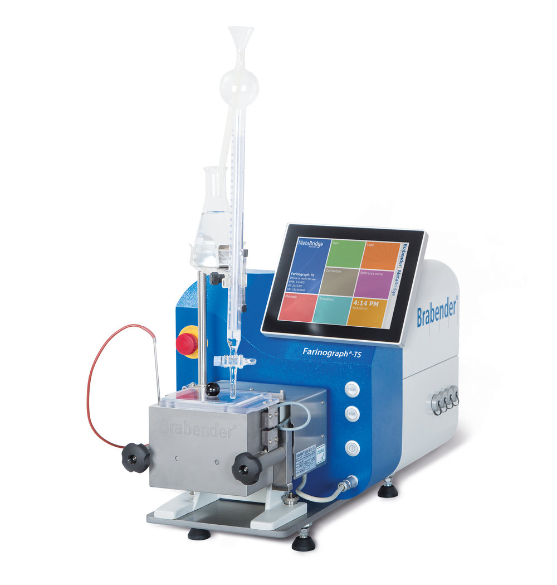
- Extensiograph
It determines the gluten strength. It assures the bread making characteristics of flour. It evaluates the dough performance.

The Extensiograph Test
It measures the resistance of a dough to stretching.
- Resistance to extend
It is denoted as R value & it is the maximum height of the curve which is measured in centimeters, Brabendar , Extensiograph Unit.
- Extensibility
- It is also called as E value and which is the length of the curve. It is measured in millimeters or centimeters .
- Important R/E ratio
It is the ratio of dough strength R to E.
- Area
It is the combined Resistance and extensibility. It is denoted as cm². R to E ratio is greater than weak gluten.
Method
- 300gm flour sample is of 14% moisture with a salt solution and form a dough in the farinograph.
- It allows the dough for 5 minutes that is called peak time.
Analysis
- 150gm sample is kept in extensiograph and shaped into a ball.
- Then Make the ball into a cylinder form.
- This dough cylinder is kept into the extensiograph and rested for 45 minutes in a desired condition.
- The dough is hanged in a hook and stretch it down.
- This graph records a curve .
- This step is repeated for two times more, at 90 minutes & at 135 minutes gradually.
- Strong gluten flour
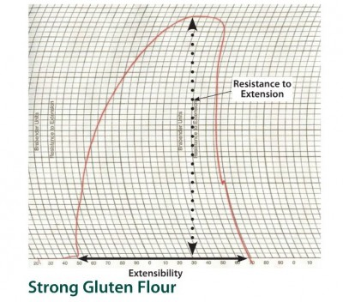

- Weak gluten flour
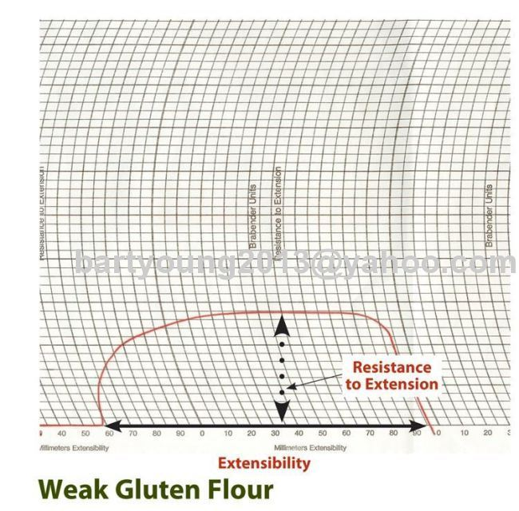

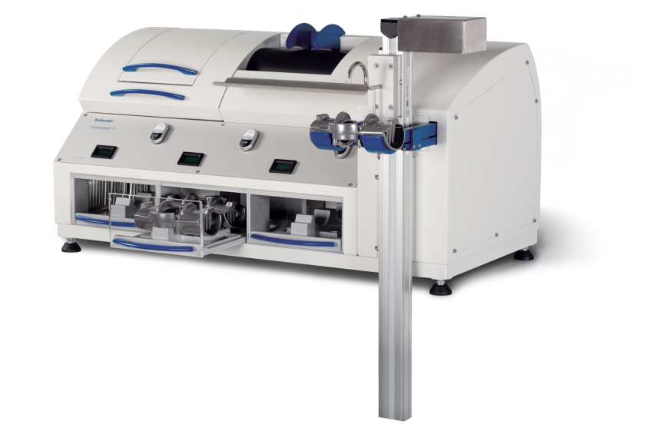
- Alveograph
It ensures a more consistent process & product. Strong gluten flour will have high P values & preferred for breads. It is the acceptable value.

The Alveograph Test
- Measures & records the force required to blow & break a bubble of dough.
- P –value – It means the force required to blow the bubble of dough which is expressed by the length of the curve .
Method
- 250 gms of flour sample is mixed with a salt solution to make a dough.
- Divide five different dough patties having 4.5 cm each.
- The sample is kept in the alveograph where temperature is 25ºC for 20 minutes
- Each dough portion is taken for testing. This Alveoraph blows air in a dough to expand bubble and gradually break it. Pressure inside the bubble is recorded as a curve.
- Fig – Alveograph 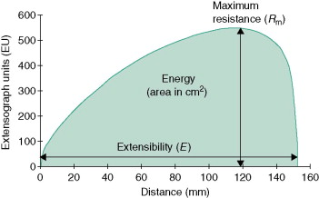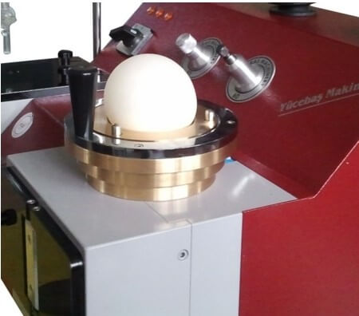
4. Mixograph
It measures the dough gluten strength. It also measures the flour water absorption.

The Mixograph Test
It measures the resistance of a dough mixing .
- Peak time for test
- Mixing tolerance of dough
- Peak time
This time begins the moment of mixer & recorder are started & continuing till the maximum consistency.
It is expressed in minutes.
- Mixing tolerance
It resists to break the dough while mixing and that affects the shape of curve. It tolerates over mixing. Strong flour has high peak value.
Method
- A flour sample of 35gm weight that is placed in a bowl of mixograph.
- Water is mixed and placed in a mixograph for making a dough.
- We get the curve on graph while it is mixing .
- Strong Gluten Flour –
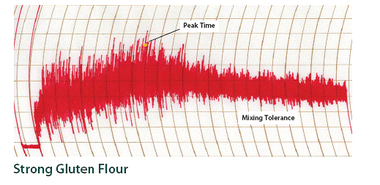

- Weak Gluten Flour –
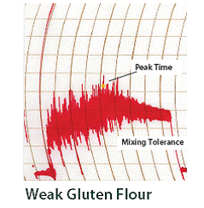
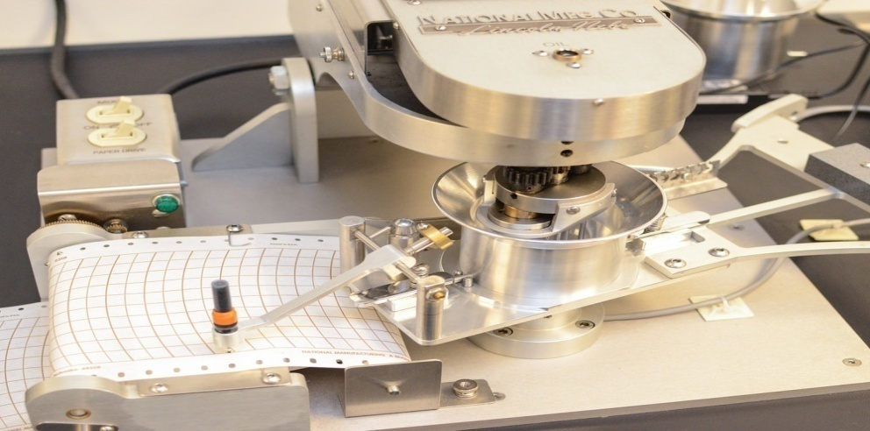

- Amylograph :
- It measures the viscosity of a flour water suspension as it is heated.
- It measures the changed viscosity as the starch granules gelatinize & swell during heating of that.
- This suspension of flour & water is made as per standard process.
- This mixture is heated from 30ºC to 92ºC in a rotating bowl.
- It records the viscosity as Brabender Amylograph (AU) against time or temperature.
- If the gelatinization is maximum between 300 & 700 AU is the good bread making performance.
- In case of low level of alpha amylase activity, there is low level of bread making quality.
- Rapid Visco-Analyzer can be replaced with amylograph.
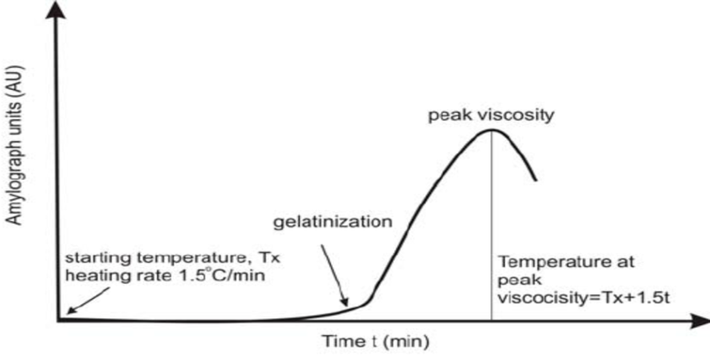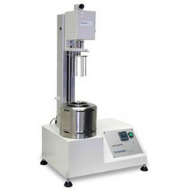

References
  - Khetarpaul N.(2020) Manufacture of bread “Bakery science and Cereal Technology” book.
  - Manay N. S. , Shadakshraswamy M. “Food facts and Principles” page no. 279 – 280.
  - Shrilakshmi B., “ Food Science” page no. 35.
  - Rodgers R, ed (2001) Yeast Breads and Flatbreads, The Baker's Dozen. THE BAKER'S DOZEN COOKBOOK: United States of America: HarperCollins Publishers Inc.
  - Fance W. J. and Wragg BH. Up - to - date Bread Making, Maclaren and Sons, London
  - Link : https://ecourses.icar.gov.in
  - www.aarushijain.com/baking_ingredients.html

