AN OVERVIEW OF THE METAL-ORGANIC FRAMEWORK
N.Ganeshwari, M.Karunakaran*, S.Usha and S.Prabakaran
Thin Film & Nano Science Research Lab, PG & Research Department of Physics, Alagappa Government Arts College, Karaikudi – 630 003, Tamilnadu, India.
tvdkaruna@gmail.com
ABSTRACT
Metal-Organic Frameworks(MOFs) have a unique class of porous hybrid organic-inorganic materials that have fascinating attention over the fast decennium. MOFs and their imitative have distributed ideal answers in detection, separation, solving water, electromagnetic pollution, developing catalysis, and energy storage efficiency due to their advantages in addition to their high porosity, structure, and adaptability. In this present article, structural exposure; types (MOF-5, HKUST-1, UiO, Zeolitic imidazolate framework(ZIF), MOF-76), methods ofsynthesis, and applications have been discussed. MOFs by replacing conventional organic linkers with biomolecules to magnify the stability joining metal ions/clusters and ligands and avoid the formation of toxic by-products. In addition unique advantages such as biocompatibility and mechanical strength, ideal reusability, and stability. Finally, the provocation and perspectives are discussed to provide the future development of MOFs as methodical tribunes for disease diagnosis and drug delivery systems.
Keywords: MOFs, ZiF, drug delivery, biocompatibility, diseases diagnosis.

1. INTRODUCTION
Metal-organic frameworks (MOFs), a specific class of coordination polymers, have captivated attention in different areas of science. Metal-organic frameworks (MOFs) are composed of chemical bonds between inorganic metal clusters and organic ligands as linkers [1]. Which, in terms of their potential for diversity, puts them ahead of other manmade materials like zeolites [2]. which benefits from their well-defined structure, high porosity, modularity, high surface area, a wide range of pore shapes, relatively low toxicity, and easy chemical functionalization [3]. MOFs can be fastly converted into metal oxides, metal sulfides, and porous carbon (PC) electroactive materials for energy storage devices. and that have potential applications in various fields such as ultra-strong applicability in adsorption, gas storage, catalysis, and electrochemical energy conservation [4]. The copper-based metal-organic porous materials, such as HKUST-1 and CuAdeAce are MOFs and metal-organic aerogels of CuDTA and CuZnDTA for the production of alcohols from hydrogenation of CO₂ with the saturated electrolyte of KHCO₃[5]. MOF is one of the most promising areas of human health care in the development of safer and more effective drug carriers, which is a constantly developing area of biomedical material sciences [6]. In recent years, biological metal-organic frameworks (bio-MOFs) with exemplary biocompatibility and disparate functionality have attracted wide attention [7]. It is possible to know the four basic abilities of MOFs to be used in pursuing applications. These attributes are (1) composition, (2) pore diameter, (3) pore morphology, and (4) combination with different nanomaterials [8].
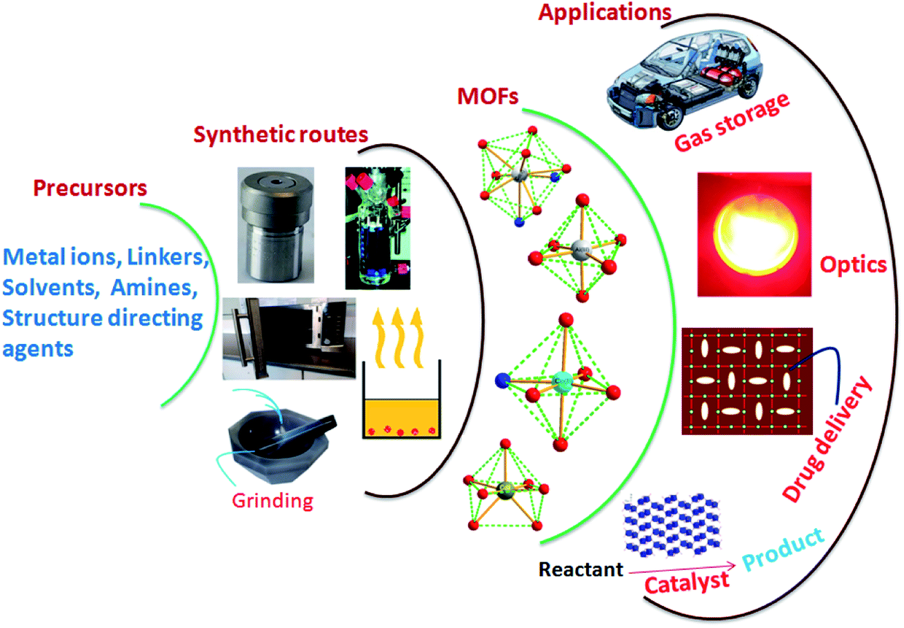

Fig. 1 Schematic representation of MOF synthetic routes and probable application
2. TYPE OF METAL-ORGANIC FRAMEWORKS
A porous extended organic-inorganic metal organic structure. An extended structure is one whose sub-units are arranged in a repeating pattern ad occur in a fixed ratio Among the most common types of MOFs alternatively employed in sensing, we can list MOF-5, HKUST-1, UiO, Zeolitic imidazolate framework (ZIF), and MOF-76.
2.1 MOF-5
A Cubic metal-organic framework substance MOF-5 or IRMOF-1 has the formula Zn4O (BDC)³, Where BDC2=1,4 azodicarboxylate (MOF-5) with a surface area to volume ratio of 2200m²/cm³. MOF-5 Stands out among metal-organic frameworks as having one of the highest surface area to volume ratios [9]. It was also the first metal-organic framework that was investigated for hydrogen gas storage. The structure of MOFs has extraordinarily high porosity and thermal stability due to its fully large and secondary building unit and benzene links [10]. The major methods used to synthesize MOF-5 were hydrothermal, solvothermal, microwave-based, and sonochemical processes. The solvothermal approach, which may produce a large amount of product in a single batch, is the most straightforward and effective of the procedures discussed. A MOFs derivative produced by replacing Zn2+ with Mn2+ revealed selective catalytic epoxidation of olefins in which the SBU of MOF-5 played a significant catalytic role [11].

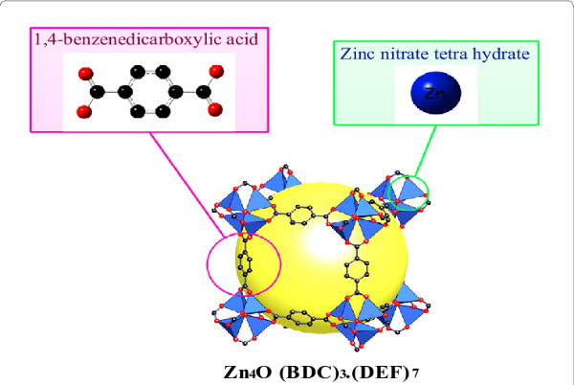

Fig2: Schematic illustration of the construction of metal-organic framework material (MOF-5)

(black; Zn, blue; O, red; gust molecule, yellow sphere, and all H atoms have been omitted for clarity).
2.2 HKUST-1
A cubic lattice (fm-3m) of benzene dicarboxylate (BTC) ligands that coordinate copper ions. Cu (II) ions from dimers in the HKUST-1 Framework, with each copper atom being coordinated by four oxygen atoms from BTC linkers as well as a water molecule[12]. the creation of composites based on HKUST-1 is a popular and active research and as a result, fresh and noteworthy instances have demonstrated intriguing applications (e.g. H₂ Storage, catalysis, chromatography, CO₂ capture, and lithium–sulfur batteries)[13]. The creation of composites (hybrid functionalized materials) employing MOF materials and other crystalline structures, like graphene or multi-walled carbon nanotubes, is another form of functionalization[14]. When HKUST-1 and GO are combined the former’s ability to decompose in water is prevented and the ladle's adsorptive, photochemical, and electrical capabilities are enhanced [15]. HKUST-1 is a copper-based metal-organic framework (MOF) that exhibits high electrical conductivity as a result of the copper ions it contains. It can be used as an antimicrobial agent in hydrogels [16].
2.3 UIO
Uio_{s} are a family of MOF_{S} encompassed by three main classes such as UiO-66, UiO-67, and UiO-68. Particular uninventive of these MOFs have been synthesized with linkers occupancy functional groups such as amines, halogens, hydroxyls, or nitrous. UiO-66 and UiO-67 are two Zr-based frameworks used regularly [17]. Especially, UiO-67 is a MOF procured by coordinating the theZR6O4(OH)4 metal unit with the 4,40-biphenyl dicarboxylate organic linker. On the other side, UiO-66 and UiO-68 prevailed by coordinating the same metal building block but with different linkers such as 1,4-benzene-dicarboxylate and 4,40,40-triphenyl dicarboxylate, respectively [18]. In pertinent lung experiments, we demonstrate that UiO-66 NPs exhibit great biocompatibility and minimal cytotoxicity both in vitro and in vivo. Our findings show that UiO-66 offers a novel opportunity to control lung penetration and particle deposition with potential applications in inhaled immunotherapies, nano vaccines, drug delivery, and COVID-19 [19].
2.4 ZIF-8 and ZIF-67
A subfamily of MOFs with a cage resembling sodalite is known as zeolitic imidazolate frameworks (ZIFs), which are based on imidazole bridging with metallic nodes (such as Zn and Co). and Using a pyrolysis-oxidation-phosphorization method, a CoP/NCNHP nanostructure can be created using the ZIF-8@ZIF-67 framework as a precursor. Li et al. developed Zn/Co-ZIF with a regulated hollow structure using a template that was similar to ZIF-8@ZIF-67. This structure-based Pd@H-Zn/Co-ZIF exhibits better activity and selectivity in the semi-hydrogenation of acetylene [20]. Due to the high porosity of the framework, ZIF-8 and ZIF-67 have a relatively large surface area (1970 m2 g). These compounds also have stable chemical and thermal characteristics. ZIF-8/ZIF-67 is made up of two MIM or Zn/Co ions and has a sodalite-like structure. They have an opening with a diameter of 3.4 nm in the center, which leads to a micropore with a diameter of 11.6 nm [21].
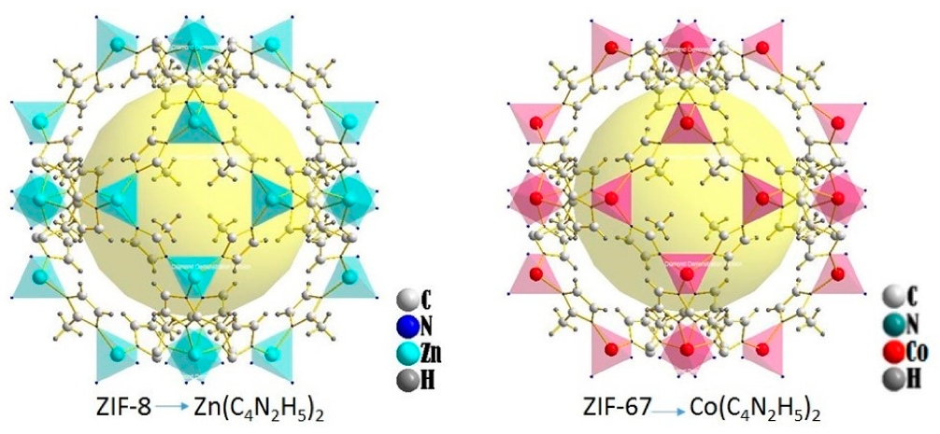

Fig3: Representative crystal structures of ZIFs under study.

2.5 MOF-76
The MOF-76 family's gadolinium(III) form was selected due to its ease of synthesis, high reaction yield, and successful use in our studies as a magnetic refrigerator, a humidity sensor, and an adsorbent of carbon dioxide, methane, and hydrogen [22]. Terbium(III) and benzene-1,3,5-tricarboxylate(-III) ions, one coordinated aqua ligand, and one crystallization N, N'-dimethylformamide molecule make up the crystal structure of MOF-76(Tb). MOF-76 can be used in sensing studies as well as biological imaging and light interactive devices.

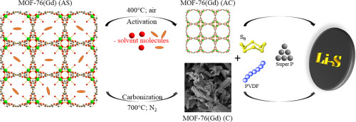

Fig4: structures of MOF -76

3. SYNTHESIS OF METHODS OF METAL-ORGANIC FRAMEWORK
Numerous variables, including reaction time, temperature, solvent, type of organic ligands and metal ions, size of nodes, structural characteristics, presence of counter ion, and crystallization kinetics, which should result in nucleation and crystal growth, affect the synthesis of MOFs [23]. Oxalatotitanates and titanophosphates were first made using hydrothermal processes.
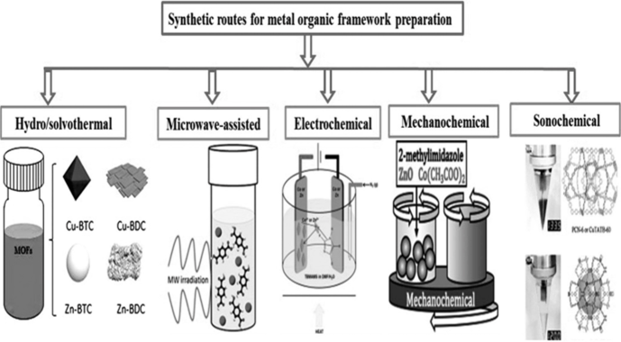
Fig 5: Overview of synthesis methods for the preparation of MOFs
. The hydrothermal process has been conventionally applied during metal extraction. Also, the application for the construction of extensive crystals has been observed. It depends on the temperature in a thermodynamically controlled experiment. High-pressure and -temperature circumstances are critical requirements for the synthesis media. MW radiation has been developed for the construction of inorganic or organic solid-state compounds with the benefits of particle size distribution, phase and microstructure control, and reduction in crystallization times[24].
The electrochemical method can be achieved in continuous flow operation or batch mode. A common advantage of this synthesis is that it works under mild conditions than ordinary microwave and hydrothermal synthesis. Sonochemical strategy stimulates homogeneous nucleation and fast kinetics; consequently, it forms a remarkable reduction of particle size due to that acoustic cavitation by ultrasound waves[25].
4. APPLICATIONS
The applications of altered MOFs are mainly distinct in medical-related fields such as disease diagnosis and drug delivery (e.g., diabetes, cancer, anti-diabetic agents, wound healing, neurological diseases, ocular diseases, and factorial infections). then energy-related fields like hydrogen production, overall water splittings, and environmental-related fields that dye degradation and water pollution[26].
The most potential alternative energy source to combat the current issue of fossil fuel use is hydrogen energyMOFs can also play a significant part in the generation of hydrogen. In photocatalytic and electrocatalytic production methods, MOFs are used to produce hydrogen[27].
4.1 DRUG DELIVERY
MOFs are a good candidate for drug delivery because of their highly tunable properties (pore size as well as tuning of the metal ion or organic linker), large surface area, and pore size. Nano-MOFs, which were created by scaling down MOF particle size, are effective for drug delivery vectors[28]. The cavity of MOF and/or the framework structures might be filled with a range of hydrophobic, hydrophilic, and amphiphilic therapeutic compounds[29]. The MOF nanocarriers attain targeted drug delivery, increased cellular uptake, and controlled drug release, making MOFs a promising class of DDSs for drug delivery, including anticancer drugs, antimicrobial agents, metabolic labeling molecules, antiglaucoma medication, and hormones [30].
4.2 DISEASE DIAGNOSIS
There are several examples, including gold-incorporated MOFs for magnetic resonance imaging (MRI) and PTT for breast cancer treatment, target-specific anticancer ZIF-8/enzyme hybrid MOFs with minimum recompense to the healthy cells, Fe₃O₄@bio-MOF-folic-acid-chitosan combine (FC) hybrid structures as theranostic in breast cancer, Zr-MOF@glucose-6-phosphate appeal in kidney cancer treatment, highly selective and sensitive Cu-MOFs for liver cancer therapy, Fe₃O₄@nickel-cadmium quantum dots (QDs)/MOFs as a biosensor for prostate cancer diagnosis, and Fe₃O₄@5-aminolevulinic-acid-Zn MOF for MRI and brain tumor therapy[31].
MOFs derived from ZnO@MoS2 nanosheets core /shell heterojunctions were used to detect acetone. On metamorphose non-luminescent MOFs to highly luminescent frameworks that exhibit a huge selectivity to acetone and can be used to fabricate fluorometric sensors to diagnose and monitor diabetes[32].
4. CONCLUSION
In this chapter, we have seen the various MOF families and the synthesis methods that could be used. The unique properties of MOFs are a result of their large surface area, high porosity, and their adjustable pore size. We conclude, therefore, that the discovery of MOF has proved to be beneficial to every aspect of our lives today, and it continues to attract the eyeballs of the researchers of our times. There is still a lot of research that has to be undertaken in the area of MOFs to improve their applicability in various fields.
REFERENCES
[1] .Vedia Foziya Yusuf, Naved I, Malek and Suresh Kumar Kailasa. Review on Metal Organic Framework Classification, Synthetic Approaches, and Influencing Factors: Application in Energy, Drug Delivery, and Waste Water Treatment ACS Omega 20227,49 44507-44531 DOI:10.1021/acs omega.2c05310.
[2] Miral Al Sharabati,Rana Sabouni, and Ghaleb A. Husseini. Biomedical Applications of Metal-Organic Frameworks for Disease Diagnosis and Drug Delivery: A Review Nanomaterials 2022 doi:10.330/nan012020277
[3]. Jie Liu, Yanjun L, and Zhichao Lou. Recent Advancement in MOF/Biomass and Bio-Mof Multifunctional Materials: A Review Sustainability 2022 ,14,5768 https://doi.orgl 103390/ Su 14105768
[4] Lakshmanan Gurusamy1, Sambandam Anandan2 and Jerry J. Wu1Metal-Organic Frameworks for Chemical Reactions. DOI: https://doi.org/10.1016/B978-0-12-822099-3.00018-6
[5] Rajasekaran Elakkiya and Govindhan Maduraiveeran. Metal-Organic Frameworks for Chemical Reactions. DOI: https://doi.org/10.1016/B978-0-12-822099-3.00013-7
[6]. Parth Malik1, Rachna Gupta1,2, and Rakesh Kumar Ameta1. Metal-Organic Frameworks for Chemical Reactions. DOI: https://doi.org/10.1016/B978-0-12-822099-3.00016-2
[7]. Huai-Song Wang, Yi-Hui Wang Ya Ding Development of biological metal organic frameworks designed for biomedical applications; and from bio-sensing/bio-maging to disease treatment.rsc.li/nanoscale-advances.
[8]. Metal-Organic Frameworks for Chemical Reactions. DOI: https://doi.org/10.1016/B978-0-12-822099-3.00016-2
[9].Rosi, Nathaniel L.; Eckert, Juergen; Eddaoudi, Mohamed; Vodak, David T.; Kim, Jaheon; O'Keefe, Michael; Yaghi, Omar M. (2003). "Hydrogen storage in microporous metal-organic frameworks". Science. 300 (5622):

[10].Engin Burgaz, Ayse Erciyes, Muberra Andac, Omer Andac.Synthesis and characterization of nano-sized metal organic framework-5 (MOF-5) by using consecutive combination of ultrasound and microwave irradiation methods https://doi.org/10.1016/j.ica 2018.10.014

[11] Abdul Malik P. Peedikakkal Isam H. Aljund Upgrading the Hydrogen Storage of MOF-5 by Post-Synthetic Exchange with Divalent Metal ions. Appl. Sci. 2021, 11, 11687. https://doi.org/10.3390/app112411687

[12]. Kuen-Song Lin, Abhijit Krishna Adhikari, Chi-Nan Ku, Chao-Lung Chiang, Hua Kuo. Synthesis characterization of porous HKUST-1 Metal Organic Frameworks for hydrogen Storage.https://doi.org/10.1016/j.ijhydene 2012.04.105
[13]. Jonathan Cortes-Suarez, Vanessa Celis-Arias, Hiram I Beltran, Adriana Tejeda-Cruz lich A Ibarra, Josue E Romero-Iberra El, Sanchez-Gonzalez, Sandra Loera-Serna. Synthesis and Characterization of an SWCNT@HKUST-1 Composite: Enhancing the CO₂ Adsorption Properties of HKUST-1 ACS Omega 2019, 4, 3, 5275–5282 https://doi.org/10.1021/acsomega.9b00330
[14]. Paulina Jogodka, Krzysz tof Matus and Agata Lamaca .On the HKUST-1 1/Go and HKUST-1/Rgo composites: The impact of Synthesis method on physicochemical properties. Molecules 2022,27(20), 7082; https://doi.org/10.3390/molecules27207082

[16].Wanli Zhao, Yuanhui Long, Yunging He,Jiabing Cai, Mingxian Liu. HNTS@HKUUST-1 Strenthened PAAM hydrogel for Strain Sensing and antibacterial application. https://doi.org/10.1016/j.micromeso.2022.112207

[17]. Michel J. Katz, Zachary J. Colon, Paul W. Siu, Karl A. Scheidt, Randall Q. Snurr, Joseph T. Hupp and Omer K. Farha. A facile synthesis of UiO-66, UiO-67 and their derivatives. Chem Common.,2013,49, 9449 DOI:10.1039/c3cc46105j

[18] Tolga Zorlu1, Luca Guerrini1 and Ramon A. Alvarez-Puebla1,2 The sensing applications of metal-organic frameworks and their basic features affecting the fate of detection. Metal-Organic Frameworks for Chemical Reactions DOI: https://doi.org/10.1016/B978-0-12-822099-3.00011

[19]. Bader M. Jarai, Zachary Stillman, Lucas Attia, Gerald E. Decker, Eric D. Bloch, and Catherine A. Fromen. Evaluating UiO-66 Metal Organic FrameWork(MOF) Nanoparticles as Acid-Sensitive Carriers for pulmonary Drug Dellivery Applications:ACS Appl Mater interfaces.2020 sep2; 12(35):38989-39004 doi:10.1021/acsami.0c10900

[20].Aotian Gu , Jiuyu Chen , Qianhong Gao, MuhammadMusaa Khan , Peng Wang , Yan Jiao , Zongxiang Zhang , Ying Liu , Yi Yang :The preparation of Ag/ZIF-8@ZIF-67 core-shell composites as excellent catalyst for degradation of the nitroaromatic compounds https://doi.org/10.1016/j.apsusc.2020.146160,

[21].Zahra Pouramini, Seyyed Moitaba Mousari, Aziz Bubapoor, Seyyed Alireza Hashemi Chin Wei Lai, Yousef Mazaheri and Wai- Hung Chiang. Effect of Metal Atom in Zeolitic Imidazolate Frameworks (ZIF-8 & 67) for Removal of Dyes and Antibiotics from Wastewater: A Review, Catalysts 2023, 13(1), 155; https://doi.org/10.3390/catal13010155

[22].D. Capková , T. Kazda , O. Čech , N. Király , T. Zelenka ^{e}, P. Čudek, A. Sharma , V. Hornebecq , A. Straková Fedorková , M. Almáši Influence of metal-organic framework MOF-https://doi.org/10.1016/j.est.2022.1044197
[23] A. Ratnamala1, G. Deepthi Reddy2, M. Noorjahaan2, H. Manjunatha1, S. Janardan1, N. Suresh Kumar3, K. Chandra Babu Naidu4, Anish Khan5,6 and Abdullah M. Asiri5, Titanium-based metal-organic frameworks for photocatalytic applications. Metal-Organic Frameworks for Chemical Reactions. DOI: https://doi.org/10.1016/B978-0-12-822099-3.00003

[24]. Mohammad, Ramezanzadeh ,and Bahram Ramezanzadeh Thermomechanical and anticorrosion characteristics of metal-organic frameworksMetal-Organic Frameworks for Chemical Reactions. DOI: https://doi.org/10.1016/B978-0-12-822099-3.00012-5

[25]. Rajasekaran Elakkiya and Govindhan Maduraiveeran. Metal-organic frameworks: preparation and application in electrocatalytic CO2 reduction reaction, Metal-Organic Frameworks for Chemical Reactions. DOI: https://doi.org/10.1016/B978-0-12-822099-3.00013-7
[26] Miral Al Sharabati, Rana Sabouni, GhalebA.Husseini. Biomedical applications of metal organic frameworks for disc diacnosis and Drug Delivery: A Review Nanomaterials 2022 doi:10.330/nan012020277
[27] Jiao, L., Seow, J. Y. R., Skinner, W. S., Wang, Z. U., & Jiang, H. L. (2019). Metal–organic frameworks: Structures and functional applications. Materials Today, 27, 43-68.

[28] Gaurav Awasthi , Sahil Shivgotra , Shibyendu Nikhar , Subramanian Sundarrajan Seeram Ramakrishna , Pawan Kumar. Progressive Trends on the Biomedical Applications of Metal Organic Frameworks Polymers 2022, 14(21), 4710; https://doi.org/10.3390/polym14214710
[29] Biomedical Applications of Metal Organic Frameworks 10.3390/polym14214710
[30] Yujia Liwei Zheng Yu Yang , Xu Qian , Ting Fu , He Yan , Cheng Cui , Weihong Tan Metal–Organic Framework Nanocarriers for Drug Delivery in Biomedical Application103 (2020)

[31] Mohammad Reza Saeb Mohammad Reza ,Metal–Organic Frameworks (MOFs) for Cancer Therapy ,2021 Dec; 14(23): 7277. doi: 10.3390/ma14237277
[32] Gutierrez.m, Moslein A.F., Tan J.C., Facile and fast tronsfomation of non-luminescenct to highly luminescent metal organic frameworks:Acetone sensing for diabetes diagnosis lead capturefrompollutendwater.ACSapplmater.interface.2021;13;7811.doi;10.1021/acsami.0c22307

