Future Trends of AI in Food Science & Technology and Agriculture

Authors Name: Rahul Dnyanesh Gunjal, Dr. Sheetal Sonawdekar.
Affiliation Name: D Y Patil University School of Biotechnology and Bioinformatics-Navi Mumbai, India
Email: rah.gun.bt21@dypatil.edu

ABSTRACT
Artificial Intelligence (AI) falls under the domain of computer science and aims to replicate human cognitive processes, learning abilities, and knowledge retention. AI can be categorized into strong AI and weak AI. Weak AI focuses on creating machines that imitate human intelligence and judgment, while strong AI asserts that machines can replicate human thought processes. A variety of sectors, including gaming, weather prediction, heavy industry, process industry, food production, medicine, data analysis, stem cell research, and knowledge representation, have adopted AI techniques for their specific purposes. AI encompasses a diverse range of algorithms like Support Vector Machine (SVM), K-nearest neighbour (KNN), Random Forest, Reinforcement Learning, and Artificial Neural Network (ANN), among others. AI's impressive performance has made it increasingly popular in various industries, particularly for decision-making and process estimation, with the main objectives of cost reduction, improved quality, and enhanced profitability.
Keywords: AI in Food Industry; AI driven agriculture; Machine Learning; Food Sensors; Sustainable food supply

- INTRODUCTION

Artificial Intelligence (AI) represents a branch of computer science dedicated to replicating human cognitive functions, learning capabilities, and knowledge retention. It can be categorized as strong AI or weak AI. Weak AI involves creating machines that mimic human intelligence and judgment, while strong AI contends that machines can replicate human thought processes. Various sectors, including gaming, weather forecasting, heavy and process industries, healthcare, data mining, and more, have adopted AI for their specific applications. AI encompasses a range of algorithms like Support Vector Machine (SVM), K-nearest neighbour (KNN), Random Forest, Reinforcement Learning, and Artificial Neural Network (ANN). Its exceptional performance has made it a favoured tool for decision-making and process estimation, aiming to reduce costs, improve quality, and enhance profitability [1].
Recent discussions have revolved around food production and factors influencing commodity markets in the supply-demand chain. These insights have raised concerns about meeting the food demands of a growing population sustainably. Addressing whether this challenge can be met without harming the environment and overexploiting resources is crucial. Factors include population growth, rising income levels in developing nations, global warming, and environmental hazards stemming from human activities. The food industry has evolved with modern innovations, especially in functional foods promoting a healthy lifestyle. To meet demands, the industry has adopted advanced processing techniques, transitioning from traditional machinery to intelligent machines and production lines. The question remains if these innovations can cater to the growing population while averting potential challenges. Hope for a solution lies in increased demand paralleled by advancements in technical innovations. The past decade has witnessed the rise of 4IR technologies like AI and computer vision robotics, altering business models and investments. These technologies hold promise in addressing future sustainable food supply demands [2].
The application of AI in food science and technology has yielded positive outcomes, improving production methods and personalized nutrition approaches. As AI continues to progress, its impact on the food industry is expected to grow significantly. In this chapter, we will explore upcoming developments of AI in food science and technology that are poised to revolutionize food manufacturing, distribution, and consumption practices.

- EARLY INNOVATIONS IN FOOD INDUSTRY

Many ages ago, the beginnings of progress in the realm of food production can be historically identified. In the beginning, simple implements were employed, but gradually, these transformed into the application of expansive mechanized systems. The domains of agriculture and food processing presently rank among the most lucrative fields, accountable for the creation and refinement of roughly 64% of the global food supply utilizing diverse technological breakthroughs. With the passage of time, each facet of the food sector has embraced inventive techniques to amplify effectiveness and curtail squander. Furthermore, these inventive approaches harbor the capacity to invigorate economic expansion and furnish enhanced prospects for generating income.

- FOOD PROCESSING PERSPECTIVE

Within the realm of the culinary sector, beyond the realms of food processing and administration, a pivotal segment exists that holds the power to profoundly affect the food economy. According to statistical information, the food processing domain is impacted by various variables, including the control of quality, the array of food categories, prevalent patterns, consumer psychology, and human welfare. These variables impose specific limitations on the food processing sphere, thereby necessitating the integration of technologies to amplify production efficiency, manage waste, and fulfil market requirements. As mentioned previously, the advancement of food processing technologies is significantly molded by shifts in market tendencies, which subsequently mold the entirety of the food industry. Essentially, market trends are hinged upon consumer viewpoints concerning food items, and these viewpoints can be altered through methodologies or marketing tactics.
Global reports on food technology indicate that certain occurrences such as time limitations, social circumstances, stress mitigation, and indulgence have led to an upsurge in the desire for modular foodstuffs within the marketplace. Similarly, the escalating proclivity toward health awareness and well-being has considerably spurred the acceptance of functional edibles. Expressions like "Embrace the Global, Support the Local," "Where Organic Meets Wholesome," and "Gluten-Free, Catering to Prominent Asian Markets" vividly exemplify the profound sway of health consciousness and well-being on market drifts [10]

- AI REVOLUTION

Artificial Intelligence (AI) embodies a fusion of various techniques and phenomena, yet its notable advancements can be largely attributed to two pivotal technological breakthroughs known as Neural Networks (NN) and Deep Learning (DL). This progress, once deemed unattainable, has now become feasible due to the contemporary high computational capacity of Graphics Processing Units (GPUs). The computational prowess of GPUs has empowered neural networks to emulate the intricate operations of the human brain, facilitating AI in acquiring proficiency in intricate tasks by leveraging extensive sets of training data. This profusion of data has resulted in remarkable discoveries, with prominent technology companies such as Google, Microsoft, Amazon, Facebook, and Apple actively participating in AI investigations, accumulating substantial data through their services. Nonetheless, these recent advancements in Artificial Intelligence have spurred contemplation within the human community regarding the potential of machine learning and the boundless prospects that AI could achieve in the times ahead [5].

- ARTIFICIAL INTELLIGENCE'S ROLE IN THE FOOD SECTOR

The expansion of artificial intelligence (AI) usage within the food sector has seen substantial growth over time, driven by several factors such as food categorization, parameter identification and forecasting, quality assurance, and food safety protocols. A range of widely utilized methodologies, including expert systems, fuzzy logic, artificial neural networks (ANN), adaptive neuro-fuzzy inference system (ANFIS), and machine learning, have found application in the food domain. Prior to the integration of AI, extensive research had already been conducted on topics related to food, aimed at both public awareness and improvements in food characteristics and production outcomes. The integration of AI into the food industry has been an ongoing process spanning decades, and its implementation continues to broaden, yielding a multitude of advantages [3], [12].

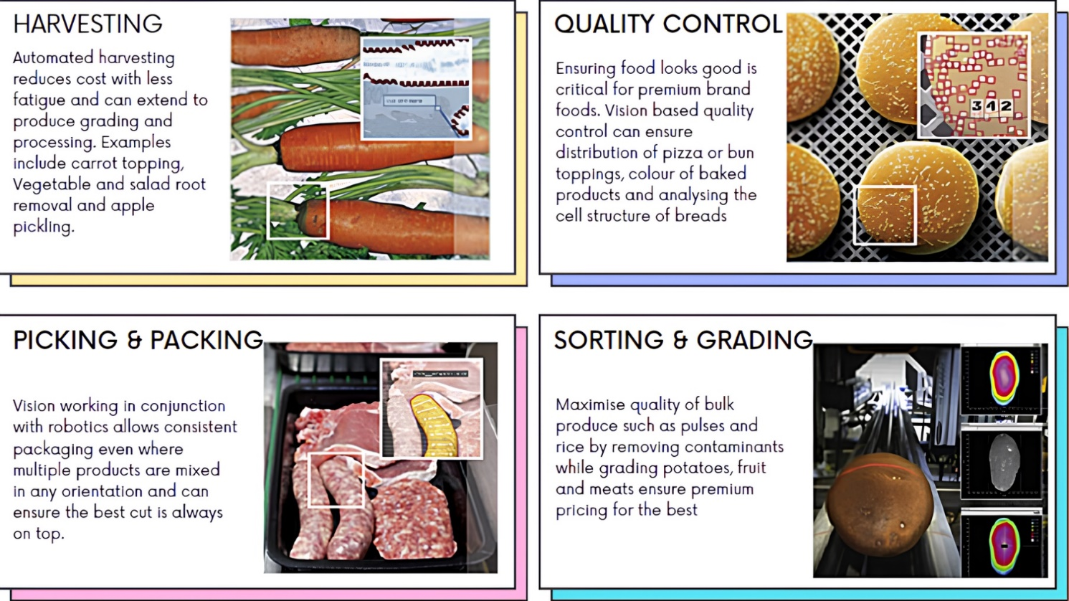
Fig.1 The food industry, propelled by artificial intelligence (AI), employs AI algorithms for tasks such as harvesting, quality assessment (QA), pickling, and sorting. [25]

- AREAS OF AI IN FOOD INDUSTRY

- Precision Agriculture and Smart Farming
AI-driven technologies will play a crucial role in transforming traditional agriculture into precision agriculture and smart farming systems. Drones and autonomous robots equipped with AI algorithms will be deployed to monitor and manage crops efficiently. These devices will gather data on soil conditions, plant health, and weather patterns, allowing farmers to make data-driven decisions for irrigation, fertilization, and pest control. The result will be increased crop yields, reduced resource consumption, and minimized environmental impact.

- Personalized Nutrition and Health Monitoring
AI will revolutionize the way we approach nutrition and health. Personalized nutrition will become a reality through AI-powered applications that analyse an individual's genetic data, lifestyle, and dietary preferences to recommend optimal meal plans. Moreover, wearable devices and smartphone apps will use AI to track and interpret health metrics, providing real-time insights into a person's nutritional needs and health status. This personalized approach will not only prevent diet-related diseases but also improve overall well-being.

- Food Quality and Safety Assurance
AI will enhance food quality and safety assurance by revolutionizing the way we detect and prevent contamination and spoilage. Intelligent sensors and AI algorithms will be deployed across the food supply chain to monitor factors like temperature, humidity, and chemical composition, enabling real-time tracking and early detection of potential hazards. This proactive approach will minimize foodborne illnesses and food waste, ensuring a safer and more sustainable food system.

- Culinary Creativity and Recipe Generation
AI will empower chefs and home cooks with creative culinary solutions. AI-driven recipe generation systems will analyse vast databases of ingredients, Flavors, and cooking techniques to propose innovative and delectable recipes. Moreover, AI-powered robotic kitchen assistants will become more prevalent, helping to prepare complex dishes, and reducing the workload in professional kitchens.

- Sustainable Food Production
AI will be instrumental in promoting sustainable food production practices. By leveraging machine learning and data analytics, AI can optimize resource utilization, minimize food waste, and reduce the carbon footprint of food production processes. Additionally, AI will drive advancements in alternative protein sources, such as plant-based and lab-grown meat, making them more accessible and palatable to a broader audience.

- Enhanced Food Packaging and Labelling
AI will revolutionize food packaging and labelling to ensure consumer safety and improve transparency. Smart packaging integrated with AI sensors will monitor product freshness and integrity, providing consumers with accurate information about the product's condition. AI-powered apps will also enable real-time scanning of product labels, helping consumers make informed choices based on their dietary preferences and allergens.

- AI-Enabled Food Delivery and Logistics
With the surge in online food delivery, artificial intelligence will have a pivotal role in optimizing delivery routes, forecasting demand patterns, and minimizing delivery durations. Advanced algorithms will guarantee that customers receive food when it's at its freshest and highest quality. Additionally, self-driving delivery vehicles and AI-equipped drones will further enhance the efficiency of logistics, streamlining the entire process and making it more economically viable, among other things.
The future of AI in the realm of food science and technology appears extremely promising, offering potential advantages across various facets of the food industry. From sustainable production methods to personalized nutrition and enhanced food safety systems, AI is set to transform how we manufacture, distribute, and savor our food. Nevertheless, as these technologies progress, it is crucial to address ethical concerns, safeguard data privacy, and ensure accessibility to ensure that the benefits of AI in the food sector are widely accessible and implemented responsibly. By harnessing AI's complete potential, we have the opportunity to construct a more resilient, efficient, and nourishing food ecosystem for future generations [4], [8].

- Artificial intelligence-driven food processing tactics
The existence of data related to food has sparked interest among researchers in the field of artificial intelligence, leading them to delve into the domain of culinary exploration. By 2015, computers had achieved a level of intelligence that allowed them to recognize food items depicted in images. In the early months of 2016, the Massachusetts Institute of Technology (MIT) engineered an AI system with the capacity to anticipate the constituents and nutritional composition of visually presented food. This innovation swiftly transitioned to the public domain, accessible as a mobile application within a matter of months. These strides in AI have yielded significant advantages for the food industry, facilitating efficient product promotion based on global culinary trends and strategic decision-making. Moreover, food processing has become more versatile, with machines demonstrating the ability to differentiate not only between basic tasks like distinguishing apples from oranges but also tackling more intricate challenges such as discerning between low-saturated fats and high unsaturated fats. Figure 1 showcases the food monitoring methodologies employed for diverse applications at "Stemmer Imaging".

- AI DRIVEN AGRICULTURE

Developed nations swiftly embrace novel advancements in technology, discarding outdated machinery in favor of more effective solutions. An intriguing advancement in agriculture involves the merger of computer vision and robotics, which has completely transformed the methods employed for land surveys and data inspections. A recent remarkable achievement in this field involves the utilization of drones and unmanned aerial systems equipped with multi-spectral sensors. This technological integration empowers farmers to oversee their crops meticulously, aiding them in making well-informed decisions related to irrigation and soil fertility.
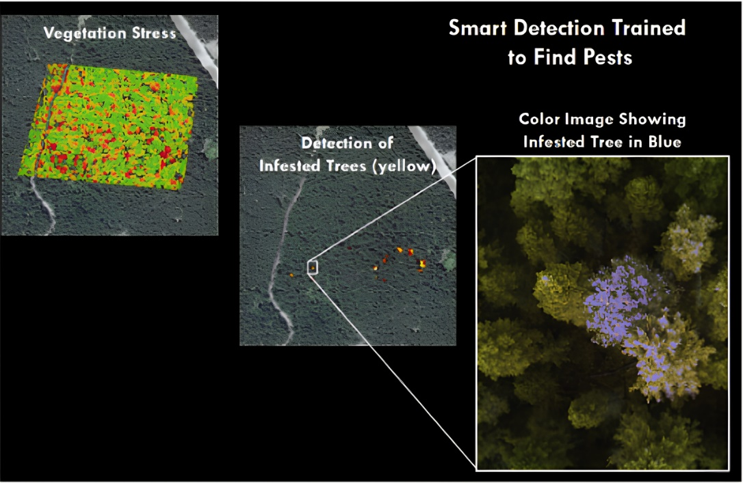
Soil, an intricate ecosystem teeming with countless cells, bacteria, and fungi, requires a conducive environment to foster plant growth. Cultivating fertile soil involves promoting beneficial microorganisms while simultaneously managing detrimental nematodes and pests. Conventional techniques for diagnosing soil pathogens are limited; however, Trace Genomics has introduced a more holistic approach that addresses multiple pathogens concurrently. By scrutinizing the soil's microbiome, Trace Genomics compiles critical data as its primary input. The genetic profiles of the soil are harnessed to anticipate diverse factors, encompassing sustainable yield, crop caliber, and susceptibility to diseases. Given the intricate interplay of variables such as environmental circumstances, nutrient compositions, and fertilization methods, this issue exhibits inherent nonlinearity. Machine Learning plays a pivotal role for enterprises like Trace Genomics in processing extensive data samples and constructing empirical models capable of predicting elements that contribute to elevated crop yields [15].
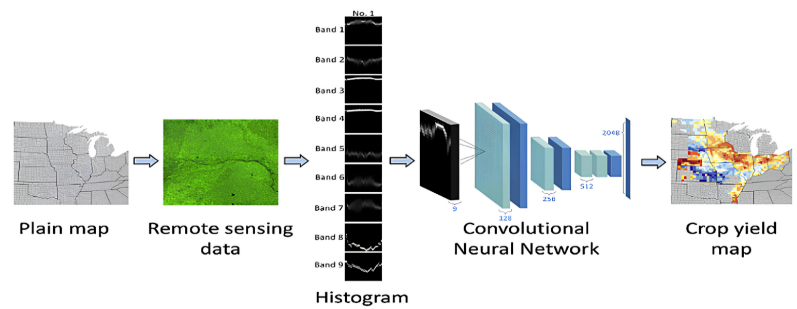
Fig.2.Intelligent Detection trained to find pests using Machine Learning Algorithms Employed by SLANTRANGE [24]
Fig.3. Intelligent Detection of Crop Yield Mapping Through Machine Learning Algorithms Employed by SLANTRANGE [23]
At the global scale, the burgeoning population exerts a profound influence on a multitude of facets, encompassing governmental policies and services. A pressing concern intertwined with this predicament involves striking an equilibrium between the escalating demand for sustenance and its provision in developing nations grappling with population growth. The march of technology has ushered in opportunities to uplift a nation's economic standing. Presently, both governmental entities and private investors are directing their attention towards the integration of AI and computer vision innovations across domains such as the food industry and agriculture, with the aim of tackling specific challenges and augmenting overall productivity.
In the realm of Agriculture Technology (AgTech), startups are actively cherry-picking AI and computer vision solutions that are finely tailored to specific tasks, all in pursuit of boosting agricultural yields and realizing the ambitious target of achieving sustainable food production by 2050. Pioneering companies like Ceres Imaging, SkySquirrel Technologies, and Blue River Technologies are harnessing the power of computer vision technologies, harnessing drones and robotic systems for image acquisition and spectral image analysis. The indispensable role of sensor data in scrutinizing various facets of farm operations cannot be understated, and emerging startups like Centaur Analytics, Spensa Technologies, and Sencrop are harnessing diverse sensor data to pinpoint anomalies in crop yields and irregularities in resource provisioning. For an exhaustive inventory of Agriculture Technology startups that leverage AI and computer vision technologies, please consult Table 1.

Table.1 AI-Powered Agricultural Technology Ventures: Robotics, Sensors, precision agriculture, smart irrigation, Next generation farms.
Serial Number | Technology | Entity | Details | Use-Case | Investors | References
1 | Robotics, Drones | Ceres Imaging | Founded in 2014, Oakland, California, USA | Detecting nutritional insufficiencies, defining management regions, facilitating variable-rate applications, and conducting water stress assessments. | ImagineH20, Lemnos Labs, Silicon Badia | [18]
2 | Sensors | Spensa Technologies | Founded in 2009, Great Lakes, USA | Intelligent sensor technology for the identification and forecasting of weeds and the anticipation of pest infestations. | Emerging Innovations | [19]
3 | Precision Agriculture and Predictive Analysis | Agrilyst | Founded in 2015, Brooklyn, New York, USA | Predicting the timing of crop harvesting and providing recommendations for planting cycles guided by data-driven solutions that result in bountiful crop production. | Brooklyn Bridge Ventures, Metamorphic Ventures | [20]
4 | Smart Irrigation | AquaSpy | Founded in 1998, Adelaide, South Australia, Australia | Monitoring the performance of crops in terms of water and nutrient management by utilizing a profiling model constructed based on anticipated soil moisture parameter predictions. | Alpina Partners, Centre for Energy and Greenhouse Technologies | [21]
5 | Next Generation Farms | Aero Farms | Founded in 2004, Newark, New Jersey, USA | Cultivating vibrant, leafy greens and herbs devoid of natural light and traditional soil, creating a precisely regulated environment utilizing data-driven modeling techniques. | 21Ventures, GSR Ventures, Middleland Capital | [22]

- BASICS OF MACHINE LEARNING

If you have ever engaged in a conversation with a data scientist about supervised, unsupervised, or reinforcement learning, you are essentially delving into discussions about the optimal approaches for addressing issues based on the data available to them. This segment will delve into the fundamental distinctions between supervised, unsupervised, and reinforcement learning within the domain of machine learning (ML), which itself falls under the umbrella of Artificial Intelligence. Prior to exploring the various types of ML, let us first clarify the concept of learning. At its core, ML revolves around crafting programs through the use of examples – specifically, data. While traditional programs rely on established rules and human intuition, data scientists generate fresh insights by implementing machine learning algorithms on short-term observed data.

- Supervised Learning
Supervised Learning is a data science approach that constructs a predictive model using labelled data. In simpler terms, labelled data includes various characteristics (features) of the data along with a specific outcome we aim to predict. To illustrate, if we want an AI model to distinguish between apples and bananas, the label would be either "apple" or "banana," while the features could encompass measurements like weight, length, and width of the fruits.
Now, let us delve into a more pertinent business example: customer attrition. To comprehend customer churn, you must first identify potential signs that a customer might leave. For this type of model, your dataset would contain indicators such as days since last purchase and average purchase amount, along with the labelled target variable indicating if the individual is still a customer. Given the historical data on customer status, constructing a model using this dataset aligns well with the concept of supervised learning.
Indicators of discussing supervised learning techniques might include terms such as:
  - Linear regression
  - Logistic regression
  - Support vector machines (SVM)
  - Decision trees
  - Random forest
Key Aspects of Supervised Learning: In supervised learning, the underlying assumption is that forthcoming data will resemble past data. Algorithms "learn" from a provided dataset, meaning they create a model based on historical patterns and labels. However, sometimes these models may not perform optimally when faced with new data. This phenomenon, known as "overfitting," indicates that the model is overly tailored to historical data. In simpler words, an overfit model lacks the ability to generalize.
When a model's performance declines, data experts must strike a balance between model accuracy and adaptability as the foundational dataset evolves. The process of retraining and adjusting the model to accommodate these changes typically unfolds gradually during the model's utilization. This constitutes a recurring stage in the data science lifecycle and underscores the importance of consistent model monitoring to ensure continued relevance [14].

- Unsupervised Learning
Unsupervised Learning involves a methodology aimed at discovering patterns and connections within data that lacks labels. This approach is commonly utilized to establish groupings and clusters.
To illustrate, consider the scenario of an email marketing campaign. Suppose you possess a dataset containing information about recipients, including their past purchasing behaviours, most recent website visits, and average expenditure on transactions. Since there are no predefined categories for grouping specific customers, you can utilize unsupervised learning to potentially create your own categories. By employing unsupervised learning, you can analyse this behavioural data and arrange your customers into distinct clusters. The remarkable advantage of this machine learning technique is that you do not need to possess prior knowledge of the inherent groupings – the clusters naturally form based on data patterns. Subsequently, these clusters can be associated with business terms. As a result, you can make informed decisions about which subset of customers to target in your email campaign.
Unsupervised learning is frequently employed for exploratory analysis and anomaly detection, aiding in the comprehension of relationships between different segments of data and the identification of potential trends. Such techniques can also serve as preprocessing steps before applying supervised learning algorithms or other artificial intelligence methodologies. Notable examples of unsupervised learning techniques encompass:
- K-Means Clustering
- Principal Component Analysis (PCA)
- Autoencoding
Often, unlabelled data is subjected to unsupervised learning methods due to the absence of desired output during application. Evaluating the accuracy of an unsupervised model becomes intricate in the absence of corresponding labels that signify the intended outcome. The validation of a model's effectiveness requires either manual examination of the results obtained or the formulation of precise rules. These challenges can sometimes be alleviated by combining unsupervised learning algorithms with other techniques, a process occasionally referred to as "stacking" [14].

- Reinforcement Learning
Reinforcement Learning, a methodology centered around a reward-based mechanism, involves training through iterative interactions. It employs a machine or an Agent to engage with an environment, experimenting with diverse approaches to achieve specific outcomes. This Agent receives rewards or penalties upon attaining favourable or unfavourable states, consequently discerning the paths leading to positive results and those resulting in negative consequences. Progress is gauged by a score (referred to as Q-Value, giving rise to the alternate term Q-learning), enabling the Agent to progressively enhance its performance. The concept finds application in scenarios such as guiding a car along a curving road. In this case, the Agent monitors its present status by measuring variables like speed, alignment with the road, and proximity to road edges. The Agent can execute actions that alter its state, like steering, accelerating, or braking. Rewards are bestowed upon desired behaviours such as staying centered on the road and successfully completing the route, while penalties are incurred for collisions or sluggish movement.
A proficient execution of Reinforcement Learning harmonizes immediate and future rewards, facilitating optimization. For instance, the car must learn to avoid crashes while advancing toward the destination. Unlike supervised learning, which necessitates labelled data, and unsupervised learning, which employs unlabelled datasets, reinforcement learning operates without these prerequisites. It continually refines its performance by adapting from past experiences and crafting new ones. In essence, it generates fresh datasets and outcomes with each attempt.
Reinforcement Learning finds application across domains such as:
- Robotics
- Self-driving systems
- Gaming
These algorithms are often leveraged to tackle intricate challenges. Although they excel in gaming scenarios, their collaboration in team-based activities remains a developing area. Additionally, reinforcement algorithms are under assessment in recommendation engines, alongside supervised and unsupervised methods, to ascertain their optimal use in specific contexts [14].
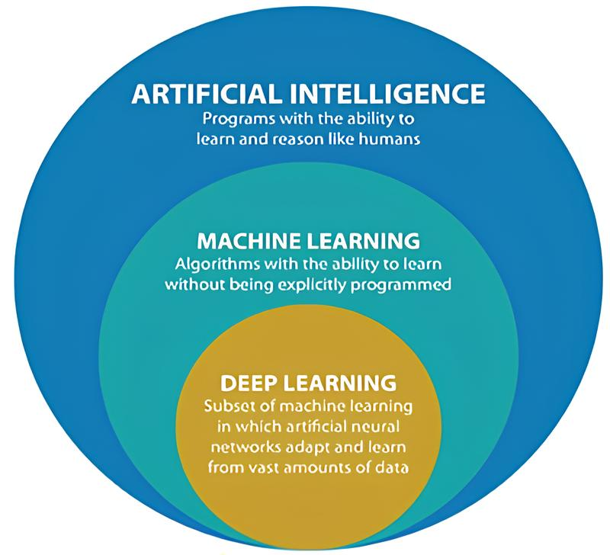
- SUB-TYPES OF AI
Fig. 4 AI & its Sub Types [26]

- Machine Learning (ML)
Machine Learning (ML) is recognized as a subset within the realm of Artificial Intelligence (AI). It represents a computer algorithm that evolves autonomously through experiences. ML can be categorized broadly into three main branches, namely supervised learning, unsupervised learning, and reinforcement learning. Supervised learning's primary objective revolves around forecasting the desired target or output based on provided input data. Conversely, unsupervised learning lacks predefined outputs to predict and instead is employed to categorize input data and unveil inherent patterns within it. Reinforcement learning enters the picture when there is an interactive dynamic between the program and its environment as it strives to attain specific objectives.
Among the well-known models in the field of machine learning are decision trees (DT), Random Forest (RF), Support Vector Machines (SVM), regression analysis, Bayesian networks, genetic algorithms, kernel machines, and federated learning. ML has emerged as a staple for tackling intricate tasks and vast datasets, alongside a multitude of variables, where no pre-established formula or conventional solution exists for the given problem. Additionally, ML models possess the unique capability to glean insights from examples rather than being strictly reliant on predefined rules. [1], [2], [4], [17].

- Random Forest (RF)
Random Forest (RF) technique is a supervised approach extensively employed for classification and regression tasks. It operates on an ensemble learning principle, wherein during training, RF amalgamates numerous decision trees. These trees collectively determine the output class by utilizing the class mode from each individual tree. Comprising decision trees, RF boasts simplicity in construction, utilization, and interpretation. While decision trees perform well with their training data, they lack adaptability when applied to classify novel samples. The noteworthy aspect is that random forest harmonizes simplicity with a substantial enhancement in precision. RF offers multiple benefits, with one of its key strengths lying in versatility. It aptly serves both classification and regression objectives, while also enabling a clear assessment of the significance it attributes to input features.
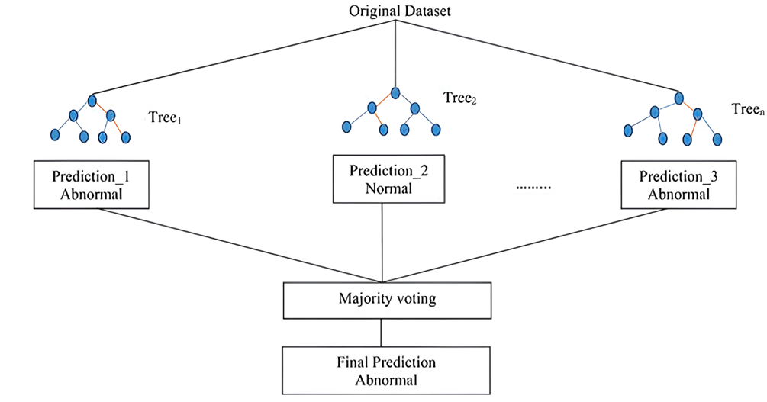
Fig.5 A common RF architecture for prediction [17]

- Deep learning (DL)
In recent years, deep learning, a subset of artificial intelligence, has witnessed remarkable progress in the domain of detecting impurities and defects. This specific field places a strong emphasis on the intricate layering within neural networks. Any neural network comprising more than three layers, encompassing both inputs and outputs, is categorized as a deep learning algorithm. The introduction of convolutional neural networks (CNNs) in the latter part of the 1990s marked the inception of a series of transformative developments in deep learning models. Consequently, substantial endeavors have been devoted to augmenting deep neural networks through a multitude of theoretical and practical enhancements. At present, CNNs have emerged as the forefront solution for recognizing patterns in images. [1], [2], [4], [17].

- Artificial neural networks (ANNs)
Artificial neural networks (ANNs) are engineered to mimic the cognitive processes of the human brain. They draw inspiration from the biological neuron model and consist of interconnected neurons organized into input, hidden, and output layers. Within ANNs, one can find activation functions, weights, and thresholds. ANNs are celebrated for their capacity to adapt, generalize, and withstand interference. Lately, ANNs have found utility in conjunction with fluorescence sensors for detecting adulteration in extra virgin olive oil, leveraging hyperspectral imaging and Raman microscopy, among other applications in the agricultural and food quality domains.

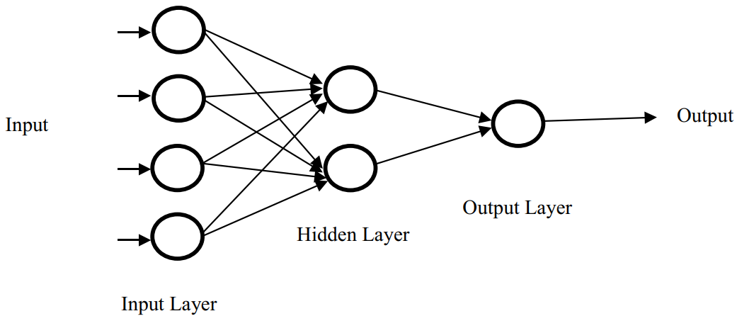

Fig.6 ANN structure in general [17]

- Convolutional Neural Networks (CNN)
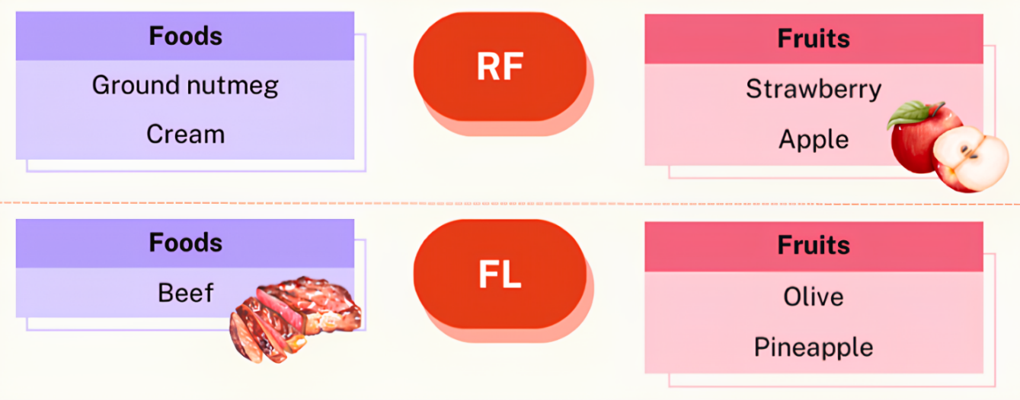
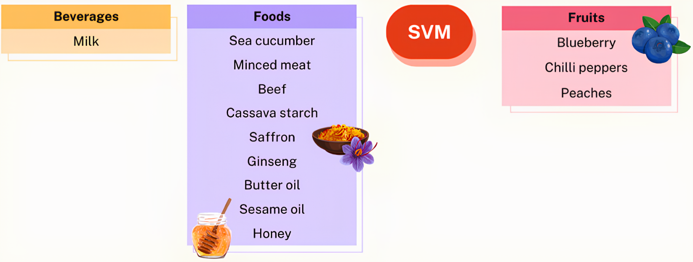
The Convolutional Neural Networks (CNN) have firmly established themselves as a cornerstone technique for delving deep into the intricacies of digital input data, effectively tackling classification and regression challenges. As depicted in the illustrative diagram in Figure 8, a CNN architecture comprises essential components: an input layer, convolutional layer, pooling layer, fully connected layer, and the ultimate output layer. Diverse CNN architectures abound and are extensively harnessed in the realms of food and agriculture image categorization. Prominent among these are VGG, AlexNet, LeNet, ResNet, DenseNet, and Inception. CNN has demonstrated its prowess in the successful detection of adulteration in food products and the quality assessment of agricultural goods.
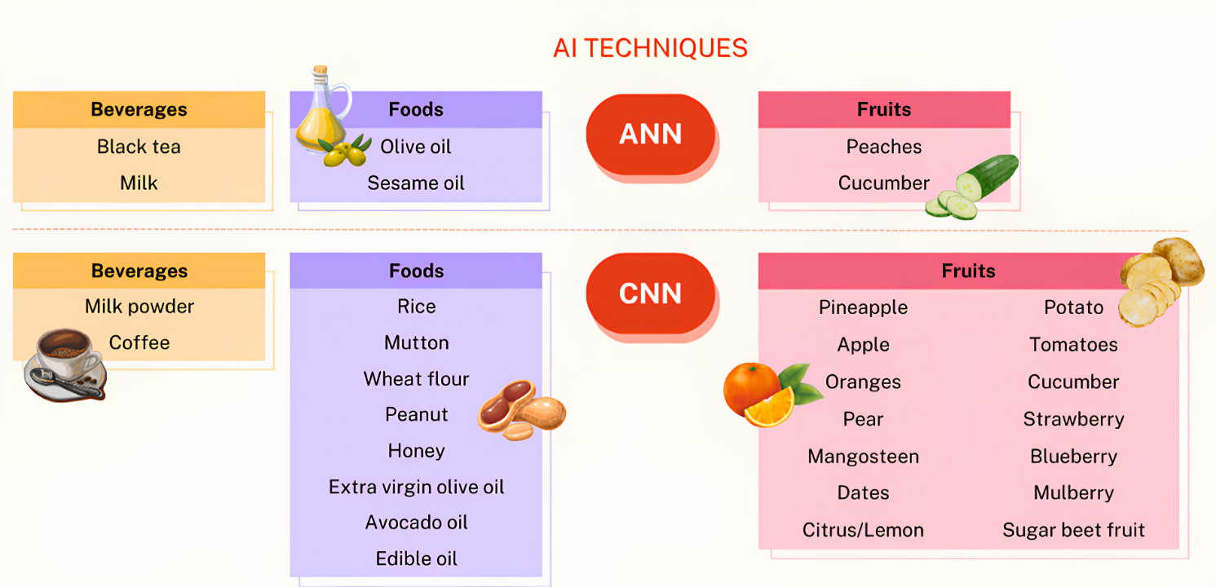
Fig.7 Exploration of Artificial Intelligence Methods Employed in the Detection of Adulteration and Fruit Imperfections in the Food and Beverage Industry [16]

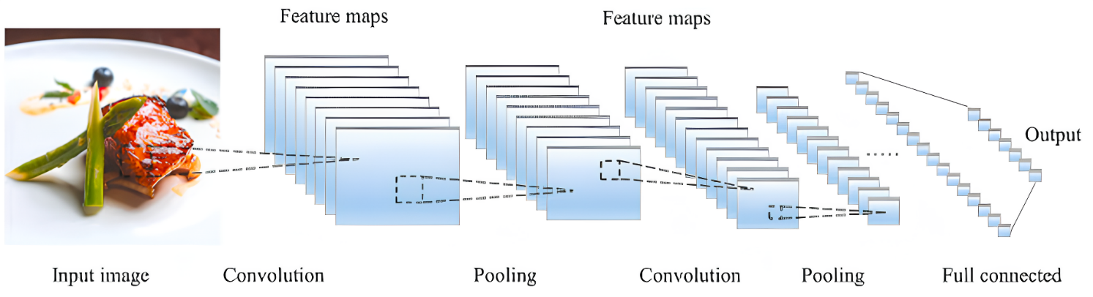
Fig.8 A typical CNN design for the identification and examination of food, comprising convolutional strata, a pooling stratum, and a fully linked stratum. [25]

- Fuzzy Logic (FL)
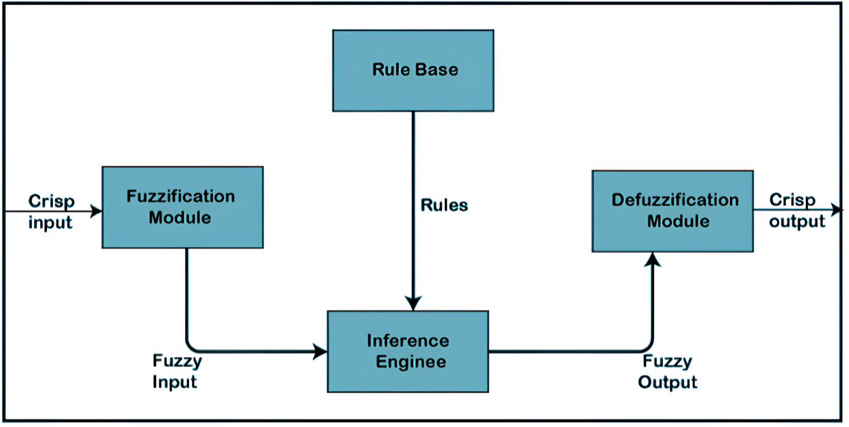
Fuzzy Logic (FL) captures the intricate thought processes involved in human decision-making when confronted with vague and uncertain data. It has proven its effectiveness in tackling classification challenges characterized by incomplete or equivocal information. However, the efficacy of fuzzy logic hinges on meticulous tuning, which can pose challenges when confronted with substantial datasets or high-dimensional data. Fuzzy systems offer the advantage of employing more uncomplicated algorithmic formulations and linguistic variables. A standard FL framework consists of four primary components: the rule base, fuzzification, inference engine, and defuzzification, as illustrated in Figure 9. Fuzzy logic has found diverse applications in assessing food quality, encompassing tasks such as pineapple quality assessment, forecasting poultry egg production, determining sunflower oil frying rates, classifying wine quality, ranking the extraction quality of Flixweed (Descurainia sophia) seeds, and detecting external defects in olives.
Fig.9 A typical fuzzy logic (FL) structure comprises four primary components: a rule repository, the process of rendering vague data more precise, an inference mechanism, and the act of transforming the refined data back into a crisp form. [17]

- Knowledge based Expert System (ES)
The knowledge-based system represents a computer program that harnesses insights derived from diverse origins, information, and data to tackle intricate dilemmas. It can be categorized into three distinct genres: expert systems, knowledge-driven artificial intelligence, and knowledge-centered engineering. The dissection of the knowledge-based system is depicted in Figure 10. The knowledge-based expert system, extensively employed in various industries, constitutes a pivotal and collaborative computerized system capable of emulating human expert decision-making prowess. This particular breed of knowledge-based system stands as one of the earliest triumphant models in the realm of artificial intelligence. It relies on the expertise of human professionals to unravel complex challenges within specific domains. Its architecture comprises two pivotal subsystems: a knowledge repository housing worldly facts, and an inference engine embodying rules and conditions governing the world, typically formulated in IF-THEN constructs. Typically, it resolves intricate quandaries with the assistance of a human expert. The foundation of this system lies in the wisdom imparted by domain experts. The key constituents of the expert system (ES) encompass the human expert, knowledge engineer, knowledge repository, inference engine, user interface, and the end user. The workflow of the expert system is delineated in Figure 11. [1], [2], [4], [17].
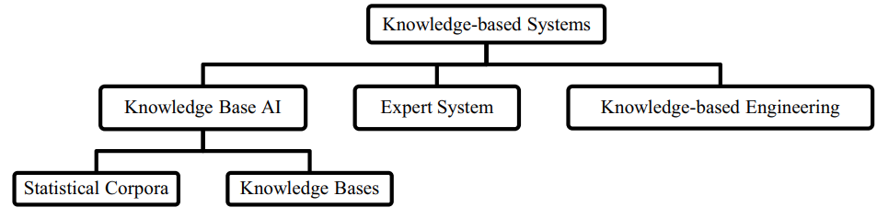
Within the realm of the food industry, ES has found manifold applications, proving its utility, particularly in the decision-making process. The knowledge-based expert system has been employed in the context of white wine production, serving as a supervisory, intelligent controller and data retrieval tool during the fermentation phase. Additionally, a web-based application was developed by integrating ES, enabling users to compute the nutritional value of food items.
Fig .10 Knowledge based system [17]
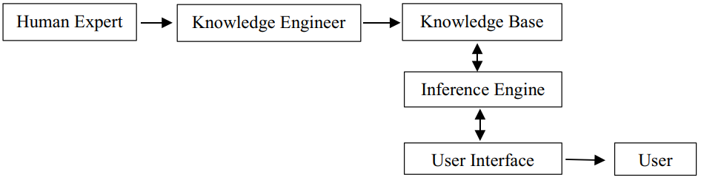

Fig. 11 Expert System [17]

- UTILIZATION OF AI-DRIVEN METHODS FOR IDENTIFYING ADULTERATION AND FLAW DISCOVERY IN THE FOOD AND AGRICULTURAL SECTOR

The food industry faces critical challenges encompassing quality, safety, and authenticity, extending beyond the concerns of consumers and government bodies. The issue of food authenticity has gained paramount importance due to the potential public health hazards associated with fraud. It is estimated that global food fraud exacts an annual toll of approximately $US49 billion. Instances of food contamination, as exemplified by the 2008 Chinese milk scandal and the 2013 horse-meat scandal, underscore the profound repercussions on the global food supply chain when such incidents occur.
These alarming events have ignited a renewed commitment to fortifying measures aimed at ensuring the integrity of the food supply chain. There is an escalating demand for rigorous, expedient, and credible food tracing mechanisms to safeguard this vital network. In this context, artificial intelligence (AI) emerges as a game-changer, possessing the capability to swiftly and accurately scrutinize vast and intricate datasets.
AI has surfaced as a potent force, bolstered by advanced computational capabilities and the prowess of big data technologies. It is instrumental in deciphering complex data patterns and has experienced a surge in adoption over recent years. Its sphere of influence spans a broad spectrum within the food and agricultural domains, encompassing activities from production and disease detection to weed identification, phenology tracking, livestock management, integrated crop-livestock systems, aquaculture, yield prediction, harvesting, processing, packaging, and distribution to the end consumer.
Existing literature reviews exist on the overarching applications of AI in the food industry and agriculture, with some focusing exclusively on specific AI algorithms, such as Artificial Neural Networks (ANN) in drying technology, ANN in food processing, and Convolutional Neural Networks (CNN) in agriculture.
Notably, AI has gained prominence in combating food adulteration in recent times. Its involvement in detecting food adulteration entails the training of algorithms through extensive datasets encompassing authentic and counterfeit products, with a keen focus on identifying subtle compositional disparities. These disparities serve as the basis for constructing models that, when applied to a food product, can precisely discern any tampering.
This approach holds immense promise for the non-destructive identification of adulteration that may elude human inspection or conventional laboratory methods. Furthermore, AI's application in food adulteration detection offers a cost-effective and efficient means to screen large quantities of products for potential adulterants, a particularly valuable asset for food producers and retailers tasked with upholding the quality and safety of their offerings.
Additionally, AI's capacity to learn and adapt from new data augments its accuracy over time as it encounters more instances of genuine and counterfeit products, thus further enhancing its efficacy in this critical domain.
[12], [15].

- ADVANTAGES AND LIMITATIONS OF AI

- Advantages:

- Reduction in Human Error
A major benefit of Artificial Intelligence is its ability to markedly decrease mistakes while enhancing precision and exactness. AI's decisions at each stage are guided by prior data collection and specific algorithms. When correctly programmed, these errors can be eliminated entirely.
Illustration:
An instance showcasing the diminishment of human errors through AI can be seen in the application of robotic surgical systems. These systems execute intricate procedures with accuracy and precision, thereby diminishing the likelihood of human errors and advancing patient safety within the healthcare sector.

- Zero Risks
An additional significant benefit of artificial intelligence involves humans being able to mitigate numerous risks by delegating tasks to AI-driven robots. These tasks encompass activities such as bomb defusal, space travel, and deep-sea exploration. Machines composed of metal materials possess inherent durability, allowing them to thrive in inhospitable conditions and adverse surroundings. Furthermore, they exhibit precision and heightened accountability, enduring prolonged periods of operation without succumbing to fatigue.
Illustratively, a case in point highlighting the eradication of risks can be observed in the implementation of a fully automated production line within a manufacturing facility. In this scenario, robots assume all responsibilities, eradicating the potential for human errors and injuries, especially in hazardous settings.

- 24x7 Availability
Numerous research studies indicate that humans typically maintain peak productivity for only around 3 to 4 hours each day. It is also widely recognized that humans necessitate regular breaks and time off to strike a balance between their professional and personal lives. Conversely, artificial intelligence (AI) possesses the capacity to operate tirelessly without the need for intervals. AI systems exhibit significantly swifter cognitive processing compared to humans, enabling them to multitask proficiently and achieve precise outcomes across various activities concurrently. Moreover, AI algorithms empower these systems to effortlessly handle monotonous and repetitive tasks. An illustrative instance of this phenomenon can be observed in online customer support chatbots, which leverage AI and natural language processing to provide instantaneous assistance to customers anytime and anywhere. These chatbots adeptly address common inquiries, resolve issues, and if necessary, escalate intricate matters to human agents, thereby ensuring continuous and seamless customer service.

- Faster Decision-making
AI offers the advantage of expediting decision-making processes. Through the automation of specific tasks and the provision of immediate insights, AI aids in accelerating and enhancing the decision-making capabilities of entities. This proves especially advantageous in critical situations where swift and precise choices are imperative to avert costly mistakes or preserve lives.
Illustration:
A case in point demonstrating accelerated decision-making is the utilization of AI-driven predictive analytics within the realm of financial trading. In this scenario, algorithms possess the capacity to swiftly analyse extensive datasets in real time, enabling them to arrive at well-informed investment decisions more rapidly than human traders. The outcome is an enhancement in returns on investments and a reduction in associated risks.

- Pattern Identification
AI demonstrates exceptional performance in recognizing patterns, showcasing its prowess in the field. Its capacity to scrutinize extensive datasets and discern patterns, as well as trends, equips AI to facilitate enhanced comprehension of customer actions, market inclinations, and other pivotal elements for enterprises and establishments. This knowledge proves invaluable for making informed choices and enhancing business results.
For instance, AI's role in pattern identification is evident in its application within fraud detection. Through machine learning algorithms, AI discerns patterns and irregularities within transactional data, thereby enhancing security measures and curbing financial losses for both individuals and entities. This exemplifies how AI's pattern recognition capability can elevate safeguards and bolster fiscal integrity.

- Perform Repetitive Jobs
In our daily job responsibilities, we will engage in various routine activities like inspecting documents for errors and sending out expressions of gratitude. These mundane tasks could potentially be streamlined and made more efficient through the implementation of artificial intelligence. By leveraging AI, we can free up individuals from monotonous duties, enabling them to channel their energy into more innovative endeavors. This parallels the utilization of robots in manufacturing assembly lines, where tasks like welding, painting, and packaging are executed precisely and rapidly, resulting in cost savings and enhanced productivity [13].

- Limitations:

- High Initial Costs
Generating a machine capable of emulating human intelligence is a significant accomplishment, demanding substantial time, resources, and financial investment. Additionally, artificial intelligence necessitates up-to-date hardware and software for ongoing enhancements and compliance with current standards, contributing to its considerable expenses.

- No Creativity
One major drawback associated with artificial intelligence is its limitation in thinking innovatively. While AI can accumulate knowledge through pre-existing data and past occurrences, it falls short in displaying creativity. An illustrative case is exemplified by the bot named Quill, which generates earning reports for Forbes. These reports solely rely on information and figures previously input into the bot. Although the bot's ability to autonomously compose articles is noteworthy, it lacks the distinctive human element found in other articles featured in Forbes.

- Unemployment
A particular utilization of artificial intelligence involves robots, which are supplanting jobs and potentially causing a rise in joblessness in certain instances. This has led to assertions that the substitution of humans by chatbots and robots could potentially lead to ongoing unemployment. Take, for example, the widespread use of robots to take over tasks previously handled by human workers in technologically advanced countries like Japan. Nevertheless, this does not apply universally, as it simultaneously opens up new avenues for human employment while also serving to enhance efficiency by substituting certain human roles.

- Make Humans Lazy
AI technology automates the bulk of monotonous and recurring activities. As a result, the need for manual memorization or puzzle-solving diminishes, leading to a decreasing reliance on our cognitive capacities. This overreliance on AI has the potential to create challenges for upcoming generations.

- Emotionless
From a young age, we have been educated those machines, including computers, lack emotions. Human collaboration is integral to success, requiring proficient team administration. Although it is undeniable that robots outperform humans in efficient performance, the irreplaceable aspect of human interactions, fundamental to teamwork, remains evident.

- No Improvement
Creating artificial intelligence is beyond human capabilities as it relies on pre-existing information and knowledge. AI excels at repetitive tasks, but any modifications or enhancements necessitate manual code adjustments. While AI can store vast amounts of data, it lacks the adaptability of human intelligence. Machines are restricted to performing tasks they have been specifically designed or programmed for; any deviation often leads to failures or irrelevant outcomes, potentially causing substantial harm. Consequently, achieving conventional outcomes remains elusive [13]

- DIRECTIVES FOR SELECTING THE SUITABLE AI APPROACH

Artificial Intelligence (AI) has found extensive use in the industry due to its manifold benefits when compared to conventional methods. While all AI algorithms are acknowledged for their precision and dependability, it is imperative to exercise discernment by considering both their advantages and limitations. Various algorithms possess distinct strengths and weaknesses, necessitating a case-specific approach when selecting them for applications within the food industry. The subsequent guidelines outline the process for algorithm selection:
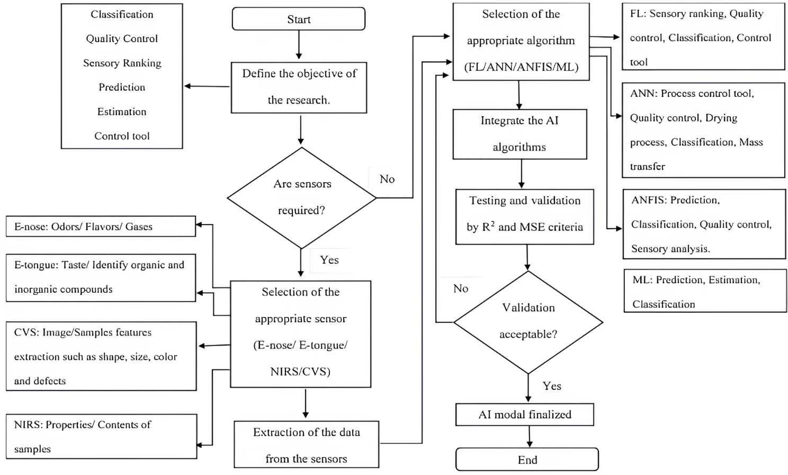
The meticulous choice of an algorithm is pivotal during AI model development as it plays a pivotal role in enabling users to attain results that are accurate, expeditious, and cost-effective. Therefore, the guideline presented in Figure 12 serves as an invaluable resource for optimizing outcomes in case studies. The initial step in this selection process mandates that users clearly define and finalize the objectives underpinning their utilization of AI in research or implementation. Common aims for AI applications in the food industry encompass prediction, classification, quality control, detection of adulterants, and estimation.
Fig.12 Schematic for the Creation of an Artificial Intelligence Model [17]

Following this, a determination must be made regarding the necessity of sensors such as E-tongue, E-nose, CVS, and NIRS for data collection from the samples. Typically, integration with these sensors is performed to procure parameters and characteristics of the samples, which are subsequently incorporated into the AI algorithms for sample testing. Once the requirement for sensors has been established, users should undertake a comparative assessment to identify the most suitable algorithm for their study. Frequently employed AI algorithms include Fuzzy Logic (FL), Artificial Neural Networks (ANN), Adaptive Neuro-Fuzzy Inference System (ANFIS), and Machine Learning (ML) methods.
ANFIS, while renowned for its high accuracy, is often less favored due to the complexity of its model. It is advisable for users to gauge the complexity of their research when selecting the most appropriate algorithm. Upon confirming the algorithm selection, the available data are seamlessly integrated with the chosen AI algorithms.
Ultimately, testing and validation procedures are executed to evaluate the performance of the developed model. Successful validation indicates the successful creation of the AI model, while any discrepancies necessitate a return to the previous step for algorithm reconsideration. Figure 12 provides a comprehensive roadmap for algorithm selection and AI model development in the context of the food industry application. [11], [17].

- EMERGING DIRECTIONS FOR AI UTILIZATION IN THE FUTURE OF THE FOOD INDUSTRY

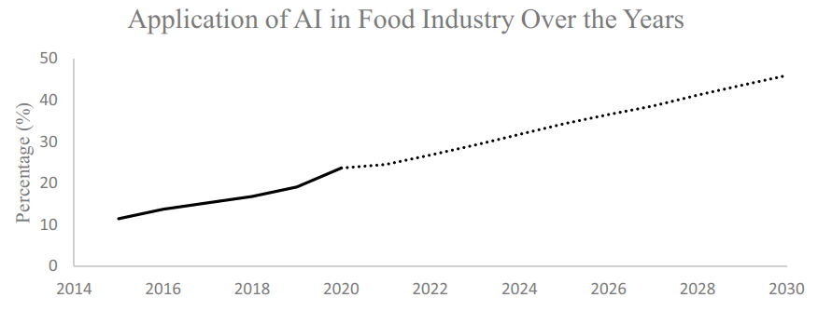
The overall trend on the operation of AI in the food assiduity is shown in Fig. 13. From the studies within the once many times, the operation of the AI styles has been observed to increase from 2015 to 2020 and is prognosticated to rise for the coming 10 times grounded on the current trends. Among the rising factors for the operation of AI in the food assiduity is the preface of Industrial Revolution4.0(IR4.0). The coupling of technologies or intelligent systems into conventional assiduity is what is known as IR4.0 and can also be called smart plant. AI which is distributed under the IR4.0 technologies focuses on the development of intelligent machines that functions like the humans. IR4.0 makes a great impact in the product recalls due to the examinations or complains in the food diligence. The perpetration of the AI integrated in the detectors suitable to descry the crimes during the manufacturing process and amend the problems efficiently. piecemeal from that, IR4.0 also plays a big part in the mortal geste as consumers in the twenty-first century frequently discover information regarding the foods in the internet. The rising enterprises on the food quality allow more operation of AI as they can enhance the quality of the food and aids during the product process. The loftiest quantum of operation of AI in the food assiduity was seen in the time 2020 as further experimenters are carrying out studies using the AI system, and it is believed to continue rising for the forthcoming times due to adding in food demand and the concern on the safety of the foods which are being produced [5], [6].
Fig.13 Utilization of Artificial Intelligence in Food Industry [17]

- SUMMATION AND PROSPECTS ON THE HORIZON

In summary, artificial intelligence (AI) has emerged as a pivotal player in the food industry, serving diverse purposes such as modeling, forecasting, control, food preservation, sensory analysis, quality assurance, and addressing intricate challenges in food processing. Furthermore, AI exhibits the potential to revolutionize business strategies by enabling sales projections and yield optimization. AI's widespread recognition is primarily attributable to its user-friendly, precise, and cost-effective approach in the food sector. This text has comprehensively outlined the applications, advantages, and limitations of AI, as well as its integration with various sensors within the food industry. Additionally, a step-by-step guideline has been proffered for developing tailored algorithms before implementing AI models in food-related domains, with the aim of facilitating and inspiring researchers and industry stakeholders to embrace this cutting-edge technology, renowned for delivering superior outcomes.

REFERENCES

- Borana J, Jodhpur NU (2016) Applications of artifcial intelligence & associated technologies. Proceeding of International Conference on Emerging Technologies in Engineering, Biomedical, Management and Science [ETEBMS-2016], March,
- Iqbal J, Khan ZH, Khalid A (2017) Prospects of robotics in food industry. Food Science and Technology 37(2):
- Ramakrishna RR, Hamid ZA, Zaki WMDW, Huddin AB, Mathialagan R (2020) Stem cell imaging through convolutional neural networks: current issues and future directions in artifcial intelligence e technology PeerJ 8
- Corney D (2002) Food bytes: intelligent systems in the food industry. British Food Journal 104(10):
- Stăncioiu A (2017) The Fourth Industrial Revolution “Industry 4.0.” Fiabilitate Şi Durabilitate 1, 74–78.pdf/2017-01/11_Alin STĂNCIOIU - THE FOURTH INDUSTRIAL REVOLUTION INDUSTRY 4.0”.pdf
- Bai C, Dallasega P, Orzes G, & Sarkis J (2020) Industry 4.0 technologies assessment: a sustainability perspective. Int J Prod Econ 229, 107776.
- P. Bairoch, M. Grindrod, Agriculture and the Industrial Revolution, 1969 (Collins).
- N.P. Mahalik, A.N. Nambiar, Trends in food packaging and manufacturing systems and technology, Trends Food SciTechnol. 21 (2010)
- N. Perrot, I.C. Trelea, C. Baudrit, G. Trystram, P. Bourgine, Modelling and analysis of complex food systems: state of the art and new trends, Trends Food Sci. Technol. 22 (2011).
- Senauer, E. Asp, J. Kinsey, et al., Food Trends and the Changing Consumer, Eagan Press, 1991.
- N.R. Mavani, J.M. Ali, S. Othman, M.A. Hussain, H. Hashim, N.A. Rahman, Application of artificial intelligence in food industry—a guideline, Springer, Food Eng. Rev. 14 (1) (2022)
- P. Li, S. Tang, S. Chen, X. Tian, N. Zhong, Hyperspectral imaging combined with convolutional neural network for accurately detecting adulteration in Atlantic salmon, Food Control 147 (May 2023), 109573,
- Nikita Duggal, Advantages and Disadvantages of Artificial Intelligence [2023 Edition]
- Christina Bernard, Supervised vs. Unsupervised vs. Reinforcement Learning: What’s the Difference? December 21, 2021
- Journal of Agriculture and Food Research Volume 2, December 2020, 100033
- S. Othman et al. Journal of Agriculture and Food Research 12 (2023) 100590
- Application of Artificial Intelligence in Food Industry—a Guideline. Food Engineering Reviews (2022) 14:134–175
- P. Shah, Image Processing Aerial Thermal Images to Determine Water Stress on Crops (2014)
- S. Caplan, B. Tilt, G. Hoheisel, T.A. Baugher, Specialty crop growers' perspectives on adopting new technologies HortTechnology, 24 (2014), pp. 81-87
- N.N. Prescott, Agroterrorism, resilience, and indoor farming Anim. Law, 23 (2016), p. 103
- D.H. Sloane, Aquaspy-a revolutionary new soil moisture sensor Proceedings of the Beltwide Cotton Conferences, National Cotton Council of America, Memphis, TN (2007)
- K. Januszkiewicz, M. Jarmusz, Envisioning urban farming for food security during the climate change era. vertical farm within highly urbanized areas IOP Conference Series: Materials Science and Engineering, IOP Publishing. (2017), Article 052094
- J. You, X. Li, M. Low, D. Lobell, S. Ermon, Crop yield analysis
- M. Barre, Slantrange & dronedeploy part i: flight planning
- Stemmer, Vision technology for the food and beverage industry
- Natalie Yelton, Dallin Porter. What is artificial intelligence (AI?)

