Plants Structures and Functions for Biomimetic Innovations

Dr. M. Padma Sundari,

Assistant Professor,

St.Joseph’s college for women,

Visakhapatnam

Introduction

Biomimicry or biomimetics is ‘‘a new science that studies nature’s models and then imitates or takes inspiration from these designs and processes to solve human problems’’ (Benyus 2002). ‘‘The term ‘Biomimicry’ first appeared in scientific literature in 1962, and grew in usage particularly amongst material scientists in 1980s. Some scientists preferred the term ‘Biomimetics’ or not so frequently ‘bionics. There has been a vast interest in Biomimicry during the last ten years, based on scientific writings by biological scientist like Janine Benyus, professor of biology, Steven Vogel and Julian Vincent, professor of Biomimetics. Julian Vincent defines it as ‘the abstraction of good design from nature’, while for Janine Benyus it is ‘the conscious emulation of nature’s genius’.” (Michael,2011). Biomimicry is used at developing sustainable design solutions. Because of growing pressures on resources and on the environment, there is increasing need to look for alternatives for the sustainable design solution for industries without ecosystem destructing technologies (cf. European Commission 2012). Biomimicry’s main aim is making a great design by mimicking the different living organisms which have been evolving through 3.8 billion years.

Many designs with shape-morphing features have been gifted by nature, particularly the plant kingdom (Poppinga et al., 2020). After billions of years of evolution ,plant have the ability to respond to environmental changes by regulating constituent element of its system and structures, expressing in the “morphological features ” in growth and maturation (Pfeifer and Gomez, 2009; Guo et al., 2015). This dynamic interactions between plant and the environment make them adapt to the new environment, and adjust them in their morphology and physiology ,which also is the major and primary cause of “morphological computation” (Zambrano et al., 2014).

Plants, the dominating flora on our earth, are sessile with multifunctional surfaces and thus make apparent mechanical properties, influence on reflection and absorption of spectral radiation, reduction of water loss or increase of water uptake, moisture harvesting, adhesion and nonadhesion , drag and turbulence increase, air retention under water for drag reduction or gas exchange .

Some of the ways the botanical world has inspired human designs.

1.Hook and loop –

Burdock plants (Articum) have hooked seed pods. These seeds stuck to clothes and other fur animals. The seeds when examined under a microscope, the burrs were covered with tiny hooks which were caught with a loop. With this Biomimicry Velcro was created by George de Mestral, a swiss electrical engineer in 1940s. This Hook and loop structure became an essential fastener on clothes, shoes, and even on the space suits of astronauts.

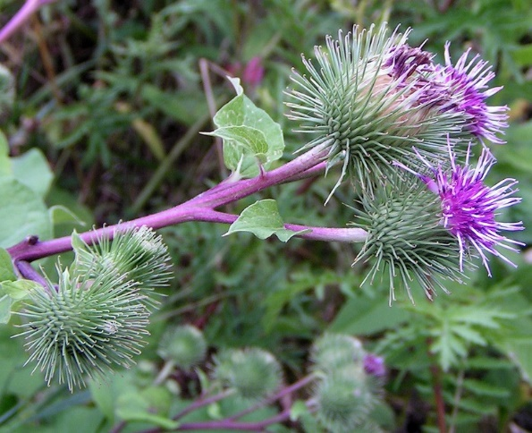
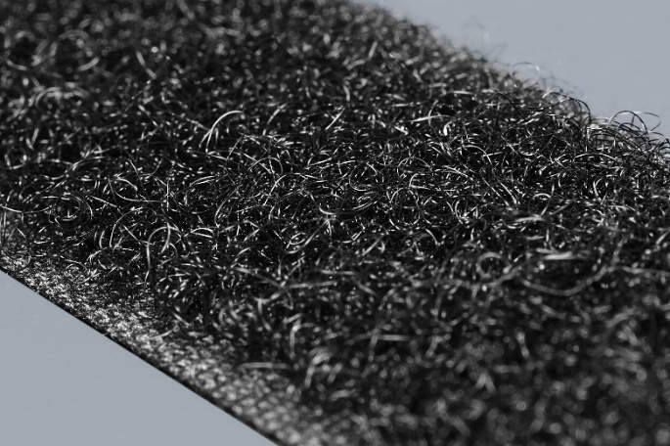

Fig1: Articum Hook and loop biomimicry on nylon fibre

2.Keeping clean with lotus effect

These are aquatic plants with beautiful flowers and are edible in many parts of the world. The leaves are source of biomimicry. The leaves are superhydrophobic and when water drops on leaf then roll on its surface. The surface organization are covered with tiny papillae with tough waxy tubes. These papillae reduce the contact area between water and leaf there by preventing from sticking together.

This keeps the leaf dry and also removes dirt particles -a self-cleaning mechanism.
Mimicking the structure of Lotus leaves nanotechnologists developed superhydrophobic technology to create water proof and stain resistant clothing, coating metals that prevent corrosion and also in making low maintenance, self-cleaning solar panels

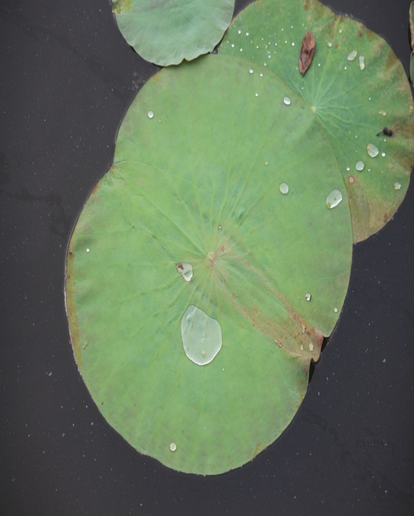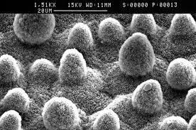

Fig:2 Lotus leaf with SEM Image of leaf surface

3.Colour from shapes

There is striking colour variation in flowers and fruits among plant world. This pigmentation is due to absorption of light of specific wavelength and reflecting specific colours back.
The berries of Pollia condensata shows the brightest blue in the natural world, due to a phenomenon known as structural colour. The berries of this plant have structures inside their cells made from spirals of cellulose which cause light to scatter into different wavelengths, which then interfere with each other to create the incredible deep blue colouring of the berries.
Structural colours have inspired engineers to mimic its function in developing paints, to create coats for heat reflected windows and roofs on buildings.

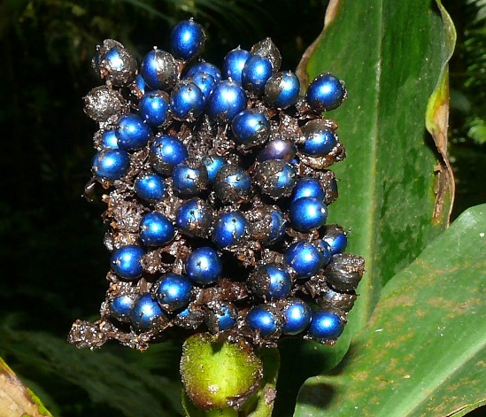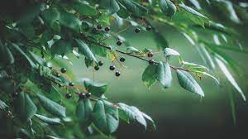

Fig 3: Berry fruit of Pollia condensata

4.The plant Movements and its Structural Strategies

Plants respond to a variety of signals and the movements observed are characteristic of the structures, not a consequence of metabolic processes (Studart and Erb, 2014). The movement of plants are categorized into tropistic and nastic movements. Tropistic movement is in response to stimuli such as gravity, light, and mechanical touches. For example, the growth of tendrils depends on the location and manner in which they contact the supporting object. Nastic movements are direction independent in response to stimuli. As a case in point, the closing of the Dionaea trap does not rely on the location and orientation of the sensitive hairs being touched (Fig:4). Therefore, these principles widely existing in the plant world are more easily extracted and applied to soft actuators.

A 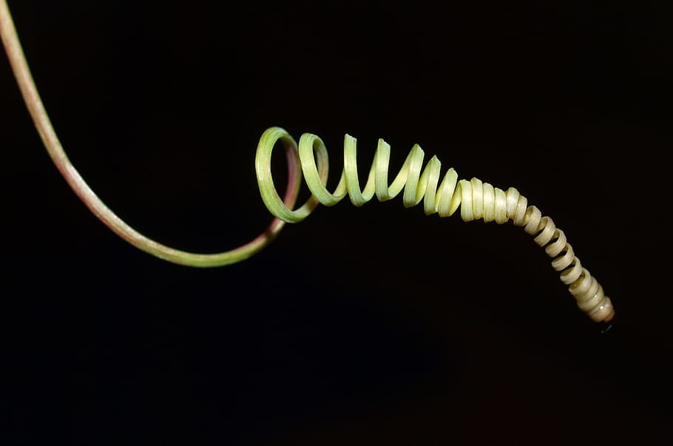 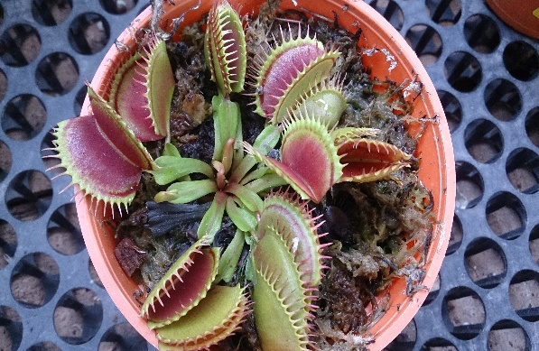 B

Fig4: The movement classification based on (A) Tropical Tendril and (B)Nastic (Dionea trap)

5.Cellular Organization

In the active and passive actuation systems, cellular organization (distribution, density, morphology, etc.) is a frequently used measure to confer various movements to homogeneous materials, for example, the locomotion of pulvinus stems from the volume change and pressure difference between subepidermal and supraepidermal motor cells Besides, some passive systems, such as S.lepidophylla mentioned above, curl their stems to form spheres . They are also caused by the cell density variation within the lower and upper regions of the dry tissue. Another passive actuation example is ice plant seed capsule. To enable seed dispersal, its keel cells have evolved ellipsoid–hexagonal shape, translating a isotropic swelling into a unidirectional deformation and, thus, unfolding of the capsule.

Conclusion

The diversity of plants is a result of several billions of years of evolutionary processes. Plants developed a high diversity of surface structures and functionality for their interaction with the environment. Millions of years of mutation and selection, is a free information for engineers and materials scientists for innovations. Bionics is an old field of research and development starting around 1800—but surfaces played a surprisingly late role for biomimetic applications, the only exception is the hook-and-loop fasteners (‘‘Velcro’’) in the 1950s based on burrs. Surfaces play an increasing roll, the global market for nanocoating’s is estimated to reach 14.2 billion US dollars by 2019 (Bauer 2008). Biological surfaces structures and function have offered number of innovations in the last three decades. There are 10 million different species present as possible biological role models. There is a high biodiversity loss due to changing world resulting in loss of bio mimics- ‘‘living prototypes’ ‘for material scientist. Thus, Bionics is an intrinsic value to the diversity of life which should be treasured.

References

Benyus, J. M. (2002). Biomimicry. Innovation inspired by nature. New York: Harper Perennial
Bauer U., Bohn H.F., Federle W., (2008). Harmless nectar source or deadly trap: nepenthes pitchers are activated by rain, condensation and nectar. Proc. R. Soc. B 275, 259–265

Pfeifer, R., and Gomez, G. (2009). “Morphological computation – connecting brain, body, and environment,” in Creating Brain-Like Intelligence. Lecture Notes in Computer Science, Vol. 5436, eds B. Sendhoff, E. Körner, O. Sporns, H. Ritter, and K. Doya (Berlin: Springer), 66–83
Michael Pawlyn(2011) Biomimicry in Architecture, Reprint edition., RIBA Publishing.

European Commission (2012). Manifesto for a resource-efficient europe. (http://europa.eu/rapid/pressrelease_MEMO-12-989_en.htm)

Studart, A. R., and Erb, R. M. (2014). Bioinspired materials that self-shape through programmed microstructures. Soft Matter 10, 1284–1294.

Zambrano, D., Cianchetti, M., and Laschi, C. (2014). “The morphological computation principles as a new paradigm for robotic design,” in Opinions and Outlooks on Morphological Computation, eds H. Hauser, R. Fuchslin, and R. Pfeifer (Zurich: E-Book), 214–225.

Guo, Q., Dai, E., Han, X., Xie, S., Chao, E., and Chen, Z. (2015). Fast nastic motion of plants and bio-inspired structures. J. R. Soc. Interface. 12:20150598.

Barthlott W., Rafiqpoor D., Erdelen W., (2016) Bionics and Biodiversity- Bio-Inspired Technical Innovation for a Sustainable Future, in Biomimetic Research for Architecture and Building Construction-Biological Design and Integrative Structures, ed. by J. Knippers, K. Nickel, T. Speck (Springer, Berlin)

Poppinga, S., Weisskopf, C., Westermeier, A. S., Masselter, T., and Speck, T. (2016). Fastest predators in the plant kingdom: functional morphology and biomechanics of suction traps found in the largest genus of carnivorous plants. AoB Plants 8:lv140.

