Knowledge, Perception and Awareness of Renewable Energy (the future trend of energy)
Hitika Dhingra
Research Scholar
University School of Financial Studies, Guru Nanak Dev University, Amritsar.

Sirjan Singh
Student
Department of Computer Science and Engineering,
Thapar Institute of Engineering and Technology, Patiala.

Abstract
“I don’t understand why when we destroy something created by man, we call it vandalism, but when we destroy something by nature, we call it progress” (Ed Begley Jr.).
There is more energy conversation going on these days than energy conservation. The pyramid of life is on very tremulous ground. Saving and protecting the environment is not a subject anymore. It is survival veracity. No war machine, however strong, can repel the dangers to our ecological security. Furthermore, there is no technology available anywhere in the world, which can recreate soil, bring to life extinct species. With growing energy demand and concern for depletion of conventional fuel resources, there is an urgent need to increase awareness regarding usage of green energy. In this paper emphasis has been placed on respondent’s awareness and opinion on ecosystem, global warming, environment pollution, climate change and benefits of renewable energy. The sampling unit consists of different individual respondents of different age and gender from Amritsar city. The sample size of the study is two hundred and twenty respondents. Descriptive research using interview schedule was done, whereby the data was collected with the help of a questionnaire. Percentages, graphs and diagrams have been used for analysis of the study.
It has been found that environmental awareness and social acceptance of renewable energy is not adequate. The environment degradation cannot be prevented and renewable energy can’t be adopted until and unless people are enlightened and appraised about the fact that the resources are their own and it is their duty to protect them. It has come to light that lack of awareness can result in a major lag between the time when decision-makers express their interest in going forward with a proposed initiative and the time the proposal wins acceptance by a majority of the public.

Introduction
We have been conquering nature for more than 200 years and now we are almost killing it. The pyramid of life is on very tremulous ground. Saving and protecting the environment is not a subject anymore. It is survival veracity. It is vital for individuals, organizations and governments to come forward and join hands to save whatever is left of our beautiful planet so that the future is not annihilated. No war machine, however strong, can repel the dangers to our ecological security. An extract from noted journalist’s work says: “Our enemy is no longer Pakistan or China: it is now landslides. We live in fear of landslides. Our weapon is now trees, to save civilization”.
There is more energy conversation going on these days than energy conservation. Time has come to walk the talk. The environment cannot be protected until and unless people are enlightened and appraised about the fact that the resources are their own and it is their duty to protect them.
Development should focus just not on fulfilling social, political and economic goals but on the overall growth of all aspects of human life besides other living organisms. Ecology and development can blend if man realizes that he’s a part of nature’s mechanism and his survival depends upon prudent use of resources without endangering natural biotic systems. As a planet we are using up our environmental capital far faster than we can replenish it. Energy is one such area that takes out a lot from nature. Environmentalists have long been warning to look for non-conventional sources of energy to reduce the dependence on non- conventional sources as well as providing breathing space to nature to repair itself. The government of any country or state should ideally be the foremost practitioner of safe environmental practices that serves as an example to others to follow. Initiatives taken by our government are not sufficient. Punjab government has though taken some steps in tapping renewable energy and its sources but a lot needs to be done.
Objective
• The aim of the study is to analyse the level of awareness among people of Amritsar regarding renewable energy;
• In this study emphasis has been placed on respondents’ awareness and opinion on ecosystem, global warming, climate change and factors that attribute to environmental degradation;
• Willingness to pay more for 24hrs of power supply augmented by supply from renewable source and preference of people towards personal or district level generation of power from renewable source has also been studied.

Research Methodology
Sampling Plan: The following are included in the sampling plan for the purpose of present study:
a) Universe of sample:
The sample has been taken from the universe of Amritsar city.
b) Sampling unit: The sampling unit consists of different individual respondents of different gender and age from the city of Amritsar.
c) Sample size:
The sample size of the study is two hundred and fifty-seven respondents.
d) Sampling procedure and Method:
A convenience sampling technique was used for the survey. The study is based on primary data collection by administering an interview schedule.
e) Collecting the Information:
The data collection is the most expensive and the most prone to error. The interview schedules of 239 were received back and response of 220 respondents was found fit for the purpose of study.
f) Tools of analyses:
Percentages, bar graphs and pie charts have been used for analysis of the study. The tools automatically provide visual representations for a clear understanding of the analyses of the collected data.

Review of Literature
Amritsar Tribune (2014), reported that solar energy is still largely untapped in Amritsar even after subsidized equipment offered by Union Government. This is proved by the fact that though a large number of resident colonies have come up and are even coming up but hardly any house is using solar energy. Raman Gupta, an industrialist, has stated that though thousands of houses are being constructed every year but not even a percent of these houses are using solar energy. According to him the reason behind this was an indifferent approach of the government in popularizing solar energy. The state has released a draft policy on net metering for solar energy in August 2013. Even the Union Government is extending its support by giving 33 per cent subsidy on installing of apparatus under this scheme. Harpinder Singh, a construction material dealer, said that though people were spending lakhs of rupees on construction of houses but they were not investing any money for saving on energy resources. He was of the opinion that this was due to lack of awareness among people.

Mishra S. (October, 2016) in his paper “Renewable energy awareness in India” has aimed to address the issue of energy proliferation. He has mentioned that Awareness is a key factor in promoting renewable energy proliferation. Although a large number of people are aware of the importance of energy and its role in the growth and development of the nation, it is also very much comprehendible that there is a yawning gap which needs to be addressed in the area of energy education and awareness in India. Among Indian audiences, renewable energy and its resources have lower awareness levels. For most, energy is limited to conventional sources. People are familiar but not educated on popular energy issues. Much effort has been showered by government departments and other agencies in India over the past decade in the form of launching various schemes at school, city, and village block levels, but most these have come at abstract timings. Also, the advertising campaigns have been too heavy upon the target audiences leaving them half-baked. The paper proposes a strategic and regimented approach model towards target audiences, preparing them thoroughly before actually disseminating the knowledge package to them.
Fatma Agpak F. and Ozcicek O. (December, 2017) in their paper, “The Role of Education on Renewable Energy Use: Evidence From Poisson Pseudo Maximum Likelihood Estimations” has highlighted the role of education level on the non-hydro renewable energy use and analysed it with regard to two different indicators. According to them, education level of a society is a key determinant of renewable energy demand and supply in that economy. In highly educated societies, environmental awareness and social acceptance of renewable energy is expected to be high and so is renewable energy demand. On the supply side, it has been reported that higher levels of scientific knowledge and know-how facilitate innovation and diffusion of renewable energy technologies. In their study, these theoretical arguments are examined using a sample of 62 countries spanning the period of 1990-2014. To overcome this problem, pseudo Poisson maximum likelihood technique is applied. The findings suggest that education level is positively related to renewable energy participation at the 1% level. Furthermore, the impact of higher levels of education is found to be stronger than the lower levels.

Nandy J. (2022) in the article, “climate crisis linked to India’s spring heatwave” in Hindustan Times has warned of a severe heatwave in major parts of India over the next few days, stretching from east to west and north west. Dry warm winds have been blowing in north India pretty sooner than usual and therefore raising summer temperatures before time. According to Friederike Otto, leader of World Weather Attribution group and senior lecturer in Climate Science at the Grantham Institute, Imperial College London, the present heatwave in India has been intensified due to climate change which in turn is the outcome of activities by human. Otto has further warned that the heat waves in India will further become more dangerous and hotter if the net greenhouse gas emissions aren’t eliminated. The conditions in India have been in the follow-up of abnormal weather conditions in rest of the world. It has been reported that both the polar regions of Earth encountered heat waves simultaneously, resulting in the average temperature to be 4.8°C higher than the average.

Results and Discussion
The first and second questions dealt with the general idea about the eco-system and awareness regarding climate change, global warming, renewable and green energy. These questions were deliberately set to help participants by introducing the concept and need of using renewable energy technology towards better environment.

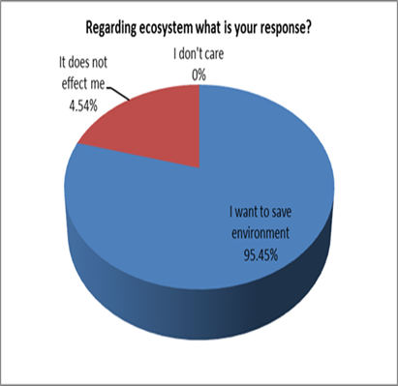
Figure 1
Majority of the respondents (95%) want to save environment, whereas only 4.54% of respondents are of the view that it does not
affect them personally. However, no negative response such as ‘I do not care’ was received
(Figure 1).
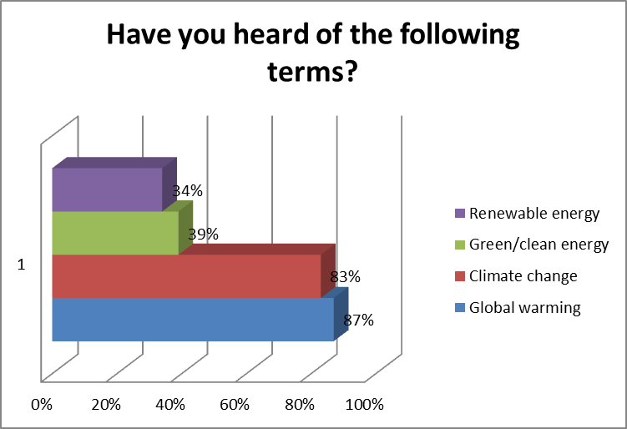
Figure 2
About 87% respondents had heard about ‘global warming’ and 83% about climate change.
44% of respondents had heard of the term “Renewable Energy”.
There is overall lack of education and awareness among people when it comes to knowing what renewable/clean/green energy (Figure 2).
The third question checks the respondents’ awareness about the different kinds of power from renewable sources. The question itself provided those with five different options, namely solar power, hydro power, wind power, biomass and waste to energy. This question was more of an informative type that educated people about the existing sources of power from renewable sources.
78% of respondents were aware of solar power and 57% had heard of power from winds.
77% of the respondents were aware of hydro energy while 45% were aware of biomass.
Awareness of waste to energy was quite low (Figure 3).
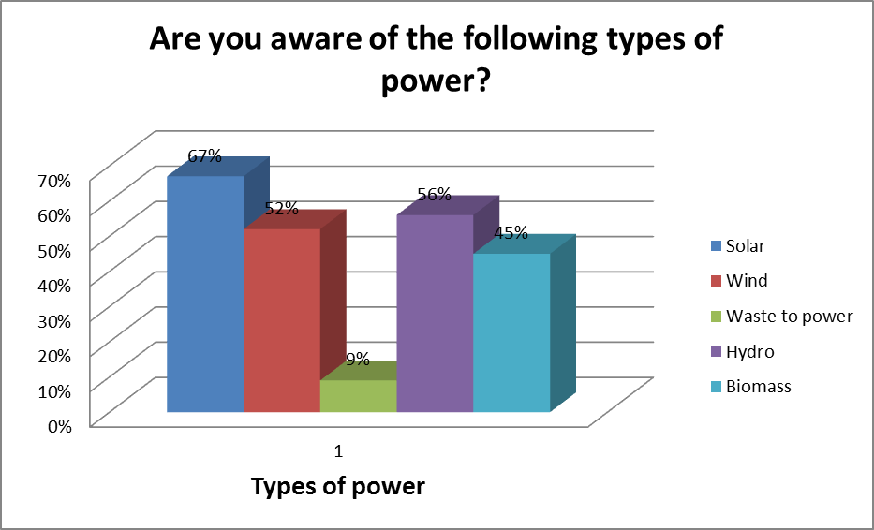
Figure 3

Figure 4
Majority of the respondents identified renewable energy mainly with ‘good for environment’, around 76% agreeing with it. Surprisingly 11% did not even know what are the benefits of renewable energy. 68% of respondents said ‘no power cuts’, 20% said ‘good for businesses as benefits of renewable energy and 16% said ‘less dependence utility’. (Figure 4).
Lack of knowledge and education regarding benefits of renewable energy was predominant. It is important for the government as well as renewable energy agencies to communicate and educate the benefits of renewable to the people as well as adopt intensive marketing to have an advantage of better acceptance of products developed using renewable energy.

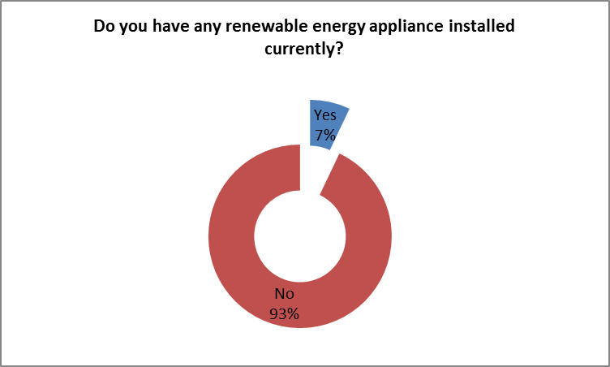
Figure 5

Around 16% of all the respondents had renewable energy appliance installed (Figure 5). Out of
these 24 respondentsOut of these respondents 9 had solar heaters and 6 had solar lights installed. 7 had solar panel and 2 had biomass installed. 84% had no type of renewable energy installed(Figure 5.1).

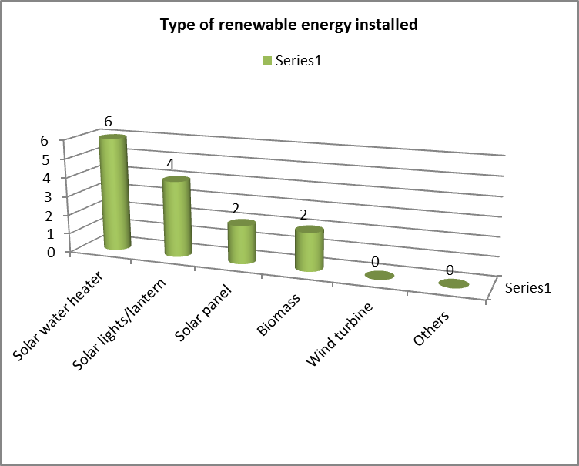
Figure 5.1

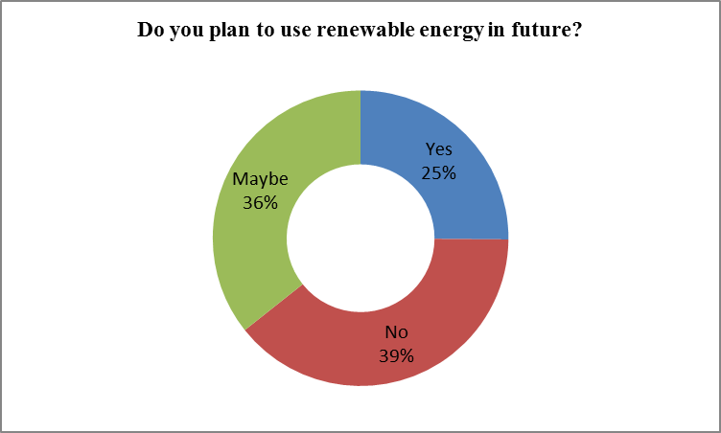
Figure 6
About 36% of the respondents said that they may think about installing renewable energy in future and 25% said they definitely will install renewable energy in future whereas 39% said they had no future plans of installing any type of renewable energy.

A majority of 97.98% respondents favored having electricity round the clock (Figure 7).
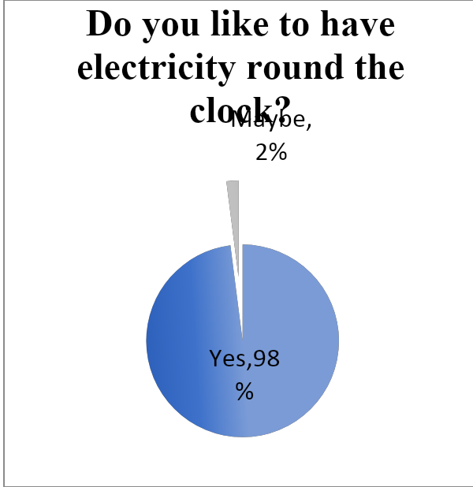
Figure 7

But the irony of the findings is that not all are willing to pay a slightly higher amount to get electricity from a renewable source. 55% of respondents are willing to pay more while 29% said ‘maybe’. 16% even refused to pay extra for energy from renewable source.
Most of these respondents had installed their backup generators.
There is a chance to convert maybe’s to yes but it is possible only by educating and communicating to them the benefits of renewable energy. Moreover, the government should try to bring down the cost of generating electricity from renewable source, by investing in research and development.

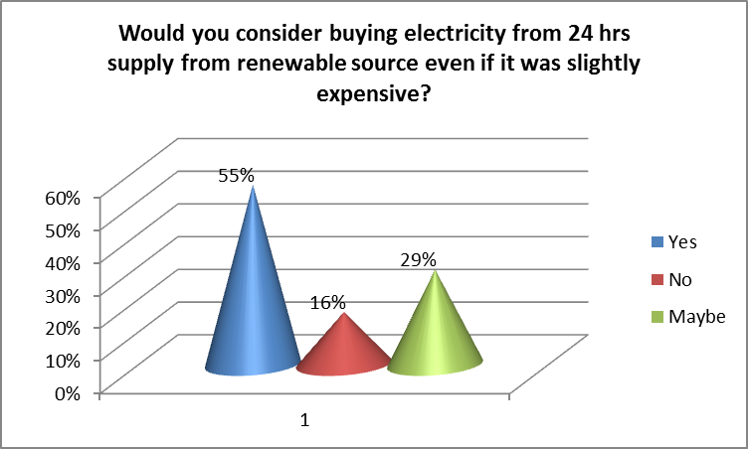
Figure 8

96.46% of all the respondents show their preference for generation and distribution of renewable energy at district level. It is basically because people do not prefer to have solar panels on their roof tops as it disturbs the view and occupies lot of space. Also, people are hesitant as these panels are not a common sight in the society and neighbourhood. Government should build at least one passive house in every region to develop confidence among people and also advertise it.

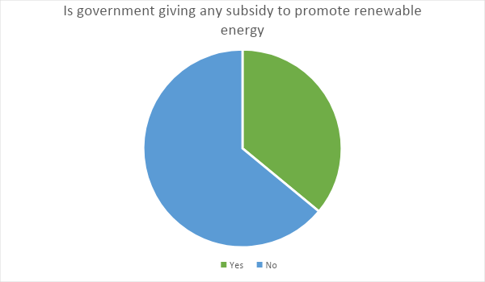
Figure 9

About 64% of respondents had not heard of any subsidy by government for renewable energy. Awareness is quite low among the people. To speed up the installation of renewable energy, education, increasing communication and intensive marketing should be done.

Conclusion

Overall it was found that there was a lack of awareness among people about renewable energy and its benefits. The respondents surveyed were more aware of solar than other renewable sources. It was basically due to awareness of solar water heaters, solar panels and solar lights.
Government has responsibility to educate and communicate about subsidy programs and policies.
It becomes much easier to develop a renewable energy project on a land close to population if they are already communicated and educated about the benefits.
Majority of the people are not willing to pay more even if they get electricity for 24 hours.
There is also need for the government and renewable energy agencies to take the lead and focus investment in Research and Development (R&D) for making cost effective equipments for providing energy from renewable sources at par with conventional sources of energy.
In democratic societies, decision making needs to consider not only what experts know but also between what the public feels and thinks; and its knowledge. Lack of awareness and absence of good marketing strategies can result in a major lag between the time when decision-makers express their interest in going forward with a proposed initiative and the time the proposal wins acceptance by a majority of the public.
SUGGESTIONS
In India, every year there is an increase of 8-10 percent in energy requirement in the commercial sector and 20-30 percent increase in residential sector. This is leading to a situation where there are energy deficits. Green Energy is the only answer to overcome this deficit.
Cost reduction, grid management, community acceptance, landscape issues and lack of adequate marketing are the main bottlenecks to awareness and commitment to Green Energy.
India needs to take the lead and develop efficient, hi-tech and cost effective equipments based on Green Energy, not only for industrial and domestic purpose, but also for agricultural and irrigation needs. There is an imperative need for extensive focus and investments in Research and Development (R&D) for making cost effective equipments as well as marketing them to bring about the much-needed GREEN ENERGY REVOLUTION in India.
People in general do not have similar outlook towards renewable energy technology issues as energy technologist do. For the development, acceptance and increased usage of renewable energy technology, there is need to shed light on people’s in-depth knowledge about the importance of using existing renewable energy technology. The general public should be made aware and allowed to learn more and more about the advantage of using renewable energy technology.

References
Bagga, N. (2014, November 16). Solar energy largely untapped. Amritsar Tribune , p. 1.
Bebbington, J. and Thy, C. (1999). Compulsory Environment Reporting in Denmark: An Evaluation. Social and Environmental Accountability Journal, Vol. 19 (2).
Bhalla,G.S. and Khanna, H., (2007). Environment Education. New Delhi: Deep and Deep Publication.
Bhattacharjee, J.B., (1996). Our Environment. Silchar. AU.
Blackstone, W.T., (1974) “Philosophy and Environment Crisis”, University of Georgia Press, Athens.

Dasgupta, P. (2001), "Human Well-Being and the Natural Environment", Oxford University Press, Oxford.
India Renewable Energy Awareness Survey (2010), Mercom Capital Group. Retrieved on 24th April, 2014 from www.mercomcapital.com
Jha, P.K. 1998.
Khalid, Fazlam and Joanne O’Brien (eds.), (1992) “Man and Ecology”, Cassell, New York.
Marilyn, A. B. and Sovacool, B.K. (2011), “Climate Change and Global Energy Security: Technology and Policy Options”, MIT Press, Cambridge, USA.
Mark Diesendorf, (2007) “Greenhouse Solutions with Sustainable Energy”, University of New South Wales Press, Sydney.
Moula, E., Johana Maula, Mohamed Hamdy et.al (2013), “Researching social acceptability of renewable energy technologies in Finland”, International Journal of Sustainable Built Environment, UNESCO Commission, Finland, pp. 89-98
Ozcicek, O. and Agpak, F. (2017). The Role of Education on Renewable Energy Use: Evidence From Poisson Pseudo Maximum Likelihood Estimations. Journal of Business & Economic Policy Vol. 4 No.4
Viegas , P. and Menon, G.(1989) "The impact of environmental degradation on people", Indian Social Institute, New Delhi.
10.1007/s40518-016-0055-z

Dear Respondents,
I am pursuing B.Tech. from Thapar Institute. I request you to kindly spare your valuable time to give appropriate responses to the issues addressed in this questionnaire. I shall be highly thankful for your kind cooperation in this regard.

1. Regarding environment what is your response to the following?
(a) I want to save environment
(b) It does not affect me
(c) Don’t care

2. Have you heard of the following terms? (You can tick multiple options)
(a) Global Warming (b) Climate Change
(c) Renewable Energy (d) Green Energy/Clean Energy

3. Have you heard of the following types of power? (You can tick multiple options)
(a) Solar power (d) Hydro power
(b) Wind power (e) Biomass
(c) Waste to power

4. Can you point out the benefits of renewable energy? (You can tick multiple options)
(a) Good for environment (b) Less dependence
(c) Good for business/industry (d) Government subsidy
(e) No power cuts (f) No benefit
(g) Don’t know

5. Do you currently have any renewable energy appliance installed?
(a) Yes (b) No

If yes, which type of renewable energy have you installed? (You can tick multiple options)
(a) Solar water heater (b) Solar panel
(c) Biomass (d) Wind turbine
(e) Any other, please specify_________________________

6. Do you have plans to use renewable energy in near future?
(a) Yes (b) No (c) Maybe

7. Do you like to have electricity round the clock?
(a) Yes (b) No (c) Maybe

8. Would you consider buying electricity for 24 hours supply from a renewable source even if it was slightly
expensive?
(a) Yes (b) No (c) Maybe

9. What will you prefer, renewable energy source generated and distributed at
(a) District level (b) Personal level

10. Are you aware of any government subsidies for renewable energy?
(a) Yes (b) No

