CASE STUDY ON MARKET SHARE OF EV IN INDIA

¹AMOL SHINDE
Mechanical Engineering Department
A. P. Shah Institute of Technology, Thane, INDIA
amolshinde01991@gmail.com

²ATHARVA AMBRE
Mechanical Engineering Department
A. P. Shah Institute of Technology, Thane, INDIA
athrava.ambre1506@gmail.com,

³CHIRAG NOR
Mechanical Engineering Department
A. P. Shah Institute of Technology, Thane, INDIA
chiragnor2017@gmail.com

ABSTRACT
The transition to electric vehicles (EV) in India has immense potential for investment and rapid market growth, with a 30% EV transition in 2030 expected to have a wide-ranging impact on the economy. The study projects a vehicle stock increase of nearly 2.7 times between 2016 and 2030, with EV sales growing by at least nine times in four years. The Indian government has prioritized supporting the transition to EVs through the national FAME schemes and state-level equivalents. The EV roadmap for India should identify activities beyond manufacturing within the EV value chain for job creation. The Indian EV sector faces challenges such as supply chain disruption and job creation, but the government's plans should also include diversification of revenue sources. The market share of EVs in India is diverse, with two-wheelers accounting for over 75% of the 250 million vehicles registered in the country. The transition to EVs could lead to significant economic growth and job creation.
The electric vehicle market in India is expected to grow rapidly in the next two years, with the three-wheeler segment having the highest penetration of all segments. The e-rickshaw market is also growing, but more than half of this market is unregulated and dominated by small players. Electric four-wheelers have the lowest penetration rate of 0.12%, with only 3,400 of the 2.77 million passenger vehicles sold in FY202021 being electric. The market maturity varies by state, with Uttar Pradesh having the highest penetration of electric two-wheelers, Maharashtra having the highest penetration, and Delhi having the largest electric commercial vehicle fleet. The report highlights the importance of income diversification and government initiatives in promoting EV adoption.
Keywords: Electric Vehicle, Two Wheeler EV, Three Wheeler EV, EV Market
- INTRODUCTION
Among the avenues for economic recovery and sustained growth after the COVID-19 pandemic dies down, paving the path with a transition to electric vehicles (EV) has immense potential for investment and rapid market growth. The 30 per cent EV transition in 2030 is likely to have a wide-ranging impact on the economy and we focus specifically on changes in oil import, value-addition, employment, impact on public finances, market size for EV components, and environmental gains from reduced local air pollutants and greenhouse gas (GHG) emissions. We attempt at unpacking these issues by projecting the vehicle stock in 2030 in business-asusual (BAU) and a scenario with 30 per cent EV penetration. In addition, we explore three different mobility paradigms – (i) high public transport, (ii) high private vehicle and (iii) high shared mobility to gauge the range of impact of mode-share coupled with 30 per cent EV sales in 2030 on the industry, economy and environment. Our key findings and recommendations are summarised as follows.
By our estimates, we project the vehicle stock (passenger + freight) to increase by nearly 2.7 times between the base year 2016 and the projected year 2030. We explored the consequences of 30 per cent EV sales (35 per cent in e-two-wheelers [e-2Ws] and e-three-wheelers [e-3Ws]; 30 per cent in electric buses [e-buses]; 25 per cent in electric taxis [e-taxis]; and 13 per cent in electric cars [e-cars]) in in contrast to a business-as-usual (BAU) scenario.
- INCREASE IN EV SALE

A total of 5,30,560 EVs (including electric two-wheelers [e-2W], electric three-wheelers [e-3W], electric rickshaws [e-rickshaws], electric cars [e-cars], and electric buses [e-buses]) were sold in India (CEEW - Centre for Energy Finance 2020). This remains far from the National Electric Mobility Mission Plan (NEMMP) 2020 target of 6-7 million EV and hybrid sales by 2020. However, there is a steady uptick in the sales of EVs since 2017 as shown in Figure 3. A number of high-voltage electric cars were launched towards the end of 2019 and many more models showcased at the Auto-Expo 2020 were being readied for launch, including Tata Altroz EV, Mahindra eKUV100, and MG Marvel X (Carandbike 2020). The unexpected outbreak of the COVID-19 pandemic and its fallout has disrupted the global supply chains for EV components, mainly power electronics, battery, and the minerals that are used in these components (Wood Mackenzie 2020). The supply chain disruption has cast its shadow over the entire auto-industry, not just the EV sector (ETAuto 2020). The blossoming EV industry in India stares at an unclear future, as experts are divided on how the EV sector will eventually emerge out of the present situation: some have forecast stagnation while others see a possibility of the Indian EV sector becoming a strong contender in the global electric mobility manufacturing space (Panday and Ghosh 2020; Inc42 2020).

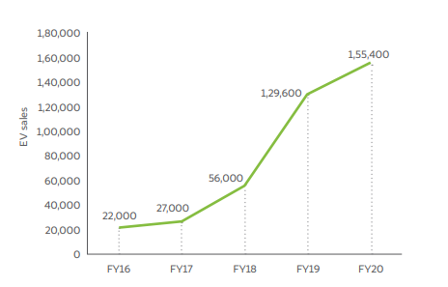
Figure 1 EV sales in India have grown by at least nine times in four years [1]

- BENEFITS OF EV SECTOR
When comparing direct jobs, there are more jobs lost than created in the transition. However, assessment of job creation only considers direct manufacturing jobs associated with EV powertrain, batteries, and charging infrastructure and jobs in the electricity sector. Direct jobs from activities such as installation and operations, charging infrastructure, battery recycling, telematics, and other service-related jobs and indirect jobs have not been taken into account. But we suggest that the EV roadmap for India should identify activities beyond manufacturing within the EV value chain for job creation. If EVs garner 30 per cent of vehicle sales by 2030, the central and state governments are set to lose revenue from petrol and diesel taxes by 15 per cent compared to BAU. When pushing for EV transition, the government’s plans should also include diversification of revenue sources.
- GOVERNMENT POLICIES
One critical area, which is a high priority for both national and state government in India, is supporting the transition to electric vehicles. Through the national FAME (Faster Adoption and Manufacturing of (Hybrid &) Electric Vehicles) schemes, and state-level equivalents, the Indian government has signalled a strong commitment to growing the sector and reducing the carbon-intensity of transport, in line with its targets under the Paris Climate Agreement. Fortunately, this is also an area where UK companies have a lot to offer – be it new battery technologies and management systems, electric micro-mobility solutions or software solutions to better manage EV fleets or the electricity grid.
- TYPE OF VEHICLE AND MARKET SHARE
Car ownership is very low (approximately 22 cars per 1000 people), whereas ownership rates for two-wheelers and three-wheelers are among the highest in the world. A wide range of vehicles are used in Indian cities; from two- and-three wheelers (rickshaws – either pedal or largely powered by CNG (compressed natural gas) or diesel) used for last mile transportation to taxis, buses and vans. Two-wheelers account for more than 75% of the 250 million vehicles registered in India, representing the second largest market globally for two-wheelers, second only to China (Forbes, 2019).
In terms of market growth, domestic sales (i.e., excluding exports) have grown at a rate of 1.2% between FY2015-20 with 21.6 million vehicles sold in FY20. 80% of the sales were two-wheelers and 16% four-wheelers including passenger and commercial vehicles. From a manufacturing perspective, India is the world’s fourth largest manufacturer of passenger cars and seventh largest manufacturer of commercial vehicles as of 2019. Domestic manufacturing has grown at 2.4% between FY2016-20 with 26.4 million vehicles manufactured in FY2020 (IBEF, 2020)2 . Transport is a major contributor to air pollution in India, and many cities suffer from severe congestion during peak hours. On average, the peak hour travel speed is 15-20 km per hour in Indian cities (Verma et al. 2015).

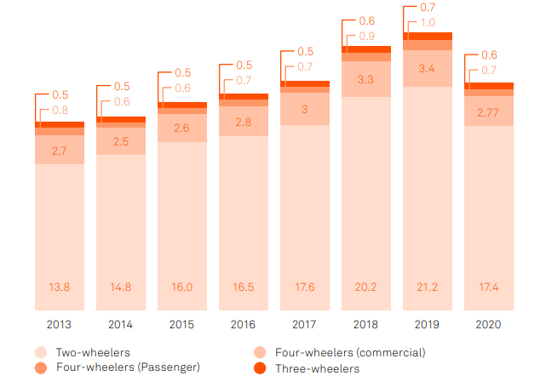
Figure 2: Vehicle Types and Market Share
In the electric two-wheeler segment, electric motorcycles and scooters are popular modes, as like conventional two-wheelers they are easier to navigate through congested roads, as is often the case in India. These vehicles mostly have a removable battery, which can be charged from traditional wall sockets. COVID-19 disrupted the supply chain of electric two-wheelers for most of FY2020 but activity has gradually recovered over the last few months. The vast majority (97%) of vehicles sold in this segment are electric scooters, while motorcycles and e-bikes account for the remaining 3%. From a speed point of view, low speed (up to 25 km/hr) and medium speed electric two-wheelers (up to 40 kmph) with conventional lead-acid batteries currently dominate the market. This is mainly because in terms of upfront cost, they are already on a par with ICE vehicles. However, 152,000 units 90,000 units 3,400 units 126,000 units 100,000 units 3,600 units FY20 Twowheelers Threewheelers Passenger Vehicles FY19 0.9% 14.1% 0.12% 0.6% 14.3% 0.11% 22 4. Electric Vehicle Market Overview with more companies becoming eligible for FAME-IIvi incentives in 2020, the market for highspeed models is expected to grow rapidly in the next two years. In the three-wheelers segment, there are an estimated 14 electric three-wheelers for every 100 three-wheelers (penetration of 14%), representing the highest penetration of all segments. This estimate however doesn’t include the sizeable e-rickshaw market with estimated annual sales of 0.7 million20. More than half of this market, however, is unregulated and dominated by several small players. Electric four-wheelers have the lowest penetration rate of 0.12%, implying of the 2.77 million passenger vehicles sold in FY202021, only 3,400 were electric. This low traction is attributed to factors including high upfront costs and the lack of models in the market that qualify for government incentives (as discussed in Section 7.2). The level of market maturity also varies by states depending on factors including demographics, income levels, regulatory landscape and urbanization. The state of Uttar Pradesh, for instance, with one of the lowest urbanisation rates has seen significant uptake of electric two-wheelers. Maharashtra, on the other hand, with a higher urbanisation rate, has the highest penetration of electric three-wheelers and passenger cars. Delhi is home to the largest electric commercial vehicle fleet due to a higher demand for electric buses and trucks. Figure 6 shows how the country’s EV policy (FAME-I) drove EV sales in different states.
Over the last two years, start-ups in the segment have raised more than $600 million in investment (list of major investments in appendices). The largest funding infusions are usually seen from consortiums of investment firms such as Westbridge Capital, Ant Financial, Astrend India Investment and Nexus Venture Partners. These investments have been used as upfront capital required in the initial stages of assembly and supply chain setup, as well as to keep the price of the EVs low for customers (JMK Research, 2020)31 . The segment has also seen some international activity. For instance, in May 2020, Ola Electric Mobility acquired Amsterdam-based Etergo BV, manufacturer of electric scooters. Ola Electric also plans to develop the world’s largest electric scooter factory in Tamil Nadu. Other leading firms such as Hero Electric, Ather Energy, Ampere, Okinawa, are also establishing manufacturing units throughout the country.
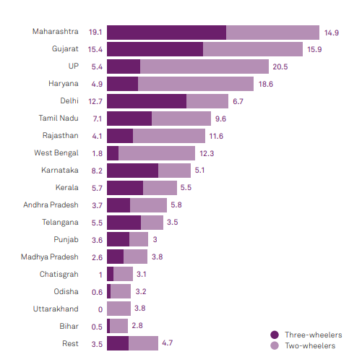
Figure 3: State wise adoption
Company | Price | Motor | Battery | Range | Charging Time | Warranty | Max Speed
TVS iQube | 1 Lakh | 4.4 kW | 4.56 KWh | 75 km | 6 Hours | 3 YEARS/50000 Km | 85
Ola S1 | 1.10 Lakh | 8.5 KW | 3.97 KWh | 181 km | 6.30 Hours | 3 YEARS/40000 Km | 95
Ather 450X | 1.13 - 1.32 Lakh | 6.0 KW | 2.9 kwh | 116 km | 3.35 Hours | 5  YEARS/60000 Km | 80
Revolt RV400 | 90,799* | 3.0 KW | 3.24 KWh | 150 km | 4.5 Hours | 5 YEARS/75000 Km | 85
Bajaj Chetak | 1.15 Lakh* | 4 KW | 48 V, 60.3 Ah | 95 km | 5 Hours | 3 YEARS/50000 Km | 63
Simple One | 1.09 Lakh | 4.5 KW | 4.8 kwh | 236 km | 1 hour | 3 YEARS/30000 Km | 105
Hero Electric Flash | 56,940 | 0.250 KW | 51.2 V, 30 Ah | 85 km | 4-5 hours | 3 YEARS/  UNLIMITED Km | 25
OKINAWA R30 | 65000 | 0.250 KW | 1.25 KWH | 60 km | 4-5 hrs | 3 YEARS/30000 Km | 25
OKINAWA IPRAZE | 1,05,990 | 1 KW | 3.3 kWh | 139 km | 4-5 hrs | 3 YEARS/30000 Km | 58
TUNWAL  LITHINO LI | 75000 | 1.2 KW | 12 V, 28 Ah | 75 | 3-4 hrs | 3 YEARS/  UNLIMITED Km | 25
PURE EV EPLUTO 7G | 80000 | 1.5 KW | 2.5 KWH | 85 | 4-5 hrs | 3 YEARS/40000 Km | 45

- CONCLUSION
In conclusion, this detailed case study shows how electric vehicles (EVs) might revolutionize India's post-COVID-19 economic recovery approach. This analysis uncovers complicated economic, environmental, and social repercussions by concentrating on the lofty target of 30% EV uptake by 2030. It examines oil imports, value addition, jobs, governmental budgets, and EV component market size via careful research. The study of EV sales growth, sector advantages, government regulations, and vehicle type market shares deepens knowledge of India's EV ecosystem. Data shows the market's development, resistance to challenges, and ability to become a global electric mobility manufacturing player.
The report stresses EV value chain auxiliary employment generation outside direct production. It also shows the need of income diversification for a seamless transition. Also emphasizes government initiatives, focusing on the national Faster Adoption and Manufacturing of (Hybrid &) Electric Vehicles (FAME) programs. The report addresses the particular characteristics of the Indian market, where two-wheelers dominate, to outline the difficulties and possibilities ahead. Investment inflows and foreign interactions show India's EV market's rising confidence.
This report guides policymakers, investors, and industry stakeholders as India transforms its transportation. The findings of this research may help the country manage the complex intersection of economic recovery, environmental stewardship, and technical innovation to create a greener, more prosperous future via broad EV adoption.
REFERENCES
- Abhinav Soman, Harsimran Kaur, Himani Jain, and Karthik Ganesan, “ India’s Electric Vehicle Transition: Can Electric Mobility Support India’s Sustainable Economic Recovery Post COVID-19?”, CEEW Report November 2020.
- Lovedeep Brar Bob Burgoyne Lovisa Eriksson Rimaljit Likhari Thalia Skoufa Lowri Williams, “The India Electric Vehicle Opportunity: Market Entry Toolkit”, CPC india report, March 2021.
- Randheer Singh, NITI Aayog Akshima Ghate, RMI India Isha Kulkarni, RMI India Clay Stranger, RMI Ryan Laemel, RMI, Banking on Electric Vehicles in India, A Blueprint for Inclusion of EVs in Priority Sector Lending Guidelines, Report/ Jan 2022.
- Shifting gears: the evolving electric vehicle landscape in India, KPMG CII Report, October 2020.
- IESA, India Electric Vehicle Market Overview Report: 2019-2026.
- IESA, India Electric Vehicle Market Overview Report: 2020-2027.
- GR EV POLICY 2021, MAHARASHTRA STATE.

