**Development of IoT Based Weather Monitoring System**

**[1]Mr.Mogili.Siva,[2] Mr.JVNSP.Ganesh,[3]Mrs.K.Susheela,**

**[1],[2],[3]Assistant Professor,**

**[1],[2],[3] Department of Computer Science and Engineering(Data Science)** [**Email:[1]msiva438@gmail.com**](mailto:Email:[1]msiva438@gmail.com), **[2]ganeshjuturi2@gmail.com [3]**[**ksusheela473@gmail.com**](mailto:ksusheela473@gmail.com)

**Abstract** These days, it's difficult to predict the weather because the climate has such a strong influence on it. Because of this, weather reporting systems are primarily used to track the constantly shifting climatic and weather conditions over regulated regions including homes, businesses, and farms in real time. The weather parameters should be able to be displayed on the OLED with two-way microcontroller communication via Wi-Fi hotspots using the Internet of Things (IoT) platform ThingSpeak. The information will be viewable wherever in the world. The state of a specific location as provided by a satellite weather report system does not accurately reflect the situation. The issue arises, though, when a precise weather forecast for the moment is required. However, the problem occurs when needed the accurate weather report for current time. With weather reporting system all weather parameters sensor will be controlled by ESP32 microcontroller as the server that will send all the data collected by sensors to the database by ThingSpeak and will visible anywhere in the world and also display on OLED that use Wemos D1 mini as its microcontroller and a client. This data then will be compared with the weather forecast data and statistics made by forecast station. All data collected will be also saved in google sheet format by IFTT tool for easier to analyse the data. This system will monitor the changes of weather condition happening over the environment and then provides the users fastest way to access the information from anywhere.

**1. Introduction**

Climate plays an important role in human life the unprecedented growth of industries and vehicular traffic have seriously affected the purity of clean air and environment [1]. Satellite weather report system gives condition of present which does not give the exact condition of the particular place. The building sector offers a great potential for the energy savings, where it is necessary to have accurate weather data in the exact location where the building is being built in order to improve the calibration of energy simulation programs [2]. By develop a controlling local weather reporting system with ESP32 and Wemos D1 mini microcontroller can minimize the error in weather forecast system at exact location. A precision agriculture and farming can be defined as the art and science of using technology to improve crop production [3]. Even though water is a scarce resource, overall 50% of water is wasted in agriculture due to the improper scheduling of irrigation [4]. In this context, the real-time monitoring of water usage in the fields can prevent misuse of water [4].

Difficulty to monitor weather parameters through offline system such as agriculture zone during certain hazardous envy and critical situations where the people need to check manually the weather condition at the places and it will take time unless it is online system. In the evolving generation of wireless technology, the concept of smart cities and IOT has given a new remark in the world. One such remark leads towards the online smart weather station system [6]. The weather parameters should be able displaying, analysing and monitoring system using ThingSpeak that connect user with internet that visible anywhere in the world. To analyse and monitoring system using ThingSpeak that connect user with internet that visible anywhere in the world. Internet of Things (IoT) is playing a leading role in providing solutions to many applications with the support of software, internet and embedded systems [7].

There is a necessity in security or alarming system that give warning and alerting when there is a bad condition at the place. The existing technologies are developed using microcontrollers like Arduino, Node MCU etc. and ARM processors like Raspberry Pi [7]. So, machine learning techniques achieved better performance than traditional statistical methods in learning without being expressly customized [8]. Data measured by the stations could be used for various purposes, such as: air quality management to reduce pollutant gases in the local atmosphere and climate monitoring for a better yields of the region crops [9]. To making alarming system this project has uses the Blynk apps to send a notification when the weather at bad condition to the user and also the buzzer sound at the weather station to put the user at home alert about the situation outside.

**2. Methodology**

This project will focus on development of the ThingSpeak an IoT platform that to show the data of the sensor. The method divided into two parts which are hardware and software development part. The hardware development involves the circuit construction and develops the prototype. Meanwhile, the software part involves the IoT coding, circuit schematic diagram, circuit simulation and data acquisition.

By using three (3) types of sensor to monitoring the weather parameter that are temperature, humidity, rain, and air quality the system will be able to display the weather condition by an analysis about the current weather with the sensor value data. All the data will be control by a microcontroller ESP32 and Wemos as the client that will receive the sensor data from ESP32 and display it on OLED.

*2.1. Project Block Diagram*

The overall project block diagram is illustrated in **Error! Reference source not found.**. The block diagram consists of the components that are utilized in this project. There are two modes available in this project working operation. Firstly, controlling mode will involve ESP32 and monitoring mode will involve Wemos D1 mini. This two-microcontroller board will communicate each other in order the monitoring mode get sensor data from controlling mode via wireless communication and hotspot Wi-Fi. Controlling mode will collect all the sensor data then send to the ThingSpeak website and monitoring mode to display on OLED. The data collected will be analyse to configure the actual condition and the current condition by using simple formula in Equation 1. The result of this data analysis then will be made the weather state for this system to tell the user about the rain and air quality condition is it good or bad in actual condition.

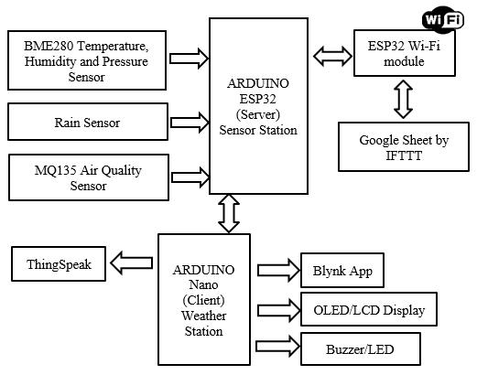

Project block diagram

*2.2. Monitoring Unit (Weather Station)*

Meanwhile, wireless weather station using Wi-Fi system is employed monitoring unit. This will be controlled by Wemos D1 mini microcontroller to connect to the Wi-Fi and received live sensor data and display on OLED. This communication will simulate the master-slave network protocol or client-server protocol to develop a perfect data input/output from a control unit to a monitoring unit. If the sensor data come with faulty the buzzer/led will be on as the security of the system. Then a push notification will be sent to the user by Blynk app on android smartphone. All of these process flows are simplified in a form of flowchart in Figure**2**. 

*2.3. Hardware Development*

The hardware selection is vital in this project hardware development process. Every hardware components are necessary to be considered first before selected to be utilized in the project. The components selection is according to the advantages and characteristic of the component to fulfil the functionality of every part used. For this project, ESP32, Wemos D1 mini, BME280, MQ135, Rain Sensor, OLED, LCD, Buzzer, and LED are used.

*2.4.1. Circuit Construction.* The circuit of the system can be divided to two where first circuit as weather station that displaying all the value of weather parameters. Other circuit is control unit circuit for controlling all the sensor data and send it to the ThingSpeak and websites. Weather station will be communicating with control unit via client-server communication where all the data catches by the

sensor control unit will send it to weather station to display it. This station also equips by emergency alert where there is bad weather such as heavy rain and poor air quality. Figure 3 shows the electronic circuit of the sensor. The weather station completed circuit is shown in Figure 4. The bme280 sensor connect on I2C pin at ESP32 which is pin 21 and pin 22. There rain sensor and air quality sensor are connected on pin 33 and pin 32. In the monitoring mode the Wemos D1 mini is uses to connect I2C LCD and I2C OLED. The pin that use to connect LCD are D2 and D1 also OLED on D3 and D5.

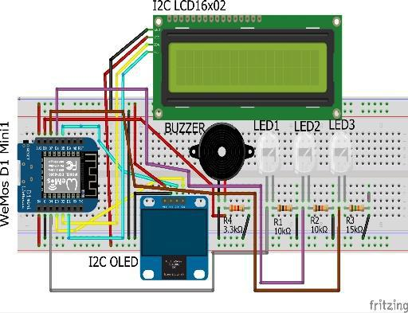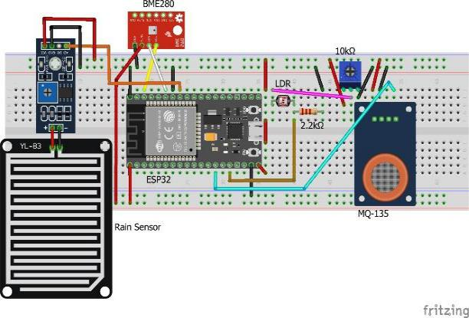

*2.4. Software Development*

Generally, most of project involves various type of software to be utilized in order to simulate and analyse the hardware configuration. This process can at least help the project member to troubleshoot and analyse the project configuration and result. Therefore, in this project few types of software will be used in order to develop the project. Most help is Arduino IDE with the software for compile and upload the coding, SolidWorks for 3D design, and Proteus for simulation are using in this project.

*Internet of Things (IoT) Setup.* The IoT platform that used in this project is ThingSpeak, new user needs to create ThingSpeak account at[https://thingspeak.com.](https://thingspeak.com/) From the website create a new channel called Weather Reporting System and select these field as weather parameter output results as

**Creating account:**

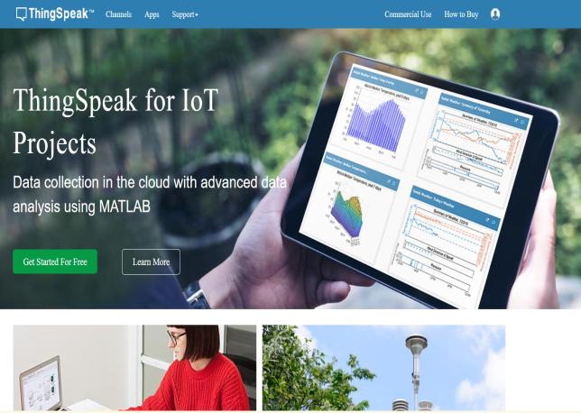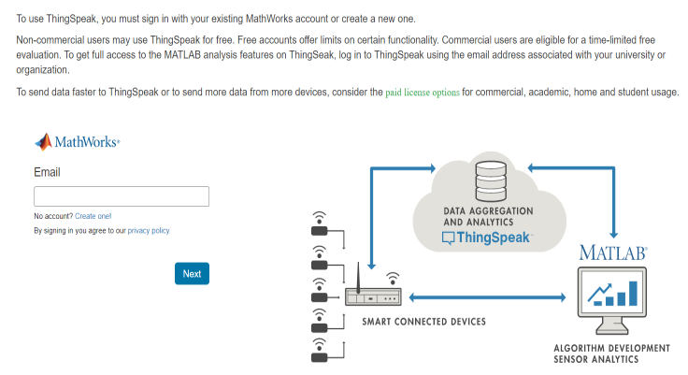

Creating fields:

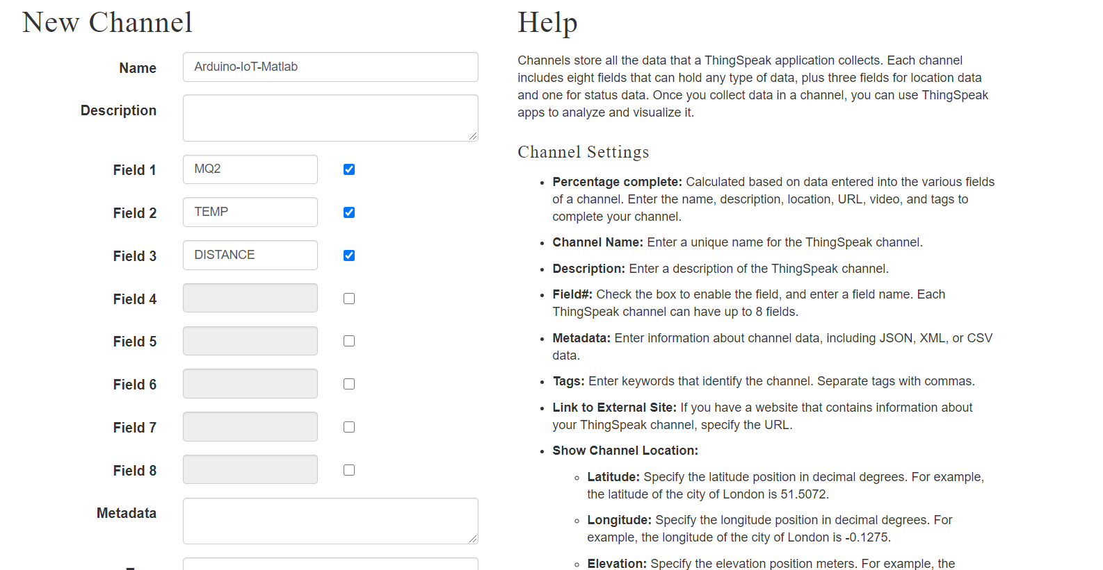

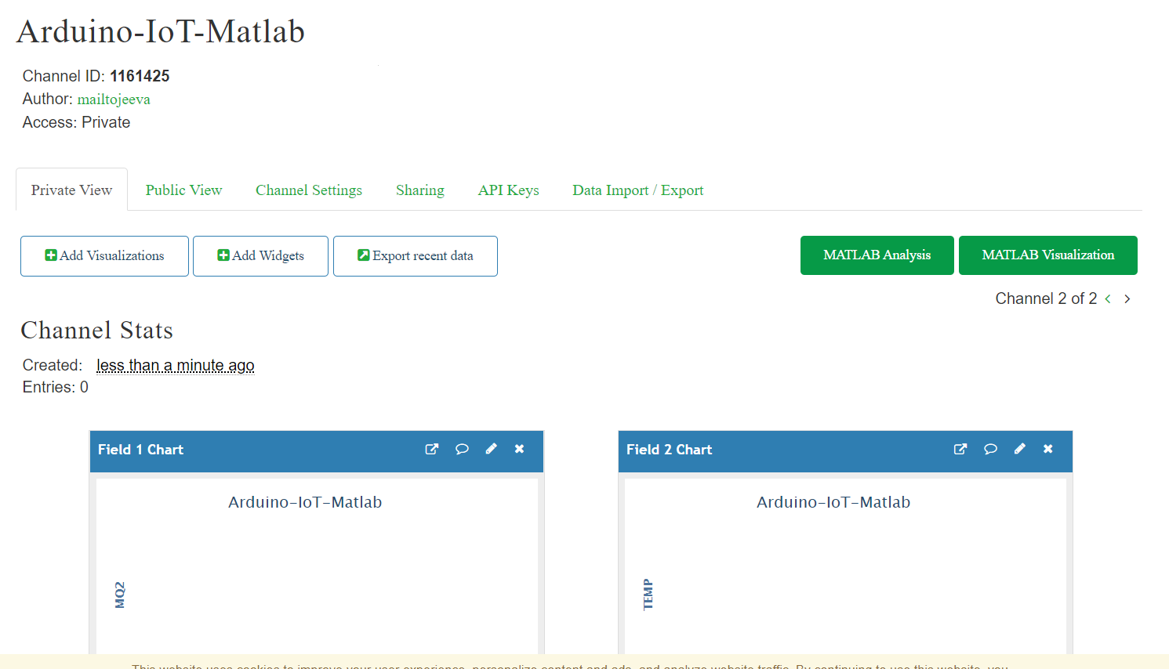

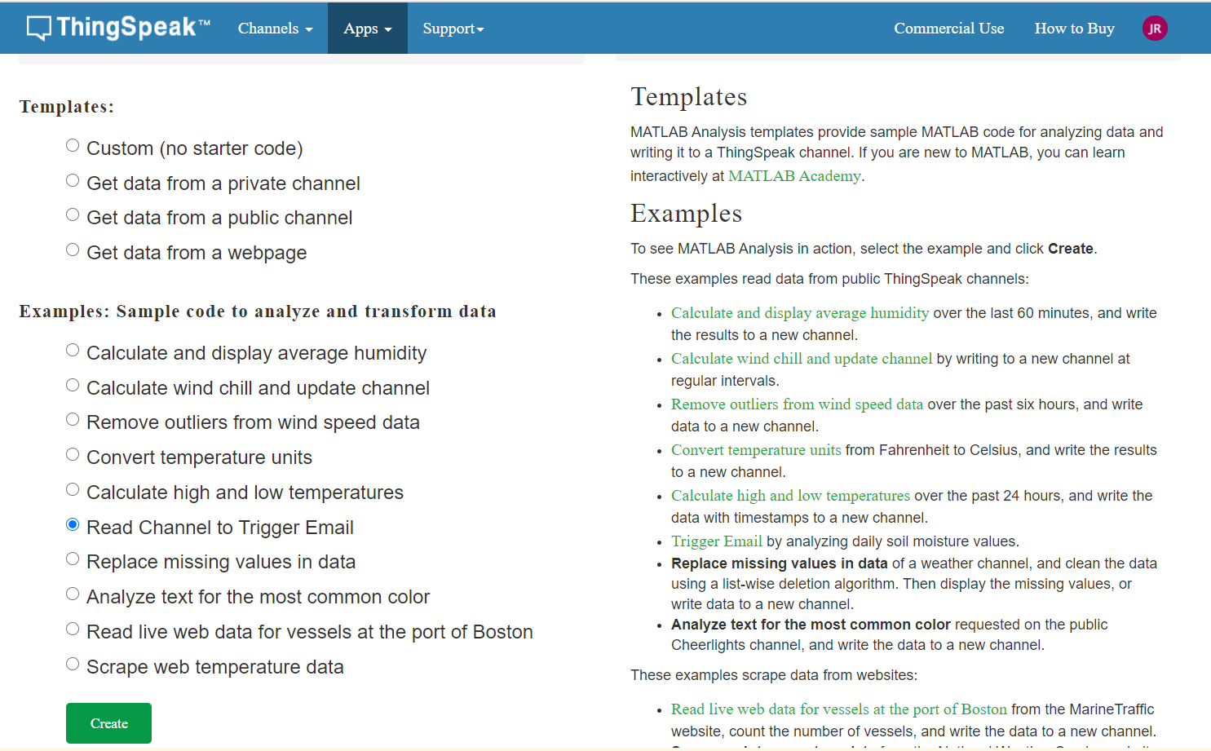

*OLED display sensor data*

*The monitoring mode Wemos D1 mini is act as a client to receive the sensor data from ESP32 as the server. The data completed shown on OLED as shown on Figure 13 via wireless communication. The setting up of the board was to determine the I2C pin and power supply for both LCD and OLED where*OLED use 3.3V and LCD use 5V. The weather station will receive a packet of data from sensor station to display on OLED, the communication use between both boards is Wi-Fi hotspot communication. The LCD will display real time and data that use NTP client to update the time and date by internet communication. As the main point in this project is Internet of Things all the outcome comes in IoT result.

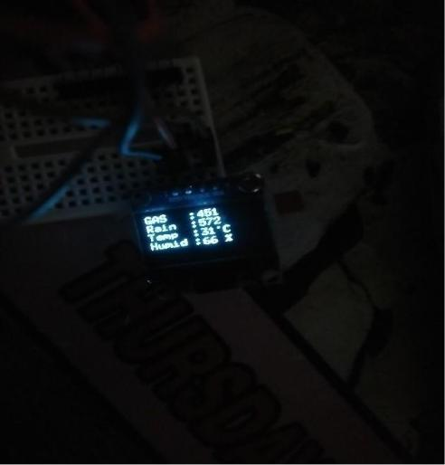

*Discussion*

Based on the results that are obtained by the sensors send and display to ThingSpeak for user viewing. This will make monitoring weather parameter more easily with the Wi-Fi connection this system will start and ThingSpeak start displaying sensor data by graph and also all this data can be analysing in ThingSpeak. From the data Table 1, 2 and 3 and Table **4**, the results have been compared and shown that the weather parameter from forecast station is not too accurate so with weather reporting system people can get the actual condition at their place with ease.

The results of MQ135 and rain sensor from Table 6 uses to make comparison in actual condition of particular location in determine the sensor data value corresponding with actual condition and conclusion of the results data recorded can be made.

With wireless monitoring network devices, the people can check online on the web page the weather condition to take certain steps and issues even in worst case for monitoring the weather parameters. With all the data also weather reporting system is to monitoring certainly weather to overcome the most important factor determining agricultural enterprise success or failure and have ease the user from getting inaccurate forecast from Forecast Company for their place. The IoT component that has established the communication between the microcontroller boards were ESP32 and Wemos D1 mini with communication via Wi-Fi hotspot.

**4. Conclusion**

As the conclusion this project have cleared the objective that to build a system that can monitored weather parameter by wireless system and IoT. The Sensor station and Weather station will be communicated by hotspot Wi-Fi and it is limited in areas covered but still better in communication via wireless. The value that been recorded from google sheet and Table 1, 2 and 3 it seen that the weather at particular place has different condition from the exact condition with the accuracy of weather reporting system and forecast system data has been compared. It says that weather reporting system is more accurate than forecast system. This weather reporting system will display the sensor data to

**References**

1. Kulkarni, V. A, Satpute G. M (2017). “Weather Reporting System Using FPGA : A Review,” vol. 4, no. 11, pp. 319–320.
2. Carlos, M, Jorge, P.B, Daniel F, Pablo S (2018). “Design, Development and Implementation of a Weather Station Prototype for Renewable Energy System,” Journal Energies, 11(9), 2234, pp. 1-13.
3. Karim F, Karim F and Frihida A (2017). “Monitoring system using web of things in precision agriculture,” *Procedia Computer Science.*, vol. 110, pp. 402–409.
4. Kodali R K, Yerroju S and Sahu S (2018). “Smart Farm Monitoring Using LoRa Enabled IoT,”*Proceedings 2nd International Conference Green Computing Internet Things, ICGCIoT 2018*, pp. 391–394.
5. Gahlot N, Gundkal V, Kothimbire S and Thite A (2015). “Zigbee based weather monitoring system,” *Internnational Journal Engineering Science*, vol. 4, no. 4, pp. 2319–1813.
6. Kodali R K and Sahu A (2016). “An IoT based weather information prototype using WeMos,”*Proceedings 2016 2nd International Conference Contemporary Computing Informatics, IC3I 2016*, no. 1, pp. 612–616.
7. Joe F, and Joseph J (2019). “IoT Based Weather Monitoring System for Effective Analytics,”International Journal of Engineering and Advanced Technology (IJEAT), no. 4, pp. 311– 315.
8. Nallakaruppan, M.K, and Kumaran U.S (2019). “IoT based Machine Learning Techniques for Climate Predictive Analysis,” International Journal of Recent Technology and Engineering (IJRTE), no. 5, pp. 171–175.
9. Monteiro M S, De Caldas Filho F L, Barbosa L A, Martins L M C E, De Menezes J T M and Da Silva Filho D A(2019). “University campus microclimate monitoring using IoT,” *WCNPS 2019 - Workshop Communication Networks Power Systems*, no. Wcnps, pp. 3–7.