Feeding a Hungry Planet: The Evolution of Agriculture Revolution and Agribusiness
Swathi Chanumolu, Dr.D.Rafi, Sangappa
Ph:9391126021 , email:Swathichanumolu@gmail.com

Abstract:
The agriculture revolution and agribusiness have become crucial components in addressing the challenges of feeding a growing global population while ensuring sustainability and economic viability. The agriculture revolution encompasses various advancements, innovations, and transformative practices that aim to enhance productivity, efficiency, and environmental stewardship in the agricultural sector. This revolution is driven by the integration of cutting-edge technologies, data-driven decision-making, precision agriculture, and sustainable farming practices. Agribusiness, on the other hand, refers to the application of business principles and practices to agricultural production, processing, distribution, and marketing. It encompasses a wide range of activities, including farming, food processing, supply chain management, marketing, and finance. The agriculture revolution and agribusiness are closely intertwined, with each influencing and supporting the other. The revolution in agricultural practices, driven by advancements in technology, has paved the way for agribusiness to capitalize on these innovations and create new opportunities.

AGRICULTURE REVOLUTION
The agricultural revolution, also known as the Neolithic Revolution, refers to a significant shift in human society that occurred around 10,000 to 12,000 years ago. It marked a transition from a hunter-gatherer lifestyle to settled farming communities and is considered one of the most important developments in human history. The agricultural revolution had profound impacts on human civilization, shaping the way we live, work, and organize societies.
The motives behind the agricultural revolution were driven by various factors, including the need to address food security, increase agricultural productivity, alleviate rural poverty, and promote overall economic development. some key motives that shaped the agricultural revolution are:
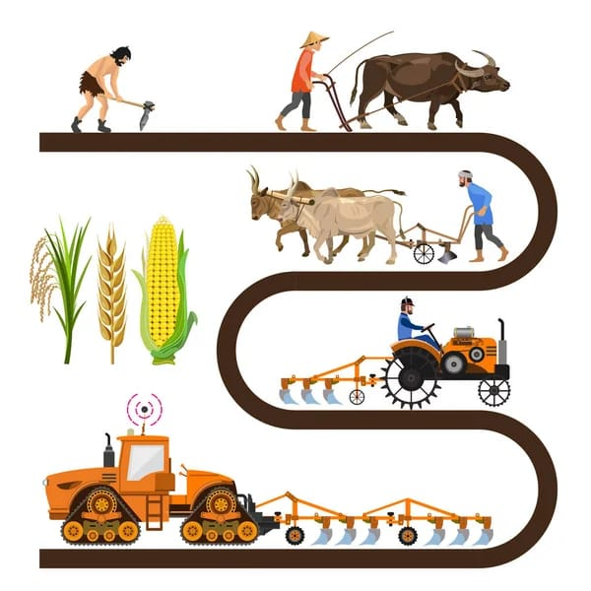
- Food security
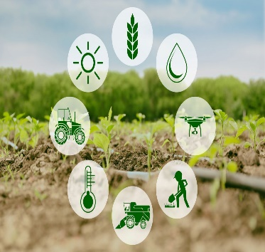
- Poverty alleviation
- Economic development
- Technological advancements
- Self-sufficiency in food production
- Increase in agricultural exports.
- Modernization of agriculture

AGRICULTURE AS A BUSINESS – AGRIBUSINESS
agriculture can be considered a business. Agriculture involves the production, processing, and distribution of crops, livestock, and other agricultural products for commercial purposes. Farmers and agribusinesses engage in various activities such as cultivating crops, raising livestock, managing fisheries, operating dairy farms, producing and selling agricultural inputs (seeds, fertilizers, pesticides), processing food and fibre, and marketing agricultural products.
Agricultural businesses aim to generate revenue and make a profit by efficiently producing and selling agricultural commodities or value-added products. They may also involve activities such as agricultural research, consulting services, equipment manufacturing, and agricultural finance. Like any other business, agricultural enterprises require management, investment, marketing strategies, and risk management. Agricultural businesses may face challenges such as fluctuating commodity prices, weather risks, market volatility, regulatory compliance, and access to capital. However, successful agricultural businesses can contribute to economic growth, employment, food security, and rural development. It is important to note that while agriculture is a business, it also has social and environmental dimensions. Sustainable and responsible agricultural practices are increasingly emphasized to ensure the long-term viability of agricultural systems, conserve natural resources, protect biodiversity, and address societal concerns such as food safety and animal welfare.
Agribusiness matters, and its significance cannot be overstated. It intertwines agriculture and business, addressing global challenges, driving economic growth, ensuring food security, and promoting sustainable development. With the world's population projected to exceed 9 billion by 2050, the role of agribusiness in meeting future food demands becomes even more crucial. By investing in agribusiness, we can create a resilient, efficient, and sustainable food system that benefits both present and future generations.
HOW AGRICULTURE REVOLUTION IMPROVED AGRIBUSINESS
The agriculture revolution significantly improved agribusiness by introducing innovations and practices that enhance Productivity, Profitability, and sustainability.
As agriculture revolution introduces new technologies, such as improved seed varieties, mechanization, and irrigation system that have significantly increases agriculture productivity. Agribusiness benefit from higher crop yields and increases output leading to improved profitability and competitiveness in the market. Also including precision agriculture, automated machinery, and advanced irrigation systems that helped to improve efficiency in agribusiness operations. Farmers can optimize resource utilization, such as water, fertilizer, and pesticides, reducing waste and increasing overall efficiency in production.
By agriculture revolution, new market opportunities have been opened for Agribusiness. Improved transportation infrastructure, advancements in logistics, and global trade have facilitated the expansion of markets, allowing agribusinesses to reach a broader customer based and export agriculture products to international markets.
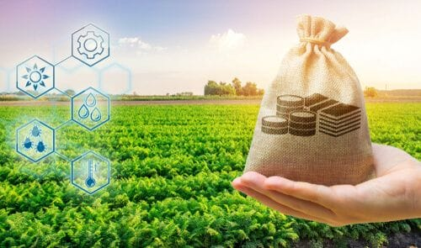
The agriculture revolution has encouraged agribusiness to explore value addition and diversification. by processing, packaging, and marketing agricultural products, agribusiness can capture a large share of the value chain and generate higher profits. Value - added products , such as processed foods, beverages, and bio-based materials can offer higher margins and differentiate agribusiness in the market.
This also has placed a greater emphasis on sustainable farming practices. Agribusinesses are adopting environmentally friendly practices, such as organic farming, conservation agriculture, and integrated pest management, to minimize the environmental impact of their operations. These sustainable practices improve the long-term viability of agribusinesses, meet consumer demand for sustainable products, and contribute to overall environmental stewardship.
The agricultural revolution has brought about advancements in information and communication technologies, providing agribusinesses with access to real-time data, market information, and weather forecasts. This information enables better decision-making, risk management, and planning, helping agribusinesses optimize their operations, reduce uncertainties, and improve overall performance.
has spurred increased investment in research and development in the agricultural sector. Agribusinesses can benefit from ongoing advancements in crop science, genetics, biotechnology, and agricultural practices. This continuous innovation provides agribusinesses with access to improved technologies, better crop varieties, and more efficient production systems, leading to better outcomes and competitiveness.
References
- Pretty, J. (2018). Agri-culture: Reconnecting People, Land, and Nature. Routledge.
- Godfray, H. C. J. et al. (2010). Food Security: The Challenge of Feeding 9 Billion People. Science, 327(5967), 812-818.
- Lowder, S. K. et al. (2016). The Number, Size, and Distribution of Farms, Smallholder Farms, and Family Farms Worldwide. World Development, 87, 16-29.
- Swinnen, J. F. M. (Ed.). (2011). The Economics of the Food System: Why Is Food Expensive? Why Is Food Cheap? Oxford University Press.
- Food and Agriculture Organization (FAO). (2021). The State of Food and Agriculture 2020: Overcoming Water Challenges in Agriculture. FAO.
- Goyal, R. K. (2018). Agribusiness Management: Principles and Practices. Springer.
- Conforti, P. et al. (2018). Agribusiness and Innovation Systems in Africa. Routledge.
- Oelofse, M. et al. (Eds.). (2017). Sustainable Agriculture for Food, Energy, and Industry: Strategies towards Achieving Sustainable Development Goals. Springer.
- Timmer, C. P. (2009). Did the Green Revolution Concentrate Incomes? A Quantitative Study of Research Reports. Journal of Development Economics, 90(1), 1-14.
- International Food Policy Research Institute (IFPRI). (2021). Global Food Policy Report. IFPRI.

