Plant Leaf Disease Identification and Classification using Deep ANN
¹Dr. J. CHANDRA SEKHAR, ²J. RAMU, ³V. KRISHNA PRATAP, ⁴Dr. P. VIJAYA PAL REDDY
¹Professor, Department of CSE, NRI Institute Of Technology, Visadala, Guntur, A.P, India
²Associate Professor & HOD, Department of CSE, NRI Institute Of Technology, Visadala, Guntur, A.P, India
³Associate Professor, Department of CSE, NRI Institute Of Technology, Visadala, Guntur, A.P, India
⁴Professor, Department of CSE, Matrusri Engineering College, Hyderabad, Telangana, India
Corresponding Email ID : jcsekhar9@gmail.com

ABSTRACT: Plant diseases are commonly to responsible for low yields and low farm income. Currently, researchers are putting in a lot of effort to create a system that automatically recognizes plant diseases. If plant diseases are correctly diagnosed, it may be easier to find a treatment as soon as possible to minimize damage. Plants are constantly concerned about the diseases that pathogens spread. For instance, diseases, bacteria, and parasites that live inside plant bodies. It is widely acknowledged that pathogens frequently result in significant yield losses. Numerous researchers have looked into ways to reduce the danger represented by pathogens in plants. Because they provide mankind with their energy, plants are regarded as significant. Any time between planting and harvesting, plant diseases can damage the leaves, greatly reducing crop productivity and market price. However, the detection of leaf diseases is essential in the agricultural sector. However, it takes a lot of people and time to process, and a lot of knowledge about plant diseases. As a result of its ability to examine data from many perspectives, Deep ANN is used to identify illnesses in plant leaves. Plant leaves physical properties, such as colour, intensity, and size, are considered when determining for classification purposes. This analysis introduces the Deep ANN approach for identifying and classifying plant leaf diseases. Accuracy, Precision, and Recall are some of the factors taken into consider when determining the algorithm's performance. As a result, the Deep ANN will produce the best results in this analysis.
KEYWORDS:Plant diseases, Artificial Neural Network (ANN), Classification, Disease Detection.

I. INTRODUCTION
India's economy is expanding rapidly, and its early development was based on mostly

agriculture. The major goal of agricultural development is to satisfy the population’s growing demand. Agriculture must be improved in order to recover in its current state. Both bacterial and fungal infections can harm crops. The two main elements influencing a plant’s productivity are diseases and disorders. There is a significant effect on farmers output. For crops to produce the most, they need to be healthy. The procedure of diagnosing diseases with our naked eyes will always be challenging. To achieve that, the farm must be constantly watched properly. This procedure is challenging. When the farm is large, this is also highly expensive. Even experts in agriculture have trouble diagnosing the diseases and finding a solution to the issue because of this difficulty. Diseases are having a major impact on India’s agriculture sector, and productivity is declining. Early detection is critical because most infections are likely to spread quickly.

Because farmers use poisonous drugs to treat plant diseases and eliminating pests, everyone consumes poisonous food on a daily basis. Therefore, these dangerous medicines have some connection to everyday meals in some manner. Therefore, if they are able to reduce plant infections, agriculture may require lower pharmaceuticals. They will be able to use less dangerous chemical drugs when we can identify diseases at an early stage and stop them from spreading. Farmers would benefit greatly from a machine that could recognise plant diseases. This technology might serve as a tool to alert farmers when it’s appropriate so they can take the appropriate precautions. Plant parts including leaves, fruits, seeds, etc. can be harmed by a number of plant diseases. These infections only affect specific plant body sections. The primary source for disease detection and identification is the leaf of the plant.

The most critical component of a plant is its leaves. The life cycle of a plant is directly effected when a disease affects its leaf. Bacterial, fungal, and other diseases are those that frequently harm leaves. Therefore, it is essential to find plant diseases early. The solution to this problem appears to be machine learning. Digital plant images can be used to automatically identify and classify plant diseases using a variety of machine learning (ML) methods. Diseases affect different parts of the plant's body, like the leaf, stem, fruit, and seed.

Diseases have different effects on various parts of the plant's body. In general, the plant's heart is made up of its leaves, however, leaves are the only thing that can support photosynthesis. If a leaf is susceptible to disease, the plant's life cycle is immediately impacted. It is essential to establish a system that automatically identifies and categorizes these diseases in order to bravely combat them. Experienced and expertise farmers are able to identify a number of diseases, but as they get older, their ability to do so declines and becomes less effective. Therefore, a different approach is needed to accurately detect the condition. To identify plant diseases with the use of computers, they must first instruct the system about various diseases and their characteristics. As a result, they are able to apply machine learning to this situation by training the model with plant leaves at various infection stages.

Because of the lack of datasets, Machine Learning models are extremely uncommon in both India and other countries. Images of plant leaves in various stages of disease needs to be included in the datasets. For a small number of plants, there are only a few datasets available. Create a dataset for that specific disease for that specific plant as the first step in constructing a machine

learning model for that plants to recognize the various stages of diseases. Finding an appropriate learning algorithm is the next step. Because it suggests the method of training or the manner in which the training is carried out, a learning algorithm plays a important role in machine learning. A subset of machine learning known as deep learning involves more than one stage of training [1-2].

Without an expert’s assistance, it is impossible to identify plant diseases early. Many young people have just entered the farming industry, because they are unaware of infections, they are unable to identify plant diseases with great accuracy. As a result, this examination provides a Deep ANN approach algorithm to accurately identify plant leaf disease. A camera is used to take pictures of the leaves while the agricultural field is being observed. Artificial Neural Networks (ANN) are used to extract the necessary information and categorize the photos as either unhealthy or contaminated . Forward propagation, the brain of a neural network, is used by Artificial Neural Networks. A type of deep, feed-forward Artificial Neural Network known as a Convolution Neural Network includes input, output, numerous hidden layers, convolutional layers, pooling layers, fully connected layers, and normalizing layers. By combining the output of several tiny areas of neurons into one output, pooling lowers the dimensionality of the feature map [3].

The following is the order of the remaining analysis: the literature review is described in Section II. In Section III describes the methods for identifying and classifying plant leaf diseases using Deep ANN. The analysis of the results is described in section IV, and the conclusion is described in section V.

II. LITERATURE SURVEY
Uday Pratap Singhet. al. [4] Anthracnose, a mango leaf-borne disease, was detected using a neural network model. Fungal disease anthracnose causes morphological changes in leaves. A data set consisting of both infected and uninfected mango leaf images was gathered from 1070 images. From plant village, a further 1130 images were gathered, giving the dataset a total of 2200 images. The images are classified according to class, such as sick and healthy.

Peng Jianget. al. [5] They have examined several pathologies and categorization methods applied to apple leaves. Since there was no dataset with apple leaves, a sizable dataset was constructed in order to train the model. Almost 2000 images of apple leaves with various diseases have been collected.

Xihai Zhang et. al. [6] launched their research on various diseases as part of a government-funded effort supported by China. They have gathered almost 500 pictures of maze leaves with various diseases from several websites, including plantvillage. They developed a dataset with nine classes, eight of which contain photographs of leaves with particular diseases and one class of which has images of healthy leaves. The dataset’s duplicate data is removed using a Python script, and each image is cleaned. Each category is then assigned a label to the image. The generated photos were subsequently examined by human experts in the agricultural field.

S. W. Chenet. al. [9] The five most common apple diseases are brown spot, mosaic, Alternaria leaf spot, rust, and grey spot. These diseases are classified in the dataset. These disorders are used to label the dataset. The infections were chosen because they are highly associated with morphological changes in apple plant leaves.

These infections are infamous for having a negative impact on the apple and fruit industry. Industry professionals check and verify the photos of the sick leaves. In order to expand the dataset and avoid overfitting, an approach called data augmentation is used.

Vijai, S., A.K.Misraet. al. [10] utilised genetic algorithm for plant disease detection. The only disease detection method presently utilised is expert leaf examination performed on-site, which makes it possible to diagnose and find plant diseases. This activity, which is quite costly for larger farms, requires a large group of experts and frequent plant observation. Only a few nations lacked sufficient farming infrastructure. As a result, they feel that hiring experts is essential. However this leads to time-consuming and expensive activities. When examining crops with a high yield, this advising method has been shown to be useful in such instances.

B. S. Ghyar and G. K. Birajdaret. al. [11] demonstrated a technique using computer vision to identify diseases created with pests in the rice crop. For the leaf’s diseased section, three features were retrieved. Selecting the important features is done using a genetic algorithm. When using ANN and SVM classification, ANN produces the best results.

M. Jhuria, A. Kumar and R. Borse et. al. [14]suggested the use of neural network algorithms to track and detect disease in fruit plants from the time of planting until harvest. Maximum, morphology, and composition feature vectors were retrieved. When compared to the other two vectors, the morphological features provides the most accurate results.

Revathi, P., Hemalatha, M. et. al. [15] explained a new methods for recognizing plant visual disorders. The plant is captured on camera and processed for digital imaging. After that, effective extraction methods like edge detection, color space, and textural aspects are used. The retrieved characteristics are provided to the classifiers. Using image processing, this technique attempts to locate the cotton leaf’s affected area.

III. PLANT LEAF DISEASE IDENTIFICATION AND CLASSIFICATION USING DEEP ANN
Figure 1 shows a block diagram of Plant Leaf Disease Identification and Classification Using Deep ANN. The presentation of Plant Leaf Disease Identification and Classification Using Deep ANN is the detailed discussion in this section.

Input image:The plant's leaf’s picture is photographed. The picture is in RGB format. The photographs are taken from the internet and come in a number of sizes and sources. The photos also have noise because of poor lighting, weather occlusion, etc. The images are scaled down to a standard width and height in order to reduce the amount of computational work required. The noise in this scaled image is then filtered using a Gaussian filter. In order to reduce the high frequency components of the noise, the Gaussian blur is a low pass filter, consequently they chose a 5*5 kernel size to reduce noise. The Grabcut segmentation algorithm is used to separate the leaf portion of the preprocessed image from the background image. This approach uses the Gaussian Mixture Model (GMM) to classify pixels as foreground or background and also uses an initial rectangle to roughly distinguish between them. As the bounding box, we chose a rectangle with the dimensions (10, 10, w-30, and h-20), where w and h are the image’s width and height. The infected sections are taken from the foreground, which is the leaf component.
Lesions, coloured patches, and some yellowing leaf tissue make up the diseased section. They have two alternative procedures for removing the infected area from the leaves.

Input image

Pre-Processing

Grabcut Segmentation

Diseased Part Identification

Feature Extraction

Standard Deviation
Mean Value

GLCM Texture Feature

Classification

Deep ANN

Healthy Leaf
Disease Leaf

Fig. 1: THE BLOCK DIAGRAM OF PLANT LEAF DISEASE IDENTIFICATION AND CLASSIFICATION USING DEEP ANN

In the BGR image, the damaged leaf tissue typically has a blue colour. Blue colour pixels are removed from the RGB image by converting it to BGR image in order to segment the diseased parts. The input image's blue pixels are then filtered out of the lower and upper boundaries. The lower and upper border pixels are then filtered out of the input image as blue pixels. Thresholding is used on the filtered image, and then the infected areas are found. The characteristics and disease symptoms of each crop vary. During the feature extraction stage, statistics including Mean Value, Standard Deviation, and GLCM are computed for both infected and healthy leaves. Here are the mathematical equations.

Mean Value for Image: Using this formula, the image's average colour value is determined.

Mean= Ei$\sum_{J=1}^{N}{Pij}$ (1)

Standard Deviation: Utilizing the following formula, the image's standard deviation is determined.

S.D=$\sqrt{\frac{1}{N}\sum_{J=1}^{N}{(Pij-Ei)}}$² (2)

GLCM Texture Feature Calculations: GLCM Texture's following features are calculated with

Energy = $\sum_{i,j=0}^{N-1}{(Pij)}$² (3)

Homogeneity =$\sum_{i,j=0}^{N-1}{\frac{Pij}{{1+(i-j)}^{2}}}$ ( 4)

Contrast =$\sum_{i,j=0}^{N-1}{Pij(i-j)}$² (5)

Correlation = $\sum_{i,j=0}^{N-1}{\frac{Pij(i-μ)(i-σ)}{σ^{2}}}$ (6)

The term "Artificial Neuron Network" (ANN) refers to a computer simulation that simulates the organisation and functioning of biological neural networks. Learning is how a neural network gathers up new information. Therefore, it has to be programmed to increase classification accuracy. Three layers make up ANN, and they are related to one another. The proposed data are transported from the second layer to the third layer from the first layer (input neurons) to the second layer (hidden layers) (output neurons). The described technique chooses three hidden levels out of N input layers (N=1, 2,..., 8). The output layer displays the classification of the leaf picture into normal and diseased leaf images. If the anticipated value is more than 0.5, it is determined that the person is healthy; otherwise, they are impacted by disease.

IV. RESULT ANALYSIS
This section shows the results of the provided Plant Leaf Disease Identification and Classification using Deep ANN.

Using the following definitions for True Positive (TP), True Negative (TN), False Negative (FN), and False Positive (FP), the performance of the suggested model is assessed:

True Positive (TP): The total number of factually positive positive predictive instances classified without error is known as TP.

True Negative (TN): TN represents the total number of factually negative, correctly classified negative predictive events.

False Positive (FP): The total number of instances that are not factually positive and are classified as positive predictive cases is known as the false positive rate, or FP.

False Negative (FN): The number of cases with a negative predictive value, or FN, that have been completely incorrectly classified and are actually neutral is provided.

Accuracy: It is given as the ratio of correctly identified instances to all instances and is described as

$$Accuracy=\frac{TP+TN}{TP+FP+TN+FN}×100 (7)$$

Precision:Precision indicates the percentage of data points that a model predicts to be relevant and in actual relevant. In precision, this indicates that classification models only return important examples, and it is written as
$Precision=\frac{TP}{(TP+FP)}×100$(8)

Recall:Recall demonstrates a dataset’s capacity to contain every significant instance. As a result, categorization models define all instances in a recall that are pertinent as

$Recall=\frac{TP}{TP+FN}×100$ (9)

The performance analysis of the presented Plant Leaf Disease Identification and Classification Using Deep ANN is presented in table 1.

Table 1: PERFORMANCE ANALYSIS
Performance Metrics | Decision Tree (DT) | K- Nearest Neighbo (K-NN) | Deep ANN
Accuracy (%) | 76.7 | 82 | 98.6
Precision (%) | 74.5 | 81.3 | 95.4
Recall  (%) | 73.2 | 79.8 | 96.3

The above table shows that the Deep ANN gives the high accuracy, precision and recall which is used to identify and detect the plant leaf disease.
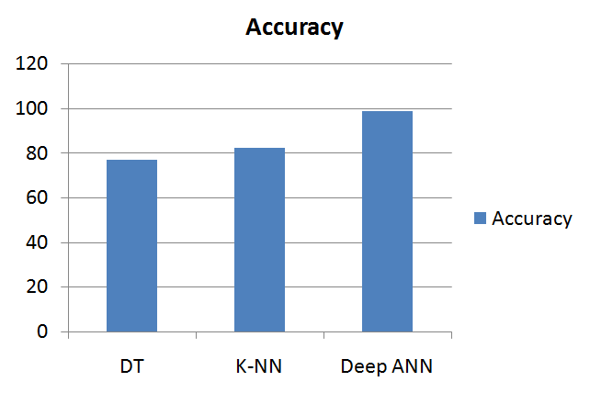
Fig. 2: ACCURACY PERFORMANCE
COMPARISON BETWEEN METHODS

In this comparision the above graph shows that Deep ANN has higher accuracy.

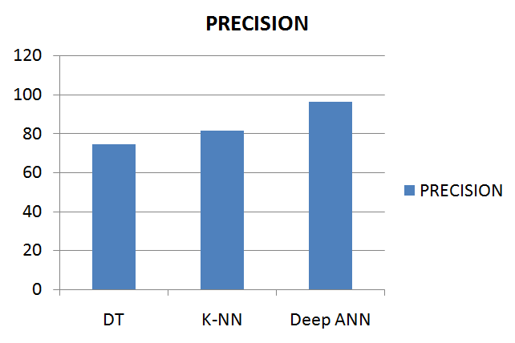
Fig. 3: PRECISION PERFORMANCE
COMPARISON BETWEEN METHODS

In this comparision the above graph shows that Deep ANN has higher precision.

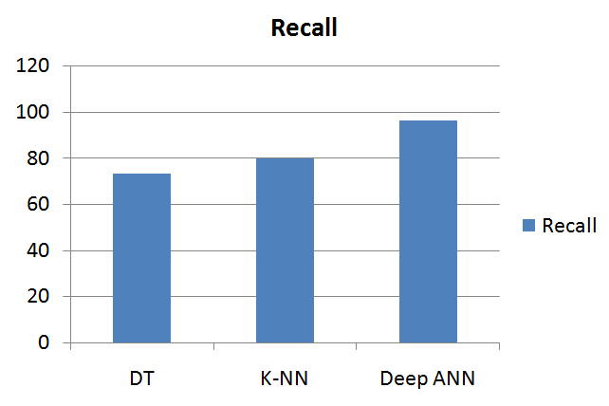
Fig. 4: RECALL PERFORMANCE
COMPARISON BETWEEN METHODS

The graph above indicates that Deep ANN has greater recall in this comparison. Therefore, compared to DT and K-NN, the presented Deep ANN method is more effective at identifying and detecting plant leaf diseases.

V. CONCLUSION
Technology is being used in all aspects of everyday life. Plant diseases can be difficult for farmers to manually identify. Also, farmers are unable to easily obtain expert advice. The use of an automated system to detect plant diseases is significant. Deep ANN was used over K-NN and DT classifiers to achieve the primary goal of this study, which was to demonstrate enhancements to existing classification methods for the identification of plant leaf disease. This analysis presents the experiment on different machine learning techniques which are useful in identifying and classifying the plant leaf illness. And the performance of these techniques is calculated. Deep ANN has provided higher accuracy, recall, and precision than Decision Tree, K-NN, based on the calculated performance metrics of the three algorithms on various aspects like accuracy, precision, and recall. Hence in this analysis the Deep ANN has given the best results.

VI. REFERENCES
[1] A. Haldorai and A. Ramu, “Security and channel noise management in cognitive radio networks,” Computers & Electrical Engineering, vol. 87, p. 106784, Oct. 2020. doi:10.1016/j.compeleceng.2020.106784
[2] A. Haldorai and A. Ramu, “Canonical Correlation Analysis Based Hyper Basis Feedforward Neural Network Classification for Urban Sustainability,” Neural Processing Letters, Aug. 2020. doi: 10.1007/s11063-020-10327-3
[3] X. E. Pantazi, D. Moshou, and A. A. Tamouridou, “Automated leaf disease detection in different crop species through image features analysis and One Class Classifiers,” Computers and Electronics in Agriculture, vol. 156, pp. 96-104, 2019.
[4] Uday Pratap Singh “ Multilayer Convolution Neural Network for the Classification of Mango Leaves Infected by Anthracnose Disease ” IEEE Access Volume -7 pages-43721 - 43729, March 2019.
[5] Peng Jiang “Real-Time Detection of Apple Leaf Diseases Using Deep Learning Approach Based on Improved Convolutional Neural Networks” IEEE Access Volume-7 pages 59069 - 59080, May 2019.
[6] Xihai Zhang “Identification of Maize Leaf Diseases Using Improved Deep Convolutional Neural Networks” IEEE Access Volume-6 pages 30370 - 30377, June 2018
[7] Juncheng Ma, “A recognition method for cucumber diseases using leaf symptom images based on deep convolutional neural network,” in Computers and Electronics in Agriculture, vol. 154, pp. 18-24, 2018, doi: 10.1016/j.compag.2018.08.048. .
[8] Konstantinos P. Ferentinos, “Deep learning models for plant disease detection and diagnosis,” Computers and Electronics in Agriculture, vol. 145, pp. 311-318, 2018. doi: 10.1016/j.compag.2018.01.009.
[9] S. W. Chen “Counting Apples and Oranges with Deep Learning: A Data-Driven Approach,” in IEEE Robotics and Automation Letters, vol. 2, no. 2, pp. 781-788, April 2017, doi: 10.1109/LRA. 2017.2651944.
[10] Vijai, S., A.K.Misra, (2017), “Detection of plant leaf diseases using image segmentation and soft computing techniques”, Information Processing in Agriculture, vol 4, pp 41-49
[11] B. S. Ghyar and G. K. Birajdar, "Computer vision based approach to detect rice leaf diseases using texture and color descriptors," 2017 International Conference on Inventive Computing and Informatics (ICICI), Coimbatore, 2017, pp. 1074-1078, doi: 10.1109/ICICI.2017.8365305
[12] H.Sabrol, K.Satish “Tomato plant disease classification in digital images using classification tree.” In: 2016 International Conference on Communication and Signal Processing (ICCSP), pp. 1242–1246 (2016)
[13] R. Satheesh Kumar and S. Vijayan., " Computer Aided Content Analysis of Web Based Medical Queries: Classifying affective and Informative Post ", Journal of Pure and Applied Microbiology, vol. 9, No. Special Issue, pp. 37-45, 2015.
[14] M. Jhuria, A. Kumar and R. Borse, "Image processing for smart farming: Detection of disease and fruit grading," IEEE Second International Conference on Image Information Processing (ICIIP-2013), Shimla, 2013, pp. 521-526, doi: 10.1109/ICIIP.2013.6707647
[15] Revathi, P., Hemalatha, M. (2012) “Classification of cotton leaf spot diseases using image processing edge detection techniques”.169- 173.10.1109/ INCOSET.2012.6513900J. Clerk Maxwell, A Treatise on Electricity and Magnetism, 3rd ed., vol. 2. Oxford: Clarendon, 1892, pp.68–73.
[16] Aanand, H., K., Ashwin Patil (2012) “Applying image processing technique to detect plant diseases “, Int J Mod Eng. Res, pp. 3661- 3664M. Young, The Technical Writ er’s Handbook. Mill Valley, CA: University Science, 1989.

