The Introduction of Robotics into Basic Farming Operations
Author Name: Hilaas Ahmad Peerzada¹, Nuzhat Bint Nazir² and Dr. Purshotam Singh
¹M.Tech Farm Machinery & Power Engineering, COAE&T, SKUAST KASHMIR
²Ph.D Soil and Water Conservation Engineering, COAE&T, SKUAST-KASHMIR
³Professor Agronomy, Directorate of Extension, SKUAST-K, Shalimar

Abstract- Agriculture is a fundamental component of human survival. Farmers who work in agriculture spend the majority of their time ploughing the field, watering the field, and so on. The agricultural industry accounts for 20.5% of India's Gross Domestic Product. In India, agriculture employs about half of the population. As a result, India's agricultural system is critical and should be advanced to lessen farmers' efforts. Innovation is necessary in any industry, but it is more important than ever in agriculture. Embracing new technology such as robotics, machine learning, and computer vision will be critical in changing the face of agriculture around the world. It will also change the definition of farmworkers by reducing workload while demonstrating promising results in crop efficiency, better yields, and reduced input costs. Automation, robotics, vertical farming, modern greenhouse practices, artificial intelligence, and precision agriculture are all here to stay, and investors are more focused than ever on sustaining our economy through automation, robots, vertical farming, modern greenhouse practices, artificial intelligence, and precision agriculture. Farmers currently spend a lot of money on devices that help them reduce labour and enhance crop yield, but the profit and efficiency of these machines are quite low. As a result, automation is the ideal method for overcoming all limits. The suggested method, which mixes robotics with agriculture, is a godsend to farmers. This system can go about the field like a farmer, plough it, sow the seeds, and irrigate it in a predetermined pattern. Furthermore, it is capable of crop cutting, re-planting paddy crops, and monitoring the field via a wireless camera. This chapter discusses the fundamentals of robotics, with a special emphasis on farm machinery in agriculture. In addition, the chapter briefly discusses the areas of application based on the latest literature available.

Keywords: Agricultural Informatics, Artificial Intelligence, Automation, Development in farming, Robotics.
Introduction
Robotics is an engineering and scientific discipline concerned with the design, manufacture, operation, and use of robots. A robot is a machine or mechanical device that may be programmed to perform a sequence of autonomous or semi-autonomous activities. Robots can range from basic industrial robotic arms used in production to humanoid robots capable of emulating human actions. In Agricultural Robotics practices, it is critical that the machine learn and prepare prior to their work with programming and new technologies. The machines should get understanding of the various variables that they must study or do. Robotics applications and markets in agriculture and related industries are fast expanding, and according to industry Research Consultancy business (Verified Market Research), this industry might reach $11.58 billion by 2025. Robotics, which is driven by Artificial Intelligence (and among these technologies, a few prominent ones are Expert Systems, Deep Learning, and Machine Learning), is one of the technologies engaged with agricultural robotics [1]. It is finding new uses in a variety of farm machines and associated fields, including drones for weed control, plant sowing, environmental assessment and monitoring, fruit picking, automated spraying (Manual and Driverless).
Key aspects of robotics include:
- Sensing: Robots employ a variety of sensors (e.g., cameras, infrared, ultrasonic) to detect and interact with their surroundings.
- Actuation: Mechanical components such as motors and actuators enable robots to move and perform physical activities.
- Control: Algorithms manage robot intelligence, which can range from basic if-then statements to complex machine learning models.
- Autonomy: Some robots are designed to function independently without the need for human involvement, whilst others may require human input or teleoperation.
Artificial Intelligence
It is a simulation of human intellect that is performed by machines. Artificial intelligence (AI) is the emulation of human intellect in computers that are programmed to think, learn, and solve problems. Perception, thinking, learning, and decision-making are all functions that AI systems attempt to execute. Programs in such computers essentially operate like people and nicely replicate their behaviours. It is also relevant to machines that demonstrate features similar to the human brain, such as learning and problem-solving. It is the capacity to rationalize as well as conduct activities in order to achieve a certain and pre-defined objective. Robotics and artificial intelligence are not the same thing. These two are related, yet many people believe they are the same [2]. Artificial intelligence is a subset of human intelligence that provides gadgets or systems that resemble humans or are just technologies. Following that, the mimic machine basically does jobs or labour. The following are the primary goals of artificial intelligence:
- Learning
- Logic reasoning
- Perception
Initially, AI is defined as machines that can calculate simple functions or read text using optical character recognition. However, as time passes, the circumstance changes and continues to evolve [3]. Artificial intelligence is developing through the use of cross-disciplinary themes such as:
- Mathematics
  - Mechanical Engineering
  - Computer Science
  - Linguistics, Psychology and more.
There are several forms of AI:
    - Narrow AI: Also known as Weak AI, it is intended to accomplish narrow tasks but lacking broad intelligence. Virtual assistants such as Siri and Alexa are examples, as are recommendation algorithms used by streaming services and online retailers.
    - General AI: Also known as Strong AI or AGI (Artificial General Intelligence), this is a theoretical AI that can understand, learn, and apply knowledge across several areas. General AI is a huge scientific and technical issue that is still being researched.
    - Artificial Super intelligence: This is a more sophisticated version of AI that outperforms human intelligence in almost every way. It's a notion that presents ethical and existential concerns, and it's a source of contention within the AI community.

Brief idea of the architecture of agricultural robots
In the field, the Bots employ GPS, vision processing, Lidar, and other technologies to navigate. It computes the field's waypoints, after which robots travel across and complete the specified operation. The essential premise for the agricultural robot is that the speed and rpm of the motor, obstacle recognition, and managing the angular and linear movement of the robot are all controlled by the speed and rpm of the motor. Solar and battery electricity are the primary sources of energy. This leads to field operations such as optimal seed placement, weed management, spraying, harvesting, crop monitoring, and so on (Fig. 1).

Fig. 1 Brief architecture of agricultural robots

The convergence of robotics and artificial intelligence
Robotics and AI are frequently combined to produce intelligent robotic systems. Machine learning and computer vision AI algorithms are integrated into robots to improve perception, decision-making, and adaptability. Robots may now work in complicated and dynamic situations, execute difficult jobs, and even learn from experience thanks to this integration. Autonomous cars, surgical robots, warehouse automation, drones, personal assistants, smart home gadgets, and other robotics and AI applications abound. These technologies have enormous promise, with constant research and development pushing the frontiers of what is conceivable. It is crucial to remember that as sophisticated AI and robots evolve, there are ethical problems such as privacy, safety, employment displacement, and responsible use of these technologies that must be addressed by society and legislators.

Agricultural Informatics
Agricultural informatics is the use of information science and technology to agriculture and related fields/industries. IT in Agriculture is another term for it. Agro informatics is an interdisciplinary area that integrates agricultural science, computer science, and information technology to enhance the efficiency, productivity, and sustainability of agricultural activities. It entails the use of various information technologies, data analytics, and communication networks in agricultural settings. Agricultural Informatics is an interdisciplinary discipline with applications in a variety of fields. This is becoming a topic of study in a variety of nations, with varying levels of programs. Agricultural Informatics employs many information technology components such as database technology, software technology, multimedia technology, web technology, networking technology, and so on. Agricultural Informatics includes not only the use of IT, but also documentation and the fundamentals of information management [4]. Various developing technologies, such as Cloud Computing, Big Data, HCI, Usability Engineering, Robotics and AI, and so on, have grown fast in recent years. These technologies are also playing an important part in the development of Smarter Agricultural Practices. Robotics, AI, and Machine Learning have seen enormous growth in recent years. Agricultural robots are assisting farmers in increasing crop productivity by employing drones, harvesting machines, autonomous tractors, agro-based robotic arms, and so on. This will aid in meeting the food needs of the growing population. According to the United Nations, the population will increase by 9.7 billion by 2050 (from 7.3 billion now). As a result, more food is required, and farmers must look beyond existing ways to meet such demand in the future. As a result, in this setting, Agricultural Informatics and related areas such as -
- Agricultural Information Systems
- Agricultural Computing
- Agricultural Information Technology
Agriculture Information and communication technology (ICT), for example, will play a significant role. Robotics and artificial intelligence (AI) are particularly significant for developing more intelligent and wiser agricultural and horticulture processes [5].
Applications of Agricultural Robots
Agricultural robots that can do many tasks It usually has the capability of running or performing the operation automatically, either slowly or repetitively. As a result, farmers may be able to focus more on the field and increase agricultural productivity. Fig. 2 depicts the fundamental work performance of agricultural robots.

Fig.2 Farming Robot Applications
Harvesting and picking are the most common agricultural robotic applications. It improves both accuracy and speed. As a result, it helps to improve not only the size of harvests but also the waste from crops. Agricultural robot vision systems can detect a position and retrieve a product regardless of the conditions, including dust, temperature, and wind movement [6]. Though harvesting and picking robots are becoming key robotic applications in agriculture, there are other sectors where it is useful and eventually aids in the development of the agricultural business through automation. The fundamental motivation for the deployment of robots in agriculture is the demand for food. Agriculture and related industries are heavily reliant on robotics for pre- and post-production. Agricultural Robotics is useful for the following (but not limited to) activities:
  - Enhancing the efficiency
  - Lowering manual labour
  - Enhanced productivity
  - Industrial promotion and development
  - Lowering production cost
  - Aid in harvesting
  - Manpower participation, etc.
Commonly used agricultural robotic sensors
- GNSS (Global Navigation Satellite System)
- RGB (red, green, blue) scale sensor
- Infrared (IR) sensor
- Light detection and ranging (LiDAR)
- Vision sensor
- Multispectral sensors
Core technologies employed in agricultural robotics
Although different farm robots are distinguished by their application situations, they share a number of key technologies. A robust mobile platform, multi-sensor collaboration, superior visual image processing technology, complex algorithms, and flexible locomotion control, for example, are normally required to build an agricultural robot. In addition, several relevant strategies [7] are shown in Fig. 3.
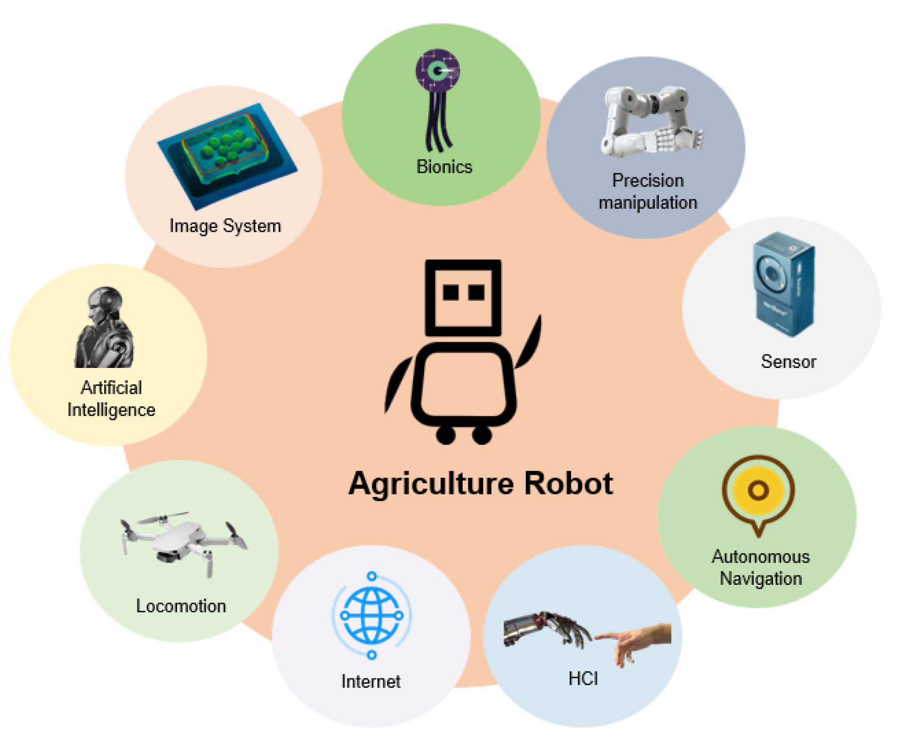
Fig. 3 Core technologies employed in agricultural robotic applications [7].
Some developed robotic component implications with examples
Field Robots
Field robots [7] are autonomous, decision-making, mechatronic, and transportable operating equipment capable of performing a variety of agricultural production activities semi-automatically or automatically. This section reviews significant literature, including robots and their various techniques of mobility. Most field robots are intended to move on wheels; caterpillars and drones are uncommon. Surprisingly, the use of drones is concentrated on crop protection via pesticide spraying. Tilling, sowing, crop protection, information gathering, and harvesting are common tasks.
a. Tillage Robots
Tillage robots are intelligent devices that work to develop the soil. Tillage, as we all know, is a tedious and labour-intensive process. Tillage robots may relieve farmers of heavy labour while improving crop productivity and quality, and they can play an important role in digital agriculture. Due to extensive research, tillage robot machinery is still in its early stages. As a result, recent advances in tillage robot technology have focused mostly on modernizing robot systems. Because of their rapidly aging population, the countries are deeply worried about agricultural automation. John Deere has released the Sesam 2, an electric robot tractor that can produce 300 kW (400 hp) of power and play an important role in both tilling and harvesting. Furthermore, it can collaborate with a number of different robots.
b. Seeding Robots
The basic procedure in field production is sowing. As a result, seed-sowing robots allow farmers to spread seeds precisely, saving both time and money. Many functioning seeding robots have been designed and widely used to date. For example, Fig. 4 depicts a precision sowing robot [8] for wheat equipped with four wheels, servo motors, and stepper motors. The seeding rate exceeded 93% at normal sowing speed, according to the testing findings. The authors presented a seeding robot in which can excavate dirt, sow seeds, and cover them with earth. There is also the option of adding fertilizer and watering.
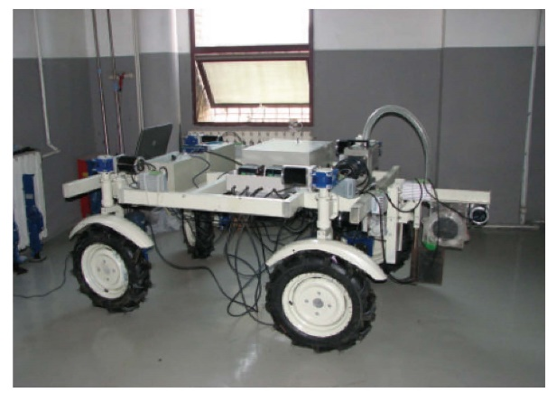
Fig. 4 Precision wheat seeding robot.
c. Crop Protection Robots
Traditional crop protection generally entails manually spraying hazardous pesticides, which is harmful to farmers' health. Drones are already widely used to apply spray treatments in Southeast Asia, with South Korea employing them for around 30% of their agricultural spraying. Drone sprayers (Fig. 5) [9] can reach locations that are otherwise inaccessible, such as steep tea plantations at high altitudes. Drone sprayers eliminate the need for personnel to travel fields while carrying backpack sprayers, which can be dangerous to their health. Drone sprayers offer extremely thin spray treatments that may be targeted to particular locations, maximizing productivity and lowering chemical costs. Drone sprayer rules now vary greatly across nations. To reduce pesticide exposure, an intelligent robotic system was designed to automatically spray pesticides based on a navigation control algorithm and a high-efficiency trajectory calculation algorithm. For example, a cost-effective spraying robot to meet the need for pesticides and fertilizers was made, while tiny drones, such as sensing and actuation drones offered revolutionary technologies (Fig. 6) [10]. The intelligent system delivers long-term pest control by interacting with one another.
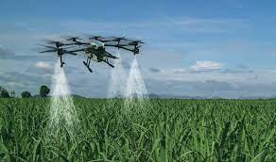
Fig.5 Sprayer drone

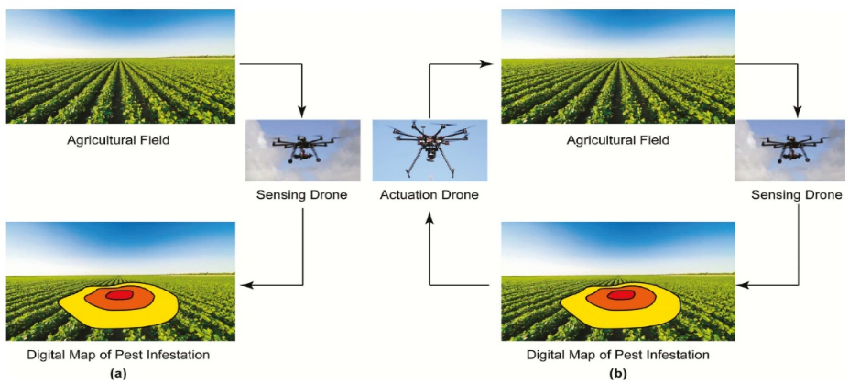
Fig. 6 (a) State-of-the-art open-loop remote sensing paradigm and (b) closed-loop IPM paradigm envisioned.

Sensing drones can locate pest hotspots, while actuation drones can distribute treatments precisely. Aside from insect control, general environmental management is important for crop security. An autonomous gardening robot that can plant and monitor soil and water was presented. Similarly, a multi-function field robot based on Dual tone multi-frequency (DTMF) that can assess soil moisture, irrigate and spray pesticides, and so on, was created. Furthermore, it may be operated remotely. A paddy field weeding robot was created and based on trial results, this robot with two wheels, touch sensors, and a rotating azimuth sensor may uproot weeds by churning up the soil and obstructing sunlight, potentially enhancing agricultural output. Crop protection robots have benefited from improved technology such as the ant colony algorithm, trajectory approach, and optimized robot systems. A more precise and efficient ant colony method for plant protection robots was developed, with the goal of improving path planning dependability and precision. A unique trajectory approach for crop planting in western China, an area characterized by fragmented farmland, by assessing crop layout using the ant colony algorithm was developed. An automated pesticide spraying robot system that detects rows and activates nozzles was developed.
d. Field Information-Collecting Robots
Although gathering information in the field might be time-consuming and exhausting, the knowledge acquired supports farmers in making undetectable judgments. As a result, field information-gathering robots have been designed to carry out this task. For example, a field-based high-throughput plant phenotyping mobile robotic device to monitor Canola plants at the University of Saskatchewan was created, constructed, and tested. The technology can automatically acquire and analyze wide-range photos of plant canopies. This invention has been shown to increase agricultural output while lowering long-term costs. A field robot named Robhortic for identifying pests and illnesses in horticulture crops, as shown in Fig. 7 [11] was created. After three trials in carrot fields, its performance was remarkable, with detection rates in the laboratory and field of 66.4% and 59.8%, respectively.
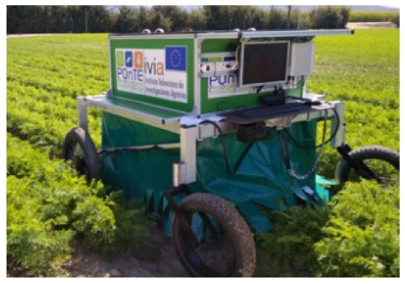
Fig. 7 Remotely controlled RobHortic working on a carrot field.
Breakthroughs in neural network algorithms and visual navigation have contributed to the technical advancement of information-gathering robots. The convolutional neural network algorithm of a field information-gathering robot was improved by modifying the route tracking to provide steady mobility, little deviation, and human-machine separation.
e. Crop Harvesting Robots
Rice cutter machines, as is widely known, have been available for many years. Many algorithms have been devised to automate such harvesters based on the current mechanical foundation. Cameras, LiDAR, infrared sensors, and other vision technologies are used in crop harvesting robots. These sensors assist them in identifying ripe crops, detecting impediments, and navigating the fields. Machine learning techniques are used by the robots to recognize and discriminate various crops. They can identify the crop that needs to be picked and assess its maturity. Crop harvesting robots are meant to harvest crops precisely and selectively. They may pick just the ripe crops, letting the unripe ones to grow later, maximizing harvest output. For example, in 2022, an autonomous corn harvester system capable of meeting trial criteria at regular harvester speeds with a deviation rate of 95.4% was developed. Notably, these developments serve as a model for furthering the automated row alignment procedure. As illustrated in Fig. 8, a deep-learning system based on ICNet to aid a robotic harvester with precise obstacle identification in real-time [12] was created and used. At an average continuing speed, this autonomous harvester equipped with a trimmed model was able to achieve collision avoidance with a success rate of 96.6%.
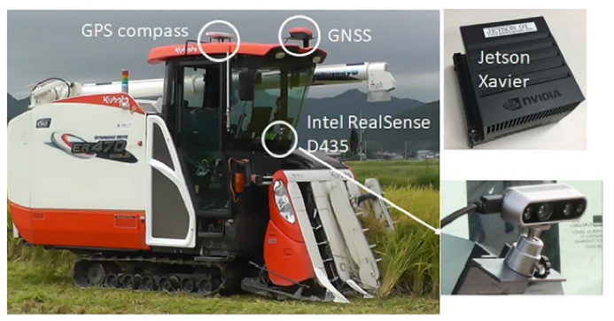
Fig. 8 Combine Harvesting robot with installed gadgets.
Fruit and Vegetable Robots
Manpower cannot adequately fulfil the agricultural goods market's growing demands. Smart robotics, on the other hand, can be an efficient option for increasing market planting areas in conjunction with advancements in agriculture, preservation, and processing technologies [7]. This section introduces key types of fruit and vegetable robots: transplanting robots, patrolling robots, pesticide spraying robots, gardening robots, and picking robots based on the latest literature available.
a. Transplanting Robots
Accuracy and stability are two essential measures of transplanting performance. As a result, an enhanced control strategy for hydraulic transplanting robots employing manipulators was suggested. For example, a transplanting control precision and stability were increased and a three-degree of freedom transplanting robot was created. A further study revealed that the transplanting robot could obtain a success rate of 95.3% even when the acceleration reached 30 m/s². A multi-task transplanting robot that could achieve a 90% success rate even at a speed of 960 plants/min per gripper was built and tested. Future research that combines agronomic and mechanical needs is predicted. Furthermore, the development of more affordable goods for smallholder farmers is expected. In Fig. 9, an advanced sweet potato transplanting robot with two degrees of freedom route control [13] was constructed. Notably, this machine can automatically adopt several transplanting techniques based on terrain type. The minimum qualifying rate of seedling erecting angle and planting depth was 94.7% and 94.8%, respectively, meeting the practical criteria of mechanical sweet potato transplanting.
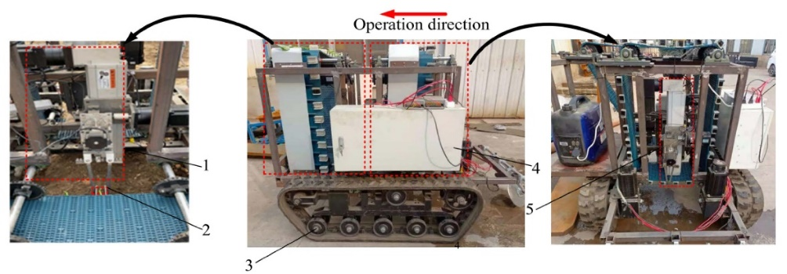
Fig. 9 1. Transplanting robot arm; 2. Transplanting position; 3. Crawler chassis; 4. Control box; 5.
Filling robot arm.
b. Fruit and Vegetable Patrolling Robots
Fruit and vegetable patrolling robots typically move independently, collect various data, and then provide feedback to farmers. They collect information on fruit and vegetable ripeness, environmental conditions, and pests. Sensors and cameras aboard robots might be used to monitor crop health, growth, and general condition. They may gather data on temperature, humidity, soil moisture, and nutrient levels, allowing farmers to make more educated decisions regarding irrigation, fertilization, and insect management. These robots might detect pests or illnesses on plants at an early stage by using powerful image recognition and machine learning techniques. Farmers would be able to take fast action and reduce crop losses if early diagnosis was possible. For example, a scouting robot to identify tomatoes and estimate their ripeness using YOLOV4 based on colour proportion analysis was made. The detection speed in the natural greenhouse exceeded 5 frames/second and the identification accuracy rate exceeds 95%. To identify early pests, the Robot framework (Fig. 10), [14], was created a ROS-based architecture that successfully integrates several robotic competences such as navigation and manipulation. These novel methods open the door to the development of new mobile robotic manipulators.
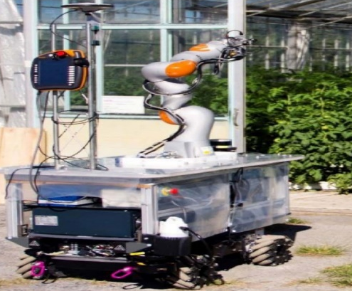
Fig. 10 A robotic platform from Green Patrol entering a greenhouse.
c. Pesticide Spraying Robots
Spraying pesticides on fruits and vegetables, like spraying pesticides on field crops, is a burden on the ecosystem owing to excessive spraying ranges. As a result, numerous pesticides spraying robots have been developed to accomplish more precise spraying through the use of various technologies such as servo-controlled nozzles, flow control systems, and ultrasonic sensors. Pesticide spraying robots have received a tremendous interest and research effort and thus the first completely automated selective pesticide spraying system for specialty crops was developed. As illustrated in Fig. 11, a semantic segmentation-based flow control system for a smart spraying robot [15] was suggested. Following that, contrastive field tests were done to show that the suggested system outperformed existing control systems. A robotic selective sprayer with ultrasonic sensors was created. The nozzles, which use ultrasonic sensing technology, spray only at the tree canopy, lowering pesticide consumption in orchards by 26%. In a robotic spraying system for spraying pesticides in orchards was suggested, consisting of hardware setup, semantic segmentation, and depth data fused with learned RGB data. Their ecologically friendly spraying robot performed admirably in field tests.
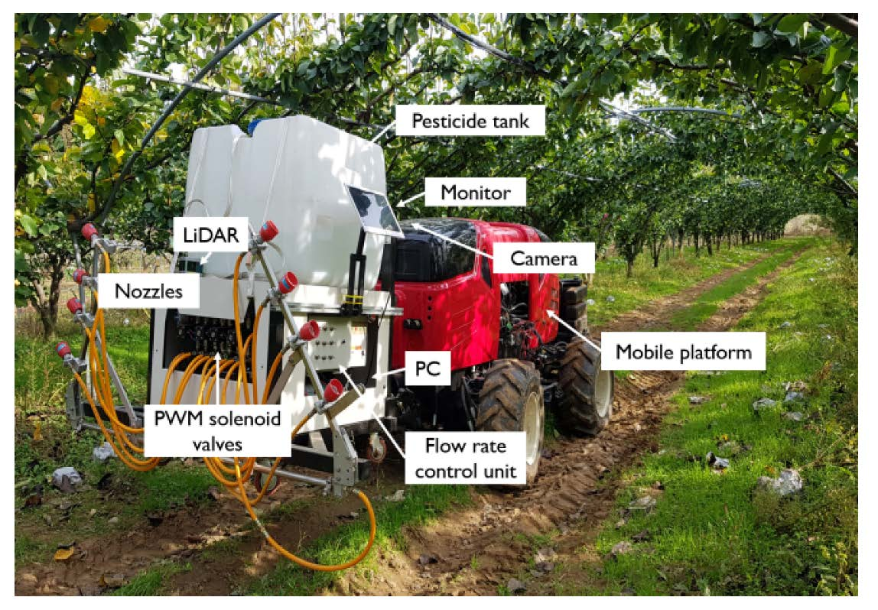
Fig. 11 Spraying system with intelligence.
The "X-Bot" (Fig. 12) built by Ozgul and Celik is substantially smaller [16] when compared to ordinary pesticide-spraying robots. The semi-automatic mobile robot can spray insecticides and repel insects without the need for human intervention.
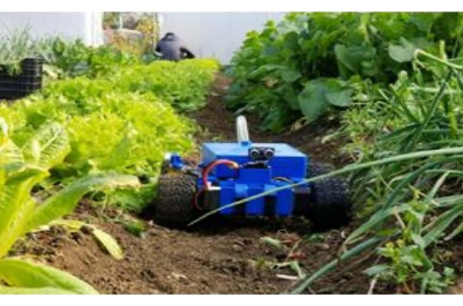
Fig. 12 X-Bot in action on a field.
The remote control is accessible via Bluetooth connection. A pesticide spraying robot with an interface controller for remotely controllable spraying was presented. Furthermore, they created and tested a prototype that met all essential requirements.
d. Gardening Robots
A garden with distinct characteristics is a challenge for autonomous gardening robot systems due to the dynamic circumstances created by seasonal changes and plant growth. The garden map for robot navigation applications is impacted by the trimming of hedges by gardening robots since its look and geometry vary at this point. As a result, the existence of pitches and the gardening robot movement plan should be taken into account in navigation approaches. This region has received a tremendous lot of research attention. The use of revolutionary path planning and visual servo technologies in a prototype was pioneered. A jujube pruning manipulator [17] with five degrees of freedom, as shown in Fig. 13 was constructed. Following that, a performance test was carried out, which confirmed the good qualities of the automatic equipment, with little positioning error and an average success rate of more than 85.16%.
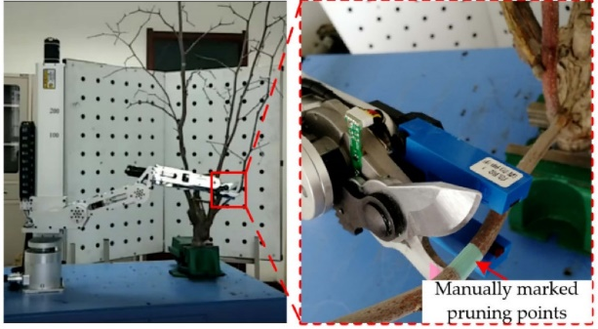
Fig. 13 Pruning manipulator
Small-sized gardening robots [18] based on an autonomous watering system (Fig. 14) have been built and tested to aid people in growing plants. Plants were able to develop up to 20% quicker under the care of gardening robots thanks to the usage of sprinkler controls and moisture sensors. More sensors are likely to be accessed in future work, and image-based machine learning can be highlighted. A multi-functional planting system that could be used on rooftops and in nurseries was created. This semi-autonomous support device can provide water while also detecting leaf illness. The solar charging technology, however, limits the gardening robot when there is little daylight. An autonomous mobile gardening system was created, comprised of four components: a monitoring kit, an artificial intelligent classifier, a mobile application, and cloud storage, with the goal of enhancing planting efficiency.
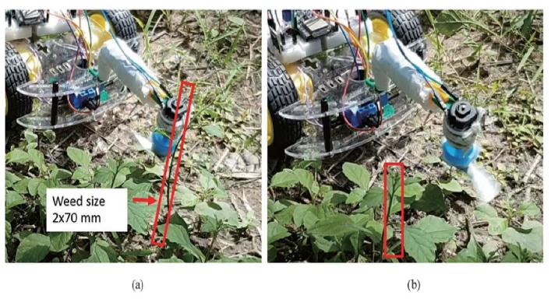
Fig. 14 (Colour online) Weeds (a) Prior to cutting with a cutter blade and (b) Post cutting with a
cutter blade.

e. Fruit and Vegetable Picking Robots
Fruit and vegetable picking robots are automated equipment used in contemporary agriculture for large-scale detection and picking of fruits and vegetables. These robots are outfitted with advanced cameras, sensors, and, in certain cases, LiDAR (Light Detection and Ranging) technology. These sensors enable the robot to recognize ripe fruits, distinguish them from leaves and branches, and assess their harvestability. The robot's arm or grasping mechanism is meant to pluck the fruit carefully without hurting it. The pattern changes based on the type of fruit. For berries, for example, a mild vacuum suction system may be utilized, whereas robotic arms with grippers are used for bigger fruits such as apples or oranges. Fruit harvesting robots are fitted with wheels or tracks that allow them to navigate uneven terrain and travel effectively across orchards or fields. Some versions may be capable of autonomous navigation in order to avoid obstacles and reach specific fruit trees or rows. Robotic harvesters are categorised as bulk or selective, and include kiwi-picking robots, apple-picking robots, strawberry-picking robots, tomato-picking robots, and others. Furthermore, multiple cases have demonstrated that fruit and vegetable picking robots have become a popular topic among agricultural robots. A machine vision system, end effectors, and harvesting arms are included in this sort of kiwi fruit picking robot. The robot uses a convolution neural network (CNN) to conduct semantic segmentation on photos of the canopy. However, due to obstacles and loss, only 51% of the kiwi fruits in the test orchard were successfully collected by the unique robotic kiwifruit harvesting system. Octinion, an agricultural R&D startup, developed a fully autonomous picking robot [19] can locate and select ripe fruits without hurting them. The prototype was extremely efficient, plucking strawberries in about 4 seconds. A reliable system for harvesting robots (Fig. 15) based on RGB-D to automatically find lychee clusters was developed, enabling collection in large-scale settings. In field tests, dealing with a single lychee string took only 0.464 seconds.
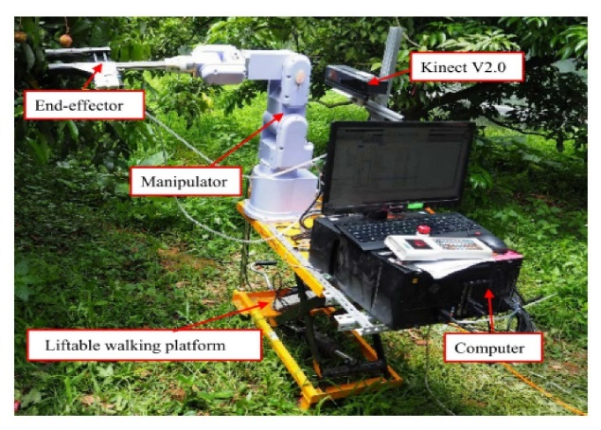
Fig. 15 Robotic system for lychee harvesting.
A novel robotic harvester as part of the entire operation for harvesting sweet peppers was designed. It produced a harvesting success rate of 58%, a grasping success rate of 81%, and a detachment success rate of 90% for the sweet pepper using a vision-based algorithm, a 3D localisation and grip selection approach, and an end-effector, which constitutes a breakthrough. Although these results may not yet meet commercial requirements, this autonomous sweet pepper harvester has a bright future. Thermal pictures, which are more efficient than RGB photographs, were utilized to recognize chili peppers in complicated situations using deep learning. The use of thermal cameras can improve harvesting efficiency; this work offers up new options for harvesting in low-light conditions. Unlike rigid grippers, flexible soft grippers may interact with items softly. The breakthroughs and relative brilliance of soft robotic grippers in vegetable and fruit picking, as well as their adaptability to various needs was evaluated. They presented the concept and state of soft robotic grippers briefly. They stated that while advances in materials, chemistry, and other diverse fields have been accomplished, obstacles remain in manipulating methodologies, controllability, and mechanical design.

Expected growth of agricultural robotic market in the United States from 2016-2025
Expected growth of agricultural robotic market in the United States has been shown in Fig.16 [20]
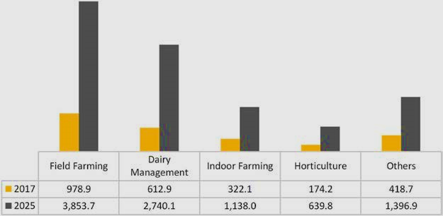
Fig.16 Expected growth (in million U.S. dollars, Verified Market Research, 2018)
Conclusion
Farming robots provides great promise for the agriculture business. It has the ability to bring about dramatic changes and alleviate some of the issues encountered by modern agriculture by merging automation and advanced technology into many elements of farming. Robotic systems can accomplish jobs with higher accuracy and consistency than human labour, resulting in enhanced agricultural productivity. This can lead to increased yields, less resource waste, and more efficient use of inputs such as water, fertilizer, and pesticides. Farmers may lessen their reliance on physical labour, which is frequently vulnerable to shortages and rising expenses, by having technology take over repetitive and labour-intensive operations. Precision agriculture is made possible by robotics, which provides real-time data and insights on crops, soil conditions, and environmental elements. This data enables farmers to make more educated decisions and take focused steps to improve crop health and yield. Robotics in farming leads to more sustainable and environmentally friendly agricultural operations by maximizing resource consumption and decreasing the environmental effect of agricultural processes. While the benefits are significant, there are certain hurdles to overcome, such as high upfront expenditures, integration with conventional agricultural processes, and the requirement for specialized training to operate and maintain robotic equipment. As technology advances, robots in farming will become more accessible and efficient, making it a feasible alternative for a broader range of farmers and agricultural situations. With continued research and development, we may anticipate increasingly more complex robotic systems capable of tackling a greater range of agricultural chores and further revolutionizing the sector. The use of robots in farming marks a paradigm changes in agriculture, opening the way for more sustainable, efficient, and productive farming techniques in the future. Agriculture stands to profit considerably from this technological breakthrough by solving the problems and capitalizing on the possibilities, maintaining food security and fulfilling the demands of a growing global population.
References

- Bera, A., and Dutta, D. Application of robotics in modern agriculture. Just agriculture, vol 1, issue 11, e-ISSN:2582-8223
- Cheng, C., Fu, J., Su, H., & Ren, L. (2023). Recent advancements in agriculture robots: Benefits and challenges. Machines, 11(1): 48.
- Cubero, S., Marco-Noales, E., Aleixos, N., Barbé, S., & Blasco, J. (2020). Robhortic: A field robot to detect pests and diseases in horticultural crops by proximal sensing. Agriculture, 10(7):276.
- De Preter, A.; Anthonis, J.; De Baerdemaeker, J. Development of a robot for harvesting strawberries. IFAC-PapersOnLine 2018, 51:14–19.
- Channe, H., Kothari, S., & Kadam, D. (2015). Multidisciplinary model for smart agriculture using internet-of-things (IoT), sensors, cloud-computing, mobile-computing & big-data analysis. Int. J. Computer Technology & Applications, 6(3), 374:382.
- Iost Filho, F. H., Heldens, W. B., Kong, Z., & de Lange, E. S. (2020). Drones: innovative technology for use in precision pest management. Journal of economic entomology, 113(1), 1:25.
- Li, Y., Iida, M., Suyama, T., Suguri, M., & Masuda, R. (2020). Implementation of deep-learning algorithm for obstacle detection and collision avoidance for robotic harvester. Computers and Electronics in Agriculture, 174: 105499.
- Haibo, L., Shuliang, D., Zunmin, L., & Chuijie, Y. (2015). Study and experiment on a wheat precision seeding robot. Journal of Robotics, 2015, 12:12.
- Liu, Z., Lv, Z., Zheng, W., & Wang, X. (2022). Trajectory Control of Two-Degree-of-Freedom Sweet Potato Transplanting Robot Arm. IEEE Access, 10: 26294-26306.
- Martin, J., Ansuategi, A., Maurtua, I., Gutierrez, A., Obregón, D., Casquero, O., & Marcos, M. (2021). A generic ROS-based control architecture for pest inspection and treatment in greenhouses using a mobile manipulator. Ieee Access, 9: 94981-94995.
- Na, A., & Isaac, W. (2016, January). Developing a human-centric agricultural model in the IoT environment. In 2016 International Conference on Internet of Things and Applications (IOTA) (pp. 292-297). IEEE.
- Ozgul, E., & Celik, U. (2018, May). Design and implementation of semi-autonomous anti-pesticide spraying and insect repellent mobile robot for agricultural applications. In 2018 5th International Conference on Electrical and Electronic Engineering (ICEEE) (pp. 233-237). IEEE.
- Kajol, R., & Akshay, K. K. (2018). Automated agricultural field analysis and monitoring system using IOT. International Journal of Information Engineering and Electronic Business, 12(2):17.
- Monteiro, A., Santos, S., & Gonçalves, P. (2021). Precision agriculture for crop and livestock farming—Brief review. Animals, 11(8):2345.
- Gill, S. S., Chana, I., & Buyya, R. (2017). IoT based agriculture as a cloud and big data service: the beginning of digital India. Journal of Organizational and End User Computing (JOEUC), 29(4): 1-23.
- Kamble, S. S., Gunasekaran, A., & Gawankar, S. A. (2020). Achieving sustainable performance in a data-driven agriculture supply chain: A review for research and applications. International Journal of Production Economics, 219:179-194.
- Seol, J., Kim, J., & Son, H. I. (2022). Field evaluations of a deep learning-based intelligent spraying robot with flow control for pear orchards. Precision Agriculture, 23(2): 712-732.
- Tangtisanon, P. (2019). Small Gardening Robot with Decision-making Watering System. Sensors & Materials, 31.
- Zhang, B., Chen, X., Zhang, H., Shen, C., & Fu, W. (2022). Design and performance test of a jujube pruning manipulator. Agriculture, 12(4): 552.

