Statistical Analysis of Successive Over-Relaxation Method
Arshan Homi Dastur and Soubhik Chakraborty*
Department of Mathematics, Birla Institute of Technology, Mesra, Ranchi 835215, India
arshandastur2898@gmail.com, soubhikc@yahoo.co.in
*corresponding author

Abstract: In numerical analysis, the successive over-relaxation method, an iterative technique that is a variation of the Gauss-Seidel technique, is applied to determine the solutions of systems of linear equations Ax=b. The main purpose of this study is to statistically analyze this method by filling the coefficient matrix A and the vector b with random numbers from different probability distributions- uniform inputs - both discrete uniform U[1, 2, 3,…,k] and continuous uniform U[0, θ] inputs are considered and non-uniform inputs, random numbers simulated from the binomial B(n, p) distribution. The values of the parameters are gradually varied during the course of the study. We also changed the size of the matrix as well to see if that has any effect on the overall outcome. There is nothing in the data to suggest that the number of iterations depends upon the parameter in case of uniform inputs, whether discrete or continuous. However, in the case of binomial distribution, a definite trend is observed when the value of parameter p is fixed and n is varied, and also when n is fixed and p is varied. Regression analysis further shows that the number of iterations can be estimated by a third degree polynomial in p when for fixed n and another third degree polynomial in n when p is fixed.

Keywords: Successive over-relaxation method, discrete uniform distribution, continuous uniform distribution, binomial distribution, regression

1. Introduction
The successive over-relaxation method is a variation of the Gauss-Seidel method that usually provides the solution in fewer iterations thereby leading to faster convergence, even though the method is not without limitations. The successive over-relaxation method has a wide number of real world applications especially in the field of fluid dynamics such as chemically reacting flows, boundary layer flow and so on.

Suppose there is a system of equations Ax=b, where A denotes an n x n matrix filled with coefficients and b is a nx1 vector and the problem is to solve for x which is unknown [1]-[2].
A = $\left[\begin{matrix}a_{11} & ⋯ & a_{1n} \\ ⋮ & ⋱ & ⋮ \\ a_{n1} & ⋯ & a_{nn}\end{matrix}\right]$ b = $\left[\begin{matrix}b_{1} \\ b_{2} \\ ⋮ \\ b_{n}\end{matrix}\right]$ x = $\left[\begin{matrix}x_{1} \\ x_{2} \\ ⋮ \\ x_{n}\end{matrix}\right]$
The coefficient matrix A= D+L+U, where D denotes the diagonal part of A , L and U denote the strictly lower and strictly upper part respectively. The successive over-relaxation method being an iterative method performs calculations on the left hand side for x by making use of the previous value of x from the right hand side. Now the given system of linear equations is reorganized as:
$(D+ωL)x^{(k+1)} = ωb – [ωU + (ω-1)D]x^{k}$ (1)
Here , x^{k} is the approximation of x at the kth iteration, and x^{(k+1)} gives the value of the next iteration, the (k+1)th iteration. ω is referred to as the relaxation factor here. If we consider T_{ω}=${(D+ωL)}^{-1}[ωU + (ω-1)D]$ and c = ${ω(D+ωL)}^{-1}b$ then the above formula can also be written as
$x^{(k+1)} = T_{ω}x^{k}+c$ (2)
By making use of the triangular form of (D+ωL), the values of various elements of x^{(k+1)} may be formulated with the help of forward substitution:
$x_{i}^{\left(k+1\right)}=\left(1-ω\right)x_{i}^{\left(k\right)}+\frac{ω}{a_{ii}}(b_{i}- \sum_{j=1}^{i-1}{a_{ij}}x_{j}^{\left(k+1\right)}- \sum_{j=i+1}^{n}{a_{ij}}x_{j}^{\left(k\right)}$ (3)
The main strength of this method, just like Gauss-Seidel lies in the fact that in addition to using the previously computed values in the previous iteration, it also makes use of the newly solved values. In the SOR formula, when ω=1 then it turns into the Gauss-Seidel method. If 0<ω<1 then it is called the under-relaxation method and if 1<ω<2 then it is called the over-relaxation method. The value of ω which leads to minimum number of iterations cannot be determined beforehand except for a few special scenarios. Even though under-relaxation where ω<1, needs greater number of iterations than the standard Gauss-Seidel method, it happens to be useful in slowing down the convergence if a scaling factor having a value ≥1 causes divergence in a given problem [3]. For further information on this topic, refer to [4,5,6].

2. Literature Review
The PhD thesis of David M. Young Jr. [7] focuses on some iterative techniques in order to solve partial difference equations which are elliptic type, and it also mentions how this method can be used on digital computers. We came across another insightful research work done by authors Mayooran and Light [3], where they initially explain the details of the successive over-relaxation method and then apply it to a problem involving the heat equation. An important scientific work that needs to be mentioned here is the work done by Modi and Chakraborty [8], where the paper examines the Gauss-Seidel method used for solving a system of linear equations where the coefficients of the matrices were filled with random values from the discrete uniform distribution. The results of this paper drew our interest and encouraged us to conduct a similar study on a different iterative method using different types of distributions for generating random numbers.
3. Methodology
In order to fill the coefficients in the equations of successive over-relaxation method, we use the Scipy package for Python programming language which has a module for statistical functions called scipy.stats, which contains different functions depending upon the probability distribution used for generating the random variables. The coefficient matrix A is initially filled with random numbers generated and then allowing the diagonal elements to have the maximum of the randomly filled values in each row. The matrix B is a vector which is filled without any change. In case of discrete and continuous uniform distributions, matrices of size 3x3, 4x4 and 5x5 are used whereas for binomial distribution, only matrices of size 3x3 are considered. In all the above cases, the next steps involve obtaining separate plots between the parameter of the distribution used along the x-axis, and the mean iteration for successful convergence along the y-axis. Using MS-EXCEL, we conduct regression analysis [9] to obtain a suitable model that explains the trend observed in case of binomial distribution.

4. Experimental Results and Discussion
Table 1: Data for number of iteration from k=10 to k=100 when size of matrix is 3x3
Serial number | Value of k | Mean iteration till convergence for 100 trials | Standard deviation till convergence for 100 trials
1 | 10 | 17.4 | 30.714
2 | 20 | 15.14 | 14.791
3 | 30 | 11.59 | 7.007
4 | 40 | 12.51 | 10.649
5 | 50 | 12.47 | 8.125
6 | 60 | 12.90 | 10.853
7 | 70 | 15.21 | 13.551
8 | 80 | 13.78 | 17.089
9 | 90 | 14.85 | 12.476
10 | 100 | 13.99 | 11.069

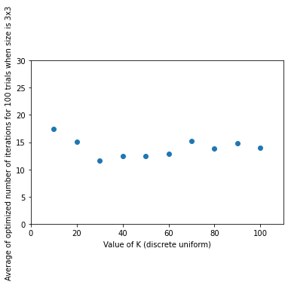
Figure 1: Scatter plot of Mean iterations for 100 trials versus k when matrix size is 3x3

Table 2: Data for number of iteration from k=10 to k=100 when size of matrix is 4x4
Serial number | Value of k | Mean iteration till convergence for 100 trials | Standard deviation till convergence for 100 trials
1 | 10 | 31.67 | 48.817
2 | 20 | 29.68 | 32.971
3 | 30 | 21.53 | 19.746
4 | 40 | 33.06 | 90.054
5 | 50 | 27.86 | 54.666
6 | 60 | 28.20 | 44.548
7 | 70 | 25.69 | 30.138
8 | 80 | 27.47 | 40.205
9 | 90 | 24.71 | 27.811
10 | 100 | 21.78 | 15.037

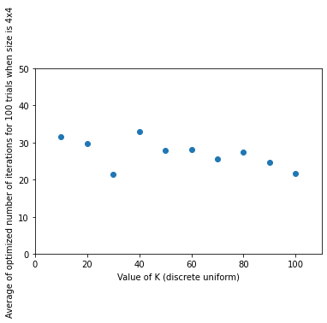
Figure 2: Scatter plot of Mean iterations for 100 trials versus k when matrix size is 4x4

Table 3: Data for number of iteration from k=10 to k=100 when size of matrix is 5x5
Serial number | Value of k | Mean iteration till convergence for 100 trials | Standard deviation till convergence for 100 trials
1 | 10 | 46.34 | 61.630
2 | 20 | 39.28 | 37.340
3 | 30 | 37.96 | 43.525
4 | 40 | 40.62 | 31.736
5 | 50 | 50.81 | 89.719
6 | 60 | 51.83 | 95.011
7 | 70 | 59.41 | 101.602
8 | 80 | 37.84 | 40.520
9 | 90 | 39.87 | 42.855
10 | 100 | 50.30 | 83.655

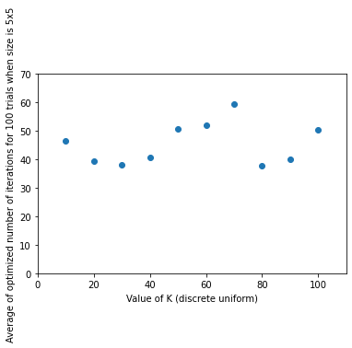

Figure 3: Scatter plot of Mean iterations for 100 trials versus k when matrix size is 5x5

Tables 1, 2 and 3 display the mean iterations and the standard deviation obtained for different values of the parameter ok of discrete uniform distribution for 100 trials. Figures 1, 2 and 3 depict the mean number of iterations plotted against the varying values of parameter k. We cannot infer any discernable pattern from the plots. The number of iterations does not seem to depend on the parameter k.

Table 4: The mean and standard deviation of the number of iterations needed for solving the system of equations Ax=b by Successive Over-relaxation method for a matrix of size 3x3 and the matrix is filled randomly from a Continuous uniform distribution [0,….,θ] for different values of θ from θ=10 to θ=100:
Serial number | Value of θ | Mean iteration till convergence for 100 trials | Standard deviation till convergence for 100 trials
1 | 10 | 19.40 | 68.762
2 | 20 | 17.12 | 24.631
3 | 30 | 14.85 | 20.489
4 | 40 | 12.00 | 8.505
5 | 50 | 13.66 | 9.441
6 | 60 | 11.82 | 7.480
7 | 70 | 12.65 | 10.733
8 | 80 | 13.50 | 10.571
9 | 90 | 12.92 | 8.154
10 | 100 | 14.20 | 13.745

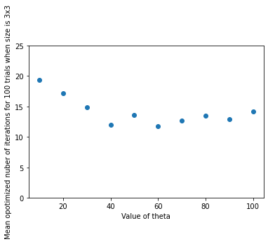
Figure 4: Scatter plot of Mean iteration for 100 trials versus θ when matrix size is 3x3

Table 5: The mean and standard deviation of the number of iterations needed for solving the system of equations Ax=b by Successive Over-relaxation method for a matrix of size 4x4 and the matrix is filled randomly from a Continuous uniform distribution [0,….,θ] for different values of θ from θ=10 to θ=100:
Serial number | Value of θ | Mean iteration till convergence for 100 trials | Standard deviation till convergence for 100 trials
1 | 10 | 27.38 | 41.448
2 | 20 | 26.76 | 26.952
3 | 30 | 29.23 | 63.179
4 | 40 | 23.62 | 30.633
5 | 50 | 23.25 | 21.474
6 | 60 | 23.61 | 28.752
7 | 70 | 32.64 | 51.907
8 | 80 | 26.58 | 28.517
9 | 90 | 22.17 | 25.685
10 | 100 | 24.48 | 29.489

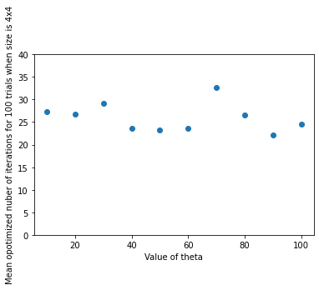
Figure 5: Scatter plot of Mean iteration for 100 trials versus θ when matrix size is 4x4

Table 6: The mean and standard deviation of the number of iterations needed for solving the system of equations Ax=b by Successive Over-relaxation method for a matrix of size 3x3 and the matrix is filled randomly from a Continuous uniform distribution [0,….,θ] for different values of θ from θ=10 to θ=100:
Serial number | Value of θ | Mean iteration till convergence for 100 trials | Standard deviation till convergence for 100 trials
1 | 10 | 45.46 | 56.781
2 | 20 | 37.84 | 34.683
3 | 30 | 44.81 | 51.431
4 | 40 | 54.45 | 88.445
5 | 50 | 56.87 | 108.748
6 | 60 | 40.19 | 45.067
7 | 70 | 54.14 | 85.613
8 | 80 | 44.57 | 50.935
9 | 90 | 43.15 | 56.137
10 | 100 | 50.02 | 73.432

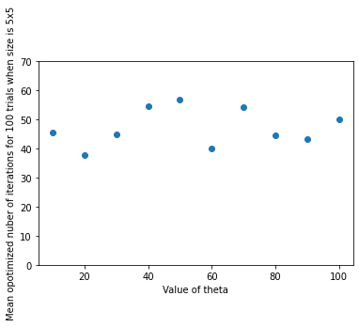
Figure 6: Scatter plot of Mean iteration for 100 trials versus θ when matrix size is 5x5

Tables 4, 5 and 6 display the mean iteration and standard deviation till convergence for values of the shape parameter of the continuous uniform distribution θ. Figures 4 ,5 and 6 show the mean number of iterations plotted against the parameter θ. Similar to the discrete uniform case, we do not observe any pattern. The number of iterations seems not to depend on θ.

Table 7: The mean and standard deviation of the number of iterations needed for solving the system of equations Ax=b by Successive Over-relaxation method for a matrix of size 3x3 and the matrix is filled randomly from a Binomial distribution when n=10 and p is varied from p=0.2 to p=0.8:
Serial number | Value of p | Mean iteration till convergence for 50 trials | Standard deviation till convergence for 50 trials
1 | 0.2 | 11.76 | 6.045
2 | 0.3 | 15.88 | 8.303
3 | 0.4 | 21.60 | 23.119
4 | 0.5 | 21.72 | 14.552
5 | 0.6 | 25.74 | 16.531
6 | 0.7 | 35.14 | 27.489
7 | 0.8 | 41.78 | 36.114

Table 8: The mean and standard deviation of the number of iterations needed for solving the system of equations Ax=b by Successive Over-relaxation method for a matrix of size 3x3 and the matrix is filled randomly from a Binomial distribution when n=100 and p is varied from p=0.2 to p=0.8:
Serial number | Value of p | Mean iteration till convergence for 50 trials | Standard deviation till convergence for 50 trials
1 | 0.2 | 45.34 | 54.363
2 | 0.3 | 43.68 | 33.519
3 | 0.4 | 71.94 | 165.963
4 | 0.5 | 62.94 | 60.358
5 | 0.6 | 63.60 | 26.342
6 | 0.7 | 85.06 | 45.655
7 | 0.8 | 118.34 | 90.685

Table 9: The mean and standard deviation of the number of iterations needed for solving the system of equations Ax=b by Successive Over-relaxation method for a matrix of size 3x3 and the matrix is filled randomly from a Binomial distribution when p=0.2 and n is varied from n=10 to n=100:
Serial number | Value of n | Mean iteration till convergence for 50 trials | Standard deviation till convergence for 50 trials
1 | 10 | 11.76 | 6.045
2 | 20 | 18.20 | 15.086
3 | 30 | 21.82 | 27.577
4 | 40 | 28.22 | 60.251
5 | 50 | 22.58 | 12.195
6 | 60 | 29.28 | 29.579
7 | 70 | 23.98 | 15.630
8 | 80 | 31.98 | 22.154
9 | 90 | 36.94 | 26.737
10 | 100 | 45.34 | 54.363

Table 10: The mean and standard deviation of the number of iterations needed for solving the system of equations Ax=b by Successive Over-relaxation method for a matrix of size 3x3 and the matrix is filled randomly from a Binomial distribution when p=0.4 and n is varied from n=10 to n=100:
Serial number | Value of n | Mean iteration till convergence for 50 trials | Standard deviation till convergence for 50 trials
1 | 10 | 21.60 | 23.119
2 | 20 | 23.00 | 21.993
3 | 30 | 35.58 | 32.684
4 | 40 | 35.62 | 23.781
5 | 50 | 46.46 | 44.584
6 | 60 | 44.38 | 50.767
7 | 70 | 47.94 | 70.810
8 | 80 | 51.80 | 55.367
9 | 90 | 49.40 | 41.195
10 | 100 | 71.94 | 165.963

TABLE 11: The mean and standard deviation of the number of iterations needed for solving the system of equations Ax=b by Successive Over-relaxation method for a matrix of size 3x3 and the matrix is filled randomly from a Binomial distribution when p=0.6 and n is varied from n=10 to n=100:
Serial number | Value of n | Mean iteration till convergence for 50 trials | Standard deviation till convergence for 50 trials
1 | 10 | 25.74 | 16.531
2 | 20 | 38.84 | 31.583
3 | 30 | 45.18 | 74.911
4 | 40 | 47.96 | 40.641
5 | 50 | 63.90 | 56.252
6 | 60 | 55.22 | 36.210
7 | 70 | 50.98 | 24.921
8 | 80 | 61.64 | 39.958
9 | 90 | 64.94 | 35.400
10 | 100 | 63.60 | 26.342

TABLE 12: The mean and standard deviation of the number of iterations needed for solving the system of equations Ax=b by Successive Over-relaxation method for a matrix of size 3x3 and the matrix is filled randomly from a Binomial distribution when p=0.8 and n is varied from n=10 to n=100:
Serial number | Value of n | Mean iteration till convergence for 50 trials | Standard deviation till convergence for 50 trials
1 | 10 | 41.78 | 36.114
2 | 20 | 54.62 | 34.399
3 | 30 | 65.04 | 31.127
4 | 40 | 72.14 | 41.002
5 | 50 | 78.06 | 42.379
6 | 60 | 91.04 | 71.896
7 | 70 | 97.28 | 75.174
8 | 80 | 98.62 | 67.782
9 | 90 | 115.48 | 84.295
10 | 100 | 118.34 | 90.685

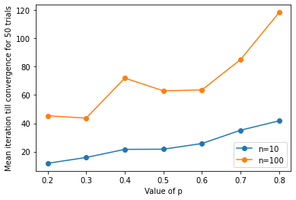
Figure 7 : Comparison between mean iterations (for 50 trials) for n=10 and n=100

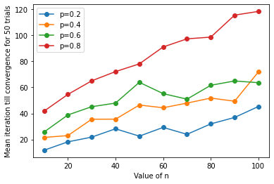
Figure 8: Comparison between mean iterations (for 50 trials) for p=0.2, p=0.4, p=0.6 and p=0.8

Tables 7 to 9 provide information about the mean number of iterations till convergence as well as the standard deviation when the value of parameter n is fixed and parameter p is varied , while tables 10 to 12 offer information when parameter p is fixed and n is varied. In both instances, the experiment was conducted for 50 trials. Figure 7 shows the values of mean iterations plotted against different values of p in such a manner that the value of parameter n was kept constant at n=10 and n=100, while that of parameter p was gradually increased. The plots indicate the emergence of a pattern prompting further investigation to make any claims regarding how the number of iterations depend upon the parameter p when n is fixed. Using Microsoft Excel, regression analysis is conducted by fitting a polynomial of degree 3, 4 and 5 as shown by Figures 9, 10 and 11 respectively. Since the increase in the value of R² is very small, a third degree polynomial is the simplest model that is adequate enough to prove our point without involving higher degree polynomials, keeping in mind the fact that fitting higher degree polynomials carries the risk of encountering the problem of ill conditioning.
In case of Figure 8, the value of p was kept constant and that of parameter n was varied gradually. This was done for p=0.2, p=0.4, p=0.6 and p=0.8. After observing a trend in the plots, Microsoft Excel is again used to fit polynomials of degree 3, 4 and 5 as shown by Figures 12,13 and 14. A third degree polynomial proved to be sufficient to demonstrate that the number of iterations can be predicted by it because the loss of predictive power is acceptable (increase in the value of R² in going from lower to higher degree polynomial is negligible).

Figure 9: Polynomial of degree 3 fitted to mean iteration vs value of n parameter when the value of p if fixed and n is changed

Figure 10: Polynomial of degree 4 fitted to mean iteration vs value of n parameter when the value of p if fixed and n is changed

Figure 11: Polynomial of degree 5 fitted to mean iteration vs value of n parameter when the value of p if fixed and n is changed

Figure 12: Polynomial of degree 3 fitted to mean iteration vs value of p parameter when the value of n if fixed and p is changed

Figure 13: Polynomial of degree 4 fitted to mean iteration vs value of p parameter when the value of n if fixed and p is changed

Figure 14: Polynomial of degree 5 fitted to mean iteration vs value of p parameter when the value of n if fixed and p is changed

Ethical Declaration
The authors hereby declare that this research did not receive any funding. They further declare that they do not have any conflict of interest.
5. Conclusion
We can conclude that for uniform inputs, both discrete and continuous, there is no confirmation that the number of iterations depend upon the parameter value k in case of discrete uniform, and the same goes for parameter θ in case of continuous uniform distribution. On the other hand, the binomial distribution inputs provide an interesting result. For fixed value of p and varying values of n, the number of iterations can be estimated by a third degree polynomial in n. Similarly for fixed n and varying values of p, another third degree polynomial in p is sufficient to estimate the number of iterations.

References

[1] A. Hadjidimos, . Accelerated Overrelaxation Method. Mathematics of Computation, vol. 32, no. 141, 1978, 149–157
[2] https://en.wikipedia.org/wiki/Successive_over-relaxation, Accessed on May 5,2022

[3] T. Mayooran, and Elliott Light, Applying the Successive Over-relaxation Method to a Real World Problems. American Journal of Applied Mathematics and Statistics , vol. 4, no. 4, 2016, 113-117
[4] I.K. Youssef, On the Successive Overrelaxation Method. Journal of Mathematics and Statistics, vol. 8, no. 2, 2012, 176-184

[5] R.L. Burden and J.D. Faires, Numerical Analysis 9th edition, Brooks/Cole CENGAGE
Learning, 2010
[6] R.S. Varga, Matrix Iterative Analysis, prentice-Hall, Englewood cliffs, N. J., 1962.
[7] David M. Young, Jr., Iterative Methods for Solving Partial Difference Equations of Elliptic
Type. Ph.D. thesis, Harvard University, Mathematics Department, Cambridge, MA, USA,
May 1950.
[8] D. N. Modi and S. Chakraborty, A Statistical Analysis of Gauss-Seidel Algorithm, Annals Computer Science Series, Vol. VIII, Fasc. 2, 2010, 169-181
[9] S.C. Gupta and V.K. Kapoor, Fundamentals of Mathematical Statistics, Sultan Chand & Sons, 2014.

