Pearl Millet
Introduction
As we know, grains are important, just like millet and sorghum. Pearl millet (Pennisetum glaucum is the crop developed in the world. In Gujarat, the western state of India, known locally as Bajra, the total production area of ​​Gujarat Pearl Millet is 7033 hectares. Gujarat, has large production is recorded in the northern Banaskantha plain. product 26According to the Gujarati government's 2007-2008 Seasonal Harvest Report, pearl millet accounts for 61%, followed by wheat (11.7%).
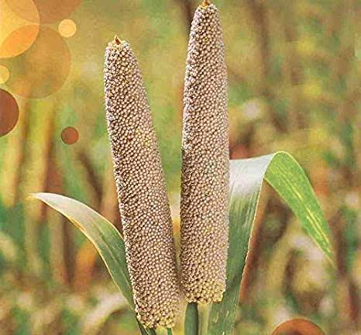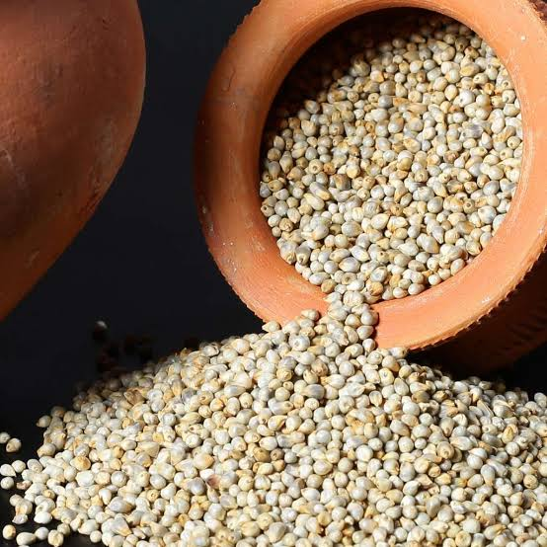

Climate change Improved heat tolerance

The reference genome and analysis of 1,000 lines of the pearl millet genome have provided clues as to crop live temperatures in excess of 42 °C. Nutrients quality of pearl millet may and their productivity be affected at higher as higher worldwide temperatures, it is time to develop crops that are resistant to the adverse issue for change in climate.The clarification of the pearl millet grain by a team of 60 technologist from 32 researcher institutes showed its adaptability and expanding drought tolerance.

This will help increase farmer productivity as pearl millet is the livelihood. Specialist suppose, there will be increased drought and high temperatures on both continents at next few years according to change in climate. Bajra is currently grown on about 27 million hectares globally. It is also an principal food origin for millions of families. However, crop yields have been low for six decades in because crops are grown on poor soil.

Varieties of pearl millet
The Pearl millet flour hybrids and varities.latest is in below table.
Region/ State |  | Recommended Hybrid | Recommended Variety
Rajasthan | Kharif | KBH 108, GHB 905, 86M89, MPMH 17, Kaveri Super Boss. | MBC 2, PC 443, JBV 3, PC 383, ICMV 221, Raj 171
 | Summer | Nandi 70, Nandi 72, 86M64
 | Kharif – arid parts | HHB 234, Bio 70, HHB-226, RHB-177 | CZP 9802
Gujarat | Kharif | KBH 108, GHB 905, 86M89, MPMH 17, Kaveri Super Boss. | MBC 2, PC 443, JBV 3, PC 383, ICMV 221, Raj 171
 | Summer | Nandi 70, Nandi 72, 86M64
 | Kharif – arid parts | HHB 234, Bio 70, HHB-226, RHB-177 | CZP 9802
Haryana | Kharif | KBH 108, GHB 905, 86M89, MPMH 17, Kaveri Super Boss, | MBC 2, PC 443, HC 20, JBV 3, PC 383, HC 10, ICMV 221, Raj 171
 | Kharif – arid parts | HHB 234, Bio 70, HHB-226, RHB-177 | CZP 9802
Punjab | Kharif | KBH 108, GHB 905, 86M89, MPMH 17 | PCB 164, ICMV 221, Raj 171
Delhi | Kharif | KBH 108, GHB 905, 86M89, MPMH 17, Kaveri Super Boss. | JBV 3, PC 383, ICMV 221, Raj 171
Uttar Pradesh | Kharif | KBH 108, GHB 905, 86M89, MPMH 17, Kaveri Super Boss, Bio 448. | JBV 3, PC 383, ICMV 221, Raj 171
Madhya Pradesh | Kharif | KBH 108, GHB 905, 86M89, MPMH 17, | JBV 4, JBV 3, PC 383, ICMV 221, Raj 171
Maharashtra | Kharif | Kaveri Super Boss, Pratap, PKV Raj, Shine, MP 7792, 86M86 | ABPC-4-3, PC 612, Parbhani Sampada, Samrudhi, ICMV 221, Raj 171, ICMV 155
 | Summer | Nandi 70, Nandi 72, 86M64
Tamil nadu | Kharif | Kaveri Super Boss, Pratap, Co 9, Shine, MP 7792, 86M86 | PC 612, CoCu 9, Samrudhi, ICMV 221, Raj 171, ICMV 155
 | Summer | Nandi 70, Nandi 72, 86M64
Andhra Pradesh | Kharif | Kaveri Super Boss, Pratap, Shine, MP 7792, 86M86, PAC 909 | PC 612, Samrudhi, ICMV 221, Raj 171, ICMV 155, Ananta
Karnataka | Kharif | Kaveri Super Boss, Pratap, Shine, MP 7792, 86M86, PAC 909, 86M64, 86M53 | PC 612, Samrudhi, ICMV 221, Raj 171, ICMV 155

Production and cultivation of pearl millet/Bajra
Development of Bajra in India remained nearly steadily raised with the introduction of high-amount of varieties in the year 2000 production of Bajra increased , but per capta intake in the country down by 50-75%. 10.28 million tons of Bajra grains were produced on almost 8.8 million hectares in Rajasthan, UP, Haryana, Maharashtra, Gujarat, Madhya Pradesh and Karnataka. The higher intake of Bajra in these states are more.
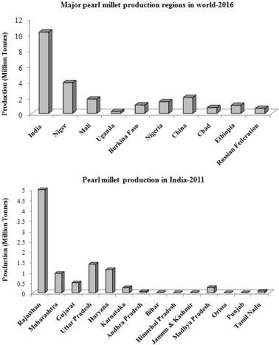
Major production of Bajra in world and india
Nutrients in pearl millet
As compared to other crops Pearl millet (Pennisetum glaucum) is a rich source of nutrients. However, the main factors that limit its use are the presence of anti-nutritional factors (phytates, tannins and polyphenols) that reduce the availability of minerals and average keeping quality due to increased lipase activity.
Nutrient composition of pearl millet
Pearl millet's nutritional value surpasses other grains in terms of protein value, and an magnificent stabilize the amino acids and relatively excessive amount of vitamin A. It is also examined a "more energy" grain. The nutritional content of pearl millet is shown in the table below. The protein value of Bajra is between 9 and 11.8%. 32% of total nitrogen. Pearl millet also has a higher fat content (4g/100g) than rice, corn, wheat and sorghum. Approximately 70% of dry grains are mainly carbohydrates, contain of 56-65% starch, of which 20-22% is amylase.
Nutrients | Per 100 g
Protein (g) | 11.8
Carbohydrate (g) | 67.0
Fat (g) | 4.8
Minerals (g) | 2.3
Fibre (g) | 3.3
Calcium (mg) | 42
Phosphorous (mg) | 238
Iron (mg) | 8
Energy (kcal) | 36.5
Thiamine (mg) | 0.37
Niacin (mg) | 2.5
Source: NIN, hyderabad (2021)
Health benefits of pearl millet
1.Benefit for Diabetic Diet - Millet contains carbohydrates that are absorb slowly and keep glucose levels fixed over a long duration and for diabetics it is nutritious option.
2. Heart Health Benefits –Pearl millet is High in fiber and lower the cholesterol level and pearl millet is also beneficial for heart diseases.
3. Ideal for celiac disease and gluten intolerance – Gluten intolerance can opt a miilet as in the diet as it is gluten free and can tolerate by anyone. It is good for Patients with celiac disease.
4. Heals for Suffering From Frequent Acidity And Ulcers in stomach - Pearl Millet is that food which reduces acidity, and the discomfort caused by frequent hyperacidity.
5. Prevents Constipation – Pearl millet benefits include promoting good gut health.Simply put, consuming pearl millet prevents constipation.
6. Provides Protein for Vegetarians – Meat and fish product is good source of protein Vegetarians cannot get as they need. This is where pearl millet comes into play. Pearl millet health benefits also include its ability to provide vegetarians with the protein they need.
7. Lowers Blood Pressure – Bajra is known to be rich in potassium, which people with high blood pressure need. Eating more potassium-rich foods helps remove sodium from your body, which lowers your blood pressure.
8. Strengthens Bones – Alcohol's high phosphorus content helps strengthen bones.
9. Helps Relieve Constipation – The high fiber content helps build mass and relieves constipation.
10. Lowers Cholesterol – Millet contains the right amount of good fats, which is a desirable dietary quality for sufferers of high cholesterol.
11.Nutrient-Rich Baby Food - Millet is easily digested and well tolerated by babies, making it an indispensable part of baby meals during and after weaning.
12. Rich in Antioxidants - Reduces free radical damage in the body and prevents premature aging, Alzheimer's disease, Parkinson's disease and cardiovascular disease and supports wound healing.
13. Ideal for weight control and obesity.
14. Reduces the risk of colon cancer – It makes the pH of the stomach alkaline, thus reducing the risk of colon cancer.
Pearl Millet or Bajra comes in several forms for regular consumption. You can use it as a flour dosas, as a granola for oatmeal, as a processed grain like poha or upma for breakfast, and as a RTE snack like millet or multigrain biscuit. The great health benefits of pearl millet make it an ideal nutrient rich food that is optimal for regular eaten by everyone. You can pair your favorite millet food with high-protein recepies like lentils, soybean chunks, fresh fruit and a veggie smoothie or salsa to create the perfect recommended meal for a balanced diet. .
Advantages and disadvantages of pearl millet
Whole grains are increasingly recognized as great holistic food . Bajra is in high demand for its many health benefits.
1. Pearl millet supports digestion
2. Pearl millet helps in losing weight
3.Pearl millet may improve diabetes control
4. Pearl millet improves muscle mass
Pearl millet, like all millet groats, is high in fiber. Dietary fiber is one of the most valuable nutrients for gut health, as it helps maintain the balance of the various intestinal flora, protects the gastric and intestinal mucosa, and also improves intestinal function.
Pearl millet helps to lose weight
One of the main reasons for the popularity of pearl millet is that it can promote weight loss, especially as a substitute for unhealthy carbohydrates in weight loss diets. Pearl millet is low in calories but high in fiber. The fiber in the bagel can also aid in digestion and speed up your metabolism.
Pearl millet may improve diabetes control
Pearl millet has a low glycemic index of 54 and a glycemic load of 6.06. Both numbers suggest that Pearl millet is unlikely to cause a postprandial spike in blood sugar. This in turn indicates that pearl millet is safe to consume by people with diabetes and pre-diabetes.
Pearl millet improves muscle mass
The protein in the bagel is a high quality plant protein rich in nearly all essential amino acids and for maintaining muscles mass. Bajra is important by regular intake, especially if you are an athlete. It can also benefits for who of suffering from malnutrition, deficiency of protein.
Disadvantages
Pearl millet is a healthy and nutritious food that is safe for most people to consume. Although, sometimes, excessive utilization of bajra can also lead to side effects. Below are all the health disease that can be aggravated by the intake of bajra.
1. Pearl millet can cause malabsorption syndrome
2. Pearl millet can cause kidney stones
3. Pearl millet can increase indigestion
4. Pearl millet may aggravate thyroid dysfunction
5. Pearl millet can cause malabsorption syndrome
Pearl millet can cause malabsorption syndrome
Pearl millet carry numerous nutrients and the specific class of phytochemicals in this grain are also called as antinutrients. Antinutrients like phytic acid are plant compounds that interfere with the body's ability to occupy important nutrients and are generally not a problem in a balanced diet free of antinutrients - heavy grains and legumes.
Pearl millet can cause kidney stones
Bajra contains large amounts of calcium and oxalates. Both compounds tend to build up muscles and form kidney stones in the long run, especially if the bajra is not washed and cooked properly.
Pearl millet can increase indigestion
Pearl millet is high in fiber, which is great for most people but a nightmare if you already have digestive issues.
Pearl millet may aggravate thyroid dysfunction
Millet, like pearl millet, can contain high levels of goiter-forming compounds such as glucosylvitexin, glycosylvitexin, and vitexin.eating excessive quantity of Bajra can harm impair thyroid function, and also weaken iodine absorption. Eating large amount of pearl millet can cause hypothyroidism,deficiency of iodine, and even goiter.
References
- https://vikaspedia.in/agriculture/crop-production/package-of-practices/cereals-and-millets/bajra-1
- FAO (2016). http://www.fao.org/faostat/en/#data/QC. Accessed 18 Dec 2017

- Savita Rani, Rakhi Singh, Rachna Sehrawat, Barjinder Pal Kaur, Ashutosh Upadhyay.(2018).Nutrition & Food Science.ISSN: 0034-6659 Pearl millet processing: a review
- Ref. FAO (2016). http://www.fao.org/faostat/en/#data/QC. Accessed 18 Dec 2017
- Ref. https://pharmeasy.in/blog/12-nutritional-benefits-of-bajra-pearl-millets/
- Nutritive value of Indian foods, national institute of nutrition, hydrabad (2021)
- www.downtoearth.org.climate change of pearl millet.

