A brief review on biosynthesis, extraction and purification of Microbial melanin and its industrial applications

Priya Sundararajan¹
Research Scholar, Department of Microbiology
PSG College of Arts & Science
Coimbatore, Tamil Nadu, India
priyasundararajan2509@gmail.com

Shanmuga Priya Ramasamy²*
Associate professor, Department of Microbiology
PSG College of Arts & Science
Coimbatore, Tamil Nadu, India
priyajasper@gmail.com

*Corresponding author

ABSTRACT
Melanin is an ideal class of biological pigment having huge industrial significance. Owing to its intrinsic properties, it could act as a photo-protector, antioxidant, biosorbent and colourants. In addition, it exhibits various therapeutic properties like antimicrobial, anticancer, hepatoprotective and hypolipidemic effects. Hence, it is widely used in various industries, including dyeing, food, medical and cosmetic industries. Melanin could be obtained by means of both synthetic and natural means. Because of the toxic issues in using chemical-based melanins, they have been restricted for commercial use. Thus, industrialists seek an effective alternative to replace synthetic melanins. In this regard, using microorganisms would be a promising source for melanin production due to its cost-effectiveness and eco-friendliness. Thus, this review is focused on the usage of melanogenic microbes for the extraction of microbial melanins and its usage in various industries.

Keywords— Microbial pigment, Melanins, Food, Cosmetics, Pharmaceuticals

INTRODUCTION

Pigments are the coloured substances, produced by most living organisms through refraction or absorption of certain wavelength of light. There are many kinds of biological pigments ranging from monomeric to polymeric forms which includes carotenoids, flavonoids, melanins, tannins and humic substances [1]. Among various biological pigments, melanin seeks huge attention from researchers and industrialists owing to its vast applicability, physical, chemical, and biological properties. Melanin is a unique, mystifying pigment that is amorphous, hydrophobic, high molecular weight and is negatively charged pigments. They are dark-coloured biological macromolecules which can be solubilized in alkali and phenols, insoluble in most solvents, and bleached through oxidizing agents. Melanins are synthesized by the oxidative polymerization and hydroxylation of indolic or phenolic compounds [2, 3]. Melanin could be extracted from plants and animal tissues or synthesized by chemical process. However, melanin extraction through a chemical process is expensive, not efficient, and not an eco-friendly process due to its toxic nature. Hence, the production of melanins using microorganisms, including bacteria, fungi and actinomycetes would be a suitable alternative to synthetic melanins [4, 5]. Melanin exhibits various biological properties, which include antimicrobial activity, photoprotective activity, antioxidant activity and further acts as a thermoregulator. Thus, melanin has varied applications in the pharmaceutical, agricultural, and cosmetic industry [6]. Thus, this review significantly highlights the sources, production, and extraction strategies of microbial melanins. Further, various applications of microbial melanins that are used in diverse industries were also discussed.

II. CLASSIFICATION OF MELANINS

Melanins are the heterogenous polymers of phenolic or indole compounds. Melanins are mainly classified into three categories as eumelanin, pheomelanin and allomelanin based on their source. Eumelanin and pheomelanin are obtained from animals, whereas allomelanin is obtained from plants and microorganisms. Eumelanin is black to brown water-insoluble pigments composed of 5, 6-dihyoxyindole (DHI) and 5, 6-dihydrocyindole-2-carboxylic acid (DHICA) polymers. They are predominantly present in the hair and skin of humans and produced by some bacteria, fungi, and myxomycetes [7, 8]. Pheomelanin are yellow to reddish-brown pigments, soluble in alkaline solutions and are composed of benzothiazine polymers. They are predominantly present in the skin and hair of humans and in the feathers of hens [9, 10]. Allomelanin is a brown, black coloured pigment which is further categorized as 1,8-dihyoxynaphthalene (DHN)-melanin, catechol-melanin and 3,4-dihydroxyphenylacetate (HPQ)-melanin. All these are formed due to the oxidation or polymerization of 1,8-dihyoxynaphthalene or 1,3,6,8-tetrahydroxynaphthalene (THN) or catechol, respectively. Allomelanin is synthesized mainly by bacteria and the ascomycetes group of fungi [11, 12]. In addition, pyomelanin is a brown to black coloured pigment that belongs to the group of allomelanin. It is said to be the natural polymer of homogentisic acid (HGA, 2,5-dihydroxyphenylacetic acid), which is obtained from bacteria, fungi, mammals, and plants [13].

III. SOURCES OF MELANINS

Melanins could be obtained either through synthetic or biological processes. However, the commercially available melanins are predominantly produced by means of chemical processes, where they are produced through the oxidation or polymerization of phenolic or indole compounds. Still, natural melanins are obtained from plants, animals, or microorganisms. Among these, marine cephalopods (animal) are the best studied as melanin producer, where it produces melanin by sepia as a defensive strategy against their predators. Melanins can also be produced by plants but are often obtained only through the chemical conversion of flavonoids. All these synthetic, plant and animal sources of melanins are found to be highly expensive, time-consuming, and not efficient for production at a larger scale. In addition, they are detrimental to the environment and human health. Therefore, microorganisms are considered a vital source for melanin production with huge advantages such as seasonal stability, shorter growth, and production time, and able to grow even on low-cost substrates like agro-industrial wastes [14]. Various groups of microorganisms produce melanins, which include bacteria, fungi and actinomycetes. The bacterial genera that biosynthesize melanins include Vibrio sp., Pseudomonas stutzeri, Providencia sp., Bacillus sp., Shewenella algae, Staphylococcus sciuri, Petrobius maritimus, Glutamicibacter creatinolyticus. In addition, several fungi were reported to produce melanin includes, Aspergillus niger,
Aspergillus nidulans, Alternaria alternata, Cladasporium carionii, Fonsecaea compacta, Exophiala jeanselmei,
Hendersonula toruloidii, Phaeoannellomyces wernickii, Cryptococcus neoformans, Auricularia auricula, Gliocephalotrichum simplex and Armillaria cepistipes [15, 16]. Nevertheless, the yield of the existing microbial melanins is limited and fails to satisfy the industrial needs. Hence, researchers should focus more on isolating high-level melanin from varied microorganisms for their substantial usage in industries for commercial applications.

IV. BIOSYNTHESIS OF MICROBIAL MELANIN

A. Bacterial melanin
Bacteria synthesize melanin either through the L-3,4-dihydroxyphenylalanine (L-DOPA) pathway or the Malonyl CoA pathway. In general, bacteria synthesize melanins through the oxidation of tyrosine to dehydroxylated aromatic compounds, which are further oxidized to form dopaquinone or benzoquinone. These quinone derivatives undergo an autopolymerization process to acquire melanins (Figure 1). In addition, some bacteria could synthesize melanin through the malonyl-CoA pathway, in which sequential decarboxylative condensation of malonyl-CoA leads to the formation of 1,3,6,8-tetrahydroxynaphthalene (THN). This THN undergoes an oxidization process to form hexahydroxyperylenequinone (HPQ), which is further autopolymerized to get HPQ melanin (Figure 2) [17, 18, 19].

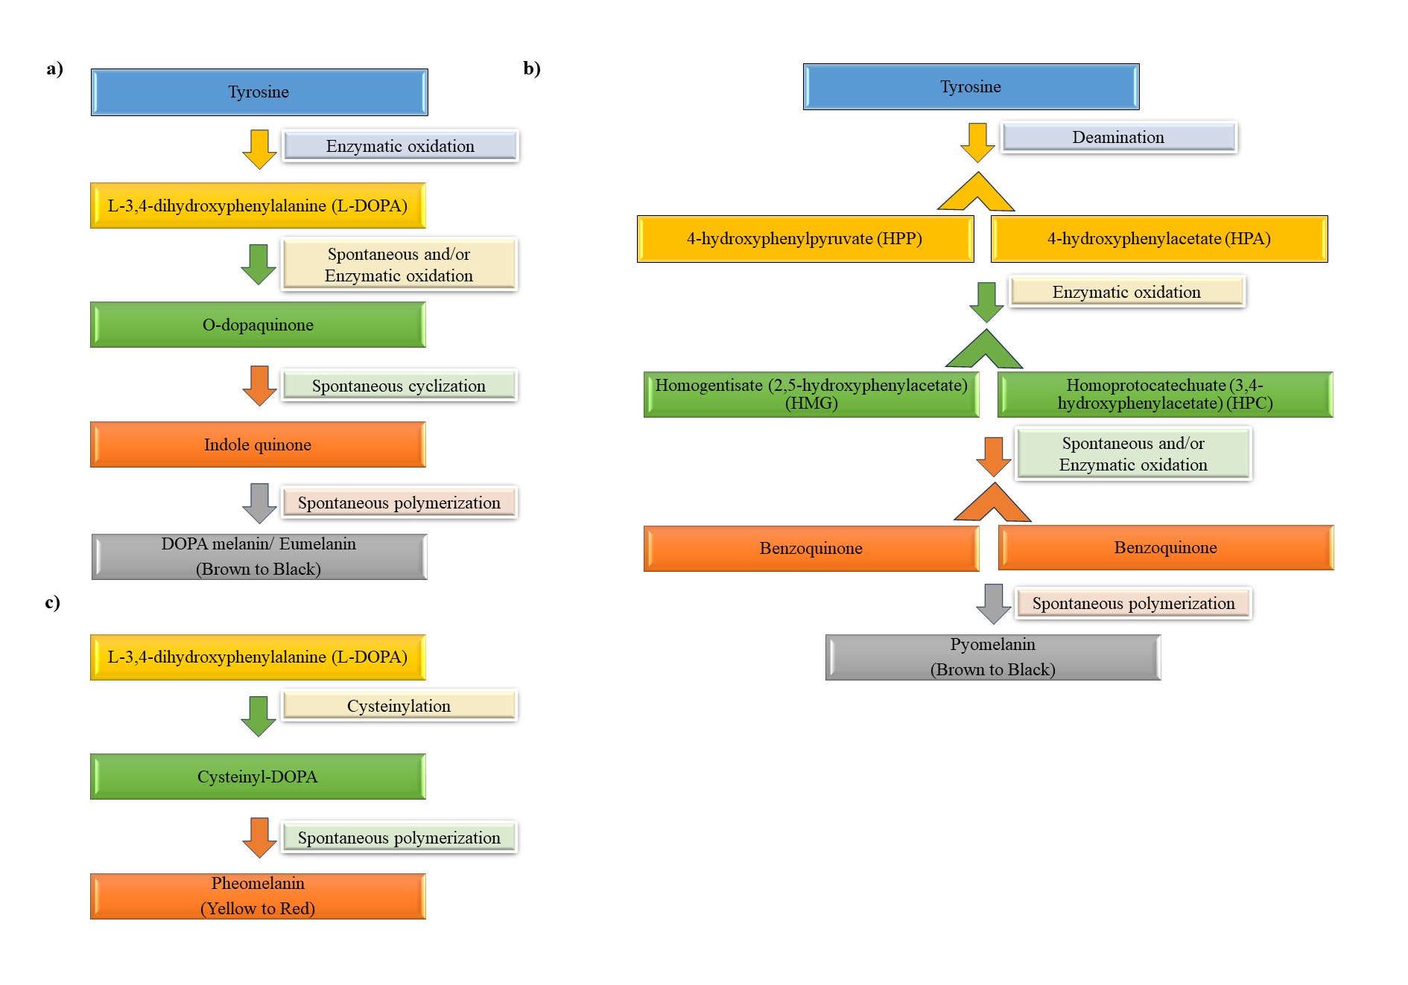
Figure 1: Schematic representation of L-DOPA (L-3,4-dihydroxyphenylalanine) pathway for synthesis of Melanin.
a) Synthesis of Eumelanin. b) Synthesis of Pyomelanin. c) Synthesis of Pheomelanin.

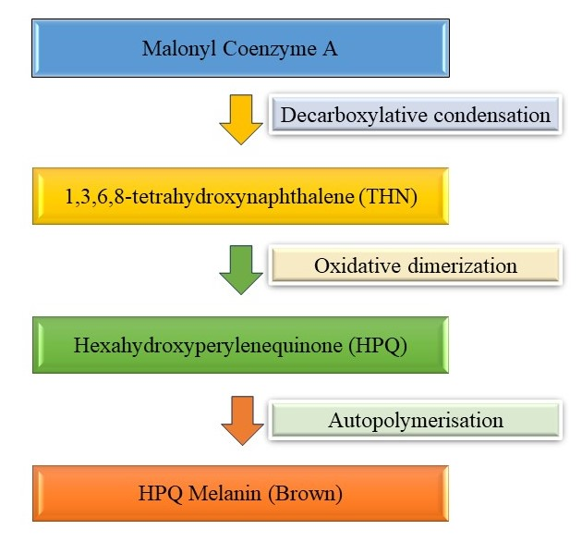
Figure 2: Schematic representation of Malonyl CoA pathway for synthesis of HPQ melanin.

B. Fungal melanin

Fungi biosynthesize melanin either through the 1,8-dihydroxynaphthalene (DHN) pathway or L-3,4-dihydroxyphenylalanine (L-DOPA) pathway. In the DHN pathway, the starting molecule, acetyl coA or malonyl coA, is converted to 1,3,6,8-tetrahydroxynaphthalene, with the help of polyketide synthase. Thereafter, a series of reduction reactions occurs to form key intermediates such as scytalone, 1,3,8-trihydroxynaphthalene, vermelone, and finally, 1,8-dihydroxynaphthalene (DHN) is formed. Further, oxidative polymerization of DHN leads to the production of 1,8-DHN melanin (Figure 3). In contrast, the synthesis of melanin through the L-DOPA pathway uses either L-DOPA or tyrosine as precursor molecules. If fungi use tyrosine as a precursor molecule, then it will be converted to dopaquinone by two-step oxidation processes, whereas L-DOPA is used as a precursor then it will be converted to dopaquinone by means of laccase enzyme. This dopaquinone is further converted to leucodopachrome and oxidized to form dopachrome. Further, through the tautomerization process, dopachrome will be transformed into dihydroxy indole derivatives and subsequently polymerized to get DOPA melanin (Figure 4) [20, 21, 22].
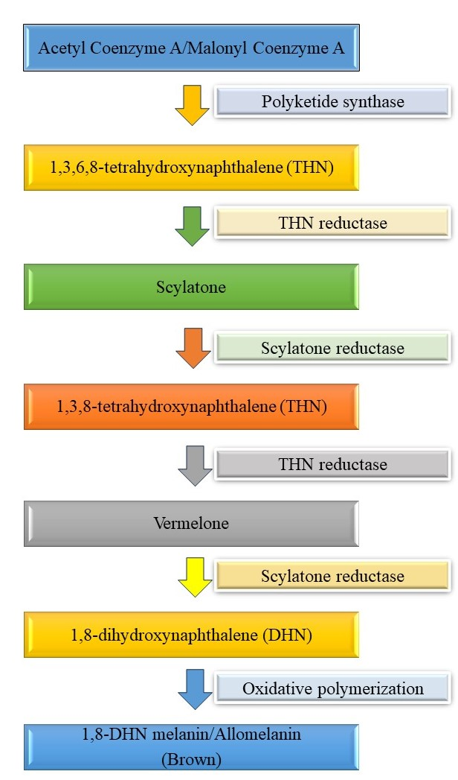
Figure 3: Schematic representation of DHN pathway for synthesis of DHN melanin/Allomelanin.

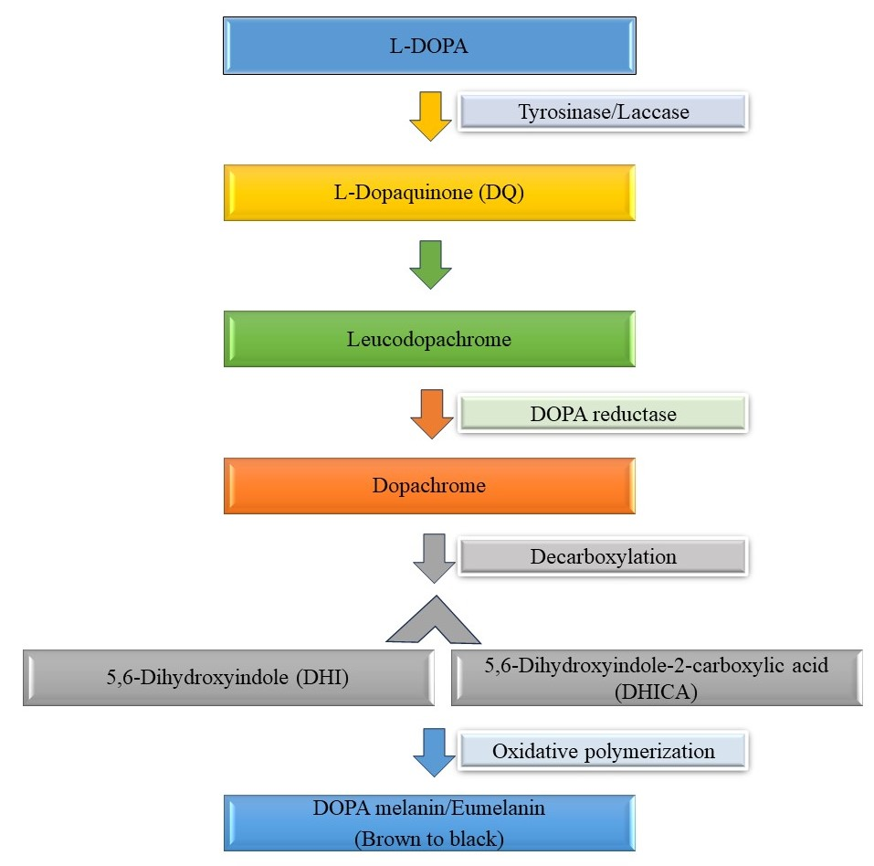
Figure 4: Schematic representation of L-DOPA pathway for synthesis of DOPA melanin/Eumelanin.

V. PRODUCTION PARAMETERS FOR MICROBIAL SYNTHESIS OF MELANIN

The production of melanin by microorganisms is dependent on melanin synthesis enzyme, which in turn influenced by various nutritional and physicochemical parameters. In this concern, peptone, yeast extract and glucose are predominantly used as nitrogen and carbon sources for melanin production. However, to reduce the production cost, agricultural residues like fruit waste extract, wheat bran extract, and corn steep liquor have been used. Moreover, copper is used as a metal cofactor, which stimulates laccase and tyrosinase enzymes that are responsible for melanin production. Besides copper, other metals like iron and nickel have also been used to induce melanin synthesis by microorganisms. Subsequently, various environmental parameters like temperature, pH, light, stress, irradiation, oxygen, and aeration are also responsible for the growth of biomass and melanin production.
The nutritional and physicochemical parameters adopted by microorganisms differ from one species to another. Owing to this, the universal nutritional or physicochemical parameter for melanin production by melanogenic microorganisms is still not explored promptly. Thus, both nutritional and physicochemical parameters for each organism should be optimized for the industrial scale-up of microbial melanin [23, 24]. Moreover, conventional optimization processes are time-consuming and tedious, which may provide inconsistent results. Thus, statistical optimization offered a better solution to overcome the limitations of conventional processes. Among various statistical tools, Plackett-Burman designs (PBDs) are frequently used to identify the important parameters within multiple parameters available for melanin production. In PDBs, the low response values are considered to be insignificant and could be excluded, whereas high response values with significant effects are considered for further optimization processes. Based on the significant values obtained from PBDs, the Response Surface Method (RSM) and the Central Composite Design (CCD) need to be obtained to assess the relationship between the responses and variables [25]. Hence, a suitable production parameter has to be derived based on the organism to optimize the production of melanin.

VI. MOLECULAR STRATEGIES FOR ENHANCED MELANIN PRODUCTION

DNA sequencing technology helps to identify biosynthetic pathways and the genes responsible for melanin production. It lays the foundation for generating recombinant strains, which can give rise to enhanced melanin production in non-melanogenic microorganisms. The genes encoding for tyrosinase (a key enzyme for melanin production) enzyme could be expressed in the non-melanogenic microorganism through recombinant technology for melanin production. In addition, heterologous expression of tyrosinase enzyme would increase melanin production, and thereby, it offers host organisms to resist harmful UV radiation. Further, transposon mutagenesis can be used to produce mutant strains that yield high melanin content [26].

VII. EXTRACTION AND PURIFICATION OF MELANIN

Melanin extraction is quite challenging as they reside within melanosomes (organelle where melanin is synthesized and stored) and are bound tightly to cellular components like proteins or minerals or attached to the inner surface of the cell wall. Thus, the choice of extraction and purification of melanins are dependent on the microbial source (bacteria/ fungi) and the existence of melanin (intracellular/ extracellular) in microbes. In general, melanin extraction can be done through alkali treatment by using either 1M NaOH or 1M KOH or 0.5M of NH₄OH to eliminate other cellular components and proteins. Followed by the purification of melanin is achieved by acid hydrolysis or by continuous washing with organic solvents like acetone, chloroform, ethanol, petroleum ether, etc. [27, 28]. However, acid hydrolytic extraction may result in the decomposition of melanins, and thus an effective extraction strategy in turn depends on the type of organism as the extraction process differs for each organism.

VIII. APPLICATIONS OF MELANIN

A. Environmental applications
The release of volatile organic compounds from industrial processes presents a major hazard to humans and the environment. As melanogenic microorganisms and melanins can tolerate acidic and dry conditions, it could be exploited in the remediation of volatile compounds from polluted environments [29]. In addition, melanogenic microorganisms coordinate with the carboxyl, amine, and hydroxyl groups of heavy metals and thus remediate the metal from polluted sites [30]. Moreover, melanin facilitates radioprotection by absorbing radiation energy or neutralizing the free radicals (ROS) [31].

B. Food applications
Because of the antimicrobial activity of melanin against various food-borne pathogens, melanin could be used as a food preservative. Melanin could also be used as a natural colourant and nutritional supplement in various food products, thus replacing the usage of synthetic colourants. Melanin also exhibits antioxidant activity, and thus, the quality of food could be enhanced through extended shelf-life, which gives a positive insight into using melanin in food packaging materials [14, 32].

C. Cosmetic applications
Melanin pigment plays a crucial role in protecting skin against carcinogenesis as it neutralizes 99% of absorbed UV light. In addition, melanin pigment finds its use in formulation of skin care products due to its antimicrobial property [33, 34]. Furthermore, formulation of skin whitening products using melanin in cosmeceutical industry reduces tanning and thus maintains the skin colour [6].

D. Pharmaceutical applications
Melanin plays a crucial role in the development of several pharmaceutical and health care products as it exhibits antioxidant, anti‐inflammatory, immunomodulatory, radioprotective, and gastrointestinal activity. As melanin exhibits antimicrobial activity, it could also be used as major ingredient in the development of antimicrobial and anticancer drugs that are used to treat breast, liver, and colon cancer. Melanin can also be used in the formulation of skin care ointments due to its potential wound healing and tissue regeneration activity [25, 35, 36].

IX. CONCLUSION

Melanin production upholds diverse applications because of its environmental sustainability, and therefore, the market demand for melanin has increased substantially in recent years. However, commercialization of melanin is still hampered due to its huge biodiversity and hurdles in obtaining melanin with high quality imbibed with desired properties. Nevertheless, identifying non-pathogenic melanogenic microorganisms is often a great challenge that should be addressed as far as final applications are concerned. The future of melanin-based products lies in the increased melanin yield at a low cost while simultaneously employing the green process of melanin synthesis. Further investigation should essentially include in providing an appropriate method for synthesis and production thereby melanin could be exploited promptly in various industrial applications like photoprotection, radioprotection, bioremediation, food preservation, cosmetics, and biomedicines.

REFERENCES

[1] R. J. B. Cordero and A. Casadevall, “Functions of fungal melanin beyond virulence,” Fungal Biology Reviews, vol. 31, no. 2, pp. 99–112, Mar. 2017, doi: 10.1016/j.fbr.2016.12.003.
[2] M. T. Shaaban, S. M. M. El-Sabbagh, and A. Alam, “Studies on an actinomycete producing a melanin pigment inhibiting aflatoxin B1 production by Aspergillus flavus”. Life Science Journal, vol. 10, no. 1, pp. 1437-1448, 2013.
[3] M. Rudrappa, S. Kumar M, R. S. Kumar, A. I. Almansour, K. Perumal, and S. Nayaka, “Bioproduction, purification and physicochemical characterization of melanin from Streptomyces sp. strain MR28,” Microbiological Research, vol. 263, pp. 127130, Oct. 2022, doi: 10.1016/j.micres.2022.127130.
[4] G. S. El-Sayyad, F. M. Mosallam, S. S. El-Sayed, and A. I. El-Batal, “Facile Biosynthesis of Tellurium Dioxide Nanoparticles by Streptomyces cyaneus Melanin Pigment and Gamma Radiation for Repressing Some Aspergillus Pathogens and Bacterial Wound Cultures,” Journal of Cluster Science, vol. 31, no. 1, pp. 147–159, Jul. 2019, doi: 10.1007/s10876-019-01629-1.
[5] Vasanthabharathi and S. Jayalakshmi, “Review on Melanin from Marine Actinomycetes,” Journal of Basic & Applied Sciences, vol. 16, pp. 39–42, Jan. 2020, doi: 10.29169/1927-5129.2020.16.05.
[6] M. J. Kiki, “Biopigments of Microbial Origin and Their Application in the Cosmetic Industry,” Cosmetics, vol. 10, no. 2, pp. 47, Mar. 2023, doi: 10.3390/cosmetics10020047.
[7] M. Al Khatib, M. Harrir, J. Costa, M. C. Baratto, I. Schiavo, L. Trabalzini, S. Pollini, G. M. Rossolini, R. Basosi and R. Pogni, “Spectroscopic Characterization of Natural Melanin from a Streptomyces cyaneofuscatus Strain and Comparison with Melanin Enzymatically Synthesized by Tyrosinase and Laccase,” Molecules, vol. 23, no. 8, pp. 1916, Aug. 2018, doi: 10.3390/molecules23081916.
[8] L. Guo, W. Li, Z. Gu, L. Wang, L. Guo, S. Ma, C. Li, J. Sun, B. Han and J. Chang, “Recent Advances and Progress on Melanin: From Source to Application,” International Journal of Molecular Sciences, vol. 24, no. 5, pp. 4360, Feb. 2023, doi: 10.3390/ijms24054360.
[9] N. N. Gessler, A. S. Egorova, and T. A. Belozerskaya, “Melanin pigments of fungi under extreme environmental conditions (Review),” Applied Biochemistry and Microbiology, vol. 50, no. 2, pp. 105–113, Mar. 2014, doi: 10.1134/s0003683814020094.
[10] S. Roy and J.-W. Rhim, “New insight into melanin for food packaging and biotechnology applications,” Critical Reviews in Food Science and Nutrition, vol. 62, no. 17, pp. 4629–4655, Feb. 2021, doi: 10.1080/10408398.2021.1878097.
[11] P. M. Plonka and M. Grabacka, “Melanin synthesis in microorganisms--biotechnological and medical aspects.,” Acta Biochimica Polonica, vol. 53, no. 3, pp. 429–443, Sep. 2006, doi: 10.18388/abp.2006_3314.
[12] E. Tsouko, E. Tolia, and D. Sarris, “Microbial Melanin: Renewable Feedstock and Emerging Applications in Food-Related Systems,” Sustainability, vol. 15, no. 9, pp. 7516, May 2023, doi: 10.3390/su15097516.
[13] F. Lorquin, F. Ziarelli, A. Amouric, C. Di Giorgio, M. Robin, P. Piccerelle and J. Lorquin, “Production and properties of non-cytotoxic pyomelanin by laccase and comparison to bacterial and synthetic pigments,” Scientific Reports, vol. 11, no. 1, Apr. 2021, doi: 10.1038/s41598-021-87328-2.
[14] N. E.-A. El-Naggar and W. I. A. Saber, “Natural Melanin: Current Trends, and Future Approaches, with Especial Reference to Microbial Source,” Polymers, vol. 14, no. 7, pp. 1339, Mar. 2022, doi: 10.3390/polym14071339.
[15] P. Velmurugan, C. K. Venil, A. Veera Ravi, and L. Dufossé, “Marine Bacteria Is the Cell Factory to Produce Bioactive Pigments: A Prospective Pigment Source in the Ocean,” Frontiers in Sustainable Food Systems, vol. 4, Nov. 2020, doi: 10.3389/fsufs.2020.589655.
[16] K. Y. Choi, “Bioprocess of Microbial Melanin Production and Isolation,” Frontiers in Bioengineering and Biotechnology, vol. 9, Nov. 2021, doi: 10.3389/fbioe.2021.765110.
[17] P. Manivasagan, J. Venkatesan, K. Senthilkumar, K. Sivakumar, and S. K. Kim, “Isolation and characterization of biologically active melanin from Actinoalloteichus sp. MA-32,” International Journal of Biological Macromolecules, vol. 58, pp. 263–274, Jul. 2013, doi: 10.1016/j.ijbiomac.2013.04.041.
[18] M. E. Pavan, N. I. López, and M. J. Pettinari, “Melanin biosynthesis in bacteria, regulation and production perspectives,” Applied Microbiology and Biotechnology, vol. 104, no. 4, pp. 1357–1370, Dec. 2019, doi: 10.1007/s00253-019-10245-y.
[19] M. Singh, G. P. Singh, and S. Tyagi, “Microbial Products,” Microbial Products Applications and Translational Trends, 1st edition, Oct. 2022, doi: 10.1201/9781003306931.
[20] H. C. Eisenman and A. Casadevall, “Synthesis and assembly of fungal melanin,” Applied Microbiology and Biotechnology, vol. 93, no. 3, pp. 931–940, Dec. 2011, doi: 10.1007/s00253-011-3777-2.
[21] S. Liu, S. Youngchim, D. Zamith-Miranda, and J. D. Nosanchuk, “Fungal Melanin and the Mammalian Immune System,” Journal of Fungi, vol. 7, no. 4, pp. 264, Mar. 2021, doi: 10.3390/jof7040264.
[22] V. Lino and P. Manini, “Dihydroxynaphthalene-Based Allomelanins: A Source of Inspiration for Innovative Technological Materials,” ACS Omega, vol. 7, no. 18, pp. 15308–15314, Apr. 2022, doi: 10.1021/acsomega.2c00641.
[23] S. R. Pombeiro-Sponchiado, G. S. Sousa, J. C. R. Andrade, H. F. Lisboa, and R. C. R. Gonçalves, “Production of Melanin Pigment by Fungi and Its Biotechnological Applications,” Melanin, Mar. 2017, doi: 10.5772/67375.
[24] A. N. Tran-Ly, C. Reyes, F. W. M. R. Schwarze, and J. Ribera, “Microbial production of melanin and its various applications,” World Journal of Microbiology and Biotechnology, vol. 36, no. 11, Oct. 2020, doi: 10.1007/s11274-020-02941-z.
[25] S. Singh, S. B. Nimse, D. E. Mathew, A. Dhimmar, H. Sahastrabudhe, A. Gajjar, V. A. Ghadge, P. Kumar, and P. B. Shinde, “Microbial melanin: Recent advances in biosynthesis, extraction, characterization, and applications,” Biotechnology Advances, vol. 53, pp. 107773, Dec. 2021, doi: 10.1016/j.biotechadv.2021.107773.
[26] L. M. Martínez, A. Martinez, and G. Gosset, “Production of Melanins With Recombinant Microorganisms,” Frontiers in Bioengineering and Biotechnology, vol. 7, Oct. 2019, doi: 10.3389/fbioe.2019.00285.
[27] I.-E. Pralea, R.-C. Moldovon, A.-L, Petrache, M. Llies, S.-C. Hegches, I. Ielciu, R. Nicoara, M. Moldovan, M. Ene, M. Radu, A. Uifalean, and C.-A. Luga, “From Extraction to Advanced Analytical Methods: The Challenges of Melanin Analysis,” International Journal of Molecular Sciences, vol. 20, no. 16, pp. 3943, Aug. 2019, doi: 10.3390/ijms20163943.
[28] S. Pandey, R. Shahwal, and A. Sur, “Melanin: progress, prospects, and challenges in synthesis and commercial applications”, International Research Journal of Engineering and Technology, vol. 10, no. 1, pp. 980-996, Jan. 2023.
[29] E. R. Mattoon, R. J. B. Cordero, and A. Casadevall, “Fungal Melanins and Applications in Healthcare, Bioremediation and Industry,” Journal of Fungi, vol. 7, no. 6, p. 488, Jun. 2021, doi: 10.3390/jof7060488.
[30] V. T. Orlandi, E. Martegani, C. Giaroni, A. Baj, and F. Bolognese, “Bacterial pigments: A colorful palette reservoir for biotechnological applications,” Biotechnology and Applied Biochemistry, vol. 69, no. 3, pp. 981–1001, May 2021, doi: 10.1002/bab.2170.
[31] R. J. B. Cordero, R. Vij, and A. Casadevall, “Microbial melanins for radioprotection and bioremediation,” Microbial Biotechnology, vol. 10, no. 5, pp. 1186–1190, Aug. 2017, doi: 10.1111/1751-7915.12807.
[32] X. Yang, C. Tang, Q. Zhao, Y. Jia, Y. Qin, and J. Zhang, “Melanin: A promising source of functional food ingredient,” Journal of Functional Foods, vol. 105, pp. 105574, Jun. 2023, doi: 10.1016/j.jff.2023.105574.
[33] A. Nawaz, R. Chaudhary, Z. Shah, L. Duffose, M. Fouillaud, H. Mukhtar, and I.U. Haq, “An Overview on Industrial and Medical Applications of Bio-Pigments Synthesized by Marine Bacteria,” Microorganisms, vol. 9, no. 1, pp. 11, Dec. 2020, doi: 10.3390/microorganisms9010011.
[34] E. Di Salvo, G. Lo Vecchio, R. De Pasquale, L. De Maria, R. Tardungo, R. Vadala, and N. Cicero, “Natural Pigments Production and Their Application in Food, Health and Other Industries,” Nutrients, vol. 15, no. 8, pp. 1923, Apr. 2023, doi: 10.3390/nu15081923.
[35] Ghattavi, A. Homaei, E. Kamrani, and S.-K. Kim, “Melanin pigment derived from marine organisms and its industrial applications,” Dyes and Pigments, vol. 201, pp. 110214, May 2022, doi: 10.1016/j.dyepig.2022.110214.
[36] M. Afroz Toma, Md. H. Rahman, Md. S. Rahman, M. Arif, K. H. M. N. H. Nazir, and L. Dufossé, “Fungal Pigments: Carotenoids, Riboflavin, and Polyketides with Diverse Applications,” Journal of Fungi, vol. 9, no. 4, pp. 454, Apr. 2023, doi: 10.3390/jof9040454.

