Soil Nutrient Manager: A Mobile App for Soil Fertility Check and Prediction of Crop Yield
Dr. Priyanka R^{1†} and Tejaswini.N^{2††},

¹ Dept. of Information Science and Engineering, Cambridge Institute of Technology Bangalore, Affiliated to VTU Belagavi (Karnataka), India ,priyanka.89.r@gmail.com.
² Assistant Professor, Dept of Computer Science and Engineering, JSS STU, Mysore, Karnataka, tejaswini.dec06@gmail.com India

Abstract - The purpose of the study is to create an application in order to establish a solution for Soil Fertility Checks and Crop Prediction Using Machine Learning. In India, traditional farming practices are used without knowledge of the soil's quality or composition. The suggested application will assist farmers and gardeners in determining the soil's fertility using only common household items and no special equipment. Using pH drops or litmus paper, we may calculate the pH value based on the colour intensity. We can then use the pH of the soil to evaluate the levels of nitrogen (N), potassium (K), and phosphorus (P) in the soil. To estimate pH value, we are utilising a classification system, a clustering method, and suitable techniques based on sustainable crops.
Keywords- pH value, classification algorithm, soil fertility and clustering algorithm.
I. INTRODUCTION
Agriculture is one of the main sources of income contribution of Indian economy. India is ranked 2nd worldwide in farm output. Due to usage of traditional forms, we still have lowest per capita productivity and farmers income. And usage of traditional forms, we still have lowest per capita productivity and farmers income. The seasonal climatic conditions are also being changed against the fundamental assets like soil, water and air which lead to insecurity of food. In a scenario, crop yield rate is falling short of meeting the demand consistently and there is a need for a smart system which can solve the problem of decreasing crop yield. For farmers, it is difficult when there is more than one crop to grow especially when the market prices are unknown to them. In such scenario we plan to use a particular plant to execute our project, that is crop yield prediction and soil analysis.
In the past, yield prediction was calculated by analysing a farmer's previous experience on a particular crop. But now, the proposed system uses machine learning to make the predictions. It plays an important role which helps farmers to decide the suitable crops for condition. Soil analysis is important methodology as it gives nutrients present in soil such as NPK values and pH values. Depending on the values we get from proposed system the suitable list of crops is predicted and procedures are depicted. In recent years, India has been shaken by economic and social forces related to higher suicide rates amongst small and marginal farmers. Our aim is to offer assistance and tools to help such farmers and communities and address these issues.
There is no existing software solution which recommends crops based on multiple factors such as type of the soil and weather components which include temperature and rainfall. And the systems that already exist are hardware based which makes them expensive and difficult to maintain. The proposed system suggests a Mobile based application, which can precisely predict the most profitable crop to the farmer by predicting the yield.
The proposed system will help the farmers to check the fertility of soil without any kit & using only household products (i.e., Vinegar & Baking soda). We can find the pH value whether it is alkaline or acidic and we use litmus paper or pH drops, based on intensity of colour we can determine the pH value & we can estimate Nitrogen(N), potassium(K) and phosphorous(P) from the pH of the soil. So, with the help of the NPK values and the pH of the soil we can predict the suitable crops for particular.
For greater agricultural yields, farmers must be knowledgeable about soil fertility. To maximise the production of a given crop and to choose the appropriate fertiliser, farmers must be aware of the macronutrients and micronutrients present in the soil. Soil testing is a crucial component of farming. Currently, it takes a few weeks for a government lab to evaluate a specific soil sample. There is a danger that farmers could receive inaccurate information and that soil samples will go missing. Therefore, we are recommending an application to automate the manual procedure of soil testing and nutrient estimation.
II. LITERATURE SURVEY
[1] Crop Yield Prediction Using Deep Reinforcement Learning Model for Sustainable Agriculture Applications.
The project will help the farmers by predicting the crops that need to be cultivated before they cultivate crops in their agriculture land. So, by this system prediction the farmer can take a proper decision where he can select a high yielding crop to be cultivated in his farm. For this prediction method Deep reinforcement learning will provide the way a by building a proper framework in order to predict the crop yield. This method will usually collect all the raw data of the soil, land, climate, humidity etc. that are needed to be mapped to give the prediction. This project constructs a Deep Recurrent Q-Network model which is an algorithm that determines the crop yield. This algorithm is stacked with a layer of Networks that have data parameters passed to constructs a crop yield prediction by taking the input parameters given by the user. A linear layer from the network algorithm will map the Recurrent Network output values to the Q-values. Finally, the algorithm provides the output values that have minimal error and have forecast accuracy.
[2] Crop Type Prediction: A Statistical and Machine Learning Approach.
This paper aims to help to predict the crop that helps the Indian agriculture sector if provided with the proper set of data on rainfall and humidity. The parameters also require the data on potassium, nitrogen, phosphorus and the pH value of the soil in-order to provide the required output [10]. This research uses different types of machine learning algorithms that will help to predict the type of crop required for plantation if provided with the climatic conditions as the input data. This work also helps in analysing the role and impact of the soil and it conditions to predict the suitable crop. We got to know from the output that by humidity and rainfall data parameters we can predict specific crop for the land to be planted. The potassium and nitrogen content ratio present in the soil will help the selection of the crop. By using the feature selecting algorithm rainfall acts as important attribute to provide the output data. Different ML algorithms like k-NN, RF and GB trees were taken into consideration to compare the provided input data values [11]. These methods gave the best output accuracy to build a proper prediction system. However, we can still improve this system using different set of data to predict the crops.
[3] Crop Yield Prediction Using Machine Learning Approaches on a Wide Spectrum.
Crop yield prediction plays a major role in the agricultural sector that can be done using the statistical and machine learning algorithms. In this model, mainly we use statistical model MLR and machine learning models such as BPNN, SVM, and GRNN models, are used for taking wide area data parameters of agriculture land. Compared to the statistical model, the ML models give the results more accurately as predicted by the model when it is validated with the real time result analysis. GRNN model plays significant role to provide more variance and higher prediction than the other ML models [12]. So, by the analysis we can conclude that GRNN model is more suitable for the prediction of wide area spectrum to make the accurate prediction of the crop to be yield.
[4] Smart Crop Prediction using IoT and Machine Learning.
This work helps the farmers with two different approaches. Along with the parameters of present data inputs, historic data sets are also taken by the government websites in-order to predict the crop more accurately. The historic data sets consist following parameters temperature, humidity and rainfall. These data sets are collected and stored. To be accurate in crop prediction, the work will analyse the parameters using DHT-22 sensor and historic data collected from government website [14]. The type of soil is determined by using the supervised and non-supervised algorithms. Using the learning network algorithms dataset is trained. The most accurate prediction is compared with others and delivered to the end users. Along with the crop prediction it will also predict the required and suitable fertilisers for the crop. With the use of both present and historical data sets it helps to increase the accuracy of the result [15]. Thus, this system will reduce the difficulties faced by the farmers and will increase quality of work done by them.
[5] Application of Machine Learning on Crop Yield Prediction in Agriculture Enforcement
Crop prediction is mainly based on soil vegetation and humidity of the land. In-order to predict it this work uses the Deep Recurrent Q-Networks vector algorithm. This algorithm will predict in depth about the required functionality of the plants for predictive purpose. Deep reinforcing function creates a suitable yield prediction framework which will plan the unmapped facts in crop prediction rates. The proposed work creates a set of rules over Q-Learning to give the strong set of rules for predicting yield. These predictions done by the algorithm is completely base on input criteria. The algorithm contains a mix of parametric functions that helps predict the yield [13]. Finally, the function provides the prediction by mixing the required steps and minimising the errors, giving the accurate results of the forecast.
[6] Multispectral Crop Yield Prediction Using 3D-ConvolutionNeural Networks and Attention Convolutional LSTM.
This project is mainly used to forecast the market prices of the crop yield. In addition, it also provides economic plans and suitable agricultural products. Here we use the different ML algorithms such as Deep Yield, CNN-LSTM that predicts the suitable crop, prices and agricultural products. However, in this study there are mainly two architectures that have been considered. The first architecture includes 2D-CNN, skip connections, and LSTM-Attentions. The second architecture includes 3D-CNN, skip connections, and Conv LSTM Attention. The second proposed architecture provides the more accurate predictions compared to the first architecture predictions [10]. Finally, this project provides us the prediction of the crops along with plans to get a proper market price for the crop to sustain the needs of the farmers.
[7] Soil Analysis and Crop Fertility Prediction.
Most of the farmers do farming by traditional method, without knowing the soil type, humidity and data sets that are required to give a good crop. Because of this farmer will not get profits from the farming. Thus, we need an automated process from the existing soil methods that will predict the yield more accurately rather than having human errors and thus crop prediction can be done. So, we provide a hand device that determines the pH of soil and provides data on phosphorous, potassium and nitrogen based on the pH of the soil [8]. We use classification algorithm to predict suitable crops based on the values we get from our device and we will also provide suitable fertilizers required for that land [16].
III. PROPOSED METHODOLOGY
Our system's primary goal is to automate the manual process of soil testing and nutrient estimate. In our approach, we check the soil fertility using common household items like litmus paper. The fertility level of the soil will be determined by our system's analysis of the soil's characteristics and nutrients, such as NPK. Our system will analyse the soil and forecast the crops as well. According on NPK values, the system will also recommend a list of fertilisers for that crop [9]. During the cultivation phase, farmers can test the soil several times and take the required precautions to produce good yield. Reports will be produced at the conclusion so farmers may track their fertility.
The system uses machine learning to make predictions of the crop and Python as the programming language since Python has been accepted widely as a language for experimenting in the machine learning area. Machine learning uses historical data and information to gain experiences and generate a trained model by training it with the data. This model then makes output predictions. The better the collection of datasets, the better will be the accuracy of the classifier. It has been observed that machine learning methods such as regression and classification perform better than various statistical models. Crop production is completely dependent upon geographical factors such as soil chemical composition, rainfall, terrain, soil type, temperature etc. These factors play a major role in increasing crop yield. Also, market conditions affect the crop(s) to be grown to gain maximum benefit. We need to consider all the factors altogether to predict the yield. Hence, using Machine Learning techniques in the agricultural field, we build an application that uses machine learning to make predictions of the production of crops.
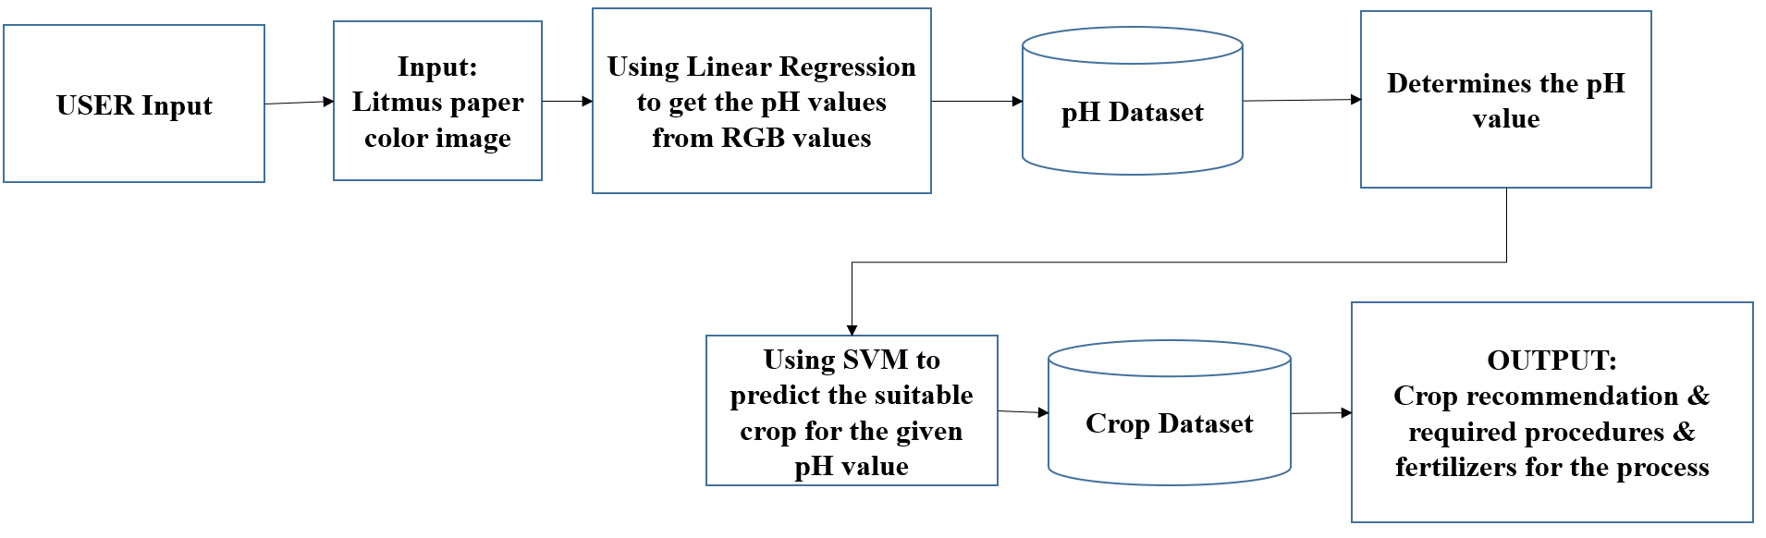
Figure 1 System Architecture
The system architecture gives a high-level overview of the functions and responsibilities of the system. It defines the breakdown of the system into various sub systems and the individual roles played by them
Farmer’s input: After litmus paper test, the user can upload the image of the litmus paper for the colour classification to determine the pH value from the colour dataset. The user can directly input the pH value.
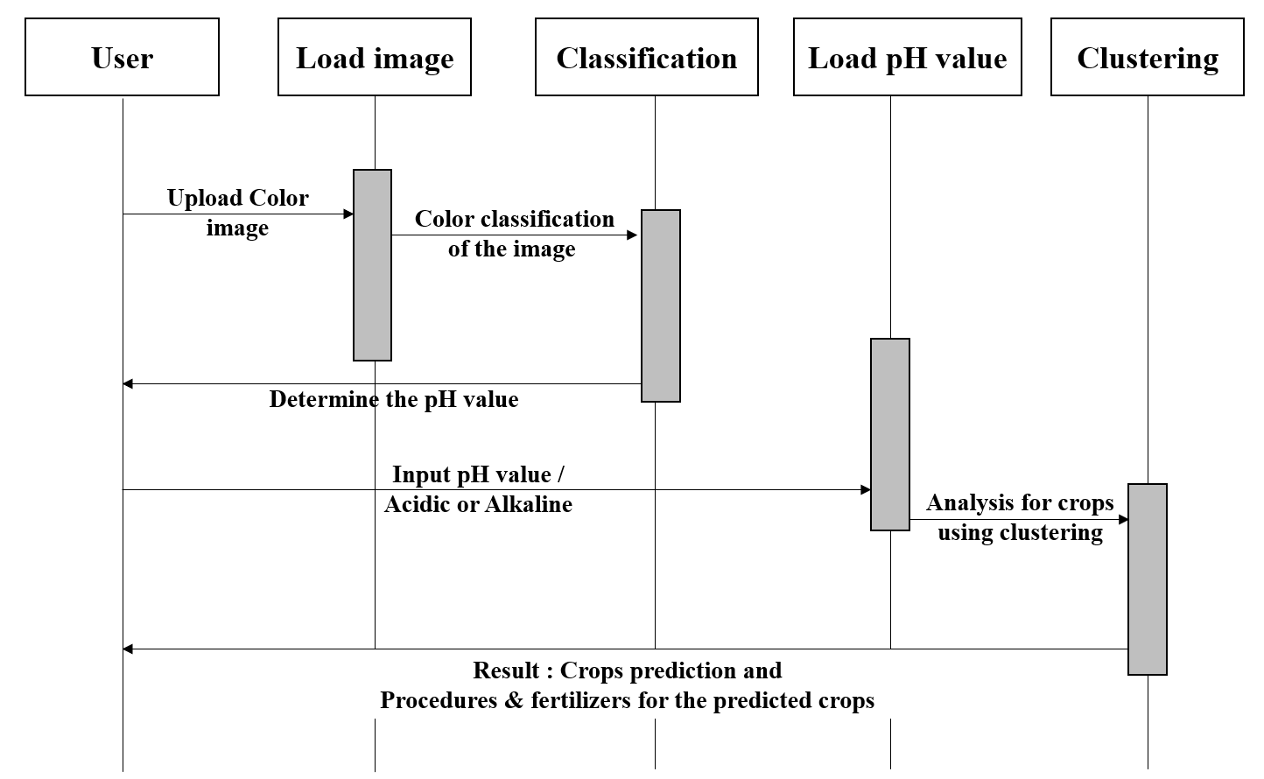
Figure 2 Sequence Diagram
A sequence diagram in Unified Modelling Language (UML) is a kind of interaction diagram that shows how processes operate with one another and in what order. It is a construct of a Message Sequence Chart. Sequence diagrams are sometimes known as event diagrams or event scenarios. Sequence diagrams help to plan and understand the detailed functionality of an existing or future scenario. They can be useful references for businesses and other organizations. The sequence diagram for the proposed system is shown above in fig. 2
Incise the pH value is unknown, the User will upload the litmus colour image to the system to determine the pH value.
Using KNN model the image is classified and the pH value is determined. If the pH value is known, the user will load the value as the input to analyse the NPK values.
Using the Keans model the crops are predicted with the analysis of NPK values. As a result, the predicted crops and the fertilizers & procedures for the crops are given to the user.
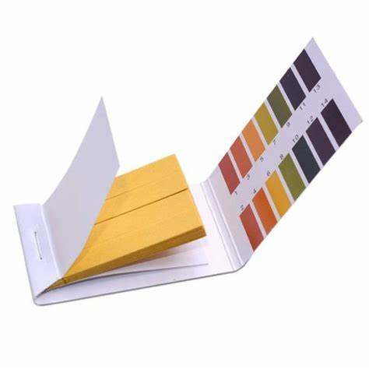
Figure 3 Litmus Paper.
Litmus paper is a filter paper that has been treated with a lichen-provided natural-soluble dye. Litmus paper is a piece of paper that produces a result which can be used as a pH indicator. Wood cellulose, lichens, and adjunct compounds are the primary raw materials used to produce litmus paper. Litmus paper is made mainly of paper, as the name suggests. Litmus paper must be free of pollutants that could influence the pH of the system being tested.
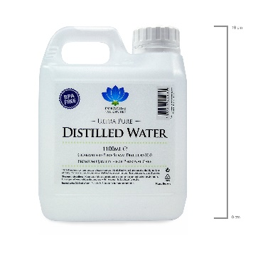
Figure 4 Distilled Water
Distilled water is water that has been boiled into vapour and condensed back into liquid in a separate container. Impurities in the original water that do not boil below or near the boiling point of water remain in the original container. Thus, distilled water is a type of purified water.
IV. RESULTS
Firstly, the farmer must perform the manual test using the litmus paper and distilled water. Upload the image of the litmus paper in the web application. After the image is uploaded, the linear regression takes place to predict the pH value using the colour of the litmus paper. After the pH values is determined, it predicts the crops for the obtained pH value using Keans clustering algorithm.
Secondly, it also predicts the cost and amount of basic nutrient fertilizers to be used for the land. To predict the NPK values, it uses Gradient boosting algorithm. The user interface figures are shown below:
Figure 5. Interface Design
Figure 6. Interface Design showing about us

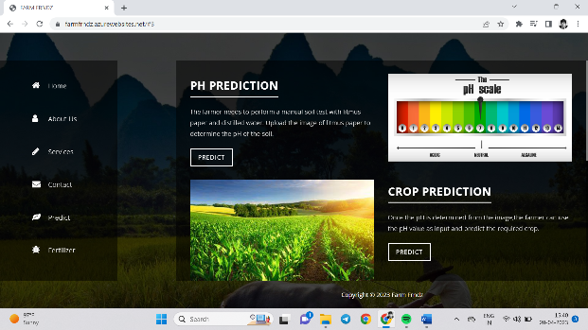
Figure 7. Interface Design showing PH prediction

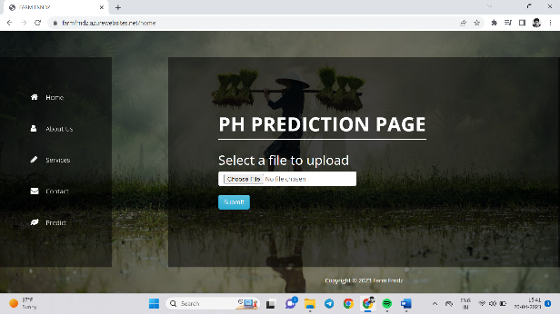
Figure 8. Interface Design showing PH prediction page

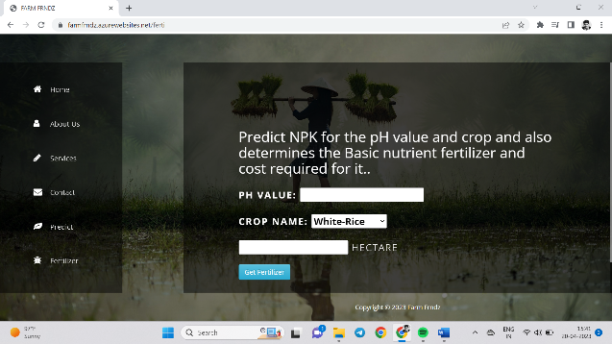
Figure 9. Interface Design showing PH prediction
V. CONCLUSION
In the strategy we propose, we employ a soil testing technique that uses Litmus paper to ascertain the pH of the soil. Then, based on pH, we forecast a list of appropriate crops and fertilisers. By substituting our model, which produces results in real time, for the manual soil testing process, we will be able to overcome its shortcomings. The suggested approach is quite effective.
VI. REFERENCES
[1] Crop Yield Prediction Using Deep Reinforcement Learning Model for Sustainable Agrarian Applications by Dhivya Elavarsan and P. M. Durairaj Vincent., Open Access Journal, May 6, 2020.
[2] Crop Type Prediction: A Statistical and Machine Learning Approach, LISV Laboratory, by Bikram Pratim Bhuyan, Ravi Tomar,T. P. Singh and Amar Ramdane Cherif. University of Paris Saclay, Accepted:23 December 2022 Published: 28 December 2022
[3] Crop Yield Prediction Using Machine Learning Approaches on a Wide Spectrum, by S. Vinson Joshua, Selwin Mich Priyadharson, and Worawat,Tech Science Press, DOI: 10.32604/cmc.2022.027178.
[4] Smart Crop Prediction using IoT and Machine Learning by Archana Gupta, Dharmil Nagda, Pratiksha Nikhare, Atharva Sandbhor. International Journal of Engineering Research & Technology (IJERT) ISSN: 2278-0181 Published by, www.ijert.org NTASU 2020 Conference Proceedings.
[5] An Improved Farmland Fertility Algorithm for Global Function Optimization, by Yan-Jiao Wang and Ye Chen from School of Electrical Engineering, Northeast Electric Power University, Jilin 132012 China, June 15, 2020.
[6] Application of Machine Learning on Crop Yield Prediction in Agriculture Enforcement”, by D. Jayakumar, S. Srinivasan, P.Preethi Sreelekha Vemula, Narashema Sri from the Geintec Innovative Technologies (ISSN:2237-0722), Accepted: 01.05.2021.
[7] Multispectral Crop Yield Prediction Using 3D-ConvolutionNeural Networks and Attention Convolutional LSTM Approaches, by Seyed Mahdi Mirhoseini Nejad Dariush Abbasi-Moghadam , Alireza Sharifi IEEE Journal of Selected Topics in Applied Earth Observations and Remote Sensing, vol. 16, 2023.
[8] Soil Analysis and Crop Fertility Prediction by Komal Abhang Surabhi Chaughule, Pranali Chavan, Shraddha Ganjave from International Research Journal of Engineering and Technology.
[9] Crop Yield Prediction Using Random Forest Algorithm”, 2021 7th International Conference on Advanced computing and communication system (ICACCS) issues:June 30,2021.
[10] Crop Yield Prediction using Regression”, International Research Journal of Engineering and Technology(IEGRT), volume:07, Issue:05 may,2020.
[11] Heuristic Prediction of Crop Yield using Machine Learning Technique” by S. Pavani, Augusta. Sophy Beulet P, International Journal of Engineering and Advanced Technology (IJEAT) Volume-9, December 2020.
[12] Crop Prediction using Machine Learning”, Proceedings of the Third International Conference on. Smart Systems and Inventive Technology (ICSSIT 2020), IEEE Xplore Part Number: CFP20P17-ART.

[13] Prof. Priyanka R and Dr. Satyanarayan Reddy, “An end-to-end securitu aware WSN approach with localization & Authentication and data exchange security”, International Transaction Journal of Engineering, Management, & Applied Sciences & Technologies, ISSN 2228-9860, 23-05-2022.
[14] Prof. Priyanka R and Dr. Satyanarayan Reddy, “An efficient routing mechanism for node locaization,cluster based approach and data aggregation to extend WSN lifetime”, INASS, ISSN:1882-708X, 16-09-2021.
[15] Prof. Priyanka R and Dr. Satyanarayan Reddy, “Design and Implementation of contact-less face mask dispenser”, GIS SCIENCE, ISSN NO:1869-9391, 2021.
[16] Dr. Satyanarayan Reddy K and Ms.Priyanka.R, “A Comprehensive Survey on Energy Efficient Routing Techniques and Various Attacks in Wireless Sensor Networks”, Scopus Indexed Journal (Unpaid) International Journal on Emerging Technologies (IJET), ISSN No. (Online): 2249-3255 0975-8364,2020.

