APPLICATION OF NANOTECHNOLOGY IN THE FIELD OF MEDICAL SCIENCE

MR. KHOTE GAURAV TULSHIRAM, MR. SHAIKH SOHAIL ALLIBABA
K.T. PATIL COLLEGE OF PHARMACY, OSMANABAD.

ABSTRACT:
In a world full of technologies and inventions, the medical field has also achieved its way over the period of time in developing more and more technologies in order to make therapy and diagnosing much more, easier with the help of nanotechnology and nanoparticles. With the help of nanotechnology and nanoparticles such as nanobubbles, nanosomes, liposomes, nanotubes, nanopores, respirocytes and microbivores drug delivery at target and specific sites has been much more, easier than the conventional preparations. The use of nanotechnology in major diseases like Cancer, Respiratory diseases, etc has been very useful for effective therapy and instant improvement of signs and symptoms for particular diseases.
KEYWORDS:
Nanopores, Liposomes, Nanotubes, Nanobubbles, Nanosomes, Respirocytes, Microbivores.
INTRODUCTION:
Nanotechnology is a branch that deals with manipulation at molecular and atomic levels to introduce the world to new structures, materials and devices. Nowadays nanotechnology is gaining tremendous demand in the field of medical sciences in terms of diagnosing, imaging and treatment of diseases. Introduction of new devices called nanodevices (at cellular and tissue level these nanoparticles interact with specific tissue or cell and perform specific functions). Innovation in the field of nanotechnology is very much required for human civilisation. The use of nanotools for diagnosing such as nanowires, cantilevers, quantum dots and nanoshells for treatment applications too. Treatment of certain diseases such as cancer, gastrointestinal disorders, etc has achieved an eye-capturing image in the field of nanoworld. The introduction of nano doctors which have a huge hand in the focus of the treatment of the diseases with help of nanodevices for the productivity of the patients. The use of nanotechnology in various fields of science and therapeutics has brought tremendous changes in the field of medicine where nanoparticles of various dimensions ranging between 1-100nm are designed and used for diagnostics, treatment and as biomedical tools for research(1). Today, in the era of technology and the highly developed medical field it is very much possible for providing treatment to diseases at the molecular level in order to produce with correct pathogenesis of a particular disease.

MATERIAL | PROPERTY | APPLICABILITY
Gold nanoparticles | It has optical, thermal and electronic properties. | Diagnosis and detection of biological molecules in the body which are at low concentration
Quantum dots | Cd/Zn selenides | In-vitro diagnostic imaging at the cellular level.
Magnetic nanoparticles | Magnetic properties | Immuno assay, drug delivery, tissue repair, cell suppression and purification
Polylactic acid | Biodegradable and biocompatible | Drug and gene delivery system

Table 1.1: Comparison of different materials of nanodevices displaying their properties and applicability (2).

NANOTECHNOLOGY AND ITS APPLICATION IN MEDICINE:

1. NANOPORES:
Nanopores were designed in 1997 by Desai and Ferrari, and consist of wafers with a high density of pores (20 nm in diameter). These pores allow the entry of specific substances such as glucose, oxygen and other products such as hormones(insulin) to pass through and permeable substances only(1).
Nanopores do not allow to pass any type of cells and antibodies through it. This application can be used in the transplantation of any tissue or organ transplantation as they protect the transplanted tissues from the immune cells of the host body and helps in the survival of tissue or an organ from being rejected.
For example, the transplantation of beta cells with nanopores benefits as they get unidentified and rejection of these cells is majorly not possible. DNA sequencing can be also done with the help of nanopores for medical therapy. Branton’s team at Harvard University has been working on modified nanopores that can differentiate DNA strands based on differences in base pair sequences(1).
Many promising biomedical applications for nano-porous materials have been discovered and several are currently being explored. In implantable devices, nanoporous materials act as the semipermeable membrane as they allow the entry of desired molecules in a controlled way.

2. LIPOSOMES:
Liposomes were first discovered in mid of the 1960s. Generally, used in nanoscale drug delivery. These are small round-shaped vesicles generally made from cholesterol and non-toxic phospholipids. As they are smaller in size with hydrophobic and hydrophilic characteristics, they have a promising character of delivering the drug. Many cancer therapy drugs which have adverse effects on the body and many other toxic drugs such as Amphotericin B, hanamycin can be given through a liposomal drug delivery system to avoid the adverse effects of conventional preparations of these drugs(1).

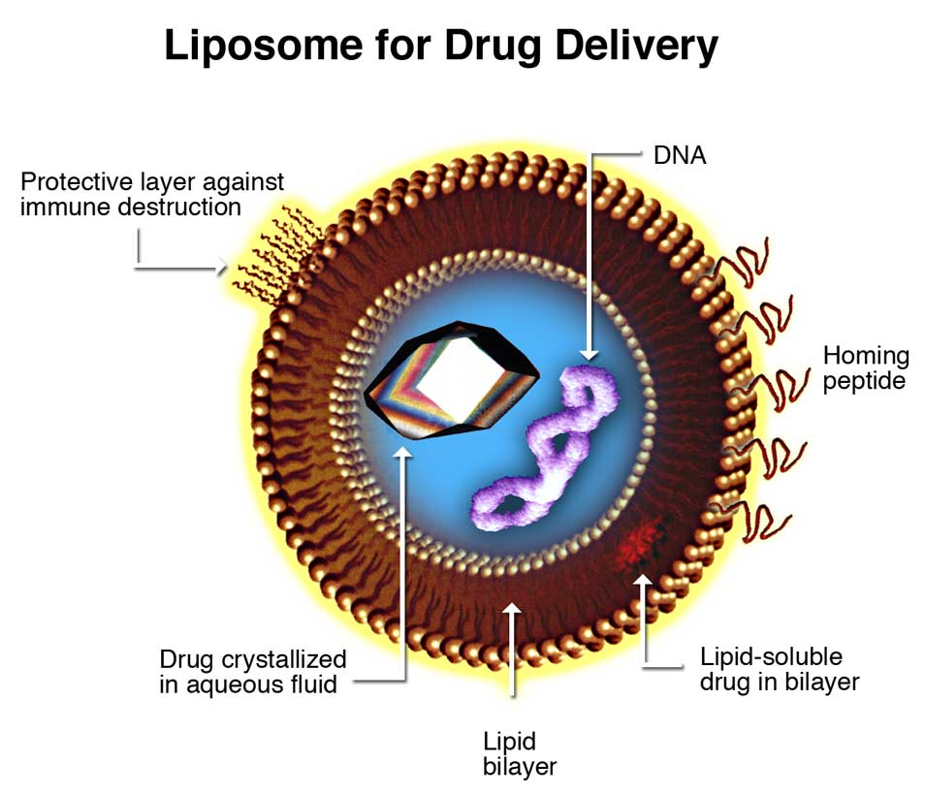
Fig 1.1: Liposomes for Drug Delivery (3).

Liposomes can be incorporated as anti-infective agents for drug delivery in diseases like leishmaniasis, candidiasis, aspergelosis, histoplasmosis, erythrococosis, gerardiasis, malaria and tuberculosis. Pathogens aside near or in the liver and spleen(intracellularly) can be bacterial, fungal and protozoal. Targeted sites with therapeutic agents in liposomes carrying drug delivery are as follows:
ACTIVE CONSTITUENTS | APPLICATION
Pentamidine | Leishmaniasis
Antisense oligo-nucleotides | Leishmaniasis
Anamycin | Leishmaniasis
Asiaticoside | Tuberculosis/Leprosy
Rifampicin | Tuberculosis
Table 1.2: Some liposomal preparations for infective diseases (4).
The use of Amphotericin B (Polyene antibiotic) for systemic fungal infections has severe renal toxicity. They act by the mechanism of, they bind to the ergosterol membrane of sensitive fungi and forming pores which cause cellular damage to the fungal cell and ultimately cause death. This binding may be non-specific which causes toxicity. Such drugs can be given through the liposomal drug delivery system which acts on targeted sites in the body.

3. NANOTUBES:
Carbon nanotubes were discovered in 1991 by Sumio Lijima and Ichihashi. Carbon nanotubes are tubular structures in which the sheet of graphite is rolled in the form of a cylinder. Which is covered by one end or both ends by a buckyball.

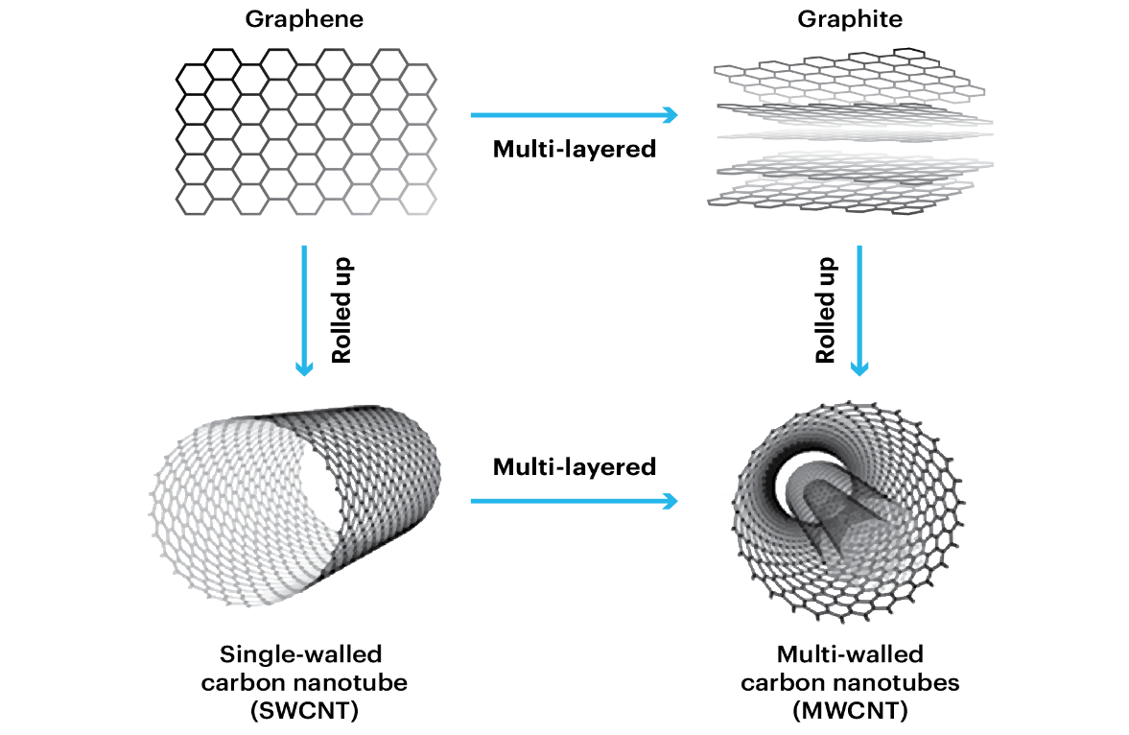
Fig 1.2: Single-walled and doubled-walled carbon nanotubes (5).

Carbon nanotubes are broadly classified into two main classes:
1.Single walled carbon nanotubes (SWCNT)
2.Multi walled carbon nanotubes (MWCNT)
Single-walled nanotubes have an internal diameter of 1-2nm while multi-walled carbon nanotubes have an internal diameter of 2-25nm diameter. In multi-walled layered carbon, tubes have approximately 0.36 nm distance between the two layers. The passage of nanotubes within the cell can be provided by the process of endocytosis and insertion of nanotubes within the cell. As these nanotubes are less insoluble, nanotubes can be made easily soluble in the body by the addition of carboxylic groups or ammonium groups to their structure. These nanotubes can be used in the transport of peptides, nucleic acid and other drug molecules.
The tremendous use of nanotubes can be used in the administration of Amphotericin B (Anti-fungal) via the help of nanotubes for drug delivery. The efficacy and potency of Amphotericin B with the addition of nanotubes can be enhanced by comparing without nanotubes. And this activity of Amphotericin B with nanotubes is very useful and helpful against the resistant bacteria which are resistant to Amphotericin alone.
Here is the demonstration through the figure of Amphotericin with nanotubes.
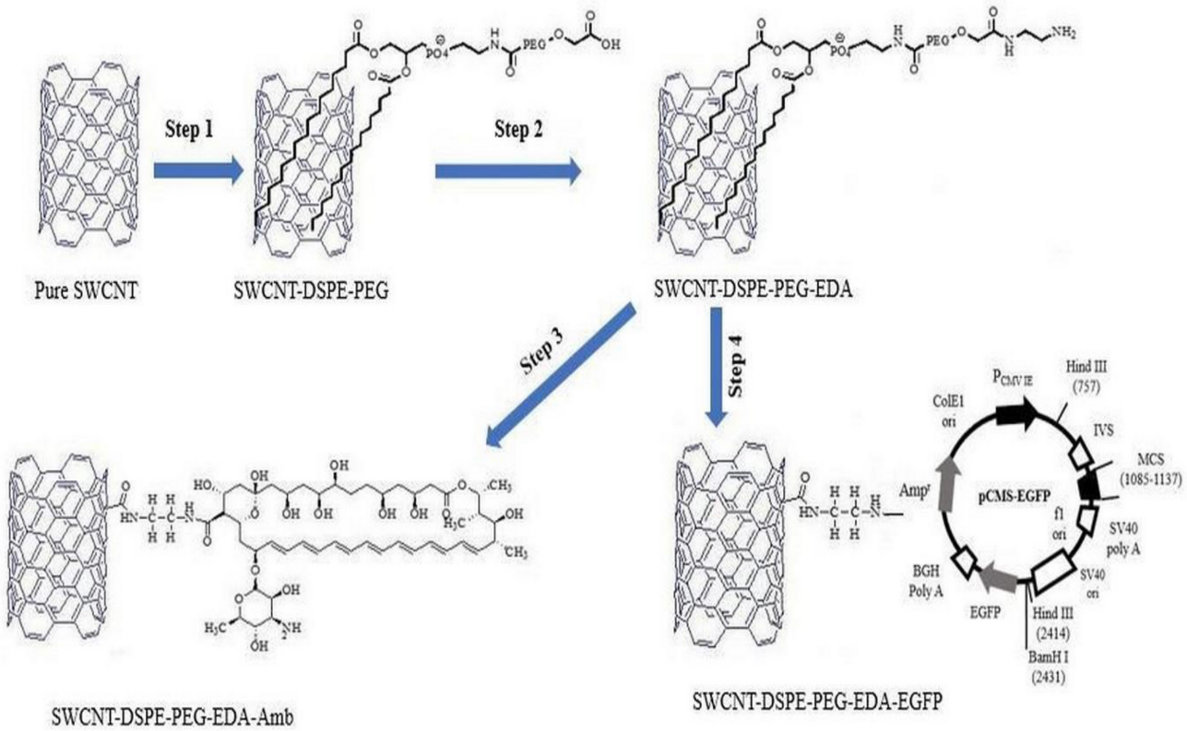
Fig 1.3: Nanotube with Amphotericin B. (6)

4. NANOBUBBLES:

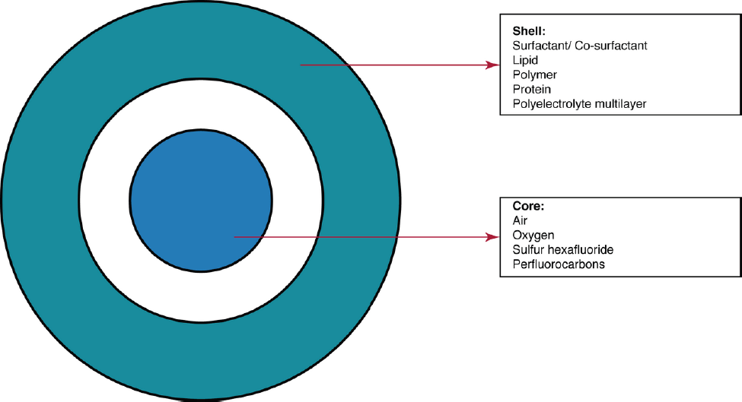
Fig 1.4: Schematic representation of nanobubble structure (7).

Nanobubbles are gas-carrying concavities in aqueous solutions with a size range of below 1µm (bubbles are round globular particles with a shell and a gas-filled core structure (7). Generally, nanobubbles are less than 1µm. Nanobubbles can be used to deliver cancer therapeutic agents. These nanobubbles are generally stable at room temperature but combine to form microbubbles in the body under physiological temperatures. Nanobubbles have a special advantage as this target the specific target tumour tissue and deliver the drug under the influence of ultrasound exposure which results in high intracellular uptake of the drug by the tumour tissue. Rapaport et al. have demonstrated the utility of nanobubbles in the delivery of drugs like doxorubicin based on in vitro and in vivo experiments using breast cancer cells MDA MB231 and mice with breast cancer xenograft respectively(1). Nanobubbles combined with ultrasound exposure have shown improved transfer of genes in both in vitro and in vivo studies respectively (1). Through nanobubbles, ultrasound imaging has been much useful in diagnosing and for clinical decision-making. Ultrasound beam majorly decreases the toxic side effects of Anti-cancer drugs used in the treatment of cancer (7).
Nanobubbles can be also used for the treatment of Parkinson's disease. The authors demonstrated that nanobubbles can be used to deliver apomorphine, a particularly beneficial but unstable drug for treating Parkinson's disease, through the blood barrier (). Nanobubbles can be also used as supersaturated fluids for oxygen delivery. Liposome-based nanobubbles and microbubbles are under development for gene-based drug delivery for various diseases.
Various studies suggest that nanobubbles can be used for the removal of clots from any vessel of blood in various vascular diseases of tissues with the induction of ultrasound(1).

5. NANOSOMES:
Raoul Kopelman’s group at the University of Michigan, USA, has been working on nanosomes also called PEBBLEs (Probes Encapsulated by Biologically Localised embedding) which integrate various applications such as targeting, diagnosis and therapy(1). There are many nanosomes which have been developed for the therapy of tumour-causing cancer particularly central nervous system (CNS) tumours. Silica-coated iron oxide nanoparticles coated with polyethylene glycol and affixed with targeting antibody and contrast elements like gadolinium are used to access specific areas of the brain involved with the tumour. The heat generated by the iron oxide particles of nanoparticles can destroy the tumour cells. Nanosomes when combined with a photocatalyst produce reactive oxygen species which destroy the target tissue. This method of nanosomes of drug delivery system is very advantageous and is safer without any adverse reactions of cancer chemotherapy drugs and is also absent of developing drug resistance of chemotherapeutic anticancer drugs over the conventional preparations.

6. RESPIROCYTES AND MICROBIVORES:
Respirocyte is considered a device approved by FDA and is regulated under the provisions of the Medical Device Amendments of 1976, the Safe Medical Devices Act of 1990 and the Medical Device Amendments of 1992(1). Respirocytes are artificial Red Blood Cells (RBCs) or nanodevices used for carrying or functioning as Red Blood Cells with high efficacy. These respirocytes deliver oxygen to the tissues in a higher capacity than that of normal Red Blood Cells. These supply oxygen to tissues 236 times more oxygen per unit volume. Respirocytes consist of sensors on their outer surface which detect the changes in the external environment and on the onboard nanocomputer which regulate the exchange of oxygen and carbon dioxide output. An infusion of a one-litre dose of 50 per cent respirocytes saline suspension in a human can theoretically keep the patient oxygenated for up to four hours with the following cardiac arrest(1).
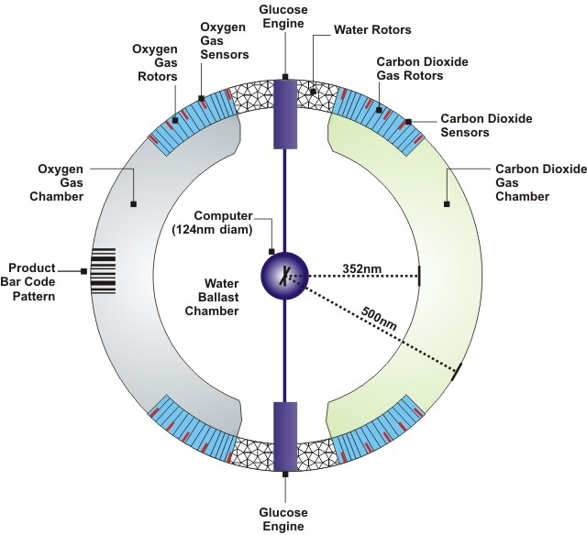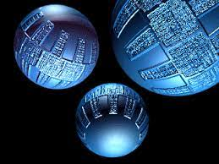
Fig 1.5: Internal structure of Respirocytes(8). Fig 1.6: Artificial respirocytes by
Robert A. Frcitas Jr.(8).

Microbivores are the type of micro devices which works same as the White Blood Cells (WBC) in the human bloodstream to engulf the microorganisms as the natural White Blood Cells do in the body. They perform phagocytosis on another level as their efficacy is much more than the natural ones. The microbivores have four fundamental components in which the microbe binds to the reversible binding site and trap the microorganisms. Once trapped, the morcellation chamber of microbivore minces the microbe into small, easily digested pieces and further are chemically digested. The application of microbivores in human circulation could theoretically clear the bloodstream in septicaemia at a much greater rate than the natural defence mechanism with antibiotics (1).
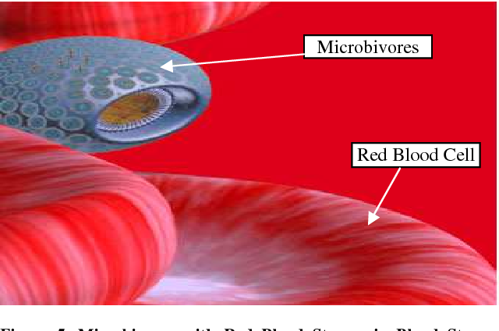
Fig 1.7: Microbivores in Bloodstream (9).
APPLICATIONS OF NANOTECHNOLOGY IN DIAGNOSING AND IMAGING:

- NANOWIRES:
Devices which basically work on nanowires provide powerful general platforms for ultrasensitive direct electrical detection of biological and chemical species (2). Nanowires can be laid down across a microfluidic channel, the nanowire sensors pick up the molecular signatures of these particles and relay the information to a signal analyser.

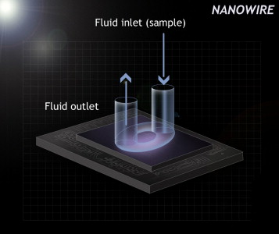
Fig 1.8: Schematic of regular planner planar nanowire sensor with integrated microfluid sample delivery (2).

A silicon nanowire field effective device was invented in which distinct nanowires and surface receptors were incorporated into arrays (2).

- CANTILEVERS:
The nanocantilevers are used for quantitative measurement of low concentrations of certain molecules within the body. For example, the antibody-coated cantilever binds selectively to the secreted products of cancer cells.

- QUANTUM DOTS:
Quantum dots (QDs) are the type of semiconductor device or nano dots which are synthetic in nature. The fluorescence property of quantum dots specifically can be used in the detection and imaging of cancer cells. Generally, the diameter of these quantum dots is between 2-10 nm.

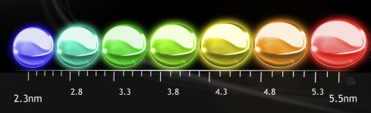
Fig1.9: Quantum dots (2).
The targeted site at which the accumulation of Quantum dots has been experimentally performed and demonstrated in vivo experiment in a xenograft model involving a human prostate cancer cell line in nude mice(2).
Many, cancer-causing agents can be detected through the specialized Quantum dots.

And many more nanotools can be used for diagnosing and imaging such as:
- DENDRIMERS
- LIPOSOMES
- NANOPYRAMIDS
- NANOGELS
- NANOSHELLS

As we know and we have covered in this review the applications and advantages of nanotechnology in our day-to-day life and in upcoming future generations. There is vast and huge scope in future for the nanotechnology but there will be newly coming and hazardous diseases via nanotechnology which is its dark side.

SOME HAZARDS OF NANOPARTICLES ARE AS FOLLOWS:
1. These particles tend to cause some pathologic disorders of the respiratory, cardiovascular and gastrointestinal systems.
2. Intracranial instillation of carbon nanotubes particles in mice has shown that carbon nanotubes have the potential to cause varied lung pathologies like epitheloid granuloma, interstitial inflammation, peribronchial inflammation and necrosis of the lungs (1).
3. Nanoparticles as a whole, or the decomposition products of these nanoparticles are known to cause symptoms such as dermal changes, neurotoxicity, sensitization, growth toxicity and cardiac toxicity (10).
4. As these nanoparticles are foreign bodies for the human body the immune cells tend to remove these nanoparticles from the body through processes like phagocytosis which harm the human body only.
5. The American Heart Association found out that even short-term exposure to elevated particulate matter concentrations in outdoor air was accompanied by a significant increase in acute cardiovascular mortality, particularly in certain subsets of the population (11).
6. Even it is very difficult to eliminate these nanoparticles from the body through the urine as kidneys face an extra workload to eliminate them.

CONCLUSION:
At the end, nanotechnology has exerted or played an important role in the life of human beings. The use of nanotechnology in the field of therapeutics and diagnosing has led to tremendous growth in improving the productivity and quality of life of patients.
However, in a few more years nanomedicine will achieve a great peak in the field of medicine and drug delivery system in order the efficacy of the treatment will be more enhanced.

ACKNOWLEDGEMENT:
The authors are thankful to the Principal, of ASPM's K.T. Patil College of Pharmacy for providing the necessary facilities for studying and providing new opportunities.

REFERENCES:

- Surendiran A, Sandhiya S, Pradhan SC, Adithan C. Novel applications of nanotechnology in medicine. Indian Journal of Medical Research. 2009 Dec 1;130(6):689-701.

- Laroui H, Rakhya P, Xiao B, Viennois E, Merlin D. Nanotechnology in diagnostics and therapeutics for gastrointestinal disorders. Digestive and Liver Disease. 2013 Dec 1;45(12):995-1002.

- Fazal-ur-Rehman M. Novel applications of nanomaterials and nanotechnology in medical sciences-a review. J. Basic Appl. Sci. Res. 2018;8(4):1.

- Samad A, Sultana Y, Aqil M. Liposomal drug delivery systems: an update review. Current drug delivery. 2007 Oct 1;4(4):297-305.

- Filchakova M, Saik V. Single-walled carbon nanotubes: structure, properties, applications, and health & safety. Tuball. 2021 May.

- Yazdani S, Mozaffarian M, Pazuki G, Hadidi N, Gallego I, Puras G, Pedraz JL. Design of double functionalized carbon nanotube for amphotericin B and genetic material delivery. Scientific Reports. 2022 Dec 7;12(1):21114.

- Pasupathy R, Pandian P, Selvamuthukumar S. Nanobubbles: A Novel Targeted Drug Delivery System. Brazilian Journal of Pharmaceutical Sciences. 2022 Jul 8;58.

- Muhammad, Yahaya & Bk, Muh'd & Muhammad,. (2020). Nanotechnology and Artificial Blood; Future Revolution in Modern Transfusion Medicine. 3. 23-27.

- Mishra J, Dash AK, Kumar R. Nanotechnology Challenges; Nanomedicine: Nanorobots. International Research Journal of Pharmaceuticals. 2012;2(4):112-9.

- Abdussalam-Mohammed WJ. Review of therapeutic applications of nanotechnology in medicine field and its side effects. Journal of Chemical Reviews. 2019;1(3):243-51.

- Sotropa¹ RM. The advantages and disadvantages of nanotechnology. Romanian Journal of Oral Rehabilitation. 2018 Apr;10(2).

- Bamrungsap S, Zhao Z, Chen T, Wang L, Li C, Fu T, Tan W. Nanotechnology in therapeutics: a focus on nanoparticles as a drug delivery system. Nanomedicine. 2012 Aug;7(8):1253-71.

- Khan I, Saeed K, Khan I. Nanoparticles: Properties, applications and toxicities. Arabian journal of chemistry. 2019 Nov 1;12(7):908-31.

- Bodunde OP, Ikumapayi OM, Akinlabi ET, Oladapo BI, Adeoye AO, Fatoba SO. A futuristic insight into a “nano-doctor”: a clinical review on medical diagnosis and devices using nanotechnology. Materials Today: Proceedings. 2021 Jan 1;44:1144-53.

- Gwinn MR, Vallyathan V. Nanoparticles: health effects—pros and cons. Environmental health perspectives. 2006 Dec;114(12):1818-25..

- Singh R, Nalwa HS. Medical applications of nanoparticles in biological imaging, cell labeling, antimicrobial agents, and anticancer nanodrugs. Journal of biomedical nanotechnology. 2011 Aug 1;7(4):489-503.

- Chakraborty M, Jain S, Rani V. Nanotechnology: emerging tool for diagnostics and therapeutics. Applied biochemistry and biotechnology. 2011 Nov;165:1178-87.

