**" Discriminant Analysis of Marketing Mix Factors influencing Patient Satisfaction in Eye treatment."**

**Anita Bora, Associate Professor, Pearl Academy, New Delhi**

# **Introduction**

Health services are one of the most demanding industries in terms of customer satisfaction. The need to improve healthcare quality, for achieving higher patient satisfaction, is increasing. All the service providers in healthcare sector, right from hospitals, center for medical care and insurance services, are constantly evaluating health care service parameters to improve their service quality. Patient satisfaction is the most critical component of quality in health care. Health care, as a services industry, shares features defined for other service industries like hotel, airlines, etc. Patient is essential to the marketing mix, like in other service industries. He is part of the of the service product in the process of delivery and consumption. It is, in fact, a degree more sensitive in health care because process of the service product delivery happens on the patient. Another challenge is that the patient cannot experience the product prior to the purchase. Eye, being the most important organ, makes this vertical of healthcare even more critical. Patient satisfaction is considered to the most important outcome of any eye surgery. A satisfied patient becomes a brand ambassador and forms a critical link for the subsequent patient footfall in any of the eye centers. That's how most of the centers have grown in terms of the patient base. Patient satisfaction is the prime indicator of a doctor and a hospital's success. This leads to an improved clinical outcome, better word of mouth, and patients' loyalty for the doctor. A hospital, thus, focuses on timely, efficient, and quality healthcare ( (Tracy, 2015).

A satisfied customer plays crucial role in increasing the footfall of prospective patient, researchers say the he would talk to at least five people about his experience of the services, however a dissatisfied patient would tell nine other people about his dissatisfaction. Therefore, word of mouth has a direct effect on hospital's revenue.

While obtaining a new patient involves high cost, losing him would lead to a substantial loss of this investment. This investment includes the cost of every interaction with the customer, right from reminders and follow calls, insurance claim processing, maintenance of patient documentation, pharmacy and follow up of the laboratory reports.

Patient satisfaction corresponds to its relationship with continuity of care and patient outcomes. Conversely, dissatisfaction can lead to situations as serious as malpractice lawsuit situations. (Allah, Eid, & Hasanin, 2017)

The health services in eye care, like in any service industry, is categorised by its inherent features of intangibility, perishability, inseparability and heterogeneity in their offerings to the patients.

Elements of service marketing mix also apply to health care. These elements are the foundation for successful health care services. And because they change quickly, examining each of these regularly is important in order to sustain and maximise revenue results. Each of the elements carry a very important position in delivering quality services for patient satisfaction.

## **People**

Eye care is essentially a people centric business.It includes patients, doctors, paramedical staff, front office staff, support staff, and management. Anyone who is involved in the process of service delivery forms this component of the marketing mix. Their quality of contribution helps in building patients' perception of the overall quality of the treatment. Patients are not in a position to understand the technical competency of the treating doctors; however, how well the doctors and paramedical staff has treated them in terms of explaining everything in a layman's language, making the entire process transparent to them and their family are the Evidence for the patients to form their perceptions about the quality of their treatment. Nevertheless, in this fast-paced environment, it is incredibly challenging to maintain the desired level of communication and interaction with the patients.

## **Product**

In the current competitive landscape of eye care, the treating organisations must strive to balance the values created by their products and services to meet and exceed patients' expectations. This will be only possible when healthcare organisations are entirely aligned with patients' perceived and received quality of treatment.

## **Price**

For any service product, price is ascertained by customers' affordability, level of competition and the perceived and delivered value of the product. In eye care services, the patients are willing to pay higher prices for superior quality services. However, due to the intervention of insurance companies' payment processes, the medical service prices are scrutinised by both parties. A flexible price strategy helps in attracting and retaining new patients. In healthcare, there is a growing trend toward value-based pricing, where the cost of a procedure or treatment is tied to its effectiveness and outcomes. This approach aims to ensure that patients receive value for their healthcare spending.

## **Promotion**

Health care is a protocols-driven industry. Personal and direct interactions with the patients are done in a very professional manner. From a service marketing standpoint, the promotion includes all the touch points the hospital attempts to reach its prospective patients. These touch points include the website, conventional and digital advertising, referrals, and word of mouth. Patients in eye care have more specific expectations than those in a conventional retail business. Patients receive this communication carefully. They seek information about doctors' reputations, technical competence, experience, in-house advanced treatment facilities, and the quality of the instruments and equipment.

(Gandolf, 2023)

## **Place**

The promotion of the place in eye care should be considered carefully. How this communication reaches prospective patients has a lot of influence on their purchase decisions. The most appropriate point of promotion is the place of the practice. That is where patients explore their alternatives and contemplate their purchase decisions. In eye care, the patients' purchase decision is driven more by intrinsic factors than the time and place of the treatment.

**Physical Evidence**

Physical Evidence encompasses the customer's overall experience and interaction with product and service offerings. It includes tangible and, most notably, intangible aspects of the services as part of their value proposition. In health care, the intangible aspect is more significant as it includes the experience patients receive at the reception, quality and presentation of communication through brochures and websites, hygiene and appearance of staff, and quality of interaction with doctors. Remarkably, they form their first impression within 10 seconds; therefore, the organisation must pay attention to the minutest details to make this moment a lasting impression in patients' minds.

**2. Problem Definition**

## **2.1 Problem Statement**

Patient Satisfaction is crucial for success in eye-care practice; therefore, it is essential to understand what factors influence patient satisfaction. In other words, our goal is to identify what marketing mix factors discriminate the most between satisfied and non-satisfied customers. Hence, our goal in this research activity is to perform a *Discriminant Analysis* of *Marketing Mix Factors* influencing *Patient Satisfaction* in *Eye Treatment*.

## **2.2 Conceptual Framework**

The framework we use for this research is based on the theoretical framework of marketing of services. As per the framework, customer satisfaction in a service environment depends on the seven Ps of service marketing – Product, Place, Price, Promotion, People, Physical Evidence, and Process. For our research, we are using only five of the seven Ps as the target hospital has little interest in changing promotional strategy (so promotion is relatively fixed) and given almost perfect competition in this space, an individual hospital is a price taker rather than a price setter.

Hence, we hypothesise that customer satisfaction depends on the perceived differences in the 5Ps of service marketing. Accordingly, for this study, we are studying patient satisfaction as dependent variable and 5 Ps (People, Product, Place, Physical Evidence and Process as independent variables and as shown below:

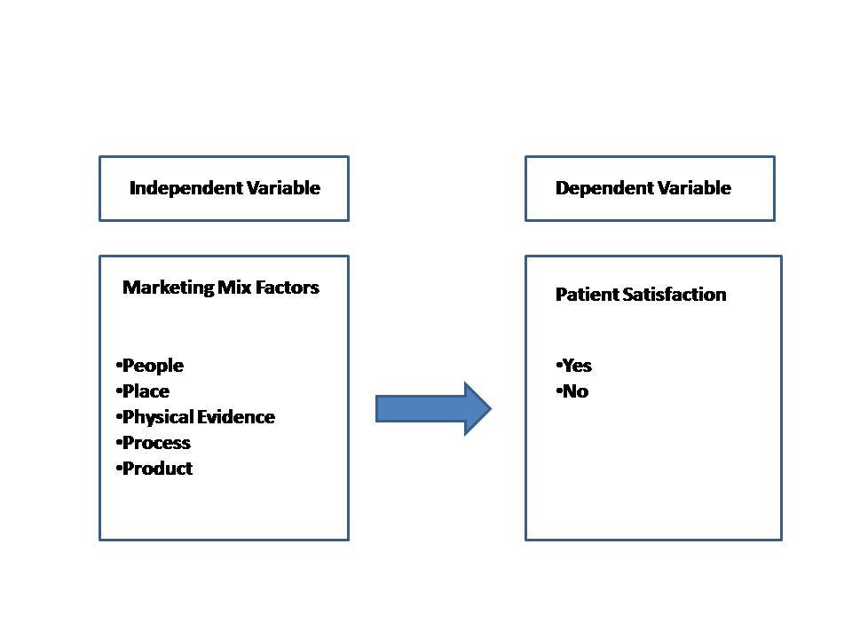

## **2.3 Population and Sampling**

This study involves a conclusive study on the patients who have gone through the cataract surgery in the last one year. To identify the factor influencing patient satisfaction involve descriptive research with help of a survey. The data collection tool was questionnaire.

**Scope of the research:** All the eye care centers of a particular hospital. The hospital has centers in Moti Nagar, Sujan Singh Park, Kirti Nagar and Rajouri Garden in Delhi.

**Sampling Method:** Convenience Sampling

**Sample Size:** 52

## **2.4 Patient Base Analysis: Geographical Reach**

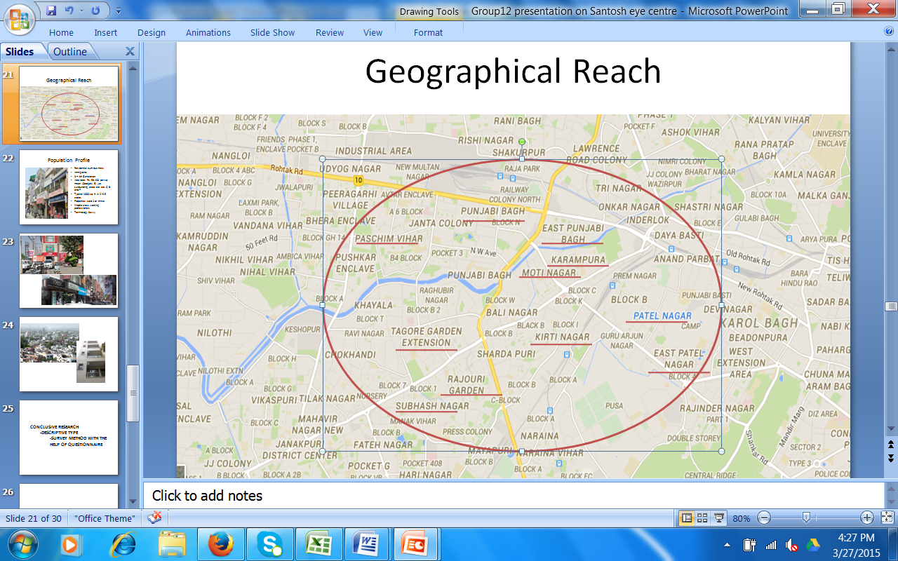

As shown with the help of above map, the majority of the patient belongs to area with a periphery of 2Km of the hospital.

## **2.5 Population Profile**

The area covered for this research is a privately held residential colony. Most of the early residents were immigrants with limited source of incomes but later on the properties have been sold out to the working class as they were getting good rates. Broadly, the profile of majority of the residents may be described as middle class working professionals. They are the third or fourth generation of the residents and are technology savvy.

## **2.6 Pictorial Representation of the Area / population profile**

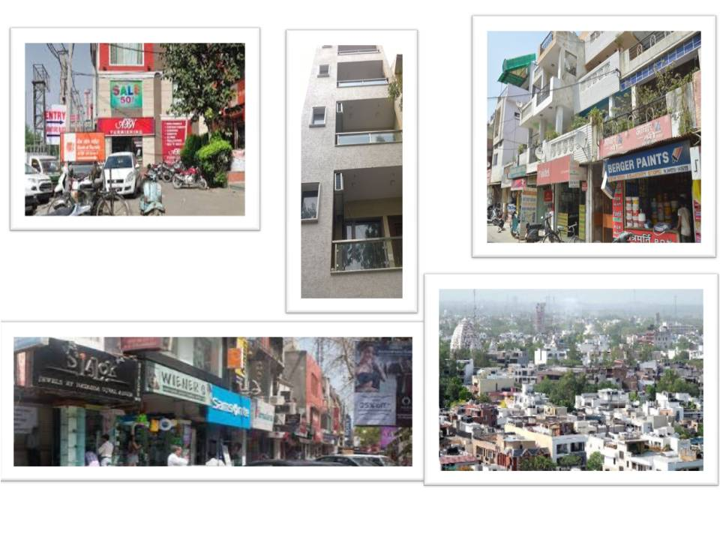

# **3. Literature Review**

For the purpose of this analysis, we have looked at 3 studies linked to the use of marketing in services. The studies are selected in such a way that they cover all the major aspects of the research in the current situation – Patient Satisfaction in Eye Care, Consumer Satisfaction in Hospitals in India and Marketing Mix for services in an equivalent industry.

## **Study I: Patients' Satisfaction with their Cataract Surgery** (Ehab I Wasfi, 2008)

Ehab conducted this study I in the Eye Department in Egypt.

### **About the Study**

### This retrospective study involved 150 patients who underwent cataract surgery. The patients responded through a postal questionnaire. The survey included information about the sources of reference for the treatment, the time lag between their call and the first meeting with the ophthalmologist, their experience with the outpatient services like written information communication, detailed explanatory sessions with paramedical staff and doctor in terms of receiving detailed guidance about pre or post-treatment care and followup sessions. The respondents were also asked about their experience with treatment timelines in terms of the waiting time for surgery, the number of surgery cancellations, changes in the appointment with the doctor, and the care provided during the treatment tenure.

## 

## **Study II: The Study on Customer Satisfaction in Hospitals** (T Sreenivas, 2012)

This study was about patients' satisfaction in three hospitals of Guntur District in Andra Pradesh.

The study was done to assess patients' satisfaction levels in these hospitals. Second, to suggest measures to improve patient handling practices.

They studied seven dimensions: staff behaviour, cleanliness, admission process, patient facilities, dietary services, diagnostic services, and discharge process.

### **Conclusion**

The scale was developed to assess the perceived quality of the services in all three hospitals. The study concluded that the perceived quality at public facilities is marginally favourable. The identified factors to improve patient satisfaction were interpersonal skills, infrastructure, drug availability and, most importantly, the physician's relationship with the patient.

## **Study III: Discriminant Analysis of Marketing Mix Factors** (Pitauk Chancharoen, 2015)

This study covered the Marketing Mix impact Factors in the Hospitality Industry. A discriminant analysis technique was used to study the influence of marketing mix factors. A sample size of 1467 customers from six hotels was surveyed for this study. It involved studying customers' characteristics, marketing approach, and behavioural aspects of the hotel services.

The conclusion was as follows:

* One night use of services by customers and their companions.
* The discriminant analysis output reflected that the discriminating factors for the companion were price and people.
* Discriminating factors influencing the duration of the stay were product, promotion and place.
* Discriminating factors for using other services were promotion and people.

**4. Research Design**

### 

### **Exploratory Research**

The exploratory research has been done with the help of secondary data. The intent of this exploratory research was to formulate a hypothesis for the analysis which would help in the survey design.

### **Conclusive Research**

To identify the discrimination factors the multivariate technique of discriminant analysis was done.

### **Scope of the Research**

Scope limited to areas served by a single hospital and its eye-care centers. These include Moti Nagar, Sujan Singh Park, Kirti Nagar and Rajouri Garden in Delhi.

### **Sampling Method**

Convenience Sampling has been used for this study as a particular hospital was chosen for analysis. The entire data of the patients from that hospital have been arranged chronological order (according to date of operation) and every 10th patient has been chosen from the same list.

### **Sample Size**

After removing the records with missing values, the sample size available for the analysis was 52 unique patients.

### **Field Work**

Data was collected with the help of the front office employees of various eye-care centers of the hospital in discussion. The printed forms were left with the assistants by the team members and were collected a few days later. The researchers had no direct interactions with the end users to avoid any bias.

### **Data Collection**

Data collection was done with the help of a questionnaire. All the current patients were considered as eligible candidates for the sampling.

# **5. Methodology**

The analysis of descriptive statistics for distribution of variables has been done by using frequency, mean and standard deviation. The results has been shown with the help of graphic charts. Thereafter the multivariate technique of discriminant analysis has been applied to identify the discriminating factors of service marketing mix for maximising the patient satisfaction.

Discrimination analysis is a handy tool to predict group membership through a linear combination of independent interval variables. This is done based on first finding observed values for two or more groups. The resulting analysis leads to the formulation of a model to predict group membership based on the value of one interval variable. Another significant contribution of discriminant analysis is understanding the relationship between the group membership and the variable used for prediction.

For the current research, we are more interested in the second purpose, i.e. using Discriminant Analysis to identify the key perceived factors discriminating the patient's satisfaction. We have two groups (i.e. Satisfied vs. Non-Satisfied), so only one Discriminant Function will be sufficient for our purpose.

# **6. Data Analysis and Presentation**

## **Data Analysis**

### **Family Income**

**Inference:** More than half of the patient profile belongs to ₹ 50,000 to ₹100,000 per month income category. This implies that

### **Reference Source**

47% patients have come by self-assessment, 33% have referred by their relative and 18% through friends.

### **Perception of Medical Facilities**

**Inference:** 80% of the people perceive Santosh Eye Clinic to be sophisticated in terms of the medical facilities.

### **Overall Satisfaction**

**Inference:** Close to 63% are very satisfied. The above data suggests that there is a scope of improvement in the overall satisfaction, however situation is not too bad at present also.

### **Courteousness of Staff**

### **Quality of Explanation**

**Inference:** Other parameters like explanation by staff, doctor and pre during and post operation procedures, behavior of staff and doctors have shown the same statistics where people have opined to be very satisfied or very satisfied.

The responses where responses have been varying are as follows:

### **Availability of Parking**

**Observation and inference**: Many people have shown discontentment regarding parking.

### **Explanation of Procedure and Next Steps**

**Inference:** In explaining the next procedure, 4% of patients have shown discontentment.

## **Result and Analysis of Discriminant Analysis**

Discriminant function coefficients were estimated with the help of estimated and observed data. The following table highlights the discriminant analysis output drawn with the help of SPSS.

| **Tests of Equality of Group Means** | | | | | |
| --- | --- | --- | --- | --- | --- |
|  | Wilks' Lambda | F | df1 | df2 | Sig. |
| Staff Courteous | .933 | 2.436 | 1 | 34 | .128 |
| Staff Explanation | .971 | 1.014 | 1 | 34 | .321 |
| Parking | .913 | 3.256 | 1 | 34 | .080 |
| Location | 1.000 | .000 | 1 | 34 | .988 |
| Appointment | .904 | 3.615 | 1 | 34 | .066 |
| Initial Check up | .912 | 3.299 | 1 | 34 | .078 |
| Cleanliness | .999 | .035 | 1 | 34 | .852 |
| Toilet | .896 | 3.930 | 1 | 34 | .056 |
| Doctors Introduction | .903 | 3.668 | 1 | 34 | .064 |
| Doc Explanation | .973 | .944 | 1 | 34 | .338 |
| Patient Relax | .965 | 1.243 | 1 | 34 | .273 |
| Patient Understanding | .998 | .073 | 1 | 34 | .789 |
| Next Step | .996 | .139 | 1 | 34 | .712 |
| Risk | .703 | 14.337 | 1 | 34 | .001 |
| Anaesthesia Check | .452 | 41.191 | 1 | 34 | .000 |
| Explained | .430 | 45.059 | 1 | 34 | .000 |
| Information | .398 | 51.352 | 1 | 34 | .000 |
| Length | .328 | 69.635 | 1 | 34 | .000 |
| Patient Care | .275 | 89.677 | 1 | 34 | .000 |

| **Eigenvalues** | | | | |
| --- | --- | --- | --- | --- |
| Function | Eigenvalue | % of variance | Cumulative % | Canonical Correlation |
| 1 | 11.342a | 100.0 | 100.0 | .959 |
| a. analysis used the first one canonical discriminant function. | | | | |

| **Wilks' Lambda** | | | | |
| --- | --- | --- | --- | --- |
| Test of Function(s) | Wilks' Lambda | Chi-square | df | Sig. |
| 1 | .081 | 61.570 | 19 | .000 |

 

 

## **Interpretation of the Result**

1. The pooled within groups correlation matrix shows broadly low correlation between the predictors, expect for a few places, like staff courtesy and staff explanation. Multicollinearity is unlikely to be a problem.
2. The significance F ratio indicates that when predictors are considered individually only risk, Anesthesia check, Explanation by the doctor, Length of the treatment Information provided in writing, Patient care significantly differentiate between those who were satisfied and those who were not.
3. An 11.34 Eigenvalue associated with this function explains 100% of the variance. The function shows a canonical correlation value of .959; thus, we get the squared value of (.9592) = .95. This suggests that 95% of the dependent variables have been used to explain the model.
4. Wilk's Lambda is 081. This declines the badness of fit of the proposed model. Since it is less than 10% and the significance of the Chi-Square value is .000, the null hypothesis stands rejected, and the proposed model is fit to explain the data well.
5. Out of the predictor variables, patient care is the most important indicator in the standardised correlation discriminating function. This is followed by the length of the treatment, information given in writing, anaesthesia, risk and toilet cleanliness with a descending order value of the coefficient in explaining or discriminating the patients' satisfaction.
6. A hit ratio value of 84.6% indicates model's strength in explaining, thus determining the patients' satisfaction.

## **Conclusion and Final Recommendation**

Based on the above Analysis, it clearly visible that the data is able of identify the independent values which are explaining the patient satisfaction after go through the eye treatment. This study strongly recommends that the following factors must be given at most importance in order to achieve greater patient satisfaction:

1. Patient care
2. Length of the treatment,
3. Information given in writing,
4. Anesthesia,
5. Risk and
6. Toilet cleanliness

Five out of the six factors are forming part of the service product and one of the factors is part of physical Evidence which indicates that the most discriminating element in service marketing is that product followed by physical Evidence.

# **References**

1. Ehab I Wasfi, P. P.-E. (2008). Patient satisfaction with cataract surgery. *International Archives of Medicine*.
2. Pitauk Chancharoen, K. J. (2015). Discriminant Analysis of Marketing Mix Factors' Influence Using the Hotel Services. *International Conference on Global Business, Economics, Finance and Social Services.* Bangkok, Thailand.
3. T Sreenivas, N. S. (2012). A Study on Patient Satisfaction in Hospitals. *International Journal of Management Research and Business Strategy*.
4. Tracy, B. (2015). *The Seven 7 Ps of Marketing.* Retrieved from Healthcare Success: http://www.healthcaresuccess.com/blog/medical-advertising-agency/the-7-ps-of-marketing.html