Paper Title
IoT and Artificial Intelligence
Mrs.B.Divya Rekha, Malika Rawat and Anumathi Singh
Department: Computer Science
Bhavan’s Vivekananda Degree College
Sainkpuri, Secunderbad, India
b.d.rekha0310@gmail.com
malikarawat2003@gmail.com
anumathisingh@gmail.com

ABSTRACT

The rapid advancement of technology has given rise to a revolutionary concept known as the "Artificial Intelligence of Things" (AIoT). This abstract delves into the convergence of two groundbreaking technologies, Artificial Intelligence (AI) and the Internet of Things (IoT), and their transformative impact on various industries and everyday life.
Moreover, AIoT has a significant impact on smart cities, enabling urban planners to optimize traffic management, waste disposal, energy consumption, and public safety. Smart homes also leverage AIoT to create seamless home automation systems, enhancing energy efficiency and providing personalized user experiences.
In conclusion, AIoT represents a groundbreaking paradigm that is reshaping industries and transforming the way we interact with technology. The synergy of AI and IoT offers unparalleled opportunities to create a more connected, intelligent, and efficient world. While facing challenges, the benefits of AIoT applications are poised to revolutionize multiple sectors and improve the quality of life for individuals worldwide. Continued research, collaboration, and responsible development will be crucial in unlocking the full potential of this innovative and transformative technology.

INTRODUCTION

Introduction to IoT:
The network of physical objects that are embedded with sensors, software, and other technologies to connect and exchange data over the internet is called Internet of Things (IoT). These objects can be everyday devices such as smartphones, wearable fitness trackers, home appliances, vehicles, industrial machinery, and more.
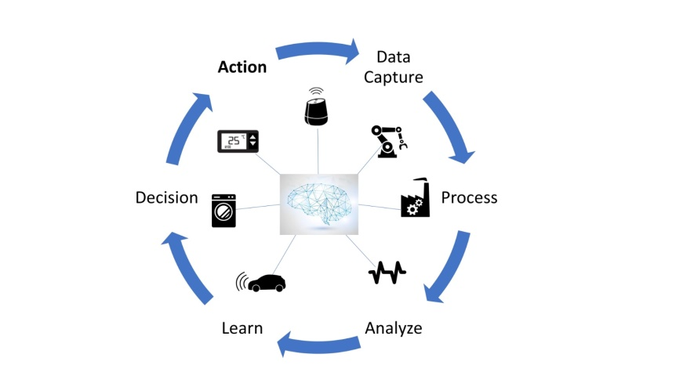
What is the AI of Things(AIoT)?

Fig.1

The main goal of IoT is to enable these devices to collect, share, and analyze data to enhance automation, efficiency, and decision-making processes.
Introduction to AI:
A branch of computer science that focuses on creating intelligent machines that can perform tasks that typically require human intelligence refers to Artificial Intelligence (AI). AI systems can process large amounts of data, learn from it, and make decisions or predictions based on the learned patterns. The field of AI is continuously evolving, and it encompasses several subfields and approaches, including machine learning, natural language processing, computer vision, robotics, and expert systems.
Introduction to IoT with AI:
IoT with AI, is also referred to as AIoT (Artificial Intelligence of Things), is the combination of artificial intelligence technologies with the Internet of Things environment. It combines the data collection and connectivity capabilities of IoT with the advanced analytics and decision-making capabilities of AI.

Digitalization, IoT and Artificial Intelligence
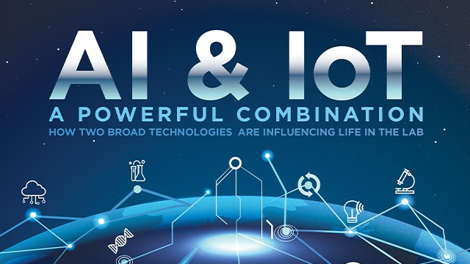
Fig 1.1

The goal is to create more intelligent, efficient, and autonomous systems that can make informed decisions and take actions based on real-time data.
Here's how IoT and AI work together:
- Enhanced Data Analysis: IoT devices generate a massive amount of data from various sources. AI algorithms can analyze this data in real-time, identifying patterns, trends, and anomalies that might be challenging for traditional rule-based systems. This analysis enables AIoT systems to make accurate predictions and recommendations.
- Predictive Maintenance: AIoT can revolutionize maintenance practices in industries. By analyzing data from sensors embedded in machinery or equipment, AI can predict potential failures or issues before they occur. This enables proactive maintenance, reducing downtime and preventing costly breakdowns.
- Real-time Decision Making: AIoT systems can make instant decisions based on incoming data. For example, in autonomous vehicles, AI algorithms process sensor data to navigate, adjust speed, and respond to changing road conditions, ensuring safe and efficient driving.

How IoT is enabled with AI?
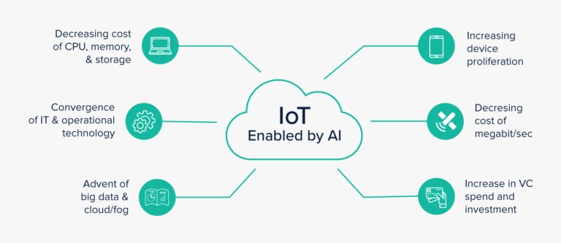
Fig 1.2

- Personalization: AIoT can personalize user experiences by understanding individual preferences and behavior. For instance, AI-powered smart homes can adjust lighting, temperature, and other settings based on residents' habits and preferences.
- Energy Optimization: AIoT can optimize energy consumption in buildings by analyzing data from IoT devices, such as smart thermostats and sensors, to create efficient heating, cooling, and lighting schedules.
- Healthcare Advancements: AIoT has significant implications in healthcare. IoT devices like wearables can collect patient data, and AI algorithms can analyze this data to provide personalized health insights and early disease detection.
- Environmental Monitoring: AIoT can be employed for real-time monitoring of environmental parameters, such as air quality, water quality, and weather conditions. This data helps in predicting natural disasters and managing resources efficiently.
- Smart Agriculture: AIoT can revolutionize agriculture by integrating data from IoT devices like soil sensors, weather stations, and drones. AI algorithms can optimize irrigation, detect diseases in crops, and improve yield prediction.
- Security and Anomaly Detection: AIoT can enhance security by identifying suspicious activities or anomalies in data patterns, helping prevent potential cyber-attacks or intrusions.
- Edge Computing: AIoT often leverages edge computing, where data analysis and decision-making occur at or near the data source. This reduces latency, bandwidth usage, and enhances privacy and security.
Despite its potential benefits, AIoT also raises concerns about data privacy, security, and ethical use of AI algorithms. Striking the right balance between convenience and safeguarding user information is crucial for the widespread adoption of AIoT technologies.
Overall, AIoT is a powerful combination that has the potential to drive innovation, automation, and efficiency across various industries, transforming the way we interact with technology and the world around us.
So how AI is implemented using IoT?
Implementing IoT and AI requires a combination of hardware, software, and cloud services. Here's a high-level overview of the steps involved in implementing IoT and AI:
- Define the Use Case: Start by identifying the specific problem or use case you want to address with IoT and AI. It could be anything from smart home automation to industrial predictive maintenance or healthcare monitoring.
- Select IoT Devices: Choose the appropriate IoT devices (sensors, actuators, cameras, etc.) that can collect the necessary data for your use case. Make sure these devices are compatible with the communication protocols you plan to use (Wi-Fi, Bluetooth, Zigbee, etc.)
- Data Collection and Communication: Set up the IoT devices to collect data and establish communication with a gateway or cloud platform. The data collected could be anything from temperature and humidity to motion or image data, depending on your use case.
- Cloud Platform Integration: Choose a cloud platform that supports IoT services and provides data storage, real-time data processing, and scalable computing resources. Examples include AWS IoT Core, Microsoft Azure IoT Hub, or Google Cloud IoT Core.
- Data Preprocessing: Raw data from IoT devices might require preprocessing before feeding it to AI algorithms. This step involves cleaning, filtering, and aggregating data to make it suitable for analysis.
- AI Model Selection: Depending on your use case, select the appropriate AI model or algorithm. For example, you might use machine learning for predictive maintenance, computer vision for image analysis, or natural language processing for voice commands.
- AI Model Training: Train the AI model using historical data to learn patterns and make predictions. This step is essential for supervised learning tasks, where the AI model needs labeled data to understand the relationships between input and output.
- Real-Time Analysis: Deploy the trained AI model to your cloud platform or edge devices to perform real-time analysis on the incoming data from IoT devices.
- Decision Making and Actuation: Based on the AI model's analysis, make decisions or trigger actions. For example, an AIoT system in a smart home might adjust the thermostat settings, turn on lights, or notify users of potential issues.
- Security and Privacy: Ensure that your IoT and AI implementation follows best practices for security and privacy. Encrypt data during transmission, use authentication mechanisms, and implement access controls to protect sensitive information.
- Continuous Monitoring and Optimization: Continuously monitor the performance of your IoT and AI system. Gather feedback and data to improve the AI model and optimize the system for better results.
- Scalability and Expansion: Plan for scalability as your IoT and AI implementation grows. Consider the ability to add more devices, handle increased data volumes, and support additional use cases in the future.
- Integration with User Interfaces: Implement user interfaces (e.g., mobile apps, web dashboards) to interact with the AIoT system, allowing users to monitor and control devices, view insights, and receive alerts.
Keep in mind that IoT with AI implementations can vary significantly based on the specific use case, the level of AI complexity required, and the available resources. It's crucial to thoroughly test and iterate on your implementation to achieve the desired functionality and performance. Additionally, leveraging existing IoT and AI platforms and services can speed up the implementation process and simplify maintenance and scalability.

Below is a simple Python program that demonstrates the integration of IoT and AI. The program simulates a smart home scenario where an IoT device (a temperature sensor) collects data and an AI algorithm (a simple decision-making AI) analyzes the data to control a smart thermostat.
In this example, we assume the temperature data is generated randomly for demonstration purposes. In a real-world scenario, the IoT device would read data from an actual temperature sensor.
import random
# AI Decision-Making Function
def smart_thermostat_controller (temperature):
if temperature > 25:
return "Cooling ON"
else:
return "Cooling OFF"
# IoT Temperature Sensor Simulation
def get_temperature_data():
# In a real IoT scenario, this function would read temperature from an actual sensor
# For simplicity, we generate random temperature data between 20 and 30 degrees Celsius
return random.randint(20, 30)
# Main Program Loop
def main():
while True:
# Read temperature data from IoT device (sensor)
temperature = get_temperature_data ()
# AI makes the decision based on the temperature data
decision = smart_thermostat_controller (temperature)
# Display the result
print(f"Temperature: {temperature}°C - {decision}")
if _name_ == "_main_":
main()
In this program, we have a simple AI decision-making function smart_thermostat_controller (). The function takes the current temperature as input and returns the decision of whether to turn the cooling system ON or OFF. If the temperature is above 25 degrees Celsius, the AI decides to turn ON the cooling, otherwise, it decides to turn it OFF.
The get_temperature_data() function simulates the IoT temperature sensor and generates random temperature data between 20 and 30 degrees Celsius.
The main() function runs an infinite loop to continuously read the temperature data from the IoT device and make decisions based on that data using the AI algorithm.
Keep in mind that this is a basic example to illustrate the integration of IoT and AI. In a real-world scenario, you would use actual IoT devices and implement more sophisticated AI algorithms for data analysis and decision-making.
Where AI is implemented using IoT?
IoT with AI was being implemented and utilized across various industries and applications. Some of the sectors where IoT with AI was actively deployed include:
- Smart Homes: IoT devices like smart thermostats, smart lighting, and voice-activated assistants (e.g., Amazon Echo, Google Home) leverage AI to understand user preferences, optimize energy consumption, and automate home tasks.
- Healthcare: AIoT is used for remote patient monitoring, wearable health devices, and predictive analytics to assist in early disease detection, personalized treatment plans, and better healthcare management.
- Industrial IoT (IIoT): Manufacturing, oil and gas, and other industries are adopting AIoT for predictive maintenance, quality control, and process optimization, leading to increased efficiency and reduced downtime.
- Autonomous Vehicles: AIoT plays a critical role in self-driving cars by processing data from various IoT sensors (e.g., lidar, cameras) to make real-time decisions and navigate safely.
- Smart Cities: In urban planning, AIoT enables efficient traffic management, waste management, public safety monitoring, and environmental monitoring.
- Agriculture: AIoT is applied in precision agriculture, using data from IoT sensors and drones to optimize irrigation, monitor crop health, and enhance overall farm productivity.
- Energy Management: AIoT is employed to optimize energy consumption in buildings and industrial settings, reducing costs and promoting sustainability.
- Retail: AIoT is used for personalized customer experiences, demand forecasting, inventory management, and in-store optimization.
- Logistics and Supply Chain: AIoT aids in tracking goods in real-time, optimizing shipping routes, and predicting supply chain disruptions.
- Environmental Monitoring: IoT devices equipped with AI capabilities are deployed to monitor air and water quality, weather patterns, and wildlife preservation.
It's important to note that the implementation of IoT with AI is continuously evolving, and new use cases and applications are emerging as technology advances.
Future of enhancing IoT with AI:
The future of enhancing IoT with AI is promising, and several developments are expected to further optimize and advance the integration of these technologies. Here are some of the key changes we can anticipate:
1. Edge AI Advancements: Edge computing, where data processing and AI analysis occur closer to the IoT devices rather than relying solely on cloud resources, will see significant improvements. Edge AI will enable faster decision-making, reduced latency, and better privacy as sensitive data can stay within local networks.
2. Federated Learning: To address privacy concerns and bandwidth limitations, federated learning will gain traction in AIoT systems. Federated learning allows AI models to be trained across multiple devices locally without sharing raw data with a central server, maintaining user privacy while still benefiting from collective intelligence.
3. AI Model Compression: IoT devices often have limited computational resources and memory. To address this, AI model compression techniques will be further developed, allowing complex models to be efficiently deployed on resource-constrained devices.
4. Energy-Efficient AI: Power efficiency is crucial for IoT devices running on batteries or energy harvesting. Future advancements will focus on developing AI algorithms optimized for low-power consumption, ensuring longer device lifespans.
5. Explainable AI: As AI applications in IoT become more critical, there will be an increased emphasis on making AI decisions more interpretable and explainable. Understanding why AI systems make specific choices will be essential for building trust and ensuring safety.
6. Swarm Intelligence: Inspired by collective behaviors observed in natural systems (e.g., ants, birds), swarm intelligence will be used in IoT with AI. Swarm-based algorithms will enable collaborative decision-making and resource optimization across distributed IoT devices.
7. AI-Driven Autonomous Systems: IoT with AI will lead to more sophisticated autonomous systems in various domains, such as autonomous vehicles, smart factories, and robotic automation. These systems will be capable of learning from dynamic environments and adapting to changes in real-time.

Statistics on How AI is taking all over the market
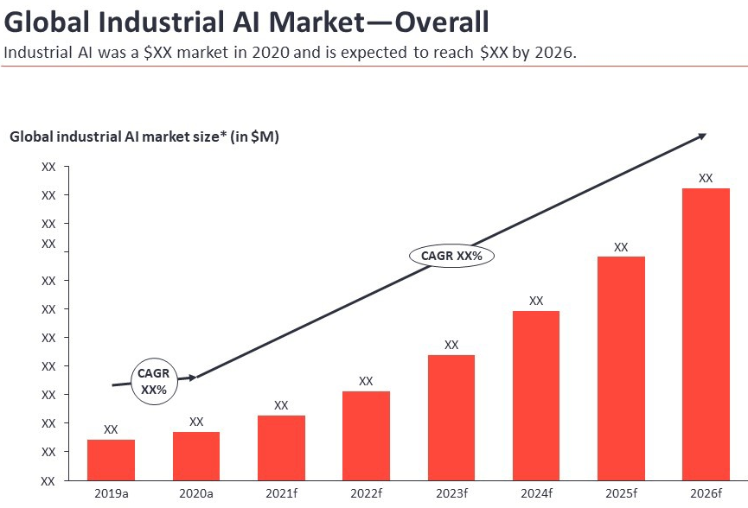
Fig 1.3

7. AI-Driven Autonomous Systems: IoT with AI will lead to more sophisticated autonomous systems in various domains, such as autonomous vehicles, smart factories, and robotic automation. These systems will be capable of learning from dynamic environments and adapting to changes in real-time.
8. IoT Block chain Integration: The combination of IoT and block chain will enhance security, transparency, and data integrity in AIoT systems. Block chain technology can provide a decentralized and tamper-resistant ledger for IoT data, ensuring data authenticity and reliability.
9. Contextual Awareness: AI algorithms will become better at understanding contextual information from IoT devices. This will enable more personalized and adaptive experiences for users in applications like healthcare, smart homes, and personalized marketing.
10. AIoT Ecosystem Standardization: As AIoT becomes more pervasive, there will be a need for standardized protocols, interfaces, and frameworks to enable seamless integration of various IoT devices and AI models from different vendors.
11. Ethical AIoT Development: The ethical implications of AIoT will receive increased attention. Guidelines and regulations will be established to ensure responsible AI development, data privacy, and algorithmic fairness.
12. AI-Driven Predictive Maintenance: AIoT will play a significant role in predictive maintenance across industries. Advanced AI algorithms will be utilized to predict equipment failures and optimize maintenance schedules, reducing downtime and costs.
Overall, the future changes in IoT with AI will foster innovation, transform industries, and create more intelligent, autonomous, and interconnected systems that improve efficiency, convenience, and sustainability in our daily lives.
Advantages of IoT using AI:
1. Enhanced Automation: AI in IoT enables autonomous decision-making and automation, reducing the need for human intervention and streamlining processes.
2. Real-Time Insights: AI algorithms can analyze data from IoT devices in real-time, providing valuable insights and enabling immediate actions or responses.
3. Predictive Maintenance: AI can analyze data from sensors in industrial equipment and predict potential failures, allowing for proactive maintenance, reducing downtime, and saving costs.
4. Personalization: AI can analyze user behavior and preferences from IoT devices to deliver personalized experiences and services, such as personalized recommendations or customized settings.
5. Energy Efficiency: AIoT systems can optimize energy usage in smart homes and buildings by analyzing data from sensors and adjusting devices to conserve energy.
6. Improved Healthcare: AI in IoT enables remote patient monitoring, early disease detection, and personalized treatment plans, leading to improved healthcare outcomes.
Various advantages of AIoT

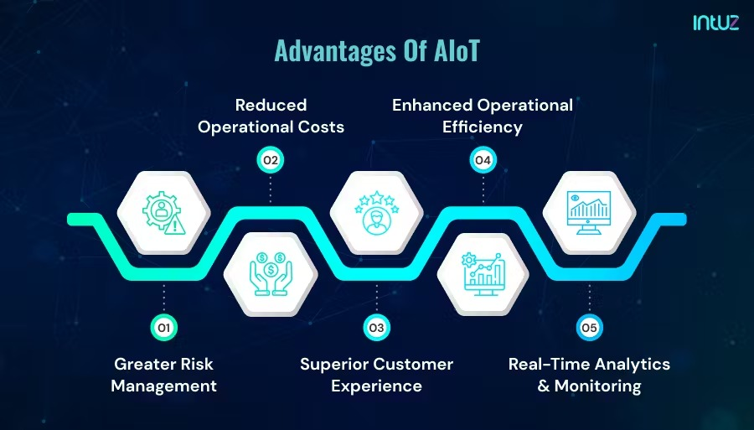
Fig 1.4

7. Smart Cities Advancement: AIoT can optimize traffic flow, manage waste efficiently, and enhance public safety, contributing to the development of smarter and more sustainable cities.
8. Data-driven Decision Making: AI-driven insights from IoT data enable better decision-making and resource allocation across various domains.
Disadvantages of IoT using AI:
1. Privacy and Security Concerns: The integration of AI with IoT raises concerns about data privacy and security, as vast amounts of personal data are collected and processed.
2. Complexity and Cost: Implementing AI in IoT systems can be complex and costly, particularly when dealing with large-scale deployments and sophisticated AI models.
Various disadvantages of AIoT
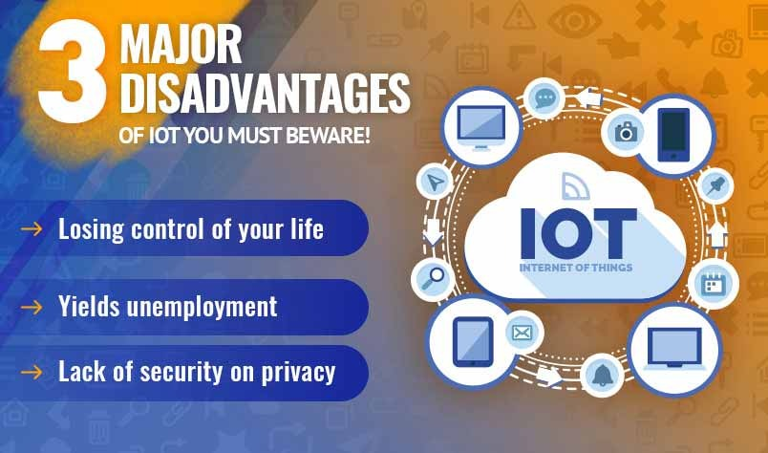
Fig 1.5

3. Dependence on Connectivity: IoT devices rely on stable and reliable internet connectivity. Disruptions or downtime in connectivity can impact the functioning of AIoT systems.
4. Data Overload: IoT generates enormous amounts of data, which can overwhelm AI systems and require robust data management and storage solutions.
5. Ethical Considerations: AIoT systems need to address ethical issues, such as biased decision-making, transparency, and accountability of AI algorithms.
6. Scalability Challenges: Scaling AIoT solutions to accommodate a growing number of devices and users can be challenging, requiring careful planning and architecture.
7. Technical Complexity: Integrating AI and IoT requires expertise in both domains, making it challenging for some organizations to implement these technologies effectively.
8. Limited Local Processing: AI models often require significant computational power, which can be a limitation for resource-constrained IoT devices operating at the edge.
Overall, while IoT using AI offers numerous benefits, it also comes with challenges that need to be carefully addressed for successful implementation and widespread adoption. Organizations must be mindful of the potential risks and invest in robust security measures and ethical guidelines to build trust and confidence in AIoT solutions.

Increasing Popularity of IoT and AI
Many businesses have formerly adopted AI and IoT as part of their process and operations. IoT and AI are the popular technologies presently in use. It has been seen that many companies are highly investing in top technologies like AI and IoT to increase efficiency and give competitive advantage. The graph below depicts the details:

Graphical representation of increasing popularity of IoT and AI

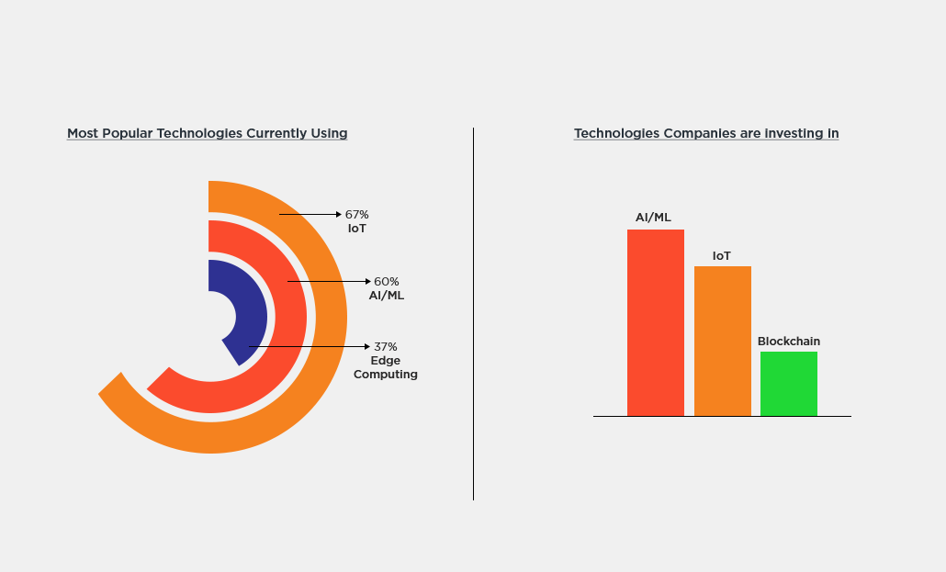
Fig 1.6

IBM Global C- suite directors have begun to resuscitate their business by digitizing relations and dispatches. IBM Institute canvassed a group of C- suite directors and set up that 19 of repliers( grouped as high players called Reinventors) are keenly concentrated on the benefits of stoked IoT with AI.
Use Cases of AIoT

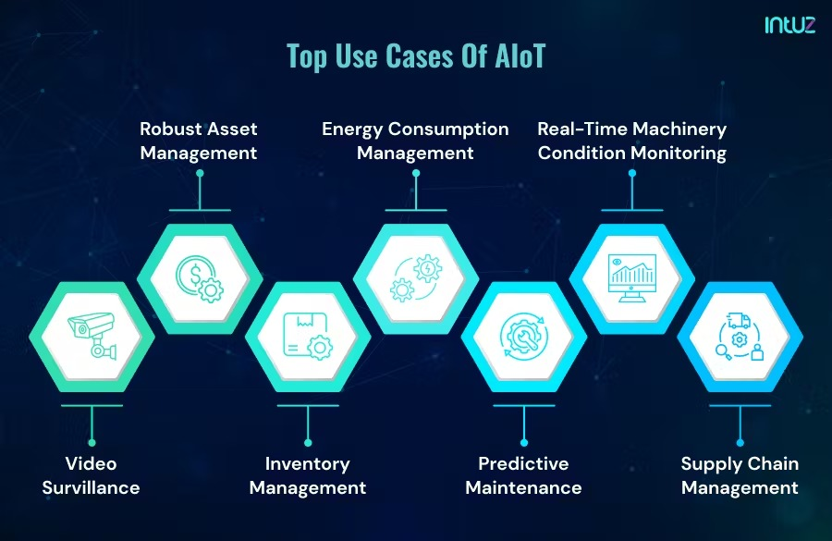
Fig 1.7

Startups and large companies prefer to use AI technology for unleashing the full potential of IoT. The leading merchandisers of IoT platform like Oracle, Microsoft, Amazon, and Deals forces have started consolidating AI capabilities into their IoT operations. However, keep in mind that the landscape of technology companies is constantly evolving, and new players might have emerged or adopted AIoT solutions since then. Here are some well-known companies that were implementing IoT with AI at that time:
1. Amazon: Amazon uses AI and IoT in its Echo devices with Alexa, offering voice-activated smart home controls, personalized recommendations, and more.
2. Google: Google incorporates AI into its Nest smart home devices, providing features like intelligent thermostats, security cameras, and voice commands using Google Assistant.
3. Microsoft: Microsoft employs AI and IoT in its Azure IoT platform, offering cloud services for IoT data management, analysis, and predictive maintenance.
4. IBM: IBM uses AIoT solutions in various industries, including manufacturing, healthcare, and agriculture, for predictive maintenance and process optimization.
5. Apple: Apple uses AI and IoT in its Home Kit platform for smart home control and automation using Siri.

SUMMARY

In this chapter, we discussed the concept of IoT (Internet of Things) and AI (Artificial Intelligence) individually, followed by their implementation together, known as IoT with AI or AIoT (Artificial Intelligence of Things).
- IoT refers to the network of physical objects or "things" embedded with sensors, software, and connectivity that enable them to collect and exchange data over the internet. The main components of IoT include devices/things, connectivity, data processing, data analysis, and action/control.
- AI is a branch of computer science that focuses on creating intelligent machines capable of performing tasks that typically require human intelligence. Key concepts of AI include machine learning, natural language processing, computer vision, and robotics.
- AIoT is the integration of AI technologies with IoT systems. It combines data collection and connectivity capabilities of IoT with AI's advanced analytics and decision-making capabilities.
- Implementing IoT with AI involves selecting appropriate IoT devices, choosing a cloud platform for data processing, training AI models, real-time data analysis, decision-making, security, and scalability considerations.
- AIoT offers enhanced automation, real-time insights, predictive maintenance, personalization, energy efficiency, improved healthcare, and advancements in smart cities and data-driven decision-making.
- Challenges include privacy and security concerns, complexity and cost of implementation, dependence on connectivity, data overload, ethical considerations, scalability issues, and technical complexity.
- The future of IoT with AI is expected to see advancements in edge AI, federated learning, AI model compression, energy-efficient AI, explainable AI, swarm intelligence, AI-driven autonomous systems, IoT block chain integration, and ethical AIoT development.
Overall, IoT with AI holds immense potential to revolutionize various industries, improve efficiency, and provide personalized and intelligent services. However, addressing challenges related to security, privacy, and scalability will be crucial for its successful and responsible implementation in the future.

BIBLIOGRAPHY

- https://www.embedded.com/what-is-the-ai-of-things-aiot/
- https://blog.gopenai.com/from-smart-to-intelligent-the-rising-era-of-aiot-f55b1e04f6e3
- https://www.clariontech.com/blog/ai-and-iot-blended-what-it-is-and-why-it-matters
- https://www.indianai.in/aiot-artificial-intelligence-of-things/
- https://www.datadriveninvestor.com/2019/12/10/aiot-the-new-technology-powerhouse-for-new-age-businesses/
- https://cyfuture.com/blog/3-major-disadvantages-of-iot-you-must-beware-of/
- https://iot-analytics.com/product/industrial-ai-aiot-market-report-2021-2026/

