A COMPREHENSIVE STUDY ON FUZZINESS AND INTERNET OF THING (IOT) AND REAL-LIFE APPLICATIONS
I. S Kharsyntiew¹* Fokrul A. Mazarbhuiya¹*, M. Shenify², A. S. Wungreiphi¹, and J. Kez¹
1 Department of Mathematics, School of Fundamental & Applied Sciences
Assam Don Bosco University, Tapesia Garden, Assam-782402, INDIA
Email: ibanskharsyntiew@gmail.com , fokrul.mazarbhuiya@dbuniversity.ac.in, wungreiphias@gmail.com, janetkrengma@gmail.com
2 Department of Computer Science, AlBaha University, Albaha, Saudi Arabia
Email: maalshenify@bu.edu.sa

ABSTRACT
Fuzziness has gained ground in every area of human understanding because of its capacity to handle the most realistic systems. It has several theoretical and real-world applications in fields including medicine, security, and the stock market, among others. One of the methods for replicating human mind is generally recognised as fuzzy set. It has been demonstrated to be effective in addressing a range of real-life issues linked to the aforementioned domains. Internet of Things (IoT) is one area where this is applicable. IoT technology has improved human life by enabling a variety of practical smart applications. The IoT is made up of many digital devices that are connected to one another and generate a lot of data for calculations. In this chapter, we propose to discuss about different notions of fuzziness like fuzzy logics, fuzzy graphs etc. along with their applications We also discuss a small example to show how fuzzy logic is used in household appliances specifically washing machines. It is also discussed about IoT, key-features, their advantages and disadvantages with applications Finally, it is also discussed the various applications of fuzzy in the context IoT.
The section 1, discusses introduction describing various stages of development in this field. The section 2 reviews the definitions of fuzzy sets and its applications. A brief discussion on fuzzy graphs and its applications will be found in Section 3. The definitions of IoT, key features, advantages and disadvantages are discussed in section 4. Real-life applications of IoT are discussed in Section 5. Some important applications of fuzzy in the context of IoT are discussed in section 6 and lastly, the chapter is concluded with a brief conclusions and references are given at the end.
Keywords: fuzzy sets, fuzzy logic, fuzzy logic control fuzzy graphs, applications
- INTRODUCTION
More frequently, we have observed that genuine or factual events cannot be described by the classical or crisp set [1]. It is obvious that a "class of real numbers," "class of intelligent students," or "class of tall girls and boys" does not, from a classical mathematical perspective, constitute a set. However, it is a truth that these vague "classes" play a substantial role in human intellect, notably in the area of pattern identification, information transfer, and abstraction. Fuzzy set theory is a new branch of human knowledge that has emerged in connection with the aforementioned concepts. In the year 1965, it was first presented by Lofti A. Zadeh [2] as an extension of the conventional notion of classical set. Fuzzy sets offer a more realistic picture of reality than the conventional demonstration in mathematics. The idea is crucial for demonstrating the finite degree of precision in mental representations because membership in fuzzy sets is progressive [3]. Following the creation of fuzzy sets, it has been noted that several other subjects or areas of research connected to fuzzy sets have also been developed, including fuzzy graphs and fuzzy logic, which have many uses in a range of fields, including computer sciences, artificial intelligence, agriculture, and medicine.
The theory's inventor, Lotfi A. Zadeh, published the initial article on the subject in 1965. In order to strengthen the basis of the fuzzy set theory, Zadeh developed fuzzy similarity linkages, linguistic hedges, and fuzzy decision-making between 1965 and 1975. In 1970, Mamdani invented the first fuzzy logic controller. In 1977, certain industrial settings in Europe and Japan began to employ fuzzy logic. Due to its popularity in Japan at the beginning of the 1980s, fuzzy logic saw a rebirth in the US at the conclusion of the decade [4].
There are huge numbers of applications that rely on sensors that provide essential information that changes over time, largely on account of the development of IoT [5], and connected real time data sources. Streaming and time-series data availability has increased exponentially due to IoT. Analysis of this data can provide valuable insights. In addition, the IoT systems allow us to increase automation, analytics and integration within our system. They enhance the accessibility and accuracy of the aforesaid areas. The IoT takes advantage of existing and new technologies in sensing, networking, and robotics. It also takes advantage of recent software innovations, falling hardware prices, and evolving attitudes towards technology. The combination of new and advanced elements leads to significant changes in the delivery of products, goods, and services; and the social, economic, which has great political impacts of these changes.
- SOME IMPORTANT CONCEPTS RELATED FUZZY SETS AND APPLICATIONS
  - FUZZY SET AND FUZZY LOGIC
The fuzzy set itself is known as the fuzzy logic and the fuzziness of any set is described by fuzzy logic. A fuzzy set [1] A in X (universe of discourse) is a collection of ordered pairs A= {( $x$,$µ_{A}$($x$))} such that $µ_{A}$(x) is the grade of membership of $x$ ∈ A and $µ_{A}$(x) ∈ [0,1].
Example: Let X be a set of natural numbers from 1 up to 10 i.e.,
$$X=\{1, 2, 3, 4, 5, 6, 7, 8, 9,10\}$$
A = “natural number close to 5”
$$µ_{A}\left(x\right)=\{({\left(5^{2}-x^{2})-1\right)}^{-1}\}$$
$$A=\frac{0.04}{1}+\frac{0.045}{2}+\frac{0.05}{3}+\frac{0.1}{4}+\frac{1}{5}+\frac{0.1}{6}+\frac{0.043}{7}+\frac{0.026}{8}+\frac{0.018}{9}+\frac{0.013}{10}$$
  - FUZZY LOGIC CONTROL
In a fuzzy logic controller, there are three stages. The first stage is called fuzzy conversion. In this stage, the crisp variable is transformed into a fuzzy variable. The second stage is called if-then. Here, some rules are defined and the inference system is executed. The third stage is called defuzzification, in which the resulting fuzzy output gets converted back to a crisp variable. [6].
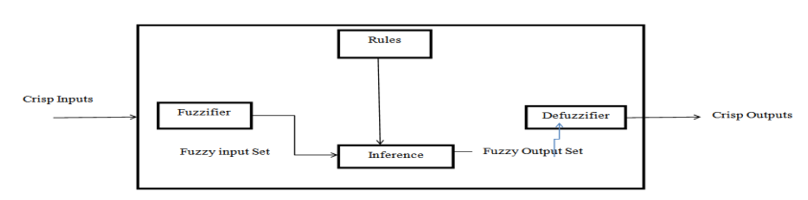
Fig 1: Fuzzy Logic System

  - APPLICATIONS OF FUZZY SETS AND FUZZY LOGIC
Fuzzy mathematics is based on fuzzy sets and is an extension of traditional mathematics. The scope of fuzzy logic extends far beyond mathematics. In this study, we will look at a few uses of fuzzy logic which have been shown to be effective. In chemical science, Davidson and Hayward [8] looked at multiple instances using fuzzy control systems. For example, in the case of Almardy, the study showed that the fuzzy control system was effective in protecting a long buried pipeline by applying current to a set of anodes. The study also showed that the use of the fuzzy control system helped to minimize the power used in protecting the pipeline.
In agriculture, the work of [9] looked at the uses of fuzzy logic for pest management, disease management, and weed management. They also looked at using fuzzy logic to develop expert system for different crops and to analyse and study soil.
In washing machines, fuzzy logic is used to help the washing machine achieve an economical wash. For example, using fuzzy logic, the following input parameters will help the washing machine: Amount of dirt, Type of dirt, Sensitive cloth, Amount of cloth [7]. Fuzzy Logic Inference System is a type of fuzzy logic system has been applied to determine the probability of candidate selection to win in the election. Most widely used types of fuzzy inference are Mamdani type and Sugeno type. Fuzzy logic toolbox is available in MATLAB. [10]. Other areas of research, like the medical field and environmental sciences, also use fuzzy logic.
  - APPLICATION OF FUZZY LOGIC ON WASHING MACHINE
The most important job of a washing machine is cleaning the cloths without harming them. To accomplish this task, the input parameters of fuzzy logic system associated to washing need to be given importance. The inputs and outputs of the fuzzy logic system are given in Fig. 2

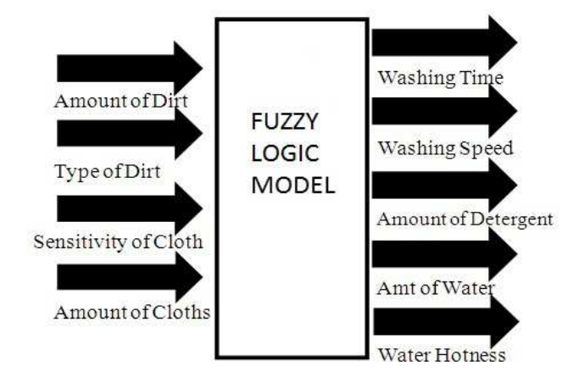
Fig 2: Inputs and outputs of the system

The values, names, and upper and lower limits of the input and output parameter are being defined according to the problem. Figure 3 and Figure 4 display the membership functions of the inputs and outputs, as well as their upper and lower limit.

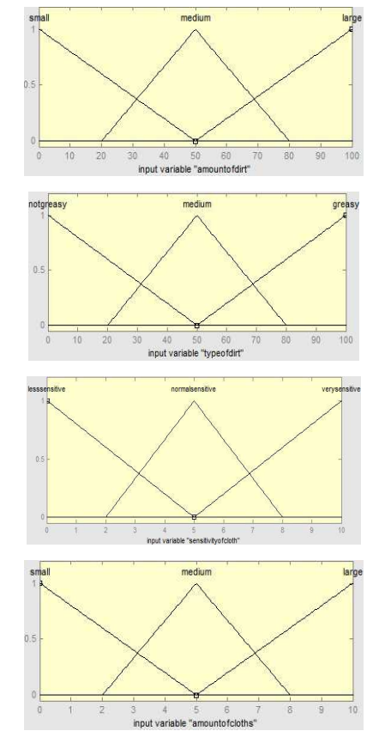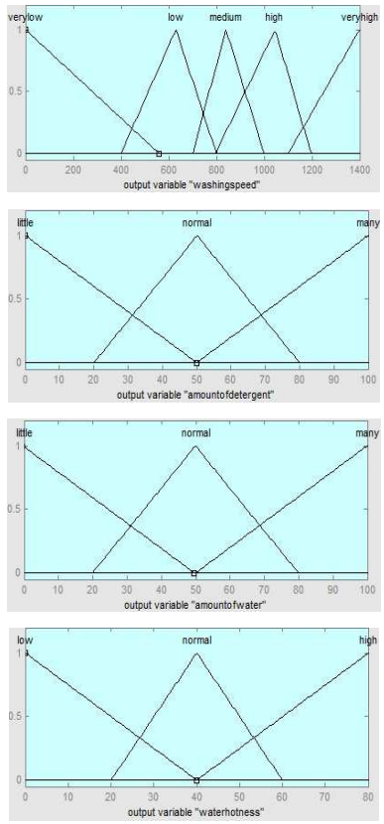
Fig 3: Fuzzy logic input membership functions Fig 4: Fuzzy logic output membership functions

Modelling a washing machine using fuzzy rules has been done. The entire system has been created using MATLAB's fuzzy logic tool box [11].

- SOME IMPORTANT CONCEPTS RELATED FUZZY GRAPHS AND APPLICATIONS
  - FUZZY GRAPH
Rosenfeld developed fuzzy graphs ten years after Zadeh published his seminal study "Fuzzy Sets." A number of fundamental graph-theoretic notions, including bridges, paths, cycles, trees, and connectedness, have fuzzy analogues, and Rosenfeld has discovered some of their features. It is commonly known that graphs are essentially illustrations of relationships. For visualizing data on the connections between items, a graph is a valuable tool. Edges depict relationships, whereas vertices identify the items. A "fuzzy graph model" is required if there are ambiguities in item’s descriptions or relationships, or both [12]
3.2 DEFINITION: Let E be the (crisp) set of nodes. A fuzzy graph is then defined by
$$G\left(x_{i},x_{j}\right)=\{(\left(x_{i},x_{j}\right),μ\left(x_{i},x_{j}\right))|\left(x_{i},x_{j} \right)∈E×E\}$$
where $(x_{i},σ\left(x_{i}\right))$ and $(x_{j},σ\left(x_{j}\right))$ are fuzzy nodes and $\left(g,μ\left(x_{i},x_{j}\right)\right)or \left(g,μ\left(g\right)\right)$ are the fuzzy edges of the fuzzy graph.
If $g=\left(x_{i},x_{j}\right)$, then the fuzzy points $(x_{i},σ\left(x_{i}\right))$ and $(x_{j},σ\left(x_{j}\right))$ are adjacent nodes and the fuzzy nodes $(x_{i},σ\left(x_{i}\right))$ and the fuzzy edge $(g,μ\left(x_{i},x_{j} \right))$ are incident with one another. If two distinct fuzzy edges $(g_{1},μ\left(g_{1}\right))$ and $(g_{2},μ\left(g_{2}\right))$ are said to be fuzzy adjacent if they are incident on a same fuzzy node [1].
Example:
($x_{1}, 0.6)$ ${(x}_{1}x_{2},0.4)$ ($x_{2}, 0.4)$

${(x}_{1}x_{4},0.3)$ ${(x}_{2}x_{3},0.3)$

($x_{4}, 0.4)$ ${(x}_{3}x_{4},0.4)$ ($x_{3}, 0.6)$
In the above figure,
- ($x_{1}, 0.6)$, ($x_{2}, 0.4)$, ($x_{3}, 0.6)$ and ($x_{4}, 0.4)$ are the fuzzy points.
- ${(x}_{1}x_{2},0.4)$, ${(x}_{2}x_{3},0.3)$, ${(x}_{3}x_{4},0.4)$ and ${(x}_{1}x_{4},0.3)$ are the fuzzy edges.
- ($x_{1}, 0.6)$ and ($x_{2}, 0.4)$ are fuzzy adjacent points.
- ${(x}_{1}x_{2},0.4)$ joins ($x_{1}, 0.6)$ with ($x_{2}, 0.4)$ hence ${(x}_{1}x_{2},0.4)$ is incident with ($x_{1}, 0.6)$ and ($x_{2}, 0.4)$.
- Since ${(x}_{1}x_{2},0.4)$ and ${(x}_{2}x_{3},0.3)$ are incident with ($x_{2}, 0.4)$ hence ${(x}_{1}x_{2},0.4)$ and ${(x}_{2}x_{3},0.3)$ are adjacent edges.

3.3 APPLICATION OF FUZZY GRAPHS
Fuzzy graph has a wide range of applications. Some of these applications are given below:
- TRAFFIC LIGHTS PROBLEM’S SOLUTION: Traffic lights problem [13] is basically about controlling a traffic light system in a way that gives you a certain level of safety. It's been studied like an intersection graph, and you can model it by colouring the graph. Cars go from one way to another, and each intersection shows where two arrows might intersect. But the number of cars in each path isn't always the same. That's why we think of it as a fuzzy set, and its membership value depends on how many cars are in each path. If you have a lot of cars in one path, it's going to have a high membership value, and if you don't have many cars in any path, it'll have a low membership value. Also to represent telecommunication network fuzzy graphs have been used [13]

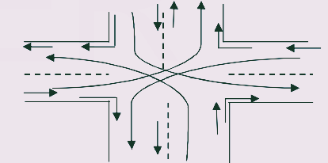

- IoT
  - Key Features
AI, connection, sensors, active involvement, and small devices are the most important aspects of IoT. In below, we discuss the features briefly:
- Connectivity – New technologies for networks, especially IoT networking, mean networks are no longer just for big companies. Networks can now run on much smaller scales and at much lower costs while still being viable. IoT creates these small networks between its system devices.
- AI – The IoT makes almost anything “intelligent”, which means it improves almost all dimension of our lives due to data capture, IoT network and AI algorithms.
- Active Engagement – Most of the technology engagement of today is passive. IoT presents a whole new way of engaging with active content, products, or services.
- Sensors –IoT without sensors loses identity. Sensors act as essential tools to develop an active system from a simple network of devices.
- Small Devices – As predicted, devices have grown smaller, more cost-effective, and more efficient as time went on. IoT takes advantage of purpose-made small devices to provide its accuracy, scalability and flexibility.
4.2 IoT − Advantages
The benefits of IoT extend to every aspect of life and business. Below is a brief overview of some of IoT’s benefits:
- Improved Customer Engagement – Existing analytics suffers from blind spots and glaring inaccuracies; and as mentioned earlier, participation remains passive. IoT entirely changes this, enabling richer and more meaningful participation with audiences.
- Enhanced Data Collection – The difficulty of present data collection is that it is limited and designed to be used passively. IoT takes data collection from those silos and places it where people actually desire it to be used to understand their world. IoT enables an absolute picture of the whole thing.
- Technology Optimization – The same tools and data that enhance the customer journey also enhance device usage and help drive more powerful technology enhancements. IoT opens up a world of essential functional and field information.
- Reduced Waste – The IoT makes it clear where improvements need to be made. While traditional analytics only provide surface-level insights, IoT delivers real-world data that leads to better resource management.
  - IoT − Disadvantages
The IoT has a lot of advantages, but it also has a lot of problems. Here are some of its main problems:
- Privacy – The advanced nature of the IoT gives access to large amounts of personal information in extremely granular detail without the consent of the user
- Security – The IoT creates a network of devices that are always in communication with each other. The system provides limited control over these devices, even though there are security measures in place. This leaves users vulnerable to a wide range of attack types.
- Complexity – For some, IoT systems are difficult to design, set up, and maintain because they leverage multiple technologies and a wide range of emerging enabling technologies.
- Compliance – The IoT, like any other business technology, is subject to regulatory compliance. Due to the complexity of the technology, the compliance challenge seems insurmountable when many view standard software compliance as a battle.
- Flexibility – Many people are worried about how easy it is for an IoT system to connect to another system. They’re worried about having multiple conflicting or locked systems.
- Real-life applications of IoT technology
In below we discuss some real-life applications to the futuristic trends of IoT technology.
  - Government and Safety
Infrastructure-as-a-Service (IoT) for government and safety enables better law enforcement and defense, better urban planning, and better economic governance. IoT fills gaps, addresses many existing shortcomings, and broadens its scope. For instance, IoT helps city planners achieve a superior insight of their design impact, and governments obtain insight into the local economy.
  - Home and Office
From the convenience of our homes to the convenience of our offices, from the convenience of our businesses to the convenience of the organizations we interact with on a daily basis, IoT offers a personalised experience that enhances our overall satisfaction, productivity, and safety. For instance, IoT help us to customise office space to optimise work.
  - Health and Medicine
The IoT is pushing us to our vision of the future of medicine that leverages a extremely interconnected network of advanced medical devices. Nowadays IoT has the potential to significantly improve research in medical field, medical devices, medical care and emergency care. Integrating these provides greater precision, greater attention, quicker responses to events and continuous betterment while reducing typical operating costs for research and organizations.
  - Marketing and Content Delivery
The way IoT works same way to the technology, analytics and big data work today. Prevailing technologies collect explicit data to create metrics and trends over time, but this data usually lacks granularity and precision. IoT, on the other hand, looks at more behaviours and analyses them in different ways. This results in extra information and granularity, which provides robust metrics and trends. IoT enables organizations to understand and response its customers’ needs or wants more accurately. It increases business efficiency and strategy, while improving the overall experiences of consumer by supplying the precise solutions and right contents.
  - Improved Advertising
Advertising of today is over-the-top and under-targeted. Even with the most up-to-date analytics, contemporary advertising is struggling. The IoT promises a more diverse and personalized advertising experience, rather than a one size fits all approach. It takes advertising from being noise to noise. Since people interact with advertising through IoT, rather than just passively consuming it, it becomes more useful and functional for people who are searching for solutions in the market or wondering if there really are any solutions.
  - Extreme Weather
Deep monitoring is possible with today’s advanced, cutting-edge systems. However, these systems are limited by their reliance on broad instruments, such as radar and satellite. Their small-scale instruments do not provide the same level of targeting accuracy as more robust technology. New innovations in the IoT promise more detailed data, greater precision, and greater scalability. High-level forecasting necessitates high-level details and scalability of range, tool types, and deployment. This allows early detection and response to minimize the risk of loss of life and property.
  - Commercial Farming
Modern commercial high-tech farms have been using cutting-edge technology and biotech for a long time, but the IoT brings automation and deeper analysis to an extreme level. Most of the commercial farming, such as weather monitoring, relies on human labor and is still limited in its automation. IoT-based operations remove maximum human involvement in system operation, analysis and monitoring of farming. The systems identify variations in crops, soil and environment etc. Such systems optimize typical processes by analysing huge data collections, and prevent risks (such as E. coli) and permit better control.

- Some important applications fuzzy in IoT.
In below, we discuss some real life applications where fuzzy has been used in the IoT-based technology.
  - Fuzzy set consensus analysis in IoT resource ranking:
The process of finding, categorizing, and choosing the right resources to meet customer needs is getting harder and harder to do, especially with more and more resources connected to the internet. In [14], the authors looked at the association between limited equivalence functions, or consensus measures, and if it's possible to build the latter using the first. So, if you have two consensus measures of a fuzzy value and a consensus measure on a fuzzy set, they're both defined by an aggregation, like the arithmetic mean or the exponential mean. They also looked at any inaccuracies that could be related to the measurements outside of the uncertainties. They modelled the uncertainty in classifying a bunch of resources in the IoT-based on an IT2FL-EtherDA-RR Model.
  - Fuzzy in IoT Devices for Smart Home to Assist Blind People for Navigation:
As wireless communication advances, the need for devices to enable safe mobility for blind people is growing. AI devices with several inputs and outputs have been applied for accurate data estimates based on maximum likelihood. A smart home model for safe and reliable mobility for blind people was presented in [15] using fuzzy logic for simulation. Sensors and bluetooth outputs from IoT devices are input of fuzzy controller. Rules based on blind person conditions and requirements are generated to generate decision as output. These outputs are communicated via IoT devices to help the blind person/user for safe mobility. The proposed system makes it easy for the user to navigate and avoid obstacles.

  - Fuzzy logic-based IoT health monitoring:
Health Monitoring is really taking off right now. With all the family members being busy and busy, it's really important to keep an eye on the health of older people and patients. A system was created in [16] where caretakers could get info on the temperature and pulse rate of people they're monitoring at home, as well as info on the air quality of the home. If any dangerous gas was found, the system would sound an alarm. Fuzzy logic was used to monitor and analyse the data from temperature, heartbeat, and gas sensors. The data was trained and the outliers from the sensors would be spotted. The data was sent off to the cloud and you can download it using Thing speak. Future work is looking at how to automate the sending of the outlier reports to the caretaker and doctor using deep learning.

- CONCLUSION
The idea of fuzzy has changed the mathematical landscape significantly, enabling it to make significant contributions to other fields of study. Similarly, introduction of IoT technology has enabled a significant change in the life and work of people. Numerous real-world issues that could not be resolved by Boolean logic or conventional logic have been addressed using fuzzy logic, fuzzy graphs IoT etc. This study has depicted a brief over on notions fuzzy and their real life applications particularly in machines. It has addressed the applications fuzzy graphs to study the issues associated with traffic and accident-prone locations. Further, the study also covers IoT technology, key features, advantages and disadvantages, and some real life applications with examples. Finally, the study also covers the applications of fuzzy on some of IoT-based systems. We can therefore draw the conclusion that studies are effective and very helpful for analysing situations that can only be fully understood by the human intellect. We can infer from the examples provided that it is a crucial idea that will require extensive future study.

REFERENCES
[1] Zimmermann, H.J. (1985) Fuzzy Set Theory and Its Applications. Kluwer, Boston, 11-17
[2] L.A. Zadeh, Fuzzy sets, Information and Control, 8 (1965) 338-353.
[3] D. Dubois, W. Ostasiewicz, H. Prade, Fuzzy Sets: History and Basic Notions Fundamentals of Fuzzy Sets, The Handbooks of Fuzzy Sets Series, 7 (2000) 21-124

[4] Cengiz Kahraman, Başar Öztayşi, Sezi Çevik Onar, A Comprehensive Literature Review of 50 Years of Fuzzy Set, International Journal of Computational Intelligence Systems, 9 (2016) 3-24.
[5] P. Sethi, and S. Sarangi, Internet of things: Architectures, protocols, and applications, Journal of Electrical and Computer Engineering, pp. 1–25,2017. doi:10.1155/2017/9324035.

[5] Poonam Gupta. Application of Fuzzy Logic in Daily Life. International Journal of Advanced Research in Computer Science. 2017; 8(5):1795-1800.
[6] Renu Makkar, Application of fuzzy logic: A literature review, International Journal of Statistics and Applied Mathematics 2018; 3(1): 357-359
[7] Hayward, Davidson. Fuzzy Logic Application, Analyst. 2003; 128:1304-1306.
[8] Philomine Roseline TN, Ganesan, Clarence Tauro JM. A study of Applications of Fuzzy Logic in Various Domains of Agricultural Sciences. International Journal of Computer Applications (0975 -8887). 2015, 15-18.
[9] M. Demetgul, O. Ulkir, and T. Waqar, Automation, Control and Intelligent Systems, 2, 27, 2014.
[10] Tohida Rehman, Fuzzy Rule Based Candidate Selection Evaluator by Political Parties, International Journal of Advanced Research in Computer Science, Volume 8, No. 3, March – April 2017
[11] R.Myna , Application of Fuzzy Graph in Traffic, International Journal of Scientific & Engineering Research, Volume 6, Issue 2, February-2015
[12] ¹A Muneera,²Dr. R.V.N. Srinivas Rao, Study on fuzzy graphs and applications, ¹Department of Mathematics, Andhra Loyola Institute of Engineering and Technology, ²Department of Mathematics, KL University, Vijayawada.
[13] S. Samanta and M. Pal, Telecommunication System Based on Fuzzy Graphs, J Telecommun Syst Manage ISSN: 2167-0919 JTSM, Volume 3(1), pp. 1-6.
[14] L. de Souza Oliveira, A. Argou, R. Dilli, A. Yamin, R. Reiser, B. Bedregal, Exploring fuzzy set consensus analysis in IoT resource ranking, Engineering Applications of Artificial Intelligence, Vol. 109, March 2022, 104617
[15] Shahzadi Tayyaba, Muhammad Waseem Ashraf, Thamer Alquthami, Zubair Ahmad, and Saher Manzoor, Fuzzy-Based Approach Using IoT Devices for Smart Home to Assist Blind People for Navigation, Sensors (Basel). 2020 Jul; 20(13): 3674. doi: 10.3390/s20133674
[16] Vani K S and Rajesh Rayappa Neeralagi, IoT based Health Monitoring using Fuzzy logic, International Journal of Computational Intelligence Research ISSN 0973-1873 Volume 13, Number 10 (2017), pp. 2419-2429.

