AUTHOR-Dr. Sakshi Deorah
Junior Resident
Department of Oral Pathology and Microbiology
King George’s Medical College, Lucknow
Uttar Pradesh, India
CRISPR in Dentistry: A Revolution in Oral Health
ABSTRACT
Dental science has experienced significant advancements in the treatment of dental diseases and improvements in oral health. Despite these advancements, it can still be difficult to properly treat some oral conditions. CRISPR (Clustered Regularly Interspaced Short Palindromic Repeats) technology development, also holds promise for revolutionising dentistry. CRISPR gives scientists the ability to change DNA sequences, opening up previously unimaginable options to target genes linked to dental diseases, dangerous bacteria, and inherited dental abnormalities. This thorough chapter examines the fundamentals of CRISPR, as well as its uses in several dentistry specializations, ethical issues, and prospective effects on oral health.
KEYWORDS: CRISPR; Cas9; dentistry; oral cancer.
1. Introduction
With the advent of CRISPR (Clustered Regularly Interspaced Short Palindromic Repeats), genetic science has undergone a paradigm shift which also has the potential to transform dentistry. Cas9 (CRISPR - associated protein 9) is a protein that is employed in CRISPR gene therapy. It has the ability to cut DNA like a pair of molecular scissors (an endonuclease), which can change the genome. ⁽¹⁾ With the use of the versatile and accurate genome editing technology CRISPR, researchers may change DNA sequences, providing previously unheard-of opportunities to target certain genes linked to dental illnesses, harmful microorganisms, and genetic dental problems. This chapter explores the principles of CRISPR, its uses in several dental specialties, ethical issues, and the potential applications of this ground-breaking technology for improving oral health.
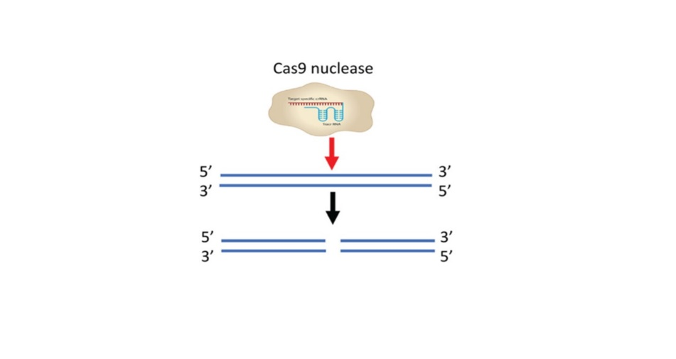
FIGURE 1. Genome Editing
2. CRISPR Fundamentals and Mechanisms
2.1 Overview of CRISPR-Cas System
Historical background and discovery of CRISPR-Cas system.

The first CRISPR repeats were unintentionally found in the Escherichia coli genome by Yoshizumi Ishino and his colleagues in 1987 while studying the genes involved in phosphate metabolism. ^{(2,3)}
CRISPR was shown to be prevalent in both bacteria and archaea in 2000. ⁽⁴⁾ In eukaryotic cells, Cas9 genome engineering was first demonstrated in 2013. ^{(5,6)} In 2018, a study was conducted to demonstrate the CRISPR-Cas9 System's potential for reducing pro-tumorigenic behavior in human OSCC. ⁽⁷⁾
2.2 CRISPR-Cas System Mechanisms
Prokaryotes have an adaptive immunity system called the CRISPR-Cas system that enables them to fight against genetic invaders like bacteriophages and plasmids. Since this defense system may specifically target DNA sequences that are guided by single guide RNAs (sgRNAs), for applications involving genome editing, it has been modified. The CRISPR-Cas9 process is activated as part of a bacteria's natural immune response to a virus. When a virus infects bacteria, a little portion of the virus' DNA is inserted into the bacterial genome's CRISPR locus as spacers. As a result, the bacteria acquire a virus-specific adaptive immunity. Pre-rRNA and tracrRNA are created when the CRISPR locus is activated by subsequent infection with a virus that is identical. They aid in the gRNA (guide RNA) synthesis process. Using Cas9, the guide RNAs (gRNAs) cleave the complementary portions of the invading virus genome.
2.3 Types of CRISPR Systems
Several CRISPR systems and their unique applications in genome editing.
A summary of different CRISPR systems and their potential applications in genome editing and other scientific fields.
1. CRISPR-Cas9 System
Cas9 protein is the basis of a more straightforward CRISPR system from Streptococcus pyogenes. The trans-activating CRISPR RNA (tracrRNA) and crRNA are two tiny molecules that make up the four-part Cas9 endonuclease system.
2. CRISPR-Cas12 (Cas12a) System
Cas12a relied on a "T rich" PAM (providing an alternative targeting site to Cas9), induced a "staggered" cut in double-stranded DNA as opposed to Cas9's "blunt" cut and only required a CRISPR RNA (crRNA) for successful targeting. In contrast, Cas9 requires both a crRNA and a transactivating crRNA (tracrRNA). After cleaving its target, Cas12a stays linked to the target and cleaves other ssDNA molecules without discrimination. This is a distinguishing characteristic of Cas12a. This characteristic is known as "trans-cleavage" or "collateral cleavage" activity.
3. CRISPR-Cas13 System
The nuclease Cas13a, formerly known as C2c2, was identified in Leptotrichia shahii in 2016. Cas13 can only cut single-stranded RNA; it cannot cut DNA because it is an RNA-guided RNA endonuclease. When Cas13 is led to a ssRNA target by its crRNA, it attaches to it and cleaves it. Like Cas12a, Cas13 stays linked to the target before indiscriminately cleaving other ssRNA molecules. ⁽⁸⁾

3. Applications in Bacterial Pathogens
3.1 Dental Plaque:
The Function of Streptococcus mutans in Dental Plaque
An essential part of streptococcus mutans pathogenicity is glucosyltransferases (Gtfs), which consume sucrose to produce extracellular polysaccharides (EPS), that lead to the formation of dental plaque biofilm. The first phase in the process of dental plaque formation is biofilm formation. Self-targeting CRISPR arrays with gtfB-identifying spacer sequences were created and cloned onto plasmids. To obtain the necessary mutations, this plasmid was converted into UA159 (self-targeting). EPS synthesis was significantly reduced as a result, and biofilm development was consequently disrupted. ⁽⁹⁾
3.2 Dental Caries: An oral health concern
Streptococcus mutans is the main causative agent of human dental caries. There is already a healthy bacterial flora in the mouth cavity, but as it grows, the disease may begin to appear. As a result, we need to understand how to manage bacterial composition to maintain a dynamic, healthy equilibrium in the oral ecology. The dysbiosis of the biofilm is responsible for the demineralization of the tooth surface and the eventual formation of dental caries. This condition is accompanied by changes in the bacterial makeup, specifically an accumulation of S. mutans. Although a number of antimicrobial strategies, such as antibiotics, antimicrobial peptides (like C16G2), and lytic bacteriophages, may offer partial solutions, there is still a need for a precise and programmable method that can distinguish between closely related microorganisms and that permits fine control over the composition of a microbial population. Using RNA-guided nucleases (RGNs) and CRISPR/Cas technologies, scientists have produced antimicrobials with a predetermined range of activity. RGNs also enable the genetic signature-based selective knockdown of particular strains, enabling the control of intricate bacterial populations. ^{(9,10)}
3.3 Periodontal Diseases: The Role of CRISPR
Porphyromonas gingivalis, a Gram-negative anaerobic rod, has been identified as the primary pathogen causing microbial dysbiosis. It has been observed that CRISPR arrays are present in about 95% of P. gingivalis clinical strains. Bacteriophages are prevalent and may even outnumber bacteria in the periodontal pocket, where it's probable that this genetic immune system of bacteria helps to regulate the microbiome of "chronic" periodontitis. Hence, CRISPR can be a tremendous asset and a potential technology that dental clinics can use to stop the growth of dental plaque and eventually stop periodontitis. ⁽¹¹⁾
4. Chronic Pain
Several orofacial disorders cause prolonged discomfort. Numerous medications, from NSAIDs to opioids, briefly reduce symptoms, but the pain returns as the medication's impact wears off. It has been found that some variants of this gene prevent the affected individual from experiencing pain. The underlying cause of this is a gene abnormality that prevents pain signals from traveling through the neural pathway by regulating certain molecules involved in this process that are located on the surface of neurons. Editing epigenetic markers that triggered this pathway is possible with CRISPR technology. ⁽¹²⁾
5. Oral Cancer
The most common form of oral cancer is OSCC. With the use of the cutting-edge technology CRISPR, cancer can be treated by genetically altering the patient's own cells. A small number of genes that change rapidly are the focus of most research, however slowly mutating genes can also result in cancers. By CRISPR technology- Knockout of Cancer driving genes, Correcting cancer-associated mutations using CRISPR-mediated homology-directed repair (HDR). ⁽¹³⁾
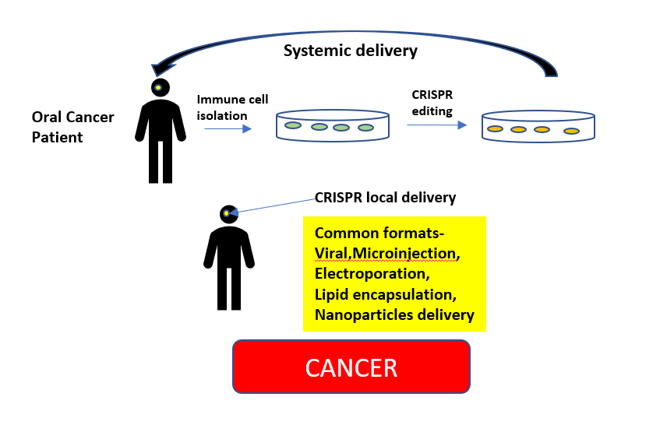
FIGURE 2. Application of CRISPR System in Oral Cancer
Kiyosue et al. investigated the immunohistochemistry expression of the p75 neurotrophin receptor (p75NTR) in oral leukoplakia (OL) and OSCC. The results of this study showed that populations of undifferentiated cells in OL and OSCC express p75NTR. The study also found that p75NTR might contribute to OSCC invasion and a bad prognosis. ⁽¹⁴⁾ Huang et al. investigated the relevance of the p75NTR in human tongue squamous carcinoma cells using CRISPR/Cas9 technology. This research demonstrates that the deletion of p75NTR inhibits a number of tumor-promoting characteristics in SCC-9 cells, suggesting that p75NTR is a promising target for the creation of novel tongue cancer therapies. ⁽¹⁵⁾
6. Craniofacial Malformations
CRISPR-based basic research has revealed previously unknown pathways for craniofacial development. The quick identification of specific gene mutations is made possible by CRISPR.
Mesenchymal stem cells (MSCs) have drawn a lot of attention in recent years for their potential application in the treatment of oral and craniofacial conditions. MSC subsets have been discovered in the pulp, periodontal ligament, and alveolar bone. CRISPR/Cas9 edited MSCs can treat disorders of the mouth, gums, and face. ⁽¹⁶⁾

7. Salivary Dysfunction
Xerostomia is a common side effect of radiation therapy for cancer patients. The CRISPR/Ca9 method can be used in this situation to increase the expression of the AQP1 gene. A water-specific protein called aquaporin 1 (AQP1) may encourage salivation. ⁽¹⁷⁾ It may be possible to create a viable MSC-derived therapy for primary Sjogren's syndrome using the CRISPR/Cas9 technology, which has been used to successfully target critical genes in numerous cell lines. ⁽¹⁸⁾
8. Viral Infections
Herpes simplex virus, human cytomegalovirus (HCMV) (infectious mononucleosis), and Epstein-Barr virus (EBV) (hairy leukoplakia, mucocutaneous ulcers) are responsible for a variety of oral lesions. The genomes of virus-infected cells can be targeted using the CRISPR/Cas9 system. As a result, the virus is rendered dormant and is unable to reproduce inside the host cell. ⁽¹⁹⁾

9. Palate and Tooth Development
The C-terminal domain of the Msx1 gene has been shown to be important for the development of the tooth and palate using the CRISPR/Cas9 technology. In non-syndromic tooth agenesis, the MSX1 homeodomain has been found to mostly affect premolars and third molars. ⁽¹⁹⁾
10. CRISPR for Dental Tissue Regeneration
Periodontal Tissue Regeneration: Cementum, periodontal ligament, and alveolar bone can all be stimulated to regenerate through the use of CRISPR-mediated genome editing. The restoration of periodontal health and the treatment of periodontal disorders may benefit from this strategy. ⁽²⁰⁾

Ethical Considerations for the Use of CRISPR
The use of CRISPR poses a number of ethical issues, such as the possibility of undesired off-target consequences, the implications of germline editing, and the responsible application of gene editing technology in human patients. For the appropriate and secure implementation of CRISPR, it is essential to strike a balance between scientific advancement and ethical issues.

Conclusion
CRISPR technology has emerged as a transformative force in dentistry, offering innovative solutions for dental diseases and genetic dental disorders. By harnessing the power of genome editing, CRISPR opens up new possibilities for personalized dental care, tissue regeneration, and pathogen control ultimately enhancing oral health and quality of life for patients.
CRISPR technology represents a groundbreaking advancement in research and offers unprecedented potential for targeted therapeutic interventions. However, careful research, ethical considerations, and regulatory oversight are imperative to ensure the safe and responsible integration of CRISPR technology.

References
- Goyal, Anjana & Doomra, Reena & Garg, Aayushi & Kruthiventi, Hemalata. (2019). CRISPR Gene Therapy in Dentistry. Asian Pacific Journal of Health Sciences. 6. 182-183. 10.21276/apjhs.2019.6.2.26.
- Ishino Y, Shinagawa H, Makino K, AmemuraM, Nakata A. Nucleotide sequence of the iap gene, responsible for alkaline phosphatase isozyme conversion in Escherichia coli, and identification of the gene product. J Bacteriol, 1987; 169: 5429–5433.
- Han W., & She, Q. CRISPR History: Discovery, Characterization, and Prosperity. CRISPR in Animals and Animal Models, 2017; 1–21.
- Mojica FJ, Diez-Villasenor C, Soria E, Juez G. Biological significance of a family of regularly spaced repeats in the genomes of Archaea, Bacteria, and mitochondria. Mol Microbiol, 2000; 36: 244–246.
- Cong L, Ran FA, Cox D, et al. Multiplex genome engineering using CRISPR/Cas systems. Science, 2013; 339: 819–823.
- Mali P, Yang L, Esvelt KM, Aach J, Guell M, DiCarlo JE, Norville JE, Church GM. RNA-guided human genome engineering via Cas9. Science, 2013; 339: 823–826.
- Huang, P, Tong, D, Sun, J, Li, Q, Zhang, F. Generation and characterization of a human oral squamous carcinoma cell line SCC-9 with CRISPR/Cas9-mediated deletion of the p75 neurotrophin receptor. Arch Oral Biol, 2017; 82: 223–232.
- Carte J, Christopher RT, Smith JT, et al. The three major types of CRISPR-Cas systems function independently in CRISPR RNA biogenesis in Streptococcus thermophilus. Mol Microbiol. 2014;93(1):98-112. doi:10.1111/mmi.12644.
- Gong, T et al, Genome editing in Streptococcus mutans through self-targeting CRISPR arrays. Molecular Oral Microbiology, 2018.
- Citorik RJ, Mimee M, Lu TK. Sequence-specific antimicrobials using efficiently delivered RNA-guided nucleases. Nat Biotechnol, 2014; 32(11): 1141-1145.
- Chen, T., & Olsen, I. Porphyromonas gingivalis and its CRISPR-Cas system. Journal of Oral Microbiology, 2019; 11(1): 1638196.
- Thomas L. Using CRISPR to switch off pain gene becomes a possibility with new study. News Medical Life Sciences, Jan 7, 2020.
- Yirka B. Identified: 15 genes that trigger rapid growth of head and neck squamous cell carcinoma. Oral cancer news compiled by the oral cancer foundation March 2020.
- Kiyosue, T., Kawano, S., Matsubara, R., Goto, Y., Hirano, M., Jinno, T., et al. Immunohistochemical location of the p75 neurotrophin receptor (p75NTR) in oral leukoplakia and oral squamous cell carcinoma. International Journal of Clinical Oncology, 2013; 18(1): 154–163.
- P. Huang et al. Generation and characterization of a human oral squamous carcinoma cell line SCC-9 with CRISPR/Cas9-mediated deletion of the p75 neurotrophin receptor. Archives of Oral Biology, 2017; 82: 223–232.
- Yu N, Yang J, Mishina Y, Giannobile WV. Genome Editing: A New Horizon for Oral and Craniofacial Research. J Dent Res. 2019;98(1):36-45. doi:10.1177/0022034518805978.
- Wang Z et al., CRISPR-Cas9 HDR system enhances AQP1 gene expression. Oncotarget, 2017; 8, (67):111683-111696.
- Chen W, Yu Y, Ma J, et al. Mesenchymal stem cells in primary Sjogren‟s syndrome: prospective and challenges. Stem Cells Int, 2018; 2018: 4357865.
- Vastardis, H., Karimbux, N., Guthua, S. W., Seidman, J. G. & Seidman, C. E. A human MSX1 homeodomain missense mutation causes selective tooth agenesis. Nat. Genet, 1996; 13: 417–421.
- Andrés de Pablo J, Javier Serrano L, García-Arranz M, Romeu L, Liras A. Gene and Cell Therapy in Dental Tissue Regeneration [Internet]. Human Tooth and Developmental Dental Defects - Compositional and Genetic Implications. IntechOpen; 2022. Available from: http://dx.doi.org/10.5772/intechopen.97757.

