An Overview of Anaesthesia Classification & Its Applications
¹Dr B.Durga* ²S.Harinipriya ³R Siva Sabitha
^{1*} Associate Professor and Vice Principal, FAHS, Meenakshi Academy of Higher Education and Research, Chennai.
² I - B.Sc., AnaesthesiaTechnology, FAHS, Meenakshi Academy of Higher Education and Research, Chennai.
³ I - B.Sc., Renal Dialysis Technology, FAHS, Meenakshi Academy of Higher Education and Research, Chennai.

Corresponding Author
Dr B.Durga M.Sc., M.Phil., Ph.D.,
Associate Professor and Vice Principal,
FAHS, Meenakshi Academy of Higher Education and Research,
Chennai.
Contact Number: 8610076917
Email ID: viceprincipal@maherfahs.ac.in

INTRODUCTION:

Insomnia, memory loss, the absence of pain, and the use of muscle relaxants are all characteristics of the short-term condition of anesthesia. It is a medical procedure that, rather than providing any direct medical advantages, merely facilitates the action of other drugs. At Massachusetts General Hospital in 1846, Cambridge dentistry by the name of William T.G. Morton gave a demonstration of the aforementioned anaesthetic term in order to eliminate the cervical tumor, doctor administered diethyl ether anesthesia. On large, cocaine was the first discovered viable local anaesthetics. It can be administered via injection or through inhaled gases or vapors, which can affects the nerves in many ways by preventing the nerve impulses and causes discomfort.
Currently, highly skilled experts utilize various kinds of reliable, contemporary drugs and remarkably effective tracking technology in healthcare facilities and during surgeries. An anesthesiologist is a medical professional who focuses on handling and controlling anaesthetics, or the drugs that make people drowsy or numb certain parts of the body. ^{[2]}
Modern anesthetic treatments, however, were made possible by scientific advancements made in the last quarter of the eighteenth and early nineteenth centuries. Two significant advancements in relation to modern surgery occurred in the final decades of the nineteenth century in microorganism hypothesis that illness is a consequence of the development of antiseptics reduces the rate of death and morbidity along with advances in pharmaceuticals and physiological research, has contributed to the creation of general anesthesia and pain management. Tracheal dilatation and more sophisticated breathing procedures became available in the twentieth century made further development over general anesthesia’s safety and pain control.
Moreover, in 20th and 21st centuries, the business administration of principles and application of economic to healthcare initiation of management practices, to increase the therapeutic efficacy of analgesics consider pricing transfer. ^{[1]}
A medical practice known as anesthesia renders patients painless during procedures like surgery, some viewing and investigative tests, the cutting off skin (such as tissues specimens in biopsies), and Dentistry. It enables patients to endure surgeries to improve their health and extend their lives.

CLASSIFICATION OF ANAESTHESIA
Anaesthesia is classified into four types (Image 1). They are,
- General anaesthetics
- Regional anaesthetics
- Sedation
- Local anesthetics
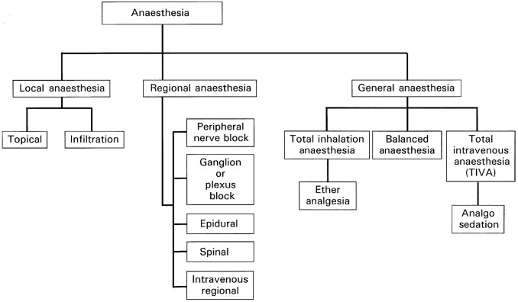

Image 1 Sub classification of Anaesthesia

General anaesthetics
A combination of drugs used in general anesthesia induces a state that is similar to sleep. The drugs, also referred to as anesthetics, are administered prior to and throughout surgery or other medical procedures. Inhaled gases and a mix of intravenous medications are typically used for common sedation. It inhibits the nervous system's neurological action, causing coma and a complete absence of sensibility. ^{[4]}

Types
- Inhalational anaesthetics
- Intravenous anaesthetics

Inhalational anaesthetics
It can be given at an appropriate level of focus, and because the brain has a strong blood flow, results are seen quickly. This circumstance makes to reach the brain with partial pressure and the lung becomes equal & makes it to monitor the anaesthesia ^{[5].}
For example: A gas called nitrous oxide has a fairly sweet smell and can cause mild anesthesia despite depressing the vasomotor center. ^{[7]}

Intravenous anaesthetics
When the anaesthetics are administered through intravenous route, it helps to attain the higher concentration, which is especially important with drugs of narrow range of the therapeutic value. ^{[6]}
For example: Thiopentone sodium is a short acting drug and has rapid onset of action which acts over the cardiovascular and profound respiratory depression and it is known as ‘truth serum’ in medico legal use. ^{[7]}

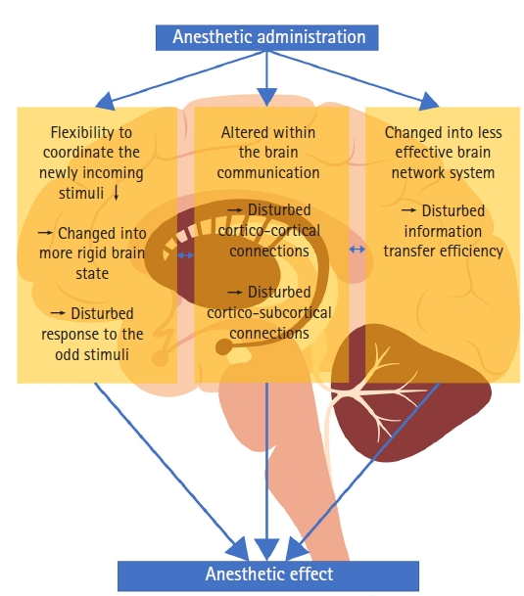
Figure 1: General Anaesthetic mechanism

Stages of General Anaesthesia based on Guedel's Classification:
It's generally accepted that wakefulness, awareness, and consciousness are all parts of an alert state. General anesthesia is characterized by a permanent impairment of awareness, perception, and reflexes related to autonomic control. Along with drowsy effects, it also has antinociceptive, immobility-related, and reflex blockade effects. A number of medications can be used to induce relief from pain, muscles in the skeleton repose, forgetfulness, and the absence of impulses in the nervous system responsible for controlling emotions.(Image 2).
- Analgesia
- Delirium
- Surgical anaesthesia
- Medullary or respiratory paralysis

Stage: 1 – Analgesia
Analgesics, commonly known as painkillers, are drugs that treat many kinds of distress, especially arthritic conditions, abrasive wounds as well as migraines. Although opioid-based analgesics change how the human mind perceives pain, beneficial analgesics minimize inflammation.
Disorientation, which is another name for painkillers, might begin at a pre anesthesiologist consultation retaining vicinity when the valetudinarian receives the medicine along with might instigate to experience its property however isn't hitherto fully asleep¹⁶. It is the period of time between the inhalation of anesthesia and the loss of consciousness, which is marked by a slight neuronal depression, which is ideal for simple surgical procedures.
Stage: 2 – Delirium
Delirium is otherwise called as Excitement. It starts from the loss of sensation to the surgical anaesthesia which is associated with exhilaration and leads to involuntary muscle activities. Disinhibition, irrational behavior, it is distinguished by the absence of the ocular sense of balance, elevated blood pressure, and palpitations. It also shortening the duration of second stage, hence rapid-acting medications improves transition towards stage 3.

Stage: 3 – Anesthesia for surgery
For treatments requiring general anesthesia, this is the desired anesthetic level. Due to its suitability for the majority of procedures, it has been known as "true surgical anesthesia". This stage is characterized by reduced respiratory function and ceased ocular movements¹⁷ & phase is divided as 4 (four) plane characterizes via, i) Impairment of lumbar abilities, ii) diminished muscle mass in the skeleton abilities, iii) immobility of the muscles between the thighs, and iv) finally a decline in the majority of strength in the muscles are all symptoms of developing neurological depression.

Stage: 4 – Medullary or respiratory paralysis
This stage happens when a surgical stimulus is stimulated too much when compared to the amount of anesthetic administered, which worsens a Cognitive function / axial depressive disorders, hence this period is also called as overdose which is characterized by vasomotor and respiratory paralysis. The arterial pressure is frequently significantly less below average, exhibiting feeble impulses, as a result of the arterial dilation along with blockage of the coronary valve. It's lethal at that point with minimal assistance to the pulmonary & circulatory processes. Nowadays, these stages are not preferred in the actual use of anaesthesia due to its related use of other drugs. ^{[4] [7]}

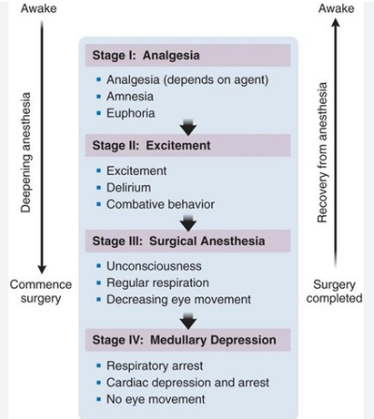

Image 2: Stages of Anaesthesia & its action

Mechanism of action
General anaesthetics binds on the GABA receptor chloride channels and activates the receptors (figure 2), which leads to inhibit the neurotransmission and depresses the CNS. Local anesthetics' precise mode of effects is undisclosed. However, the following represent what occurs in the processes of operation:
- There is a nerve impulse.
- This results in the opening of calcium ion channels, which allows an invasion of ions (Ca²⁺) into the endpoint.
- By fusing onto the distal membranes, vesicles called synaptic vesicles release chemical across the synaptic cleft, which refers to the area connecting synapses.
- When antidepressants attach to respective sites of receptors in the membrane surrounding the postsynaptic neuron, channels of ions in that barrier release.
- After a certain level of threshold has been attained, molecules permeate the neuron that is
postsynaptic, and eventually induce it to create an action pulse.
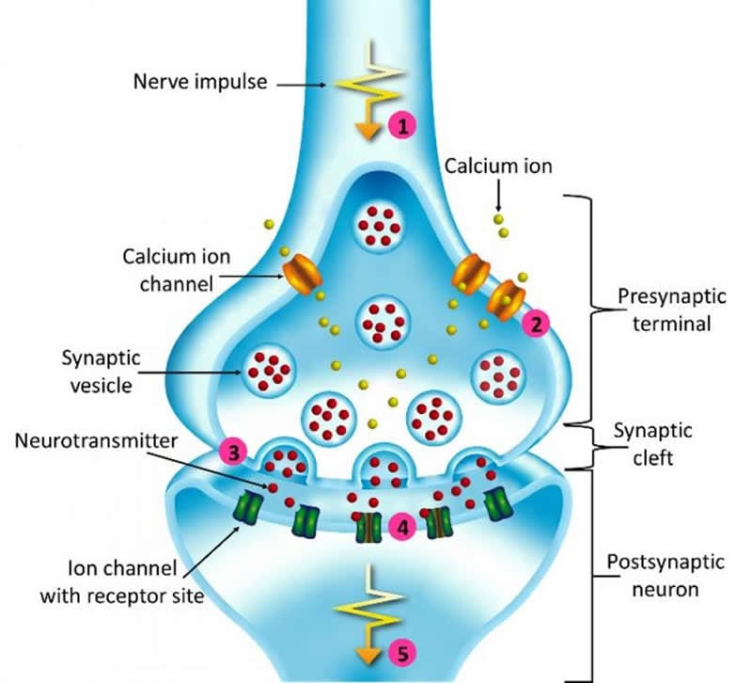
Figure 2 - GABA receptor complex

- For inhalational anaesthetics - When an anesthetic's dosage (or partial pressure) in the air passages is exactly identical to what exists in the skull, as is strongly reflected near the location of anesthetic measurements, this is known as a minimal capillary dosage.
- For intramuscular medications, the effectiveness is the level in the blood (at homeostasis) that triggers fifty percent of patients to lose responsiveness to the cut made during surgery. ^{[4]}

Regional anaesthetics
The goal of regional anaesthesia is to attain the loss of sensation in a specific extremity or area of the body (Image 3). Unlike common sedation, sufferer's extent of alertness is unaffected as a means of numbing their discomfort¹⁸. There are various benefits to regional anesthetic over general anaesthetic, including the avoidance of airway manipulation, lower dosages, fewer systemic drug adverse effects, quicker recovery, and much less postoperative discomfort.
Regional anaesthesia is also used in orthopedic surgeries on an appendage of the body (arm, leg, hand, or foot) and in female genital mutilation such as gynecology operations and both in masculine testicular surgeries and in c-sections. Further it is employed in procedures involving the kidneys and its functions. ^{[8]} Regional sedation is frequently administered with an overall anesthetic to manage a number of acute as well as persistent pain conditions in contrast to having been utilized subsequently.

Types and its action
- Spinal anaesthetics
- Epidural anaesthetics
- Nerve blocks

Spinal anaesthetics
It is administered underneath the level of the vertebral column or through the space located between L2 and L4 lumbar region, where it works on nerve terminals. The midsection and lower part of the body are anesthetized and affected during this form of anesthesia. The amount of injection, the fluid's concentration, and the individual's position can all affect the numbing agent level.
- Epidural anaesthetics
It is injected in the extradural spaces which is directly acts on the nerve roots whereas the small quantities get diffused into subarachnoid spaces. Minimal uses of epidural opioids may require comparing the oral dose, which produces better analgesia.

Nerve blocks
With less medication than the methods described previously mentioned, deeper areas of anesthesia generate when infused nearby or close to a person's nerves in the legs or spinal plexuses. Several millimeters proximal to the administration are where anesthesia begins. ^{[7]}
Regional Sedation

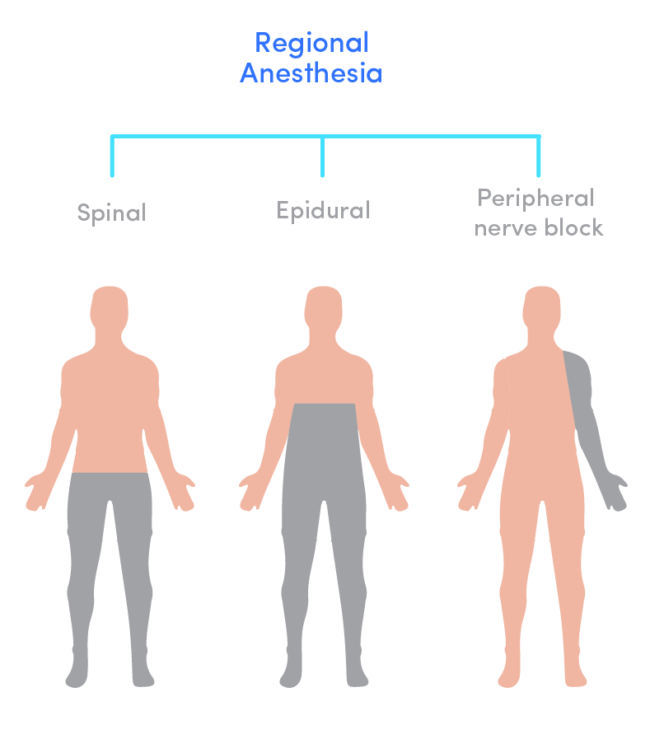
Nerve Blocks
Spinal
Epidural

Image 3 Action area for Regional Anaesthesia

Sedation
Sedation is defined as the relaxed state or temporary decrease in an instance of mindfulness. The usage of sedation and its action showed (Image 4)

Levels of sedative agents:
- Minimal sedative agents
- Moderate sedative agents
- Deep sedative agents
- Minimal sedative agents
It acts as relaxants when the patient is awake and can respond to the verbal commands. Example: antihistamines such as diphenhydramine (Benadryl), dimenhydrinate (Dramamine).

Moderate sedative agents
Sleepy and can be awakened or to respond to verbal tactile stimuli. Example: morphine, diazepam, ketamine, and midazolam.
- Deep sedative agents
Deep sleep can occur in this case and can be easily aroused; which is nearly in unconscious state. Example: oral ketamine and midazolam. ^{[9]}

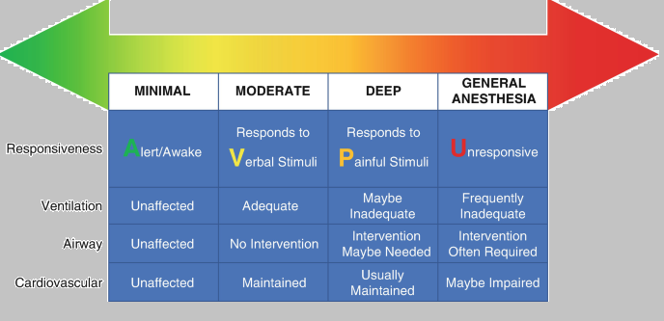

Image 4: Action Levels of sedation.

Local anaesthetics
Local anesthetics (LA) are a group of pharmacological substances that are commonly employed in modern medicine for a variety of operations, from minor surgery to more involved ones like reconstructive hand surgery or wound suturing ¹⁹. Local anaesthetic agents depresses the action potential in highly strung tissues by jamming the sodium channels, which inhibits the action potential leads to blockade in the transmission of pain impulse (Image 5).
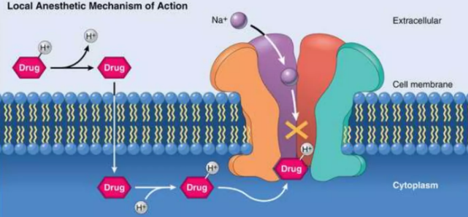
Image 5 Mechanism of Action of Local Anaesthetics
It can be either given by topical or given directly into a limited space to cause numbness or discomfort. ^{[7]} When the substances such as amide or ester local anaesthetics are applied or locally injected, they cause transient loss of pain perception in a specific body region by blocking sodium channel (Image 6). They work by obstructing both sensory and motor nerve transmission to cause momentary loss of sensation without consciousness. (Figure 3)

Image 6 local Anaesthetics blocks Na Channel

The plasma cholinesterase, or pseudo cholinesterase, which is dispersed throughout each tissue in the body, quickly hydrolyzes the amino-ester type LA. From the moment of injection, it is subsequently somewhat processed for an anesthetic action in the bloodstream, bladder, and other organs. ^{[9]}

Figure 3: Steps involved in effect of local anaesthetics

Types of Local Anaesthetics:
- Surface anaesthesia
- Injectable anaesthesia

Surface anaesthesia
It is directly applied by topical application over the mucous membrane such as sensory organs (eye, nose, mouth) respiratory tree, gastrointestinal tract and urogenital system. In topical applications, phenylephrine (but not adrenaline as its penetration is poor) causes vasoconstriction, which prolongs the duration of action. Local anaesthetics are also used on abraded skin. ^{[7]}
For example: Even the area around the eye is treated with local anesthesia is oxybuprocaine (Benoxiate HCl) within 60 seconds of administration, the cornea of the eye becomes anaesthetized. ^{[7]}

Injectable anaesthesia
It is the type of local anaesthetics which is directly injected into the body tissues. For example: Rapid and long acting widely used local anaesthetic called Lignocaine and these induces sleepiness and mental confusion additionally, it works well as an ophthalmic painkiller.
Managing of Anesthesia:
The administration of anesthesia is crucial to delivering standardized treatment and hastening recovery. The anaesthetists must provide great care when doing any of the major or minor surgery. There are many different concurrent medical conditions present in patients undergoing any sort of surgery. Anesthesiologists play a crucial role in all phases of patient management since the unhealthy person could need an operating procedure to regulate the pathogen's source ²⁰. Hence analysis of the patient's clinical characteristics that can affect the result of the surgical procedure should be considered.
- In Cardiovascular management
The primary site in the cardiovascular system is myocardium, in which the local anaesthetics are administered and can leads to reduced nervousness, transmission speed, and strength of contraction Whereas the inhalational anesthetics tends to reduce the myocardial contractility, oxygen requirement, arterial pressure and also produces some coronary vasodilation.

In Respiratory management
All inhalational anaesthetic agents are acts as respiratory depressants, which may leads to decreased tidal volume, ventilation and also mucociliary function and are widely used as bronchodilators.

In Central nervous management
Breathed anesthetics reduce cranial vascular stiffness, which improves mental circulation. In addition, they slow down the central nervous system's rate of metabolism and can boost the pressure within the skull.
Local anaesthetics suppresses the cortical inhibitors pathway, thereby it allows the agonistic activity of excitatory components. Breathing difficulties may cause mortality when peripheral excitement is subsequently accompanied by wide depression of the cerebral cortex.

In Renal and Hepatic management
Volatile anaesthetics decrease the Glomerular Filtration Rate, renal and hepatic blood flow. Halothane and its derivatives decrease cardiac output and arterial pressure. The effect on heart rate is viable and some may cause tachycardia and bradycardia. ^{[3]}

Adverse effect of Anaesthesia

Hypersensitivity reactions
Inflammation of skin, allergic attack and reactions are most prevalent side effects of ester-type medications. Hence, the use of medications ought to be monitored for such adverse effects. In addition, allergies are frequently brought on via the regulator methylparaben.
- In central nervous system
Dizziness, sedation, auditory and visual impairment, mental confusion and disorientation may occur. Higher doses may leads to anxiety, nystagmus, muscle tremors, convulsions and respiratory failure due to the depression in the cortical inhibitory pathways leading to CNS stimulant effects. LA including for infiltration, pre-medication with BZD helps.

In cardiovascular system
Blockade of sodium channels in the myocardium may results in myocardial depression with reduces in the force of contraction, bradycardia, excitability and conduction velocity; rarely cardiac arrest can occur. As the local anesthetics can cause vasodilation, hypotension may occur. Bupivacaine is the most cardiotoxic. Rarely cardiac arrest may occur.

Others
As a result of therapeutic error, local anaesthetics toxicity may occur generally. A situation leading to toxicity includes inadvertent venous or arterial injection or topically administered local anaesthetic containing preparations.
Repeated use of halothane may occasionally cause hepatitis, comparing to other inhalational agents. A metabolite of enflurane may leads to nephrotoxicity due to prolonged exposure.
Malignant hyperthermia and megaloblastic anemia are including adverse effects. ^{[5] [7]}
Current trends of Anaesthetic Applications:
Utilization of anaesthetics in Cancer.
An important component of routine clinical treatment for unhealthy person recuperating from surgery is through the process of anesthetic during the postoperative period. The postoperative phase in surgical process of cancer represents an essential phase for the development of the illness since cells of the tumor from the original cancerous tumor which are released into the bloodstream of the individual can still end up in secondary miniature metastases although after the underlying tumor has been entirely excised.²¹Numerous studies have looked at the rate of tumor recurrence in relation to various anaesthesia techniques and agents, as well as the importance of anesthesia's benefits against tumors, inflammation, and metastasis. Study investigation has illuminated possible processes via how sedation may impact tumor cells. (Image7).
General anesthesia is a composition of drugs that, prior to surgery, puts a sick person into a slumberous or not paying attention as well as suppresses their autonomic neurological system's reactions to pain and drowsiness. The administering of general anesthetic may have an impact on the body's defenses via physiological and genomic alterations, by promotion of the hypothalamus, pituitary, adrenal axis particularly sympathetically nerve systems, and to prolong a considerable amount of duration if tumors recur subsequent removal via surgery. ²⁵
Patients with cancer may have a worsening of their prognosis as a result of the immunosuppression brought on by general anesthesia, which includes the malfunctioning of large granular lymphocytes. Hence defense system of the person being negatively affected by anesthesia, which could encourage tumor recurrence. Cancer does not directly arise as a result of general anesthesia. However, the immunological suppression brought on by anesthesia could accelerate the progression of cancer.
The effect of local anaesthesia during cancer surgeries, because of their potent anti-inflammatory effects, local anesthetics may have some indirect or direct effect on tumor cells that are shed during surgery. As an illustration, they could aid in lowering the immune-mediated response to stress induced by the intraoperative stimulation. Nevertheless, has been demonstrated that certain type of locally administered analgesic can inhibit the metastasis and preserve immune cell activity.
According to in vitro studies²², with improving the functionality of the natural killer (NK) cells, intravenously lidocaine treatment as a component of the operational sedative agent has a chance to reduce the probability of malignancy relapse or recurring among individuals post surgical treatment for cancer.

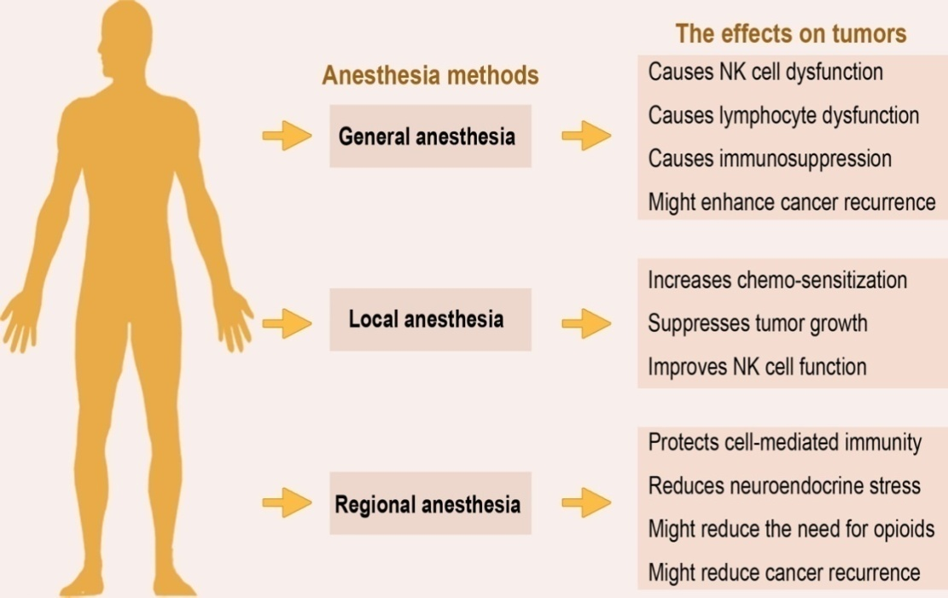
Image 7: Effect of Anaesthetics on tumor
Area-specific analgesia is used toward alleviate ache in a specific body location. According to certain research, localized anaesthetic techniques relieve perioperative pain, which lowers the need for systemic anesthetics and opioids. The main objective of epidural anesthesia is to reduce sensation by interrupting communication between nerves that come from the lowest lumbar regions.
Preclinical and retrospective investigations indicate toward the possibly advantageous effect of regional anesthesia since it safeguarding defense generated by cells and diminish the post-operative action by inhibiting sensory neural transmission, which promotes the axis of the hypothalamus, pituitary and the parasympathetic and sympathetic nervous systems, hence the body's neuroendocrine system is able to respond to stressful circumstances. As a result, there is no longer a requirement of opioids and fluid anesthesia drugs, thereby minimizing the possibility of a tumor that is malignant reoccurring. s²³.
In additional support of analgesic drug called Propofol believed to strengthen immune responses mediated by cells and reduce tumor angiogenesis²⁴, hence proven that the propofol has anti-cancer properties. In contrast to volatile analgesics and opioids, which often reduce T lymphocytes mechanism and promotes the multiplication of cancer cells by angiogenesis hence these strongly suggest for reducing the usage of opioids. Numerous studies have subsequently hypothesized that localized anesthetic may lower the probability of an extended cancer recurrence.
Unless additional research come’s conclusively linking anaesthetic to trials, practitioners can keep trying to choose most effective anesthetic-analgesic drugs and treatments in collaboration of their tumor victims based on their clinical expertise and current recommendations. It is necessary to do larger prospective trials to assess how anesthesia procedures can stop tumors from relapsing or spreading.
Before surgeries or other potentially traumatic operations, anesthesiology comprises the application of medication to numb the patient's senses for discomfort or different sensations. However, it causes some side effects, it is very important to both the minor and major surgeries. ^{[3]} Cancer is currently the most prevalent health issue in the globe. With the future perspectives, working together with oncologists and surgeons is crucial if patients with cancer are to receive the best care possible. For all patients with a history of cancer, preoperative evaluation to detect any treatment-related adverse reactions, a well-organized intraoperative management plan, and a postoperative treatment strategy are necessary. It is known that anesthetic methods and medications can reduce perioperative inflammatory and immunological alterations. Evidently, this could result in better outcomes for cancer patients in future generations. But more investigation towards perioperative "onco-anesthetic" and perioperative treatment for cancer is required.

REFERENCES:
- Kuntz, L; Vera, ( September 2005 ) ., Health Care Management Review
- Anaesthesia - a review ., AkshaySatwik et.al - 2015
- Morgan & Mikhail’s Clinical Anesthesia – 5th edition – 2013
- Anesthetic agents: General and local anesthetics ., Timothy J. Maher
- Inhalational Anesthetics: An update on mechanism of action and toxicology ., J Jedlicka – 2021
- Kinetics and dynamics of intravenous anesthesia by Gerland M. Woerlee
- Medical Pharmacology – 7th edition ., PadmajaUdaykumar – 2021
- Anesthetic agents and adjuncts C. Regional anesthesia ., Kim Kraft – 2014
- Anesthesia for medical students – Anesthesia University of Toronto., AhtshamNiazi et al – 2000
- Intravenous anesthetic agent ., Jaideep J Pandit
- Basic pharmacology of local anaesthetics., A Taylor et al - 2020
- Special article - Practice guideliness for sedation and analgesia by non- anesthesiologists .,Lippincott Williams & Wilkins -2002
- The journal of the American medical association - August 2011
- Anaeshesia at the dis. Hosp. - 2nd edition ., Michael B. Dobson - 2000
- Short textbook of Anesthesia ., Ajay Yadav - 6th edition., 2018
- Winterberg AV, Colella CL, Weber KA, Varughese AM. The Child Induction Behavioral Assessment Tool: A Tool to Facilitate the Electronic Documentation of Behavioral Responses to Anesthesia Inductions. J Perianesth Nurs. 2018 Jun;33(3):296-303.e1
- Hedenstierna G, Edmark L. Effects of anesthesia on the respiratory system. Best Pract Res Clin Anaesthesiol. 2015 Sep;29(3):273-84
- Li J, Lam D, King H, Credaroli E, Harmon E, Vadivelu N. Novel Regional Anesthesia for Outpatient Surgery. Curr Pain Headache Rep. 2019 Aug 01;23(10):69.
- Lazar, A.E.; Gurzu, S.; Kovecsi, A.; Perian, M.; Cordos, B.; Gherghinescu, M.C.; Enache, L.S. Cardio Protective Effects of Lipid Emulsion against Ropivacaine-Induced Local Anesthetic Systemic Toxicity—An Experimental Study. J. Clin. Med. 2022, 11, 2784. https://doi.org/10.3390/jcm11102784
- Carsetti A, Vitali E, Pesaresi L, Antolini R, Casarotta E, Damiani E, Adrario E and Donati A (2023) Anesthetic management of patients with sepsis/septic shock. Front. Med. 10:1150124. doi: 10.3389/fmed.2023.1150124.
- Müller SD, Ziegler JSH, Piegeler T. Local Anesthetics and Recurrence After Cancer Surgery-What’s New? A Narrative Review. J Clin Med (2021) 10:719. doi: 10.3390/jcm10040719
- Chamaraux-Tran T-N, Piegeler T. The Amide Local Anesthetic Lidocaine in Cancer Surgery—Potential Antimetastatic Effects and Preservation of Immune Cell Function? A Narrative Review. Front Med (2017) 4:235. doi: 10.3389/fmed.2017.00235
- Cata JP, Hernandez M, Lewis VO, Kurz A. Can Regional Anesthesia and Analgesia Prolong Cancer Survival After Orthopaedic Oncologic Surgery? Clin Orthop Relat Res (2014) 472:1434–41. doi: 10.1007/s11999-013-3306-y.
- Cakmakkaya OS, Kolodzie K, Apfel CC, Pace NL. Anaesthetic Techniques for Risk of Malignant Tumour Recurrence. Cochrane Database Syst Rev (2014) (11):CD008877. doi: 10.1002/14651858.CD008877.pub2
- Makito K, Matsui H, Fushimi K, Yasunaga H. Volatile Versus Total Intravenous Anesthesia for Cancer Prognosis in Patients Having Digestive Cancer Surgery. Anesthesiology (2020) 133:764–73. doi: 10.1097/ALN.0000000000003440

