LPG Gas Identification and Alert System using IOT in Thingspeak cloud

1. Dhananjaya M K 3. Dr Ganesha M
Dept of Information Science and Engineering Dept of ComputerScience and Engineering
Acharya Institute of Technology,Bangalore-560107 Dr SMCE,Bangalore
dhananjaya2443@acharya.ac.in ganeshastjit@gmail.com

2. Dr Swarnalatha K
Department of AI and DS
,MIT Thandavapura, Mysore
swarnapradyu@gmail.com

Abstract: This paper presents a novel approach to identify leaks of liquefied petroleum gas (LPG) using a microcontroller-based Node MCU. The goal is to detect and prevent LPG leaks, ensuring the safety of individuals and avoiding potential accidents. The proposed device continuously monitors the area using gas sensors. The data from these sensors is then transmitted to the Node MCU, which displays the results as a warning on an Android-based smartphone. Additionally, apart from LPG gas, the device can also detect leaked gases from air conditioners and refrigerators, which are equally harmful when released in a home environment. By utilizing this device, users can effectively prevent accidents caused bygas leaks, thereby ensuring their safety. In today's world, safety is of utmost importance, both in educational institutions and workplaces. It is crucial to have effective safety systems in place, not only in industries but also in homes and businesses. One specific safety measure isthe installation of gas leakage detectors in vulnerable areas. These detectors are devices that can identify the presence ofgases, forming part of a safety system. When a leak occurs, the gas detector can sound an alarm, alerting individuals in the vicinity to take appropriate action. This is essential because certain gases can be harmful to living beings, such as humans and animals.

INTRODUCTION
The primary objective of this paper is to detect gas leakage in residential areas such as homes, hotels, and schools, and provide alert messages to people in the vicinity. Gas sensors, like the MQ-6 gas sensor used in our implementation, are widely employed for detecting gas leaks in various applications. The MQ-6 sensor measures gas concentration in parts per million (ppm) and outputs an analog signal that can be converted into a digital format. By comparing intensity values with predefined thresholds for gas, smoke, and fire, the system makes appropriate decisions. Additionally, we incorporatea GSM module to upload the data to the cloud using Wi-Fi, allowing responsible individuals to monitor the system effectively. Gas leaks can lead to fires that pose a significant threat to human life and property. Delayed information about the occurrence of fire can further exacerbate the situation. Existing products in the market mainly function as fire extinguishers. However, our project aims to not only detect gas leaks but also trigger an alarm. In case of a fire, a water sprinkler system is activated, and an exhaust fan is utilized to remove any lingering gas from the kitchen area. LPG, short for liquefied petroleum gas, is a non-renewable energy source derived from fossil oil and gas. It primarily consists of propane and butane and is odorless in its natural state. However, an odorant called ethyl mercaptan is added to LPG to make it detectable. Detecting the presence of natural gases is not as quick for humans as it is for gas sensors. Therefore, a gas sensing system is essential for real-time monitoring of gas systems.

LITERATURE SURVEY

In this system, we have developed an innovative solution for detecting and alerting gas leakage, specifically focusing on economic fuels such as petroleum, liquid petroleum gas (LPG), and alcohol. The primary objective is to ensure safety by promptly identifying gas leaks and providing a mechanism for automatic valve closure to control the leakage.

To achieve this, the system incorporates sensors that effectively detect any leaked gas. These sensors are connected to a microcontroller, which acts as the central processing unit. Upon receiving the signal from the sensors, the microcontrolleranalyzes the data based on pre- programmed logic. In response to a detected gas leak, the microcontroller triggers various components, including water sprinklers, buzzers, and exhaust fans, to mitigate the hazard.
Furthermore, the system leverages Internet of Things (IOT) technology to enable remote control and monitoring. This functionality is facilitated by a servo motor, which is responsible for rotating the regulator by 180 degrees, effectively shutting off the gas cylinder valve.By implementing this gas leakage detection and alerting system, the issue of gas wastage can be significantly reduced, promoting resource efficiency.

In the literature survey conducted for this system, various sources were explored to gather relevant information on gas leakage detection and safety systems. Existing research and practical implementations were analyzed to identify the most suitable components and techniques for our proposed system. By carefully reviewing and synthesizing the literature, wehave developed a robust solution that addresses the challenges associated with gas leaks and enhances overall safety in domestic and commercial environments.

Components of System
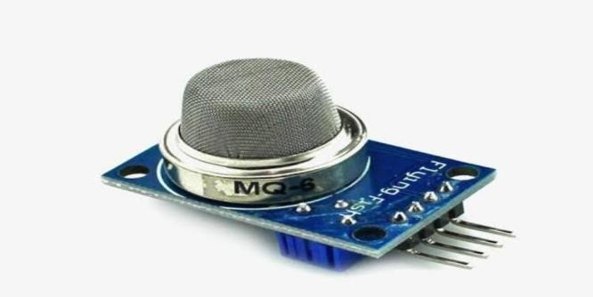

Gas Sensor :
Figure 1 : Gas Sensor
The gas sensor module, specifically the MQ-6 sensor, proves to be highly valuable in detecting gas leaks. Its sensitivity can be adjusted using a potentiometer, allowing for customization based on specific requirements. The MQ-6 sensor utilizes a sensitive material called SnO2, which exhibits low electrical conductivity in clean air. However, when flammable gas is present, the electrical conductivity of the sensing element increases significantly. This change in conductivity leads to a variation in the sensor's resistance, resulting in a corresponding voltage change. By connecting thesensor to a microcontroller, this voltage change can be accurately measured and analyzed. It is important to note that

different gaseous elements exhibit varying sensitivity values, which further enhances the sensor's versatility andeffectiveness in detecting specific types of gases.

Relay :

Figure 2 : Relay

A relay is an electrical switch that can be controlled by an Arduino or any other microcontroller. Its purpose is to enablethe programmable control of devices that operate using high voltage and/or high current. By utilizing a relay, the microcontroller can effectively turn these devices on or off according to the desired program or logic. The relay acts as amediator, allowing the low-voltage control signal from the microcontroller to safely control the higher voltage or current required by the connected devices. This provides a convenient and reliable method for automating the operation of variouselectrical devices in a programmable manner.

Arduino :
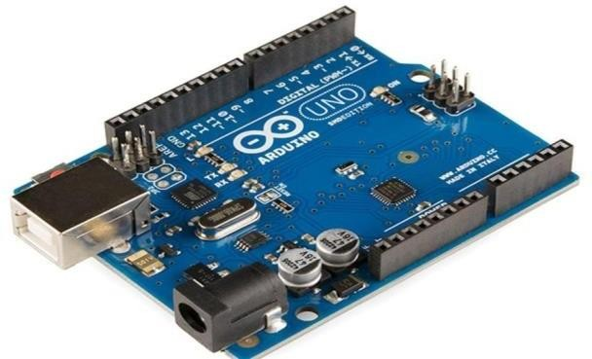

Figure 3: Arduino Board
The Arduino Uno board is a microcontroller that utilizes the ATmega328 as its core component. It offers a range of features and capabilities to support various applications. These include 14 digital input/output pins, with six of them functioning as pulse width modulation (PWM) outputs. The board is equipped with a 16-megahertz ceramic resonator, an ICSP (In-Circuit Serial Programming) header, a USB connection, six analog inputs, a power jack, and a button. Thesecomponents provide the necessary support and functionality required for the microcontroller.

To get started, the Arduino Uno board can be connected to a computer using a USB cable, or it can be powered using anAC-to-DC adapter or battery. Unlike other boards, it does not require the use of a USB-to-serial driver chip. Instead, it distinguishes itself by incorporating

the Atmega16U2 (or Atmega8U2 in earlier versions) as a dedicated USB-to-serial device. This feature enables easy communication between the Arduino board and the computer.

ThingSpeak : ThingSpeak is a freely available Internet of Things (IoT) platform that offers both an application and an API. Its primary purpose is to facilitate the storage and retrieval of data from various devices or "things" through the use of the HTTP protocol. This communication occurs either over the Internet or within a Local Area Network (LAN). ThingSpeak provides a versatile platform for creating a wide range of applications, including those focused on sensor logging, tracking the location of devices, and establishing a social network of connected things where status updates canbe shared and accessed.

Fire Sensor :
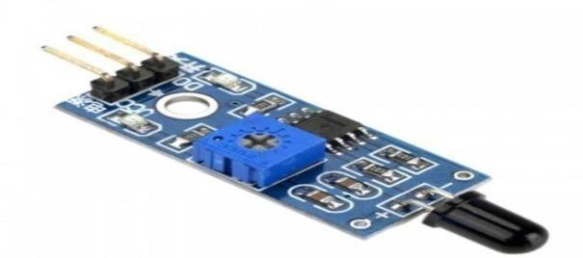

Figure 4 : Fire Sensor

Fire detectors operate by detecting the presence of smoke and/or heat. Their function is to respond to the indications of afire, such as the presence of smoke particles or abnormally high temperatures. Once triggered, these devices send a signalto the alarm system, which in turn activates the pre-programmed response specific to the corresponding area or zone. By promptly detecting and alerting the system to a potential fire, fire detectors play a crucial role in safeguarding against fire-related hazards.

DC Motor :

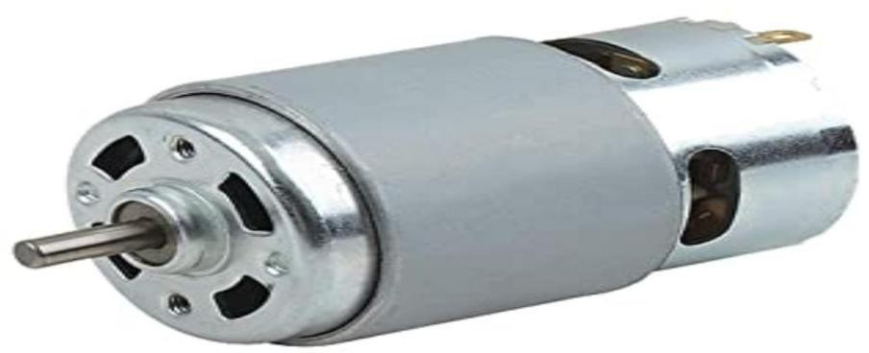

Figure 5 : DC Motor

IMPLEMENTATION

The implementation of the proposed system involves several key steps to ensure the effective detection and monitoring of gas leaks. These implementation details are outlined below:
Hardware Setup: Begin by assembling the required hardware components, including the Arduino UNO board, MQ-6 gas sensor, LCD display, and WiFi module. We have Connect the components as per the circuit diagram .
Sensor Calibration: We have Calibrated the MQ-6 gas sensor to ensure accurate detection of Methane, Butane, and LPGleaks.
Coding and Programming: We have Written the code in Arduino IDE to interface the MQ- 6 gas sensor , Fire Sensor and all other hardware's with the Arduino UNO board. The code includes functions to read sensor data, compare it withpredefined thresholds, and trigger appropriate actions such as activating the buzzer, displaying alerts on the LCD, and transmitting data to the cloud.
Cloud Integration: We did Set up of the cloud platform using ThingSpeak to receive and store the gas leakage data fromthe Arduino board. There we can visualize and analyze the collected data.

CONCLUSION
Gas leakage incidents can have severe consequences, resulting in property damage and endangering human lives. These incidents often occur due to inadequate equipment maintenance and a lack of awareness among individuals. Therefore, itis crucial to develop a reliable system for detecting and alerting gas leaks, specifically focusing on LPG (liquefied petroleum gas). The presented research paper introduces a straightforward yet reliable approach to detect LPG leaks andpromptly notify individuals about their severity. When an LPG leak is detected, the system triggers a buzzer and displaysrelevant information to alert users. This system operates using a 5V battery, and future improvements could include using a larger, rechargeable battery to prolong the gas detection module's lifespan and provide alerts when the battery runs low. By incorporating additional enhancements such as gas concentration detection and refining the system's design, it can become more user-friendly and cost-effective. These improvements will contribute to a more efficient system that helps prevent accidents and save lives.

REFERENCES

- Mr. Akshay D. Prabhu, Mr. Ashwin D. Pathak, “Gas Leak Detector using Arduino UNO Microcontroller”,
International Journal for Research in Applied Science & Engineering Technology (IJRASET), Volume 5, July 2017
- Al-Karaki, J. N. and A. E. Kamal (2004). "Routing techniques in wireless sensor networks: a survey." Wirelesscommunications, IEEE 11(6): 6-28.
- S. Rajitha, T. Swapna, “Security alert system using GSM for gas leakage”
International Journal of VLSI andEmbedded Systems IJVES
- Ravindra R. Hiwase, Priya K. Kewate, Sushmita P. Tajane, Jitendra Waghmare “Automatic LPG Cylinder Booking and Leakage Detection using Arduino UNO” IJESC.
- Shital Imade, Priyanka Rajmane, Aishwarya Gavali, V.N. Nayak wadi “Gas leakage detection and smart alerting system using iot” International Journal of Innovative Research & Studies.
- L. K. S. Rohan Chandra Pandey, Manish Verma, “Internet of things (IOT) based gas leakage monitoring and alerting system with MQ-2 sensor,” International Journal of Engineering Development and Research, Vol. 5, 2017.
- Shailendra Kumar Dewangan3 Praveen Singh Rathore4 Abid Khan1, Neju K. Prince2. Gsm based automatic lpg ordering system with leakage alert. IJRET: International Journal of Research in Engineering and Technology, 3(12),Jun-2014.
- P. M. Vidya, S. Abinaya, G. G. Rajeswari, and N. Guna, “Automatic lpg leakage detection and hazard prevention forhome security,” in Proceeding of 5th National Conference on VLSI, Embedded and Communication & Networks onApril, vol. 7, 2014.

