Knowledge Management in Practice: An Exploratory Case Study
Niranchana shri Viswanathan*, Assistant Professor, Bibi Hajira**, Assistant Professor, , Assistant Professor, Shwetha.S*** School of Management Studies, REVA University, Bangalore.
niranchanaphd@gmail.com, shwethas1098@gmail.com , hajira54@gmail.com

ABSTRACT
Knowledge has been identified as one of the most important resources that contributes to the competitive advantage of an organization. The organizational and social issues associated with the development, implementation and use of information technology have increasingly attracted the attention of knowledge management researchers. The paper is based on an empirical investigation of knowledge sharing processes from an international organization, Buckman Laboratories. Through the socio-technical perspective, the paper traces the interactions between knowledge management practices and the organizational context. On the basis of the research, we propose a perspective of socio-technical theory relevant to knowledge management within organizations. We conclude that management and leadership play a critical role in establishing the multi-level context for the effective assimilation of knowledge management practice.

INTRODUCTION
In recent years, a number of management researchers have outlined the theoretical case for knowledge management. It is claimed that with product life-cycles shortening and technologies becoming increasingly imitable, organizational knowledge emerges as a major source of competitive advantage by virtue of its testiness, inimitability and immobility. Despite the plausibility of these arguments, however, relatively few studies have provided empirical insights into how companies develop and manage ‘know-how’ through the interplay between organizational context and information technology. Indeed, much of the existing literature is concerned with an ontological debate about the nature of knowledge and therefore tends to promote particular approaches as universal panaceas. These theoretical arguments are difficult to relate to the actual experience of business organizations. This is partly because the very qualities of tactless which lend such importance to organizational knowledge, make it an elusive item for practitioners. Second, the study uses a case-study of one pioneering organization—Buckman Laboratories—to examine the dynamics of successful knowledge management practices, and to consider the extent to which such practices can be generalized and adapted by others. Therefore, the overall effect of this theoretical approach is to bridge a gap between the abstract concepts that we employ to understand knowledge and the practical, context-dependent realities facing business organizations. This paper consists of four parts. After the introduction, the second section develops a socio-technical perspective on knowledge management, drawing both on the canonical accounts of ‘socio-technical systems’ but also on more recent studies which allow the elaboration of a synthetic framework of analysis. Thirdly, and drawing on this new socio-technical view, we present an analytically structured case study of Buckman Laboratories which explores the socio-technical dynamics underlying successful approaches to knowledge management. The paper concludes by presenting the managerial and theoretical implications of our analysis, and seeks to draw out some of the key issues which. Broadly speaking, knowledge management, in the sense used here, relates to organizations and encompasses both processes and outcomes.
Knowledge is understood here as multi-layered and multi-faceted, comprising cognition, actions and resources. It is socially constructed and embedded in social networks and communities of practice. First, despite the growing tendency to emphasize the role of information technology in knowledge management, a growing number of studies are starting to provide powerful arguments for a more holistic view which recognizes the interplay between social and technical factors. Second, there is the point made by Kogut and Zander which re focusses attention on the work process itself; ‘it is in the regularities of the structuring of work and the interactions of employees conforming to explicit and tacit recipes that one finds the content. Third, according to Grant, compatibility between social and technical subsystems is the key to meeting the needs of customers and hence the competitive position of the firm. It follows those adaptations to new information technologies (such as knowledge sharing systems) The term ‘socio-technical’ was coined by Trist and Bamforth to describe a method of viewing organizations which emphasizes the interrelatedness of the functioning of the social and technological subsystems of the organization, and the relation of the organization as a whole to the environment in which it operates. According to Pasmore et al., ‘the socio-technical system view contends that organizations are made up of people that produce products or services using some technology’ and that each ‘affects the operation and appropriateness of the technology as well as the actions of the people who operate it’.Initially, socio-technical principles and practices were developed for, and applied to, routine, linear work systems. In the earlier years of socio-technical systems (STS) thinking (the 1950s and 1960s), the concepts of ‘joint optimisation’ of technical and social factors and open systems planning were revolutionary and provided a fresh viewpoint for creating new organization designs, distinct from that of industrial engineers or behavioural scientists work group) for organization design.
Equally, broader changes such as the advent of IT and new possibilities of networked organizations and virtual patterns of interaction have posed problems for the conventional socio-technical focus on the point of production. These critiques of STS suggest the need for renewal of the perspective if it is not to become obsolete. Pava, for example, is con dent that ‘if it can be re-mobilised, the STS approach could play a vital role in an era of far-reaching change’ In outlining a socio-technical perspective on knowledge management, we aim to recognize the limitations of the socio-technical systems approach, while applying its potentially powerful analytical tools to the contemporary issues created by the management of knowledge—notably, the issues of valorising tacit knowledge through the application of IT.

ANALYSING KNOWLEDGE MANAGEMENT
Our analysis of knowledge management takes as its starting point, a number of features which we see as axiomatic to the socio-technical perspective. This is a holistic approach which highlights the interweaving of social and technical factors in the way people work. It also underlines the complex interactions which take place between the subjective perceptions of employees and the objective characteristics of work processes. Building on existing precepts (such as the open systems approach, the ideal of the ‘best match’ and principles of redundancy), our development of the socio-technical approach is concerned with the subtle and diffuse structuring of behaviour and perceptions arising from information.
This kind of knowledge can thus be transmitted across individuals formally and easily. Tacit knowledge, by way of contrast, is not available as a text and may conveniently be regarded as residing in the heads of those working on a particular transformation process, or to be embodied in a particular organizational context. It involves intangible factors embedded in personal beliefs, experiences, and values. Secondly, we need to recognize the distributed and context-septic structuring of knowledge within organizations.
Argyris and Schon, for example, suggest that an organization is a ‘cognitive enterprise’ and its structure (knowledge structure) is different from organizational culture and climate. According to them, some of the characteristics of knowledge structure are as follows; it is narrower than culture and climate; it deals with goals, cause-and-beliefs; and it possesses distinctive cognitive elements. In addition, knowledge structure is more clearly linked to an organization’s strategy for survival.
This view has been recognized by a number of earlier works: sense-making, communities of practice story-telling and communities of knowing. The Structuring of Knowledge Management Systems This socio-technical account of knowledge can now be applied to the specific features of knowledge management systems. With our view that organizational knowledge is a) socially constructed, b) shaped by the emergent interplay between technological and organizational factors, and c) structured both between tacit and explicit forms, and by the organizational context, we propose that knowledge management activities can usefully be seen as multi-layered systems, with loosely coupled technological, informational and social elements interacting over time to determine practical outcomes.This socio-technical analysis can be broadly summarized in terms of three major layers of interaction, as defined by the forms of knowledge), organizational context (rules and resources) and technologies (more or less determined) involved (see Figure 1: adopted from Pan and Scarbrough 34 , 1998)
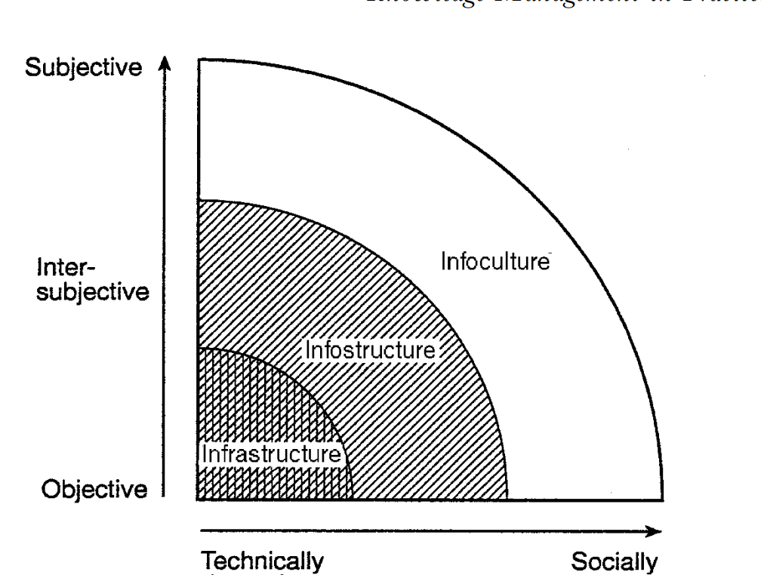

INFOSTRUCTURE:
the formal rules which govern the exchange between the actors on the network providing a set of cognitive resources (metaphors, common language) whereby people make sense of events on the network.
RESEARCH METHOD
A qualitative approach was used to analyse the data. The research adopted a retrospective approach. It was based on a single case study, semi-structured interviews, the researcher’s own on-site observations of the firm over six-weeks’ time and extensive
The technical details of the knowledge sharing systems were provided mainly through archival data. Documentary evidence permitted cross-checking of much of the interview materials. It was possible to control reliability of the managers’ recollections on technical and other details by comparing them with internal documents. Interpretation of empirical events was furthered through discussions with the other members of the research group and several knowledge management researchers and practitioners outside the case company. The use of externally oriented articles provided yet another possibility to triangulate the validity of the interview data.
In addition to interviews, observations, archival material and supplemental data collection and member checks were applied. Specially, archival data was collected in the form of newsletters, handbooks, vignettes, and instructional videos produced by Buckman Laboratories or from information held on Buckman Laboratories’ intranet. In the subsequent analysis, we develop a socio-technical model of knowledge management that highlights the carefully managed interplay between organizational context and knowledge management tools developed at Buckman.

BUCKMAN LABORATORIES CASE STUDY
In keeping with our aim of developing a socio-technical perspective on knowledge management, the following is an analytically structured case-study which highlights the interaction between the key characteristics (i.e. knowledge, IT, management, change processes, and the layers of infrastructure, infostructure, info culture) outlined above.

ORGANIZATIONAL BACKGROUND
Buckman Laboratories is a $300 million chemical company serving industries in 102 different countries selling 1000 different specialty chemicals. It was established in 1945 as a manufacturer of specialist chemicals for aqueous industrial systems. In 1989, Bob Buckman made a personal pledge that knowledge would become the foundation of his: Although this paper focuses on the period of development between 1992–2022, the evolution of Buckman Laboratories’ knowledge management development can be seen in terms of two major stages : historical 1945–2022) and transformative (1992–2022) periods.
The knowledge sharing initiatives were planned and emerged over time to respond to internal and external changes. The findings below can be grouped into four areas. The fist describes the info culture which identifies the change activities Buckman Laboratories undertakes to facilitate a knowledge sharing environment.
The second looks at the knowledge infrastructure which includes knowledge architecture and organizational knowledge memory.
The third describes an infostructure which includes the structure and processes used in the sharing of knowledge within the case company.
The fourth section describes the issues and concerns of the knowledge sharing activities at Buckman. We then discuss some of the key managerial and theoretical implications of this paper.
EMPIRICAL ANALYSIS
Our data suggest that different elements of Buckman Laboratories’ knowledge manage- ment system have interacted over time.
There is the obvious role of the infrastructure, for instance, in the shape of the ‘K’Netix’ network connecting knowledge suppliers and knowledge users on a world-wide basis. There is also the evident importance of the infostructure, with the implicit norms and protocols attached to both requesting and supplying knowledge and information on this specialist topic.
Finally, we note the diffuse but hugely in impact of the info culture. The core values and attitudes of Buckman employees are rejected in their willingness to exchange knowledge simply to solve company problems, without the usual political baggage and ulterior motives. In the following section, the analysis will concentrate mainly on the key processes and mechanisms that were found to be important to knowledge management.
ANALYSIS OF INFRASTRUCTURE KNOWLEDGE ARCHITECTURE:
A major requirement for effective knowledge management is a knowledge architecture, which needs to be designed and specified according to hierarchical levels and with a given conceptual framework for knowledge. Major knowledge architecture elements consist of humans, organizational entities, documents, books, other knowledge repositories and operating entities. The process of building a global knowledge sharing architecture began after the integration of information systems, telecommunications departments and the Technical Information Centre. As a result, a Knowledge Management Transfer Department (KTD) was set up in March 1992. The main responsibility of the department is to monitor and support the sharing of both explicit and tacit knowledge within the organization.
Organizational Knowledge Repository (Memory) A major building-block in implementing knowledge management is the organizational memory. Organizational memory is defined as the means by which knowledge from the past is brought to bear on present activities, thus resulting in higher or lower levels of organizational effectiveness.
K’Netix is an interconnected system of knowledge bases used as a world-wide resource by Buckman Laboratories associates. It is the network through which Buckman associates share knowledge electronically and then pass it on to the customer. Combining Buckman knowledge with electronic forums, bulletin boards, virtual conference rooms, libraries and e-mail, K’Netix gives associates unlimited access to expertise, experience and resources in around 102 countries.
ANALYSIS OF INFOSTRUCTURE KNOWLEDGE SHARING PROCESSES ACCESS TO KNOWLEDGE
Is governed by formal and informal rules on use and access. Thus, K’Netix is not a static repository. According to a forum specialist of the Knowledge Resource Centre: A feedback loop was set up so that, after listening to customers, any queries relating to a particular area that cannot be answered by the technical-sales personal- based associates are posted on the forum. Usually, the request for help is picked up and answered by anyone who has expertise in the related subject area. If the request is unattended for a few hours, two scenarios emerge. First, the forum specialist will pick up the request, identify the potential experts and try to get their attention in order to answer the question. Second, formally, there is also a team of experts with related industrial experience who volunteer to be listed as section leaders who help answer any requests and prepare weekly summaries
ANALYSIS OF INFOCULTURE KNOWLEDGE ENTERPRISING CULTURE
At Buckman Laboratories, one very significant aspect of its culture consists of its knowledge-enterprising characteristics that promote knowledge sharing. Part of the unique culture puts the world’s most knowledgeable experts at all levels of Buckman’s organization in touch with each other, thus, encouraging group problem-solving and the sharing of new ideas and knowledge.

KNOWLEDGE ENTREPRENEURSHIP AND THE ROLE OF TOP MANAGEMENT
A shared, challenging, knowledge entrepreneurship vision is critical to the success of knowledge management. A shared vision provides the focus and energy for knowledge sharing. It encourages and energizes people to uncover the organization’s picture of the future, and should provide meanings and value for everyone. These factors underline the importance of management in creating and co-ordinating the different elements of the knowledge management system.
CONCLUSIONS
This research presents a model of knowledge management and illustrates it with a case study of one organization. It suggests that this organization represents a particular form of knowledge management—one that utilizes various mechanisms for leveraging knowledge towards business advantage. This study presents an initial attempt at understanding this phenomenon from a socio-technical perspective, though it falls short of claiming that such a system can be readily replicated in other organizations. In this research, we argue that the socio-technical view offers a particularly important approach to examining and exploring the development, processes, and mechanisms of knowledge management within a knowledge-intensive firm. We drew on findings from an empirical study in order to apply the concept to illustrate the multi-faceted, multi-layered and socially constructed phenomenon of knowledge management. The conceptual framework developed here has important implications for both practice and research.

THEORETICAL IMPLICATIONS
This study has investigated the effects of implementing a knowledge management system within a particular organization. This study leads towards the conclusion that such systems involve more than technology but rather a culture in which new roles and constructs are created. It changes the communication patterns between individuals and teams, and also alters the design of the organization by fostering new processes and structures. Learning and competence development need to be encouraged, and a knowledge sharing system instituted to foster the integration of knowledge towards business objectives. This study also provides an important new perspective on the interplay between knowledge management and the organizational context, suggesting that much of the existing literature in this field is based on dubious functionalist and rationalist assumptions. This study describes in theoretical terms how one organization is developing its systemic capability to effectively and efficiently share tacit knowledge from on-going practice and to create explicit organizational knowledge for future events. While no single organization has a knowledge management system similar to that of Buckman Laboratories in its entirety, many organizations set up mechanisms and management processes to achieve portions of it. Much work remains to be done, but this study lays some groundwork for research on the characteristics and effects of knowledge management.
REFERENCES:
P. Senge, ‘The Leader’s New Work: Building Learning Organizations’, Sloan Management Review, Fall 1990, pp. 7–23. J.C. Spender, ‘Competitive Advantage from Tacit Knowledge?
Unpacking the Concept and its Strategic Implications’, in: B. Moingeon & A. Edmondson (Eds), Organizational Learning and Competitive Advantage (London, Sage; 1996). R.M. Grant, ‘Toward a knowledge-based Theory of the Firm’, Strategic Management Journal, 17 (Winter Special Issue), 1996, pp. 109–122. G. Huber, ‘Organizational Learning: The Contributing
Processes and the Literatures’, Organization Science, 2(1), February 1991, pp. 88–116. B. Tsoukas, ‘The Firm as a Distributed Knowledge System: A Constructionist Approach’, Strategic Management Journal, 17, Winter Special Issue 1996, pp. 11–25. 2. R.M. Grant, ‘The
Knowledge-based View of the Firm: Implications for Management Practice’, Long Range Planning, 30(3), 1997, pp. 450–454. 3. A. Nonaka & H. Takeuchi, The Knowledge Creating Company (New York, NY, Oxford University Press,

