Serviceability Performance Of Dapodi – Nigdi Road, Pune (MH)
Samradni S. Mulayª, Sagar K. Sonawane^{b}, Rajshekhar G. Rathod^{b}, Achyut A. Deshmukh
ªStudent, Civil Engineering Department, MIT SOE, MIT Art, Design and Technology University, Pune, 412201, India.
^{b}Assistant Professor, Civil Engineering Department, MIT SOE, MIT Art, Design and Technology University, Pune, 412201, India.
Abstract
Pavement deterioration poses a significant challenge in flexible pavements, and various factors, including pavement age, traffic volume, moisture, subgrade conditions, and materials, contribute to this problem in India. Consequently, it is crucial to assess the performance of pavements through pavement evaluation. The Falling Weight Deflectometer (FWD) testing is a commonly employed method that uses a back-calculation process to evaluate the structural condition of pavements and predict layer moduli. The Visual Pavement Condition Survey (VPCS) is another widely adopted measure to assess pavement serviceability performance. Additionally, the International Road Assessment Programme (iRAP) is a valuable tool for improving global road safety by identifying and addressing high-risk roads. This project aims to evaluate the serviceability performance of the Dapodi-Nigdi Road in Pune, utilizing iRAP as a preliminary study to gain initial insights into the road's functional condition. Subsequent evaluations should incorporate VPCS and FWD assessments based on specific requirements. Importantly, both VPCS and iRAP offer cost-effective and reliable methods for pavement evaluation compared to FWD.

Keywords: Falling Weight Deflectometer; Visual Pavement Condition Survey; International Road Assessment Programme.
- Introduction
India possesses an extensive road network spanning 6,215,797 kilometres, which is the second largest in the world after the United States. The deterioration of road surfaces typically occurs due to various factors, including traffic, weather, drainage issues, and environmental elements. Among the different types of roads, flexible pavements tend to degrade at a faster rate compared to rigid pavements. Functional deterioration and structural deterioration are two primary forms of pavement deterioration.
VPCS can be conducted in two ways: either by conducting a physical walk-through survey or by employing specialized imaging equipment while moving at traffic speed. The purpose of these surveys is to accurately map and assess the type and extent of distress present on the pavement. Severity and quantity ratings can be assigned to each type of defect, providing a standardized approach to evaluate their significance and quantity. By applying consistent assessment criteria and reducing subjectivity, VPCS enables accurate and reliable data collection, leading to effective pavement management and maintenance decisions.
FWD method is used to assess structural condition of pavement. It involves applying an impulse load to the pavement and measuring the deflected shape of the surface using geophones placed at various radial distances from the centre of the falling weight.
iRAP is a registered charity committed to saving lives by addressing high-risk roads worldwide. Star ratings, based on road inspection data, offer a straightforward and objective measure of safety levels incorporated into the road infrastructure for vehicle occupants, motorcyclists, bicyclists, and pedestrians. Roads with a 5-star rating are considered the safest, while those with a 1-star rating are deemed the least safe.
- Research methodology
  - Traffic volume count
A detailed Traffic Volume Count (TVC) survey was conducted on the Dapodi-Nigdi road to assess traffic characteristics. The survey focused on commercial vehicles.
Table 1 Annual Average Daily Traffic
Vehicle Type/ chainage/ location |  | PHUGEWADI |  | PCMC BLD |  | CHINCHWAD ST |  | BAJAJ AUTO
 |  | 1+850 | 1+810 | 6+700 | 6+500 | 8+300 | 9+000 | 10+500 | 10+470
 |  | LHS | RHS | LHS | RHS | LHS | RHS | LHS | RHS
Fast moving vehicles | Bus | 1301 | 1234 | 814 | 847 | 1200 | 806 | 1504 | 1539
 | Minibus | 111 | 96 | 62 | 64 | 116 | 69 | 142 | 132
 | Car/ Van/ Jeep/ Taxi | 9436 | 8129 | 8377 | 6770 | 9027 | 9233 | 8071 | 7954
 | 3- Wheeler | 5882 | 4862 | 5986 | 4942 | 6377 | 4893 | 4086 | 4127
 | 2- Wheeler | 25346 | 22566 | 25367 | 19769 | 30089 | 21065 | 18309 | 19619
 | LCV | 1738 | 1518 | 1135 | 1071 | 1753 | 1009 | 572 | 1012
 | 2- Axle truck | 285 | 139 | 70 | 147 | 808 | 119 | 112 | 86
 | 3- Axle truck | 112 | 148 | 88 | 97 | 102 | 69 | 91 | 68
 | MAV | 519 | 374 | 127 | 245 | 134 | 117 | 141 | 112
 | Tractor | 9 | 4 | 2 | 3 | 2 | 3 | 5 | 4
 | Trailer | 47 | 23 | 25 | 43 | 29 | 31 | 21 | 25
Slow moving vehicles | Cycle | 52 | 59 | 61 | 59 | 79 | 63 | 49 | 39
 | Animal/ hand drawn | 0 | 0 | 0 | 0 | 0 | 0 | 0 | 0
AADT |  | 44838 | 39152 | 42114 | 34057 | 49716 | 37477 | 33103 | 34717
The highest AADT is at Chinchwad station, hence the commercial vehicles per day at Chinchwad station are considered for further calculations i.e., 4144 CVPD.
  - Design parameters as per IRC 115-2014
Traffic growth rate was considered as 5% as per IRC 115-2014. For calculations vehicle damage factor was assumed as 4.5. The lane distribution factor for a dual 2-lane carriageway road has been determined to be 75%. Utilizing this specific traffic parameter, the cumulative Million Standard Axles were computed using the below equations

N =$\frac{365 X [{\left(1+r\right)}^{n}-1 ]}{r}$X A X D X F
A= P(1+r)^{x}
Using the above equations, A = 4352 CVPD and N = 67.3 MSA. For further calculations N = 70 MSA.
  - Data collection of FWD
According to IRC 115-2014 data collection of FWD was carried out and the data recorded for each point included section identity, position of lane, spacing, air and pavement temperature, drop number, deflection value. The KUAB PVD software conducts modulus and strain analysis, considering the required strength based on the provided input data. This software incorporates built-in calculations for determining the elastic moduli of each layer within a pavement, utilizing the specified thickness and Poisson's ratio for each layer. Below sample deflection data is shown in table 2.
Table 2 Sample deflection data
Sr. No. | Position | D0 | D1 | D2 | D3 | D4 | D5 | D6 | Surface temperature | Air temperature
 | m | µm | µm | µm | µm | µm | µm | µm | C | C
1 | 0 | 156 | 139 | 131 | 111 | 99 | 73 | 52 | 32 | 17.5
2 | 200 | 147 | 92 | 53 | 47 | 41 | 39 | 33 | 31.4 | 17.8
3 | 750 | 100 | 91 | 78 | 69 | 61 | 50 | 40 | 31.8 | 17.9
4 | 1260 | 79 | 65 | 56 | 43 | 35 | 23 | 20 | 31.2 | 17.6
5 | 1700 | 399 | 335 | 295 | 254 | 169 | 99 | 53 | 32.5 | 17.6
6 | 2900 | 262 | 212 | 200 | 159 | 135 | 89 | 54 | 31.4 | 17.4
7 | 3240 | 225 | 189 | 169 | 141 | 112 | 75 | 47 | 32 | 17
8 | 3700 | 542 | 429 | 367 | 265 | 188 | 120 | 85 | 32 | 16.9
9 | 4200 | 354 | 279 | 265 | 200 | 165 | 100 | 56 | 31.5 | 17
10 | 4700 | 680 | 511 | 405 | 289 | 201 | 100 | 60 | 31.9 | 16.8
11 | 5250 | 420 | 331 | 289 | 200 | 147 | 78 | 62 | 32.3 | 17.2
12 | 5750 | 315 | 256 | 212 | 165 | 119 | 59 | 29 | 32.5 | 17.3

  - Visual pavement condition survey
Firstly, test stretch was selected in such a way that it was straight without any curves and steep gradient. Cross drainage works, over bridge are to be avoided within the selected test stretches. Rutting is longitudinal deformation or depression of the pavement surface along the wheel paths of heavy vehicles. Rutting was observed in terms of depth i.e. Shallow (0.6 cm to 1.2 cm), Deep (1.3 cm to 2.5 cm), Severe (2.5 cm to 5 cm), failure (5 cm and above).
Potholes are small bowl-shaped holes developed on the surface layer of flexible pavements formation of potholes is the most common type of distress that develops in flexible pavement at several locations. The weakening of bond is the main cause of potholes. Potholes are measured in terms of number of potholes per 100 m.
These potholes are repaired by patching. If in case the patching work is not done properly, over a period the patch layer is separated from the pothole which again leads to distress. Patching is measured in terms of surface area.
  - International road assessment programme
In the star rating demonstrator, there are 4 different road user types ie. Vehicle occupants, motorcyclists, pedestrians, and bicyclists. These 4 road users get star rating for each segment of road. Attributes related to geography of the road, geometry, land use, pedestrian flow, vehicle flow, speed limit, area type, road severity, road furniture, traffic calming devices, etc were recorded.
- Results and discussions
  - Falling weight deflectometer
The output data of FWD includes position, elastic moduli, critical layer and overlay as shown in table 3. Average overlay for both left hand side as well as right hand side were calculated.From the output, it is seen that the overlay required in both sections is not the same. But being four lane road with a divider it is preferable to provide the uniform overlay for both the section i.e., the left side and right side. The average overlay worked out is 92.25 mm. Adopting 100 mm overlay as a design thickness with 50 mm bituminous concrete course and 50mm dense bituminous macadam.
Table 3 Sample data for elastic moduli and overlay.
Sr. No. | Position | D0 | E0 | Emod2 | Emod3 | Critical layer | overlay | overlay
 | m | µm | Mpa | Mpa | Mpa |  | cm | mm
1 | 0 | 156 | 2300 | 2000 | 130 | 1 | 9 | 90
2 | 200 | 147 | 2270 | 2000 | 350 | 1 | 8 | 80
3 | 750 | 100 | 2270 | 1700 | 350 | 1 | 9 | 90
4 | 1260 | 79 | 2200 | 2000 | 150 | 1 | 9 | 90
5 | 1700 | 399 | 2125 | 1850 | 130 | 1 | 10 | 100
6 | 2900 | 262 | 2150 | 2000 | 350 | 1 | 9.5 | 95
7 | 3240 | 225 | 2160 | 1900 | 350 | 1 | 8 | 80
8 | 3700 | 542 | 900 | 750 | 200 | 1 | 12 | 120
9 | 4200 | 354 | 2150 | 1814 | 200 | 1 | 10 | 100
10 | 4700 | 680 | 800 | 750 | 100 | 1 | 14 | 140
11 | 5250 | 420 | 1300 | 1170 | 180 | 1 | 12 | 120
12 | 5750 | 315 | 2200 | 1725 | 160 | 1 | 9.5 | 95

  - Visual pavement condition survey
Based on the findings, the data clearly shows that rutting is the most prevalent issue, followed by potholes, and then patching. The main cause of rutting is repeated action of heavy wheel loads and poor compaction of pavement layers. In this case, potholes are majorly developed due to water entering the pavement layers through cracks. These potholes are not maintained by following proper practices; hence it has led to patching.
Table 4 Sample data of type and extent of distress
Distress type | Patching | Rutting | Potholes
Section no | Sq.m |  | (no.)
1 | 0 | Deep | 1
2 | 1.5 | Deep | 1
3 | 0 | Deep | 1
4 | 0 | Deep | 1
5 | 0 | Deep | 1
6 | 0 | Deep | 0
7 | 3 | Deep | 0
8 | 0 | Deep | 1
9 | 0 | Deep | 0
10 | 0 | Deep | 1
  - International road assessment programme
iRAP star rating map shows 3 stars or better rating for vehicle occupants as shown in fig.1. Out of the total 6.7 km stretch around 6.6 km (98.51%) is 3 star or better. From fig .2 and fig.3, for pedestrians, it is 1 star due to the lack of pedestrian infrastructure. For bicyclists, the star rating lies between 1 star and 2 star due to lack of infrastructure for bicyclists. Of the 6.7 km where pedestrians are present and traffic flows at 40 km/hr or more, 6.5 km have no footpath. Also where bicyclists are present and traffic flows at 40 km/hr or more there are no bicycle facilities. Similarly, there is no provision of motorcycle facilities for high motorcycle flow and speed greater than 60 km/hr. There are no sections of curves where traffic flows at 80 km/hr or more. Of the 2 intersections where traffic flows at 60 km/hr or more, 1 has no roundabout, protected turn lane or interchange.

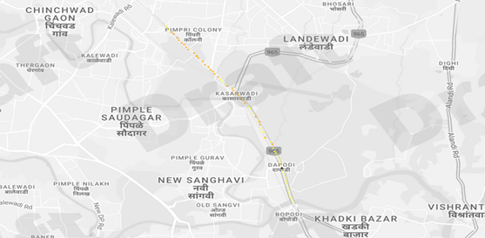
Fig. 1. iRAP star rating map

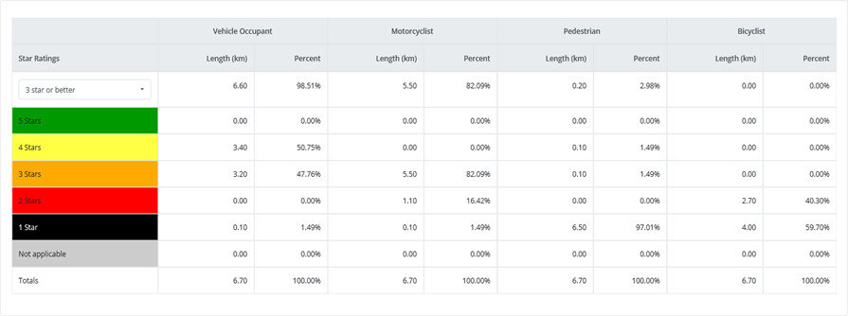
Fig. 2. iRAP star rating table
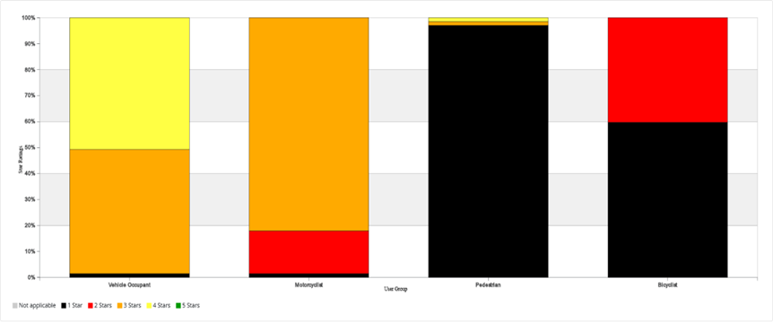
Fig. 3. iRAP star rating chart

Graph 1 Relative comparison of VPCS, FWD and iRAP
Graph 1 states that according to the results of FWD and VPCS the pavement condition is poor, overlay is suggested. The results from the iRAP state that the pavement is in fair condition based on functionality.
- Conclusions
- Following a thorough VPCS and iRAP, it can be determined that the overall condition of the pavement on the Dapodi-Nigdi road falls within the fair to poor range. This assessment clearly signifies the need for resurfacing and patching measures to enhance the road's serviceability performance. Undertaking these improvements will ensure a higher level of functionality for the road, resulting in improved driving conditions and increased safety for all road users.
- One of the notable distresses observed on the Dapodi-Nigdi road is rutting, which pertains to the permanent deformations or indentations on the pavement surface resulting from repeated traffic loads. To effectively enhance the structural serviceability performance of the road, it is highly recommended to undertake a complete overlay.
- It is important to note that patching alone may not be sufficient to eliminate all the distresses observed on the pavement. Recurring distresses, such as potholes, may persist if they are not properly addressed.
- Recurring distresses is an indicator of improper maintenance activities. it is crucial to highlight the significance of following proper procedures when carrying out pothole patching. Poorly executed pothole patching leads to recurring distresses thus increasing the maintenance cost.
- To increase or maintain the serviceability performance of road, pavement evaluation plays vital role according to which further strategies are developed. In case of Dapodi- Nigdi road, according to VPCS rutting is deep, also FWD has suggested overlay considering that the remaining life is less than the calculated life.
- References
- Fuentes, L., et al. (2021), “Modelling pavement serviceability of urban roads using deterministic and probabilistic approaches.” International Journal of Pavement Engineering, 22 (1): 77–86.
- Elhadidy, A. (2021), “A simplified pavement condition index regression model for pavement evaluation.” International Journal of Pavement Engineering, 22 (5): 643–652.
- Hassan, S. B. (2021), “Calibration of IRI-based PSI Equation using Updated Quarter-Car Parameters.” MS. West Virginia University Libraries.
- Al-Haddad et. al. (2018). “Modeling of Flexible Pavement Serviceability Based on the Fuzzy Logic Theory.” J. Transp. Eng., Part B: Pavements, 144 (2): 04018017
- Tsubota, T. et. al. (2018). “Effect of Road Pavement Types and Ages on Traffic Accident Risks.” Transportation Research Procedia, 34: 211–218.
- Rahman, M. et. al. (2017). “Pavement performance evaluation models for South Carolina.” KSCE J Civ Eng, 21 (7): 2695–2706.
- Nega, A., et. al. (2016). “Dynamic analysis of falling weight deflectometer.” Journal of Traffic and Transportation Engineering (English Edition), 3 (5): 427–437.
- Tarefder, R. A., and M. U. Ahmed. (2014), “Modeling of the FWD Deflection Basin to Evaluate Airport Pavements.” Int. J. Geomech., 14 (2): 205–213.
- Salour, F., and S. Erlingsson. (2013). “Investigation of a pavement structural behaviour during spring thaw using falling weight deflectometer.” Road Materials and Pavement Design, 14 (1): 141–158.
- Sandra, A. K., and A. K. Sarkar. (2013), “Development of a model for estimating International Roughness Index from pavement distresses.” International Journal of Pavement Engineering, 14 (8): 715–724.
- Kezhen Y et. al. (2012), “Predicting the Pavement Serviceability Ratio of Flexible Pavement with Support Vector Machines”, Road Pavement and Material Characterization, Modelling, and Maintenance.
- Seo, J.-W. et. al. (2009), “Evaluation of layer properties of flexible pavement using a pseudo-static analysis procedure of Falling Weight Deflectometer.” Construction and Building Materials, 23 (10): 3206–3213.
- Donovan, P., and E. Tutumluer.(2009). “Falling Weight Deflectometer Testing to Determine Relative Damage in Asphalt Pavement Unbound Aggregate Layers.” Transportation Research Record, 2104 (1): 12–23.
- Zhang B et. al. (2008), “Temperature Effects on Falling Weight Deflectometer Measurement”, GeoCongress.
- Terzi, S. (2007), “Modeling the pavement serviceability ratio of flexible highway pavements by artificial neural networks.” Construction and Building Materials, 21 (3): 590–593.
- Lin D F et al. (2006). “Factors Affecting Portable Falling Weight Deflectometer Measurements.” Journal of. Geotech. Geoenviron. Eng., 132 (6): 804–808.
- Abaza, K. A. (2004), “Deterministic Performance Prediction Model for Rehabilitation and Management of Flexible Pavement.” International Journal of Pavement Engineering, 5 (2): 111–121.
- Prozzi J A et. al. (2003), “Incremental Nonlinear Model for Predicting Pavement Serviceability”, Journal of Transportation Engineering Vol. 129, Issue 6.
- Chang J R et. al. (2003), “Non-additive fuzzy regression applied to establish flexible pavement present serviceability index.” The 12th IEEE International Conference on Fuzzy Systems, 1020–1025.
- Ganji, V et. al. (2002), “Utilization of Falling Weight Deflectometer for Project Sectionalization.” Applications of Advanced Technologies in Transportation (2002), 410–416. Boston Marriot, Cambridge, Massachusetts, United States: American Society of Civil Engineers.
- Liu, C. (2000). “Vehicle-road interaction, evolution of road profiles and present serviceability index.” Road Materials and Pavement Design, 1 (1–2): 35–51.
- Chen, J., M. Hossain, and T. M. Latorella. 1999. “Use of Falling Weight Deflectometer and Dynamic Cone Penetrometer in Pavement Evaluation.” Transportation Research Record, 1655 (1): 145–151.
- Tang B, (1993), “Structural Evaluation of Airfield Rigid Pavements Using Falling Weight Deflectometer.” Journal of Transportation Engineering Vol. 119, Issue 3.
- Rao, D. S. “Improving the Pavement Conditions: Pavement Condition Assessment methods, Methods for optimizing the reparation and maintenance cost for roads.”
- Au, N. A., and P. KHosLA. n.d. “Determination of Layer Moduli Using a Falling Weight Deflectometer.” Transportation research record.
- Murozi, S. Z. et al. "The Application of International Road Assessment Programme (iRAP) as a Road Infrastructure Risk Assessment Tool".

