Additive Manufacturing: Revolutionizing Modern Manufacturing Technology
Authors: [Dr.Pradeep Johnson, Dr. Jonah]

INTRODUCTION
Additive Manufacturing Landscape: Past, Present, and Future
Past: Additive Manufacturing (AM), also known as 3D printing, has its roots dating back to the 1980s. The first methods focused on polymer-based materials, which allowed for rapid prototyping of concepts. These technologies were expensive and primarily used for creating prototypes rather than end-use products.
Present: Over the years, AM has evolved significantly and expanded to various industries, including aerospace, automotive, healthcare, and consumer goods. The technology has diversified with a range of materials, including metals, ceramics, and composites. This has led to the production of functional and complex parts suitable for end-use applications. Some key trends in the present AM landscape include:
- Materials Advancements: The development of new materials and material processes has significantly expanded the range of applications for AM. High-performance metals, biocompatible polymers, and advanced ceramics are now being used to create functional and durable parts.
- Scale and Speed: Improvements in AM processes have increased printing speed and scalability. Large-format printers and faster layer-by-layer techniques enable the production of bigger parts in shorter timeframes.
- Industrialization: AM has moved from being a prototyping tool to an industrial production method. Industries are adopting AM for low-volume, high-complexity, and customized manufacturing, reducing lead times and minimizing waste.
- Hybrid Approaches: Hybrid systems combine traditional manufacturing techniques like CNC machining with AM, allowing for the optimization of parts with complex geometries.
- Post-Processing Solutions: The industry is focusing on improving post-processing techniques to achieve desired surface finishes, mechanical properties, and overall part quality.
- Regulations and Standards: As AM becomes more prevalent in critical industries like aerospace and healthcare, there's a growing emphasis on establishing industry-specific regulations and quality standards to ensure safety and consistency.
Future: The future of AM holds immense potential for further disruption and innovation. Several key trends and possibilities include:
- Multi-Material Printing: Advancements in multi-material and multi-process printing will enable the creation of more complex and functional parts with varying properties within a single build.
- Speed and Scale: Continued improvements in printing speed and scalability will make AM more competitive for larger production runs.
- New Materials: The discovery and development of novel materials optimized for AM will unlock new applications, from high-temperature alloys for aerospace to bioinks for 3D bioprinting.
- Sustainability: The AM industry will likely focus on reducing waste, energy consumption, and the environmental impact of production processes.
- In-situ Monitoring and Control: Real-time monitoring and feedback systems will enhance quality control and consistency during the printing process.
- Space and Extraterrestrial Applications: AM could play a vital role in enabling manufacturing on other planets and in space, where traditional supply chains are not feasible.
- AI and Automation: Integration of AI and automation will streamline the design-to-production workflow, optimizing part designs and minimizing human intervention.
- Mass Customization: AM's ability to create highly customized products economically could lead to a shift away from mass production to more personalized manufacturing.
- Tissue and Organ Printing: Bioprinting could revolutionize healthcare by enabling the creation of functional tissues and even organs for transplantation.

Categories of Additive Manufacturing
Material Jetting: Precision Additive Manufacturing
Authors: [Dr.Pradeep Johnson, Dr. Jonah]
Introduction
Material jetting is a revolutionary additive manufacturing (AM) technique that enables the creation of intricate and highly detailed objects with an unprecedented level of precision. Also known as inkjet printing, 3D inkjet printing, or drop-on-demand printing, material jetting employs principles similar to traditional 2D inkjet printing but extends them into the three-dimensional realm. This chapter explores the principles, processes, applications, and advancements in material jetting, shedding light on its immense potential in diverse industries.

Principles of Material Jetting
Material jetting is based on the controlled deposition of liquid materials onto a build platform, layer by layer, to create a three-dimensional object. The process involves the following key components:
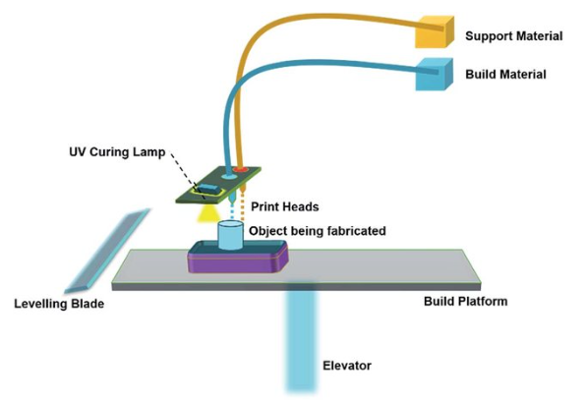
Fig. 1 Schematic representation of the material jetting process (Merum Sireesha et al. 2018)
Print Head: The print head is the heart of the material jetting process. It contains multiple tiny nozzles, each capable of jetting precise droplets of material. These nozzles are controlled electronically to create intricate patterns and structures.
- Materials: Material jetting is versatile in its choice of materials. It can work with polymers, metals, ceramics, composites, and even biological substances. These materials are formulated to be in liquid form and are cured or solidified after deposition.
- Build Platform: The build platform serves as the foundation on which the object is constructed. It can move in the vertical direction to accommodate each new layer.
- UV Light Source: Many material jetting systems use UV light to cure the liquid materials. As the droplets are deposited, they are exposed to UV light, causing them to solidify and adhere to the previous layers.
The Material Jetting Process
The material jetting process involves several sequential steps:
- Preparation: The 3D model of the object is digitally designed using computer-aided design (CAD) software. This digital model is sliced into layers using slicing software, generating a set of instructions for the printer.
- Material Loading: The liquid material is loaded into the print head's reservoir. The print head heats the material to lower its viscosity, ensuring smooth jetting.
- Printing: The print head moves over the build platform, depositing droplets of material layer by layer according to the instructions from the slicing software. UV light may be applied to cure the material after each layer.
- Layer-by-Layer Construction: The object is built layer by layer, with each layer fusing with the previous one to create a seamless, homogenous structure.
- Support Structures: Some material jetting systems can print support structures made of a sacrificial material that is later removed. These supports prevent the collapse of overhangs and intricate geometries during printing.
- Post-Processing: Once printing is complete, the object may undergo post-processing steps such as curing, polishing, and surface finishing to achieve the desired final appearance and properties.
Applications of Material Jetting
Material jetting's remarkable precision and ability to use a variety of materials make it suitable for various applications:
- Prototyping: Material jetting excels in producing highly detailed prototypes for design validation and functional testing.
- Dental and Medical: The technique is used to create custom dental implants, surgical guides, and anatomical models for medical education.
- Aerospace: Material jetting is employed to manufacture lightweight, complex components with reduced material waste.
- Consumer Goods: Customized consumer products, such as jewelry and fashion items, are produced with fine details and intricate patterns.
- Electronics: The precision of material jetting is harnessed to create miniaturized electronics components.
- Art and Design: Artists and designers use material jetting to create intricate sculptures and art installations.
Advancements and Future Prospects
Material jetting is continually evolving with advancements in print head technology, material formulations, and process optimization. Researchers are exploring ways to enhance the speed of printing, increase the range of printable materials, and improve the overall efficiency of the process. The integration of material jetting with multi-material capabilities and bio-printing holds significant promise for medical and biological applications.

Conclusion
Material jetting has emerged as a groundbreaking additive manufacturing technique, enabling the creation of intricately detailed objects with unmatched precision. Its versatility in materials and applications makes it a pivotal player in industries ranging from aerospace to healthcare. As technology continues to advance, material jetting is poised to redefine the boundaries of additive manufacturing and transform how we conceptualize and create objects in the modern world.

Vat Polymerization: Principles and Applications
Authors: [Dr.Pradeep Johnson, Dr. Jonah]
Vat Polymerization: Principles and Applications
Introduction
Vat polymerization is a versatile and widely used additive manufacturing technique that involves the selective solidification of liquid photopolymer resin into three-dimensional objects layer by layer. This chapter provides an in-depth exploration of the principles, process parameters, materials, and applications of vat polymerization in the field of additive manufacturing.
Vat polymerization is a type of additive manufacturing, commonly known as 3D printing, that involves creating three-dimensional objects by selectively curing liquid resin layer by layer. This process is also referred to as stereolithography (SLA) or digital light processing (DLP). Vat polymerization operates on the principle of photopolymerization, where a liquid photopolymer resin is exposed to light, typically ultraviolet (UV) light, causing it to solidify and form the desired object.
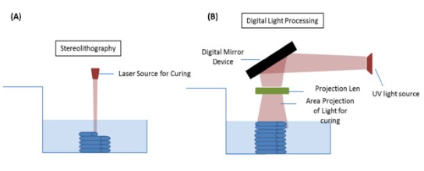
Image source: researchgate.net
Fig. 2 Schematic representation of the Vat Polymerisation (A) Stereolithography. (B) Digital Light Processing (Jia Min Lee et al 2018)
Here are the key principles and applications of vat polymerization:
Principles:
Vat polymerization, also known as stereolithography (SLA) or digital light processing (DLP), relies on the principle of photopolymerization. A vat of liquid photopolymer resin is exposed to a light source, typically an ultraviolet (UV) laser or a digital light projector, which selectively cures the resin in specific areas defined by a digital model. The cured resin forms a solid layer, and the build platform is then lowered to allow the subsequent layer to be formed on top. This layer-by-layer approach results in the gradual fabrication of a three-dimensional object.
- Photopolymerization: Vat polymerization relies on the photopolymerization process. A vat of liquid photopolymer resin is exposed to UV light in a controlled manner, causing the resin to polymerize and solidify in a predefined pattern.
- Layer-by-Layer Build: The 3D object is built layer by layer from the bottom up. Each layer of resin is selectively cured by UV light, and once a layer is complete, the build platform moves up slightly to allow the next layer of liquid resin to be spread over the previous layer.
- Selective Curing: The UV light is projected onto the liquid resin through a mask or digital micromirror device (DMD), which controls the curing process with high precision. Only the areas exposed to UV light solidify, while the uncured resin remains in the vat.
- Support Structures: Overhanging features and complex geometries may require support structures to prevent sagging or collapsing during the printing process. These supports are also cured resin but are designed to be removable after printing.

Process Parameters
1. Layer Thickness
The layer thickness determines the resolution and surface finish of the printed object. Thinner layers yield higher resolution but may extend the printing time.
2. Exposure Time and Energy
The exposure time and energy of the light source influence the degree of resin curing. Optimizing these parameters is crucial to achieve proper layer adhesion and structural integrity.
3. Light Source
The choice of light source, such as lasers or digital light projectors, impacts the speed and accuracy of the printing process.
4. Resin Properties
The photopolymer resin's viscosity, reactivity, and composition play a significant role in determining the print quality and mechanical properties of the final object.
Materials for Vat Polymerization
A wide range of photopolymer resins are available, each tailored to specific applications. These resins can exhibit various properties, including transparency, flexibility, toughness, and biocompatibility. Common resin types include:
- Standard Resins: General-purpose resins suitable for rapid prototyping and conceptual modeling.
- Engineering Resins: Resins with enhanced mechanical properties, chemical resistance, and thermal stability for functional prototypes and end-use parts.
- Dental and Medical Resins: Biocompatible resins used in dental and medical applications such as crowns, bridges, and surgical guides.
- Jewelry Resins: Resins designed to produce high-detail jewelry pieces with excellent surface finish.
- Flexible and Elastic Resins: Resins that yield rubber-like or flexible parts, suitable for gaskets, seals, and ergonomic prototypes.

Applications:
- Prototyping: Vat polymerization is commonly used for rapid prototyping due to its high level of detail and accuracy. It allows designers and engineers to quickly create physical models of their designs for testing and validation.
- Jewelry and Accessories: The fine detail and smooth surface finish of vat polymerization make it suitable for producing intricate jewelry and fashion accessories.
- Dental and Medical Devices: Vat polymerization is utilized in the production of dental crowns, bridges, orthodontic models, and surgical guides. The biocompatible materials used in this process are suitable for creating medical devices and implants.
- Engineering Components: Functional engineering components, such as gears, housings, and prototypes, can be produced using vat polymerization. However, the mechanical properties of the printed parts might be less robust compared to traditional manufacturing methods.
- Art and Design: Artists and designers use vat polymerization to bring their digital creations into the physical world. The ability to achieve intricate details and complex shapes makes it a versatile tool for artistic expression.
- Microfabrication: Vat polymerization is used in microfabrication processes to create microstructures for applications in microfluidics, microoptics, and other microelectromechanical systems (MEMS).
- Education and Research: Vat polymerization is also valuable in educational settings for teaching 3D printing principles and in research laboratories for rapid prototyping and small-scale production.
While vat polymerization offers high-resolution prints with smooth surfaces, it's important to note that the mechanical properties and material choices can vary. Different resins can have varying levels of strength, flexibility, and durability, so selecting the appropriate material for a given application is crucial. Additionally, post-processing steps like curing, cleaning, and sometimes curing under UV light are often required to achieve the final desired properties and finish.
Advancements and Future Directions
The field of vat polymerization continues to evolve, with ongoing research and development focused on improving print speed, material variety, and overall process capabilities. As new materials are formulated and printing technologies advance, vat polymerization is likely to find applications in more industries and enable the production of increasingly complex and functional objects.
Conclusion
Vat polymerization, a foundational additive manufacturing technique, offers exceptional precision, detail, and versatility. Its ability to fabricate functional prototypes, customized tools, and end-use products has solidified its place as a key technology in the additive manufacturing landscape. As material science and process optimization continue to advance, vat polymerization is set to push the boundaries of what is achievable in three-dimensional object fabrication.

Binder Jetting
Authors: [Dr.Pradeep Johnson, Dr. Jonah]
Introduction
In the realm of additive manufacturing (AM), various techniques have emerged over the years, each with unique characteristics and applications. One such technique that has garnered significant attention is "binder jetting." Binder jetting is an additive manufacturing process that allows the creation of intricate three-dimensional objects by depositing layers of material and selectively binding them together using a liquid binder. This chapter delves into the intricacies of binder jetting, exploring its history, process, applications, advantages, limitations, and potential future developments.
Historical Evolution
The concept of binder jetting dates back to the late 1990s, with early research and development primarily focused on metal and ceramic powder materials. The initial goal was to overcome the limitations of traditional manufacturing methods by enabling the creation of complex geometries with minimal material wastage. Over the years, the technology evolved from using basic powder materials to incorporating a wide range of materials, including metals, ceramics, polymers, and composites.
Binder Jetting Process
Binder jetting involves a multi-step process that combines powder deposition and selective binding:
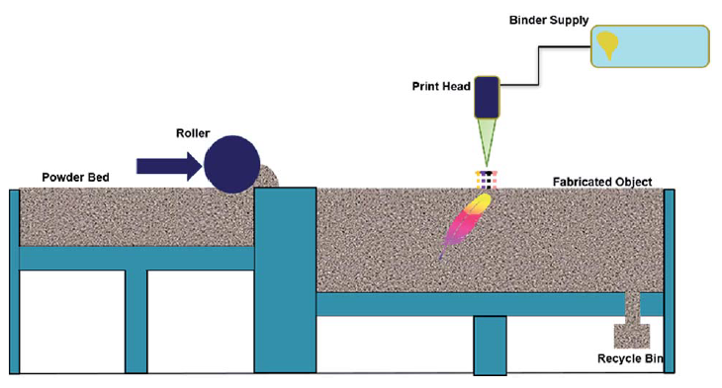

Fig. 3 Schematic representation of the binder jetting process (Merum Sireesha et al. 2018)
- Powder Deposition: The process begins with the spreading of a thin layer of powder material across the build platform. This layer serves as the base for the subsequent layers.
- Binder Application: A liquid binder is jetted onto the powder layer, selectively depositing binder in areas that correspond to the cross-sectional shape of the desired object. The binder serves as an adhesive that binds the powder particles together.
- Layer-by-Layer Buildup: The platform is then lowered, and a new layer of powder is spread on top of the previously bonded layer. The binder application process is repeated for each layer until the entire object is built up.
- Post-Processing: Once the object is fully printed, it undergoes post-processing steps such as drying, curing, and possibly sintering or infiltrating to achieve the desired mechanical properties.
Applications
The versatility of binder jetting has led to its application in various industries, including aerospace, automotive, healthcare, and consumer goods:
- Prototyping: Binder jetting offers a rapid and cost-effective method for producing prototypes with complex geometries, allowing engineers to test and refine designs before committing to full-scale production.
- Customized Medical Devices: In the healthcare sector, binder jetting has been used to create patient-specific implants, prosthetics, and dental structures, tailored to individual anatomies.
- Lightweight Structures: The technology's ability to produce lightweight yet strong components makes it suitable for aerospace and automotive applications, where weight reduction can lead to improved fuel efficiency and performance.
- Art and Sculpture: Artists and sculptors have also embraced binder jetting as a means to create intricate and detailed sculptures that would be difficult to achieve through traditional methods.
Advantages and Limitations
Advantages:
- Speed and Efficiency: Binder jetting is generally faster than other additive manufacturing methods since it doesn't require the slow heating and cooling cycles associated with techniques like selective laser sintering.
- Materials Diversity: The process is compatible with a wide range of materials, including metals, ceramics, polymers, and composites, broadening its potential applications.
- Reduced Waste: Binder jetting generates less waste compared to traditional manufacturing processes, as only the powder that becomes part of the final object is used.
Limitations:
- Surface Finish: The surface finish of binder jetted parts may require additional post-processing steps to achieve the desired smoothness.
- Mechanical Properties: While binder jetting produces prototypes and components with good accuracy, achieving certain mechanical properties may require secondary treatments such as sintering, which can add complexity to the process.
- Resolution: The achievable resolution of binder jetting may not be as high as that of other AM methods like stereolithography or digital light processing.
Future Developments
As with all additive manufacturing technologies, binder jetting continues to evolve. Researchers are exploring ways to enhance resolution, improve material options, and refine post-processing techniques. Additionally, efforts are underway to integrate binder jetting with other manufacturing processes to create hybrid manufacturing systems that capitalize on the strengths of different techniques.
Conclusion
Binder jetting has emerged as a powerful additive manufacturing method with a broad range of applications across various industries. Its ability to work with diverse materials, produce complex geometries, and offer efficiency benefits makes it an attractive option for both prototyping and limited production. While challenges such as surface finish and mechanical properties persist, ongoing research and development are likely to address these issues, further establishing binder jetting as a valuable tool in the additive manufacturing toolbox.
Material Extrusion: Processes, Applications, and Advancements
Introduction: Material extrusion is a layer-by-layer additive manufacturing process that involves melting a thermoplastic filament and depositing it onto a build platform to create three-dimensional objects. It has become one of the most accessible and widely adopted additive manufacturing techniques due to its simplicity, cost-effectiveness, and capability to work with a wide range of materials.
Fundamental Principles: Material extrusion relies on the principle of layer-wise deposition. The process begins with a 3D model sliced into numerous thin cross-sectional layers. The extrusion system heats the thermoplastic filament until it reaches its melting point, then extrudes it through a nozzle onto the build platform. The extruded material quickly solidifies, forming a layer. The build platform is then lowered, and the process is repeated for each subsequent layer until the object is complete.

Process Steps: The material extrusion process involves several key steps, including:
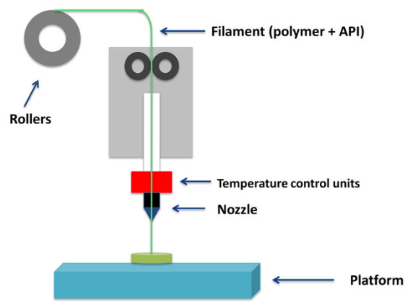

Fig. 4 Schematic representation of the Fused Deposition Modelling (Andrea Alice Konta et al. 2017)

- Material Preparation: Choosing the appropriate thermoplastic material in filament form.
- Slicing: Converting the 3D model into a series of 2D cross-sectional slices.
- Extrusion: Melting the filament and depositing it layer by layer.
- Cooling and Solidification: Allowing the deposited material to cool and solidify.
- Layer Bonding: Ensuring proper adhesion between adjacent layers.
- Key Components: The essential components of a material extrusion system include:
- Extruder: The component responsible for melting and extruding the filament.
- Nozzle: Controls the diameter of the extruded material, affecting resolution and speed.
- Build Platform: The surface on which the object is built.
- Motion System: Controls the movement of the extruder and build platform.
- Heating System: Regulates the temperature of the extruder and build chamber.
- Cooling System: Prevents excessive heat accumulation and ensures layer bonding.
Materials and Applications: Material extrusion is compatible with a wide variety of thermoplastic materials, including PLA, ABS, PETG, nylon, and more. Its applications span multiple industries:
- Rapid Prototyping: Material extrusion is ideal for quickly producing prototypes and concept models.
- Tooling: Custom jigs, fixtures, and tooling components can be fabricated cost-effectively.
- Functional Parts: End-use components, such as casings, housings, and brackets, can be manufactured.
- Medical and Dental: Patient-specific implants, prosthetics, and surgical guides can be 3D printed.
- Education: Material extrusion is popular in educational settings for hands-on learning.
- Advancements and Challenges: Recent advancements in material extrusion technology include:
- Multi-material and Multi-Nozzle Printing: Enabling the use of multiple materials or colors in a single print.
- Improved Resolution: Smaller nozzle sizes and improved motion control for finer details.
- Composite Filaments: Incorporating additives like carbon fiber for enhanced mechanical properties.
- Temperature Control: Precise temperature management for better material properties and adhesion.
However, challenges persist, such as:
- Layer Adhesion: Ensuring strong bonding between layers to prevent delamination.
- Surface Finish: Improving the smoothness of printed surfaces.
- Material Variety: Expanding the range of printable materials and their properties.
- Speed vs. Quality: Balancing print speed and object quality.
- Future Directions: The future of material extrusion holds exciting prospects:
- More Materials: Continued expansion of compatible materials, including high-performance polymers.
- Process Optimization: Improved printing speeds and quality through advanced control algorithms.
- Integration with Other Technologies: Combining material extrusion with other manufacturing methods.
- Sustainable Materials: Development of eco-friendly and biodegradable filament options.
- Mass Customization: Enabling efficient production of customized consumer goods.
- Conclusion: Material extrusion has emerged as a versatile and accessible additive manufacturing process with widespread applications. Its straightforward process, wide material compatibility, and adaptability make it a valuable tool for industries ranging from manufacturing to healthcare. As technology continues to advance, material extrusion is poised to play a pivotal role in shaping the future of manufacturing.

Powder Bed Fusion: Additive Manufacturing's Precision Technique
Authors: [Dr.Pradeep Johnson, Dr. Jonah]
Introduction
Powder Bed Fusion (PBF) is a type of additive manufacturing (AM) technology, commonly referred to as 3D printing that involves creating three-dimensional objects by adding material layer by layer. PBF is particularly well-suited for producing complex geometries and functional prototypes, as well as end-use parts in various industries such as aerospace, automotive, medical, and more.
There are several variations of PBF, but the general process involves the following steps:
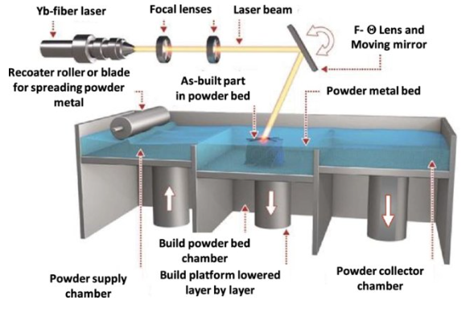
Fig. 5 Schematic representation of the Powder Bed Fusion (Tugrul O zelet al. 2020)

Preparation: The process starts with the preparation of a digital 3D model of the object to be printed. This model is usually created using Computer-Aided Design (CAD) software.
Powder Dispensing: A thin layer of powdered material (usually metal, plastic, ceramic, or composite materials) is evenly spread across the build platform. The layer thickness typically ranges from tens to hundreds of micrometers.
Energy Application: A high-energy source, such as a laser or an electron beam, is used to selectively fuse or sinter the powdered material in the desired areas according to the digital model. The energy source is precisely controlled by scanning across the layer of powder, causing the powder particles to melt and fuse together.
Layer-by-Layer Building: After the first layer is fused, the build platform is lowered by the layer thickness, and a new layer of powder is spread on top. The energy source scans the new layer to selectively fuse the powder particles, bonding them to the previous layer.
Cooling and Solidification: Once a layer is completed, the fused material rapidly cools and solidifies. This ensures that the newly fused layer adheres to the layer below it.
Repeating the Process: This layer-by-layer approach allows for the creation of complex geometries that might be difficult or impossible to achieve using traditional manufacturing methods.
Post-Processing: After the printing process is complete, the printed object is often subjected to post-processing steps, which may include removing excess powder, heat treatment (annealing), machining, polishing, or coating to achieve the desired final properties and surface finish.
There are two primary variations of Powder Bed Fusion: Selective Laser Sintering (SLS) and Selective Laser Melting (SLM). The main difference between these methods lies in the level of energy applied by the laser: SLS fuses the powder particles together without completely melting them, while SLM fully melts the powder particles. The choice between SLS and SLM depends on the material properties and the specific requirements of the printed object.
PBF technology is widely used in various industries, including aerospace, automotive, medical, and consumer goods, for producing functional prototypes, intricate components, and even end-use parts with high precision and complexity.

Sheet Lamination in Additive Manufacturing
Authors: [Dr.Pradeep Johnson, Dr. Jonah]
Introduction:
Sheet lamination is a prominent technique within the field of additive manufacturing (AM) that involves the layer-by-layer assembly of thin sheets to create three-dimensional objects. This chapter delves into the fundamental principles, processes, materials, applications, and advancements in sheet lamination-based additive manufacturing technologies. It explores the various methods of sheet lamination, including their benefits and limitations, and provides insights into the evolving landscape of this additive manufacturing approach.
Sheet lamination is an additive manufacturing process that involves layering and bonding sheets of material to create three-dimensional objects. Unlike some other 3D printing methods that work with powders or liquid resins, sheet lamination utilizes thin sheets or layers of material, typically in the form of paper, plastic, metal, or other materials.
There are a few different techniques within the sheet lamination process:
Laminated Object Manufacturing (LOM): LOM is one of the earliest forms of sheet lamination. In this process, layers of adhesive-coated paper, plastic, or metal are stacked on top of each other. A laser or knife then cuts the desired shape of the layer out of each sheet, and the layers are bonded together to create the final object.
Ultrasonic Additive Manufacturing (UAM): This process involves ultrasonically welding thin metal sheets together. The metal sheets are placed on top of each other and ultrasonic vibrations are applied along the welding path. The heat generated by these vibrations causes the metal to fuse together, creating a solid object.
Laminated Sheet Object Manufacturing (LSOM): Similar to LOM, LSOM involves layering sheets of material and cutting them into shape using a laser or knife. These cut sheets are then bonded together to create the final object.
The main advantage of sheet lamination processes is that they can work with a wide range of materials, including metals, plastics, ceramics, and composites. Additionally, they can produce relatively large objects with good accuracy and surface finish. However, compared to some other additive manufacturing techniques, sheet lamination processes may have limitations in terms of speed and complexity of geometries they can produce.
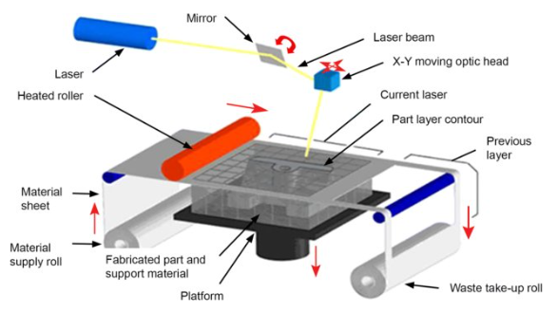

Fig. 6 Schematic representation of the Sheet Lamination Process (LOM) (Francisco Jose Mercado Rivera et al. 2020)

Materials for Sheet Lamination: This section highlights the range of materials used in sheet lamination processes. It covers the considerations for selecting suitable materials and the challenges associated with material compatibility and processing.
Advantages and Limitations: Exploring the pros and cons of sheet lamination techniques, including factors such as speed, precision, material diversity, and post-processing requirements. This section also addresses the impact of layer bonding on mechanical properties.
Applications: Detailing the diverse applications of sheet lamination-based additive manufacturing, such as aerospace components, automotive parts, medical devices, and architectural models. Real-world case studies exemplify the successful implementation of sheet lamination technologies across various industries.
Advancements and Future Directions: This section delves into recent advancements in sheet lamination, including improved layer bonding techniques, enhanced material options, and process automation. It also speculates on the future developments and potential innovations in this field.
Challenges and Research Opportunities: Exploring the current challenges faced by sheet lamination processes, such as achieving higher resolution and accuracy. It also presents avenues for further research, such as exploring new materials, optimizing process parameters, and developing novel bonding techniques.

Directed Energy Deposition
Introduction: Directed Energy Deposition (DED) is a layer-by-layer additive manufacturing process that employs focused energy sources to melt and fuse material onto a substrate. The process allows for the creation of complex geometries and functional parts directly from digital models, offering flexibility and efficiency in manufacturing.
Principles of DED: DED processes typically involve the use of lasers, electron beams, or other heat sources to melt and fuse metal or other materials onto a substrate. The energy source is precisely controlled to deposit material in a controlled manner. The material feedstock, often in powder or wire form, is delivered to the melt pool, where it fuses with the existing material upon cooling.
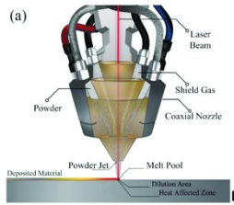
Fig. 7 Schematic representation of Directed Energy Deposition(Ahmed Selema et al. 2022)
DED Techniques: There are several variations of DED techniques, including:
- Laser Metal Deposition (LMD): Utilizes a laser beam to melt the material as it's deposited.
- Electron Beam Additive Manufacturing (EBAM): Employs an electron beam for melting material, offering deeper penetration into the substrate.
- Wire Arc Additive Manufacturing (WAAM): Uses an electric arc between a wire electrode and the substrate for material deposition.
- Plasma Transferred Arc Welding (PTAW): Adapts welding technology for additive manufacturing, using a plasma arc to melt material.
- Directed Energy Deposition with Powder Nozzle: A nozzle propels powdered material into the melt pool created by an energy source.
Applications of DED: DED has diverse applications across various industries:
- Aerospace: Rapid prototyping of complex aerospace components, repair and refurbishment of high-value parts.
- Automotive: Tooling, customization of components, and lightweight designs.
- Medical: Patient-specific implants, surgical tools, and medical device manufacturing.
- Energy: Manufacturing of intricate cooling channels for gas turbine components.
- Tooling and Die Manufacturing: Rapid production of molds and dies with conformal cooling.
- Marine and Offshore: Manufacturing of large-scale components for ships and offshore structures.
Process Parameters and Control: Controlling parameters like energy input, travel speed, material feed rate, and layer thickness is crucial for achieving desired mechanical properties and surface finish. Real-time monitoring and closed-loop control systems are often employed to ensure accuracy and repeatability.
Advantages of DED:
- Design Freedom: Complex geometries and customized structures can be produced.
- Material Efficiency: Reduced waste compared to subtractive manufacturing methods.
- Repair and Refurbishment: High-value parts can be repaired, extending their lifespan.
- Multi-Material Printing: DED can facilitate the deposition of dissimilar materials in a single build.
- Fast Prototyping: Rapid production of prototypes and small batches.
Limitations and Challenges:
- Residual Stress and Distortion: Rapid solidification can lead to residual stress and distortion in the build.
- Surface Finish: Post-processing may be required to achieve desired surface quality.
- Material Issues: Some materials are challenging to process due to their properties and susceptibility to oxidation.
- Process Monitoring: In-situ monitoring and quality control remain challenging.
Emerging Trends and Future Prospects:
- Hybrid Manufacturing: Integration of DED with other manufacturing processes like CNC machining for improved accuracy.
- In-Situ Process Monitoring: Advancements in sensors and monitoring techniques for real-time quality control.
- Material Development: Tailoring materials for DED processes to enhance performance and ease of processing.
- Automation and Robotics: Increased use of automation and robotics for process efficiency and consistency.

Conclusion:
Directed Energy Deposition is a versatile additive manufacturing technique with applications across industries. Its ability to create complex geometries, repair high-value parts, and customize designs makes it a promising technology for the future of manufacturing. Continued research and development are essential to address challenges and fully unlock the potential of DED in the years to come.
Future Trends and Implications
- Materials Innovation: One of the significant trends in additive manufacturing is the continuous exploration and development of new materials that can be used for 3D printing. This includes not only new types of plastics and metals but also materials like ceramics, composites, and even bioinks for bioprinting applications.
- Multi-Material and Multi-Process Printing: Additive manufacturing is moving beyond single-material, single-process systems. There's growing interest in multi-material and multi-process 3D printers that can combine different materials and printing methods in a single build. This enables the creation of complex, functional, and customizable parts.
- Scale and Speed: The industry is working to increase the speed of printing without sacrificing quality. Additionally, there are efforts to scale up the size of printable objects. This expansion in scale and speed opens up possibilities for larger and more efficient manufacturing processes.
- Industry-Specific Solutions: Different industries are adopting additive manufacturing for their specific needs. Aerospace, automotive, healthcare, and consumer goods are just a few examples. Future trends involve developing industry-specific solutions, materials, and processes to address unique challenges in each sector.
- Digital Inventory and On-Demand Manufacturing: Additive manufacturing allows for decentralized production and the creation of products on demand. This can significantly reduce the need for large inventories, storage costs, and wastage. As technology advances, we may see a shift toward more localized and digitally driven manufacturing ecosystems.
- Integration with AI and Automation: The integration of additive manufacturing with artificial intelligence and automation is expected to grow. AI can optimize designs for additive manufacturing, predict potential defects, and even control the printing process in real time, enhancing efficiency and quality.
- Sustainability and Circular Economy: The environmental impact of traditional manufacturing processes has led to interest in more sustainable options. Additive manufacturing can reduce waste by producing parts layer by layer. As the technology matures, there's potential for recycling and reusing materials within the 3D printing ecosystem.
- Customization and Personalization: Additive manufacturing enables the creation of highly customized products at a reasonable cost. This trend is expected to continue, with more industries offering personalized products and solutions tailored to individual customer needs.
- Bioprinting and Medical Applications: Bioprinting, the 3D printing of living tissues and organs, holds tremendous potential in the medical field. Researchers are exploring ways to print functional human tissues for transplantation, drug testing, and disease modeling.
- Education and Accessibility: As 3D printing becomes more widespread, there's a push for better educational resources and increased accessibility to the technology. This could empower a new generation of designers, engineers, and innovators to leverage additive manufacturing for their projects.

Conclusion
Additive manufacturing journey marks a pivotal moment in the realm of modern manufacturing. Throughout this exploration, we have delved into the multifaceted dimensions of additive manufacturing, uncovering its transformative potential, current achievements, and future prospects. As we draw to a close, several key takeaways come to light.
Additive manufacturing, often referred to as 3D printing, has emerged as a disruptive force that has redefined the traditional paradigms of design, production, and distribution. Its ability to fabricate complex geometries with unparalleled precision, its reduction of material waste, and its capacity for decentralized production have collectively heralded a new era of creativity and efficiency. We have witnessed how industries spanning aerospace, automotive, healthcare, consumer goods, and beyond, have embraced additive manufacturing to streamline operations, expedite innovation, and elevate customization.
However, it is essential to acknowledge that while additive manufacturing showcases immense potential, it is not without its challenges. Material limitations, production scalability, post-processing requirements, and intellectual property concerns continue to influence its widespread adoption. Moreover, the technology's rapid evolution necessitates a corresponding evolution in standards, regulations, and education to ensure its safe and responsible integration into existing manufacturing ecosystems.
Looking ahead, the trajectory of additive manufacturing is both exciting and promising. The ongoing research and development efforts aimed at overcoming current limitations are yielding breakthroughs in materials, printing processes, and post-processing techniques. As these barriers recede, additive manufacturing is poised to become more accessible to a broader array of industries and applications.
Moreover, the synergy between additive manufacturing and other cutting-edge technologies like artificial intelligence, machine learning, and the Internet of Things is amplifying its potential. These convergences are fostering the growth of smart manufacturing ecosystems, where real-time data, predictive analytics, and on-demand production are harmonizing to create a dynamic and responsive production landscape.
In conclusion, additive manufacturing stands at the precipice of revolutionizing how we conceptualize, design, and fabricate objects. Its journey from a niche innovation to a cornerstone of modern manufacturing underscores its staying power and adaptability. As additive manufacturing evolves, it has the potential to reshape supply chains, democratize creativity, and usher in a new era of sustainability. The onus is on researchers, manufacturers, policymakers, and educators to collaborate in harnessing this potential while navigating the challenges that lie ahead. With a steadfast commitment to innovation, responsibility, and collaboration, additive manufacturing can truly reshape industries, economies, and lives for the better.

References
- Kocovic P (2017) History of additive manufacturing. In:Advances in chemical and materials engineering. IGI Global,pp. 1–24. https://doi.org/10.4018/978-1-5225-2289-8.ch001
- Berman B (2012) 3-D printing: the new industrial revolution. Bus Horiz 55:155–162. https://doi.org/10.1016/j.bushor.2011.11.003
- Buchanan C, Gardner L (2019)Metal 3D printing in construction: a review of methods, research,
applications, opportunities and challenges. Eng Struct 180:332–348. https://doi.org/10.1016/j.
engstruct.2018.11.045
- Gibson I, Rosen D, Stucker B (2015) Additive manufacturing:technologies 3D printing, rapid prototyping, and direct digital manufacturing. Second, Springer, New York
- Yap Y L, Wang C C, Sing S L, et al., 2017, Material jetting additive manufacturing: An experimental study using designed metrological benchmarks. Precis Eng, 50: 275–285. http://dx.doi.org/10.1016/j.precisioneng.2017.05.015
- Fina, F.; Goyanes, A.; Gaisford, S.; Basit, A.W. Sleective laser sintering (SLS) 3D printing of medicines. Int.J. Pharm. 2017, 529, 285–293.
- Townsend, A., Senin, N., Blunt, L., Leach, R. K., and Taylor, J. S., 2016,“Surface Texture Metrology for Metal Additive Manufacturing: a Review,”Precis. Eng., 46, pp. 34–47.
- Bambach, M. Metal Additive Manufacturing: Chapter 5: Laser-Based Metal Additive Manufacturing. Available online: https://www.metal-am.com/metal-additive-manufacturing-magazine (accessed on 12 December 2021).
- Directed Energy Deposition—Synergy Additive Manufacturing. Available online:https://synergyadditive.com/directed-energy deposition (accessed on 13 December 2021)
- Taminger, K.M.B. Electron Beam Additive Manufacturing. Available online:https://www.sciaky.com/additive-manufacturing/electron-beam-additive-manufacturing-technology (accessed on 15 December 2021).
- Lee, J. M., Sing, S. L., Zhou, M., & Yeong, W. Y. (2018). 3D bioprinting processes: A perspective on classification and terminology. International Journal of Bioprinting, 4(2). https://doi.org/10.18063/IJB.v4i2.151
- Konta, A. A., García-Piña, M., & Serrano, D. R. (2017). Personalised 3D printed medicines: Which techniques and polymers are more successful? Bioengineering, 4(4). https://doi.org/10.3390/bioengineering4040079
- Özel, T., Altay, A., Kaftanoglu, B., Leach, R., Senin, N., & Donmez, A. (2020). Focus variation measurement and prediction of surface texture parameters using machine learning in laser powder bed fusion. Journal of Manufacturing Science and Engineering, Transactions of the ASME, 142(1). https://doi.org/10.1115/1.4045415
- Mercado Rivera, F. J., & Rojas Arciniegas, A. J. (2020). Additive manufacturing methods: techniques, materials, and closed-loop control applications. International Journal of Advanced Manufacturing Technology, 109(1–2), 17–31. https://doi.org/10.1007/s00170-020-05663-6
- Sireesha, M., Lee, J., Kranthi Kiran, A. S., Babu, V. J., Kee, B. B. T., & Ramakrishna, S. (2018). A review on additive manufacturing and its way into the oil and gas industry. RSC Advances, 8(40), 22460–22468. https://doi.org/10.1039/c8ra03194k
- Piłczyńska, K. (2022). Material jetting. Polymers for 3D Printing: Methods, Properties, and Characteristics, 91–103. https://doi.org/10.1016/B978-0-12-818311-3.00022-7

