BIOREACTORS : DESIGN, TYPES & APPLICATIONS

Dr. Tanmay Ghosh Assistant Professor,
Department of Microbiology, Dinabandhu Andrews College, Raja SC Mallick Road,
Baishnabghata, South 24 Parganas, Kolkata 700084, West Bengal, India.

Abstract

The bioreactor is a verifiable contraption known since old times. Old collectible societies had the option to tackle bioengineering configuration challenges for down to earth purposes, for example, wine and brew mentioning from simple experience and observable facts. This made ready for the evolvement of biotechnological processes, basically for readiness and creation of food items The idea that infinitesimal life is an immense modern asset came slowly to man and with some opposition from the laid out logical society itself. Anarray of basic logical advances prepared for the unfurling of indus-preliminary biotechnology. Developing comprehension of the instruments of infections and its exchange with cell science upheld the development.The bioreactor is the core of any biochemical interaction as it gives a climate to microorganisms to get ideal development and produce metabolites for the biotransformation and bioconversion of substrates into helpful products.The reactors can be designed or made in light of the development necessities of the organic entities utilized. Reactors are machines that can be made to change organic based materials into advantageous items. They can be utilized for the creation of different proteins and other bio-catalysis processes.A bioreactor is a kind of maturation vessel that is utilized for the development of different synthetics and organic responses. It is a shut holder with satisfactory plan for air circulation, unsettling, temperature and pH control, and

channel or flood vent to eliminate the waste biomass of refined microorganisms alongside their items.
Keywords: bioreactor,production, products

Introduction
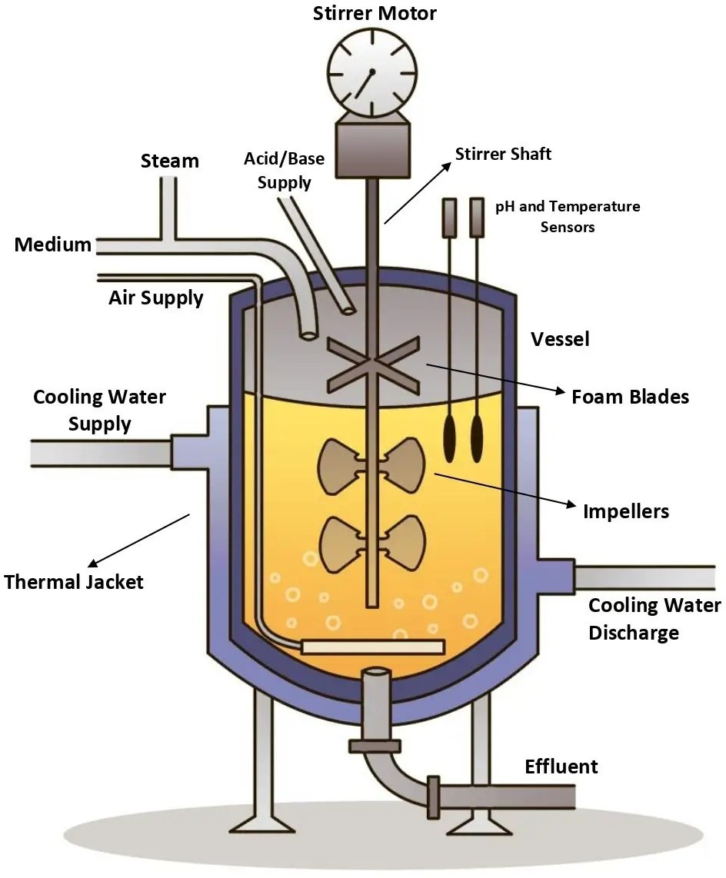
Bioreactors can extensively be defined as a vessel, sent to use the action of a natural impetus to accomplish an ideal synthetic change. Bioreactor for the most part gives a biomechanical and a biochemical climate that controls supplement and oxygen move to the cells and metabolic items from the cells . It could likewise be defined as a designed gadget intended for ideal development and metabolic movement of the organic entity through the activity of biocatalyst, protein or microorganisms and cells of creature or plants .The natural substance could be a natural or an inorganic synthetic compound or even complex material. The result of transformation might incorporate Pastry specialist's yeast, single
cell protein, starter societies, creature feed and so forth or essential metabolites (for example amino acids, natural acids, nutrients, polysaccharides, ethanol, and so forth) and optional metabolites (for example anti- infection agents and so on.). Bioreactors can be utilized for bioconversion or biotransformation items (steroid biotransformation, L-sorbitol and so on), compounds (amylase, lipase, cellulase and so on), recombinant items (a few immunizations, chemicals, for example, insulin and development chemicals and so on.). Differed bioreactor plans have been created to take
care of a wide exhibit of substrate items and biocatalysts (Prezi.com). Bioreactors vary from traditional compound reactors to the degree that they backing and control organic substances. As the organic entities are more delicate and less steady than synthetics, bioreactor frameworks should be sufficiently strong to give a more serious level of command over process upsets and

pollutions .The bioreactor conditions ought to be positive for the living microorganisms to display their action under dened conditions. This requires a progression of extraordinary highlights in the response designing of biocatalytic cycles . Keeping up with the ideal organic action and limiting undesired exercises are sure difficulties as organic life forms, by their inclination, would transform and subsequently adjust natural chemistry of the response or actual properties of the creature . The term bioreactor is much of the time used conversely with fermenter, which is a kind of bioreactor including a living cell as the biocatalyst. Maturing is suggested the advancement of microorganisms on food, under either lively or anaerobic conditions . Fermenters are contained glass, glass entrancing mixtures, solidified steel, glass- lined steel, plastic tanks outfitted with checks. These are used for the improvement of explicit pure social orders of minute organic entities, parasites and yeast, production of synthetic compounds and many developed things. The ranges of the bioreactor can move extensively from the microbial cell (few mm3) to shake flask(100-1000 ml) to lab scale fermenter (1 - 50 L) to coordinate even out (0.3 - 10 m3) to lay out scale (2 - 500 m3) for enormous volume current applications . There are a couple of parts of biotechnological processes, which require excellent thought in arranging a bioreactor. The reaction rate, cell advancement, and deal with strength depend upon the normal conditions in the bioreactor. The bioreactor's conditions like gas (for instance air, oxygen, nitrogen, carbon dioxide) low rates, temperature, pH and separated oxygen levels and aggravation speed/dispersal rate, foam creation, etc ought to be immovably noticed and controlled.
The bioreactor gives a reasonable development climate to the development and generation of microbes and elevates the microorganisms to create the items individuals need. [ The fundamental rule of the Bioreactor is to make the gas very much scattered in the fluid stage so the materials can be blended all the more uniformly, and the lopsided other fluid can be equitably suspended or completely emulsified; so the strong particles can be equally suspended in the fluid phase. Fermentation tanks are continually being updated with the improvement of the times. From conventional maturation industry to current aging industry, and afterward to microbial designing. It has not just turned into a significant mainstay of the biotechnology business yet additionally has become much more impressive when joined with hereditary designing innovation. Later on, fermenters will be all the more generally utilized, and clients ought to apply them all the more sanely and scientifically. Biological Bioreactors are broadly utilized in dairy

items, refreshment bioengineering, drug, almost negligible difference synthetic and different enterprises, and dairy items and cocktails.

Types of Fermentations Innovations

Advancements (groundbreaking thought, gadget or cycle) are the use of improved arrangements that meet new necessities, in expressed needs or existing business sector needs. Maturation types are ordered into various classes:
- In view of different angles like in light of taking care of substrate to fermenter.
- In view of need of supply of air circulation
- In view of need of light and so forth.
- Considering dealing with substrate to fermenter: There is Bunch
development; Persistent, maturation and Dealt with bunch maturing are the key modes. In group development, every material for pattern of development including substrate, inoculum and all the collaboration limits are set and filled in a fermenter and the connection is set on and until the hard and fast cycle arrives at a resolution neither substrate is added into fermenter nor thing is eliminated from fermenter. Its a closed system. In constant development, the substrate is added tirelessly to the fermenter at a legitimate rate which stays aware of the living beings at logarithmic improvement stage and the things that are molded are taken out meanwhile and here we find improvement related things. In dealt with pack mode we track down the two techniques for assignments of cluster and perpetual modes, where substrate
is added at fixed periods of time during the development cycle .
- Needing supply of air course: There are vivacious maturing and anaerobic
development. Energetic developments: some tremendous extension maturing cycles are finished in presence of oxygen consuming conditions where, the things present in fermenter are instigated with the help of agitator and with

the help of spargers by compelling cleaned air into the fermenter. There are a couple of sorts of Microbial cell incredible bioreactors: CSTR (suspended cells, unequivocally disrupted) and Transporter fermenter (Suspended cells, pneumatically upset). Anaerobic development: beside outrageous need and presence of provocateur and sparger to supply air flow, rest of the plan of the fermenter is fundamentally essentially as same as fiery maturing. Nevertheless, the presence of provocateur is made drive for the even dissemination f temperature, pH, thickness, supplements, etc along the medium in the fermenter. Anaerobic bioreactions are used in applications, for instance, ethanol creation, winemaking, ale planning and wastewater
treatment.
• Considering need of light: There are Photograph maturation (simply
photosynthetic minute organic entities can go through) and Dull maturing. Photofermentation is a course of progress of normal substances to other utilizable energy increases following a movement of biochemical reactions finished by a specific social occasion of organisms named Photosynthetic microorganisms, which simply returns inside seeing light. Dull development surrounding it is like that of photofermentation, yet requiring light, faint development shouldn't worry about any light to begin the reactions and a widened assembling of organic entities are related with faint development.

Bioreactor Design and Operations

Planning a bioreactor framework includes mechanical, electrical and bioprocess designing. The plan cycle ought to be coordinated so that frameworks can be utilized under the strictest of guidelines. Various new cycles are being created. One includes the utilization of disengaged compounds as opposed to entire cells to do a synthetic change. The benefit is that this interaction doesn't expect taking care of the exceptional necessities of living cells. Notwithstanding, proteins, as well, can go through changes and, in this way, require deciding the ideal

circumstances to communicate their reactant action. An unexpected issue is that utilizing detached catalysts is oftentimes a costly endeavor for a solitary use application. Subsequently, long response times might be fundamental assuming expense factors require that costly catalysts should be utilized exclusively in low focuses. There are different drawbacks to their utilization, as well, for example, the need to eliminate the protein from the item once the ideal bioreaction has occurred.Immobilized chemical innovation is currently effectively settling a portion of these challenges. With the chemical immobilized in a bed or cylinder, the arrangement of substrate for change is then gone through for transformation to item. The item is persistently gathered as gushing from the bioreactor. The plan and activity of an immobilized framework is like that of cycles utilizing heterogeneous catalysis. Heterogeneous frameworks empower item recuperation at lower partition costs than do relating homogeneous frameworks. Gas-fluid strong reaching bioreactors have been examined with various immobilized catalyst frameworks. Chemical immobilization can take a wide range of structures and it has been concentrated on a scope of supports. The strategy utilized in a specific application relies upon the qualities of the compound, its framework, the substrate and the bioreactor liquid. Compounds might be upheld on a lattice type or customary masstransfer structure, exemplified in a film, upheld by gel or silica- determined frameworks, on macroporous particle trade pitches, or on other polymeric backings. One framework that presently utilizes this innovation is the stream bed bioreactor. Similar to specific kinds of biofilters generally utilized for emanation control, this framework includes a screen onto which the protein is stuck and immobilized, and through which the substrate arrangement is passed for transformation. Layers and empty strands have been pursued for immobilized bioreaction frameworks. A model is empty strands with enzymesincorporated into their walls. The dispersion of the substrate through the cylinder wall permits contact with the gelled chemical and transformation into item. Ensuing dispersion of the item gives the detachment important to its recuperation. Affected by the differential tension across the cylinder wall, the item courses through to within the cylinder, at last to be gathered at a multitube header.
A decent bioreactor configuration ought to address further developed efficiency, approval of wanted boundaries towards getting reliable and more excellent items in a financially savvy way. The plan and method of activity of a bioreactor relies upon the development of creature, ideal circumstances expected for wanted item arrangement, item esteem and its size of creation. The viable bioreactor is to control and decidedly inuence the natural response and should forestall

unfamiliar pollution. The capital venture and working expense are likewise significant variables to be considered in bioreactor plan. During the maturation, monoseptic conditions, ideal blending in with low, uniform shear rates ought to be kept up with in the meantime. Aculture can be circulated air through by one, or a blend, of the accompanying strategies: surface air circulation, direct sparging, backhanded as well as film air circulation, medium perfusion, expanding the halfway strain of oxygen and expanding the air pressure . Satisfactory mass exchange (oxygen), heat move, obviously dened ow condition and suitable taking care of substrate keeping away from under or going too far would should be kept up with in a bioreactor. Appropriate inventory of suspension of solids, sufcient substrate, salts for sustenance, nutrients and so on ought to be guaranteed with water accessibility and oxygen (for high-impact processes). Gas development item and side-effect evacuation should be dealt with. The traits of a bioreactor ought to follow plan prerequisites, for example, sanitization, basic development and estimating, process control gadgets, directing methods, increase, exibility in tasks, similarity with upstream and downstream cycles, antifoaming measures and so on are fundamental variables .The essential elements of a bioreactor incorporate headspace volume, fomenter framework, oxygen conveyance framework, froth control, temperature and pH control framework, testing ports, cleaning and disinfection framework and lines for charging and purging the reactor . These are momentarily depicted as follows:
Headspace volume: The functioning volume of a bioreactor is the negligible part of its complete volume taken up by the medium, organisms, and gas bubbles and remaining volume is known as the headspace. By and large, the functioning volume will be ~70-80% of the absolute reactor volume. This, be that as it may, relies upon the pace of froth arrangement during the reactor .
Agitator framework comprises of an outer power drive, impeller and the bafes for extraordinary blending and expanded mass exchange rates through the mass fluid and air pocket limit layers. It gives sufficient shear conditions expected to separating of air pockets (srmuni.ac.in). Most microbial maturations utilize a Rushton turbine type impeller.
Air delivery system consists of a compressor, inlet air, sterilization system, air sparger and exit air sterilization system to avoid contamination.
Foam control framework is a fundamental component of bioreactor as unreasonable froth development prompts hindered air leave lters and develops tension in the reactor.

Temperature control framework includes temperature tests, heattransfer framework (coat, curl). Warming is given by electric radiators and steam created in boilers and cooling is given by cooling water delivered by cooling pinnacles or refrigerants like smelling salts.
pH control framework utilizes killing specialists to control pH; these ought to be non- destructive, non-harmful to cells when weakened in the medium. Sodium carbonate is usually utilized in limited scope bioreactor.
Sampling ports are used to inject nutrients, water, salts etc. in bioreactors and also for collecting samples .
Cleaning and sterilization framework is critical to stay away from pollution. Warm disinfection by steam is favored choice for practical and huge scope sanitizations of gear. Sanitization by compound substances is for the most part liked for heat-touchy hardware.
Charging & emptying lines are used for input of reactants and withdrawal of products in the bioreactor.

Types of Bioreactor System used in Bioprocess Technology

There are primarily three sorts of responses associated with maturation process for example cluster, ceaseless and semi-constant or took care of bunch contingent upon the taking care of system of the way of life and the medium into the bioreactor . Standard bundle mixed tank reactors (STRs) and continually blended tank reactors (CSTRs) have existed for a seriously lengthy timespan and are still extensively taken on in the manufactured and bioprocessing industry for creation as a result of their ease). Other bioreactors, which have well conceived plan and utilitarian characteristics are photo bioreactors, rotational drum reactors, haze bioreactor, film bioreactor, stuffed and uidized bed bioreactors, bubble segment and transporter bioreactors, etc. These have been made to deal with use unequivocal cycles.

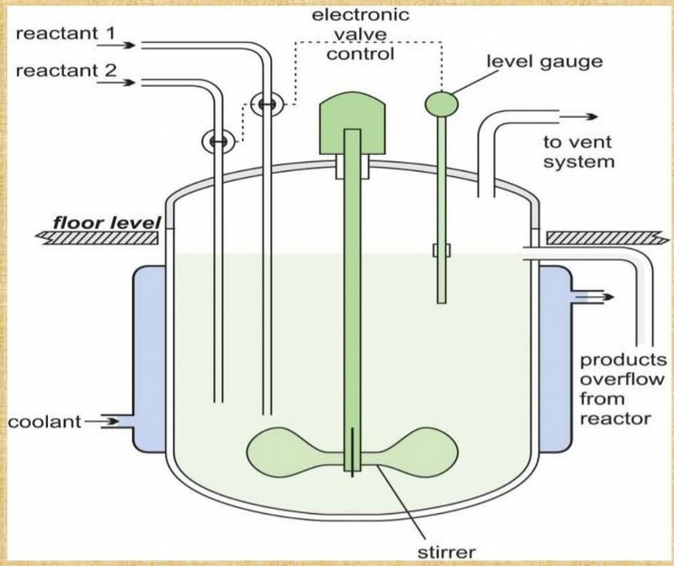
Stirred Tank Bioreator
The Stirred Tank bioreactor is the outdated arrangement in any case the most extensively used bioreactor. Most creation workplaces and

FDA embraced creation processes for biopharmaceuticals rely upon the stirred tank bioreactors. The scale-up process from research office to creation assessed systems is thusly established on this designas well. This barrel formed bioreactor uses a top or base mounted turning mixing system. The point of view firatio is ordinarily between 3-5. . In Stirred Tank Bioreactor, the things in the vessel at absolutely no point in the future contrast with time, this applies to the hold up of small living things and the combination of the pieces of the medium in the fermentor. Steady state conditions can be achieved by either Chemo static or Turbid static norms whichis used to control the stream rate. Both these systems have been used all things being equal, but the past is plainly the less troublesome from each view point.

Bouble Column Bioreactor
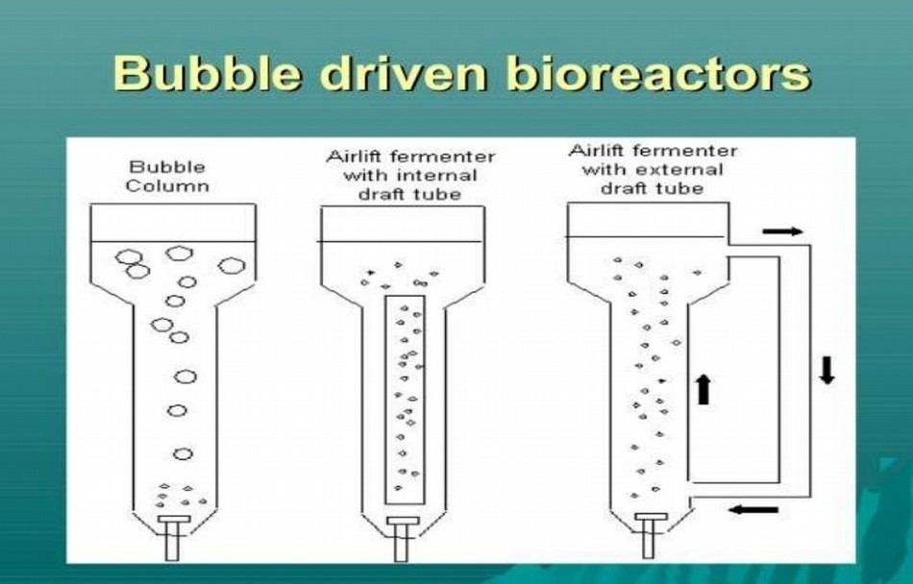
Bubble Column bioreactors are tall segment bioreactors where gas is presented in the base area for blending and air circulation purposes. The
vessel used for bubble fragment bioreactors is for the most part barrel molded with a perspective extent of 4-6. Gas is sparged at the base through penetrated lines or plates or metal porous spargers.. O2 move, mixing and other execution factors are impacted generally by gas stream rate and rheological properties of the liquid. Blending and mass trade can be
improved by setting penetrated plates or vertical frustrates in the vessel.

Air Lift Bioreactor
Carrier bioreactors are like air pocket segment reactors, however contrast by the way that they contain a draft tube. draft tube is consistently an internal cylinder (this sort of transport bioreactor is called carrier bioreactor with an inward circle) or an outer cylinder (called airdrop bioreactor with an outside circle), which further develops flow and oxygen move and adjusts

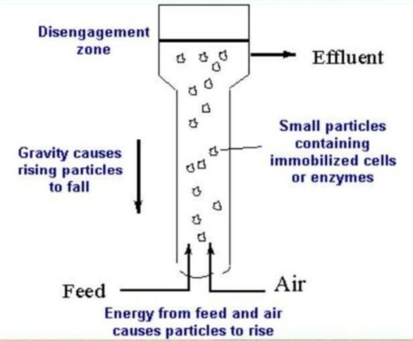
shear powers in the reactor. Inward circle transport bioreactor has a single compartment with a central draft tube that makes inside liquid
stream channels. These bioreactors are direct in plan, with volume and course at a respectable rate for development. Outside circle air lift bioreactor has an external circle so the liquid courses through disconnected free channels. These reactors can be sensibly acclimated to suit the requirements of different developments.
When in doubt, the transporter bioreactors
are more useful than bubble segments, particularly for extra denser suspensions of microorganisms. This is basically considering the way that in these bioreactors, the mixing of the things is better diverged from bubble segments.

Fluidized Bed Bioreactor
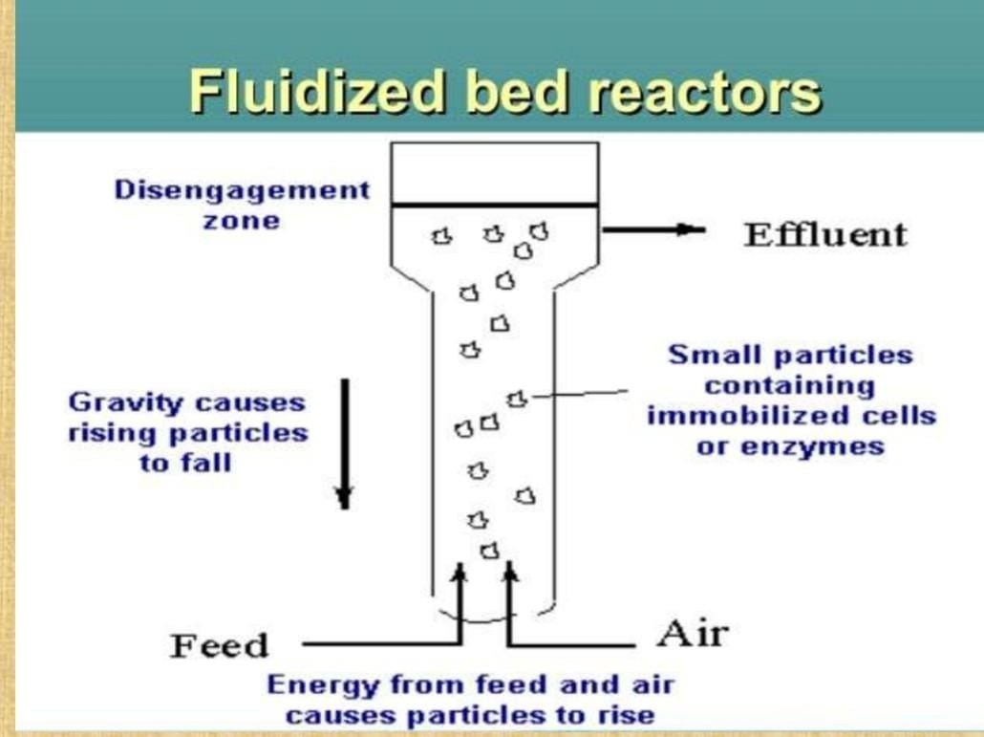
Fluidized bed bioreactor is equivalent to bubble portion bioreactor beside the top position is stretched out to decrease the speed of the fluid. The arrangement of the fluidized bioreactors (broadened top and limited reaction segment) is with the ultimate objective that the solids are held in the reactor while the liquid
streams out. These bioreactors are sensible for use to do reactions including fluid suspended biocatalysts like immobilized synthetics, immobilized cells, and microbial groups.
This is a quality of beds of standard particles suspended in an up streaming liquid stream. In case an additional gas stage is involved, there is a penchant for

the particles in the bed to end up being less evenhandedly dispersed. The fermentor involves a vertical chamber with a perspective extent is 10:1.At the most elevated mark of the zenith a separator provided for brief the gas bubbles conveyed by the reaction, to mix and escape from the liquid stage. There are two critical features of the beds of mixed atom sizes:(i) The extension in porosity from the base to the most elevated place of the bed, and(ii) The decreased particle advancement when differentiated and beds containing particles of predictable size.

Packed bed Bioreactor
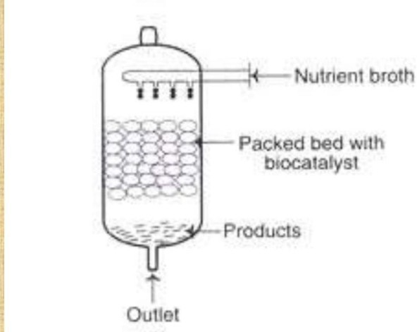
A bed of strong particles, with biocatalysts on or inside the lattice of solids, stuffed in a section comprises a pressed bed bioreactor. The solids used may be porous or non-penetrable gels, and they may be compressible or unyielding in nature. An enhancement stock streams endlessly over the immobilized biocatalyst. The things
gained in the stuffed bed bioreactor are conveyed into the fluid and dispensed with. While the movement of the fluid can be upward or diving, down stream under gravity is preferred.
The gathering of the enhancements (and in this way the things formed) can be extended by growing the stream speed of the
enhancement stock. Considering sad mixing, it is genuinely difficult to control the pH of stuffed bed bioreactors by the development of destructive or stomach settling agent. In any case, these bioreactors are enjoyed for bioprocessing development including thing ruined reactions. The stuffed bed bioreactors don't allow collection of the things to any enormous degree.

Photo Bioreactors
These are the bioreactors specific for aging that can be done either by presenting to daylight or fake enlightenment. Since counterfeit enlightenment is costly, just the outside photograph bioreactors are liked. They are by and large utilized for the development of photosynthesizing

living being (plants, green growth and microorganisms). Modern scale photograph bioreactors can likewise be open lake frameworks; as are more fragile to biological effects. They are involved glass or even more typically direct plastic The range of chambers or level sheets is light getting structures (daylight based beneficiaries). The lifestyle can be circumnavigated through the sun fueled beneficiaries by strategies, for instance, using spiral siphons or transport siphons.
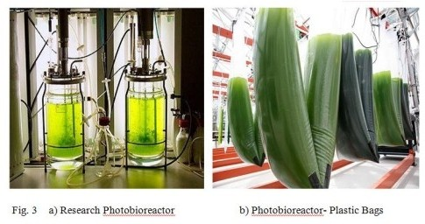
It is major that the cells are in steady course without molding sediment. Further acceptable entry of sunshine should be stayed aware of. The chambers should in like manner be cooled to prevent rise in temperature. Photo bioreactors are by and large worked in a steady mode at a temperature in the extent
of 25-40°C. Microalgae and Cyanobacteria are consistently used. The animals create during daylight while the things are conveyed during night. Certain huge combinations are conveyed by using photo bioreactors e.g., p carotene, asthaxanthin.

Stem Cell Bioreactors
Another improvement is the undifferentiated creature bioreactor. Lacking cells are uncommonly captivating for regenerative medicine, drug screening and biomedical applications. These cells have boundless self rebuilding limit and outstanding ability to convey mature cells with explicit capacities, similar to platelets, nerve cells or cardiovascular muscle. Anyway, the genuine number of cells that can be gotten from open givers is very low. One possible solution for the period of significant amounts of cells is relative up the lifestyle of these cells in vitro .A couple of joint investigation programs among industry and schools are focusing in on the improvement of undifferentiated organic entity bioreactor structures. Applikon Biotechnology has participated in a couple of these errands and has cultivated different productive plans .

Rocking bag Bioreactors
This structure relies upon the shaking development of the bioreactor holder to mix a liquid volume contained in aplastic pack. This kind of bioreactor is basically used for cell advancement, on account of the low oxygen move rates and confined cooling cutoff of such systems .as a general rule, Bioreactors are the essential part to improve many new high-regard things and the replacement of existing engineered based product processes. The fitting decision and plan of the bioreactor will choose the ideal business bioprocess and the contrasting capital endeavor. The bioreactor should not be seen as a confined unit, yet as a component of a consolidated unit action with both upstream (arranging) and downstream (partitions) unit tasks.

Factors Affecting Bioreactor Performance

Several factors can affect bioreactor performance, including −

Oxygen Supply: Microorganisms require oxygen for breath and development. The bioreactor should give sufficient oxygen to help ideal development and production.There are various reports concentrating on the impacts of oxygen fixation or oxygen move on microbial maturation. Albeit the oxygen utilization of plant and creature cells is lower than that of microorganisms, restriction in oxygen move is likewise frequently aconstraining factor for cell societies at high cell thickness. Keeping a reasonable oxygen focus in the way of life stock is equallyimportant. The ideal DO focus might be different for cell development and item arrangement.
Nutrient Supply: Microorganisms require nutrients, such as carbon, nitrogen, and phosphorus, for growth and production. The bioreactor must provide adequate nutrients to support optimal growth and production.
Temperature: Microorganisms have an ideal temperature range for development and creation. The bioreactor should keep up with the temperature inside the ideal range.In a customary microbial maturation process, when the ideal not set in stone, it will ordinarily be kept up with all through the entire maturation process. This, nonetheless, may not generally be the situation for mammalian cell culture processes. In mammalian cell culture process, an enormous part of

the protein item is combined during the postgrowth stage. Since the cell feasibility drops rapidly after the cell thickness approaches most extreme, the development of cells at diminished temperatures has been proposed to further develop bunch culture exhibitions. It has been reliably detailed that a lessening in development temperature prompts delayed culture suitability. Notwithstanding, a culture temperature under 37 °C ordinarily restrains cell development. An idea of two phases is hence proposed: a development stage and a creation stage. During the primary stage, the temperature leaning toward cell proliferation(e.g., 37 °C) is utilized to get a high cell thickness. In the subsequent stage, temperature is diminished to decelerate the drop in cell feasibility. This methodology, nonetheless, isn't clear as temperature is likewise an exceptionally basic boundary for protein blend. The impact of diminished temperature on heterologous protein creation of mammalian cells changed among various examinations. An ideal temperature exists for every individual cell culture process.
pH: Microorganisms have an ideal pH range for development and creation. The bioreactor should keep up with the pH inside the ideal range.Different organic frameworks have different ideal pH ranges. Most microorganisms develop best between pH 5 and 7. During maturation, pH can change. As the cells develop, metabolites are delivered into the medium; substrate utilization likewise causes pH change. Various scientists have examined the impact of pH on the development energy of microorganisms, enzymatic exercises, and item synthesis.In creature cell culture processes, culture pH is much of the time constrained by the expansion of a soluble reagent, like NaHCO3 or NaOH, to kill the acidic impacts of lactate and CO2 creation during cell development. One more plan for pH control in creature cell culture process is CO2 expansion. CO2 is added to a sodium bicarbonate-containing medium to control the pH. As a rule, utilizing CO2 to control pH is basic and productive. Notwithstanding, it might lead to the accompanying issues: in high-cell-thickness cell societies, a high pace of CO2 creation will restrict controllability by CO2 expansion, CO2 sparging can diminish the oxygen supply and upset DO control, and, on account of high lactate focuses or during times of quick lactate creation, the restricted buffering limit of the bicarbonate framework might become deficient. Creature cells are more delicate to changes in pH than microorganisms. A little change in culture pH can significantly impact the cell development, digestion, and creation union.

Agitation: Agitation provides mixing and aeration to the culture. The bioreactor must provide adequate agitation to prevent settling and maintain optimal oxygen transfer.
Sterility: Contamination can negatively impact bioreactor performance. The bioreactor must be maintained in a sterile environment to prevent contamination.
Product Toxicity: Some products can be toxic to microorganisms. The bioreactor must be designed to handle the toxic products and prevent their accumulation.
Mixing: In bioreactors, satisfactory blending is fundamental to guarantee the sufficient stockpile of supplements and to forestall the aggregation of poisonous metabolites. For a bioreactor intended for a suspension framework, blending time is a basic boundary to be examined and evaluated.It was found that the presence of biomass essentially diminished the blending productivity, even at low stock consistency levels. The greatness of this impact relies upon the sort of biomass and its focus and morphology. In aging or cell culture processes, blending has frequently been assessed regarding natural execution, for example, cell development rate and efficiency. The control of temperature, pH, and substrate fixation relies upon great blending in the bioreactor.Although it is not difficult to keep a homogeneous condition in a limited scale reactor, blending frequently becomes one of the imperatives during increase. In enormous scope bioreactors, unfortunate blending frequently prompts bothersome fixation slopes and a decline in mass exchange proficiency. In shear-delicate natural frameworks, for example, creature and plant cell societies and filamentous parasitic fermentation,mixing can't be upgraded just by expanding tumult power on the grounds that over the top unsettling can make mechanical harm living cells. There are various reports on the impact of blending on organic execution in the writing.

Applications

Industrial Biotechnology:

The field of modern biotechnology has been filling quickly lately, and bioreactors are a fundamental piece of this advancement. Bioreactors are particular vessels utilized in the creation of bioproducts like chemicals, anti-microbials, and biofuels. These gadgets give a controlled climate that permits microorganisms, plant cells, or creature cells to develop and duplicate in

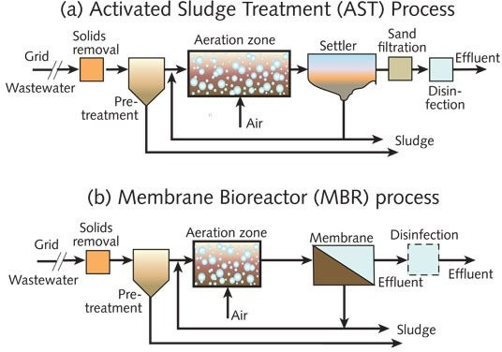
huge amounts. Along these lines, bioreactors have upset the development of numerous items that were beforehand hard to get on a modern scale.In modern biotechnology, bioreactors are utilized for many applications. For instance, they can be utilized to deliver biofuels from sustainable assets like corn, sugarcane, and green growth. They can likewise be utilized to fabricate chemicals that are utilized in food handling, materials, and paper creation. What's more, bioreactors are utilized to deliver anti-toxins and different medications that are utilized in medication. With the assistance of bioreactors, the modern creation of these items has become more productive and cost-effective.One of the
benefits of utilizing bioreactors in modern biotechnology is that they give a profoundly controlled climate to the development of microorganisms. This implies that the circumstances inside the vessel can be upgraded for the development of explicit types of microorganisms or different organic entities. The utilization of bioreactors additionally lessens the gamble of defilement and guarantees that the end result is reliable with regards to quality.

Environmental Biotechnology:

Ecological biotechnology is a quickly developing field that utilizes biotechnology to tackle natural
issues. Ecological biotechnology is tied in with tracking down reasonable answers for natural challenges.One of the fundamental motivations behind ecological biotechnology is in the treatment of modern waste. Bioreactors are utilized to get squander by utilizing microorganisms separate poisons. As modern waste is a significant wellspring of contamination, it tends to be troublesome and costly to discard appropriately. Ecological biotechnology offers an economical answer for this issue by utilizing bioreactors to treat unsafe waste. The microorganisms in the bioreactor separate the toxins in the waste, transforming them into innocuous substances. This cycle is considerably more reasonable than conventional strategies for garbage removal, for example, landfilling or incineration.Biotechnology is likewise utilized in natural remediation,

which alludes to the most common way of tidying up contaminated destinations. This can incorporate eliminating impurities from soil or groundwater, or tidying up spills and holes. Bioremediation is a kind of ecological remediation that utilizes microorganisms to separate contaminations. Bioremediation can be utilized to tidy up locales debased with oil, pesticides, or different poisons.

Cell Culture(Growing And Culturing Cells):

The utilization of bioreactors has been especially helpful in refined cells, including foundational microorganisms. Foundational microorganisms are a kind of cell that can separate into different sorts of particular cells in the body. The utilization of bioreactors is especially gainful in refined undifferentiated cells because of their remarkable necessities for development and separation. Bioreactors give an optimal climate to undifferentiated organisms to develop and separate, permitting scientists to deliver enormous amounts of these cells for use in exploration and helpful applications.One benefit of utilizing bioreactors for cell culture is that they consider more prominent command over the development climate. For example, the supplement supply can be definitively checked and changed in accordance with guarantee ideal development conditions for the cells .Moreover, bioreactors give a sterile climate, lessening the gamble of tainting, which is basic while refined stem cells. Another benefit of utilizing bioreactors is that they can be effortlessly increased or down in light of the requirements of the trial or application. This permits specialists to deliver huge amounts of cells for use in clinical preliminaries or different applications.

Tissue Engineering In Medical Applications:

Tissue designing is a field that has acquired huge consideration in the clinical business as of late. It includes the making of practical tissues and organs from cells, biomaterials, and biochemical factors.The interaction of tissue designing requires a controlled climate that can emulate the bodys normal circumstances to advance cell development and tissue development. This is where bioreactors come in. Bioreactors give the client a controlled climate for the development of cells or tissues. They are utilized widely in tissue designing to make utilitarian tissues for clinical applications.The utilization of bioreactors has opened up new roads in medication and medication testing, especially in the field of regenerative medication like transplantation.

Bioreactors are currently being utilized to foster tissues like skin, bone, ligament, and organs like the liver and heart.Bioreactors offer a few benefits over customary tissue culture techniques. They give a more controlled climate, which considers better guideline of cell development and separation. Bioreactors additionally take into consideration the consistent inventory of supplements and oxygen to cells, which is basic for their development and endurance. By giving a more regular habitat to cell development, bioreactors can deliver tissues with further developed usefulness and better caliber, which blows away what we could do 100 years back.

Food And Beverage Industries:

Bioreactors have turned into a fundamental apparatus in the food and refreshment industry, especially in the assembling of aged items. Maturation is an interaction that has been utilized for a really long time to create different food and refreshment items like lager, wine, yogurt, cheddar, and bread. Nonetheless, the utilization of bioreactors has changed the manner in which individuals play out the maturation cycle. Bioreactors give a more exact and controlled climate
for the particular microorganisms expected to develop and deliver the ideal item  cheddar,
yogurt, etc.The utilization of bioreactors not just permits command over unambiguous temperatures, pH, and oxygen levels that are basic for microorganism development, yet the utilization of bioreactors fundamentally works on the productivity and consistency of the maturation cycle, bringing about better returns of excellent products.Bioreactors can be tweaked to suit various sorts of microorganisms and maturation processes. For instance, some bioreactors are intended for high-impact maturation while others are intended for anaerobic aging. The capacity to modify bioreactors has made it workable for food and drink makers to create new and imaginative items that were unrealistic previously.

Pharmaceutical Industry:

The medication business is conceivably of the principal business in the world, at risk for finding and conveying new drugs that can help a large number of people. One of the most fundamental pieces of this industry is the bioreactor, which expects a basic part in the formation of

vaccinations, antibodies, and other medication products.Bioreactor holders are adequately colossal to allow the improvement of microorganisms, cells, and tissues while controlling the environment. In the medication business, these bioreactors grant specialists to convey gigantic measures of dynamic trimmings that can be used to make life-saving prescriptions like vaccinations and hostile to contamination specialists. Bioreactors are particularly huge in the advancement of antibodies Vaccinations are basic for thwarting the spread of powerful ailments, and they work by animating the body's safe structure to make antibodies that can avoid contaminations and minute living beings. To convey vaccinations, analysts need to turn out to be extraordinarily colossal measures of the diseases or microorganisms that cause the ailment in one restricted controlled environment. This is where bioreactor vessels end up being valuable. Another critical utilization of bioreactors in the medication business is in the improvement of antibodies. Antibodies are proteins that can see and bind to express particles, similar to those found on the external layer of illness cells or contaminations. Predominantly of these antibodies inside the bioreactor vessel, scientists can create drugs that can target and demolish harmful development cells or diseases without harming strong cells.Most lately, bioreactors were for the most part drawn in with the advancement of acquiring the SARS-CoV-2 vaccination. Bioreactors were used to cultivate two sorts of Coronavirus inoculations. The two associations that utilized bioreactors to encourage the SARS-CoV-2 neutralizer were Pfizer-BioNTech and Moderna.Stainless steel bioreactors are principal for creating gigantic measures of viral mRNA during the time spent developing first in class vaccinations like the SARS-CoV-2 immunizer. This kind of immune response can't be created in single-use bioreactors, as they can't offer the wide mixing and air dissemination expected for mRNA age and E.coli advancement.

Researching The Behavior Of Cells:

Bioreactors can assist with investigating the way of behaving of cells and figure out their metabolic pathways. By concentrating on these pathways, researchers can acquire understanding into how cells capability and what cycles are engaged with their development and development.Metabolic pathways are the series of compound responses that happen inside a cell to keep up with life. These responses are fundamental for processes like energy creation, protein combination, and the breakdown of side-effects. Bioreactors give a controlled climate to concentrating on these pathways by permitting scientists to control the circumstances inside the

reactor. By controlling elements like temperature, pH, and supplement levels, researchers can see how cells answer changes in their current circumstance and how these progressions influence metabolic pathways.The conduct of cells is one more essential area of exploration that bioreactors work with. By establishing a climate that intently imitates the circumstances inside the body, bioreactors permit us to concentrate on how cells answer various upgrades. This data is especially important in drug improvement, as it can assist researchers with distinguishing expected focuses for new treatments. For instance, a bioreactor could be utilized to concentrate on how disease cells answer various centralizations of chemotherapy drugs, permitting specialists to distinguish the best treatment choices for patients.

Conclusion

Bioreactors have been used from now onward, indefinitely a truly prolonged stretch of time to convey an extent of supportive biomolecules and other high- regard things. They allow the significant opportunity to screen and control normal conditions unendingly all through the lifestyle/reaction period close by the extra benet of keeping a shut structure. They are essential and crucial piece of the improvement of many new cycles. The authentic decision and plan of the bioreactor having a tendency to high deal with efciencies would choose the financial sensibility of bioprocess and its looking at capital endeavor. Sensible cycle planning calculation methodologies have been made to give a quantitative perception of mass trade. Imaginative frameworks for gas move, upkeep of pH, sensors and actuators distinguishing temperature, optimal dealing with and cell quantication, etc are critical instruments for process planning. As bioreactors are especially dependent upon temperature control, it is urgent for select the sensible temperature control device considering the specic essentials of each and every application by figuring the power load. The kind of bioreactor would depend on the morphology of cells, shear obstruction, advancement and creation direct of the lifestyle. In Indian setting, making different bioprocesses with quick and dirty

assessments on reaction energy; mass trade, etc acknowledges fundamental importance especially towards expanding the cycle by arranging and assembling sensible bioreactors. The specialization in process and mechanical arrangement and production of bio-taking care of stuff at the post-graduate biotechnology planning assessments would go very far in making local limit of the country.

References

- Chisti, Y. (2006). Bioreactor design. Basic Biotechnology: Third Edition, m, 181200. https://doi.org/10.1017/CBO9780511802409.009
- Ghosh, B., Bhattacharya, D., & Mukhopadhyay, M. (2018). Use of Fermentation Technology for Value-Added Industrial Research. Principles and Applications of Fermentation Technology, August, 141161. https://doi.org/10.1002/9781119460381.ch8
- Jaibiba, P., Vignesh, S. N., & Hariharan, S. (2020). Working principle of typical bioreactors. In Bioreactors. INC. https://doi.org/10.1016/B978-0-12-821264-6.00010-3
- Mandenius, C.-F. (2016). Challenges for Bioreactor Design and Operation. Bioreactors, 134. https://doi.org/10.1002/9783527683369.ch1
- Muniraj, I. K., Desikan, R., & Subburamu, K. (2019). Perspectives and Prospects of Fermentation Technology. Advances in Food Bioproducts and Bioprocessing Technologies, July 2020, 217232. https://doi.org/10.1201/9780429331817-10
- Kuila A and Sharma V (2018). In Principles and Applications of Fermentation Technology. https://doi.org/10.1002/9781119460381
- Rose, A. H. (1985). Principles of fermentation technology. In Trends in Biotechnology (Vol. 3, Issue 9). https://doi.org/10.1016/0167-7799(85)90016-2
- Singh, J., Kaushik, N., & Biswas, S. (2014). Bioreactors  Technology & Design Analysis. April 2016, 2736.

- Spier, M. R., Vandenberghe, L. P. D. S., Medeiros, A. B. P., & Soccol, C. R. (2011). Application of different types of bioreactors in bioprocesses. In Bioreactors: Design, Properties, and Applications (Issue February 2016).
- Viswalingam, K., & Solomon, F. E. (2013). A Comparative Study on Bio Reactors. Indian Journal of Economics and Development, May, 104107
- Zhong, J. J. (2010). Recent advances in bioreactor engineering. Korean Journal of Chemical Engineering, 27(4), 10351041. https://doi.org/10.1007/s11814-010-0277-5.

