RISK AND RETURN ANALYSIS OF NSE NIFTY BANK STOCKS
DEIVA VEERALAKSHMI R  Doctoral Research Scholar-Part Time Internal  Department of Management Studies  Manonmaniam Sundaranar University  Abishekapati  Tirunelveli 627012  e-mail: profdeiva@gmail.com | Dr. M. BHOOPAL  Assistant Professor  Department of Management Studies  Manonmaniam Sundaranar University  Abishekapati  Tirunelveli 627012  e-mail: bhoopalmsu@msuniv.ac.in
ABSTRACT

Even if there are many other investment alternatives, investing in the stock market carries the greatest risk. Without considering the stock performance, the majority of investors base their investing decisions purely on their feelings. Changes in bank stock prices will undoubtedly impact investor investing behavior and have an impact on the nation's economy. The study examines the return and risk of the Bank NIFTY-listed Banking equities. The research is descriptive and analytical in nature. The top 12 Banks listed under the NSE NIFTY Bank index make up the sample size. Secondary information was gathered from books, journals, and NSE reports.
Returns, Average Returns, Standard Deviation, Variance, Coefficient of Variation, and Correlation are the instruments used for data analysis. It was discovered that 12 banks had profitable returns. The two equities with the highest positive percentage of average returns were ICICI Bank and AU Small Finance Bank. Seven out of the twelve bank stocks included in the NIFTY Bank index have beta values greater than 1, indicating the riskiness of the bank stocks. Positive correlations exist between all Bank stocks and the NIFTY Bank index. Consequently, the stocks are fluctuating together with the Bank NIFTY. It is discovered that lower risk stocks produce positive returns while higher risk stocks produce negative returns. Consequently, it is crucial for investors to research the stock market on a continuous basis to pick the right stocks to invest in.

Keywords – risk ;average returns; NIFTY; bank stocks

I. INTRODUCTION

Even if there are many other investment alternatives, investing in the stock market carries the greatest risk. Without considering the stock performance, the majority of investors base their investing decisions purely on their feelings. The stock market carries a significant level of risk, thus before choosing a stock to invest in, investors must consider both the risk and profits.This will assist investors in determining the characteristics of the stocks and in choosing a solid stock to invest in.The National Stock Exchange of India (NSE), which is situated in Mumbai, Maharashtra, is the country's largest stock exchange. As the nation's first dematerialized electronic exchange, NSE was founded in 1992.The NSE was the country's first exchange, in the country to provide a modern, fully automated screen-based electronic trading system that offered easy trading facilities to investors spread across the length and breadth of the country.
The 'Bank NIFTY' index, often known as the NIFTY Bank Index,includes the largest and most liquid Indian banking stocks. The NSE established the Bank NIFTY index in September 2003 to track the capital market performance of one of India's most important service industries, banking. An index tracks a number of diverse but representative constituent securities from the market, in a specific weighting ratio, and uses that information to reflect the performance of a particular area of the financial market. The value of the index at a specific time is essentially represented by the price of a Bank NIFTY share. It offers investors and market intermediaries a benchmark that reflects the Indian Banks' capital market performance. The Index includes a maximum of 12 listed companies. It consists of 2 Public Sector Banks and 10 Private Sector Banks.
Risk refers to the possibility that the actual outcome of an investment will differ from its expected outcome. In another term, the risk is expressed in terms of variability of return. Investor has to decide about his risk tolerance level, to get the expected return by the way of investment. The return from the stock includes both current income and capital gain caused by the appreciation of the stock values.

II. STATEMENT OF THE PROBLEM
The Bank plays a major role in building the economy of an individual as well as the nation. So, the changes in stock prices of Banks will definitely affect the investment pattern of investor and also affects the economy of the country. Therefore, before taking an investment decision, it is good for investors’ to analyse the risk and return. The study analyses the risk and return of the Banking stocks listed under Bank NIFTY.

III. REVIEW OF LITERATURE
Ch V Rao and Krishna Banana (2016) investigated risk and return in relation to a few NIFTY stocks. The purpose of this study was to inform investors about the stock return pattern before they invest in a specific stock. The researchers gave a method for assessing risk along with a discussion of the trade-off utilizing beta and standard deviation tools.

The risk-return analyses of Public and Private Sector Banks Listed on Bank NIFTY were compared by Suresh A.S. & Sai Prakash L. (2018). Only 12 of the Bank NIFTY stocks were taken into consideration for the analysis, which was based on secondary data gathered from the NSE website. The authors determined that Yes Bank and IndusInd Bank had higher returns with high risk, while HDFC Bank had low risk and moderate return, using the standard deviation and beta methods to quantify risk.

The volatility and return with regard to the stocks of the Bank NIFTY were researched by Rohith U.J. (2018). The secondary data that was used in this investigation was gathered from the NSE website. In this investigation, the following metrics were used: mean, standard deviation, correlation, and beta. When analyzing the performance of sector indexes, the researcher discovered that the Bank NIFTY was in third place, followed by the NIFTY financial services, and that the volatility of the stocks in the Bank NIFTY was higher. Additionally, he came to the conclusion that compared to other chosen banks, Punjab National Bank, Canara Bank, and Bank of India had higher market risks.
In 2018, Ruchi Nityanand Prabhu examined the risk and return of the NIFTY stock on the Indian stock market. The study used 50 equities from the NIFTY index as its sample, and it was supported by secondary data that was taken from reputable sources. The mean, beta, standard deviation, covariance, and coefficient of correlation were the research variables used in this study. The main conclusions of this study were that, from 2010 to 2015, there was a negative co-relation between market returns and market volatility of -0.51. In other words, they are inversely related to one another.
Using a selection of stocks and the NIFTY, Amit Agarwal (2020) carried out an analytical analysis on the risk and return scrutiny. The study used secondary data gathered from the website www.nseindia.com and had a sample size of 11 industries drawn from the NSE NIFTY index. Return, Average Return, Standard Deviation, Variation, Correlation Coefficient, and Multiple Regression were the statistical methods employed in this investigation. The author advised investors to consider investing in the automotive business for high risk, FMCG, IT, and mining & metal industries for moderate risk, and banking & finance, cement & construction, pharmacy, and energy & power industries for low risk.

IV. OBJECTIVES
1. To analyse the risk and return of share prices of Banks listed in Bank NIFTY.
2. To study the relationship between the share prices of Banks in Bank NIFTY
and Bank NIFTY.
3. Based on risk and return, to identify the best share to invest among the Banks constituting Bank NIFTY.

V. RESEARCH METHODOLOGY
Research methodology is a systematic way of conducting a study. The research design is analytical and descriptive in nature. The sample size is top 12 Banks listed under the NSE NIFTY Bank index. They are:
1. AU Small Finance Bank
2. Axis Bank
3. Bandhan Bank
4. Federal Bank
5. HDFC Bank
6. ICICI Bank
7. IDFC First Bank
8. IndusInd Bank
9. Kotak Mahindra Bank
10. Punjab National Bank
11. Ratnakar Bank Limited
12. State Bank of India

Data Collection Method
Secondary data was collected from reports published by the NSE, Journals and Books.

Tools used for Analysis
The tools used for data analysis are: Returns, Average Returns, Standard deviation, Variance, Coefficient of variation and Correlation.

VI. DATA ANALYSIS AND INTERPRETATION
1. Average Returns of Index / Stocks

Table No .1
Average Returns of Index / Stocks
S. No. | Index / Stocks | Average Returns (%)
1. | NIFTY Bank | 0.0604
2. | AU Small Finance Bank | 0.1311
3. | Axis Bank | 0.0814
4. | Bandhan Bank | 0.0283
5. | Federal Bank | 0.0195
6. | HDFC Bank | 0.0111
7. | ICICI Bank | 0.1314
8. | IDFC First Bank | 0.0632
9. | IndusInd Bank | -0.0166
10. | Kotak Mahindra Bank | 0.0916
11. | Punjab National Bank | -0.0887
12. | Ratnakar Bank Limited | -0.0504
13. | State Bank of India | 0.0821

Chart No. 1 Average Returns of Index / Stocks
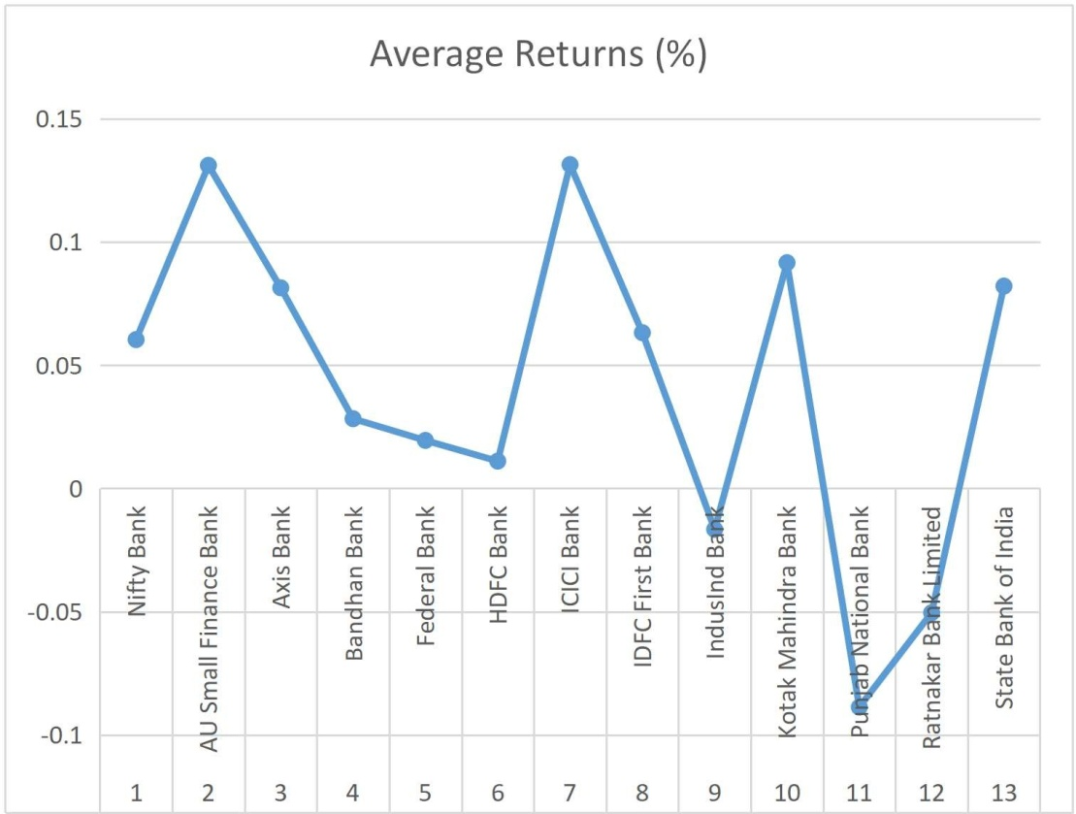

Interpretation:
The table no. 1 shows that the mean of the 12 Banks selected from NSE namely AU Small Finance Bank, Axis Bank, Bandhan Bank, Federal Bank, HDFC Bank, ICICI Bank, IDFC First Bank, IndusInd Bank, Kotak Mahindra Bank, Punjab National Bank, Ratnakar Bank Limited and State Bank of India. The average daily returns of the Bank stocks are mostly similar to the NIFTY Bank Index average daily returns. 9 Banks out of 12 Banks listed under the NIFTY Bank Index yields positive average returns. IndusInd Bank (-0.0166), Punjab National Bank (-0.0887) and Ratnakar Bank Limited (-0.0504) have the negative percentage of average returns. AU Small Finance Bank and ICICI Bank have the most positive percentage of average return of 0.1311 and 0.1314 respectively, among all the 12 stocks in the Bank NIFTY.

2. Standard Deviation of Index / Stocks

Table No.2
Standard Deviation of Index / Stocks

S.No. | Index / Stocks | Standard Deviation
1. | NIFTY Bank | 1.8782
2. | AU Small Finance Bank | 2.7750
3. | Axis Bank | 2.7793
4. | Bandhan Bank | 3.8263
5. | Federal Bank | 2.8586
6. | HDFC Bank | 2.5892
7. | ICICI Bank | 2.5321
8. | IDFC First Bank | 2.8706
9. | IndusInd Bank | 3.7468
10. | Kotak Mahindra Bank | 2.1168
11. | Punjab National Bank | 2.8132
12. | Ratnakar Bank Limited | 3.4873
13. | State Bank of India | 2.5079

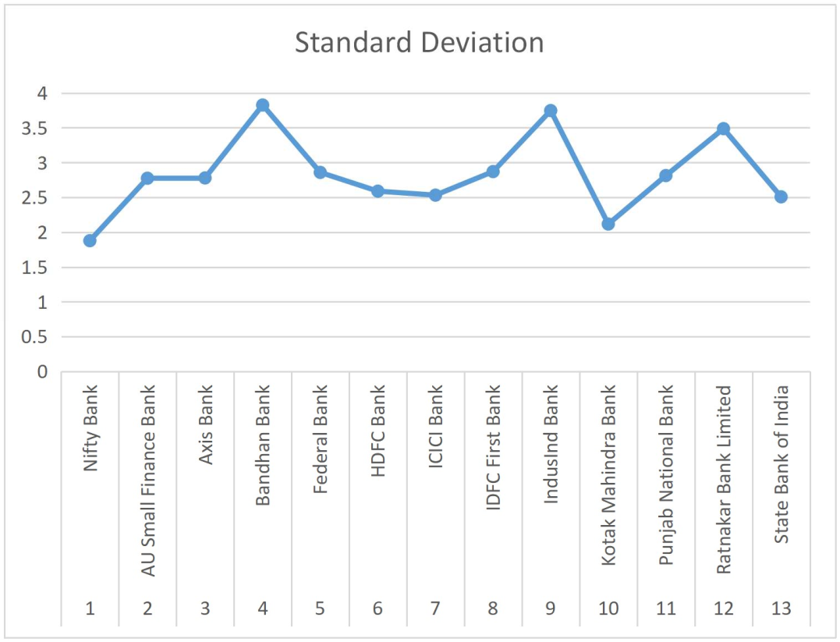
Chart No. 2

Interpretation:
The table no.2 shows that the standard deviation of the 12 Banks selected from NSE namely AU Small Finance Bank, Axis Bank, Bandhan Bank, Federal Bank, HDFC Bank, ICICI Bank, IDFC First Bank, IndusInd Bank, Kotak Mahindra Bank, Punjab National Bank, Ratnakar Bank Limited and State Bank of India. From this table, we can see that the Bank stocks have high standard deviation when compared to their benchmark index. Among all these Bank stocks, Bandhan Bank (3.8263), IndusInd Bank (3.7468) and Ratnakar Bank Limited (3.4873) have the high standard deviation, it reflects that they have high volatility, whereas, Kotak Mahindra Bank (2.1168) has the less standard deviation, indicating less volatility compared to other stocks.
3. Beta of Stocks

Table No.3 Beta of Stocks

S.No. | Stocks | Beta
1. | AU Small Finance Bank | 0.6287
2. | Axis Bank | 1.2128
3. | Bandhan Bank | 1.0943
4. | Federal Bank | 1.0978
5. | HDFC Bank | 0.8474
6. | ICICI Bank | 1.1731
7. | IDFC First Bank | 0.9329
8. | IndusInd Bank | 1.3532
9. | Kotak Mahindra Bank | 0.8245
10. | Punjab National Bank | 0.7649
11. | Ratnakar Bank Limited | 1.1497
12. | State Bank of India | 1.0336
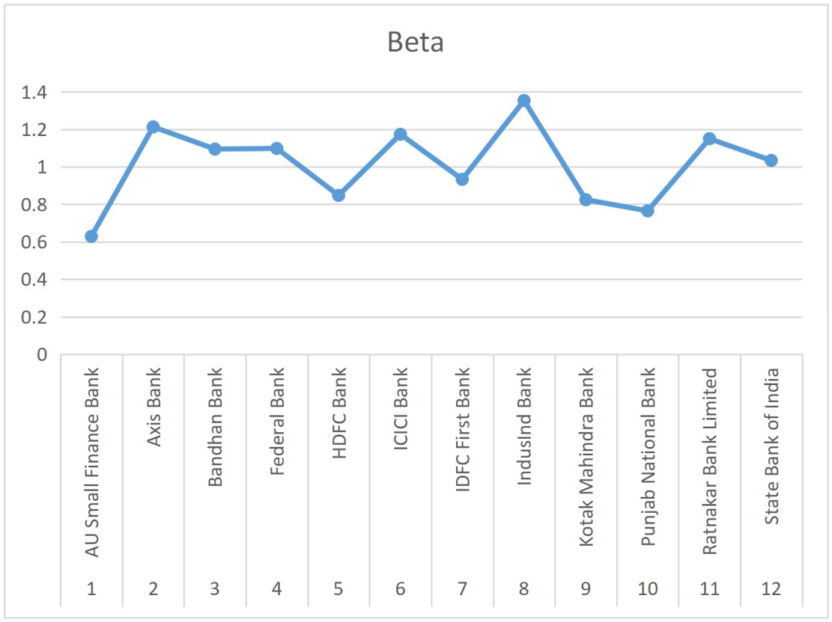
Chart No. 3

Interpretation:
The table no.3 shows that the beta of the 12 Banks selected from NSE namely AU Small Finance Bank, Axis Bank, Bandhan Bank, Federal Bank, HDFC Bank, ICICI Bank, IDFC First Bank, IndusInd Bank, Kotak Mahindra Bank, Punjab National Bank, Ratnakar Bank Limited and State Bank of India. The table shows that 7 stocks out of 12 stocks listed in the Bank NIFTY have beta value greater than 1, showing the riskiness of the stocks in Bank NIFTY. IndusInd Bank has the high beta value of 1.3532 among the 12 stocks, indicating high risk. The stocks which have beta value less than 1 are considered as less risk stocks. AU Small Finance Bank has the lowest beta value of 0.6287 among the stocks, having less risk.
4. Variance of Index / Stocks
Table No. 4 Variance of Index / Stocks

S.No. | Index / Stocks | Variance
1. | NIFTY Bank | 3.5275
2. | AU Small Finance Bank | 7.7006
3. | Axis Bank | 7.7248
4. | Bandhan Bank | 14.6407
5. | Federal Bank | 8.1714
6. | HDFC Bank | 6.7038
7. | ICICI Bank | 6.4114
8. | IDFC First Bank | 8.2406
9. | IndusInd Bank | 14.0383
10. | Kotak Mahindra Bank | 4.4809
11. | Punjab National Bank | 7.9143
12. | Ratnakar Bank Limited | 12.1615
13. | State Bank of India | 6.2895

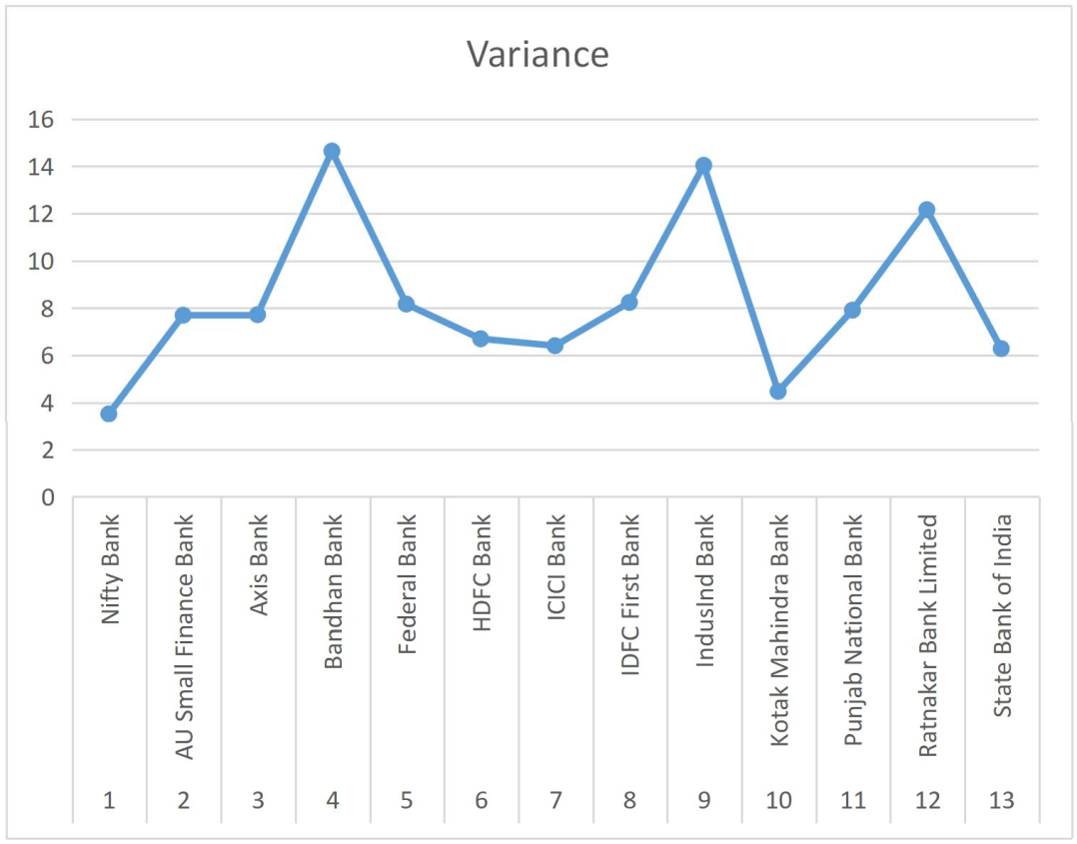
Chart No. 4

Interpretation:
The table no. 4 shows that the variance of the 12 Banks selected from NSE namely AU Small Finance Bank, Axis Bank, Bandhan Bank, Federal Bank, HDFC Bank, ICICI Bank, IDFC First Bank, IndusInd Bank, Kotak Mahindra Bank, Punjab National Bank, Ratnakar Bank Limited and State Bank of India. The table shows that, all the stocks have high variance when compared to the index. Among the 12 stocks, Bandhan Bank (14.6407), IndusInd Bank (14.0383) and Ratnakar Bank Limited (12.1615) have the higher variance, hence contains higher risk and Kotak Mahindra Bank has the lowest variance of 4.4809 among all the stocks. Hence, it is found that Kotak Mahindra Bank has the lowest risk.

5. Coefficient of Variation of Index / Stocks

Table No. 5
Coefficient of Variation of Index / Stocks

S.No. | Index / Stocks | Coefficient of Variation
1. | NIFTY Bank | 31.0848
2. | AU Small Finance Bank | 21.1666
3. | Axis Bank | 34.1481
4. | Bandhan Bank | 135.2417
5. | Federal Bank | 146.4626
6. | HDFC Bank | 233.4681
7. | ICICI Bank | 19.2699
8. | IDFC First Bank | 45.3867
9. | IndusInd Bank | -225.3809
10. | Kotak Mahindra Bank | 23.1113
11. | Punjab National Bank | -31.7023
12. | Ratnakar Bank Limited | -69.2067
13. | State Bank of India | 30.5511

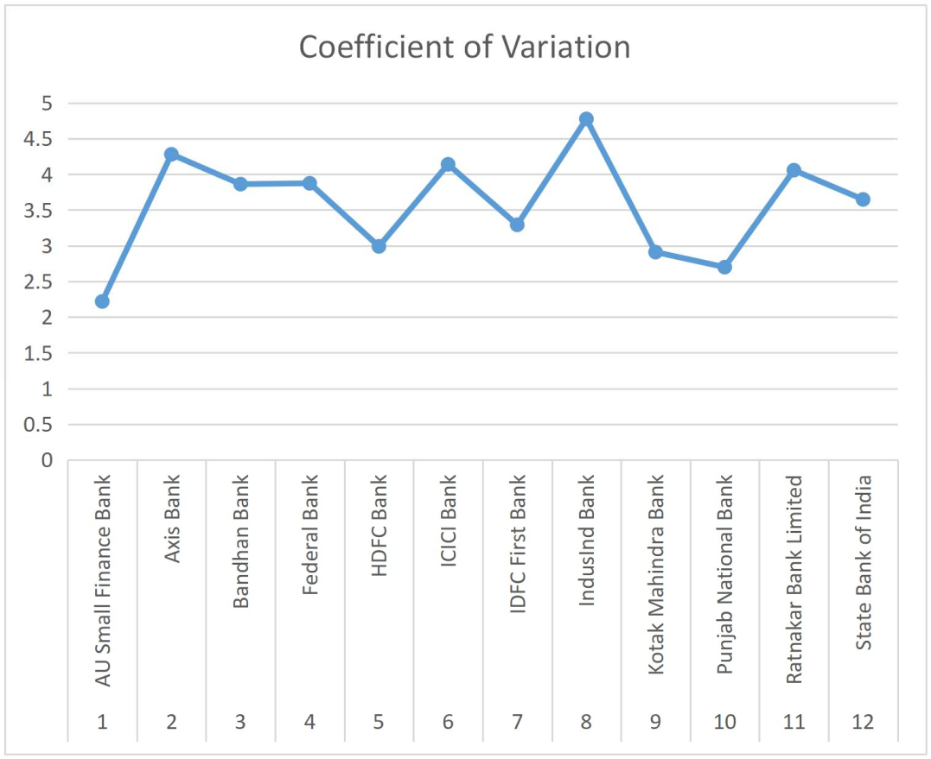
Chart No. 5

Interpretation:
The table no. 5 shows that the coefficient of variation of the 12 Banks selected from NSE namely AU Small Finance Bank, Axis Bank, Bandhan Bank, Federal Bank, HDFC Bank, ICICI Bank, IDFC First Bank, IndusInd Bank, Kotak Mahindra Bank, Punjab National Bank, Ratnakar Bank Limited and State Bank of India. All the Banks have positive coefficient of variation. Among these, IndusInd Bank (-225.3809), Punjab National Bank (-31.7023) and Ratnakar Bank Limited (-69.2067) have negative coefficient of variation, where HDFC Bank has the highest coefficient of variation of 233.4681.

6. Correlation of Stocks with Bank NIFTY

Table No.6
Correlation of Stocks with Bank NIFTY

S.No. | Stocks | Correlation
1. | AU Small Finance Bank | 0.4255
2. | Axis Bank | 0.8196
3. | Bandhan Bank | 0.5372
4. | Federal Bank | 0.7213
5. | HDFC Bank | 0.6147
6. | ICICI Bank | 0.8702
7. | IDFC First Bank | 0.6104
8. | IndusInd Bank | 0.6783
9. | Kotak Mahindra Bank | 0.7315
10. | Punjab National Bank | 0.5106
11. | Ratnakar Bank Limited | 0.6192
12. | State Bank of India | 0.7741

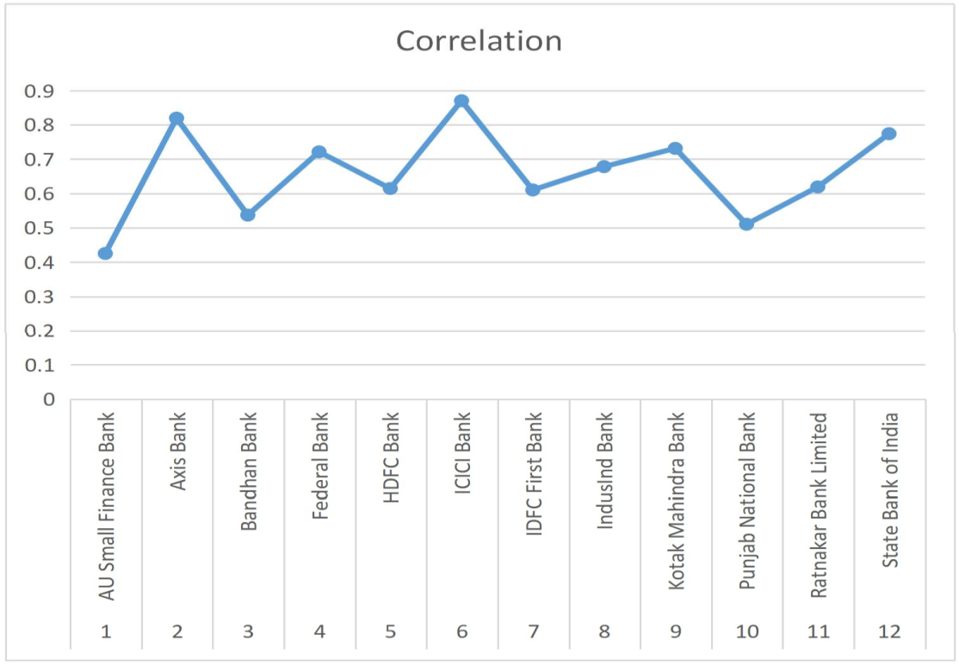

Chart No.6
Correlation of Stocks with Bank NIFTY

Interpretation:
The table no.6 shows that the correlation of the 12 Banks selected from NSE namely AU Small Finance Bank, Axis Bank, Bandhan Bank, Federal Bank, HDFC Bank, ICICI Bank, IDFC First Bank, IndusInd Bank, Kotak Mahindra Bank, Punjab National Bank, Ratnakar Bank Limited and State Bank of India. All the stocks listed under the Bank NIFTY have positive correlation values. Hence, all the Banks are positively correlated with their benchmark index. The correlation is highest for Axis Bank and ICICI Bank compared to other stocks, i.e., 0.8196 and 0.8702 respectively. The correlation is lowest for AU Small Finance Bank (0.4255).
VII. FINDINGS
The average daily returns of the Bank stocks are mostly similar to the NIFTY Bank index average daily returns. During the study period, from 1st April 2018 - 31st March 2021, 9 Banks out of 12 Banks have positive returns. IndusInd Bank (-0.0166), Punjab National Bank (-0.0887) and Ratnakar Bank Limited (-0.0504) have negative average returns. Among all the stocks, AU Small Finance Bank and ICICI Bank have the most positive percentage of average returns of 0.1311 and 0.1314 respectively. The Bank stocks listed under the NIFTY Bank index, have high volatility when compared to the index, it is because they have high standard deviation than the index. Bandhan Bank, IndusInd Bank and Ratnakar Bank Limited have high standard deviation of 3.8263, 3.7468 and 3.4873 respectively, having high volatility. Kotak Mahindra Bank (2.1168) has less standard deviation indicating low volatility. Under the NIFTY Bank index, 7 out of 12 Bank stocks have beta value greater than 1, showing the riskiness of the Bank stocks. IndusInd Bank has the higher risk of 1.3532 while AU Small Finance Bank (0.6287) has the lower risk. All the Bank stocks have high variance when compared to their benchmark index. Bandhan Bank (14.6407), IndusInd Bank (14.0383) and Ratnakar Bank Limited (12.1615) have higher variance among the stocks, hence found they have high risk. Kotak Mahindra Bank has less variance of 4.4809 among the stocks, hence it has less risk. IndusInd Bank, Punjab National Bank and Ratnakar Bank Limited have negative coefficient of variation of -225.3809, -31.7023 and -69.2067 respectively. HDFC Bank has the highest coefficient of variation of 233.4681. All the Bank stocks are positively correlated with the NIFTY Bank index. Hence, the stocks are moving together with Bank NIFTY.

VIII. SUGGESTIONS

Among all other stocks in the Bank NIFTY, ICICI Bank and AU Small Finance Bank offer investors the highest positive returns. Additionally, ICICI Bank and AU Small Finance Bank have strong correlations with Bank NIFTY, making it wiser to invest in these two equities. Due to its low volatility, Kotak Mahindra Bank is preferred for long-term investments. It is advised against investing in Bandhan Bank, IndusInd Bank, and Ratnakar Bank Limited because to their high volatility, increased risk, and poor return on investment.

IX. CONCLUSION

To make wise investing decisions, investors must weigh the stocks' returns and risks in addition to each other. The risk and returns of bank stocks listed on the Bank NIFTY are examined in this study. As a result, it is concluded that lower risk stocks are producing positive returns while greater risk stocks are producing negative returns. The only two public sector banks featured in bank nifty, Punjab National Bank and State Bank of India, appear to perform on par. During the study period, the Private Sector Banks, AU Small Finance Bank, and ICICI Bank are doing well. In order to choose the best stocks to invest in, it is crucial for investors to continuously analyze the stock market.

REFERENCES
- Vikkraman , P., & Varadharajan, P. (2009). A Study on Risk & Return analysis of Automobile Industry in India (2004-2007). Journal of Contemporary Research in Management, 35-40.
- Jeyachitra, A., Selvam, M., & Gayathri, J. (2010). Portfolio Risk and Return Relationship - An Empirical Study. Asia Pacific Business Review, 6(4), 57-63.
- Marisetty & Sudha, M. (2011). An Empirical Study on CAPM with respect to NSE NIFTY Stocks. Presented Paper in International Conference on Quality Management System.
- Sridhar, S., & Dr. Pandian. (2012). Return and Volatility Analysis of National Stock Exchange (NSE) NIFTY Junior Companies. Management Journal of Siva Sivani Institute of Management, 4(2), 5-13.
- Rangotra. (2015). Risk and Return on Investment in Auto and Banking Sectors of Indian Economy. Asian Journal of Research in Banking and Finance. 5(3), 143-154.
- Naveen & Mallikarjunappa, T. (2016). A Study on Comparative Analysis of Risk and Return with reference to stocks of CNX Bank NIFTY. International Journal of Scientific Research and Modern Education, 1(1), 737-743.
- Guha, Dutta and Bandyopadhyay. (2016). Measurement of Risk Vs Return of Indian Sectoral Indices. Journal of Advanced Management Science, 4(2), 106-111.
- Rao, V., & Banana. (2016). A Study of risk and return with reference to selected stocks of NIFTY. ZENITH International Journal of Business Economics & Management Research, 6(3), 30-40.
- Dr. Gopalakrishnan, M., & Mr. Akarsh, K. (2017). Equity Analysis of Automobile Industry in Indian Stock Market. International Journal of Advance Research and Development, 2(5), 166-171.
- Rohith, J. (2018). A Study on the Volatility and Return with reference to stocks of Bank NIFTY. International Journal of Advance Research, Ideas and Innovations in Technology, 4(1), 66-76.
- Prabhu, R. (2018). Risk and Return Analysis of NIFTY Stock in Indian Capital Market. International Journal of Multidisciplinary Research and Development, 5(3), 8-12.
- Venkatesh, Vikas & Charithra, M. (2018). A Study on Risk and Return Analysis and Data Envelopment Analysis of Public and Private Sector Banks. Srusti Management Review, 11(2), 10-18.
- Singh & Seth. (2018). Performance of Indian National Stock Exchange Indices : A Comparative Analysis. Indian Institute of Finance, 32(4), 1209-1226.
- Rajesh, E. (2019). NSE NIFTY Bank Stocks: Risk and Return Analysis. Journal of Emerging Technologies and Innovative Research, 6(5), 252-255.
- Perikala & Reddy. (2019). Risk Return Analysis of Indian Equity Markets. International Journal of Research and Analytical Reviews, 6(1), 135-143.
- Bantwa & Ansari. (2019). Risk Return Analysis of Equity Stocks: A Study of Selected Indian IT Companies. Journal of Finance and Accounting, 6(1), 31-44.
- Naveenan, R. (2019). Risk and Return Analysis of Portfolio Management Services of Reliance Nippon Asset Management Limited (RNAM). Global Journal of Management and Business, 6(1), 108-117.
- Rao, Podile & Navvula. (2020). Risk and Return Analysis of selected NIFTY Banking Stocks. European Journal of Molecular and Clinical Medicine, 7(4), 1010-1018.
- Angaraju & Murthy, B. (2020). Risk and Return Analysis of selected Indian Banks in NSE Market. Alochana Chakra Journal, 9(4), 2671-2674.
- Agarwal. (2020). An Analytical Study on the Risk and Return Scrutiny by using Selection of Equity and NIFTY. European Journal of Molecular & Clinical Medicine, 7(4), 638-645.
- Jogheel, Kanagatharani, B., Gayathri, S., & Devi, R. (2021). A Study on Risk and Return Analysis of Selected Banking Securities. Turkish Journal of Computer and Mathematics Education, 12(11), 122-127.
- Begum & Lavanya, K. (2021). Equities Risk and Return of SBI and Axis Bank. International Journal of Scientific Development and Research, 6(3), 153-158.

