Exploring Transcranial Direct Current Stimulation's Potential in Neurological Conditions
Rituporna Bhattacharjee¹, Sanjam Narayan Mishra²
Assistant Professor, Department of Physiotherapy, Chandigarh University, UIAHS¹
Prosthetist and Orthotist, RCI-A68635²
INTRODUCTION
The history of neuroscience is the discipline's memory, and this memory is based on the study of present-day traces of the past; the things left behind: artifacts, equipment, written papers, data books, photographs, memoirs, and so on. (Gross, C. G.)
TDCS is defined as a technique in which the dose is a single sustained direct current (DC) waveform given to the head using at least one cephalic electrode, with the exception of one ramp-up and one ramp-down period. tDCS is a non-invasive procedure that requires an electrolyte buffer between the electrode and the skin. (Bikson, M., Grossman, P ; et.al). For study comparability, tDCS protocols should include current strength and form, electrode size, and stimulation time. (Nitsche, M. A.; et.al)
PHYSIOLOGY OF tDCS
Subthreshold regulation of neuronal resting membrane potential is the basic mechanism of DC stimulation of the cerebral cortex. In animal tests, anodal stimulation causes subthreshold depolarization, whereas cathodal stimulation causes neuronal membrane hyperpolarisation. The situation is likely identical in humans, because blocking voltage-dependent ion channels pharmacologically eliminates any effect of anodal tDCS on cortical excitability but has no effect on the effects of cathodal tDCS. Direct currents are usually supplied during tDCS via a pair of surface conductive rubber electrodes covered with saline-soaked sponges. (Antal, A., Paulus, W; et.al)
WORKING
With a modest current of 1-2 mA, transcranial direct current stimulation (tDCS) regulates cortical excitability, whereas anodal tDCS (A-tDCS) enhances cortical excitability. It works by activating brain neurons in specific areas, resulting in a cortical change even after the stimulation is stopped.
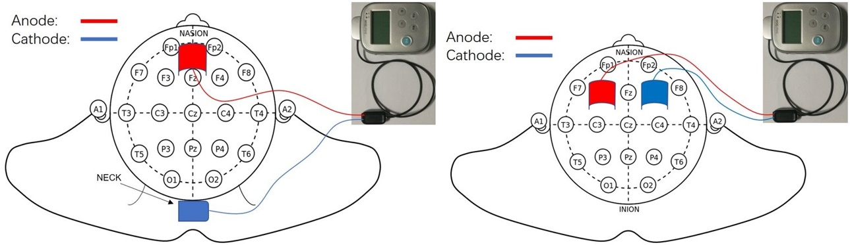
FIG: tDCS (Zhang, X., Liu, B; et.al)
EFFECTS
It has been discovered that individuals with neurological illnesses exhibit aberrant resting-state functional connectivity (rsFC), which is linked to the patients' ongoing functional impairment. Transcranial direct current stimulation (tDCS) has recently been demonstrated to enhance rsFC, albeit the outcomes are varied. (Chan, M. M., & Han, Y. M).
BRAIN FUNCTION
With the help of tDCS, it is possible to establish non-invasive causal links between specific brain regions and the underlying perceptual, cognitive, and motor tasks they support. Anodal stimulation increases neuronal excitability when tDCS is used on the primary motor cortex in humans, whereas cathodal stimulation decreases neural excitability, as shown by motor evoked potentials (MEPs) and transcranial magnetic stimulation (TMS) evoked potentials. (Filmer, H. L., Dux; et.al). Few functional neuroimaging investigations have shown alterations in cortical activity brought on by the execution of motor tasks after Tdcs administration. The primary goal of fMRI is to identify changes in blood flow. A motor performance may be impacted by the long-term effects of tDCS activation, according to fMRI research. (Jang, S. H., Ahn, S. H; et.al).
STROKE
By influencing the mobility and function of the lower limbs in the same way as it effects the upper limb, a stroke can also cause gait impairment. When anodal tDCS was applied via transcranial direct current stimulation (tDCS) to the main motor cortex of the ipsilesional leg area in chronic stroke patients, knee extensor strength in the hemiplegic side improved statistically significantly (Min Kyun Sohn; et.al). An innovative kind of non-invasive brain stimulation called transcranial direct current stimulation (tDCS) has been suggested as a means of enhancing cognitive function following an ischemic stroke. Depolarizing or hyperpolarizing brain tissue is the main mechanism of tDCS, which makes it a useful tool for modulating synaptic plasticity in stroke (Shaker, H. A; et.al).
PARKINSON
A progressive neurological condition known as Parkinson disease (PD) is brought on by the death of dopamine-producing cells in the substantia nigra, a region of the brainstem. According to research, tDCS can improve the motor system's efficiency in both healthy individuals and persons with central nervous system disorders like Parkinson's disease. Numerous tDCS studies have demonstrated its efficacy in enhancing muscular strength and gait speed (Yotnuengnit, P., Bhidayasiri; et.al) Clinical studies have shown that tDCS with anodal stimulation of the primary motor cortex (M1) dramatically improved motor function in patients with Parkinson's disease (PD). The tuning of parameters that significantly influenced the treatment effects of tDCS and the investigation of the underlying neuronal mechanisms, however, has received relatively little attention in research (Li, H., Lei; et.al).s
BALANCE
Multiple parts of the central nervous system (CNS) are involved in postural control. Central pattern generators (CPGs), which are spinal neuronal networks, produce the fundamental posture and movement patterns. Transcranial direct current stimulation (tDCS) has gained popularity as a possible therapeutic method to enhance rehabilitation techniques and balance, with promising outcomes when it comes to alterations in human postural control (de Moura, M. C. D. S; et.al). Anodal tDCS lowers local concentrations of the inhibitory neurotransmitter gamma-aminobutyric acid (GABA), but cathodal tDCS lowers levels of the excitatory neurotransmitter glutamate, according to research using magnetic resonance spectroscopy (MRS). A good E/I balance is anticipated to be restored by tDCS, enabling good homeostatic plasticity in learning and cognition.If this repeatedly turns out to be the case, a variety of clinical conditions which may be successfully treated using tDCS such as atypical brain development. (Krause, B; et.al)
GAIT
Even in the chronic stage of illness, neurological rehabilitation includes as one of its main objectives the restoration of gait function. Robot-assisted gait training (RAGT) can help you walk more comfortably. According to early research, anodal tDCS has no further impacts on patients' RAGT. This might be brought on by the unusual neural architecture of movement, which combines spinal and cerebral control. Combining it with tDCS and tsDCS in neurological patients may result in a considerable extra effect on RAGT (Picelli, A., Chemello, E; et.al). The benefits on static balance and effectiveness of gait training, according to the authors, can be amplified by tDCS of the primary motor cortex combined with treadmill training (Duarte, N. D. A. C; et.al).
CEREBRAL PALSY
The lack of selective motor control and aberrant muscle tone that accompany cerebral palsy (CP) caused by a brain injury cause an imbalance between the agonist and antagonist muscles of movement, coordination issues, sensory abnormalities, and weakness. By promoting cortical excitability of the motor region during physical training and consequently promoting motor learning and neuroplasticity, it is thought that tDCS can improve motor gains (Lazzari, R. D; et.al). In the majority of trials, anodal tDCS paired with other therapies led to improvements in spasticity, gait velocity and cadence, body sway velocity, and balance. Anodal transcranial direct current stimulation (tDCS), typically used alone or in conjunction with other conventional therapies, unilaterally across the primary motor cortex (M1) of the affected or more affected hemisphere, safely improved hand function for school-aged children with Hemiplegic CP (He, W., Huang; et.al).
ILLUSTRATION OF THE EFFECTS
BRAIN
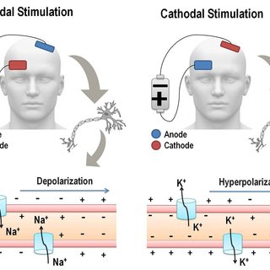
FIG 1 (Rozisky, J. R.; et.al)
STROKE
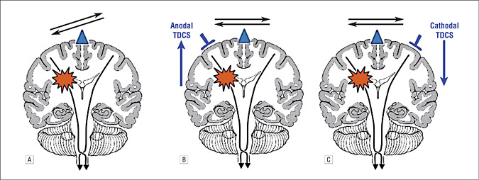
FIG 2 (Schlaug, G., Renga, V; et.al)
PARKINSON
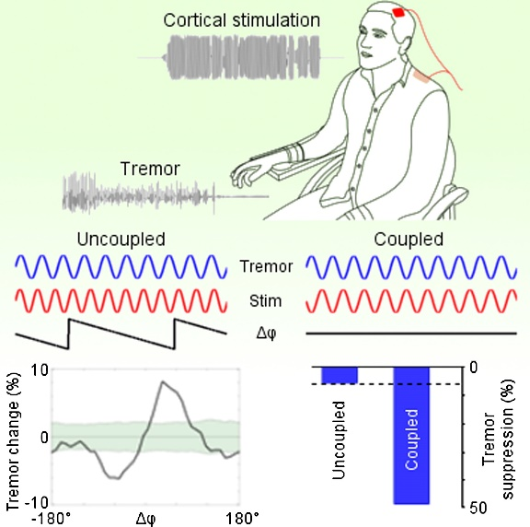
FIG 3 (Brittain, J. S; et.al)
BALANCE AND GAIT
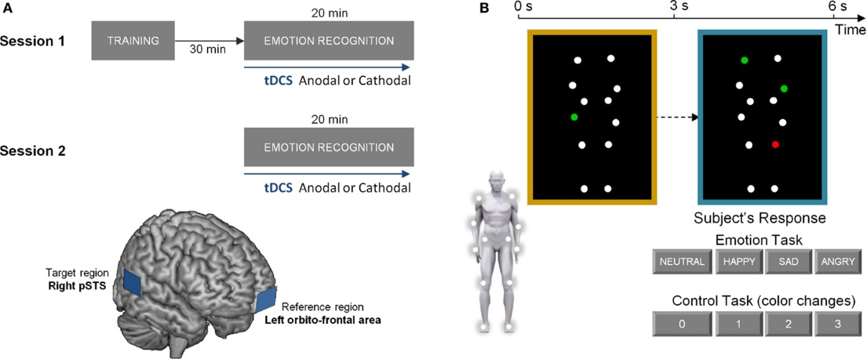
FIG 4 (Vonck, S., Swinnen; et.al)
CEREBRAL PALSY
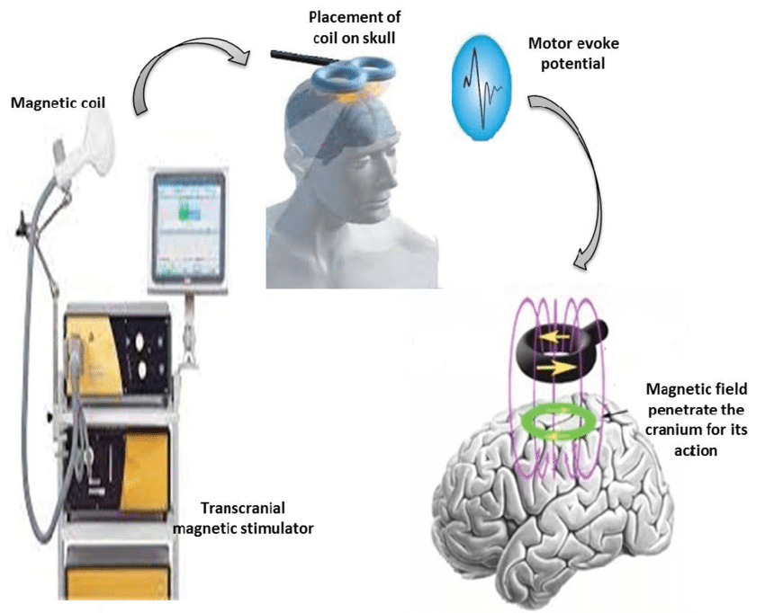
FIG 5 (Gupta, M., Bhatia, D; et.al)
A FEW CITED EXAMPLES OF TDCS CURRENT IN NEUROLOGICAL CONDITIONS
- The current review describes the commonalities and discrepancies in the methodology used by t-DCS techniques in neurocognitive rehabilitation. By providing a critical analysis of recent studies that used t-DCS to improve cognition in patients with Parkinson's disease, Alzheimer's disease, hemi-spatial neglect, and aphasia, we consider the effectiveness of tDCS for the management of specific cognitive deficits in four major neurological disorders. This novel method of cognitive rehabilitation has shown evidence that tDCS can affect cognition. We draw the conclusion that additional research utilizing a common methodology is required to fully comprehend the effectiveness of tDCS as a novel tool for the rehabilitation of cognitive deficits in a variety of neurological illnesses. (Cappon, D., Jahanshahi, M; et.al)
- Both motor and cognitive control depend on the cerebellum. The regulation of cerebellar excitability using transcranial direct current stimulation (ctDCS) has great potential. This method has grown in favor recently because it can be used to study human cerebellum function, is simple to administer, is well tolerated, and hasn't demonstrated any significant negative consequences. Notably, ctDCS is an intriguing method with a potential therapeutic role for neurological patients due to its capacity to alter behavior. The cerebellum's inferior and posterior regions (lobules VI–VIII) appear to be particularly responsive to ctDCS modulation. As a result, research has started to look into ctDCS as a potential treatment for people with neurological problems. (Grimaldi, G., Argyropoulos; et.al)
- Motor impairments are a hallmark of Parkinson's disease (PD) progression; these deficits eventually respond less well to dopaminergic medication and so present a therapeutic obstacle. We looked into the effectiveness of anodal tDCS used in 8 sessions spread out over 2.5 weeks on the motor and prefrontal cortices. Timed tests of gait (the key outcome measure), bradykinesia in the upper extremities, UPDRS, Serial Reaction Time Task, Beck Depression Inventory, Health Survey, and self-evaluation of mobility were all included in the assessment over the course of three months. 12 sham stimulations and 13 tDCS treatments. For a brief period of time, TDCS improved gait in some ways, and for more than three months, it improved bradykinesia in both the on- and off-states. There were no differences between tDCS and sham in changes to UPDRS, response time, physical and mental health, or self-assessed mobility. To make the procedure therapeutically useful, improved stimulation parameters must be devised. TDCS of the motor and prefrontal cortices may have therapeutic promise in PD. (Benninger, D. H; et.al)
- In three sessions, we administered anodal, cathodal, and sham tDCS to 10 patients with probable AD over the temporoparietal regions. Recognition memory and visual attention were assessed throughout each session at baseline (prestimulation) and 30 minutes later (poststimulation). The accuracy of the word recognition memory task improved after AtDCS, declined after CtDCS, and stayed unchanged after StDCS. In individuals with Alzheimer dementia (AD), transcranial direct current stimulation (tDCS) applied across the temporoparietal regions can specifically alter performance on a recognition memory test. (Ferrucci, R., Mameli; et.al).
CONCLUSION
• Following a lengthy list of references, it came to the following conclusion:
a. New data suggests that tDCS affects not just the cortical regions directly beneath the electrodes but also other cortical and subcortical systems. (Yavari, F., Jamil, A; et.al)
b. The rehabilitation of Working Memory (WM) in psychiatric diseases, particularly schizophrenia, may be significantly impacted by anodal tDCS. (Mulquiney, P. G., Hoy; et.al).
c. Language processing and articulation, which are two additional significant problems following a stroke, can be made easier by tDCS. (Gomez Palacio Schjetnan; et.al)

REFERENCES
- Antal, A., Paulus, W., & Nitsche, M. A. (2009). Principle and mechanisms of transcranial direct current stimulation (tDCS). J Pain Manag, 2(3), 249-58.
- Benninger, D. H., Lomarev, M., Lopez, G., Wassermann, E. M., Li, X., Considine, E., & Hallett, M. (2010). Transcranial direct current stimulation for the treatment of Parkinson's disease. Journal of Neurology, Neurosurgery & Psychiatry, 81(10), 1105-1111.
- Bikson, M., Grossman, P., Thomas, C., Zannou, A. L., Jiang, J., Adnan, T., ... & Woods, A. J. (2016). Safety of transcranial direct current stimulation: evidence based update 2016. Brain stimulation, 9(5), 641-661
- Brittain, J. S., Probert-Smith, P., Aziz, T. Z., & Brown, P. (2013). Tremor suppression by rhythmic transcranial current stimulation. Current Biology, 23(5), 436-440.
- Cappon, D., Jahanshahi, M., & Bisiacchi, P. (2016). Value and efficacy of transcranial direct current stimulation in the cognitive rehabilitation: a critical review since 2000. Frontiers in neuroscience, 10, 157.
- Chan, M. M., & Han, Y. M. (2020). The effect of transcranial direct current stimulation in changing resting-state functional connectivity in patients with neurological disorders: A Systematic review. Journal of central nervous system disease, 12, 1179573520976832.
- de Moura, M. C. D. S., Hazime, F. A., Marotti Aparicio, L. V., Grecco, L. A., Brunoni, A. R., & Hasue, R. H. (2019). Effects of transcranial direct current stimulation (tDCS) on balance improvement: a systematic review and meta-analysis. Somatosensory & motor research, 36(2), 122-135.
- Duarte, N. D. A. C., Grecco, L. A. C., Galli, M., Fregni, F., & Oliveira, C. S. (2014). Effect of transcranial direct-current stimulation combined with treadmill training on balance and functional performance in children with cerebral palsy: a double-blind randomized controlled trial. PloS one, 9(8), e105777.
- Ferrucci, R., Mameli, F., Guidi, I., Mrakic-Sposta, S., Vergari, M., Marceglia, S. E. E. A., ... & Priori, A. (2008). Transcranial direct current stimulation improves recognition memory in Alzheimer disease. Neurology, 71(7), 493-498.
- Filmer, H. L., Dux, P. E., & Mattingley, J. B. (2014). Applications of transcranial direct current stimulation for understanding brain function. Trends in neurosciences, 37(12), 742-753.
- Gomez Palacio Schjetnan, A., Faraji, J., Metz, G. A., Tatsuno, M., & Luczak, A. (2013). Transcranial direct current stimulation in stroke rehabilitation: a review of recent advancements. Stroke research and treatment, 2013.
- Grimaldi, G., Argyropoulos, G. P., Bastian, A., Cortes, M., Davis, N. J., Edwards, D. J., ... & Celnik, P. (2016). Cerebellar transcranial direct current stimulation (ctDCS) a novel approach to understanding cerebellar function in health and disease. The Neuroscientist, 22(1), 83-97
- Gross, C. G. (2012). A hole in the head: more tales in the history of neuroscience. MIT Press.
- Gupta, M., Bhatia, D., & Rajak, B. L. (2017). Study of available intervention technique to improve cognitive function in cerebral palsy patients. Curr Neurobiol, 8(1), 51-59.
- He, W., Huang, Y., He, L., Liu, L., Zeng, P., Qiu, H., ... & Xu, K. (2022). Safety and effects of transcranial direct current stimulation on hand function in preschool children with hemiplegic cerebral palsy: A pilot study. Frontiers in Behavioral Neuroscience, 16, 925122.
- Jang, S. H., Ahn, S. H., Byun, W. M., Kim, C. S., Lee, M. Y., & Kwon, Y. H. (2009). The effect of transcranial direct current stimulation on the cortical activation by motor task in the human brain: an fMRI study. Neuroscience letters, 460(2), 117-120.
- Krause, B., Márquez-Ruiz, J., & Kadosh, R. C. (2013). The effect of transcranial direct current stimulation: a role for cortical excitation/inhibition balance?. Frontiers in human neuroscience, 7, 602.
- Lazzari, R. D., Politti, F., Belina, S. F., Collange Grecco, L. A., Santos, C. A., Dumont, A. J. L., ... & Santos Oliveira, C. (2017). Effect of transcranial direct current stimulation combined with virtual reality training on balance in children with cerebral palsy: a randomized, controlled, double-blind, clinical trial. Journal of motor behavior, 49(3), 329-336.
- Li, H., Lei, X., Yan, T., Li, H., Huang, B., Li, L., ... & Hu, X. (2015). The temporary and accumulated effects of transcranial direct current stimulation for the treatment of advanced Parkinson’s disease monkeys. Scientific reports, 5(1), 12178.
- Mulquiney, P. G., Hoy, K. E., Daskalakis, Z. J., & Fitzgerald, P. B. (2011). Improving working memory: exploring the effect of transcranial random noise stimulation and transcranial direct current stimulation on the dorsolateral prefrontal cortex. Clinical Neurophysiology, 122(12), 2384-2389.
- Nitsche, M. A., Cohen, L. G., Wassermann, E. M., Priori, A., Lang, N., Antal, A., ... & Pascual-Leone, A. (2008). Transcranial direct current stimulation: state of the art 2008. Brain stimulation, 1(3), 206-223.
- Picelli, A., Chemello, E., Castellazzi, P., Roncari, L., Waldner, A., Saltuari, L., & Smania, N. (2015). Combined effects of transcranial direct current stimulation (tDCS) and transcutaneous spinal direct current stimulation (tsDCS) on robot-assisted gait training in patients with chronic stroke: a pilot, double blind, randomized controlled trial. Restorative Neurology and Neuroscience, 33(3), 357-368.
- Rozisky, J. R., Antunes, L. D. C., Brietzke, A. P., de Sousa, A. C., & Caumo, W. (2015). Transcranial direct current stimulation and neuroplasticity. Transcranial direct current stimulation (tDCS): Emerging Used, Safety and Neurobiological Effects. New York: Nova Science Publishers Inc, 1-26
- Schlaug, G., Renga, V., & Nair, D. (2008). Transcranial direct current stimulation in stroke recovery. Archives of neurology, 65(12), 1571-1576.
- Shaker, H. A., Sawan, S. A. E., Fahmy, E. M., Ismail, R. S., & Elrahman, S. A. E. A. (2018). Effect of transcranial direct current stimulation on cognitive function in stroke patients. The Egyptian journal of neurology, psychiatry and neurosurgery, 54(1), 1-8.
- Sohn, M. K., Jee, S. J., & Kim, Y. W. (2013). Effect of transcranial direct current stimulation on postural stability and lower extremity strength in hemiplegic stroke patients. Annals of rehabilitation medicine, 37(6), 759-765.
- Vonck, S., Swinnen, S. P., Wenderoth, N., & Alaerts, K. (2015). Effects of transcranial direct current stimulation on the recognition of bodily emotions from point-light displays. Frontiers in human neuroscience, 9, 438.
- Yavari, F., Jamil, A., Samani, M. M., Vidor, L. P., & Nitsche, M. A. (2018). Basic and functional effects of transcranial Electrical Stimulation (tES)—An introduction. Neuroscience & Biobehavioral Reviews, 85, 81-92.
- Yotnuengnit, P., Bhidayasiri, R., Donkhan, R., Chaluaysrimuang, J., & Piravej, K. (2018). Effects of transcranial direct current stimulation plus physical therapy on gait in patients with Parkinson disease: a randomized controlled trial. American journal of physical medicine & rehabilitation, 97(1), 7-15.
- Zhang, X., Liu, B., Li, N., Li, Y., Hou, J., Duan, G., & Wu, D. (2020). Transcranial direct current stimulation over prefrontal areas improves psychomotor inhibition state in patients with traumatic brain injury: a pilot study. Frontiers in neuroscience, 14, 386.

