Nanotechnology: A Novel Approach to Drug Delivery System

Author: Tambolkar Madhura Laxman
Department of Pharmacy Practice, ASPM’S K.T Patil College of Pharmacy, Osmanabad, Maharashtra 413 501.
Corresponding author’s email: Madhuratambolkar123@gmail.com
Abstract:
In recent times, nanomedicine and nanotechnology-based drug delivery systems are relatively new but rapidly developing fields of medical science where medicines, therapeutic agents, and various diagnostic tools are designed in a controlled manner. Recent research suggests that nanotechnology may have a considerable impact on disease prevention, diagnosis, and therapy. Faster drug absorption, controlled dose release, and reduced side effects are all made possible. Nanotechnology is redefining surgery and the early detection of diseases like cancer. With the aid of nanotechnology, drugs with a high potential for toxicity can be administered with greater safety. The purpose of this paper is to briefly examine various drug delivery system types, applications, benefits, and problems.
Keywords: Nanotechnology, Drug delivery system, Nanoparticle, Nanomedicine.
Introduction:
In the world of pharmaceuticals and medicine, nanotechnology is regarded as a recent and rapidly developing sector. As drug delivery vehicles, nanoparticles offer several benefits that improve efficacy and decrease adverse drug reactions. It was crucial in addressing some of the shortcomings of traditional dosing formulations. Nanomedicine, which uses nanotechnology to provide extremely advanced medical procedures for illness prevention, detection, and treatment is one of the most active areas of research in nanotechnology.
Innovative drug delivery technologies that are currently being developed may strategically include nanotechnology to increase drug market opportunities. Over 1,500 patent applications and numerous clinical trials have already been completed as a result of extensive research in this area over the past 20 years. There are presently significant commercialization efforts being made worldwide as a result of the recent boom in nanomedicine research, with numerous products now available and more on the way. Currently, drug delivery systems dominate nanomedicine, making up more than 75% of all sales. A drug selected for complete development based on safety and efficacy evidence but unable to move forward with clinical development because of unsatisfactory bio-pharmacological properties would be covered by such a plan.
In this study, we highlight numerous areas of potential where current and emerging nanotechnologies could enable novel therapeutic approaches while primarily focusing on the application of nanotechnology to drug delivery [1] [2]. We examine issues and broad trends in pharmaceutical nanotechnology, as well as possible solutions to drug delivery problems using nanotechnology. This article, however, can only give people a brief overview of this quickly evolving sector and what might come in the future.

Applications of drug delivery system based on nanotechnology
Gold nanoparticles:
For a longer time, colloidal gold particles were used to treat diseases like cancer, rheumatoid arthritis, multiple sclerosis, and neurological ailments like Alzheimer's disease. It has been demonstrated that gold nanoparticles have anti-angiogenesis and anti-inflammatory capabilities and can be used to treat illnesses of the retina. Due to their potential as a scaffold for drug and gene delivery, noble metal nanoparticles, like gold nanoparticles, have gained attention. They are a valuable addition to more conventional delivery vehicles. The intravenous injection of gold nanoparticles demonstrated strong anti-angiogenic characteristics in the prior laser-induced choroid neovascularization (CNV) animal paradigm. It has been demonstrated that the gold nanoparticles have a size smaller than 50 nm and may pass BBB. The most important characteristic of nanoparticles is their multifunctionality. Nanoparticles can be coupled with ligands, imaging markers, therapeutic agents, and other capabilities for precise drug delivery and cellular absorption.
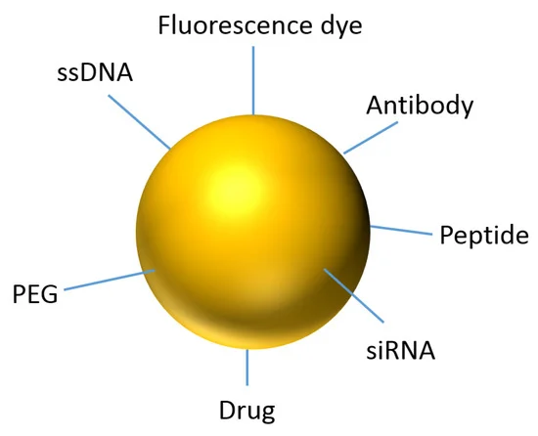
Fig. No. No. 1- gold nanoparticle

Gold nanoparticles with functionalized properties increase the active ingredient in a medication. Consequently, gold nanoparticles play a significant role in the treatment of cancer. For example, Doxorubicin, an anti-cancer prescription drug, can be combined with gold nanoparticles to boost its potency. So doxorubicin's cytotoxic action is enhanced. Gold nanoparticles functionalize weakly active drugs into highly active drugs[6]. As a result, gold nanoparticles have been essential for HIV treatment as well as cancer therapy and cancer cell diagnostics.
Magnetic nanoparticles:
One of the most researched and utilised nanotechnologies in recent years is magnetic nanoparticles. Iron (II) oxide particles' superparamagnetic characteristics can be employed to direct microcapsules where they need to go for delivery by outside magnetic fields. A further advantage of using magnetic nanoparticles is the hyperthermia effect, or the capacity to hear the particles after internalization [12]. The most significant advantages of superparamagnetic NPs over conventional cancer therapies are their reduced invasiveness, ability to approach hidden tumours, and low side effects.

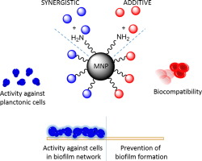

Fig. No. No. 2- Magnetic nanoparticles

There have been reports of magnetic nanoparticles that can carry medications inside of them while still retaining their MRI properties. The anticancer drugs doxorubicin and paclitaxel were loaded onto the iron oxide nanoparticles with a loading efficiency of up to 95% after being coated with oleic acid. Magnetic nanoparticles are also used for magnetic recording as well as therapeutic applications in the treatment of cancer and magnetic resonance imaging (MRI).
Ceramic nanoparticles:
Inorganic compounds with porous properties, such as oxides, carbides, phosphates, and carbonates of metals and metalloids including titania, alumina, and silica, are used to make ceramic nanoparticles (NPs). Among them, silica Nanoparticles have drawn a lot of scientific interest because of their biocompatibility, simplicity of manufacture, and ability to be surface modified. The simple process of preparation for these particles is one of its benefits. Temperature or pH changes do not affect them [13]. The size, shape, porosity, inertness, and other characteristics of these nanoparticles can all be easily altered so that different biomolecules can be attached. They are typically about 50 nm in size. Ceramic nanoparticles have already been utilised successfully to transport drugs for a variety of illnesses, most notably cancer, and bacterial infections.
Liposomes:
The first nanoscale drug delivery systems were modelled after liposomes, which were discovered in the middle of the 1960s. Amphiphilic phospholipids have been utilized for producing the artificial vesicles known as liposomes [8]. These vesicles can range in size from 50 nm to several micrometres, and they are made up of a spherical bilayer structure that wraps around an aqueous core domain. They are useful as systems for delivering medications. When utilised as liposomal medications, cancer chemotherapy agents and other hazardous pharmaceuticals like amphotericin and hamycin produce significantly greater efficacy and safety when compared to conventional preparations.
The most widely used nanosystems for delivering drugs are liposomes. The efficacy of their use has been shown to reduce toxicity and systemic effects while also decreasing drug clearance. At the nanoscale, modified liposomes have proven to have excellent pharmacokinetic characteristics for the transportation of DNA, antisense oligonucleotides, siRNA, proteins, and chemotherapeutic medicines.

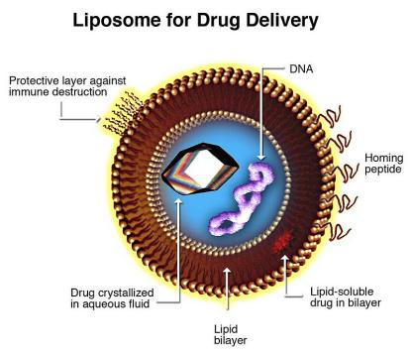
Fig. No. 3- Liposome

Both passive and active methods can be used to deliver drugs utilising liposomes to a particular organ or tissue. Liposomal drugs have a superior safety profile than non-liposomal drugs since they have a negligible effect on other tissues [3]. Doxorubicin is a common anticancer medication that is used to treat a variety of tumour types. Due to its severe toxicity, which influences heart and kidney tissue in addition to tumour tissue, its therapeutic uses are constrained. However, the development of doxorubicin encapsulated in liposomes led to the construction of a renowned nanomedical drug delivery system. This new liposomal formulation has decreased the amount of doxorubicin delivered to the heart and kidneys while increasing the EPR effect's accumulation in tumour tissue.
Niosomes:
Non-ionic and a promising drug delivery system, it is less cytotoxic and raises the therapeutic index of the medicine by directing its activity to the desired cells [1]. Since they are absorbed by tissues like the liver and spleen, niosomes are an excellent medicine delivery system in illnesses affecting these organs. Furthermore, they are utilized to target cancer cells. Niosomes are mainly composed of 1. non-ionic surfactants; 2. Cholesterol; 3. Charge inducers; and 4. hydration medium.
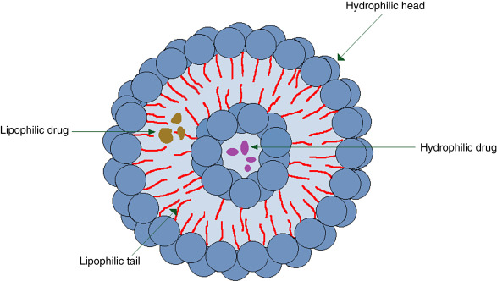
Fig. No. 3- Niosome
As powerful inducers of cellular and humoral immune responses, niosomal antigens can be utilised as adjuvants in the administration of vaccinations. High drug levels were seen in the target area when using niosomes as opposed to conventional methods of administration. Additionally, they have been used in conjunction with anti-inflammatories and anti-infectives. Several liposomal medications are also now being studied, including chemotherapeutic agents like camptothecin and paclitaxel, as well as antibiotics like vancomycin and amikacin.
Dendrimers:
Synthetic, branched macromolecules known as dendrimers possess a structure resembling a tree [5]. Compared to most linear polymers, dendrimers' chemical composition and molecular weight may be precisely controlled, making it relatively easy to anticipate their biocompatibility and pharmacokinetics. Dendrimers are often produced with diameters that increase progressively from 1 to over 10 nm in approximative nanometer steps. They are extremely uniform and exhibit extremely low polydispersities.

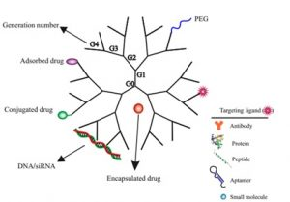
Fig. No. 4- Dendrimer
For magnetic resonance imaging and tumour imaging, the dendrimer molecule has been utilised as a contrast agent and diagnostic reagent. These substances can be modified in terms of size and hydrophilicity, combined with tumour-targeting antibodies, and employed for several specific imaging applications. The application of active drugs topically to the eye is the most typical method of administration for treating several ocular disorders. Dendrimers provide remarkable answers to difficult delivery issues for ophthalmic medicines. Drugs should be administered to the eyes using a non-irritating, biocompatible, sterile, isotonic, and biodegradable method. To address the recent problems with ocular drug delivery that were centred on extending the residence period of pilocarpine in the eye, PAMAM (polyamidoamine) dendrimers with carboxylic or hydroxyl surface groups were utilised [6]. These dendrimers with altered surfaces were expected to increase pilocarpine's bioavailability.
Carbone nanotubes:
Proteins, nucleotides, and medicinal molecules can all be transported using carbone nanotubules. Carbon nanotubes can infiltrate living cells due to their shape and size without resulting in cell death or obvious cell damage. Carbon nanotubules have attracted a lot of attention because they can be surface-functionalized for the grafting of nucleic acids, peptides, and proteins. Carbon nanotubes, fullerene, and nanodiamonds have all been extensively studied for application in medication delivery. Due to their size, shape, and surface characteristics, single-wall nanotubes (SWNTs), multiwall nanotubes, and C60 fullerenes are all intriguing candidates for use as drug carriers [14].

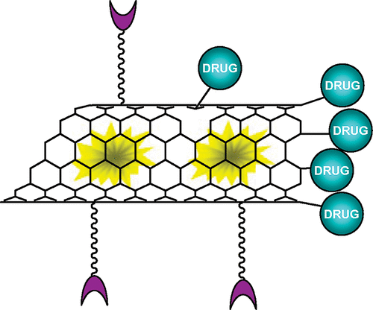
Fig. No. 5- Carbone nano tubule

One of the pharmaceuticals that has been effectively administered is amphotericin B41, which is generally insoluble and poisonous due to its aggregation propensity. When carbone nanotubes were employed for delivery, greater solubility, restricted aggregation (and hence decreased toxicity), and improved anti-fungal activity were all observed. Carbone nanotubes have been used for a variety of therapeutic uses, including gene and siRNA transfer, boron neutron capture treatment (BNCT), and triggering an immune response. However, it seems that the most significant issue with carbon-based nanomaterials is their toxicity [10]. Carbone nanotubes can cause apoptosis and reduce cell proliferation, according to experiments. Although carbon nanotubes are less toxic than carbon fibres and nanoparticles, they become much more dangerous when they have carbonyl, carboxyl, and/or hydroxyl functional groups on their surface.
Nanopores:
Desai and Ferrari (1997) created nanopores, which are made of wafers that have numerous tiny pores (20 nm in diameter). The pores allow for the movement of oxygen, glucose, and other chemicals like insulin.
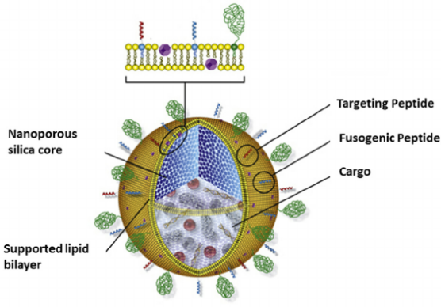
Fig. No. 6- Nanopores

However, it prevents cells and immunoglobulin from passing through them. Nanopores can be used as tools to shield transplanted tissues from the host immune system by utilising the positive advantages of transplantation [13]. A nanopore device may contain pancreatic cells that are then implanted into the recipient's body. This tissue sample takes nutrients from the surrounding tissues without being rejected by the immune system or being noticed by it. This has potential as a novel therapy for insulin-dependent diabetes mellitus and is also applicable to DNA sequencing. Based on changes in the base pair sequence, it can distinguish between various DNA strands.
Nanoemulsion:
A nanoemulsion is a colloidal dispersion of two thermodynamically unstable immiscible liquids. One liquid serves as the dispersed phase, and another serves as the dispersing medium in a nanoemulsion. Each droplet in a nanoemulsion contains a protective coating of emulsifier molecules with a diameter of 10 to 200 nm. Microemulsion is an isotropic and thermodynamically stable formulation.
Emulsions are opaque mixes of two immiscible liquids that are thermodynamically unstable and typically need the use of high-torque mechanical mixing or homogenization to create scattered droplets in the range of 0.2–25 mm. This is where microemulsions vary from emulsions. Both types come in water-in-oil (w/o) and oil-in-water (o/w) variations. For microemulsion formulations, the hydrophilicity of the model drug dictates the selection of dispersed and continuous phases [11]. Additionally, while surfactants with HLB values of 8–10 prefer to do the opposite, those with HLB values of 3-6 tend to promote the creation of o/w microemulsions. It has been reported that the formation and stabilisation of microemulsions depend on the interfacial tension between the dispersed and continuous phases [1].
Microemulsion instability can lead to Ostwald ripening, which causes the small droplets to dissolve and the size of the giant droplets to grow. Because the size of the droplets may alter as a result, stabilisation against Ostwald ripening is crucial to prevent the dosage form from losing its physical stability. The selection of components has an impact on the stability of microemulsions. Safety is a crucial aspect that must be taken into account while selecting components. It has been reported that using microemulsions as drug delivery systems will improve drug penetration across biological membranes.
The following are some benefits of microemulsions:
- Increased drug stability and absorption
- Easy and affordable scaling up.
The following are some drawbacks:
- Premature drug leakage or release
- Phase inversion
- A large number of efficient surfactants and/or cosurfactants don't have a toxicity profile suitable for medicinal usage
- The development of complex, time-consuming microemulsion systems is frequently necessary [2].
Nanosuspension:
Pharmaceutical nanosuspensions are surfactant-stabilized aqueous dispersions that include insoluble drug particles. Drug carriers, however, are either polymeric or lipid colloidal in nanoparticles. Due to Brownian motion, particles in nanosuspension do not settle, improving their physical stability [7]. The best nanosuspensions for these medications are those that maintain their optimum crystalline state and are tiny enough to be injected intravenously. They can also attain even higher levels of drug loading due to the solid form of the medication. Numerous studies have demonstrated the usage of nanosuspensions to improve the efficacy and medication release.
Nanocrystals:
Due to the larger surface-to-volume ratio, the production of crystalline nanoparticles or nanocrystals can enhance solubility, permeability, and ultimately bioavailability. All frequently used routes of administration, including oral, injectable, pulmonary, ophthalmic, and topical administrations, are suitable for the delivery of crystalline nanoparticles. A nanocrystal is a "cluster" made up of several hundred to tens of thousands of atoms. These aggregates typically range in size from 10 to 400 nm, and they have properties that are halfway between molecules and bulk solids. The size and surface area can be altered to alter other properties such as the bandgap, charge conductivity, crystalline structure, and melting temperature. Crystal stabilisation is required to prevent the production of larger aggregates. [3]. Nanosonication is used to create nanocrystals. The advantages of nanocrystallization include the capacity to solubilize poorly soluble medicines, great bioavailability, a notable reduction in dosage volume, and an increase in tolerable dose.
Micelles:
Micelles are lipid nanostructures that are spherical, but they don't have an inner cavity or bilayer. The hydrophobic ends of the phospholipids point inward while the hydrophilic ends face outward, forming a spherical structure. Typically, micelles employed in pharmaceutical applications have a size range of 10 to 80 nm. Micelles go through the body more quickly than liposomes because they are smaller. They do have the advantage of being able to reach tumour cells more quickly because of the increased permeability and retention (EPR) effect [5].
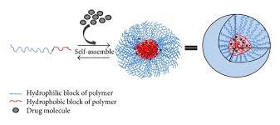
Fig. No. 7- Micelles
Micelles can be produced using polymers as well. Polymeric micelles are produced by block copolymers containing hydrophilic and hydrophobic monomer units. shorter hydrophobic blocks and longer hydrophilic blocks. They have a hydrophobic core that stabilises them. hydrophilic components. Because of their superior biodistribution and longer circulation times than traditional micelles, these micelles are more stable than those in use today and are favoured for drug delivery applications. Lipid polymer-based micelles can also be created. They are capable of transporting a variety of substances, including captothecin, diazepam, and paclitaxel. They also have good stability and lifespan. Micelles that have been coupled with transferrin can carry DNA to cancer cells. Adriamycin has also been delivered to cancer cells via folate residues bound to micelles. These agents have an advantage in that they penetrate targets more effectively due to their reduced size and ease of migration to the target site.
Advantages:
Nanotechnology is an entirely new, rapidly developing field of technology that is expected to drastically alter the world. Since nanotechnology is still in its infancy, even its basic ideas and guiding principles are not entirely agreed upon. Although it is a separate field of research, some people think that nanotechnology can be categorised as a general-purpose technology.
Many different nanoforms, including chemical ones like polymeric polymers and solid metal-containing NPs as well as biological ones like albumin, gelatin, and phospholipids for liposomes, have been tested as drug delivery methods. Usually, polymer-drug conjugates with high size fluctuation are not thought of as NPs. They are also included in these nano delivery systems, though, because their size can still be managed to within 100 nm. Targeting can be done more precisely thanks to the EPR effect, which involves site-specific features unrelated to healthy tissues or organs. These characteristics make nanodrug delivery systems particularly advantageous. Including-

- Increasing the stability of hydrophobic medicines so they can be administered;
- Enhancing pharmacokinetics and biodistribution for greater effectiveness;
- Decreasing the adverse effects caused by preferential accumulation at targeted sites;
- Biocompatible nanoparticles are used to reduce toxicity.
- Nanoparticles that transmit chemotherapy drugs.
- Qdots detect cancer cells in the body precisely at cancer cells to minimize harm to healthy cells.
- Nanoshells that focus infrared light heat to kill cancer cells with little effect on neighbouring healthy cells
- Nanotubes are used to treat broken bones and support the formation of new bone tissue.
- Recognize a specific disease in a blood sample.
Challenges of nanotechnology in drug delivery system :
Although several nanodrug products on the market show that nanotechnology in drug delivery has been successful, not all methods have had the same level of success. There are difficulties with developing new nanomaterials that must be overcome.
Biological availability:
The physicochemical characteristics of nanomaterials have been modified to enhance features like prolonged blood circulation, increased functional surface area, protection against drug degradation, passage through biological barriers, and site-specific targeting, among others. This work is still in progress.
Safety issues:
A field of research called nanotoxicology has also developed in parallel to the growth of nanomedicine. Nanotoxicology is the study of potentially harmful outcomes from interactions between nanoparticles and biological systems. According to certain early nanotoxicity tests conducted by the Nanomedicine Future Scientific Group, nanomaterials may help to produce free radicals. Numerous procedures have been hypothesised to influence the toxicity of nanomaterials following diverse factors derived from physiochemical features, physical qualities, and environmental conditions. For instance, unprocessed quantum dots demonstrate cytotoxicity by producing reactive oxygen species (ROS), which harm the mitochondria, plasma membranes, and the cell's nucleus.
Manufacturing problems:
In the research and development (R&D) of nanomaterials for medication delivery, large-scale production is a challenge. Laboratory or pilot technology must always be scaled up for eventual commercialization. Some nano drug delivery systems might not be viable for mass production due to the nature of the manufacturing process and the high cost of the materials utilised. Scaling up is hampered by a tiny amount of nanomaterials, agglomeration, and the chemical process. It is far easier to alter or maintain the size or composition of nanomaterials for improved performance at the laboratory scale than it is at a large scale.
Economic and financial challenges:
Economic and budgetary constraints may potentially restrict the use of nanomedicine. The restricted availability of reimbursement by public and private health insurers for relatively expensive new diagnostic procedures has delayed the implementation of personalised medicine generally, and nanoproducts are likely to face even larger obstacles due to their costs and complexity. Although nano drug delivery systems have received numerous patents, commercialisation is still in its early phases. Without help from "Big Pharma," which can offer the financial resources and expertise necessary to achieve regulatory and commercial success, startup businesses have little chance of bringing drugs to market. The high development expenses of nanodrugs and medical equipment are to blame for this.
Conclusion:
This study discusses the most recent advances in nanomedicine, such as novel diagnostic techniques and technological innovations in drug delivery for both conventional and novel treatments. The possibility to create numerous items that are incredibly potent by today's standards is provided by nanotechnology. Several products with amazing power by today's standards could be made with the aid of nanotechnology. This potential creates both opportunity and risk. It would be difficult to disregard the potential benefits of the topic and restrict the development of related research given that nanotechnology has already begun to permeate many other academic fields. Guidelines may be utilised in the advancement of nanotechnology to guarantee that it does not become overly potentially hazardous. The advancements in nanotechnology have the potential to lead to healthier lives for people. such as the detection of this condition, disease prevention and treatment, an improved medication delivery system with fewer side effects, and tissue rebuilding.
Acknowledgement:
The principal of ASPM's K. T. Patil College of Pharmacy deserves praise for providing the author with the resources she needed to study.
Reference:
- Nanotechnology in therapeutics: a focus on nanoparticles as a drug delivery system by Suwussa Bamrungsap1 , Zilong Zhao2,3, Tao Chen3 , Lin Wang4 , Chunmei Li3 , Ting Fu2 & Weihong Tan*2,
- Lobatto M, Fuster V, Fayad Z, Mulder W.Perspectives and opportunities for nanomedicine in the management of atherosclerosis. Nat. Rev. Drug Discov. 10(11), 835–852 (2011).
- Kipp JE. The role of solid nanoparticle technology in the parenteral delivery of poorly water-soluble drugs. Int. J. Pharm. 284, 109–122 (2004)
- Nanotechnology in novel drug delivery system Aruna kapil, *geeta aggarwal, sl harikumar journal of drug delivery and therapeutics
- LaVan DA, Langer R. Implications of nanotechnology in the pharmaceutics and medical fields. In: Societal Implications of Nanoscience and Nanotechnology. Bainbridge WS (Ed.). Springer, NY, USA, 77–83 (2001).
- Riehemann K, Schneider SW, Luger TA, Godin B, Ferrari M, Fuchs H. Nanomedicine – challenge and perspectives. Angew. Chem. Int. Ed. Engl. 48(5), 872–897 (2009).
- Wagner V, Dullaart A, Bock A, Zweck A. The emerging nanomedicine landscape. Nat. Biotechnol. 24(10), 1211–1217 (2006).Tolia G.T, Choi H.H, Ahsan F. The role of dendrimers in drug delivery. Pharmaceut. Tech 2008; 32: 88–98.
- Vandamme T.F, Brobeck L. Poly (amidoamine) dendrimers as ophthalmic vehicles for ocular delivery of pilocarpine nitrate and tropicamide. J. Control. Release 2005; 102: 23–38.
- Star A, Stoddart JF, Steuerman D, Diehl M, Boukai A, Wong EW. Preparation and properties of polymer-wrapped singlewalled carbon nanotubes. Angew Chem Int 2001; 40: 1721-1725.
- 40. Lin Y, Rao AM. Bon nanotubes with aminopolymers. J Phys Chem B 2002;106: 1294 -1298.
- Wu W, Wieckowski S, Pastorin G, Benincasa M, Klumpp C, Briand JP. Targeted delivery of amphotericin B to cells by using functionalized carbon nanotubes. Angew Chem Int 2005; 44: 6358-6362.
- Farokhzad OC, Langer R. Nanomedicine: developing smarter therapeutic and diagnostic modalities. Adv. Drug Deliv. Rev. 58(14), 1456–1459 (2006).
- LaVan DA, Langer R. Implications of nanotechnology in the pharmaceutics and medical fields. In: Societal Implications of Nanoscience and Nanotechnology. Bainbridge WS (Ed.). Springer, NY, USA, 77–83 (2001).
- Kharb V, Bhatia M, Dureja H, Kaushik D. Nanoparticle technology for the delivery of poorly water-soluble drugs. Pharm. Technol. 30(2), 82–92 (2006).
- Merisko-Liversidge E, Liversidge GG, Cooper ER. Nanosizing: a formulation approach for poorly-water-soluble compounds. Eur. J. Pharm. Sci. 18, 113–120 (2003).

