Forest Wetlands as Nature Based Solution for Climate Regulation, Water Resource Management and Biodiversity Conservation

Abhishek Maitry, Animesh Shukla and Shishir Chandrakar
Department of Forestry, Wildlife & Environmental Sciences,
Guru Ghasidas Vishwavidyalaya,
Bilaspur, Chhattisgarh- 495009, India
abhimaitry@gmail.com

ABSTRACT
Wetlands are one of the planet's wealthiest ecosystems, offering numerous valuable advantages to human society while being extremely delicate to environmental changes. Wetlands are important biological and economic systems that contain abundant natural resources and are essential for maintaining several services like hydrological cycle, carbon sequestration, and biodiversity. According to the National Wetland Inventory and Assessment (and ISRO), in India, wetlands comprise of an area over 1 lakh, 52 thousand and 6 hundred square kilometers covering 4.63 percent of the overall geographical area. The wetland has several benefits like maintaining diversity, providing food, fresh water, etc., environment regulation with enrichment of cultural values and support internal processes that maintain ecosystem functioning, resilience, and capacities to produce directly consumed services and hence being a great nature-based solution for different ecological, hydrological and forest diversity issues. Despite the significant values in the field of ecology, hydrology, and socio-economic points provided by them, wetlands are facing various threats from natural as well as anthropogenic induced factors even in densely forested areas. In this chapter, we have tried to justify the importance of forest-surrounded wetlands as a nature-based solution that provides various ecosystem services either directly or indirectly for the benefit of the human population which comprises its positive impacts on the regulation of climate for mitigation of climate change scenarios, managing hydrological resources for water security and conserve important floral and faunal species. These positive impacts evaluate the importance of forest wetlands and provide insights into planning, conservation, and sustainable management of wetland resources.

Keywords-wetland; biodiversity; climate; forest; water resource.

INTRODUCTION

Wetlands may be defined as the most productive ecosystems on the Earth, providing lots of important services to mankind but are highly sensitive. ‘Wetlands are area of marsh, fen, peat-land or water, whether natural or artificial, permanent or temporary, with water that is static or flowing, fresh, brackish or salt, including areas of marine water, the depth of which at low tide does not exceed six meters', as defined by Ramsar convention of 1971. Each of the services offered by wetlands, which support immense diversity, is defined by their genesis, geographic location, water regime and chemistry, dominant species present, and soil and sediment features [1, 2]. Globally, the areal extent of wetland ecosystems ranges from 917 million hectares (mha) [3] to more than 1275 mha with an estimated economic value of about US$15 trillion a year [4]. There are currently more than 2,200 Ramsar Sites recognised worldwide, covering 2.1 million square kilometres of these global wetlands. According to the National Wetland Inventory and Assessment (compiled by the Indian Space Research Organisation), over 1,52,600 square kilometres, or 4.63 percent of the nation's total land area, are covered by wetlands in India [5].
They can be found in every climatic region, from warm deserts to frigid tundra, and at every elevation, from ocean level to around 6000 meters in the Himalaya. Wherever water collects for long periods of time, allowing the succession of plants and animals specifically adapted to the aquatic environment, wetland formation occurs. Presence of water throughout the year is not a criterion and its depth may also fluctuate [6]. Therefore, wetland areas can be found in or near bodies of water, such as shallow or deep lakes, transient ponds, streams, springs, and rivers. Wetlands are defined as " lands that connect aquatic with terrestrial ecosystems when the water table is frequently at or near the surface or when the land is submerged in shallow water," and they compulsorily contain at least one of the following three points: a) The substrate is primarily undrained hydric soil; b) at least occasionally, the land supports primarily hydrophytes; and c) at a point during the progressive season of each year, the substrate is non-soil and is covered by shallow water [7]. Despite the fact that the continents are surrounded by water on all sides, there is just a small amount of fresh water available—less than 1%. Only 0.0001% of the available fresh water is shared by the 6.45% of the world's surface that is made up by wetlands.

- IMPORTANCE OF WETLANDS

Importance of wetlands for human and nearby forest has grown recently as the population-based pressures have increased recently due to rapid increase in the population [8, 9]. The wetland offers a variety of advantages, including meeting basic demands (food, fresh water, etc.), regulating the environment, and enhancing culture [10, 11]. Additionally, support ecosystems' internal processes so they can continue to function, be resilient, and be able to provide more directly consumed services [12]. Carbon sequestration, erosion management, and other important services are of particular relevance. Flood water storage (storing water during periods of severe rain and flooding and then gradually releasing the water to minimise downstream damage); recharge of groundwater is the process through which stored surface water seeps into the earth and replenishes aquifers, which then slowly release water to nearby surface water bodies, such as streams, to supply water during times of low flow; water filtration (catch sediments, use extra nutrients in runoff, and decompose many toxins in water); economic benefits and recreation have also achieved growth in recent times (cultural heritage, visited for leisure, hiking, bird viewing, wildlife photography, and hunting).

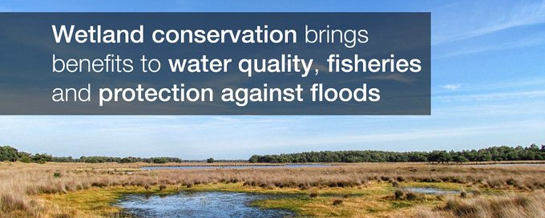

Figure 1. Global recognition of importance of wetlands. (Source: https://twitter.com/IUCN)

- THREATS TO WETLANDS

Wetlands are threatened by a number of man-made reasons, despite the significant ecological, hydrological, and socioeconomic roles they serve [13]. Due to anthropogenic concerns, even wetlands that are legally protected are not entirely free from degradation [14]. Moreover, a lot of wetlands in rural and suburban areas haven’t covered either by the Wild Life Protection Act, 1972 or Indian Forest Act, 1927.

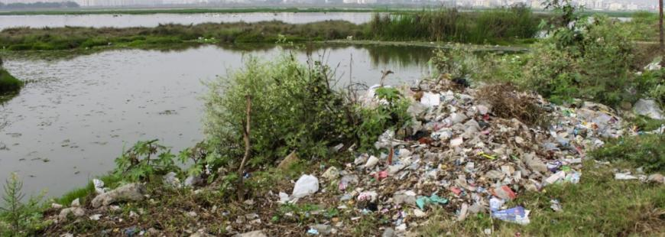

Figure 2. Major threats to wetlands. (Source: https://www.ramsar.org/resources/recognising-and-assessing-threats-to-the-site)

These wetlands face multiple threats, thus proper attention should be paid to their conservation and management. In India, there are many different types of wetlands that are dynamic and affected by both natural and anthropogenic activities. These wetlands require regular monitoring and updates on their status through planning for conservation and sustainable management, which is important in view of the increasing pressure [15].

- WETLANDS IN INDIA

Wetland habitats in India are supported and maintained by the country's geography and climate patterns. Examples of natural wetlands in India include the coral reefs, marine wetlands, high-altitude Himalayan lakes, wetlands in the floodplains of the river systems, saline and transitory wetlands, coastal wetlands, mangrove swamps, etc. With the exception of forbogs, fens, and traditional salt marshes, Indian wetlands are home to a variety of ecological types. In addition to the natural wetlands, there are a lot of man-made wetlands that were created to meet needs for fresh water supply, irrigation, electricity generation, fisheries culture, and flood control, among other things. These wetlands significantly increase the richness of the fauna and flora [11]. In addition, countless tanks, shallow ponds, and reservoirs all contribute to the biodiversity of wetlands.

Table 1. Wetland categories found in India.

 | Wetland Category | Total wetland area (ha) | % of wetland area
1. | Inland wetlands- Natural | 6623067 | 43.40
2. | Inland wetlands- Man-made | 3941832 | 25.83
 | Total – Inland | 10564899 | 69.22
3. | Coastal wetlands- Natural | 3703971 | 24.27
4. | Coastal wetlands- Man-made | 436145 | 2.86
 | Total – Coastal | 4140116 | 27.13
 | Sub- Total | 14705015 | 96.36
 | Wetlands (< 2.25 ha) | 555557 | 3.64
 | Total | 15260572 | 100
Source: National Wetland Inventory and Assessment, India

- FOREST WETLANDS FOR CLIMATE REGULATION

Wetlands can be said as one of the most valuable and prolific ecosystems on the planet. Wetland systems are sensitive to variations in the amount and quality of their water resource. Climate change is anticipated to significantly impact wetlands via modifications to highly variable hydrological systems worldwide. Wetlands are a complex system that encounters wet and dry phases in cycles over the course of seasons, years, and decades. The multitude of advantages wetland habitats offer to human society were emphasized by the Millennium Ecosystem Assessment [4]. Climate regulation is one of the most crucial environmental functions that connect wetlands to human well-being [16]. Wetlands are increasingly acknowledged to be important climate regulators additionally in the sequestration and storage of carbon [17]. Wetlands are involved in multiple facets of climate regulation beyond just the kinetics of carbon. In addition, to serve as a sink for greenhouse emissions, wetlands have the ability to regulate local and regional climate as well. Wetlands are one of the major uncharted territories for element dynamics as well as matter fluxes in the near future in a world that is suffering from global climate change [18].

- Wetland and Carbon
Globally wetlands occupy 6% of the total land area yet contain around 12% of the world's carbon reserves, contributing significantly to the global carbon cycle [19, 20]. From the poles to the equator, vegetated wetlands serve as important carbon sinks. The carbon density of terrestrial ecosystems is highest in wetlands which account for 20–25% of the organic soil carbon worldwide [21]. Mangroves are considered as one of the major forest wetland habitats with the highest concentrations of carbon in accordance with the current biogeochemical and physical circumstances being very favorable for carbon retention over the long term. Global assessments indicate that these systems are substantial carbon sinks as they could store up to 19.9 Gigatons of organic carbon [22]. The quantity of carbon retained in wetland soils is strongly correlated with climate. The role of tropical forest wetlands has garnered a great deal of attention in climatic budgets on a global scale. According to estimates, as much as 88.5 Gigatons of carbon (ranging from 81.5–91.8 GtC), equivalent to 17–19 percentage of the worldwide wetland carbon stock are stored in tropical peatlands [23]. Wetland has the potential to store a considerable amount of carbon in its soils and standing aquatic or semi aquatic vegetation. Wetlands are essential pertaining to the carbon complex and thus, they have a great potential to mitigate the harmful impacts of climate change.

- Wetland and Greenhouse Gases
One crucial aspect of wetlands is their ability to act as a source and sink of greenhouse emissions. Wetlands are essential for regulating the climate since they can alter the levels of greenhouse gases in the atmosphere such as carbon dioxide, nitrous oxide and methane [24]. Different wetlands produce and emit GHGs at varying rates in accordance with the dominant biogeochemical processes. In the anaerobic soils that predominate in wetlands, CH4 can also be produced along with CO2. So, wetlands can be an innate CH4 source. Wetlands often emit less N2O into the air. Although due to groundwater contamination or adjacent uplands leaching where substantial nitrogen infusions are present, wetlands may produce N2O emissions. Wetlands that hold a considerable amount of water throughout the year, maintaining anoxic conditions, will typically produce less N2O emissions and more CH4 emissions. The risk of rising CH4 emissions has been cited to argue against restoring wetlands. Nevertheless, it is crucial to comprehend the potential GHG fluxes to avoid unfavorable results. Therefore, at any wetland, the primary GHG emission controls are climatic conditions and the accessibility of nutrients along with the period of waterlogging and water table elevation.

- Wetland and Local Climate
Wetlands have a localized impact on climate by transferring energy and dissipating it. Wetland affects fluctuations in temperature and impacts variation in precipitation intensity and frequency. Wetlands have been predicted to have a localized cooling influence on the environment and can lower temperatures thereby up to 50C compared to the surroundings [25]. Since water is frequently present in wetlands, energy input is converted into latent heat of evaporation, however, on dry grounds solar energy is transformed into perceptible heat increasing the ambient air temperature noticeably. Wetlands serve as the first line of defence against severe weather conditions and create a physical barrier to lessen the force and speed of floodwaters. Wetlands offer a coping mechanism to guard against storms. Wetlands may assist in providing water during dry spells. Wetland provides a reliable and realistic approach for mitigating the effects of climate change.

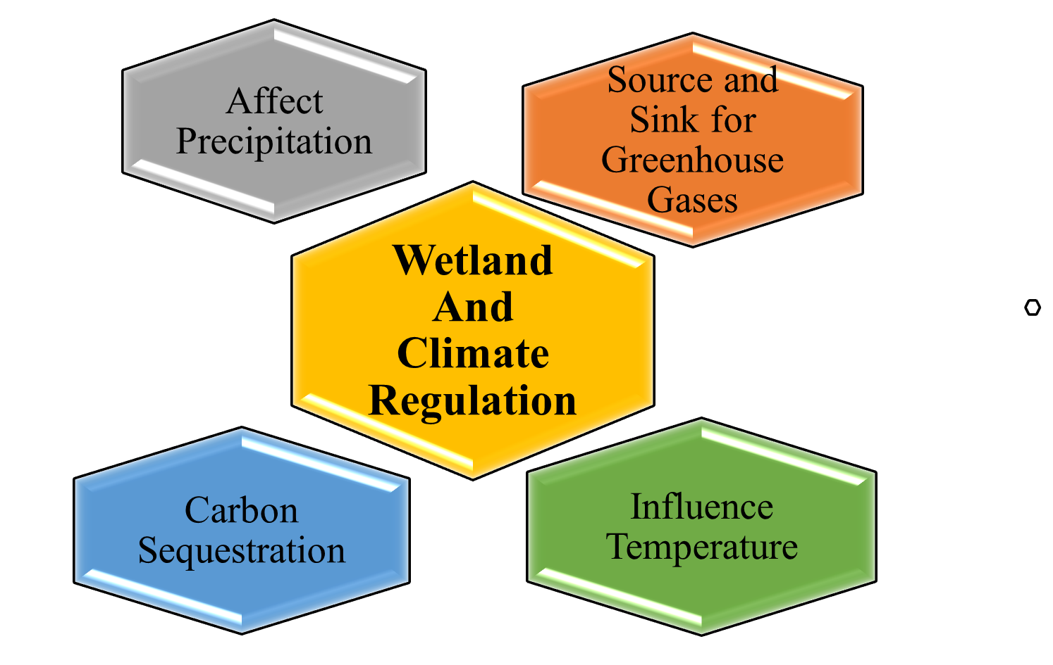

Figure 3: Multiple Aspects of Climate Regulation through Wetland.

Wetland habitats are essential to both nature and mankind. They are frequently the landscape's most valuable ecosystems. Effective and sustainable wetland resource management is becoming more difficult and crucial but it is essential to protect, preserve and conserve the wetland as they are continually being lost due to improper management yet it is increasingly clear that the services, they offer are indispensable for society. Due to their crucial function in regulating the climate, activities for managing wetlands and restoring them are being incorporated into local, regional and international levels which aspire to both prevent and respond to climate change [26]. Wetlands can act as a "safety net" against the effects of climate change if they are globally preserved, safeguarded, and restored [27].

- FOREST WETLANDS FOR WATER CONSERVATION

Wetlands are the ideal natural option for risk reduction and adaptation while preserving both flood and drought-related climatic extremes. Water and land are divided by areas known as wetlands. They can be freshwater or saltwater and exist in a transitional zone that is occasionally wet and occasionally dry. Normally, the Wetlands will remain moist during rain occurrences. Wetlands can be either natural or man-made, and the water they contain can be either still or moving, fresh, brackish, or salty. Even subsurface wetlands exist. Swamps, marshes, bogs, and fens are the principal types of wetlands.
Depending on the kind of wetlands, the specific characteristics of the soil and water, and any associated biotic impacts, wetland ecosystems are linked to a broad and complicated array of direct and indirect uses. Water supply sources and the harvesting of wetland resources like plants and fish are examples of direct applications. Environmental processes include floodwater retention, groundwater recharge and outflow, climate mitigation, and nutrient abatement produce indirect benefits. [28]. Wetlands have been identified as crucial to human existence based on the significant environmental and sustainability benefits. By maintaining the wetlands, future challenges relating to food security, clean water security, and energy security, human well-being, natural catastrophe risk reduction and climate change resilience can be met. [29].

- Water Purification
Natural wetlands provide a variety of purposes that are advantageous to both people and wildlife. The filtering of water is one of its most crucial roles. As water moves slowly through a wetland, many of the sediments that carry contaminants and nutrients also do so. As a result, the suspended solids in the water become trapped by the plants and settle out. Other contaminants are rendered inert or changed into less soluble forms that plants can absorb.

- Flood Protection
Water spreads out and moves through a lot of vegetation as it enters a wetland through a stream channel or surface runoff. Water flow has slowed down, which may reduce the likelihood of a significant flood. The effectiveness of wetlands are at reducing flood damage depends on several factors, including the size of the area, the type and health of the vegetation, the slope, the location of the wetland in the flood path, and the saturation of the wetland soils prior to flooding. A standard one-acre marsh may hold three acre feet, or one million gallons, of water [30]. As the flow of water get reduced by wetland via storing more water by infiltration than terrestrial land, the chances of causing flood get reduce.
- Ground Water Recharge
Some freshwater wetlands exist where groundwater recharges from surface water reaching an underground aquifer. Wetlands are more frequently the locations where groundwater seeps to the surface of the land, like springs. During the dry summer months, the groundwater discharge may be crucial for maintaining stream flows for fish, animals, plants, and other organisms living in or close to the stream. It might be important as an essential source of water for the community as well.

- Trap Sediments that contain Contaminate and Pollutants
The surface of the marsh may get covered in floating debris as the flow develops at a slower rate. The accumulating sediments can then be held in place by the roots of marsh plants. If the water flows through wetlands, up to 90% of the sediments in runoff or streamflow may be eliminated. Since toxins like heavy metals are linked to soil particles, the sediment that settles in wetlands also enhances the quality of the water.

- FOREST WETLANDS FOR BIODIVERSITY CONSERVATION

Wetlands are crucial for maintaining a number of natural cycles and serving as a home for a range of animals. The phrase "kidneys of the landscape" is frequently used to characterise wetlands [31]. Wetlands play important ecological roles in the preservation of biodiversity, hydrological equilibrium, and human wellbeing. More than 40% of all plant and animal species have habitats in surface freshwater wetland areas around the world. Wetland microhabitats offer abundant and high-quality food sources and shelter for avifauna populations all year long. Wetlands have sometimes been referred to as "biological super systems" because of the enormous amounts of food they produce and the extraordinary degree of biodiversity they support. They are equally as diverse and abundant in species as coral reefs and rainforests. They are ideal for the growth of creatures that form the base of the food chain on our planet due to their shallow water, high nutrient content, and high primary productivity (amount of biomass generated).
Floral Diversity Conservation
Wetland plant communities serve as effective indicators of the health of wetlands because they include species with a range of ecological tolerances and adaptations, as well as reflecting the biological integrity of wetlands [32]. Wetland plants are any species that can be regularly seen growing in wetlands of any kind, on or in the water, or when soils are flooded or saturated for long enough for anaerobic conditions to form in the root zone. The vital habitat that wetland provides for plant diversity is essential for maintaining the water cycle, nutrient cycle, carbon sequestration, storage/retention and purification of water, waste treatment, and pollution control[33]. In order to assess the effects of human interference on wetlands, different plant species respond to environmental change in different ways [34].

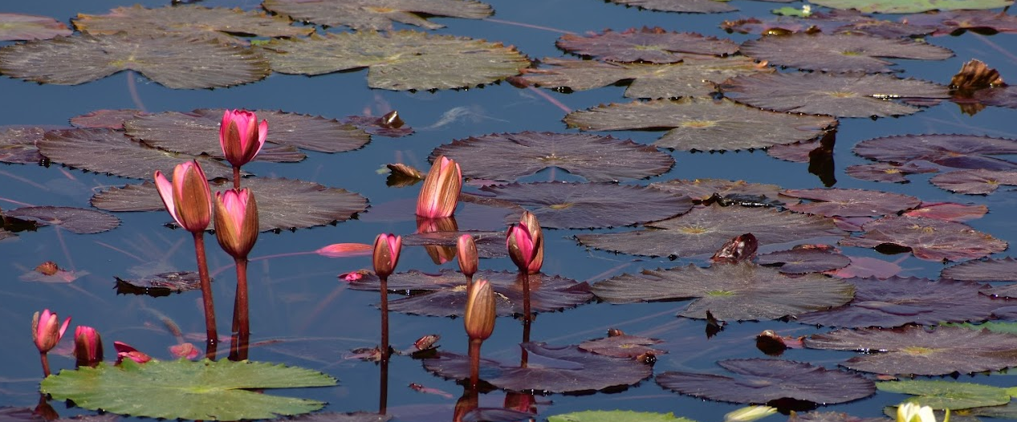

Figure 4. Floral diversity supported by wetlands. (Source: GPWC, Bemetara ©Abhishek Maitry)

- Faunal Diversity Conservation
Wetlands are vital habitats for migratory species and a large proportion of waterbirds worldwide [35, 36]. Nearly all water birds in the world use wetlands as breeding and foraging areas [37]. Waterbirds that migrate use wetlands throughout their range, which occasionally stretches almost from pole to pole. To save the habitats that migratory birds rely on for feeding, breeding, and rest stops as they travel between and between continents, multi-national coordination of conservation efforts for wetlands is required. Wetlands not only assist other animal species, but they also give other species the environment they need to cohabit peacefully within an ecosystem [38]. For the conservation and management of wetlands as well as their sustainable living, the current knowledge on faunal variety in wetland is of enormous value.
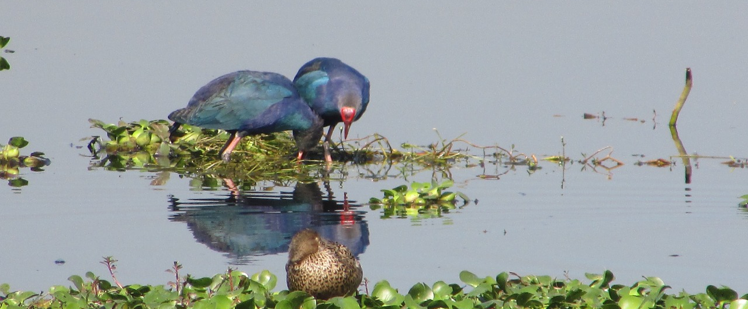

Figure 5. Faunal diversity supported by wetlands. (Source: GPWC, Bemetara ©Abhishek Maitry)

- CONCLUSION

The wetland provides a variety of benefits, including as diversity, the fulfilment of fundamental biophysical demands (such as food and fresh water), environmental control, and cultural enrichment. It is a fantastic natural solution for numerous ecological, hydrological, and forest diversity issues because it supports internal processes in ecosystems that sustain their functioning, resilience, and capabilities to create more directly consumed services. Climate control is one of the most significant environmental services that connects wetlands to human wellbeing. Wetlands are now seen as essential climate controllers that aid in the sequestration and storage of carbon. Wetland ecosystems are connected to a wide and complex range of direct and indirect uses, depending on the kind of wetlands, the characteristics of the soil and water, and any associated biotic impacts. Examples of direct uses include water supply sources and the harvesting of wetland resources like plants and fish. Indirect benefits are produced by environmental processes such as nutrient abatement, groundwater recharge, and floodwater retention. Additionally, wetlands produce a staggering amount of food and sustain a high degree of biodiversity, earning them the label "biological super systems" in certain quarters. They have a diversity and abundance of organisms that rival coral reefs and rainforests. These beneficial effects assess the value of forest wetlands as a natural approach to managing water resources, regulating climate, and preserving biodiversity. They also offer insights into the management of wetland resources in terms of planning, conservation, and sustainable management.

REFERENCES

- M. R. Goswami, A. Mukhopadhyay, An Overview of the Determination of Biodiversity of Wetlands. Handbook of Research on Monitoring and Evaluating the Ecological Health of Wetlands, 2022, pp. 150-170.
- T. Xu et al., Wetlands of international importance: status, threats, and future protection. Int. J. Environ. Res. Public Health 16(10), 1818 (2019).
- Lehner, P. Döll, Development and validation of a global database of lakes, reservoirs and wetlands. J. Hydrol. 296(1-4), 1-22 (2004).
- Millennium Ecosystem Assessment, Ecosystems and Human Well-Being: Wetland and Water Synthesis. Available at (http://www.millenniumassessment.org/proxy/Document), 2005, vol. 358.
- N. Bassi, M. D. Kumar, A. Sharma, P. Pardha-Saradhi, Status of wetlands in India: a review of extent, ecosystem benefits, threats and management strategies. J. Hydrol. Reg. Stud. 2, 1-19 (2014).
- Y. Qu et al., Prediction of wetland biodiversity pattern under the current land-use mode and wetland sustainable management in Sanjiang Plain, China. Ecol. Indic. 147, 109990 (2023).
- L. M. Cowardin, Classification of Wetlands and Deepwater Habitats of the United States (Fish and Wildlife Service, US Department of the Interior), 1979.
- W. J. Mitsch, J. G. Gosselink, The value of wetlands: importance of scale and landscape setting. Ecol. Econ. 35(1), 25-33 (2000).
- K. Avishek, M. S. Nathawat, Geoinformatics for the assessment of anthropogenic impact on landscape. Natl. Geogr. J. India 50(1-2), 13-24 (2004).
- P. A. Hambäck et al., Tradeoffs and synergies in wetland multifunctionality: A scaling issue. Sci. Total Environ. 862, 160746 (2023).
- S. Bhowmik, Ecological and economic importance of wetlands and their vulnerability: a review. Research Anthology on Ecosystem Conservation and Preserving. Biodiversity, 11-27 (2022).
- S. Thapa et al., Valuation of ecosystem services from an important wetland of Nepal: A Study from Begnas watershed system. Wetlands 40, 1071-1083 (2020).
- K. Ostad-Ali-Askari, Review of the effects of the anthropogenic on the wetland environment. Appl. Water Sci. 12(12), 260 (2022).
- A. Moi et al., Human pressure drives biodiversity–multifunctionality relationships in large Neotropical wetlands. Nat. Ecol. Evol. 6(9), 1279-1289 (2022).
- R. Abell et al., Freshwater biodiversity conservation through source water protection: quantifying the potential and addressing the challenges. Aquatic Conserv: Mar. Freshw. Ecosyst. 29(7), 1022-1038 (2019).
- A. Maitry et al., Assessment of Wetland Ecosystem Services (RAWES approach) in Urban Settlement Area: A case study of Bilaspur, Chhattisgarh, India. Indian Journal of Ecology 50(4), 954-962 (2023).
- S. Frolking, N. T. Roulet, Holocene radiative forcing impact of northern peatland carbon accumulation and methane emissions. Global Change Biol. 13(5), 1079-1088 (2007).
- IPCC (International Panel on Climate Change), 2001: impacts, adaptation, and vulnerability. Technical summary, and summary for policymakers. Third assessment report of working group I of the intergovernmental panel on climatic change, Climate Change, 2001.
- IPCC (International Panel on Climate Change) (1996), Climate change 1996—impacts, adaptations and mitigation of climate change: scientific technical analysis. Contribution of Working Group II to the Second Assessment Report of the IPCC (Cambridge University Press, Cambridge).
- R. Ferrati, G. Ana Canziani, D. Ruiz Moreno, Esteros del Ibera: hydrometeorological and hydrological characterization. Ecol. Modell. 186(1), 3-15 (2005).
- Gorham, Northern peatlands: role in the carbon cycle and probable responses to climatic warming. Ecol. Appl. 1(2), 182-195 (1991).
- J. W. Fourqurean et al., Seagrass ecosystems as a globally significant carbon stock. Nature Geosci. 5(7), 505-509 (2012).
- S. E. Page, J. O. Rieley, C. J. Banks, Global and regional importance of the tropical peatland carbon pool. Globa Chang Biol. 17(2), 798-818 (2011).
- IPCC, Climate Change 2007 Synthesis Report. Contribution of Working Groups I, II and III to the Fourth Assessment Report of the Intergovernmental Panel on Climate Change (IPCC), 2007.
- H. Taha, Urban climates and heat islands: albedo, evapotranspiration, and anthropogenic heat. Energy Build. 25(2), 99-103 (1997).
- K. L. Erwin, Wetlands and global climate change: the role of wetland restoration in a changing world. Wetlands Ecol. Manage. 17(1), 71-84 (2009).
- Ramsar 2009h. Factsheet 10: Climate change mitigation & adaptation. Gland, Switzerland, Ramsar Convention Secretariat.
- S. Abraham, The relevance of wetland conservation in Kerala. Int. J. Fauna Biol. Stud. 2(3), 01-05 (2015).
- A. Nayak, B. Bhushan, Wetland ecosystems and their relevance to the environment: importance of wetlands, in Handbook of Research on Monitoring and Evaluating the Ecological Health of Wetlands (IGI Global), 2022, pp. 1-16.
- US Environmental Protection Agency (EPA), Wetlands: Protecting Life and Property from Flooding, 2006.
- S. Jamal, M. A. Ali, Remote sensing application for exploring land use and land cover dynamics in and around Chatra wetland, English Bazar, West Bengal. Creat. Sp. 9(1), 15-27 (2021).
- N. Yapa, K. Amarasekara, S. Rathnasri, Floral Diversity Status in Urban Coastal Wetland & Associated Coastal Ecosystems of Crow Island Mattakkuliya, Sri Lanka. Open J. Ecol. 12(1), 51-65 (2022).
- R. S. Rathore, R. S. Yadav, H. A. Solanki, Wetland ecosystem – home to plant species diversity. Plant Arch. 20(2), 5341-5352 (2020).
- J. J. Sieben, R. P. Glen, H. Van Deventer, A. Dayaram, The contribution of wetland flora to regional floristic diversity across a wide range of climatic conditions in southern Africa. Biodivers. Conserv. 30(3), 575-596 (2021).
- A. Chatterjee, S. Adhikari, S. Pal, S. K. Mukhopadhyay, Foraging guild structure and niche characteristics of waterbirds wintering in selected sub-Himalayan wetlands of India. Ecol. Indic. 108, 105693 (2020).
- M. A. Salim et al., Diversity of Avian fauna of Al-Dalmaj Wetlands and the surrounding terrestrial areas, Iraq, in J. Phys.: Conf. Ser. (Vol. 1664, No. 1, p. 012105) (IOP Publishing) 1664(1) (2020, November).
- M. Mola, D. Ejigu, Y. Yitayih, Species composition, relative abundance, and habitat association of avifauna in zegie peninsula forest patches and associated wetlands, Bahir Dar, Ethiopia. Int. J. Zool. 2021, 1-12 (2021).
- T. K. Goswami, M. M. Goswami, Ichthyo Faunal Diversity and Catch Statistics of Jamlai Wetland in Kamrup District of Assam, India, 2020.

