Eco-friendly fly ash composite brick: A novel approach towards Sustainable Development.

Amarnath P C ¹, Srinidhi R Kulkarni ² and Dr. Praveen Kumar D. G ³.
- Assistant Professor Department of Chemical Engineering, BIET,Davangere-04.
- Assistant Professor Department of Chemical Engineering, BIET,Davangere-04
- Associate Professor Department of Chemical Engineering, BIET,Davangere-04
.
ABSTRACT
Fly ash is produced in vast quantities as a by-product of using fossil fuels for energy in the thermal plant generation of electricity. At present 10-15% of the fly ash produced in Australia is utilized in cement manufacturing and concrete industry, with the remaining majority requiring costly disposal processes. Due to growing environmental concerns and the need for cleaner production, the management of fly ash has become an important issue facing the power generation industry. For that reason, many analysts are actively working to find new and improved methods of combating the fly ash waste disposal problem, particularly by establishing its useful and economic utilization. One such example that is gaining considerable interest in many parts of the world is the utilization of fly ash in brick manufacturing. This paper examines the potential for using fly ashes as major constituents in the manufacture of common residential building bricks. Scaled down pressed bricks were made by varying proportions of fly ash, sand, limestone, gypsum, LDPE (low density polyethylene) and water. Both fired, oven dried and air-cured bricks were tested for their properties including compressive strength, tensile strength, water absorption, and durability. In the paper, the test results are analyzed and effects of variables discussed.
Keywords—Fly ash, Brick, Waste disposal.

I.INTRODUCTION
Fly ash is by product of coal combustion, which occurs in thermal power plants. It consists of small, solid particles that are carried away in the flue gas and collected by electrostatic precipitators or baghouses before being released into the atmosphere. Fly ash is typically composed of silicon dioxide (SiO2), aluminum oxide (Al2O3), calcium oxide (CaO), and magnesium oxide (MgO).
Composite fly ash is an created in a large amount particularly by warm power plants. Plastics are generated in large amount with increase in population. The proper disposal of waste, particularly waste plastic bags, has turned into a major issue. The waste plastics in house hold is large and increases with time. Both cause severe environmental problems. The main aim of our project is to utilize those plastics and fly ash in the manufacturing of bricks. In this paper, the fly ash bricks are casted and plastics were powdered and added up to 20% with an interval of 5%. Fly ashes bricks are manufactured with plastics and subjected to various tests like test for compressive strength, test for water absorption and efflorescence test. The durable properties of composite bricks comprising of various composite materials as the It is described the elements and considerations of design for the concrete block incorporating waste plastic bags. It will be definitely cost economical when compared with the normal fly ash bricks.

II.OBJECTIVES
- To manufacture fly ash based brick as a measure of reusing fly ash waste.
- To develop the composite fly ash brick and study on strength, dimensional stability, and water absorption.
- To find out the cost-effectiveness in comparison to traditional brick.

II. METHODOLOGY

Materials used:
The materials used for the experiment were: Fly ash, sand, LDPE (low density polyethylene), gypsum, water, limestone. Weighing machine or Oven, mold etc.

Methodology:

Collection of Raw Material (fly ash)

Fly ash is a by-product of burning coal in thermal power plants, and it can be collected and reused in various applications. The collection of fly ash typically involves the use of electrostatic precipitators (ESPs) or baghouses, which are devices that capture the fly ash particles from the flue gases before they are released into the atmosphere. In an ESP, the fly ash particulate get charged and afterwards drawn to electrodes, where they are collected and removed. In a baghouse, the flue gases are passed through fabric filters, which trap the fly ash particles. The collected fly ash can then be transported to storage facilities for further processing and use.

Mixing of Raw Materials

Composite ash bricks are made by mixing a combination of raw materials that include fly ash, sand or stone dust, lime, gypsum, And Low-Density Polyethylene.
- Fly Ash
Majorly fly ashes are obtained from industries like thermal power plants where coal is burned to produce. The ash is collected from the exhaust gases and stored in silos for further use. The fly ashes are then sieved to remove any large particles and formed a slurry when combined with water.
- m- sand
m- Sand is added to the fly ash slurry in a specific proportion. The purpose of adding sand or stone dust is to improve the strength and durability of the bricks.
- Lime
Lime is added to the mixture in a specific proportion to provide the necessary binding properties to the bricks. The lime is reacted with the silica present in the fly ash and forms a complex compound that acts as a binder.
- Gypsum
Gypsum is added to regulate the setting time of the fly ash bricks. Gypsum also helps to prevent the cracking of bricks during the drying process.
- Low density polyethylene
Low density polyethylene acts as a binding agent in the composite, helping to improve the strength and durability of the resulting brick.
- Moulding
The mixture is then poured into moulds of desired shapes and sizes. The moulds are generally made of metal or plastic.

Curing
The curing process of fly ash bricks is a crucial step that helps to enhance their strength and durability.
- Water curing
After the bricks are moulded, they need to be kept moist for at least seven days. This process is known as water curing. During this period, the bricks are covered with wet gunny bags or straw to prevent evaporation of moisture.
- Drying
After the water curing process, the bricks are taken out of the moulds and kept in a shady area for drying. This process takes around 7-10 days depending on the weather conditions. During this period, the bricks should be kept away from direct sunlight to prevent cracking.

- Natural cooling
After the steam curing process, the bricks are taken out of the chamber and allowed to cool naturally. This process takes around 24 hours. The bricks should not be cooled suddenly as it may lead to cracking.

Demoulding
Demoulding of fly ash bricks is an important step in the brick-making process, as it involves removing the newly formed bricks from their moulds without damaging them.

III. TESTING PROCEDURE

SHAPE AND SIZE TEST

Bricks' dimensions and shapes should be carefully considered. The size of each brick used in construction should be uniform. Bricks should have only a rectangular shape and distinct edges. The dimensions of a standard size are 19 cm long by 9 cm wide by 6 cm high. To do this test, choose 20 fly ash bricks at random from the bunch. Stack the bricks along their length, breadth, and height, then make a comparison. Therefore, if all the bricks are the same size, they are allowed.

TEST FOR COMPRESSIVE STRENGTH

bricks's capacity for crushing can be determined by placing brick in compression testing machine. After placing the brick, apply load on the composite brick until it breaks. The load is which breaked the brick was noted and crushing strength value of the brick can be calculated. The Crushing strength Value of the brick is 3.50 N/mm2. If the value is smaller than 3.50 N/mm2, then this brick is not applicable for construction purpose. Generally the crushing strength value of the brick can be expressed in N/mm2, and it is the proportion of the brick's area to its maximum load.
Table 3.1: Material ratio for the composite brick test.
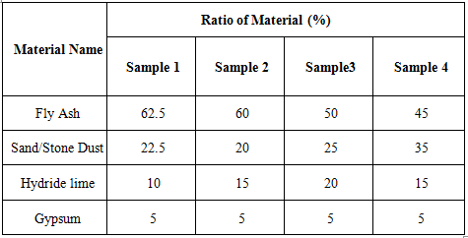

Table 3.2: Stresses in Fly Ash Composite Brick using Different Proportion of materials.
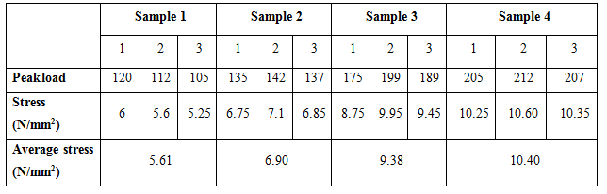
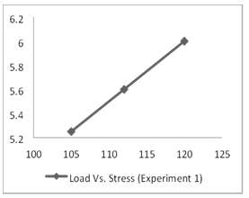  Fig 3.1:Sample 1: Load Vs Stress graph | 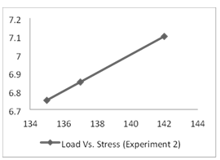  Fig 3.2: Sample 2:Load Vs Stress graph
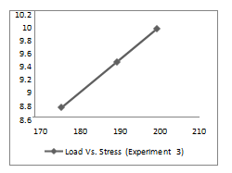  Fig 3.4 : Sample 3: Load Vs Stress graph | 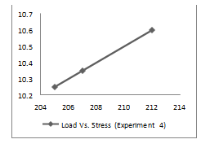  Fig 3.5: Sample 4: Load Vs Stress graph for

TEST FOR WATER ABSORPTION

Brick is subjected to a water absorption test in observe the quantity of moisture it can absorb in difficult circumstances. Dry brick samples are obtained and weighed for this test. The quantity of water absorption for a good-quality brick shouldn't be more than 20% of the brick's dry weight.

% Water Absorbed = [(Wt - Wo) / Wo] * 100 Where:
Wt = weight of the material after being immersed in water Wo = initial weight of the material before immersion in water For,
Sample 1 - [2100.19 – 2395.5/ 2395.5] * 100 =16.502%

Sample 2 - [1850 – 2006.1/ 2006.1] * 100 =7.78%

Sample 3 - [1500 – 1690.8/ 1690.8] * 100 =11.28%

Sample 4 - [1500 – 1681.7/ 1681.7] * 100 =10.80%

IV. COST ESTIMATION
Table 4.1: cost estimation
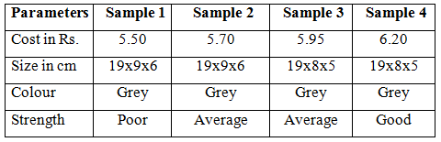

V. REFERENCES
- Ujjwal Bhattacharjee, Tara Chandra Kandpal “Potential of fly ash utilization in India” Energy 27, 2002, pp. 151-166
- Samir Mistry (2002); “Thesis report on study on compressive strength of fly ash bricks”, Sardar Patel university, V.V. Nagar
- Jayesh Pitroda (2010); paper on “A study of utilization aspect of fly ash in Indian contex” New Building Materials and Construction World October 2000, B.N. Agrawal, S.M. Kohl
- Er. Rinku Kumar, Er. Naveen Hooda, “An Experimental Study on Properties of Fly Ash Bricks”, International Journal of Research in Aeronautical And Mechanical Engineering, Vol.2 Issue.9, September 2014, Issn (Online): 2321-3051, (2014).
- Prabir Kumar Chaulia and Reeta Das, Process Parameter Optimization for Fly Ash Brick by Taguchi Method: Material Research; 2008.11. 159-164.
- Tahmina Banu, Md. Muktadir Billah, “Experimental studies on Fly Ash-Sand Lime Bricks with Gypsum Addition: American Journal of Materials Engineering and Technology, 2013, Vol. 1, no. 3, pp.35-40.
- Gupta P.C, Ray S. C.,” Commercialization of Fly ash”, The Indian Concrete Journal, 167, 1993, 554-560.
- Sengupta J., “Availability of Fly ash and its Application in Construction Industry,” NBO Journal, XXXIX, 1984, 17-22.
- Gupta, R.L., Bhagwan, Gautam, D.K., Garg, S.P., “A Press for Sand Lime Bricks Research and Industry”, 22(40), 1977, 246-249.

