Teaching Orientalism in an Undergraduate Classroom

By Dr. Sufiya Pathan
Associate Professor
Department of Languages
Presidency University
Bangalore

Edward Said’s classic text, Orientalism, first published in 1978, became a foundational text in the establishment of the field of post-colonial studies worldwide. Literary studies took on new questions and directions thanks to research triggered by Said. However, it is challenging to bring Said’s text into an undergraduate classroom in India, not least because, in most institutions, students are not familiar with the literary works or the scholarly figures that Said cites in order to build his case. In fact, typical courses in Literature in India do not include most of these texts even up to the post-graduate level.

In this essay, I would like to share how I have used one text that I have found very effective in demonstrating some of the central ideas presented in Orientalism. The text even allows us to move from simpler to more complex ideas presented in Said’s classic text, thereby allowing students to imbibe Said’s arguments in very concrete terms. Since the essay is meant to be a short primer, I will (a) focus only on an examination of the film 300 (2006, Dir. Snyder) in the background of Said’s seminal text, rather than adding a large body of reference material that may prove distracting and (b) draw attention only to key dimensions of Said’s argument that may be demonstrated through the film rather than providing an exhaustive account.

The film 300

When Zack Snyder’s film 300 first came out in 2006, huge protests erupted in Iran, with many condemning the film as “cultural warfare”. Yet, neither the protests in Iran nor the numerous articles pointing to its historical distortions, could dampen the enthusiasm of viewers. The film was a huge success. The film was a rendering of Frank Miller’s graphic novel 300, first published in 1998.

Both works revolve around the historical battle of Thermopylae between the Greeks and the Persian empire. Though there is some historical disagreement related to the battle and its details, this has not dented the majesty of the story, according to which, in 480 BC, the Greek forces, led by 300 Spartan soldiers and their King, Leonidas kept the humungous Persian onslaught at bay for a period of three days with their extraordinary courage and military strategy. While remaining forced to funnel only through a narrow pass in the mountains called the “hot gates”, the Persian numbers were rendered useless by Leonidas and his small army, which blocked every onslaught until they were betrayed and finally slaughtered.

This particular battle has an interesting history of representation. While a few Greek accounts are available, it seems like there was a rejuvenation in the interest towards this battle during the 18th century in Europe. The Enlightenment era in European history suddenly produced a plethora of artistic representations based on this moment in history. This raises some important questions about the context within which this battle gains significance, which we will return to later in this essay.

It is important to note that Greek traditions of representation focus on Leonidas, the Spartan King, and the Persian army. This was perhaps a consequence of the fact that Xerxes did not lead his forces into battle and therefore, was never encountered by the Greeks. However, it is only in Frank Miller (the author of the graphic novel 300) and subsequently the imagination of Zack Snyder (director of the film 300) that Xerxes, the Persian Emperor, takes on a significant role.

Orientalism

For ease of understanding, let us pick up three dimensions of Said’s characterisation of the phenomenon of orientalism. I place these dimensions in an order of ascending significance and complexity starting with what may be considered the most apparent and easy to apprehend, going on to the more complex, but also, the most important dimension of Said’s study. I will summarise them here only very briefly:
Firstly, Orientalism is a tradition of representation which has rather predictable consequences for the representation of the East. As Said says, that representation is most significantly “exotic”.
“The Orient was almost a European invention, and had been since antiquity a place of romance, exotic beings, haunting memories and landscapes, remarkable experiences.” (Said 1979 p.1)
Second, this representation follows a binary pattern whereby the West is determined as all the East is not and vice versa.
“[T]he Orient has helped to define Europe (or the West) as its contrasting image, idea, personality, experience…. Orientalism is a style of thought based upon an ontological and epistemological distinction made between ‘the Orient’ and (most of the time) ‘the Occident’” (p.1,2)
Thirdly, orientalism is a system of citation. Every work depicting or referring to the Orient, refers to preceding works for authority.
“Every writer on the Orient (and this is true even of Homer) assumes some Oriental precedent, some previous knowledge of the Orient, to which he refers and on which he relies. Additionally, each work on the Orient affiliates itself with other works, with audiences, with institutions, with the Orient itself. The ensemble of relationships between works, audiences, and some particular aspects of the Orient therefore constitutes an analyzable formation[…]whose presence in time, in discourse, in institutions (schools, libraries, foreign services) gives it strength and authority…. Orientalism is after all a system for citing works and authors.” (p.20, 23)

Let us take up each of these dimensions in relation to the film 300 to see what may be rendered visible through an analysis of the film.

- Exotic Representation

Much has been said about the exotic elements in the film. The Persian army is filled with creatures – some natural, some super-natural – all presented as “abnormal”, yet purportedly familiar to the East. The most obvious element is the use of monsters in Xerxes’ army, implying these are creatures you can actually find in the East. The commentary in the film describes that the “grotesque monsters” are drawn from the “darkest corners” of Xerxes’ empire.

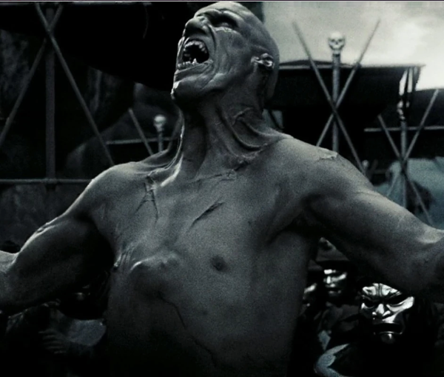

The “immortals”, Xerxes’ personal guard, are introduced as beings with “eyes as black as night, teeth sharpened into fangs”, “soulless” and of course, literally immortal. Interestingly, the personal guard was referred to as the “immortals” because they were a force of 10,000 soldiers and each one would be immediately replaced, thereby keeping the number constant, not because of any supernatural powers.

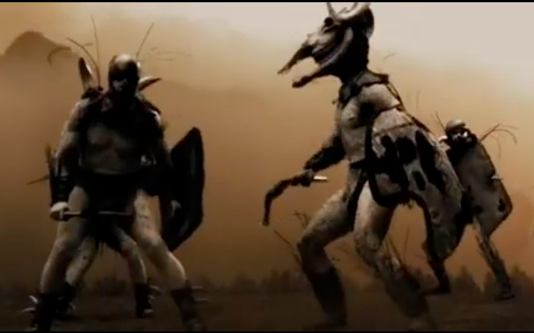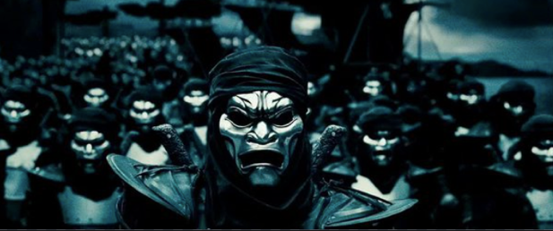
The immortals in 300

These monsters are introduced in the same vein as natural creatures like elephants and a rhinoceros used in the Persian army, both animals the Greeks were alien to. However, exaggeration in the size of the animals is used in order to render them unfamiliar. Interestingly, the exaggerated size of the elephant combined with its clumsiness is used as a metaphor for the Persian army as a whole. Another animal that is exaggerated in size is the wolf that Leonidas spears in his boyhood. This episode, which mirrors his final act of sending his spear soaring through to Xerxes, “making a God-King bleed”, drives home the conclusion that the East in the story is akin to a beastly rather than human threat.

An even more interesting element is that of the ‘Persian magicians’. In the film, the narrator states that when “muscle” fails, the Persians use “magic”. “Magic” involves hurling what look like primitive and rather ineffectual bombs at the Greeks. Thus, even scientific innovation is rendered “exotic” from this lens. While this may simply be considered in keeping with the perspective of the narrator, a 5th century Spartan soldier, it’s important to note that the film does not remain limited to the Greek lens throughout, as is made clear in the last section.

- The Binary between East and West

Perhaps the clearest means of drawing the binary between East and West is presented in the film through the figures of the Emperor Xerxes and the King Leonidas.

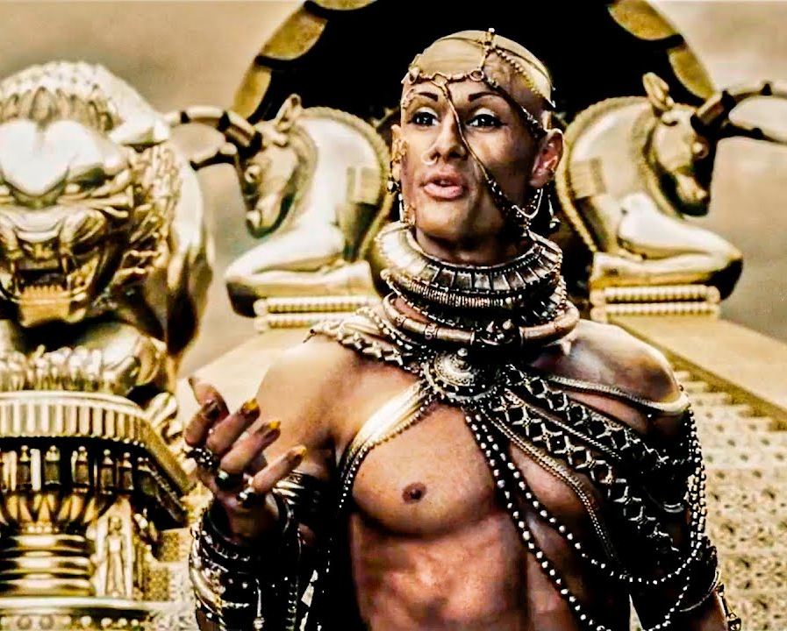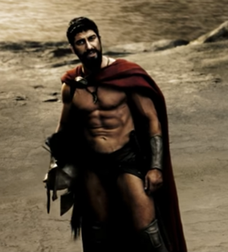
King Leonidas in 300

Emperor Xerxes in 300

The distinction drawn between the East and the West is neatly stacked along the distinction drawn between the Persian Emperor, Xerxes, and the Spartan King, Leonidas. These two figures become everything that separates East from West.

East - Emperor Xerxes | West - King Leonidas
Slavery | Freedom
Force | Strength
Corruption | Law
Depravity, disorder | Discipline, order
False God | Man, rationality

Xerxes’ army is one of slaves drawn from a “thousand nations”, men who consider Xerxes master and/or God. Xerxes’ claim to divinity is consistently underlined in the film, giving Leonidas’ final act of sending a spear soaring through the air, injuring Xerxes’ face and thereby “making a God-King bleed” the final challenge to Eastern falsity, upholding Western rationality. Interestingly, even though the Spartans were perhaps the largest slave owners amongst the Greeks, this dimension is completely erased in the film, thereby accentuating the significance of the contrast between slavery and freedom that the film attempts to draw.

As a corollary to this point, the film presents the discipline of the Spartan forces in contrast to the chaotic and clumsy functioning of the Persian army, suggesting that slaves are not capable of discipline. Perhaps this has something to do with the idea of the relationship to Law. Leonidas is shown as upholding the Law even when he disagrees with it and sees the corruption of it, as evidenced in his challenging neither the councilmen nor the priests.

In contrast, Xerxes’ eventual victory is based not on military superiority but on corruption. While Xerxes’ opulence and his easy use of bribes is highlighted throughout the film with the suggestion that Persian pay offs had reached the priests and the councilmen who opposed the Greeks going to war, the key moment highlighting Persian corruption is the seduction of Ephialtes. A deformed young man of Spartan origin, Ephialtes, who enables the Persian army to surround the Greeks through a relatively unknown mountain pass is not simply bought over but is overcome with the offer of unimaginable riches and pleasures in a scene that establishes every possible sexual “debauchery” in a veritable pageant of depravity in Xerxes’ royal tent. This, as Said himself has also highlighted, was a typical trope about the East – sexual depravity.

It is also significant that the film chooses to build the binary through the figure of Leonidas and not through a representation of the Greeks, since, there is a clear rejection of “false religion” amongst the Greeks as well through the depiction of the depraved priests at the temple of Delphi. It is Leonidas, in his rejection of the priests, who represents the Western spirit. Therefore, Leonidas’ heroism exalts this Western spirit as whole to heroic status.

- Orientalism as a system of citation

This brings us to the third dimension of Said’s characterisation of orientalism that the film helps us understand. It is this dimension that I suggest is the most significant. Said insisted that orientalism gains it credibility based on a system of citation that is strong and well-established. While his basic thrust may have been about scholarly work on the Orient, this stands true when it comes to fictional representations as well, especially visible in the film 300. In order to keep the analysis short, I will build only on the earlier points raised in relation to Leonidas.

What are the reference points for the depiction of Leonidas in the film? While there are at least two Greek statues of King Leonidas that still survive in contemporary Greece, one at Thermopylae and one at Sparta, these statues depict Leonidas alone, very much in the Greek tradition of the hero being raised to the status of a ‘god’. The film, however, emphasises at multiple points that Leonidas is not a god but a man whose greatness lies in the fact that he stands with his fellow men.

The key source for this turn in depiction is the painting ‘Leonidas at Thermopylae’ by Jacque Louis David (1814). The painting is considered a classic of the enlightenment period. Leonidas here is not simply a brave man, glorious and honourable. He is the man whose determined stand against a barbarian horde, protects Greece (depicted by the Greek columned structure in the background), and thereby protects the European future, framed many times over in the film and its artistic antecedents as the protection of “freedom against tyranny”.

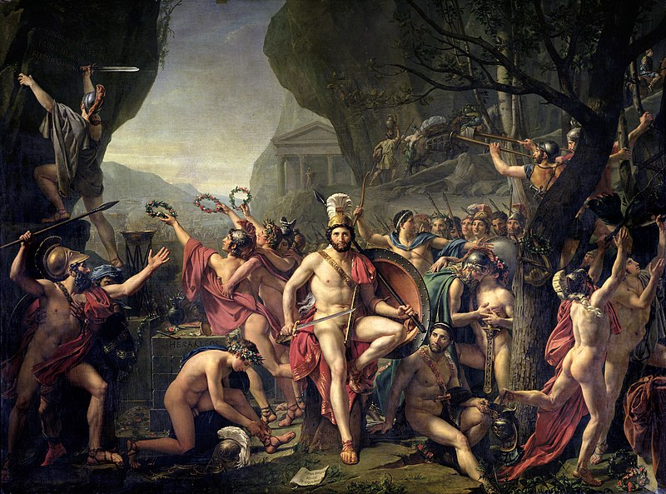

In the painting, History is inscribed for posterity to his left, honoured by laurels, while war trumpets are blown to his right. Leonidas stands unaffected looking with calm certainty at his significance to the future of the world. This European self-image is not simply a repetition of Greek self-conceptions. This is layered very clearly with the European self-conception of its role in World history. It is, after all, only in a post-democratic (in its specifically modern definition) world that Leonidas can be picked up as a warrior of freedom against tyranny. Only a Europe that saw democracy as its gift to the world against other political systems which were “tyrannical”, can tell this story as a story of freedom winning against tyranny. It is this enlightenment era European self-conception that is recreated and appropriated in the 20th and 21st century cinematic American re-tellings of the story.

A range of artistic representations of the battle of Thermopylae erupted in the 18th century. The painting above was a central contribution among many others that re-shaped this historical moment in the Western imagination.

Why focus on orientalism as a system of citations?

Edward Said emphasised that orientalism was a reflection and further perpetuation of political relations of dominance between West and East. It is clear that many in Iran, for one, did perceive the film in this way, which led to the protests. However, when we reduce the idea of orientalism to only a political standpoint, we stand to lose a much richer picture of how cultures infuse texts and what a study of those texts can actually help us understand about both history and culture.

When Said emphasised that the study of orientalism teaches us very little about the East but it does teach us about the West, this insight logically follows from his key insights numbered 2 and 3 in this essay. If orientalism is structured as a binary where the West is all the East is not, and it is based on a range of sources all knit together, then a study of these two dimensions allows us insights into Western culture and history through a study of orientalist texts.
Orientalism responded more to the culture that produced it than to its putative object, which was also produced by the West. Thus, the history of Orientalism has both an internal consistency and a highly articulated set of relationships to the dominant culture surrounding it. (p. 22)

A relatively futile approach, which has nonetheless been very popular, is taking the cinematic representation to analyse its historical accuracy. Several critics highlighted the historical distortions present in the film. However, such criticism is easily side-stepped with the defence that this is fiction, not history and therefore should not be held up to standards of historical scholarship. Secondly, it tends to render the sources for the film (and its antecedents) suspect and open to dismissal rather than serious examination. A serious examination of these sources provides not just an enriching set of visual sources but gives us an important clue about the cultural reconstruction and reimagination of the battle of Thermopylae. It is not accidental that the key visual sources are artistic representations from the Enlightenment period.

This insight opens several important questions for investigation. Why was it Enlightenment Europe that identified this historical occurrence as so significant? How was the significance given to the moment reconceptualised at this time? What functions was the artistic recreation serving? What elements were added or subtracted in order to bring this narrative in line with those functions?

All of these questions allow us to learn more about the West and understand the contexts within which key West-East narratives were built that structure how the West experiences the East till today. None of this can be achieved by banning films like 300 or lightly dismissing them as “orientalist”. To say something is orientalist should not be a means to dismiss a text but should rather convey that the text has a tradition of representation which ought to be investigated in order to understand it better.

References:

- Said, Edward. 1979 (first published 1978). Orientalism. First Vintage Books Edition. USA
- 300 directed by Zack Snyder. Performances by Gerard Butler, Rodrigo Santoro and Lena Headey. Warner Bros. 2006. [check how a movie is cited]
- Morris, Ian McGregror. 2000. ‘To Make a New Thermopylae’: Hellenism, Greek Liberation, and the Battle of Thermopylae. Greece and Rome. Vol 47., No.2 Oct 2000
- Ed. Bridges, Emma; Hall, Edith and Rhodes, P.J. 2007. Cultural Responses to the Persian Wars: Antiquity to the Third Millennium. OUP. NY.
- Dahl, Fredrik. March 13, 2007. “Iran calls Hollywood Blockbuster ‘Cultural Warfare’” Reuters.com: https://www.reuters.com/article/us-iran-film-300-idUSL13725820070313 (last viewed Aug 30, 2023)
- Mark, Joshua J. 2019. ‘Persian Immortals’. World History Encyclopedia. https://www.worldhistory.org/Persian_Immortals/ (last viewed Aug 30, 2023)

Dahl, Fredrik. March 13, 2007.
Key Greek sources: Simonides (5th century BC), Herodotus (1st century BC). It is Herodotus who became the most important source for the battle.
All images from the film 300 are screen grabs.
Mark, Joshua J. 2019
“In most cases, the Orient seemed to have offended sexual propriety” (Orientalism. 1979. p. 167)
A justification for this stand follows in the next section.
See Morris, Ian McGregor (2000) and Bridges, Hall and Rhodes (2007)

