**Futuristic Trends in Diabetic Foot Care**

**1. Introduction:** Diabetic foot complications, including ulcers, infection, and Charcot arthropathy, are influenced by various risk risk factors including peripheral neuropathy, peripheral vascular disease, compromised immune function, and delayed bone healing. Despite advancements in medical and surgical techniques, the foot remains a significant public health issue and a leading cause of hospitalization. Current management comprises of various prevention and treatment options, with this review providing an overview of advancements in diagnostics and therapeutics including techniques in diabetic foot management.

**2. Diagnostics:** Predicting diabetic foot conditions before they manifest clinically is crucial to preventing debilitating complications and improving patient outcomes. Over recent years, a blend of technology, data analytics, and clinical research has led to multiple innovations in early predicting and detecting diabetic foot complications.

***2.1. Wearable sensor technology:*** Devices, such as intelligent insoles equipped with micro-sensors, are developed to detect subtle changes in foot temperature, pressure, and moisture levels. These parameters can help identify inflammation or potential ulcer formation early.

**2.1.1. Temperature monitoring: The Orpyx SI®:** The Sensory Insole system includes temperature sensors built into the insole, which are then inserted into the wearer's shoes for use during daily activities. The sensors track temperature on the foot surface at a frequency of one measurement per minute. The testing of the assembled device has shown to be accurate within ±0.6 °C when compared to a reference standard. The sensor data is stored on board and transmitted wirelessly to a HIPAA-compliant server. The daily average difference is calculated from all measurements for that day and comparisons are made for both sides of the foot.

**Siren socks:** The Siren Socks have sensors in the fabric to measure temperature on the foot. The sensors track temperature at multiple points on the foot. The sensors have been tested for accuracy. The embedded sensors in socks were also evaluated for accuracy. A tag on the sock that holds temperature information is connected to the sensors. The sensors attach to a tiny tag on the sock that has a Bluetooth chip, microprocessor, battery, and storage for temperature data. Through a wireless cellular data hub that is connected to the Bluetooth chip on the sock, data is transmitted to the cloud. Both the patient-facing mobile device and the physician-facing web portal receive data. At six corresponding places, temperature differences are measured, and the average difference is computed. A warning is sent to the clinical personnel when a specified threshold is exceeded.

**The Podimetric SmartMat**™ is a wireless floor mat with sensors. It records the temperature of both feet. The device is accurate and the data is securely transmitted. Six areas are examined for temperature asymmetry: the hallux, first, third, and fifth metatarsal heads, the midfoot, and the heel.

**2.1.2. Pressure monitoring:** The Orpyx SI® Sensory Insole system contains force-sensitive resistors (FSRs) embedded in each insole. These resistors are calibrated to detect pressures that can cause tissue ischemia. At a threshold selected based on estimations of capillary perfusion pressure, they function as a switch. If 95% of sensor pressure readings exceed the threshold over a 15 min sliding window, the sensor is marked as being in a “high-pressure state”. Each insole is divided into six anatomical regions ( heel, midfoot, medial metatarsal, lateral metatarsal, medial toe, and lateral toe region) to simplify pressure data interpretation. The Orpyx SI® system has two paths for feedback: one for the patient and one for the clinician. For the clinician, a warning is generated if any combination of regions is in a high-pressure state for more than 40% of the day. For the patient, real-time cues are provided through an app-based display when a sensor region is in a high-pressure state. Patients are cued no more than once per hour to balance engagement and alert fatigue.

***2.2. Artificial Intelligence and Machine Learning:*** With the integration of AI and ML, vast amounts of patient data, including imaging, pressure readings, blood parameters, and medical histories, can be analyzed to predict the risk of ulceration, infection, or other complications. These predictive models refine themselves over time, improving accuracy and precision. Algorithms are being developed using large datasets of foot clinic images. A number of stages are involved in the development of computer aided diagnostics algorithms forFUD. The stages shall include preconditioning, features extraction, detection, classification and DFU segmentation of wounds.

AI model being developed by acquisition of multimodal data (2D RGB images, Lidor based 3D shape models, Color Correction, Pixel Segmentation) and clinical text notes, shall be able to characterize, determine the area and volume, identify &, grade the wound and suggest evidence-based management protocols, and predict heal ability. In recent years, "time" has been added to 3D bio printing as the fourth dimension, creating the term "4D bio printing," where printed items (such biocompatible responsive materials or cells) can change their shapes or functionalities over time in response to an external stimuli [5]. The uses of 4D bio printing in numerous biomedical sectors, including tissue engineering and medication delivery, have expanded as a result of this development.

**2.3. *Advanced Imaging Techniques:*** Beyond traditional methods like MRI or X-ray, newer imaging technologies, such as optical coherence tomography (OCT) and hyperspectral imaging, can provide detailed insights into tissue health, vascular integrity, and early signs of neuropathy. More recently, radiolabelled white blood cell (WBC) scintigraphy and positron emission tomography with 18 F-fluorodeoxyglucose (FDG-PET) are being researched for DFIs, and a recent meta-analysis showed that both techniques can offer high specificity to detect osteomyelitis in the diabetic foot. Aside from that, hybrid imaging methods including single photon emission CT/CT (SPECT/CT), FDG-PET/CT, and FDG-PET/MRI have been thought of as possible tools to enhance the specificity and accuracy of anatomical localization in the assessment of diabetic foot osteomyelitis [3].

**Podiascan®:** The footscan system Podiascan® system provides podiatrist and biomechanists with an economical and efficient method to measure static / dynamic plantar foot pressure distribution. The foot scanner system Podiascan produces instantaneous and permanent high resolution image(foot scan) of the pressure distribution across the plantar surface.

***2.4. Genetic and Molecular Markers:*** Research into understanding the genetic predisposition and molecular processes leading to diabetic foot complications is increasing. Identifying specific genetic markers or molecular signals can provide insights into a patient's risk profile. Numerous research has examined genetic risk and protective variables for DPN in T2DM, showing a potential link with specific polymorphisms in genes such as ACE, AKR1B1, ADRA2B, APOE, GPx-1, IL-4, IL-10, IFN-, MTHFR, NOS1AP, NOS3, TLR4, UCP2, and VEGF. Variants in mitochondrial genes have also been associated to T2DM, and polymorphisms in ATPase 8, ND1, ND5, and MT-CYB were recently shown to affect DPN based on single individual research. Additional potential genes have been postulated based on their role in the regulation of DPN in type 1 diabetes (T1DM).

***2.5. Skin Biome Analysis:*** The foot's skin microbiome plays a role in its health. Advanced sequencing techniques can now offer a comprehensive profile of the microbial environment of the foot, helping clinicians predict the risk of infections or ulcerations based on microbial imbalances. Novel diagnostic approaches, such as the 16S-ribosomal DNA sequence in bacteria, can help researchers better understand the microbiota implicated in DFU. This could be accomplished by utilising new biological and molecular treatments that have been demonstrated to aid in the prevention of infections, management of local inflammation, and improvement of the healing process. During illness progression, changes in the composition of the microbiome are seen. While it is well recognised that microorganisms can exacerbate wound infection, resulting in a non-healing wound, it is also crucial to note that the skin microbiome is an important component of the skin and influences skin health. More study will help us comprehend non-healing wounds and other diabetes-related skin disorders.

**2.6*.******Thermographic cameras:*** Using infrared technology, these cameras detect temperature variations across the foot. A hotspot could be an early sign of inflammation or an impending ulcer, even before visible signs appear. High throughput screening enables earlier interventions in a patient population that already has late-stage problems, considerable morbidity, and mortality risk. Thermography holds a lot of promise as an adjunct technology in diabetic foot examination. Elevated temperature, for example, is a reliable indicator of inflammation and can thus predict the risk of ulceration, infection, and amputation. Similarly, a drop in temperature may suggest ischemia due to insufficient blood supply.

***2.7. Blood flow and vascular health monitoring:*** Portable Doppler devices non wired ABI/TBI assessment, Skin Perfusion tests, and Trans-Cutaneous Oxygen Pressure and other technologies that assess blood flow in real-time can predict issues like ischemia, allowing for early interventions.

**2.7.1. Hyperspectral imaging**: An emerging technique for measuring tissue oxygen saturation and, thus, for early microvascular disease diagnosis in diabetic feet is hyperspectral imaging. It was suggested that this method, with a sensitivity of 95% and a specificity of 80%, may detect ischemia changes and their inflammatory consequences. The skin perfusion pressure-testing device is a brand-new portable tool used in routine clinical practise to detect microvascular disease and assess the ability of DFUs to heal. Both hyperspectral imaging and skin perfusion pressure are expected to aid early detection of peripheral artery disease in diabetics.

***2.8. Neuropathy detection devices:*** Newer devices and techniques can quantify the extent of neuropathy more accurately. For instance, tools measuring sudomotor function or Hot and Cold Perception tests, and vibration perception thresholds can offer insights into nerve health and predict associated complications.

**2.8.1. VibraTip:** VibraTip is a small device that produces a silent vibration similar to a tuning fork. It is used to assess diabetic patients' vibration perception. The VibraTip probe is applied on the patient's foot twice: once without and once with vibration. When the patient feels the vibration, they are asked to indicate it. If the vibration is not noticed, it may indicate diabetic peripheral neuropathy, and further testing may be required. VibraTip is an alternative or substitute for current NHS clinical practice equipment used to assess foot sensory function, such as the 10 g monofilament and the calibrated tuning fork or biothesiometer. In comparison to the varied vibration and cold touch of the tuning fork, the device provides uniform application and continuous operation across its battery life compared to the 10 g monofilament.

**2.8.2. NEURO TOUCH®:** NEURO TOUCH® is a point of care, battery-powered multi-parameter diagnostic device that enables physicians to screen for symptoms of DPN (Fig.). It combines the functions of five different neuropathy screening devices ( digital monofilament, infrared skin thermometer, hot perception test ambient, cold perception test ambient, and vibration perception test ambient) into one hand-held and portable tool and can be used in any healthcare setting. Since the test data is securely stored on the cloud and can be retrieved anytime, anywhere, it helps in continuous tracking of the patient's condition.

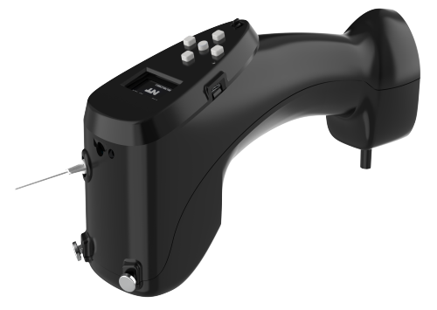

Fig.: NEUROTOUCH multi parameter diagnostic device.

**2.8.3. SUDOSCAN®:** SUDOSCAN® is a non-invasive test that gives an accurate assessment of sweat gland function, which reflects the state of the autonomic nervous system. The technology detects early and follow-up peripheral neuropathy, allowing physicians to monitor disease pogression and analyse treatment efficacy for better patient management. Its efficacy in the assessment of small fibre neuropathies in many diseases has been investigated and compared to reference tests specified in guidelines.

**2.8.4.In-shoe scanner:** A wireless in-shoe pressure measurement system is the XSENSOR Insole system. With 230 capacitive sensels and a standard sampling rate of 75 Hz, insoles can supposedly record pressures from 5-883 kPa with an accuracy of 5% of the full-scale calibration. It provides accurate and repeatable data for plantar pressure and gait evaluation.

**2.9. *Mobile health applications:*** Several smartphone apps are equipped with algorithms that help patients assess their foot health. These apps can use camera images, patient-inputted data, and other metrics to assess and predict foot health, sending alerts if potential issues are detected.

**2.9.1. FootSnap**: With the use of a tripod and a transportable LED floodlight, FootSnap takes consistent pictures of the underside of a person's feet, including the feet of diabetics, anywhere and at any time. FootSnap instructs medical practitioners on how to position and align the patient's foot to create a collection of uniform photos for comparison. The app should be accessible for download in the near future, and its creators anticipate that further development will allow for use on smartphones and other devices as well as by less experienced operators.

**3. Treatment/Therapy: 3.1**.**VELOX® Care:** It is a portable device with increased oxygen profusion at the wound site. Due to the increased temperature of 37-42°C, the average speed and kinetic energy of oxygen molecules increases. As a result, the oxygenation of the wound crevices is improved, stimulating fibroblast differentiation and proliferation as well as collagen synthesis and cross-linking. As a result, leucocyte microbial killing is stimulated, increasing neovascularization. Use of VELOX® therapy has recorded wound healing rate of 0.2410 cm2/day as compared to the healing rates of 0.1583 and 0.0252 cm2/day for hyperbaric and topical oxygen therapy.

Fig. : Velox Topical warm oxygen therapy

**3.2. Natrox® Oxygen wound therapy**: Natrox® Oxygen wound therapy is simple mobile device which is designed to deliver pure humidified topical oxygen continuously to the wound bed. It is intended for use on complex, slow-healing or non - healing wounds. This therapy is considered when there are clinical signs that the wound is hypoxic and has failed to respond to standard care. It requires minimum debridement and has reported 71% greater healing rates as compared to SOC alone.

**3.3. Topical wound oxygen therapy ( TWO2®):** A multi-modal therapy called Topical Wound Oxygen (TWO2®) therapy is used to treat chronic, difficult-to-heal wounds. TWO2 is available with a multi-patch system that can be used anywhere on the body or an extremities chamber that can be applied to the legs and arms. Greater tissue diffusion caused by higher oxygen supply pressure is essential for resuming normal wound metabolism, which promotes faster and more long-lasting healing. These items are clinically tested, FDA-approved, and simple to use at home or in any Clinical/therapeutic setting. Evidence studies have reported 88% reduction in the hospitalization rates and 71% reduction in amputations in patients utilizing this therapy. 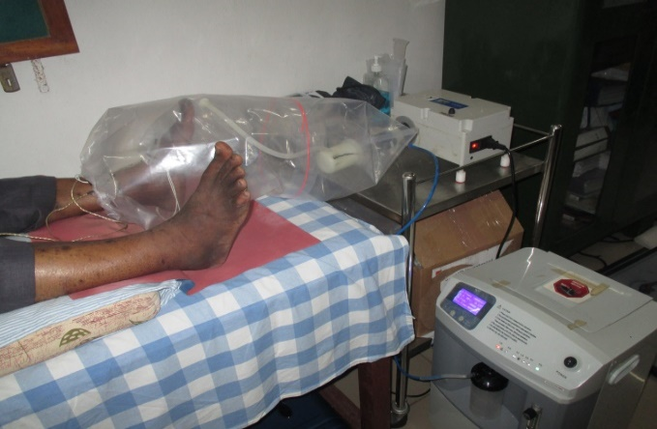

**3.4.** **Ozone (O3) therapy:** A stream of ozonized fluids is generated under a high pressure using an "OZh-2" apparatus . The wound is cleansed rapidly, reducing infection and treatment time. Hyperbaric oxygen therapy enhances wound healing, according to one study. O3 in the wound region functions as an antibacterial agent, hastening wound healing. Additionally, O3 leads to platelets aggregating and the release of growth factors that accelerates wound healing. O3 applied to DFUs eliminates pathogens and promotes fibroblast proliferation, aiding in the healing process.

**3.5 Laser:** Diabetic peripheral neuropathy and Diabetic foot ulcers are common complications in individuals with Type 2 diabetes mellitus. LLLT works by inducing a biochemical reaction in the cell known as photo biomodulation or bio-stimulation. One study found that LLLT is effective in reducing pain in T2DM with peripheral neuropathy. The possible reason for the reduction in pain could be due to increased microcirculation to the periphery. LLLT can speed up the healing of persistent diabetic foot ulcers, reducing the time needed for full recovery.

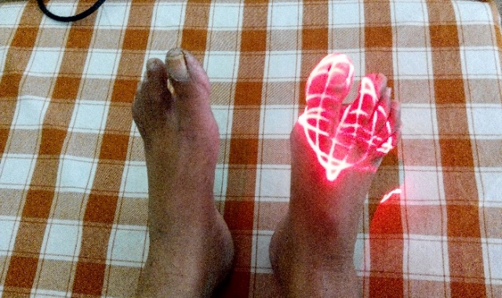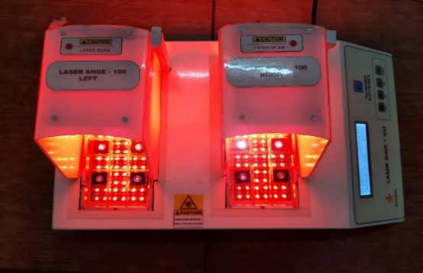

**3.6. Electrical Stimulation:** Electrical stimulation involves sending electrical impulses to the nerves and muscles through the skin to induce muscle contraction. Studies have reported improvements in cutaneous circulation and vascular endothelial growth factor (VEGF) with the use of electrical stimulation. VEGF is an angiogenic factor that helps to promote angiogenesis and improve microcirculation affected due to neuropathy. Studies have also shown that electrical stimulation increases beta endorphin, met-enkephalin, nerve growth factor expression and reduces inflammatory markers. Electrical stimulation thereby helps in reducing the symptoms associated with diabetic neuropathy and improves nerve function. In addition, electrical stimulation can enhance wound healing by promoting cellular activities, improving tissue perfusion and angiogenesis. It enables clinicians to transmit exogenous electrical signals into wound tissue, simulating the underlying natural bioelectrical response to damage. Electrical stimulation may be a non-invasive, cost-effective alternative and adjunctive therapy to current treatments for diabetic peripheral neuropathy and diabetic foot ulcer.

**3.7 Matrix rhythm therapy (MRT):** Matrix rhythm therapy (MRT) is a therapeutic device, works on the principle of “rhythmic oscillations” of body cells. This method is postulated to be effective in diabetic neuropathy and diabetic foot ulcers as it speeds up structural and functional nerve regeneration and relaxes muscle fibres. Due to diabetic pathology, the normal oscillatory rhythm of the cells slows down, and the affected area becomes deficient to blood supply. MRT is proven to improve the blood circulation up to 35%, providing pumping action that aids in transportation of nutrition, waste compounds, and defence substances. The target of MRT is to revive and synchronize the body’s corresponding processes at the cellular unit level, which is surrounded by extracellular matrix. Thus, MRT reduces neuropathic pain and accelerates wound heali-ng by improving microcirculation and triggering the metabolism. The vibration frequency of 8-12 Hz of MRT restores the extracellular matrix normalcy, allowing disrupted extracellular and cellular processes to resume, resulting in self-healing.

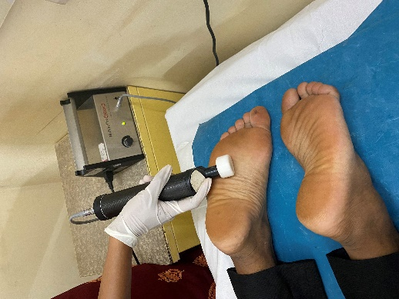

**3.8 Extra corporal Shock Wavetherapy (ESWT):** With a peak pressure that is around 1,000 times greater than ultrasound therapy, Extra corporal Shock Wavetherapy (ESWT) is a type of mechanotherapy. The transitory pressure fluctuation known as a shockwave is produced by electromagnetic, electrohydraulic, or piezoelectric devices. As an effective and safe treatment, ESWT is widely used to successfully to treat Diabetic peripheral Neuropathy, soft tissue wounds, diabetic and non-diabetic skin ulcers, and skin flaps to increase survival. The use of extracorporeal shockwave therapy (ESWT) to shield nerves from the onset of Diabetic Peripheral Neuropathy has also been documented. According to a study by Seabaugh, ESWT promoted the release of growth factors from platelets and had positive effects. Improved vascularization, the local release of growth hormones, and local anti-inflammatory effects are a few of the biological consequences of ESWT. There is evidence that ESWT encourages axonal regrowth. It has been suggested that extracorporeal shock wave therapy (ESWT) may also promote ulcer healing. The possible explanation for the ulcer healing could be tissue oxygenation. The ESWT technique for Diabetic wounds usually includes 100 impulses per 1 cm2 of the wound surface, each with a energy level around 0.037 mJ/mm2.

**3.9. Off-loading devices:** In order to promote wound healing and prevent ulcer recurrence, the major method of treating diabetic foot ulcers (DFUs) entails restricting weight-bearing activities. This lowers the risk of amputation a foot. Off-loading techniques include whole contact casts, detachable cast walkers, therapeutic shoes, foot orthoses, custom shoes, custom braces, padding, and strapping therapy in current orthopaedic practice. Total contact casts are crucial as the go-to off-loading treatment, as they make it easier for patients to follow the recommended off-loading schedule, according to recent studies. There are both removable and non-removal off-loading options available:

**3.9.1. Removable off-loading devices: Self off-loading footwear:** The therapeutic footwear that dynamically self-offloads act mechanically without the need of sensors or actuators. It accomplishes this by offloading the high-pressure region utilizing snapping arches that enter a negative-stiffness regime when a load higher than a custom setting is applied. The arches function as sensors and actuators actuated by the person's body weight, returning to their original shape when the load is removed. The footwear is made to fit the individual's body weight, gait speed, and foot size after computing the switching load and switchback time of these arches. Based on detected high-pressure zones from clinical data, the arches are positioned to dynamically unload high-pressure regions and shift pressure to other places. ( Fig.1 and 2.)

**Figure1**.: Choice of Self off-loading footwear according to different pressure points of different gait phases.

Fig.2:

**Removable (cast) boot/walker**: Premade, detachable knee-high boot with a rocker or roller outsole, padded interior, and an inserted, moveable, and maybe entire contact insole. ( e.g.-Scotchcast Softcast™, Ransart boot EvenUP™, Procare® ShoeLift™, ).

**Rocker bottom shoe**: Rigid-soled shoe featuring a transitional shift in the outsole design. In the late support phase, the shoe rocks forward to allow for walking without extending the metatarsal-phalangeal joints.

**Roller shoe** : Rigid-soled shoe is similar to rocker shoe, but with a contoured outsole for a more comfortable transition when walking.

**Scotch-cast boot** : An ankle cut-a-way removable well-padded cast. If necessary, windows are chopped to cover the sores. A fiberglass removable heel cover is inserted for severe heel ulcers. To improve patient mobility, the boot is worn with a cast sandal.

**Shoe modification**: A shoe that has been altered to have a therapeutic function, like pressure relief. (Darco Med-Surg™, PegAssist™).

**Standard therapeutic shoe**: Therapeutic shoe that is prefabricated and not individually customized for each patient’s foot.

**Temporary shoe**: Foot ulcer treatment using a temporary prefabricated shoe.

**Therapeutic shoe**: Generic term for footwear designed to allow some form of treatment to beapplied to the foot that cannot be applied by or in a conventional shoe. Extra-depth shoes,

custom-made shoes, and so on are all examples of therapeutic shoes .

**Toe orthosis**: An in-shoe orthosis to achieve some alteration in the function of the toe.

**Total contact cast:** A well-moulded, minimally padded, knee-high non-removable fiberglass or

plaster cast that maintains total contact with the entire plantar surface and lower leg. The cast is

often worn with an attachable sole to facilitate walking.

**SmartBoot:** This is the first smart offloading system developed by Kek School of Medicine (USC) that enables real-time adherence reporting, remote patient monitoring, and activity reporting. SmartBoot improved balancing abilities, probably as a result of somatosensory feedback. The findings of the survey show the technical and medical potential of SmartBoot. Future research is necessary to confirm the clinical effectiveness of real-time non-adherence alerts for persons with diabetic foot ulcers.

**3.9.2.** **Non-removable off-loading devices**

**Knee-high non-removable total contact cast (TCC)-** Severe foot and ankle deformities where fit into a controlled ankle movement (CAM) boot is questionable or impossible (i.e. Charcot deformity of the midfoot and ankle).

**Soft casting:** also known as “football dressing” soft casting consists of many layers of cast padding applied to the foot, followed by a layer of self – adherent wrap( such as Coban) and a layer of gauze bandage roll ( such as Kerlix).

**Walking boot**: Knee-high removable cast walker (RCW) rendered non-removable (instant TCC or iTCC)

**3.10. Advanced wound dressings:** The main aspects of treating diabetic foot care involve removing dead tissue and using modern wound dressings to create a moist environment. Advanced wound dressings, made from biocompatible materials, are now the preferred treatment for chronic wounds. These dressings are capable of creating as well as maintaining a moist atmosphere. Hydrogels, hydrocolloids, alginates, semi-permeable, silver, and biological dressings are the most often utilized forms of dressings, which come in the form of gels, thin films or foam sheets. Recently, new wound dressings that release therapeutic agents such as drugs, growth factors (GFs), and peptides,have become popular. Researchers are creating more advanced dressings that include collagen and other bioactive substances. These dressings can reduce inflammation and promote tissue formation.

**3.10.1. DERRIM bio-patch:** DERRIM bio-patch is an innovative AI enabled 4D bioprinting based regenerative technology. It produces a bioactive matrix MA-ECM in a controlled, clean-chamber environment. DERRIM platform delivers effective & customized regenerative therapyfor the treatment of chronic and non-healing diabetic foot ulcer using autologous adipose tissue. This ensures the safest and most optimal topical application of customized autologous adipose patch on the wound site of the patient. Preparation of a bio-patch is a multistage process consisting of debridement, creating 3D model of the wound site, liposuction, preparing bioink using DERRIM kit, preparing hyper-personalized analogous MA-ECM bio-patch using 3D printer and finally applying the bio-patch on to the wound site and finishing with appropriate dressing.

**  **

**Week 0 Week 2 Week 5**

**Fig.** An ulcer in the plantar aspect of the left foot at the 1st MPJ. Debridement was done, dressing done as per FS protocol, front offloading footwear provided . Dermal patch applied.

**3.11. Modern surgical treatment options directed towards limb saving:** Several studies have investigated the efficacy and safety of unilateral Tibial cortex transverse transport ( TTT) on bilateral diabetic foot ulcers. The results showed that TTT effectively alleviates the pain of diabetic foot ulcer patients, promotes wound healing, and improves ankle-brachial index and peripheral nerve recovery.

Integrated surgical treatment of diabetic foot wound can achieve satisfactory clinical results. which combines tibial transverse transport (TTT) technique with debridement, induced membrane technique, vacuum sealing drainage (VSD) technique and skin grafting technique. The time of wound healing, the skin temperature at midpoint of dorsum of affected foot (T), visual analogue scale (VAS) score and ankle-brachial index (ABI) are measured before and after surgery.

**Conclusion:** Despite commendable efforts in recent years to diagnose and treat the diabetic foot, it continues to be a serious public health concern. Thus, In order to decrease the burden of the diabetic foot, primary prevention is essential, and additional diabetes- specific educational programs are required . While medical and surgical advancements have been made, further research is needed to determine the best treatment approaches for clinical practice. Hopefully, future efforts will enhance our understanding of the pathogenesis of the diabetic foot and allow for the more effective use of newer technologies in diabetic foot care.

**Acknowledgement**: Acknowledging the contribution of Centre for Podiatry & Diabetic Foot Care & Research, Manipal Academy of Higher Education (MAHE Deemed to be University & Institution of Eminence, Manipal, India

Ref: