Therapeutic advancement in floating drug delivery systems
Anshu*, Iram Jahan, Shamim, Rustam ekbbal
IIMT College of Medical Sciences, IIMT University, O Pocket, Ganga Nagar, Meerut, Uttar Pradesh 250001.
Abstract
Floating drug delivery systems (FDDS) have emerged as a promising therapeutic advancement in the field of pharmaceutical research. These systems are designed to improve drug efficacy, bioavailability, and patient compliance by maintaining sustained drug release and targeted drug delivery within the gastrointestinal tract. This abstract highlight the recent therapeutic advancements achieved through the development and utilization of floating drug delivery systems. The utilization of FDDS addresses challenges associated with conventional drug delivery systems, such as poor solubility, limited absorption, and variable gastric emptying rates. By incorporating buoyant materials or effervescent agents, these systems facilitate the prolonged residence of drugs in the stomach, leading to enhanced drug absorption and therapeutic effects. Advancements in the formulation of FDDS have enabled personalized medicine by tailoring drug release profiles to individual patient requirements, optimizing therapeutic outcomes. Furthermore, the introduction of advanced techniques such as 3D printing and nanotechnology has revolutionized the manufacturing of FDDS, allowing for precise control over drug release kinetics and stability. In recent years, researchers have focused on the development of multifunctional FDDS capable of carrying multiple drugs simultaneously, promoting combinational therapy for complex diseases. Additionally, efforts have been made to incorporate stimuli-responsive elements that trigger drug release in response to specific physiological cues, further enhancing the system's targeted delivery capability. Therapeutic advancement in FDDS has also contributed significantly to the treatment of various chronic conditions, such as diabetes, cardiovascular disorders, and neurodegenerative diseases. The sustained drug release achieved through these systems ensures prolonged therapeutic effect, reducing the frequency of drug administration and improving patient compliance. This abstract discusses the promising therapeutic advancements offered by floating drug delivery systems, emphasizing their potential to revolutionize drug delivery and enhance patient outcomes. The continuous progress in FDDS research, combined with innovative formulation techniques, is expected to play a pivotal role in the future of pharmaceutical therapy, ultimately leading to improved patient care and better disease management.
Keywords: Floating drug delivery systems, Therapeutic advancement, Gastrointestinal drug delivery, Sustained drug release, Targeted drug delivery, Personalized medicine, Nanotechnology in drug delivery, Combinational therapy, Patient compliance
Introduction
Low-density systems called FDDS or Hydro-dynamically balanced systems (HBS) have a strong enough inclination to float above the contents of the stomach and stay there for a long time. It prolongs the duration of gastro-retention and lessens fluctuation while floating over the stomach contents. The mechanism of the FDDS, Using a gastro-retentive drug delivery system, a medication's pharmacokinetic release rate to a particular location is controlled to provide its pharmacological effect. (Farooq et al., 2020)
Basic gastrointestinal tract physiology: The fundus, body, and antrum (pylorus) are the three anatomical divisions of the stomach. The fundus' proximal section is the third division. (Ogobuiro et al., 2021)
Body: acts as a holding space for unprocessed materials.
Pylorus: In addition to serving as a place for mixing ingredients, the pylorus also serves as a pump for stomach emptying.
Stomach physiology: According to the physiology of the stomach: The stomach is a larger portion of the digestive system that is between the small intestine and the esophagus. Rugae are small, distinct folds that are formed by the uplift of the mucosa and submucosa. When the stomach is empty due to contraction. The four main categories of the stomach's surface-covering secretory epithelial cells, which also extend into the pits and glands of the stomach, are listed below.
- Mucous cells: release an alkaline liquid.
- Parietal cells release hydrochloric acid.
- Chief cells: Pepsin, a proteolytic enzyme, is secreted.
- Gastrin, a hormone, is released by G cells.
Gastric empty rate: Both when you are eaten and when you are fasting, your stomach empties. A sequence of electrical events that occur between meals occur during the fasting period. Occur every two to three hours in the stomach and intestines.(Goyal et al., 2019) The process is known as the myoelectric migratory cycle (MMC), further, which broken down into 4 steps.
1. Phase I (Basal phase): Usually without contractions, it lasts between 40 and 60 minutes.
2. Periodic action potentials and contractions characterise phase II (preburst phase) that continue for 40 to 60 minutes.
3. Phase III (burst phase): contains strong, frequent contractions for a brief time throughout the 4 to 6 minutes it lasts.
4. Between stages III and I is phase IV of two successive cycles and lasts 0 to 5 minutes.
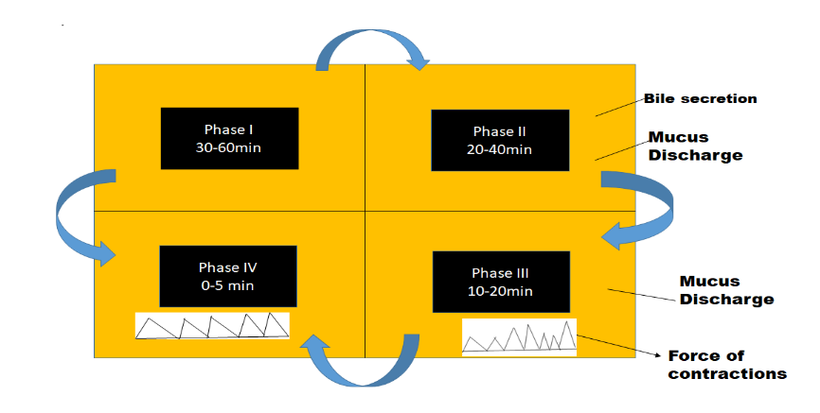
Figure 1: GIT's pattern of movement
Factors Affecting a Dosage Form's Gastric Retention Time:
- The type of food.
- Fed or unfed status
- Age
- feeding frequency
- concurrent medication administration
- Density
- Size and Shape
- Caloric Levels
- Gender
- Posture
CLASSIFICATION:
A. Effervescent FDDS
1. A gas-powered generator
2. A system containing volatile fluids
B. Non-Effervescent FDDS
- Colloidal gel barrier method.
- Tablets with two layers that float
- A system of microporous compartments
- Alginate beads and floating beads
- Hollow microspheres and micro balloons
C. Raft forming system
A bubbling FDDS
A floating chamber is used in this technique, and it can be filled with air, water, vacuum, or inert gas. CO2 can be added to the floating chamber as a result of an effervescent interaction between the organic acid (citric acid) and the carbonate/bicarbonate salts. A matrix made of commercially available polymers, such as polysaccharides that resemble chitosan, effervescent substances like citric acid, sodium bicarbonate, and tartaric acid, or chambers may be used in such a system. filled a liquid that becomes gaseous at body temperature are employed..(“An Overview on Gastro Retentive Floating Microspheres,” 2019)
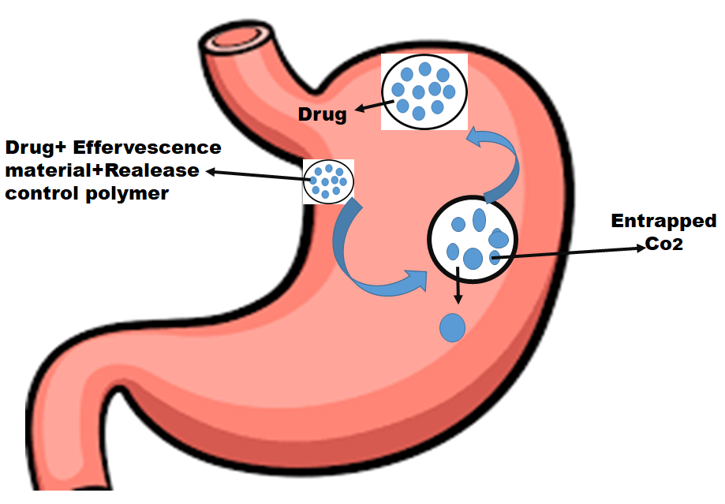
Figure 2: GRDDS based on effervescence
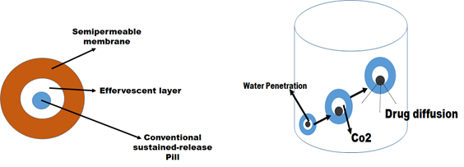
Figure 4: oral medication delivery system with many units
Gas generating system: This floaty delivery mechanism produces CO2 by the effervescence interaction comparing carbonate and bicarbonate to citric/tartaric acid ions. This further lowers the system's It floats above the chime because to its low specific gravity.
Storage system for volatile liquids: Systematic storage for volatile liquids: These have an expandable chamber that is filled with a liquid, such cyclopentane or Ether, which, when heated to body temperature, gasifies and causes the stomach chamber to expand. The device consists of two chambers: the first chamber holds the drug, while the second chamber holds the volatile liquid.
The GI tract's non-effervescent FDDS works through bio- or polymer-induced swelling of the mucosal layer. Non-effervescent FDDS most frequently contains the following excipients: the hydrophilic gums,
- Gel-like or extremely expandable hydrocolloids of the cellulose type
- Polysaccharides; matrix-forming substances including polycarbonate, polymethacrylate, and polystyrene; and bioadhesive polymers like carbopol and chitosan.

Barriers made of single-layer floating tablets and colloidal gel: one or more cellulose-based hydrocolloids that produce gels, polysaccharides, and matrix -forming polymers, all of which are extremely swellable, are present in high concentrations in Barriers made of colloidal gel and single-layer floating tablets.

Bi-layer floating tablets: Two layers make up a bi-layer tablet. The immediate release layer is the first layer, releasing the system's first dose. The sustained release layer, on the other hand, absorbs stomach contents, creating an impenetrable retaining a bulk density of less than 1 while keeping a colloidal gel barrier on its surface.

Micro porous compartment systems: A drug storage is enclosed within a permeable compartment that has perforations top and bottom of it sides to implement this technique.

Multi-particulate system: Floating beads / Alginate beads: Floating beads and alginate beads are both part of a multi-particulate system. Oral dose forms with several tiny discrete units are frequently used in multi-particulate drug delivery systems.

Micro balloons/Hollow microspheres: When submerged in aqueous solutions, hollow microspheres—also known as mini balloons—were shown to float for 12 hours in vitro.
Raft Forming System:
In most cases, a raft-forming mechanism is used to distribute medications for gastrointestinal illnesses and gastro-infections, including antacids. In contact with the gastrointestinal As the gel-forming solution expands and produces a thick, compact gel with trapped CO2 bubbles on top of the gastric fluid, the medication is gradually released into the stomach.

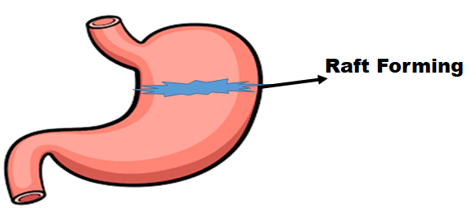

Figure 4: GRDDS based on Raft Forming system

Mechanism of floating drug delivery system: Due to its lower bulk density than gastric fluids, FDDS floats in the stomach for a longer period of time without slowing down the rate at which the stomach empties. (Niharika et al., 2018)
F=F buoyancy-F gravity
= (Df-Ds) gv
F = Total vertical force in this case
Fluid density is DF.
Object density is Ds.
Volume = V
G stands for gravitational acceleration.
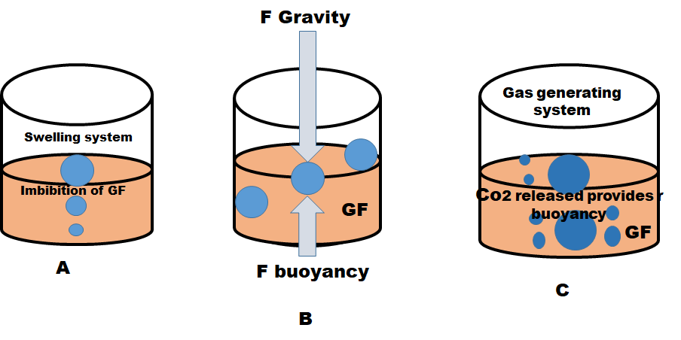
Figure 6: Mechanism of floating drug delivery system.
Designing a Delivery System for Floating Drugs:
Regarding single-use dosage forms, such as tablets:

- Floating Lag Time: It takes the tablet seconds or minutes to show up on the top of the dissolving media.
- Drug release in vitro and floating time: This is estimated by swirling simulated stomach fluid (pH 1.2 without pepsin) at 50 or 100 rpm at 370.20C using a USP II device (paddle). Following that, the samples are regularly collected and their drug content is assessed. The floating duration is visually measured as the number of hours that the tablets float on the surface of the dissolving substance.
- (C) Gastro-Retention in vivo Assessment: This is achieved using measuring the dose X-ray or gamma scintigraphy is used to observe the GIT's form transition. The pills are also examined for hardness, weight fluctuation, and other qualities.(Kharia et al., 2010)

Hydrodynamically Balanced System:
The delivery method is made to increase absorption and lengthen the time that different types of medications remain in the digestive system. The HBS system creates drugs that have particular upper small intestine absorption locations and increased solubility in acidic environments. The dosage form must release the medicine continuously and have a bulk density less than "1" in order for the drug to stay in the stomach for a prolonged length of time.

For Multiple Unit Dosage Forms (Ex: Microspheres):
- Using scanning electron microscopy (SEM), analyse morphology and dimensions. The dimension can also be determined utilising a microscope for optical data.
- The in-vitro floating potential (buoyancy level) was calculated using 900 ml of 0.1 N HCl and 0.002 level v/v Tween 80 is added to a USP (Type II) dissolving system, which is then 12 hours of being shaken at 100 rpm to ascertain the mixture's in-vitro floating potential (buoyancy level). The settling layer and floating layer are divided, dehydrated in a desiccator, and weighed after 12 hours. The formula below is used to determine buoyancy.
Buoyancy (%) = Wf / (Wf +Ws) X 100
Where,
The weights of the movable and anchored microspheres are Wf and Ws, respectively.

Drug-Excipient Interactions (DE): FTIR is typically used to do this. The drug-excipient interaction is indicated by the emergence the emergence of a new peak and/or the loss of the first drug or excipient peak.
Methods of Developing Floating Drug Delivery System: (Sharma et al., 2019)
- Technique for direct compression: It consists of quickly compressing tablets from powdered without changing the substance's physical structure. One of the most used carriers is tricalcium phosphate, which is also known as dicalcium trihydrate phosphate.
- Effervescent Technique: An effervescent reaction between organic acid (citric acid) and bicarbonate salts will cause the floating chamber of the drug delivery system to fill with inert gas (CO2).
- The use of the wet granulation method grinding, drying, or massaging wet powder. Wet granulation creates the granules by employing an adhesive to bind the particles together rather than compacting them.
- Ionotropic Gelation Technique: To create immediate microparticles, the principal anionic Sodium alginate, a polymer of natural origin, was gelled utilising calcium ions with opposing charges (counter-ions).
- Solvent evaporation technique: The amount of liquid dispersion solvent that can be removed during a continuous phase is insufficient. The dispersion surface's solvent evaporates, allowing the microspheres to become solid.

- Spray Drying Technique: This entails releasing the mixture for the core coating by environmental spraying after dipping the core layer into the liquid coating material to quickly evaporate the coating material, which will solidify the coating.
- Melt Solidification Technique: The molten material is emulsified in the aqueous phase using this technique, and then it is cooled to solidify. In this method, carriers such as lipids, waxes, polyethene glycol, etc. are used.
- Method for Melting Granulation: granulates the without the use of organic solvents or water, medicinal powders and agglomerates them using a meltable binder.
Different Floating Dosage Forms with Excipients:
- Effervescent Substances: Examples include Citroglycine, citric acid, tartaric acid, sodium bicarbonate, and Di-SGC (disodium glycine carbonate).
- Substances that slow down the rate of release include talc, Dicalcium phosphate, and magnesium stearate.
- Inert fatty compounds, including beeswax glaciers 39/01 and 43/01, long-chain fatty alcohols, and fatty acids.
- Accelerators of the release rate, such as lactose and mannitol.
- -cyclodextrin, gelatin, alginates, pectin, HPMC, and carbopol are a few examples of hydrocolloids.
- Buoyancy-increasing Agents, such as Accurel MP 1000's polypropylene foam powder and ethyl cellulose.
Floating drug delivery system benefits:(Chaitrali et al., 2014)
- Since FDDS may stay in the stomach for several hours, it can extend the period that certain medications are retained in the stomach.
- Favourable for medications intended for stomach action locally, such as antacids.
- The formulation of FDDS is helpful for diarrhoea and intestinal movement because it keeps the medication floating in the stomach, which results in a somewhat better reaction.
- FDDS increases Increasing patient compliance by lowering dose frequency.
- The therapy for digestive issues such gastroesophageal reflux disease.
- Bioavailability is unaffected despite the first-pass effect when the drug concentration in plasma has ceased.
- Aspirin and other medicines with a similar effect can be administered using HBS/FDDS formulations since they are acidic and irritate the stomach wall.
- Drugs that are absorbed via the stomach, such antacids and ferrous salts, benefit from being delivered to the desired area.

Disadvantages of Floating Drug Delivery System:(Bhosale et al., 2020)

- Drug compounds are not appropriate choices since they are delicate in the stomach's acidic environment for system integration.
- In these systems, it is typically necessary to have food present to delay stomach emptying.
- It is not appropriate for drugs with stability or GIT solubility problems.
- The only acceptable candidates are medications that have a first-pass action and that are considerably absorbed throughout the gastrointestinal system.
- The dosage form's level of hydration affects its propensity to float. It is helpful to administer water intermittently to keep these pills afloat.

Floating Drug Delivery System Evaluation: A specialised medication delivery system is called a Floating medication Delivery System (FDDS). Designed to release medication in a controlled manner while floating on the gastric fluid in the stomach. These systems are particularly useful for drugs that exhibit low solubility, narrow absorption window, or require localized delivery upper gastrointestinal tract or the stomach. FDDS can improve drug bioavailability, reduce dosing frequency, and enhance therapeutic efficacy. Here's an evaluation of the advantages and disadvantages of Floating Drug Delivery Systems (Singh et al., 2022)

Bulk Density: The percentage of the powder's bulk volume (Vo) to its total mass (m).
Db=m/Vo
Tapped Density: It is the ratio of the powder's tapped volume (Vi) to its total mass (m).
Dt = m/Vi

Compressibility Index:
By determine the powder's capacity to flow by examining its bulk density (o), tapped density (t), and rate of packing down. Using
Where, one can calculate the compressibility index.
ρo = Bulk density g/ml,
ρt = tapped density g/ml.

Hausner’s Ratio: Using the following formula, it is computed by taking the Tapped density and dividing it by the Bulk density.
Hausner’s Ratio= Tapped density / Bulk density

The forces of friction at the angle of repose that are present in grains or Loose powder is sometimes estimated using the angle of repose. The surface of a pile of powder or grains can only be angled away from the horizontal plane at this maximum angle. Granules are permitted to pass through a funnel that is mounted to a stand at a predetermined height (h). Then the granule heap's height and radius that has developed are measured to determine the angle of repose.
Tan θ = (h/r)
θ= tan-1 (h/r)
The angle of repose is.
h = the height of the pile
r is the pile's radius.

Hardness: The degree of a tablet's hardness reveals how well it can withstand managing physical shocks. The tablets' hardness was measured with a Monsanto hardness tester. Kg/cm2 was used as the unit. Three pills were randomly selected, and the toughness of those three was assessed.

Test for Friability: Roche The friability of tablets was evaluated using a Friabilator. There was a % given. (%). Initially, ten pills had been weighed (W) and converted into friability. The friability was run for 4 minutes at 25 rpm or for up to 100 rotations. The pills have undergone a second weighing (WO). The formula- was then used to compute the percentage of friability.
%F = 100 (1-Wo/W)
Tablets with less than 1% friability were deemed ideal.
Tablet Density: The criterion of tablet density for floating tablets was pretty good. When the density of the pill dropped below that of stomach fluid (1.004), it floated the best. The density was calculated using the formula below.
V = ᴫr2h
d = m/v
Where v is the tablet's volume (in cc).
R is the tablet's diameter in centimetres.
H is the tablet's crown thickness (g/cc).
m = the tablet's mass
Calculating the buoyancy lag: The buoyancy lag is the time it takes for the tablet to float and rise to the surface. We looked at the buoyancy of tablets in 900ml of synthetic stomach contents at 37°0.5°C. The total time spent floating was calculated using a timer and visually observed..(Gharti et al., 2012)
Floating time: The temperature stayed at 37 C during the research. 900ml of 0.1N HCl with a USP Dissolution Apparatus-II spinning at 50 revolutions per minute. The amount The amount of time the tablet floats (also known as the floating time), which is determined by visual inspection, also includes the floating lag time, which is the period of time it takes for the tablet to surface. —in the dissolving liquid.(Arora et al., 2005)
For the tablets with a floating sustained-release layer, the swelling index, swelling research was conducted. The precisely weighed tablets were added to USP Dissolution Apparatus II, kept at 37°C, and given time to expand up to a consistent weight. The weight changes of the pills after they had been taken out and wiped with filter paper were calculated. Three duplicates of the tests were run.
Drug Content: A mortar was used to weigh and pulverise five pills that were picked at random from a batch. After adding precisely weighed amounts of powdered tablets totalling 100 mg, 0.1 N HCL was added to a standard flask until it reached the desired level. After that, a 0.45 um membrane paper was used to filter the solution. Spectrophotometric analysis was used throughout the entire process.
Studies on in-vitro dissolution: The floating pills' rate of release was calculated using the USP Paddle-style dissolving testing device II. 900 cc of 0.1N HCL was used in the dissolving test, which was carried out at 37 0.5°C. Every hour for 12 hours, a sample (5 ml) of the solution was obtained from the dissolving apparatus, and the samples were changed for new dissolution medium. The samples were run through Whatman's filter paper to determine the solutions' absorbance.
Application of Delivery System for Floating Drugs:
The term "Floating Drug Delivery Systems" (FDDS) refers to specialised drug delivery formulations that are made to float and stay buoyant on gastric juices for an extended length of time while slowly releasing the medication. The pharmaceutical and medical industries can use them in several ways. Some of the main uses floaters are used as medication delivery methods listed below:(Chaitrali et al., 2014)
Improved Bioavailability: Riboflavin CR-GRDF has a significantly improved bioavailability as compared to the administration of polymeric formulations that are not GRDF-CR.
Drug delivery that is sustained: preparations for oral CR in the GIT have problems due to the length of the gastric stay. HBS systems that have a bulk density of less than 1, can stay in the stomach for long periods of time, these issues are typically solved by and can float on the gastrointestinal contents.
These problems can float on the gastrointestinal contents and are often resolved by. Like riboflavin and furosemide.
Enhancement of Absorption: By increasing their absorption, medicines with low bioavailability brought on by Potential possibilities for developing as floating medication delivery systems include site-specific absorption from the upper portion of the GIT.
Reduced risk of colon side effects: In HBS, drug the amount of medication that enters the colon is constrained by retention in the stomach. Unfavourable drug side effects in the colon can be prevented as a consequence.
Decrease in fluctuations in medication concentrations: After CR-GRDF therapy, Blood drug levels fall within a more limited range. In contrast to other immediate-release dose formulations.

Conclusion
In conclusion, therapeutic advancement in floating drug delivery systems has proven to be a game-changer in the field of pharmaceutical research. These innovative systems have overcome the limitations of conventional drug delivery methods by offering enhanced drug efficacy, improved bioavailability, and targeted drug delivery within the gastrointestinal tract. The ability to achieve sustained drug release and personalized medicine through FDDS holds great promise for optimizing therapeutic outcomes and patient compliance. Moreover, the development of multifunctional FDDS and the integration of advanced manufacturing techniques like 3D printing and nanotechnology demonstrate a bright future for drug delivery. As research progresses, FDDS is poised to revolutionize pharmaceutical therapy, elevating patient care and disease management to new heights.
Conflict of interest
Authors declare no conflict of interest.
Acknowledgement
Authors would like to acknowledge Dr. Gaurav, IIMT college of medical sciences, IIMT university, Meerut, Uttar Pradesh-250001 for conceptualization and drafting the study.

Reference
An Overview on Gastro Retentive Floating Microspheres. (2019). International Journal of Pharmacy Research & Technology. https://doi.org/10.31838/ijprt/02.01.01
Arora, S., Ali, J., Ahuja, A., Khar, R. K., & Baboota, S. (2005). Floating drug delivery systems: A review. In AAPS PharmSciTech. https://doi.org/10.1208/pt060347
Bhosale, A. R., Shinde, J. V, & Chavan, R. S. (2020). A Comprehensive Review on Floating Drug Delivery System (FDDS). Journal of Drug Delivery and Therapeutics. https://doi.org/10.22270/jddt.v10i6.4461
Chaitrali, K., Asish, D., Sudha, R., & Altamash, Q. (2014). Floating drug delivery system- A review. In Research Journal of Pharmacy and Technology. https://doi.org/10.46956/ijihd.vi.112
Farooq, S. M., Sunaina, S., Rao, M. D. S., Venkatesh, P., Hepcykalarani, D., & Preama, R. (2020). Floating Drug Delivery Systems: An updated Review. Asian Journal of Pharmaceutical Research. https://doi.org/10.5958/2231-5691.2020.00009.x
Gharti, K. P., Thapa, P., Budhathoki, U., & Bhargava, A. (2012). Formulation and in vitro evaluation of floating tablets of hydroxypropyl methylcellulose and polyethylene oxide using ranitidine hydrochloride as a model drug. Journal of Young Pharmacists. https://doi.org/10.4103/0975-1483.104363
Goyal, R. K., Guo, Y., & Mashimo, H. (2019). Advances in the physiology of gastric emptying. In Neurogastroenterology and Motility. https://doi.org/10.1111/nmo.13546
Kharia, A. A., Hiremath, S. N., Singhai, A. K., Omray, L. K., & Jain, S. K. (2010). Design and optimization of floating drug delivery system of acyclovir. Indian Journal of Pharmaceutical Sciences. https://doi.org/10.4103/0250-474X.78527
Niharika, M. G., Krishnamoorthy, K., & Akkala, M. (2018). Overview on floating drug delivery system. In International Journal of Applied Pharmaceutics. https://doi.org/10.22159/ijap.2018v10i6.28274
Ogobuiro, I., Gonzales, J., & Tuma, F. (2021). Physiology , Gastrointestinal. In StatPearls.
Sharma, G., Nautiyal, U., & Ahmad, S. (2019). An Overview on Gastroretentive Drug Delivery System (GRDDS). International Journal of Health and Biological Sciences.
Singh, K. A., Patel, V. K., & Rai, A. (2022). Formulation and Evaluation of Famotidine Gastroretentive Floating Tablet by Using Biopolymer. International Journal of Research and Review. https://doi.org/10.52403/ijrr.20220803

