WIRELESS SENSOR INTERFACED HEALTH MONITORING IOT ROBOT SYSTEM
K. Sarmila Har Beagam^{1,*}, S. Lekashri², Bharanigha V³, S. Dhananjeyan⁴
¹Assistant Professor (Senior Grade), Department of Electrical and Electronics Engineering, B.S. Abdur Rahman Crescent Institute of Technology, Tamilnadu, India. sarmilaharbeagam5@gmail.com
²Assistant Professor, Department of Electronics and Communication Engineering, Kings Engineering College, Sriperumbudur, Chennai, lekashri@kingsedu.ac.in
³Assistant Professor (Senior Grade), Department of Electrical and Electronics Engineering, B.S. Abdur Rahman Crescent Institute of Technology, Tamilnadu, India. bharanigha@gmail.com
⁴Assistant Professor, Department of Electrical and Electronics Engineering, Vel Tech Multi Tech Dr. Rangarajan Dr. Sakunthala Engineering College, Chennai, Tamilnadu, India. jeyan.dhanan@gmail.com,
ABSTRACT
Health monitoring is crucial for mitigation, particularly as early sickness identification can reduce suffering and medical expenses. The IoT is a network of interconnected, physical items that can be accessed online. The utilization of IOT devices in several application domains improves the daily lives of consumers. These tools are used to gather data such as blood pressure, sugar level, temperature, and others that are used to assess the patient's overall health. Patients have the comfortable feeling that their doctor is continuously watching over them as a result. Robots are machines that are controlled by software and move about to observe their surroundings using sensors and other technology. This research suggests a robotic system for patient monitoring and assistance. It has become common practice to track and document several medical indicators of patients outside of hospitals. The goal of the research is to develop a system that allows doctors to monitor a patient's body at all times via internet connection. The objective of this system is to use sensors to measure a biological parameter in the patient's body and transfer the results to an IOT cloud platform through a WiFi module. Clinicians are going to able to monitor their patients' well-being on their cellphones because all health-related data will be stored in the cloud. The Arduino Controller is used to carry out this project.
Keywords-IoT, Health monitoring, Robot system, Sensors, Blynk app.
I. INTRODUCTION
Health is currently defined as a complete condition of mental, social, and physical wholeness, rather than simply the absence of illness. The quality of a person's health mostly determines whether they want a better life. Insufficient medical care, major inequalities between towns and cities, and a shortage of physicians and nurses at particularly trying times are just a few of the issues that have regrettably made the global health crisis hard to solve [1].
All interior objects are now connected to IoT, which is seen as the impending revolution in technology. Health management, which provides capabilities to track ecological and physical variables, is where IoT is most impressively used. IoT is not anything other than the method of connecting computers to the internet by means of devices and networking. Heath monitoring technology has these related components. Following that, the data is communicated from the used sensors to remote locations via M2M, which is hardware for computers or smartphones. It is a simple method that also happens to be far more intelligent, scalable, and extensible for tracking and improving care for every health concern. In order to assist individuals live wiser lives, advances in technology today include flexible interfaces, virtual assistants, and control over mental health [2-4].
People with chronic illnesses are becoming more and more prevalent in low- and middle-income nations as a consequence of several risk factors, including dietary practises, physical inactivity, and alcohol drinking, among others [5, 6]. The progression and course of chronic illnesses, as well as their symptoms, are all very varied. When they fail to be promptly identified and addressed, some can result in the patient's mortality. For a long time, standard tests to measure blood pressure, heart rate, and glucose levels were common at specialist medical institutions. Today's technology advancements have made it possible for patients to regularly take their vital signs using a wide range of running sensors, including blood pressure cuffs, glucose metres, heart rate monitors, and electrocardiograms [7-9]. The daily readings are submitted to the physicians, who will then suggest the medications and exercise plans that will help patients to enhance their quality of life and beat these illnesses. To enhance people's quality of life, the IoT is being used more often in the healthcare industry to monitor and care for patients. The definition of the IoT is the incorporation of all remotely controllable networked gadgets, offer information in real time, and facilitate communication with users [10, 11]. The Arduino is a programmable gadget with environmental sensing and interaction capabilities. It is a fantastic open source microcontroller platform that enables amateur electrical engineers to create simple automation and monitoring projects quickly, simply, and affordably. The latest method of incorporating IoT into patient monitoring systems in healthcare is through the use of Arduino [12–15]. Data from the sensors is gathered by the Arduino Uno board and wirelessly sent to an IoT website.
The primary goals of IoT-based wireless robot monitoring medical sensor data. Consequently, the main goals are as follows:
- To build a patient monitor system, which detects things like pulse rate, oxygen saturation, and body temperature.
- To create a system employing database management for maintaining patient data over time.
- To evaluate the collected sensor data.
II. RELATED WORKS
Heng Yu et al [2021] [16] The study looks at the cloud-fusion IoT design for health, multimodal gathering of data in the medical IoT perception layer, multiple levels quality of service assurance of the healthcare IoT using the human LAN, and the connection between emotion and attachment in the health IoT. The health cloud infrastructure is suggested to be fully integrated into the cloud converging health IoT design for IoT in healthcare. The model will eventually be ready for the market after additional optimization and design based on the results of current study.
Sunil Jacob [2021] [17] have presented an Intelligent and portable exoskeleton systems (AI-IoT-SES) operated by AI collect data from a variety of detectors, successfully establish them, and generate the intended directions via IoT to help paralyzed patients in intelligent interconnected environments receive recovery and help from carers. The suggested system uses an AI-assisted navigation component to analyses the signals obtained from the exoskeleton sensors. Future research will focus on developing an exoskeleton-free AI and IoT system that uses a mix of EMG and EEG data to assist in the rehabilitation of paralysed person despite the aid of careers.
Wanqing Wu et al [2020] [18] have made a research which suggests the creation of an integrated system using IoT sensors, feature extraction from data analytics, and a one-dimensional CNN classifier must keep an eye out for signs of high-risk pregnancy, both maternal and foetal . It is important to handle performance and security issues including data privacy and fault tolerance. In order to assess efficiency, different AI strategies need be taken into account for the categorization module.
Guangyu Xu [2017] [19] have proposed a system for IoT-assisted ECG tracking with encrypted transfer of data for ongoing cardiovascular health tracking. With the IoT-assisted ECG monitoring structure, the creation and introduction of a portable ECG strong signal Assessment is suggested for automatic categorization and real-time application utilizing bluetooth connectivity, smartphones with Android, the Arduino platform, ECG detectors, and servers in the cloud. On the basis of cutting-edge machine learning algorithms, the ECG health tracking will be enhanced in the future.
Geng Yang et al [2017] [20] have recommended that in order to detect a patient's degree of discomfort using a facial sEMG, a wearable device be used in conjunction with a bio-sensing facial mask. The wearable functions as a WSN for remote pain tracking and is incorporated into an IoT system. This research concludes by recommending an extensible IoT system that real-time bio potential tracking and a mobile device for automated pain evaluation utilising expressions. To preserve the internal electronic parts throughout the integration manage, more improvement is required.
III. PROPOSED SYSTEM
Due to every aspect of the suggested project is self-sufficient, the number of medical staff members needed may be lowered. Additionally, if we utilise this monitoring system at home, the number of patients who need to be physically accompanied while being monitored can be lessened. Additionally, the cost of the clinical staff is drastically decreased. The suggested system's block diagram is illustrated in Figure 1.

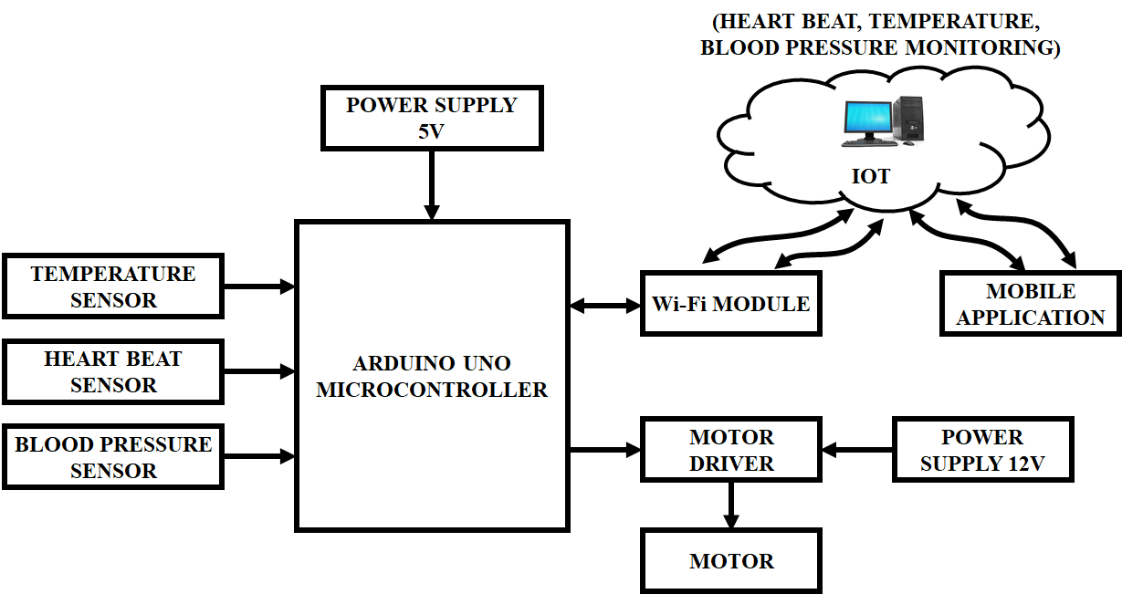
Fig. 1. Proposed system
The suggested approach was created with an IoT methodology. To monitor the temperature, blood pressure, and heartbeat, this system also includes three additional sensors: a heartbeat sensor, a blood pressure sensor, and a temperature sensor. All of the proposed framework's sensors, together with their output data, are utilized to gauge the patients' state of health. These sensors are linked to the microcontroller so that it can track various patient health indicators. If there are any anomalies, the microcontroller immediately transmits an alert signal via the Wi-Fi device. These sensors are utilized in the IoT to communicate medical data through Wi-Fi, and patient information may be kept, analyzed, presented in the form of graphs, and viewed via a mobile application. The Arduino microcontroller sends a signal to the motor driver, which uses 12 V power source to run the motor. Processing of information is done at the server, and communication is able to be performed by the controller for wireless internet data transmission. At the server location, all information is gathered and consolidated. The Blynk app may be used to see health-related data in an easily understood style. Data from the sensor is reviewed, and if any unusual behaviour is discovered, an emergency plan is started to notify the physician of patient's situation. Hospital critical circumstances decrease as an outcome.
A. ARDUINO
An open-source electrical platform called Arduino is simple to use and put into practice. It is built on connecting hardware and software. They are built such that they can read when the water exceeds a specific threshold and transform that information into an alert when it does.
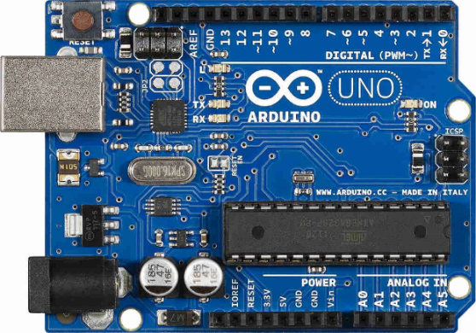
Fig. 2. Arduino Uno AT Mega 328
The ATmega328 is the foundation of the microcontroller chip known as the Arduino Uno shown in Figure 2. It has a reset button, power connection, ICSP header, USB port, a crystal oscillator with a frequency of 16 MHz, 6 analogue inputs, fourteen pins for digital input/output, and 6 of these may be utilised as PWM signals. All you've got to do to make use of the microprocessor is attach an USB connection, an AC-to-DC conversion, or a power source because it contains all you require to run it. A USB-to-serial conversion driven by an Atmega8U2 is added in its stead. For the upcoming release of Arduino 1.0, the Italian word "Uno" (which translates to "one") was chosen as the representative. The Uno and Arduino 1.0 are going to be the accepted models going ahead. The baseline for the platform and the most recent USB Arduino board is the Uno; to compare it to older incarnations, see the index of Arduino boards.

B. Wi-Fi MODULE
The Wi-Fi module for the ESP8266 is an autonomous system of control with an incorporated TCP/IP protocol stack that can provide any device with connection to a Wi-Fi system. The 802.11 b/g/n protocols are used. Less than 0.1 mW of power is consumed when in standby. The ESP8266 has the ability of running a programme or delegating all Wi-Fi network duties to a different application processor. This module's core storage and processing capabilities are sufficient. Lessens the runtime load and the quantity of work that must be done beforehand. As a result, it may be connected to sensors as well as additional devices for particular applications via its GPIOs. It only needs just a small quantity of outside circuitry due to achieve a high degree of on-chip integrating, and even the front-end module itself is designed to take up little room on the PCB.
C. TEMPERATURE SENSOR
The sensor monitors the object's temperature utilising IR rays without having any contact with it by connecting to microcontroller via I2C protocol. The pin arrangement of the MLX90614 temperature sensor is shown in Table 1. It has three pins: Gnd for the Ground terminal, $V_{dd }$for the power supply, and Serial Data and Serial Clock pins for I2C communication.
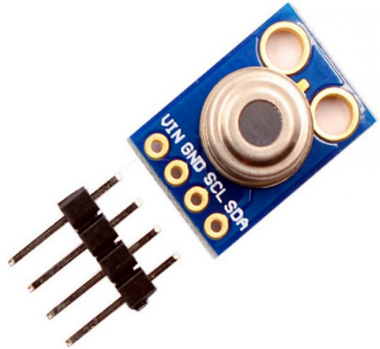
Fig. 3. MLX90614 Temperature Sensor
Table 1. Pin configuration
Pin Number | Pin Name | Description
1 | $V_{dd}$ (Power supply) | The optical sensor can be powered by${ V}_{dd }$ , generally using 5V.
2 | SCL – Serial Clock | Serial Clocks Pin is used for I2C Connectivity.
3 | Ground | A ground may additionally be made of metal.
4 | SDA – Serial Data | Serial data ports are used for I2C connectivity.
Specifications
- Operating Voltage: 3.6V to 5V.
- Accuracy: 0.02°C
- Object Temperature Range: -70° C to 382.2°
- Supply Current: 1.5Ma
- Distance between object and sensor: 2cm-5cm (approx).
- Field of View: 80°
- Ambient Temperature Range: -40° C to 125°C
MLX90614 is a non-contact melexis infrared temperature sensor with high precision. Unlike the majority of others, this sensor doesn't need physical touch to gauge temperature. It is particularly helpful for monitoring the outside temperature of things that move, such as those on conveyor belts or spinning motor shafts. It will pick up IR waves from the thing you want to evaluate and tell you what its temperature is based on the IR waves it picks up.
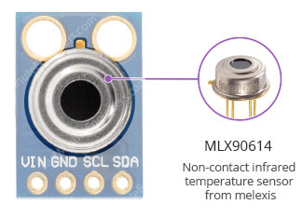
Fig. 4. MLX90614
The MLX90614 measures two temperatures: the item temperature and the outside temperature. The temperature as "observed" from the detector is measured by the object temperature, but the temperature outside the sensor is monitored by the outside temperature of the surroundings. While ambient temperature could have been used to verify information, what matters are the readings of temperature made by the instrument. It can detect a greater variety of temperatures than conventional digital sensors because it does not need to contact the object being tracked. Despite the ambient temperature range of -40 to 125°C, thing temperature measurements range from -70 to 382.2°C. Component's temperature has a median accuracy of 0.5°C compared to room temperature, while the surrounding temperature is accurate to within 0.02°C. An optically filter included into the MLX90614 reduces the effect of visible and near-infrared light on reading. It also provides security from ambient light and the sun.
One can operate the module securely with any kind of 3.3V or a 5V microcontroller since it features a 662K 3.3V accuracy regulators of voltage and voltage level converters. The MLX90614 uses less than 2mA for taking measurements. It gets utilised in devices that run on batteries like portable thermal imaging equipment because to its low power consumption.
MLX90614 MODULE PIN OUT
The MLX90614 module reveals the connections listed below.
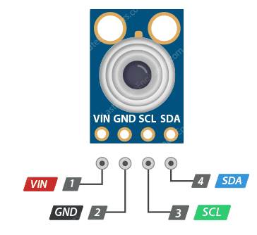
Fig. 5. MLX90614 Module Pin out
- The power pin is VCC. It may be connected to the Arduino's 3.3V or 5V output.
- The ground is GND.
- The I2C clock pin, SCL, should be connected to the Arduino's I2C clock line.
- I2C data pin SDA connects to I2C data line on Arduino.
D. PULSE OXIMETER HEART RATE SENSOR
A sensor system with a built-in pulse oximeter and heart-rate monitor is called MAX30100. It is an optical sensor that generates two wavelengths of light and infrared from two LEDs before collecting its data. After that, a light detector is used to gauge the blood's absorption. With this particular LED colour conjunction, information may be viewed with the tip of the finger. Software registries allow for complete customization, while the inbuilt 16-deep FIFO of the device holds digital output data. Through the I2C digital the interface, it may communicate with the host microcontroller. The MAX30100 can operate in a voltage range of 1.8 to 3.3V. It may be used in wearable technologies, health tracks, monitors for fitness, and other gadgets. Software may be used to reduce the MAX30100's standby current, enabling the power supply to constantly be connected. It can be powered by both 1.8V and 3.3V power sources.
Table 2. Extensive information for the MAX30100 sensor
Power Supply | 3.3V to 5.5V
Red LED Wavelength | 660nm
Current draw | ~0.7μA (during standby mode)  ~600μA (during measurements)
Temperature Range | -40˚C to +85˚C
IR LED Wavelength | 880nm
Temperature Accuracy | ±1˚C
Optical pulse oximeters and heart rate sensors, like the MAX30100, use powerful LEDs and light-detecting sensors. These LEDs are 660 nm and 880 nm in wavelength, correspondingly.
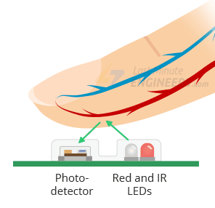
Fig. 6. Heart Beat Sensor
A photo detector measures the amount of light returned by the skin by flashing both of the lights on the finger or ear (or basically anywhere the skin isn't thick enough to absorb the light readily). The abbreviation of this method for light-based pulse identification is photoplethysmogram. The two functions of the MAX30100 are measurement of heart rate and pulmonary oximetry (which measures the amount of oxygen in the blood).

MAX30100 MODULE PINOUT
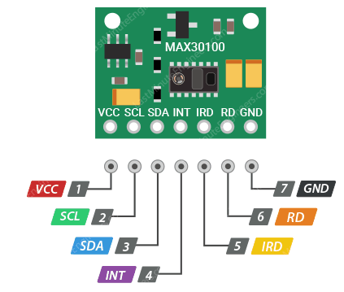
Fig. 7. MAX30100 Module Pin out
- VIN is the power pin. It may be linked to either the 3.3V or 5V output of the Arduino.
- The Arduino's I2C clock line must be linked to the SCL I2C clock pin.
- SDA is the I2C information pin; attach it to I2C information port on the Arduino.
- The interrupt function (INT) of the MAX30100 may be set up to generate an interrupt for every single pulse. The inside resistor pushes this line HIGH due to the open drain on this line. The INT pin goes low whenever an interrupt happens and remains lower until interrupt is restored.
- The MAX30100 has an LED driver known as IRD, which drives LED pulses used for SpO2 and HR readings. Turn on the IR LED if you want to use it; otherwise, leave it unplugged.
- The Red LED's RD pin, which powers it, is equivalent to the IRD pin. The ground is GND. You may omit red LED if you don't wish to drive it.
E. IOT IN HEALTH MONITORING
It is feasible to employ wearable technology to remotely track someone's health in light of the advancements made in wireless transmission, healthcare sensors, and data processing methods. By way of IoT It is feasible to trace patients and the therapy equipment utilised. Medical personnel may monitor a patient's position, designated doctor, and medical outcomes in actual time, among other things, by employing RFID tags. Defibrillators, ECG machines, spirometers, and nebulizers, among other medical devices and equipment, may be readily followed via the Internet of Things by attaching sensors to them.
Lower cost of care to real-time, round-the-clock patient monitoring made possible by the Internet of Things in healthcare. It will undoubtedly cut down on needless hospital visits and transportation expenses. At home, patients can receive medical advice from doctors via internet video streaming; only in life-threatening situations should they visit a hospital. IoT-based healthcare monitoring can lower insurance costs and allow patients to take fewer sick days. Decreased chance of error in healthcare monitoring. Sensors capture accurate physical health data, such as blood pressure and sugar levels, and big data analytics is used to make the appropriate judgements. It reduces the likelihood of human mistake. Eliminate geographical restrictions: Because doctors and patients are connected internationally through the internet, any patient may receive medical advice from anywhere in the globe. The bare minimum of documentation and records Green technology is supported by Internet of Things-based Internet healthcare monitoring, which also reduces paperwork and documentation. Combining large-scale data analysis and physiological health information mining approaches collected by medical sensors, it is feasible to identify chronic problems in the early stages and implement therapy before it becomes incurable. Producing and overseeing medications for the health sector is a huge task. Radio-frequency identification (RFID) technology can improve drug management for manufacturers, suppliers, and consumers in the pharmaceutical business. It will lessen loss brought on by theft, mismanagement of pharmaceuticals, and loss. IoT-based medical equipment can notify a doctor in the case of an illness or injury, enabling medical intervention right away, such as an increase in blood pressure or the decline of an elderly relative. Constant health monitoring and evidence-based treatment choices will aid in the quick treatment of disorders. As a consequence, treatment results will improve.
IV. RESULTS AND DISCUSSIONS
One industry where IoT technology is thriving is healthcare. As illustrated in Figure 8, blood pressure, heart rate sensors and body temperature are tracked and first presented on LCD. The sensor information, in specific the information from the body's temperature and heart rate sensors, is stored in the informational database. Medical sensors built into wearable IoT devices keep track of data on patient health, including blood pressure, body temperature, and breathing patterns. The concerned hospital or carer will get this data for future action.
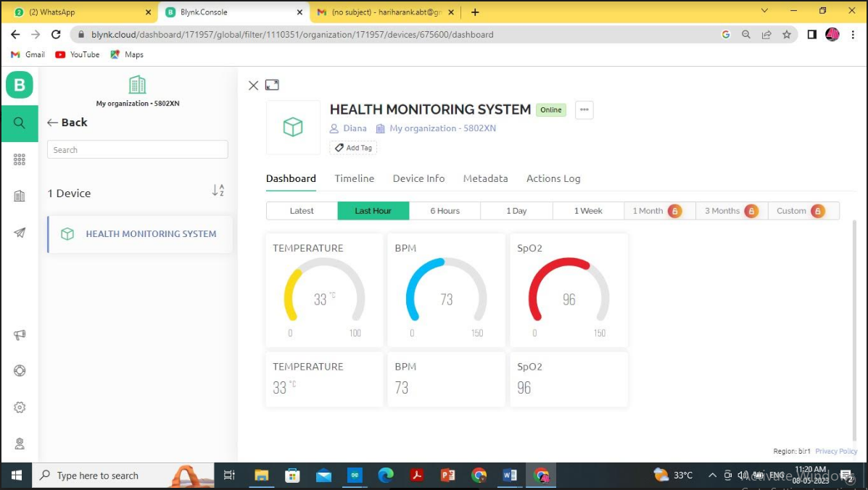
Fig. 8. Output showing the display of Temperature, Heart Rate and${ SPO}_{2}$.
Along with Blynk, this technology provides an IoT based patient monitoring system. The methodological work that is suggested shows the varying health parameter data that are gathered from sensors. The information is gathered through providing patients with higher-quality and more efficient medical care through the use of online resources and tools for communication, that then link to cloud services. By employing this technique, the doctor is able to check on his patient whenever and wherever. If the acquired current value exceeds or falls short of threshold value, emergency alert message will be sent to a specified number. It is useful for people who require round-the-clock medical care.
SL.NO | PATIENT | AGE | SEX | TEMP | BPM | SP$O_{2}$
1. | PATIENT 1 | 32 | FEMALE | 29 | 66 | 95
2. | PATIENT 2 | 28 | MALE | 31.2 | 70 | 93
3. | PATIENT 3 | 31 | MALE | 29.5 | 68 | 90
4. | PATIENT 4 | 43 | FEMALE | 29.7 | 69 | 94
5. | PATIENT 5 | 39 | MALE | 31.6 | 67 | 89

V. CONCLUSION
It is clear from this suggested system that wireless sensor technology is becoming an important component of healthcare services. A mobile physiological monitoring system that can continually track a patient's heartbeat and other important metrics at a hospital is described in this suggested system. The system has an IoT-based emergency rescue mechanism and can monitor a patient's status over an extended period of time. Thus robotic system is going to be digitalized. People are afflicted by several variations of illnesses, which are very sensitive diseases, on a daily basis. People therefore worry constantly about their health. This project focuses on the IoT, a modern idea that is expanding and has an impact on many aspects of human existence, resulting in smart technology in daily life.
REFERENCES
- G. Narendra Kumar Reddy, M. Sabarimalai Manikandan and N. V. L. Narasimha Murty, "On-Device Integrated PPG Quality Assessment and Sensor Disconnection/Saturation Detection System for IoT Health Monitoring," in IEEE Transactions on Instrumentation and Measurement, vol. 69, no. 9, pp. 6351-6361, Sept. 2020.
- T. Wu, F. Wu, C. Qiu, J. -M. Redouté and M. R. Yuce, "A Rigid-Flex Wearable Health Monitoring Sensor Patch for IoT-Connected Healthcare Applications," in IEEE Internet of Things Journal, vol. 7, no. 8, pp. 6932-6945, Aug. 2020.
- R. K. Pathinarupothi, P. Durga and E. S. Rangan, "IoT-Based Smart Edge for Global Health: Remote Monitoring With Severity Detection and Alerts Transmission," in IEEE Internet of Things Journal, vol. 6, no. 2, pp. 2449-2462, April 2019.
- P. Verma and S. K. Sood, "Fog Assisted-IoT Enabled Patient Health Monitoring in Smart Homes," in IEEE Internet of Things Journal, vol. 5, no. 3, pp. 1789-1796, June 2018.
- R. Ding, H. Zhong, J. Ma, X. Liu and J. Ning, "Lightweight Privacy-Preserving Identity-Based Verifiable IoT-Based Health Storage System," in IEEE Internet of Things Journal, vol. 6, no. 5, pp. 8393-8405, Oct. 2019.
- D. C. Yacchirema, D. Sarabia-JáCome, C. E. Palau and M. Esteve, "A Smart System for Sleep Monitoring by Integrating IoT With Big Data Analytics," in IEEE Access, vol. 6, pp. 35988-36001, 2018.
- U. Satija, B. Ramkumar and M. Sabarimalai Manikandan, "Real-Time Signal Quality-Aware ECG Telemetry System for IoT-Based Health Care Monitoring," in IEEE Internet of Things Journal, vol. 4, no. 3, pp. 815-823, June 2017.
- H. Ren, H. Jin, C. Chen, H. Ghayvat and W. Chen, "A Novel Cardiac Auscultation Monitoring System Based on Wireless Sensing for Healthcare," in IEEE Journal of Translational Engineering in Health and Medicine, vol. 6, pp. 1-12, 2018.
- S. Asutkar, M. Korrapati, D. Gupta and S. Tallur, "Novel Elastomer Vibration Sensor for Machine Health-Monitoring Applications," in IEEE Sensors Letters, vol. 4, no. 11, pp. 1-4, Nov. 2020.
- M. Haghi et al., "A Flexible and Pervasive IoT-Based Healthcare Platform for Physiological and Environmental Parameters Monitoring," in IEEE Internet of Things Journal, vol. 7, no. 6, pp. 5628-5647, June 2020.
- M. A. A. Mamun and M. R. Yuce, "Sensors and Systems for Wearable Environmental Monitoring Toward IoT-Enabled Applications: A Review," in IEEE Sensors Journal, vol. 19, no. 18, pp. 7771-7788, 15 Sept.15, 2019.
- S. Rani, S. H. Ahmed and S. C. Shah, "Smart Health: A Novel Paradigm to Control the Chickungunya Virus," in IEEE Internet of Things Journal, vol. 6, no. 2, pp. 1306-1311, April 2019.
- E. Mezghani, E. Exposito and K. Drira, "A Model-Driven Methodology for the Design of Autonomic and Cognitive IoT-Based Systems: Application to Healthcare," in IEEE Transactions on Emerging Topics in Computational Intelligence, vol. 1, no. 3, pp. 224-234, June 2017.
- S. K. Sood and I. Mahajan, "IoT-Fog-Based Healthcare Framework to Identify and Control Hypertension Attack," in IEEE Internet of Things Journal, vol. 6, no. 2, pp. 1920-1927, April 2019.
- S. Vadrevu and M. S. Manikandan, "Real-Time Quality-Aware PPG Waveform Delineation and Parameter Extraction for Effective Unsupervised and IoT Health Monitoring Systems," in IEEE Sensors Journal, vol. 19, no. 17, pp. 7613-7623, 1 Sept.1, 2019.
- H. Yu and Z. Zhou, "Optimization of IoT-Based Artificial Intelligence Assisted Telemedicine Health Analysis System," in IEEE Access, vol. 9, pp. 85034-85048, 2021.
- S. Jacob et al., "AI and IoT-Enabled Smart Exoskeleton System for Rehabilitation of Paralyzed People in Connected Communities," in IEEE Access, vol. 9, pp. 80340-80350, 2021.
- J. A. L. Marques et al., "IoT-Based Smart Health System for Ambulatory Maternal and Fetal Monitoring," in IEEE Internet of Things Journal, vol. 8, no. 23, pp. 16814-16824, 1 Dec.1, 2021.
- G. Xu, "IoT-Assisted ECG Monitoring Framework With Secure Data Transmission for Health Care Applications," in IEEE Access, vol. 8, pp. 74586-74594, 2020.
- G. Yang et al., "IoT-Based Remote Pain Monitoring System: From Device to Cloud Platform," in IEEE Journal of Biomedical and Health Informatics, vol. 22, no. 6, pp. 1711-1719, Nov. 2018.

