Preparation and Piezo Properties of Potassium Sodium Tantalate system

Manish Uniyal¹, S.C.Bhatt², Sidharth Kashyap², Richa Saxena³ & Aditya Joshi²

1 Department of Physics, BGR Campus Pauri, H.N.B.Garhwal University, Uttarakhand

²Department of Physics, H.N.B.Garhwal University,Srinagar Garhwal, Uttarakhand-246174

³IFTM University, Lodhipur, Rajput, Moradabad-244001, (Uttar Pradesh) India,

Corresponding Author Email¹: uniyaldrmanish@gmail.com

Abstract
Ceramic pellets of Na_{1-x}K_{x}TaO₃ (x= 0 & 0.5) system have been prepared by solid state reaction method and sintering process. The prepared samples are characterized by XRD and SEM techniques. Lattice parameters have been calculated by XRD pattern and grain size has been calculated by SEM. It has been observed that the prepared samples show orthorhombic structure at room temperature.After the preparation The Piezo properties of Na_{0.5}K_{0.5}TaO₃ have been studied
Key words: Dielectrics, Ceramics, X-Ray diffraction, Scanning Electron Micrographs, Piezo-Properties

1. Introduction:
The ABO₃ type tantalate perovskite compounds constitute an important group of oxide crystals with broad ranges of scientifically and technologically important dielectric, piezoelectric, ferroelectric and electro-optic properties¹. Sodium tantalate (NaTaO₃) is a member of the perovskite family. The dielectric properties of sodium tantalate were studied by Matthias² and showed that it’s Curie point is T_{c} = 475⁰C. Vousden ³ studied the tantalate by X-ray diffraction at room temperature and showed that NaTaO₃ belongs to the rhombic syngony with parameters a=5.5239 Å, b=3.881 Å and c=5.4778 Å. NaTaO₃ is a orthorhombic structure with space group Pbnm below 720 K, and belongs to another orthorhombic space group C_{m}C_{m} between 720 and 853 K. At 835 K, it is transformed into a tetragonal structure with space group Pm3m⁴⁻⁶. At room temperature and above, it is antiferroelectric with a Curie point 475⁰C.
Because of the recent developments in piezoelectric applications and optoelectronic devices viz. high speed electro-optic switches, modulators and frequency doublers, perovskite tantalate have been considered as functional materials for future technologies. For studies of fundamental properties of materials, large homogeneous single crystals are usually desirable to minimize the effects of surfaces and imperfections, however, single crystal are very expensive and difficult to grow, wheareas ceramics have the advantage of being easier to prepare than their single crystal counterparts¹. Preparation of amorphous and nano crystalline Sodium Tantalate Oxide photocatalysts with porous matrix structure for overall water has been investigated by Harun Tuysuz et.al.⁷. Microstructure of Sodium – Potassium niobate ceramics sintered under high alkaline vapour pressure atmosphere has been studied by Jerome Acker et.al.⁸. Fast synthesis of NaNbO₃ and Na_{0.5}K_{0.5}NbO₃ by microwave hydrothermal method was performed by Rigoberto Lopez-Juarez et.al.⁹. Synthesis, photophysical properties, and photocatalytic applications of Bi doped NaTaO₃ and Bi doped Na₂TaO₃ nanoparticles was studied by Pushkar Kanhere et.al.¹⁰. Theoretical & experimental studies on Ceramic Samples of different ferroelectric material has been done to understand the salient features as these materials ¹¹⁻¹⁵. Scott et.al¹⁶ reviewed the properties and technological potential of ferroelectric memories of Na_{1-x}K_{x}TaO₃. A great deal of interest has developed in the utilization of ferroelectric thin films for opto-electronic integrated circuits¹⁷. Birefringence is induced in ferroelectric materials following exposures to a constant or varying electric field. There are a number of prerequisite conditions that the ferroelectric layer must meet in order to successfully be integrated within an opto-electronic devices¹⁸. Previously we have studies different properties of Sodium potassium niobate, lead Magnesium niobate, ultrasonic properties and electrical properties of ferrofluids¹⁹⁻²⁹
2. Purpose of the present work:
The purpose of the present work is to prepare, characterize and piezo properties of material of Na_{0.5}K_{0.5}TaO₃ system, to enable researchers to select the material for device applications by keeping in view the specific requirement. These materials may be used for second harmonic generation, delay line applications & optoelectronic applications.
3. Experimental Procedure:
The raw materials used for preparing the compositions from this system were sodium carbonate, Potassium carbonate and tantalate pentaoxide. The two carbonates were both reagent-grade products of the Qualigens Fine chemicals and tantalum penta-oxide was of 99.9% purity from Fluka Chemie AG CH-9471 Buschs. The starting material was dried at 200ºC for one hour to remove the absorbed moisture. Compositions of K_{1-x}Na_{x}TaO₃ for (x=0.5) were prepared by weighing the sodium carbonate, potassium carbonate and tantalum pentaoxide ( Starting materials) in proper stoichiometric proportions. The mixture was calcined in the platinum crucible, in air, at 950⁰C for 2h for carbonate removal. After cooling, in dry air, the calcined mixtures were weighed to ensure complete carbonate removal.
The presintered mixture was ground and pressed into pellets of 10 mm diameter. The pellets were placed on a platinum crucible and sintered, in air, at 1050ºC for 26 h.

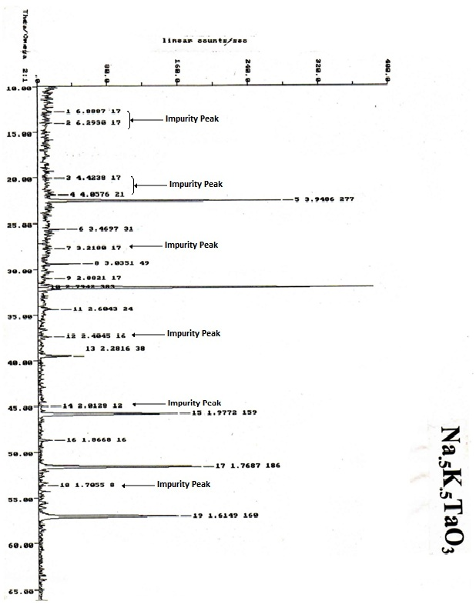

Fig.1 X-ray diffraction pattern of Na_{0.5}K_{0.5}TaO₃

4. Characterization:
4.1 X-Ray Diffraction (XRD):
To characterize the material in the present study, X-ray diffraction pattern of the samples at room temperature were obtained on a SEIFERT X-ray diffractometer made by Bruker, using Cu-K filter radiation of 1.540598 Å wavelength. The instrument is well calibrated with the silicon standard sample. Peak indexing was done by using Joint Committee on power diffraction standards (JCPDS) data cards. From the observed diffraction pattern, lattice spacing d was determined, which was used to determining the perovskite lattice parameters. The unit cell parameters were determined using the Auto-X computer software, which includes CRYSFIRE and FULLPROF software.
X-ray diffraction patterns obtained for the prepared samples show characterstic lines corresponding to the orthorhombic and cubic structure alongwith some impurity and are shown in fig.1 respectively. The peaks related to impurities for Na_{0.5}K_{0.5}TaO₃ ceramic system have been marked. The lattice parameters for all the prepared compositions have been presented in Table 1

Table -1: Variation of lattice parameters by mixing K on NaTaO₃ in replacement of Na

Composition | Lattice parameters
 | a (Å) | b (Å) | c (Å)
Na_{0.5}K_{0.5}TaO₃ | 5.588 | 5.581 | 5.585

4.2 Scanning Electron Micrographs (SEM):
Surface topology of the prepared samples were studied by Scanning Electron Micrographs (SEM) using LEO 440 scanning electron microscope. The (SEM) of prepared samples for Na_{1-x}K_{x}TaO₃ system are shown in Fig.2. The estimated grain size have been tabulated in table 2

Table–2: Estimated grain size for NaTaO₃ & Na_{0.5}K_{0.5}TaO₃ systems are as follows:
Composition | Grain Size (µm)
Na_{0.5}K_{0.5}TaO₃ | 6.874
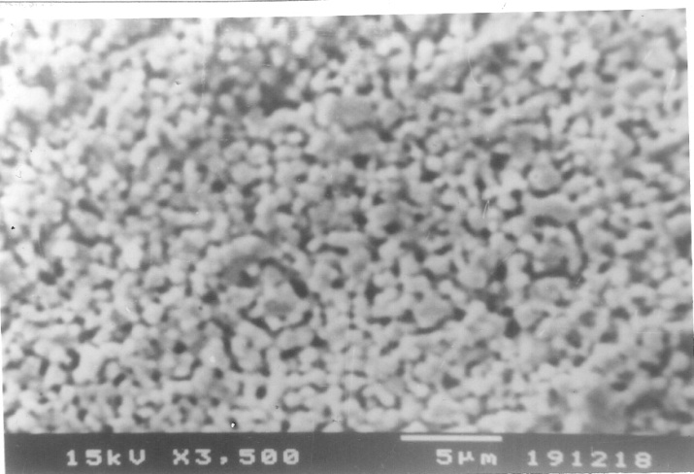

Fig.2. Scanning Electron micrograph of Na_{0.5}K_{0.5}TaO₃

5 Piezo Properties

For piezoelectric measurements sintered pellets of Na_{0.5}K_{0.5}TaO₃ at 100 V were electrode in parallel capacitor configuration, Sintered pellets were electroded, with air dryable conducting paste of silver, in metal- insulator- metal (MIM) configuration, for Polarization and piezoelectric parameters were measured using a ferroelectric- (PE loop tracer) and piezo- meter (AixACCT Systems).

5. Result and Discussion:
X-ray diffraction patterns obtained for the prepared samples show characteristic lines corresponding to cubic structure along with some impurities are shown in the Fig.1 . From X-ray patterns, it was found that the structure of is cubic, which is in agreement with the previously reported results³⁰. Lattice parameters (Table 1) also reveal the structures of the present systems. The SEM pictures of Na_{1-x}K_{x}TaO₃ sample have been shown in Fig.2. The observed polarization- electric field (P-E) hysteresis loops at room temperature, for unpoled Sodium Potassium Tantalate samples K_{0.5}Na_{0.5}TaO₃ under an applied electric field of 1000 kV/cm, have been shown in Fig.3. The Prepared samples show a normal hysteresis loop confirming ferroelectric nature of all the prepared PST ceramics. The observed large value of polarization and converse piezoelectric coefficient, as applications of small field, was found comparable with modified PST ceramics.
6. Conclusion:
It is observed that when potassium is added in Sodium Tantalate (NaTaO₃), the lattice parameters get elongated and also from the SEM patterns it is observed that the grain size of the composition also increases with increase of Potassium (K) in NaTaO₃. The Prepared samples show a normal hysteresis loop confirming ferroelectric nature of all the prepared PST ceramics
References:
- S.C.Bhatt, Manish Uniyal et.al., Indian J Pure & Appl.Physics, 45, 609 (2007).
- B.T.Matthias, Phys.Rev. 75 1771 (1949).
- P.Vousden, Acta Crystallography 4, 373 (1951).
- L E Cross, Phil. Mag. 1,76 (1956) .
- H.Iwasaki, T.Ikeda, J. Phys.Soc.Jpn., 18, 157 (1963).
- B.J.Kennedy, A.K.Prodjosantoso, J Phys: Condensed matter, 11, 6319 (1999).
- Harun Tuysuz, Candace K.Chan, Nano Energy, 2 , Issue 1, 116-123(2013).
- Jerome Acker, Hans Kungi, Roland Achierholz, Susanne Wagner, Rudiger-A.Eichel, Michael J.Hoffmann, Journal of European Ceramic Society, 34, Issue 16, 4213- 4221 (2014).
- Rigoberto Lopez-Jurez, R.Castaneda-Guzman, M.E.Villafuerte-Castrejon, Ceramic International, 40, Issue 9, Part-B, 14757-14764 (2014).
- Pushkar Kanhere, Yuxin Tang, Jianwei Zheng, Zhong Chen, Journal of Physics and Chemistry of Solids, 74, Issue 12, 1708-1713 (2013).
- Manish Uniyal , S.C.Bhatt, Indian Journal of Pure & Applied Physics ,.49, 350 (2011).
- Manish Uniyal , S.C.Bhatt, , Indian Journal of Pure & Applied Physics , .50, 248-251(2012).
- S.C.Bhatt, Manish Uniyal, International J.of materials and Chemistry, 2(2), 47-50 (2012).
- Manish Uniyal, S.C.Bhatt & R.P.Gairola, Indian Journal of Pure & Applied Physics, 50, 915-917(2012).
- Manish Uniyal , S.C.Bhatt, Indian Journal of Pure & Applied Physics, 52, 391-394 (2014)
- J.F Scott, C.A.Araujo, Science, 246, 1400(1989).
- B.W.Wessels, J.Cryst. Growth 195, 706(1998).
- B.W.Wessels, J.Electroceram. 13, 135(2004).
- Manish Uniyal, K,Singh, S.Bhatt, S.C.Bhatt, R.P.Pant, D.K.Suri & B.S.Semwal, Indian Journal of Pure & Applied Physics, 41, 305-309 (2003)
- Manish Uniyal, S.C.Bhatt, R. Bhandari, MS Rao R.P.Pant, B.S.Semwal, Indian Journal of Pure & Applied Physics, 42, 341-346 (2004)
- K,Singh, Manish Uniyal, S.C.Bhatt & B.S.Semwal, Srilankan Journal of Physics, 2, 13-19 (2001)
- Manish Uniyal & S.C.Bhatt, Indian Journal of Pure & Applied Physics, 52, 391-394 (2015)
- Manish Uniyal, S.C.Bhatt & Sidharth kashyap, Indian Journal of Pure & Applied Physics, 57, 212-216 (2019)
- Sidharth kashyap, S.C.Bhatt, Manish Uniyal & GS Kathait, AIP Conference Proceedings 2220, Issue 1 (2020)
- Sidharth kashyap, S.C.Bhatt, Manish Uniyal & GS Kathait, Materials Today: Proceedings, Vol 28, Part 1, 28-31 (2020)
- Manish Uniyal, S.C.Nautiyal S. Bhatt & S.C.Bhatt, Chemical Science ,7, Issue 4 652-655 (2018)
- Pankaj K Singh, S.C.Bhatt, Manish Uniyal, Aditya Joshi & S.C.Nautiyal, Applied Innovative Research, Vol 2, 44-47, March (2020)
- Sidharth Kashyap, S.C.Bhatt, Manish Uniyal & Gambheer Singh Kathait, Applied Innovative Research, Vol 2, 18-21, March (2020)
- Richa Saxena, S.C.Bhatt, Manish Uniyal, & S.C.Nautiyal, Applied Innovative Research, Vol 2, 36-38, March (2020)
- S.Narayan Murthy, K.V.Ramana Murthy, K.Umakanthan,A Bhanumati, Ferroelectrics,102, 243 (1990).

