INTRODUCTION TO PHARMACOKINETICS: IN BRIEF
Sakshi Sharma *¹, Soniya Chauhan ¹
¹ Noida Institute of Engineering and Technology (Pharmacy Institute), Greater Noida 210306
Corresponding author: sakshi.sharma1964@gmail.com

Abstract:
Pharmacokinetics is a critical branch of pharmacology that describes the journey of drugs within the body. It explores four primary stages - absorption, distribution, metabolism, and excretion (ADME), providing an essential understanding of how drugs function in the human system and influence therapeutic outcomes. It aids in designing optimal dosing regimens, predicting potential drug interactions, and identifying factors that could affect the drug's behaviour, such as age, disease, and genetic variability. The principles of pharmacokinetics serve as a cornerstone in drug discovery and development, clinical trials, and pharmaceutical formulation. It contributes significantly to the customization of patient-specific treatment plans, enabling the evolution of personalized medicine. A comprehensive understanding of pharmacokinetics is vital to ensuring effective and safe drug therapy, thus improving overall healthcare outcomes.
Keywords: Absorption, Bioavailability, Distribution, Clearance, Renal failure

Introduction/Definition
Pharmacokinetics (PK) studies how the body interacts with substances, such as medications, throughout exposure. It's a field closely associated with pharmacodynamics but distinctly focuses on the body's action on the drug. Four main aspects generally explored in this field are absorption, distribution, metabolism, and excretion (ADME). Understanding these processes equips healthcare practitioners with the flexibility to prescribe and administer medications with the most benefit and least risk, accommodating patients' diverse physiology and lifestyles [1]
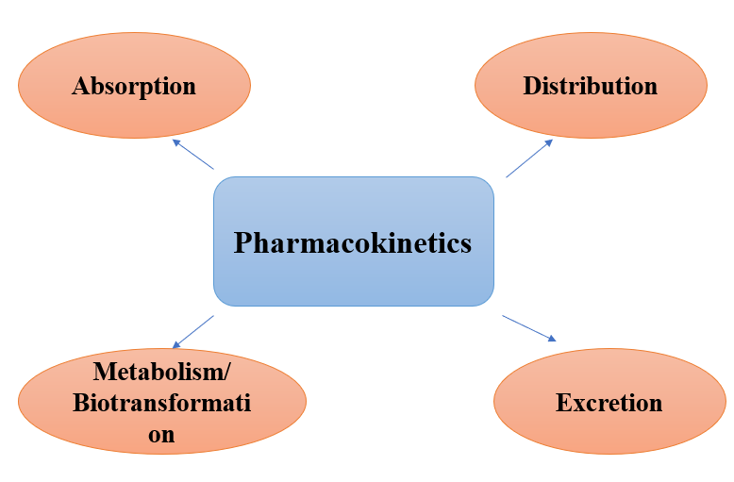
Figure 1: Branch of pharmacokinetics
Absorption
Absorption is the mechanism by which a drug enters the body's systemic circulation in various forms, such as a tablet or capsule. It plays a vital role in determining how quickly and at what concentration the drug reaches its intended site of action, such as the plasma. The methods of drug administration are numerous and include options like oral, intravenous, intramuscular, intrathecal, subcutaneous, buccal, rectal, vaginal, ocular, otic, inhaled, nebulized, and transdermal. Each method presents its specific characteristics, benefits, and drawbacks regarding absorption.
The absorption process often encompasses liberation, where the drug is freed from its pharmaceutical form. This aspect is particularly crucial for oral medications. For example, an oral drug might remain in the throat or esophagus for an extended period after ingestion, delaying the effects' onset or even potential mucosal injury. Furthermore, once the medication reaches the stomach, its low pH environment might initiate chemical reactions with the drugs, affecting them before they even enter the systemic circulation [2].
Bioavailability
Bioavailability refers to the portion of the original drug dose that successfully reaches the systemic circulation, and it is determined by the substance's characteristics and the method of administration. It can serve as an indicator of drug absorption. For instance, when a drug is administered intravenously, it is immediately and entirely available in the bloodstream, rendering a bioavailability of 100% [3]. As a result, intravenous administration is considered the benchmark for bioavailability, a principle particularly crucial for orally administered drugs.
Once consumed, oral medications must withstand the stomach's acidity and be absorbed by the digestive system. The digestive enzymes start metabolizing oral medications early on, thereby reducing the amount of drug entering the circulation even before absorption. After being absorbed by intestinal transporters, the medicines typically undergo a "first-pass metabolism." Large quantities of orally administered drugs are processed by the liver, digestive enzymes, or gut wall, which decreases the amount of medicine that reaches the systemic circulation, resulting in lower bioavailability. Further discussion on these processes will be under the metabolism section. Specific administration methods, like oral, intramuscular, and transdermal, may cause varying quantities of drugs to enter circulation simultaneously, which has led to the use of the area under the plasma concentration curve (AUC) [3]. AUC is a method used to compute the bioavailability of substances with different distribution characteristics, as it monitors the plasma concentration over a specific duration as shown in figure 2. By integrating this curve, bioavailability can be expressed as a percentage of the 100% bioavailability by IV.
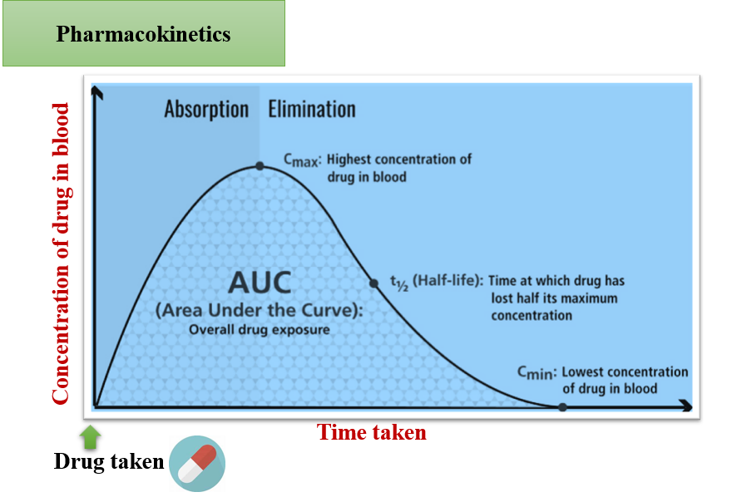
Figure 2: AUC curve for the determination of bioavalability
Distribution
Distribution refers to the way a substance disperses throughout the body, a process that can differ based on the drug's biochemical properties and the individual's physiological condition. Essentially, distribution is impacted by two principal factors: diffusion and convection. These factors can be affected by the drug's polarity, size, binding capacity, the individual's hydration level and protein concentrations, or body habitus [4].
The aim of distribution is to attain what's termed the effective drug concentration. This is the level of the drug at its targeted receptor site, where it's intended to exert its effects. For a medication to be effective, it must not only reach its designated compartment or area in the body, as characterized by the volume of distribution but also remain unbound to proteins to be active. In simpler terms, the drug must be in a form that allows it to interact with its target site and not be restricted by being tied to proteins or other substances in the body [4].

The volume of Distribution (Vd) and Protein Binding
The concept of volume of distribution (Vd) is a standard measure used to understand how a drug spreads throughout the body. It is defined as the total amount of the drug in the body divided by the drug concentration in the plasma. The body consists of several hypothetical fluid compartments like the extracellular, intracellular, and plasma, among others, and the Vd aims to portray the hypothetical uniform volume in a theoretical compartment [5].
When a drug molecule is quite large, charged, or predominantly bound to proteins in the bloodstream, such as the GnRH antagonist cetrorelix (with a Vd of 0.39 L/kg), it mainly remains within the vascular system, unable to diffuse, resulting in a low Vd. Conversely, a smaller, water-loving molecule would likely have a larger Vd, reflecting its ability to disperse into all extracellular fluids. Further, a small fat-loving molecule, like chloroquine (with a Vd of 140 L/kg), would show a significantly large Vd, as it can penetrate cells and store in fat tissues. It's crucial to note that a single drug could have multiple volumes of distribution, contingent upon the distribution rate within the patient [ 6].
Understanding the volume of distribution is crucial for healthcare providers to devise appropriate dosing regimens. For instance, in the case of a patient with a severe infection, a loading dose of vancomycin might be needed to attain the desired trough concentrations promptly. A loading dose allows the drug to quickly reach its optimal concentration without waiting for it to accumulate over time before becoming effective. This dosing strategy is directly linked to the volume of distribution. It can be computed as the product of the Vd and the desired plasma concentration, divided by the drug's bioavailability [7].
Protein Binding in Drugs
Within the human body, drugs exist in two states: protein-bound and free. The free form of the drug is the active part, capable of interacting with pharmacological sites such as receptors, moving into other fluid compartments, or being removed from the body. In a clinical context, the free concentration of a drug at its receptor sites in the plasma correlates more directly with its effects than the total concentration in the plasma. The extent of the drug's protein binding primarily influences this relationship [8].
A decrease in plasma protein binding makes more of the drug available to act on receptors, which could lead to an enhanced effect or even an increased risk of toxicity. Albumin and alpha-acid glycoprotein are the main proteins responsible for binding the drugs [9].
The levels of these binding proteins might vary due to factors such as the patient's age, growth stage, underlying liver or kidney conditions, or nutritional status. Renal failure serves as a pertinent example of this concept [10]. In this condition, uremia can reduce the capacity of acidic drugs like diazepam to bind with serum proteins. As a result, even when the exact dosage is administered, a higher amount of the drug exists in an "active" or unbound state. This can amplify the drug's effect and escalate the risk of toxic reactions, such as respiratory depression [11].
Metabolism
Metabolism refers to the body's transformation of a drug into different compounds. This change often makes the drug more water-soluble, facilitating its elimination through renal Clearance. In the case of prodrugs like codeine, metabolism is necessary to activate the drug into its effective metabolites [12].
Metabolism can happen in various body parts, such as the gastrointestinal tract, skin, plasma, kidneys, or lungs. However, the liver is the primary site of drug metabolism, where it occurs mainly through phase I (CYP450) and phase II (UGT) reactions. Phase I reactions typically convert substances into polar metabolites through oxidation, enabling the conjugation reactions of Phase II [12].
These processes usually aim to inactivate the drug, transform it into a more water-attracting (hydrophilic) metabolite, and allow for its excretion in the urine or bile. In doing so, metabolism plays a crucial role in removing drugs from the body [12].
Excretion
Excretion refers to the process through which drugs are removed from the body. While the kidneys are the primary organ responsible for excretion, some drugs can also be eliminated through the lungs, skin, or gastrointestinal tract [13]. In the kidneys, drugs can be removed via passive filtration in the glomerulus or secreted through the tubules, although reabsorption may complicate this process for certain compounds [14].
Clearance
Clearance is a vital concept in drug excretion, defined as the relationship between a drug's elimination rate and its plasma concentration. Factors like the type of drug, blood flow, and the organ condition usually responsible for excretion (often the kidneys) can affect this ratio. In a hypothetical organ where the blood is entirely cleared of the medication, Clearance would only be restricted by the total blood flow through that organ [15].
Half-life
The half-life of a drug refers to the time required for the concentration of the drug in the serum to be reduced by 50%. The equation determines it [16].
T =0.693×Vd/Clearance
where t is the half-life,
Vd is the volume of distribution, and Clearance refers to the rate at which the drug is eliminated from the body. The half-life is directly related to the volume of distribution and inversely related to Clearance. Changes in clearance parameters due to factors such as disease or aging can alter the half-life of medications.
Drug Kinetics
Drug kinetics, a visual representation of a drug's metabolism and excretion processes, primarily operates under zero-order and first-order kinetics. In the zero-order model, the rate of metabolism and/or elimination of a drug is constant, regardless of its concentration. This is seen in substances such as alcohol and phenytoin, where the half-life is variable and decreases as the overall serum concentrations reduce.
On the other hand, first-order kinetics depends on the drug's plasma concentration, having a consistent half-life with decreasing plasma clearance over time. This is the principal model for the elimination of most medications. In reality, most drugs exhibit a mix of these two models. For instance, salicylates show proportional elimination to serum concentrations below 1.4 mmol/L, while at higher levels, elimination remains constant due to the saturation of metabolic and elimination processes [17].
These models also allow us to predict the steady states and complete elimination of drugs. A steady state is achieved when the rate of drug administration balances with the rate of Clearance, resulting in a constant plasma concentration over time. Assuming the drug is given as a continuous infusion under ideal treatment circumstances, this state is typically reached after four to five half-lives. Changes in the steady-state concentration can only occur through alterations in dosing interval, total dose, or the drug's clearance rate.
Similarly, the total elimination of a drug is measurable in terms of half-lives. If a drug follows first-order elimination kinetics, it's considered completely eliminated after four to five half-lives, as 94 to 97% of the drug would have left the system by then. For instance, since morphine has a half-life of 120 minutes, one can safely assume that a negligible amount of morphine remains in a patient's system eight to ten hours after administration [18].
Clinical Significance
The primary goal of a healthcare provider when prescribing medication is to achieve a therapeutic outcome while minimizing the risk of adverse reactions. Therefore, a profound understanding of pharmacokinetics is crucial in crafting effective treatment plans involving drugs. Pharmacokinetics is a branch of science that investigates how a drug moves through the body and how the body interacts with the drug. By employing the principles, terminologies, and formulas in pharmacokinetics, medical practitioners can accurately estimate a drug's location and concentration within different body parts [19].
Determining the proper concentration to elicit the intended effect without causing adverse reactions is often achieved through laboratory tests. The formulas provided earlier allow a clinician to estimate safe medication dosing over time and predict how long it would take for a drug to be completely cleared from a patient's system. However, these estimates are statistical and may be influenced by factors such as the formulation of the drug and the patient's physiological condition. Therefore, a deep understanding of pharmacokinetics is vital in medical practice to allow for necessary adjustments and adaptability when the clinical situation demands it.
Application of Pharmacokinetics in Pharmaceutical Sectors
Pharmacokinetics plays a crucial role in the pharmaceutical industry, and its application is multifaceted. Here are a few ways it's applied:
Drug Development: During the early stages of drug development, the principles of pharmacokinetics are used to help identify promising drug candidates based on their absorption, distribution, metabolism, and excretion (ADME) profiles. This helps to predict a drug's effectiveness, the appropriate dose, and potential side effects, which are all key in the development process [20].
Clinical Trials: In clinical trials, pharmacokinetic data is collected and analyzed to determine the dosing, frequency, and duration of treatment. It helps understand how the drug behaves in the human body, ensuring safety and efficacy before it's brought to the market [20].
Formulation Design: Pharmacokinetics is crucial in designing drug delivery systems. It provides insights into the formulation of the drug to ensure optimal bioavailability. For instance, a drug not readily absorbed in the gastrointestinal tract may need to be formulated as an injectable for direct entry into the bloodstream [21].
Drug-Drug Interactions: Understanding pharmacokinetics is important in predicting and managing drug-drug interactions. Some drugs can influence the metabolism of others, causing changes in plasma concentrations and potentially leading to side effects or reduced effectiveness [22].
Patient-specific therapy (Precision Medicine): Pharmacokinetics aids in designing patient-specific therapies, considering factors such as age, sex, genetic makeup, and disease state. This individualized approach can improve drug effectiveness and reduce the risk of adverse reactions [23].
Regulatory Decision-making: Regulatory bodies like the FDA require detailed pharmacokinetic data to approve new drugs or generic equivalents. This data is essential to ensure the drug is safe and effective for patient use [24].
Post-marketing Surveillance: Pharmacokinetic studies remain important even after a drug is approved and marketed. They can provide information about real-world use, including long-term safety, effectiveness, and possible new drug interactions.
Pharmacokinetics is a vital component in pharmaceutical sectors, contributing significantly to drug development, testing, formulation, individualized therapy, and post-marketing surveillance [25].

Conclusion:
Pharmacokinetics, the study of how a drug moves through the body, plays a fundamental role in medical and pharmaceutical fields. By investigating drug absorption, distribution, metabolism, and excretion (ADME), it provides invaluable insights into predicting a drug's behaviour, dosage, therapeutic efficacy, and potential adverse effects. Its principles are crucial at various stages of drug development, including preclinical testing, clinical trials, formulation design, and post-marketing surveillance. Moreover, it contributes to the customization of drug therapies to meet individual patients' needs, leading to the emergence of precision medicine, which aims to tailor treatment strategies according to patient-specific factors. Furthermore, pharmacokinetic data is also essential in regulatory decision-making processes, ensuring that only safe and effective drugs are marketed. Even after approval, continued pharmacokinetic studies allow for monitoring of real-world use and long-term safety. In essence, a comprehensive understanding of pharmacokinetics is indispensable in the healthcare and pharmaceutical sectors. It bridges the gap between drug administration and therapeutic response, providing a scientific basis for optimal drug therapy. This ensures that patients receive the maximum benefit from medications with minimal risk, thereby improving overall healthcare outcomes.
References:
1. Gabrielsson J, Weiner D. Pharmacokinetic & pharmacodynamic data analysis: concepts and applications. 4th ed. Stockholm: Swedish Pharmaceutical Press; 2017.
2. Slørdal L, Spigset O. [Basic pharmacokinetics--absorption]. Tidsskr Nor Laegeforen. 2005 Apr 07;125(7):886-7.
3. Starkey ES, Sammons HM. Practical pharmacokinetics: what do you really need to know? Arch Dis Child Educ Pract Ed. 2015 Feb;100(1):37-43.
4. Slørdal L, Spigset O. [Basic pharmacokinetics--distribution]. Tidsskr Nor Laegeforen. 2005 Apr 21;125(8):1007-8.
5. Chiou WL. The physiological significance of the apparent volume of distribution, Vdarea or Vd beta, in pharmacokinetic studies. Research Communications in Chemical Pathology and Pharmacology. 1981 Sep 1;33(3):499-508.
6. Martinez MN, Amidon GL. A mechanistic approach to understanding the factors affecting drug absorption: a review of fundamentals. The Journal of Clinical Pharmacology. 2002 Jun;42(6):620-43.
7. Benet LZ, Kroetz D, Sheiner L, Hardman J, Limbird L. Pharmacokinetics: the dynamics of drug absorption, distribution, metabolism, and elimination. Goodman and Gilman’s the pharmacological basis of therapeutics. 1996;3:e27.
8. Mangus BC, Miller MG. Pharmacology application in athletic training. FA Davis; 2005 Jan 11.
9. De Gregori S, De Gregori M, Ranzani GN, Allegri M, Minella C, Regazzi M. Morphine metabolism, transport and brain disposition. Metabolic brain disease. 2012 Mar;27:1-5.
10. Verbeeck RK, Musuamba FT. Pharmacokinetics and dosage adjustment in patients with renal dysfunction. European journal of clinical pharmacology. 2009 Aug;65:757-73.
11. Dasgupta A. Usefulness of monitoring free (unbound) concentrations of therapeutic drugs in patient management. Clinica chimica acta. 2007 Feb 2;377(1-2):1-3.
12. Gray K, Adhikary SD, Janicki P. Pharmacogenomics of analgesics in anesthesia practice: A current update of literature. J Anaesthesiol Clin Pharmacol. 2018 Apr-Jun;34(2):155-160.
13. Kok-Yong S, Lawrence L, Ahmed T. Drug distribution and drug elimination. Basic pharmacokinetic concepts and some clinical applications. 2015 Nov 18:99-116.
14. Varma MV, Feng B, Obach RS, Troutman MD, Chupka J, Miller HR, El-Kattan A. Physicochemical determinants of human renal clearance. Journal of medicinal chemistry. 2009 Aug 13;52(15):4844-52.
15. De Paepe P, Belpaire FM, Buylaert WA. Pharmacokinetic and pharmacodynamic considerations when treating patients with sepsis and septic shock. Clinical pharmacokinetics. 2002 Dec; 41:1135-51.
16. Mangoni AA, Jackson SH. Age-related changes in pharmacokinetics and pharmacodynamics: basic principles and practical applications. Br J Clin Pharmacol. 2004 Jan;57(1):6-14.
17. Bari N. Salicylate poisoning. J Pak Med Assoc. 1995 Jun;45(6):160-1.
18. Trescot AM, Datta S, Lee M, Hansen H. Opioid pharmacology. Pain Physician. 2008 Mar;11(2 Suppl): S133-53.
19. Sung JH, Srinivasan B, Esch MB, McLamb WT, Bernabini C, Shuler ML, Hickman JJ. Using physiologically-based pharmacokinetic-guided “body-on-a-chip” systems to predict mammalian response to drug and chemical exposure. Experimental biology and medicine. 2014 Sep;239(9):1225-39.
20. Theil FP, Guentert TW, Haddad S, Poulin P. Utility of physiologically based pharmacokinetic models to drug development and rational drug discovery candidate selection. Toxicology letters. 2003 Feb 18;138(1-2):29-49.
21. Jhaveri J, Raichura Z, Khan T, Momin M, Omri A. Chitosan nanoparticles-insight into properties, functionalization and applications in drug delivery and theranostics. Molecules. 2021 Jan 7;26(2):272.
22. Christians U, Jacobsen W, Benet LZ, Lampen A. Mechanisms of clinically relevant drug interactions associated with tacrolimus. Clinical pharmacokinetics. 2002 Sep; 41:813-51.
23. Caudle KE, Gammal RS, Karnes JH, Afanasjeva J, Anderson KC, Barreto EF, Beavers C, Bhat S, Birrer KL, Chahine EB, Ensor CR. PRN OPINION PAPER: application of precision medicine across pharmacy specialty areas. Journal of the American College of Clinical Pharmacy. 2019 Jun;2(3):288-302.
24. Madabushi R, Seo P, Zhao L, Tegenge M, Zhu H. Role of model-informed drug development approaches in the lifecycle of drug development and regulatory decision-making. Pharmaceutical Research. 2022 Aug;39(8):1669-80.
25. Honek J. Preclinical research in drug development. Medical Writing. 2017 Dec 1; 26:5-8.

