PRELIMINARY PHYTOCHEMICAL SCREENING FOR VARIOUS MEDICINAL PLANTS LEAF EXTRACT

S.VIJIPRIYA, V. RAGURAMAN,
PG & Research Department of Physics, PG & Research Department of Chemistry,
Thiru. Vi. Ka. Govt Arts College, Edayanthangudy G. S. Pillay Arts and Thriuvarur- 610003. College, Nagapattinam-611002.
drsvip2022@gmail.com raguram.vr@gmail.com
ABSTRACT

Objective: The preliminary screening of phytochemicals is a crucial step in identifying the bioactive components found in medicinal plants, which may then lead to the discovery and development of new drugs. In the present study, the major phytoconstituents of five selected medicinal plants from various families were chosen, and their presence was linked to the bioactivities of the plants.
Methods: Using standard techniques, a phytochemical screening of five chosen medicinal plants was performed to check for the presence of alkaloids, carbohydrates, glycosides, saponins, phenols, flavonoids, proteins.
Result: As a result, phenols were present in every leaf extract from the chosen five medicinal plants. Furthermore, all of the selected plants with the exception of Ruellia prostrata contained flavonoids. All plants, with the exception of Pongamia pinnata, contained saponins. Alkaloids, cardiac glycosides, carbohydrates and steroids were present in all the selected plants except Ruellia prostrata, Erythrina indica and Hygrophila auriculata. However, none of the five medicinal plants we chose contained any proteins and terpenoids.
Conclusion: According to the study, Ruellia prostrata has the least number of phytochemical components, whereas Pongamia pinnata and Aegle marmelos leaf extract have the most. Secondary metabolites like phenols, saponins and flavonoids which are virtually present in all five medicinal plants, have been shown to act as a capping, reducing, and bio-reducers for the formation of metal and metal oxide nanoparticles.

Keywords: Medicinal plants, phytochemical, screening.

INTRODUCTION

Plant derived compounds have recently attracted a lot of attention due to their versatile applications. The richest bio-resource for traditional and modern medicines, pharmaceutical intermediates, and chemical building blocks for synthesized pharmaceuticals is medicinal plants [1]. Plants naturally contain compounds called phytochemicals that have positive health effects. They are referred to as secondary metabolites, and they frequently originate from primary metabolites or share primary metabolite-derived substrates [2]. Alkaloids, carbohydrates, glycosides, saponins, phenols, flavonoids, proteins, terpenoids, steroids, and other compounds all help to give plants their color, aroma, and flavor, as well as to protect them from illness. When their nutritional intake is substantial, they also play a part in safeguarding human health. Fruits, vegetables, legumes, whole grains, nuts, seeds, fungi, herbs and spices all contain dietary phytochemicals. They possess antioxidant, anti-inflammatory, anti-cancer, and antibacterial effects [3].
In this chapter we discussed about extraction procedure and preliminary phytochemical screening test for five medicinal plants leaf extract.

MATERIALS

Aagle marmelous:
Common name: Bilwa or Bael
Tamil name: Vilvam
Botanical name: Aegle marmelos

Taxonomic Position:
Kingdom: Plantae
Class: Magnoliopsida
Order: Sapindales
Family: Rutaceae
Genus: Aegle
Species: A. marmelos

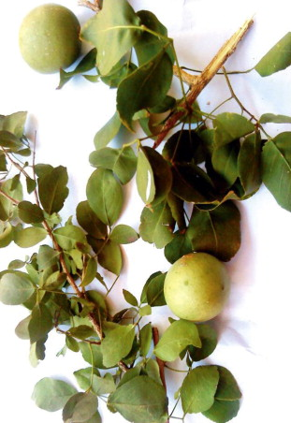
Figure 1.1 Aegle marmelos plant

Due to its numerous therapeutic characteristics, Aegle marmelos, often known as Bael and a member of the Rutaceae family, has been extensively employed in traditional Indian medical practices. A tree with trifoliate leaves and greenish-white blooms that is spiny, deciduous, and scented. Additionally, trees are planted as avenue trees next to temples and in gardens. The tree’s fruit and bark are both used [4].

Medicinal Uses:
- The dried fruit pulp from Aegle marmelos is used in various regions of India to make summer beverages that prevent sunburn.
- Salads are prepared using bael leaves.
- Bael can be used in the composition of ayurvedic medications for the loss of appetite.
- To treat respiratory issues, bael extract oil is used.
- It has anti-inflammatory properties, like Aegle marmelos. When applied to the exposed area, it helps to treat inflammation.
- Antioxidants found in abundance in Aegle marmelos aid in insulin secretion, which lowers blood sugar levels [4].

Erythrina variegata:
Common name: Tiger’s claw or Indian coral tree
Tamil name: Kalyana murungai
Botanical name: Erythrina variegata

Taxonomic position:
Kingdom: Plantae
Class: Magnoliopsida
Order: Fabales
Family: Fabaceae (Legume family)
Genus: Erythrina
Species: E. variegata
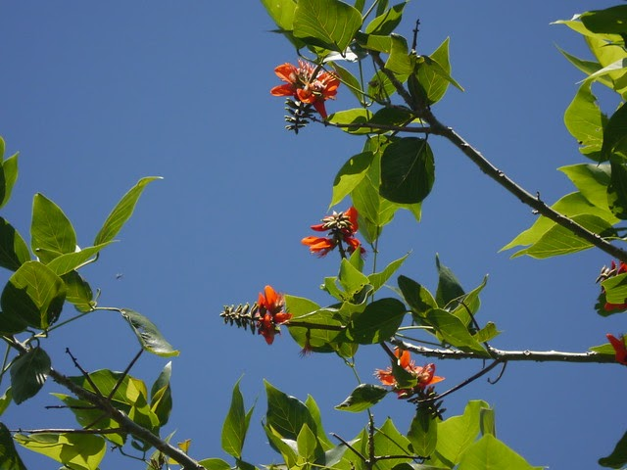
Figure 1.2 Erythrina variegata plant

Erythrina variegata, also known as Erythrina indica, is a thorny deciduous tree that grows to a height of 50-60 feet and is wide. It has 6-inch-long, leaves are green and yellow, which produce a waste canopy but have spiny branches. Before the leaves emerge in spring, coral trees are covered in colorful red blossoms that are 2.5 inches long and grouped in thick, six-inch-long racemes. Twelve-inch-long, reddish-brown seedpods with toxic seeds follow these blossoms [5].

Medicinal uses:
- In traditional medicine, several portions of E. variegata have been employed as nervine sedatives, febrifuges, anti-asthmatics, and antiepileptics.
- It has shown promise in several studies as a treatment for conditions such as convulsions, fever, inflammation, bacterial infections, sleeplessness, helminthiasis, cough, cuts, and wounds [5].

Hygrophila auriculata:
Common name: Hygrophila or Marsh barbel
Tamil name: Neermulli
Botanical name: Hygrophila auriculata

Taxonomic Position:
Kingdom: Plantae
Class: Magnoliopsida
Order: Lamiales
Family: Acanthaceae
Genus: Hygrophila
Species: H. auriculata
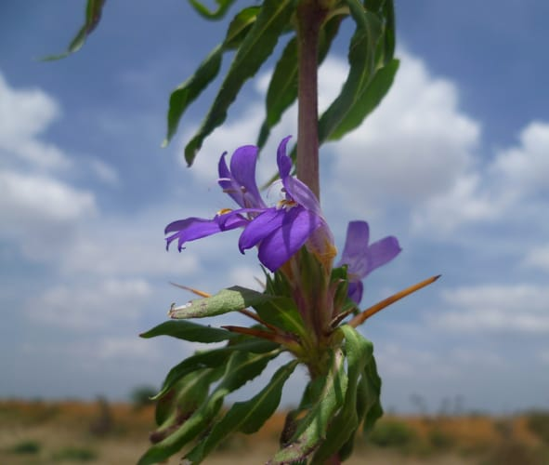
Figure 1.3 Hygrophila auriculata plant

Hygrophila, also known as Marshal Barbel, is frequently referred to as Neermulli in Tamil. An annual herbal plant can reach a height of 60 cm. Tetragonal, hairy, and hardened at the nodes, a plant stem. The leaves are elliptic-lanceolate and hispid, while the bark is dark brown. The flowers are purple-blue with violet undertones. The fruit has a four-sided shape, is linear, glabrous and about contains roughly 1 cm long, orbicularly hairy and brown seeds [6].

Medicinal uses:
- Its leaves can help with a cough.
- In an anal fistula, it is helpful.
- Consuming a root decoction helps with jaundice.
- In anemia, vegetables are helpful.
- Its root and a decoction of all of its parts are useful in rheumatoid arthritis [6].

Pongamia pinnata:
Common name: Karanj, Indian beech tree, Pongam tree
Tamil name: Pungai
Botanical name: Pongamia pinnata

Taxonomic Position:
Kingdom: Plantae
Class: Magnoliopsida
Order: Fabales
Family: Fabaceae
Genus: Pongamia
Species: P. pinnata
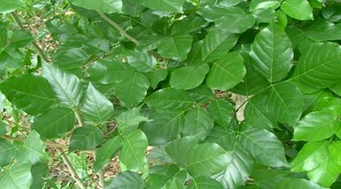
Figure 1.4 Pongamia pinnata plant

The Fabaceae (Papilionaceae) family member Pongamia pinnata is extensively distributed in tropical asia, Australia, Polynesia, and Philippine Islands. Different Pongamia pinnata elements, including the barks, leaves, seeds, roots, flowers, and stem, have historically been used in many traditional medicine systems [7].

Medicinal uses:
- It has been discovered that this plant’s blossoms have lipid peroxidation and anti-hyperglycemic capabilities.
- The bark is utilized in piles, the leaves are effective as a therapeutic bath and for rheumatic aches. The seeds are helpful for hypertension, bronchitis, whooping cough, skin conditions, and rheumatic arthritis.
- Roots are beneficial in treating gonorrhea as well as cleaning gums, teeth, and ulcers [7].

Ruellia prostrata:
Common name: Bell weed
Tamil name: Kiranthi nayagam, Pottakanchi
Botanical name: Ruellia prostrata

Taxonomical position:
Kingdom: Plantae
Class: Magnoliopsida
Order: Lamiales
Family: Acanthaceae
Genus: Ruellia
Species: R. prostrata
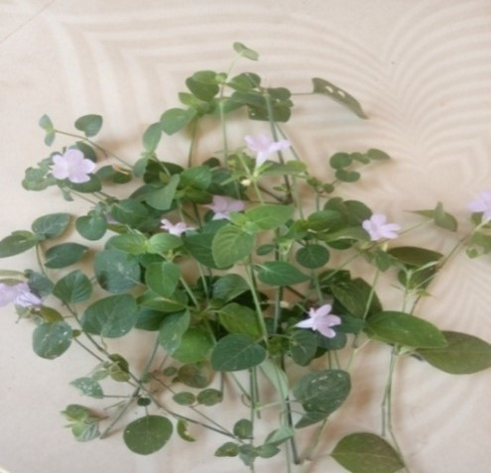
Figure 1.5 Ruellia prostrata plant

Bell weed is a perennial prostrate plant whose stems frequently root at the nodes. Ovate green leaves, 2-10 cm long with a noticeably darker lower surface. The leaf stem measures 5-30 mm. Solitary flowers appear in the leaf axils and are surrounded by oblanceolate to ovate bracts on each side 1.5-2.3 cm long. Sepals 5, 6-10 mm long. Flowers are violet blue to sporadically practically white, and densely coated with tiny hairs [8].

Medicinal uses:
- Believed to be mildly hypoglycemic and anticancer against the epidermis of the nasopharynx region.

METHODS

Procedure for Extraction:
The medicinally active elements of the plant tissues are separated from the inactive/inert components of the tissues using extraction techniques utilized in the pharmaceutical industry. Solvents permeate into the solid plant material during extraction and solubilize substances of similar polarity [9]. Standardized extraction techniques are used to obtain the therapeutically required components of crude pharmaceuticals (medicinal plant parts) and to remove undesirable substances through treatment with menstruum, a selective solvent. Thus, the acquired extract can be processed to be added to any dosage from, such as pills and capsules, or utilized as a medicinal agent as in the form of tinctures or fluid extracts. These products contain complex blend of numerous medicinal plant metabolites, such as alkaloids, glycosides, terpenoids, flavonoids and lignans [10].

The following are the standard methods of extracting medicinal plants:
- Maceration
- Infusion
- Percolation
- Digestion
- Decoction
- Soxhlet extraction (hot continuous extraction)
- Aqueous-alcoholic extraction by fermentation
- Counter-current extraction
- Microwave-assisted extraction
- Ultrasound extraction (sonication)
- Supercritical fluid extraction
- Phytonic extraction (with hydroflurocarbon solvents) [10].

The fundamental variables affecting an extract’s quality are:
- Plant part used as starting material
- Extraction solvent
- Extraction method [9]

Effect of plant phytochemicals depends on:
- The nature of the plant material
- Its origin
- Degree of processing
- Moisture level
- Particle size [9]

Different extraction techniques that will impact quantity and secondary metabolite composition of an extract depends on:
- Types of extraction
- Extraction time
- Temperature
- Nature of solvent
- Solvent concentration
- Polarity [9]

Selection of Solvents:
The type of solvent employed in the extraction process has a significant impact on the outcome of the determination of biologically active chemicals from plant material. Low toxicity, ease of evaporation at low heat, promotion of quick physiologic absorption of the extract, preservative action, and inability to cause the extract to complex or dissociate are all qualities of a suitable solvent in plant extractions [11].
The different solvents that are used in the extraction techniques are:
- Water
- Acetone
- Alcohol
- Chloroform
- Ether [9]

In this study, we used water as solvent and Soxhlet extraction procedure were involved for extraction procedure.
Water is universal solvent that can be used to extract a variety of medicinal plant compounds having antimicrobial activity. Although traditional healers usually utilize water, it has been discovered that plant extracts from organic solvents provide more reliable antimicrobial activity than water extract [12].
Only when the target component has a restricted solubility in a solvent and the impurity is insoluble in that solvent is Soxhlet extraction necessary. If the target component is highly soluble in a solvent, it can be easily separated from the insoluble material via filtration. The benefit of this system is that instead of numerous portions of warm solvent being passed through the sample, just one batch of solvent is recycled [13].

Preparation of various medicinal plant leaf extract:
The five selected medicinal plants of different family’s leaf were collected and washed properly two to three times under running tap water and sterilized with double distilled water. The samples of leaves were allowed to dry in a dust-free environment at room temperature. The leaves were dried and ground into a fine powder. 5 g of the leaf powder were boiled with 50 ml of distilled water at 100 ⁰C for 5 hours. The brown colored solution was filtered using Whatman filter paper and kept in the refrigerator following the boiling process, which produced a light brown colored solution that was cool at the room temperature [14].

Qualitative techniques for the determination of phytochemicals:
The preliminary screening test was employed to detect the presence of secondary metabolites in the leaf extract of various medicinal plants according to the standard methods [15].

- Test for Saponins:
Froth test: 2 to 3 ml of double distilled water and 1 ml of extract were gently mixed together. The mixture was then vigorously shaken after that. The presence of saponins in the leaf extracts is finally confirmed by the formation of foam.

- Test for Alkaloids:
Each extract was individually dissolved in diluted hydrochloric acid and filtered.
Hager’s Test: The extract is mixed with a little amount of Hager’s reagent. The appearance of a yellow precipitate indicates the presence of alkaloids.

- Test for flavonoids:
Lead acetate Test: The extract is treated with a few drops of lead acetate solution. The presence of flavonoids is indicated by the yellow color precipitate.
- Test for Phenol:
Ferric Chloride test: Extracts were treated to a 3 to 4 drops of ferric chloride solution. Bluish black color formation indicates the presence of phenols.

- Test for Proteins:
Xanthoproteic test: Adding a few drops of concentrated nitric acid (HNO₃) acid to 2 ml of extract causes the solution to become yellow, indicating the presence of proteins.

- Test for Cardial Glycosides:
Keller Killani test: After treating 2 ml of leaf extract with 2 ml of glacial acetic acid and a drop of FeCl₃ , a brown-colored formation appeared, indicating the presence of cardial glycosides.

- Test for carbohydrate:
Each extract was diluted 5 ml of distilled water before being filtered. The filtrates were tested for the presence of carbohydrates.
Benedict’s test: Filtrates were heated gently while being treated with Benedict’s reagent and heated gently. Carbohydrates are present when orange red precipitate forms.

- Test for steroids:
2 ml of leaf extract and 10 ml of chloroform were combined in a test tube. An equivalent volume of concentrated H₂SO₄ acid was added to the mixture using a side wall of the test tube. The upper layer of the solution changed, turning the H₂SO₄ acid layer as yellow with green fluorescence, confirming the presence of steroids.

IV. RESULT

Table 1.1 Preliminary qualitative screening analysis of selected medicinal plant leaf extract

S. No. | Test | Aegle marmelos | Erythrina variegata | Hygrophila auriculata | Pongamia pinnata | Ruellia prostrata
1 | Saponins | + | + | + | - | +
2 | Alkaloids | + | - | - | + | -
3 | Flavonoids | + | + | + | + | -
4 | Phenol | + | + | + | + | +
5 | Proteins | - | - | - | - | -
6 | Cardiac glycosides | + | - | - | + | -
7 | Carbohydrate | + | - | - | + | -
8 | Steroids | + | - | - | + | -

(+) = Presence
(-) = Absence

V. RESULT AND DISCUSSION

The enormous range of phytochemicals found in plant origin have been considered as a bioactive laboratory with numerous applications. As a result, these plant origins have been significant in treating various diseases since ancient times. The medicinal plants are cost effective, less side effects, simple effective and are widely accessible. Researching the therapeutic characteristic of phytochemicals found in plants can lead to the discovery and development of novel molecules [16].

Due to the combination of its bio-components, such as terpenoids, alkaloids, phenolics, tannins, proteins, aminoacids, polysaccharides, enzymes, vitamins and saponins, plant extract is typically utilized as a potential replacement for the stabilizing and reducing agent [17]. The major chemical components of the essential extract obtained from selected five medicinal plants of different families leaf extracts include phenols, saponins and flavonoids, as indicated in table 1.1. Phenols and flavonoids have been implicated in the bio-reduction,synthesis and stability of metal and metal oxide nanoparticles according to numerous investigations [18-20]. The presence of enormous OH groups in phenol and flavonoids are used for reducing metal into metal oxide nanoparticles. The aqueous leaf extract contains phenols, saponins and flavonoids that bind to the surface of metal precursor and stimulate the formation of metal oxide nanoparticles [21]. The -OH groups from phenol, saponins and flavonoids are secondary metabolites can act as a reducing and capping agent for the synthesis of metal and metal oxide nanoparticles [22].
In this study, the phytochemical screening test was carried out by using five medicinal plant leaf extract of different family such as Aegle marmelos, Erythrina variegata, Hygrophila auriculata, Pongamia pinnata and Ruellia prostrata.
The phytochemical screening test result revealed that all of the selected medicinal plants have been found to contain phenols in their leaf extracts. However, it is important to note that Ruellia prostrata is the only plant among them that does not contain in flavonoids. Similarly, Pongamia pinnata is the only plant that does contain saponins. Furthermore, alkaloids, cardiac glycosides, carbohydrates and steroids are present in all plants, except for Ruellia prostrata, Erythrina variegate and Hygrophila auriculata leaf extract. Lastly, it is worth mentioning that proteins are absent in all five medicinal plant leaf extract.

VI. CONCLUSION

The phytochemical analysis of five different medicinal plants clearly reveals that Aegle marmelos and Pongamia pinnata leaf extracts have the major phytoconstituents in comparison to the other three plant extracts. Consequently, these two plants leaf extract could be investigated for their maximum phytoconstituents, which are important reducing and capping agents during the synthesis of nanoparticles. Because the primary phytoconstituents are present in the other three chosen plants, they are equally important. For the synthesis of metal and metal oxide nanoparticles, these plants have been employed as reducing and capping agents. Nanoparticles have the ability to capture phytochemicals on their surfaces, improving their solubility, preventing their oxidation or degradation, and significantly increasing their absorption and bioavailability while maintaining their therapeutic efficacy.

REFERENCE

[1] Ncube NS, Afolayan AJ, Okoh Al, African Journal of Biotechnology 2008; 7 (12): 1797-1806.
[2] Kabera JN, Semana E, Mussa AR, He X, Journal of pharmacy and pharmacology, 2014; 2:377-392.
[3] Gusthinnadura Oshadie De Silva, Achala Theekshana Abeysundara and Malamige Minoli Weroshana Aponso, Ameican Journal of Essential Oils and Natural Products, 2017, 5(2):29-32
[4] https://www.dabur.com/ayurveda/ayurvedic-medicnal-plants/bael
[5] A.Kumar, S.Lingadurai, A.Jain and N.R. Barman, Pharmacogn Rev.2010 Jul-Dec; 4(8): 147-152.
[6] L.Sarvananda, Amal D. Premarathna, Journal of Ayurvedic and Herbal medicine 2018; 4(4): 185-188.
[7] Zahid Iqbal Sajid, Farooq Anwar, Ghulam Shabir, Ghulam Rasul, Khalid M.Alkharfy and Anwarul-Hussan Gilani, Molecules 2012, 17, 3917-3932; doi:10.3390/molecules17043917
[8] http://www.flowersofindia.net/catalog/slides/Bell%20weed.html
[9] Tiwari P, Kumar B, Kaur M, Kaur G, Kaur H, Internationale Pharmaceutia Sciencia, 2011; 1(1):98-106.
[10] Handa SS, Khanuja SPS, Shrivastava DK, Journal of medicinal Plants Research 2010; 4(2): 104-111.
[11] Eloff JN, Journal of Ethnopharmacology 1998; 60: 1-8
[12] Das.K, Tiwari RKS, Shrivastava DK, Journal of Medicinal Plants Research 2010; 4(2): 104-111.
[13] Nikal SB, Dambe PA, Ghongade DB, Goupale DC, International Journal of Pharmaceutical Sciences 2010; 2(1): 30-32.
[14] K. Elumalai, S. Velmurugan, Applied Surface Science (2015), http://dx.doi.org/10.1016/j.apsusc.2015.03.176
[15] K. Senthilarasan, V. Raguraman, V. Senthilmurugan, D. Sowmiya, International Research Journal of Multidisciplinary Scope (IRJMS), 2022, 3(2): 35-40.
[16] A.Umamaheswari, S.Lakshmana Prabhu, S. Adharsh John, A. Puratchikody, Biotechnology Reports 29 (2021) e00595
[17] S. Ahamed, M.Ahmad, B. L. Swami and S.Ikram, Journal of Advanced Research, 2016, 7, 17-28.
[18] F. Luo, D. Yang, Z. L. Chen, M.Megharaj, R.Naidu, J. Hazard, Mater. 303 (2016) 145-153.
[19] A. K. Mittal, Y. Chisti, U.C. Banerjee, Biotechnol, Adv. 31 (2013) 346-356.
[20] X. Weng, M. Guo, F. Luo and Z. Chen, Chemical Engineering Journal, 2017, 308, 904-911.
[21] N. Bala, S. Saha, M. Chakraborty, M. Maiti, S. Das, R. Basu and P. Nandy, RSC Adv., 2015, 5, 4993-5003.
[22] K. Aoki, J. Chen, N. Yang, H. Nagasava, Langmuir, 2003, 19, 9904-9905.

