DROWSINESS DETECTION AND AUTO ALERTING SYSTEM

USING IMAGE PROCESSING

B.Thanuja¹, A.Sri Divya², B.Karuna Sree³, Dr.M.Paul Daniel⁴

Asst. Professor, Dept of ECE, CMR Technical Campus, Hyderabad

thanujabandari@gmail.com¹

Asst. Professor, Dept of ECE, CMR Technical Campus, Hyderabad

divyaatla@gmail.com ²

Asso. Professor, Dept of ECE, CMR Technical Campus, Hyderabad

karunasree.ece@cmrtc.ac.in ³

Professor, Dept of Mechanical Engineering, Narayana Engineering College, Gudur

daniel.matcha7@gmail.com⁴

ABSTRACT

Developing intelligent systems to prevent car accidents can be very effective in minimizing accident death toll. One of the factors which play an important role in accidents is the human errors including driving fatigue relying on new smart techniques; this application detects the signs of fatigue and sleepiness in the face of the person at the time of driving. The proposed system is based on three separate algorithms. In this model, the person's face is filmed by a camera in the first step by receiving 14-16 fps video sequence. Then, the images are transformed from RGB space into YCbCr and HSV spaces. The face area is separated from other parts and highly accurate HDP is achieved. That the eyes are open or closed in a specific time interval is determined by focusing on threshold and equations concerning the symmetry of human faces.
The proposed system has been implemented on more than thirty different video sequences with average accuracy of 93.18% and detection rate (DR) of 92.71 % out of approximately 2500 image frames. High accuracy in segmentation, low error rate and quick processing of input data distinguishes this system from similar ones. This system can minimize the number of accidents caused by drivers' fatigue.
CONTENTS

LIST OF CONTENTS PAGE NO

Acknowledgement I
Abstract II
List of Figures V

CHAPTER 1: INTRODUCTION TO IMAGE PROCESSING | 1-10
1.1 Image | 1-2
1.2 Image File Sizes | 2-3
1.3 Image File Formats | 3-5
1.4 Image Processing | 6
1.5 Fundamental steps in Image Processing | 6-11
1.6 Components of Image Processing system | 12-15
CHAPTER 2: INTRODUCTION ABOUT PROJECT | 10-18
2.1 Background of Study | 17
2.2 Objectives | 17
2.3 Scope of Study | 18
2.4 Implementation of the project | 18-20
2.5 Modules of the Application | 20-21
2.6 Classification | 21-22
2.7 Literature Survey | 22-24
CHAPTER 3: TECHNOLOGY 19-27
3.1 Algorithm Used 26-27
3.2 Casscade Of Classifiers 27-28
3.3 Matlab 28-29
3.4 History Of Matlab 29-31
3.5 Matlab System 31
3.6 Applications of Matlab 31-32

CHAPTER 4: APPLICATIONS OF DROWSINESS DETECTION 33
CHAPTER 5: RESULTS 34-35
CHAPTER 6: CONCLUSIONS AND FUTURE SCOPE 36
  - Conclusion 36
  - Future Scope 36
BIBLIOGRAPHY 37-38

LIST OF FIGURES

LIST OF FIGURES Page No
Fig.1.1 General Image 1
Fig.1.2 Image Pixel 2
Fig.1.3 Transparency Image 2
Fig.1.4 Resolution Image 3
Fig.1.5 Image Fundamentals 6
Fig.1.6 Enhancement 7
Fig.1.7 Restoration 8
Fig.1.8 Colour and Gray Scale Image 8
Fig.1.9 RGB Histogram 9
Fig.1.10 Blur to Deblurr Image 10
Fig.1.11 Segmentation 10
Fig.2.1 Examples of Fatigue and Drowsiness 16
Fig.2.2 Flow Diagram 19
Fig.2.3 Flowchart of Algorithm 20
Fig.3.1 Flowchart of Project Progress 25
Fig.3.2 Cascade of Classifiers 27
Fig.3.3 Matlab various Disciples 28
Fig.3.4 Matlab Multiparadigm 29
Fig.3.5 Schematic of Matlab main features 30
Fig.3.6 Elements of Matlab System 31
Fig.5.1 Drowsy 34
Fig.5.2 Drowsy 34
Fig.5.3Active 35

V

CHAPTER 1

INTRODUCTION TO IMAGE PROCESSING

IMAGE :
An image is a two-dimensional picture, which has a similar appearance to the object or the person, such as a photograph, screen display, and three dimensional objects, such as a statue. They may be captured by optical devices—such as cameras, mirrors, lenses, telescopes, microscopes, etc. Our eyes also captures natural objects and phenomena.
The word image is also used in the broader sense of any two-dimensional figure such as a map,a graph, a pie chart, or an abstract painting. In this wider sense, images can also be rendered manually, such as by drawing, painting, carving, rendered automatically by printing or computer graphics technology, or developed by a combination of methods, especially in a pseudo- photograph.

Figure.1.1 General Image

An image is a rectangular grid of pixels. It has a definite height and a definite width counted in pixels. Each pixel is square and has a fixed size on a given display. However different computer monitors may use different sized pixels. The pixels that constitute an image are ordered as a grid (columns and rows); each pixel consists of numbers representing magnitudes of brightness and colour.
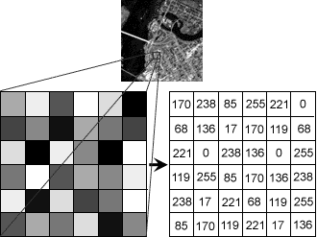
Each pixel has a color. The color is a 32-bit integer. The first eight bits determine the redness of the pixel, the next eight bits the greenness, the next eight bits the blueness and the remaining eight bits the transparency of the pixel.

Figure.1.2. Image Pixel
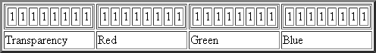
Figure.1.3. Transparency Image

IMAGE FILE SIZES:
Image file size is expressed as the number of bytes that increases with the number of pixels composing an image, and the colour depth of the pixels. The greater the number of rows and columns, the greater the image resolution, and the larger the file. Also, each pixel of an image increases in size when its colour depth increases, an 8-bit pixel (1 byte) stores 256 colours, a 24-bit pixel (3 bytes) stores 16 million colour, the latter known as true colour.
Image compression uses algorithms to decrease the size of a file. High resolution digital cameras record 12 megapixel (1MP = 1,000,000 pixels / 1 million) images, or more, in true color.

IMAGE FILE FORMATS:
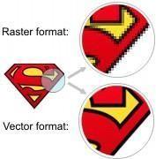
Image file formats are standardized means of organizing and storing images. This entry is about digital image formats used to store photographic and other images. Image files are composed of either pixel or vector (geometric) data that are rasterized to pixels when displayed (with few exceptions) in a vector graphic display. Including proprietary types, there are hundreds of image file types. The PNG, JPEG, and GIF formats are most often used to display images on the Internet.
Figure.1.4 Resolution Image
In addition to straight image formats, Metafile formats are portable formats which can include both raster and vector information.

RASTER FORMATS:
These formats store images as bitmaps

JPEG/JFIF:
JPEG (Joint Photographic Experts Group) is a compression method. JPEG compressed images are usually stored in the JFIF (JPEG File Interchange Format) file format. JPEG compression is lossy. Nearly every digital camera can save images in the JPEG/JFIF format, which supports 8 bits per color (red, green, blue) for a 24-bit total, producing relatively small files. Photographic images may be better stored in a lossless non-JPEG format if they will be re-edited, or if small "artifacts" are unacceptable. The JPEG/JFIF format also is used as the image compression algorithm in many Adobe PDF files.

EXIF:
The EXIF (Exchangeable image file format) format is a file standard similar to the JFIF format with TIFF extensions. It is incorporated in the JPEG writing software used in most cameras. Its purpose is to record and to standardize the exchange of images with image metadata between digital cameras and editing and viewing software. The metadata are recorded for individual images and include such things as camera settings, time and date, shutter speed, exposure, image size, compression, name of camera, color information, etc. When images are viewed or edited by image editing software, all of this image information can be displayed.

TIFF :
The TIFF (Tagged Image File Format) format is a flexible format that normally saves 8 bits or16 bits per colour (red, green, blue) for 24-bit and 48-bit totals, respectively, usually using either the TIFF or TIF filename extension. TIFFs are lossy and lossless. Some offer relatively good lossless compression for bi-level (black & white) images. Some digital cameras can save in TIFF format, using the LZW compression algorithm for lossless storage. TIFF image format is not widely supported by web browsers. TIFF remains widely accepted as a photograph file standard in the printing business. TIFF can handle device-specific color spaces, such as the CMYK defined by a particular set of printing press inks.

PNG :
The PNG (Portable Network Graphics) file format was created as the free, open- source successor to the GIF. The PNG file format supports true color (16 million colors) while the GIF supports only 256 colors. The PNG file excels when the image has large, uniformly colored areas. The lossless PNG format is best suited for editing pictures, and the lossy formats, like JPG, are best for the final distribution of photographic images, because JPG files are smaller than PNG files. PNG, an extensible file format for the lossless, portable, well- compressed storage of raster images. PNG provides a patent-free replacement for GIF and can also replace many common uses of TIFF. Indexed-color, grayscale, and true color images are supported, plus an optional alpha channel. PNG is designed to work well in online viewing applications, such as the World Wide Web. PNG is robust, providing both full file integrity checking and simple detection of common transmission errors.

GIF :
GIF (Graphics Interchange Format) is limited to an 8-bit palette, or 256 colors. This makes the GIF format suitable for storing graphics with relatively few colors such as simple diagrams, shapes, logos and cartoon style images. It is still widely used to provide image animation effects.

BMP :
The BMP file format (Windows bitmap) handles graphics files within Microsoft Windows OS. Typically, BMP files are uncompressed, hence they are large. The advantage is their simplicity and wide acceptance in Windows programs.

VECTOR FORMATS:
As opposed to the raster image formats above, vector image formats contain a geometric description which can be rendered smoothly at any desired display size. At some point, all vector graphics must be rasterized in order to be displayed on digital monitors.

CGM :
CGM (Computer Graphics Metafile) is a file format for 2D vector graphics, raster graphics, and text. All graphical elements can be specified in a textual source file that can be compiled into a binary file or one of two text representations. CGM provides a means of graphics data interchange for computer representation of 2D graphical information independent from any particular application, system, platform, or device.

SVG :
SVG (Scalable Vector Graphics) is an open standard created and developed by the World WideWeb Consortium to address the need for a versatile, scriptable and all purpose vector format for the web . The SVG format does not have a compression scheme of its own, but due to the textual nature of XML.An SVG graphic can be compressed using a program such as gzip.

IMAGE PROCESSING:
Digital image processing is the manipulation of images by computer .There is relatively recent development in terms of man’s ancient fascination with visual stimuli. In its short history, it has been applied to practically every type of images with varying degree of success. The inherent subjective appeal of pictorial displays attracts perhaps a disproportionate amount of attention from the scientists and also from the layman.

FUNDAMENTAL STEPS IN IMAGE PROCESSING:
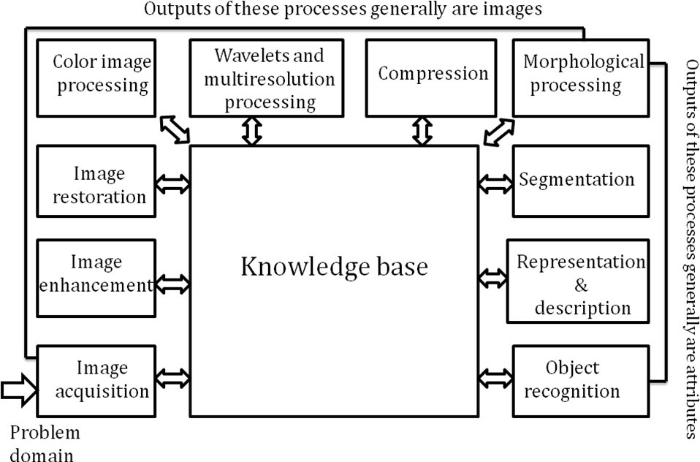

Figure.1.5.Image Fundamentals

Image Acquisition:

Image Acquisition is to acquire a digital image. To do so requires an image sensor and the capability to digitize the signal produced by the sensor. The sensor could be a monochrome or colour TV camera that produces an entire image of the problem domain every 1/30 sec. The image sensor could also be a line scan camera that produces a single image line at a time. Scanner produces a two-dimensional image. If the output of the camera or other imaging sensor is not in digital form, an analogue to digital converter digitizes it.

1.5.2 Image Enhancement:
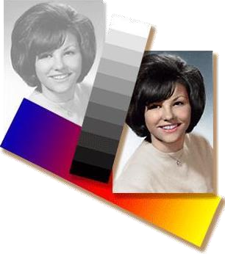
Image enhancement is among the simplest and most appealing areas of digital image processing. Basically, the idea behind enhancement techniques is to bring out detail that is obscured, or simply to highlight certain features of interesting an image. It is important to keep in mind that enhancement is a very subjective area of image processing.
Fig.1.6.Enhancement

Image Restoration:

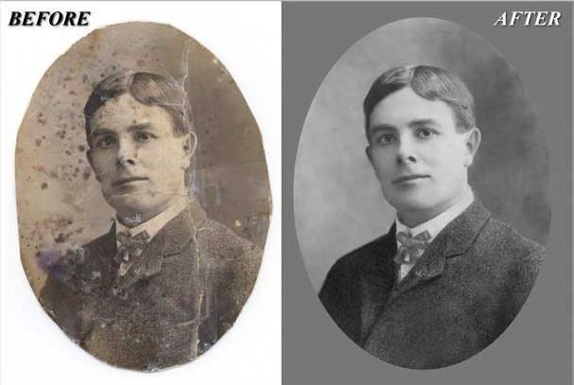
Image restoration is an area that also deals with improving the appearance of an image. However, unlike enhancement, which is subjective, image restoration is objective, in the sense that restoration techniques tend to be based on mathematical or probabilistic models of image degradation. Enhancement, on the other hand, is based on human subjective preferences regarding what constitutes a “good” enhancement result. For example, contrast stretching is considered an enhancement technique because it is based primarily on the pleasing aspects it might present to the viewer, where as removal of image blur by applying a deblurring function is considered restoration technique.
Fig.1.7.Restoration

Colour Image Processing:
The use of colour in image processing is motivated by two principal factors. First, colour is a powerful descriptor that often simplifies object identification and extraction from a scene. Second, humans can discern thousands of colour shades and intensities, compared to about only two dozen shades of gray. This second factor is particularly important in manual image analysis.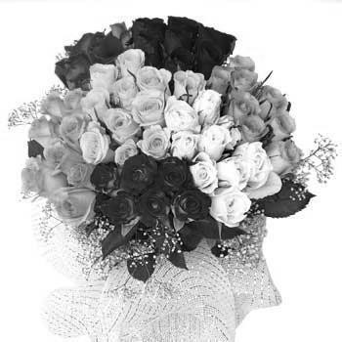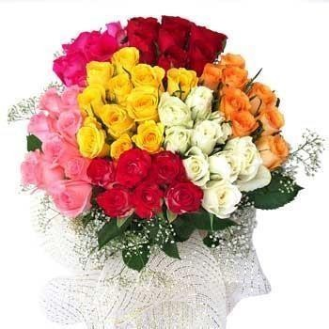
Fig.1.8.Colour & gray scale image

Wavelets and Multiresolution Processing:
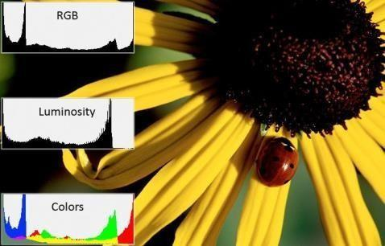
Wavelets are the formation for representing images in various degrees of resolution. Although the Fourier transform has been the mainstay of transform based image processing since the late1950’s, a more recent transformation called the wavelet transform is now making it even easier to compress, transmit, and analyze many images.
Fig.1.9.RGB Histogram Image

Compression:
Compression, as the name implies, deals with techniques for reducing the storage required saving an image, or the bandwidth required for transmitting it. Although storage technology has improved significantly over the past decade, the same cannot be said for transmission capacity.

1.5.7 Morphological processing:
Morphological processing deals with tools for extracting image components that are useful in the representation and description of shape. The language of mathematical morphology is set theory. The morphology offers a unified and powerful approach to numerous image processing problems. Sets in mathematical morphology represent objects in an image. For example, the set of all black pixels in a binary image is a complete morphological description of the image.

Segmentation:
Segmentation procedures partition an image into its constituent parts or the objects. In general,
autonomous segmentation is one of the most difficult tasks in digital image processing. A rugged segmentation procedure brings the process a long way toward successful solution of imaging problems that require objects to be identified individually.
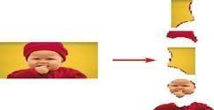

Fig.1.11.Segmentation

Representation and description:
Representation and description almost always follow the output of a segmentation stage, which usually is raw pixel data, constituting either the boundary of a region (i.e., the set of pixels separating one image region from another) or all the points in the region itself. In either case, converting the data to a form suitable for computer processing is necessary. The first decision that must be made is whether the data should be represented as a boundary or as a complete region. Boundary representation is appropriate when the focus is on external shape characteristics.

Object Recognition:
The last stage involves recognition and interpretation. Recognition is the process that assigns a label to an object based on the information provided by its descriptors. Interpretation involves assigning meaning to an ensemble of recognized objects.

1.5.11 Knowledge base:
Knowledge about a problem domain is coded into image processing system in the form of a knowledge database. This knowledge may be as simple as detailing regions of an image when the information of interests is known to be located, thus limiting the search that has to be conducted in seeking that information. The knowledge base also can be quite complex, such as an inter related to list of all major possible defects in a materials inspection problem or an image data base containing high resolution satellite images of a region in connection with change deletion application.
1.6 COMPONENTS OF AN IMAGE PROCESSING SYSTEM:
The lowering costs, this market shift also served as a catalyst for a significant number of new companies whose specialty is the development of software written specifically for image processing. Although large-scale image processing systems still are being sold for massive imaging applications, such as processing of satellite images, the trend continues toward miniaturizing and blending of general-purpose small computers with specialized image processing hardware.

Image Sensors:
With reference to sensing, two elements are required to acquire digital images. The first is a physical device that is sensitive to the energy radiated by the object we wish to image. The second, called a digitizer, is a device for converting the output of the physical sensing device into digital form. For instance, in a digital video camera, the sensors produce an electrical output proportional to light intensity. The digitizer converts these outputs to digital data.

Specialized Image Processing Hardware:
Specialized image processing hardware usually consists of the digitizer just mentioned, plus hardware that performs other primitive operations, such as an arithmetic logic unit (ALU), which performs arithmetic and logical operations in parallel on entire images. One example of how an ALU is used is in averaging images as quickly as they are digitized, for the purpose of noise reduction. This type of hardware sometimes is called a front-end subsystem, and its most distinguishing characteristic is speed.

Computer:
The computer in an image processing system is a general-purpose computer and can range from a PC to a supercomputer. In dedicated applications, sometimes specially designed computers are used to achieve a required level of performance.
- Image Processing Software:
Software for image processing consists of specialized modules that perform specific tasks. A well-designed package also includes the capability for the user to write code that, as a minimum, utilizes the specialized modules. More sophisticated software packages allow the integration of those modules and general-purpose software commands from at least one computer language.

Mass storage:
Mass storage capability is a must in image processing applications. An image of size 1024*1024 pixels, in which the intensity of each pixel is an 8-bit quantity, requires one megabyte of storage space if the image is not compressed. Digital storage for image processing applications fall into three principal categories:
(1) short-term storage for use during processing, (2) on-line storage for relatively fast recall, and (3) archival storage, characterized by infrequent access. Storage is measured in bytes (eight bits), Kbytes (one thousand bytes), Mbytes (one million bytes), Gbytes (meaning giga, or one billion, bytes), and Tbytes (meaning tera, or one trillion, bytes)

Image displays :
Image displays in use today are mainly color (preferably flat screen) TV monitors. Monitors are driven by the outputs of image and graphics display cards that are an integral part of the computer system.
- Network :
Networking is almost a default function in any computer system in use today. Because of the large amount of data inherent in image processing applications, the key consideration in image transmission is bandwidth
Colour and texture are two low-level features widely used for image classification, indexing and retrieval. Colour is usually represented as a histogram, which is a first order statistical measure that captures global distribution of colour in an image One of the main drawbacks of the histogram- based approaches is that the spatial distribution and local variations in colour are ignored. Local spatial variation of pixel intensity is commonly used to capture texture information in an image. Grayscale Co- occurrence Matrix (GCM) is a well-known method fortexture extraction in the spatial domain. A GCM stores the number of pixel neighbourhoods inan image that have a particular grayscale combination. Let I be an image and let p and Np respectively denote any arbitrary pixel and its neighbour in a given direction. If GL denotes the total number of quantized gray levels and gl denotes the individual gray levels, where, gl {0, . .
.,GL _ 1}, then each component of GCM can be written as follows:
gcm(i, j) is the number of times the gray level of a pixel p denoted by glp equals i, and the gray level of its neighbor Np denoted by gl Np equals j, as a fraction of the total number of pixels in the image. Thus, it estimates the probability that the gray level of an arbitrary pixel in an image is i, and that of its neighbor is j. One GCM matrix is generated for each possible neighbor hood direction, namely, 0, 45, 90 and 135.Average and range of 14 features like Angular Second Moment, Contrast, Correlation, etc., are generated by combining all the four matrices to get a total of 28 features. In the GCM approach for texture extraction, color information is completely lost since only pixel gray levels are considered.

CHAPTER 2

INTRODUCTION ABOUT PROJECT
Drowsiness is a state of near sleep, where the person has a strong desire for sleep. It has two distinct meanings, referring both to the usual state preceding falling asleep and the chronic condition referring to being in that state independent of a daily rhythm. Sleepiness can be dangerous when performing tasks that require constant concentration, such as driving a vehicle. When a person is sufficiently fatigue while driving, they will experience drowsiness and this leads to increase the factor of road accident.
Figure.2.1:Examples of Fatigue & Drowsiness Condition

The development of technologies for detecting or preventing drowsiness while driving is a major challenge in the field of accident avoidance system. Because of the hazard that drowsiness presents on the road, methods need to be developed for counteracting its affects.

The aim of this project is to develop a simulation of drowsiness detection system. The focus will be placed on designing a system that will accurately monitor the open or closed state of the driver’s eyes and mouth. By monitoring the eyes, it is believed that the symptoms of driver's drowsiness can be detected at a sufficiently early stage, to avoid a car accident. Yawning detection is a method to assess the driver’s fatigue. Another method to detect eye closure is PERCLOS. This detection method is based on the time of eyes closed which refers to the percentage of a specific time.

The analysis of face images is a popular research area with applications such as face recognition, and human identification and tracking for security systems. This project is focus on the localization of the eyes and mouth, which involves looking at the entire image of the face, and determining the position of the eyes and mouth, by applying the existing methods in image-processing algorithm. Once the position of the eyes is located, the system is designed to determine whether the eyes and mouth are opened or closed, and detect fatigue & drowsiness.
2.1. Background of Study
Each year, there is an increase in road accidents involving cars and heavy vehicles like buses, lorries and trucks. Drowsiness and fatigue conditions are one of the prime factors contributing to road accidents. Driving in this condition may result in terrible causes since it affects the driver’s judgment and concentration. Falling asleep on the wheel can be avoided if the drivers take efforts such as getting enough sleep before driving, taking caffeine or stop for a while to rest when the signs of fatigue and drowsiness appear.
However, in many cases, drivers refuse to take one of these steps even when they know that they are suffering from fatigue, and will continue driving. Therefore, detecting drowsiness is important as one of the steps to prevent the road accidents. This project proposed that yawning and eyes detection is the obvious signs of fatigue and drowsiness.
A drowsiness detection system which use a camera placed in front of the driver is more suitable to be use but the physical signs that will indicate drowsiness need to be located first in order to come up with a drowsiness detection algorithm that is reliable and accurate. Lighting intensity and while the driver tilt their face left or right are the problems occur during detection of eyes and mouth region. Therefore, this project aims to analyse all the previous research and method, hence propose a method to detect drowsiness by using video or webcam.

Objectives
The project focuses on these objectives, which are:
    - To suggest ways to detect fatigue and drowsiness while driving.
    - To study eyes and mouth from the video images of participants in the experiment.
    - To develop a system that use eyes closure and yawning as a way to detect fatigue and drowsiness.

Scope of Study
In this project, we will focus on these following procedures:

    - Basic concept of drowsiness detection system.

    - Familiarize yourself with the signs of drowsiness.

    - Determine the drowsiness from these parameters.

    - Eye blink.

    - Area of the pupils detected at eyes.

    - Yawning.

    - Data collection and measurement.

    - Integration of the methods chosen.

    - Coding development and testing.

    - Complete testing and improvement.

IMPLEMENTATION OF THE PROJECT:
Once the face area is found, the eyes are found by computing the horizontal averages in the area. Taking into account the knowledge that eye regions in the face present great intensity changes, the eyes are located by finding the significant intensity changes in the face.

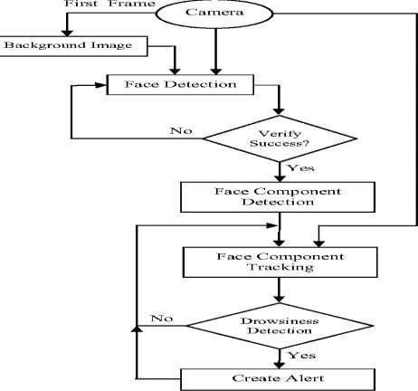

Figure.2.2 Flow Diagram

A large distance corresponds to eye closure. If the eyes are found closed for 5 consecutive frames, the system draws the conclusion that the driver is falling asleep and issues a warning signal. The system is also able to detect when the eyes cannot be found, and works under reasonable lighting conditions.
In this project we use Viola-Jones Algorithm.
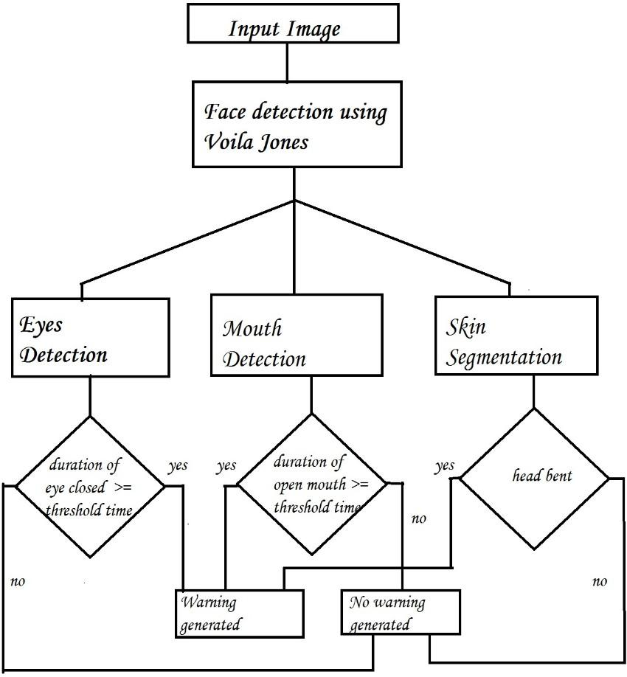

Figure2.3 Flowchart of the Algorithm

MODULES OF THE APPLICATION:

Data Acquisition:
The video is recorded using a webcam (Sony CMU-BR300) and the frames are extracted and processed in a laptop. After extracting the frames, image processing techniques are applied on these 2D images. Presently, synthetic driver data has been generated. The volunteers are asked to look at the webcam with intermittent eye blinking, eye closing, yawning and head bending. The video is captured for 30 minutes.

Face Detection:

After extracting the frames, first the human faces are detected. Numerous online face detection algorithms are there. In this study, histogram of oriented gradients (HOG).In this method, positive samples of descriptors are computed on them. Subsequently, negative samples (samples that do not contain the required object to be detected i.e., human face here) of same size are taken and HOG descriptors are calculated. Usually the number of negative samples is much greater than the number of positive samples. After obtaining the features for both the classes. To improve the accuracy of VJM, hard negative mining is used. In this method, after training. the classifier is tested on the labelled data and the false positive sample feature values are used again for training purpose.

For the test image, the fixed size window is translated over the image and the classifier computes the output for each window location. Finally, the maximum value output is considered as the detected face and a bounding box is drawn around the face. This non-maximum suppression step removes the redundant and overlapping bounding boxes.

Facial Landmark marking:
After detecting the face, the next task is to find the locations of different facial features like the corners of the eyes and mouth, the tip of the nose and so on. Prior to that, the face images should be normalized in order to reduce the effect of distance from the camera, non-uniform illumination and varying image resolution. Therefore, the face image is resized to a width of 500 pixels and converted to grayscale image. After image normalization, ensemble of regression trees is used to estimate the landmark positions on face from a sparse subset of pixel intensities. In this method, the sum of square error loss is optimized using gradient boosting learning. Different priors are used to find different structures.The red points are the detected landmarks for further processing.

Feature Extraction:
After detecting the facial landmarks, the features are computed. From the eye corner points the eye aspect ratio is calculated as the ratio of height and width of the eye.

CLASSIFICATION:
After computing all the three features, the next task is to detect drowsiness in the extracted frames. In the beginning, adaptive thresholding is considered for classification. Later using viola jones algorithm is utilized to classify the data. For computing the threshold values for each feature, it is assumed that initially the driver is in complete awake state. This is called setup phase. In the setup phase, the EAR values for first three hundred (for 10s at 30 fps) frames are recorded. Out of these three hundred initial frames containing face, average of 150 maximum values is considered as the hard threshold for EAR. The higher values are considered so that no eye closing instances will be present. If the test value is less than this threshold, then eye closing (i.e., drowsiness) is detected. As the size of eye can vary from person to person, this initial setup for each person will reduce this effect. Similarly, for calculating threshold of MOR, since the mouth may not be open to its maximum in initial frames (setup phase) so the threshold is taken experimentally from the observations. If the test value is greater than this threshold then yawn is detected. Head bending feature is used to find the angle made by head with respect to vertical axis in terms of ratio of projected nose lengths. Normally, NLR has values from 0.9 to 1.1 for normal upright position of head and it increases or decreases when head bends down or up in the state of drowsiness.

Decision Making:
The first frame is used for learning. All the results are calculated taking first frame as ideal frame.
Eyes Closed
When eyes are closed, the number of black pixels in binary image decreases considerably.
If eyes are found closed for atleast 2 consecutive seconds (i.e. 2 * 16 = 32 frames, considering 16 frames per second), then the warning will be generated.
Head Lowering
If the head is lowered, or turned around the number of skin pixels considerably decrease as compared to the ideal frame.
If head is found lowered or found turned in other directions for atleast 2 consecutive seconds (i.e. 2 * 16 = 32 frames, considering 16 frames per second), it means that the person is vulnerable for accident and in response the warning will be generated.

2.7.LITERATURE SURVEY:
There are many previous researches regarding driver drowsiness detection system that can be used as a reference to develop a real-time system on detecting drowsiness for drivers. There is also several method which use different approaches to detect the drowsiness signs. According to MIROS (Malaysia Institute of Road Safety), from the year of 2007 until 2010, they were 439 cases of road accidents have been investigated by the MIROS crash team.
Antoine Picotetal, stated that drowsiness is where a person is in the middle of awake and sleepy state. This situation leads the driver to not giving full attention to their driving. Therefore, the vehicle can no longer be controlled due to the driver being in a semi-conscious state. According to Gianluca Borghini et al, mental fatigue is a factor of drowsiness and it caused the person who experiences to not be able to perform because it decreases the efficiency of the brain to respond towards sudden events. Electroencephalography (EEG) is a method that measures the brain electrical activity. It can be used to measure the heartbeat, eye blink and even major physical movement such as head movement. It can be used on human or animal as subjects to get the brain activity. It uses a special hardware that place sensors around the top of the head area to sense any electrical brain activity.
B. T. Jap, S. Lal, P. Fischer, and E. Bekiaris mentioned that from the method that has been implemented by the previous researcher to detect drowsiness signs, the EEG method is best to be applied for drowsiness and fatigue detection. In the method, EEG have four types of frequency components that can be analyzed, i.e. alpha (α), beta (β), theta (θ) and delta (δ). When the power is increased in alpha (α) and delta (δ) frequency bands, it shows that the driver is facing fatigue and drowsiness. The disadvantages of this method are, it is very sensitive to noise around the sensors. For example, when the person is doing the EEG experiment, the surrounding area must be completely silent. The noise will interfere with the sensors that detect the brain activity. Another disadvantage of this method is that even if the result might be accurate, it is not suitable to use for real driving application. Imagine when a person is driving and he is wearing something on his head with full of wires and when the driver moves their head, the wire may strip off from their place. Even though it is not convenient to be used for real-time driving but for experiment purposes and data collection, it is one of the best methods so far.
D. Liu, P. Sun, Y. Xiao, and Y. Yin stated that the drowsiness can be detected by using face area detection.The methods to detect drowsiness within face area are vary due to drowsiness sign are more visible and clear to be detected at face area. From the face area, we can detect the eyes location. From eyes detection, authors stated that there are four types of eyelid movement that can be used for drowsiness detection. They are complete open, complete close, and in the middle where the eyes are from open to close and vice versa.
The algorithm processes the images captured in grey-scale method; where the color from the images is then transformed into black and white. Working with black and white images is easier because only two parameters have to be measured. The author then performs the edge detection to detect the edges of eyes so that the value of eyelid area can be calculated. The problem occurring with this method is that the size area of eye might vary from one person to another. Someone may have small eyes and looks like it is sleepy but some are not.
Other than that, if the person is wearing glasses, there is obstacle to detect eye region. Images that being captured must be in certain range from the camera because when the distance is far from the camera, the images are blurred.
D. F. Dinges and R. Grace, stated that drowsiness can be captured by detecting the eye blinks and percentage of eye closure (PERCLOS). For eye blink detection, propose a method which learned the pattern of duration of eyelid closed. According to T. Danisman, I. M. Bilasco, C. Djeraba, and N. Ihaddadene, ‘this proposed method measures the time for a person closed their eyes and if they are closed longer than the normal eye blink time, it is possible that the person is falling asleep’. The author mentioned that ‘nearly 310.3ms are the average of normal person eye blink’.
PERCLOS method proposes that drowsiness is measured by calculating the percentage of the eyelid ‘droops’. Sets of eye open and eye closed have been stored in the software library to be used as a parameter to differentiate either the eyes is fully open or fully closed. For eyelid to droops, it happened in much slower time as the person is slowly falling asleep. Hence, the transition of the driver’s drowsy can be recorded. Thus, PERCLOS method put a proportional value where when the eyes is 80% closed, which it is nearly to fully close, it assumed that the driver is drowsy.
This method is not convenient to be used in real-time driving as it needs fix threshold value of eye opening for the PERCLOS method to perform accurately. Both methods to detect drowsiness using eye blink pattern and PERCLOS have the same problem where the camera need to be placed at a specific angle in order to get a good image of video with no disturbance of eyebrow and shadow that covers the eyes.

CHAPTER-3 TECHNOLOGY
This chapter delves into the technological approach used to accomplish the project's goals, presenting a thorough scrutiny of the project's execution process. It encompasses a comprehensive evaluation of every pivotal stage crucial for project finalization, elucidating the reasoning behind method choices and their effective application across the project's development. The central software employed in this project is the MATLAB® Computer Vision System, and the techniques harnessed utilize pre-existing MATLAB® commands for detecting facial attributes such as the face, eyes, and mouth regions."
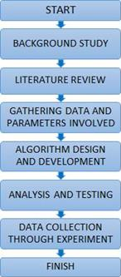
Figure.3.1 Flowchart of project progress

ALGORITHM USED:
Viola-Jones Face Detection Algorithm:

The Viola–Jones object detection framework, conceived by Paul Viola and Michael Jones in 2001, was designed to achieve real-time competitive object detection rates. While it can be trained to recognize a diverse range of object classes, its primary focus was addressing the challenge of face detection. During the detection phase of the Viola–Jones object detection framework, a window of the target size traverses the input image, and for each image subsection, Haar-like features are computed. These feature differences are then compared to a pre-learned threshold, distinguishing objects from non-objects. Given that a Haar-like feature is essentially a weak classifier (only slightly better than random guessing), a substantial number of these features is required to accurately describe an object. Consequently, the Viola–Jones object detection framework employs a classifier cascade, an arrangement of Haar-like features, to collectively form a robust classifier.
After the face is detected using Viola-Jones, the region containing the eyes and mouth has to be separated. To detect the coordinate from where the region of eye is starting certain calculations are done. After the rectangular window is extracted, we have considered that the eyes are located at a distance of (0.25 * height of window) from the top and (0.15 * width of window) from the left.The size of window is (0.25 * height of window) in height and (0.68 * width of window) in width.
After cropping the eyes, the image undergoes a conversion to the YCbCr color space, with the rationale and conversion process detailed in the "Skin Segmentation" section. Subsequently, the image is transformed into grayscale and then further converted into a binary image by applying a threshold of (minimum pixel value + 10). To identify the starting coordinates of the mouth region, specific calculations are performed. The rectangular window is then extracted, and it is assumed that the mouth is situated at a distance of 0.67 times the window's height from the top and 0.27 times the window's width from the left. The window's dimensions are 0.20 times its height and 0.45 times its width.
When capturing an image inside a vehicle, such as the driver's face, the camera typically operates in the RGB color model, which encompasses not only the primary colors (Red, Green, and Blue) but also considers brightness as an essential component alongside color information.
In the examination of a human face, the RGB color model demonstrates a heightened sensitivity to variations in image brightness, necessitating a crucial second step to mitigate these effects. To address this issue, we opt for the YCbCr color space, a prevalent choice within video compression standards. Given that skin-tone color is intricately tied to luminance, we apply a non-linear transformation to the YCbCr color space, rendering the skin cluster independent of luminance, thereby facilitating the robust identification of both dark and light skin tones. A paramount advantage of this conversion to the YCbCr domain lies in its capability to effectively neutralize the impact of luminosity during our image processing procedures.
In the RGB domain, each component of the picture (red, green and blue) has a different brightness. However, in the YCbCr domain all information about the brightness is given by the Y component, since the Cb (blue) and Cr (red) components are independent from the luminosity. Conversion from RGB to YCbCr:
Cb = (0.148* Red) - (0.291* Green) + (0.439 * Blue) + 128; Cr = (0.439 * Red) - (0.368 * Green) – (0.071 * Blue) + 128;

Conversion from RGB to HSV:
MATLAB has predefined function for conversion of RGB color space to HSV color space. I’ = rgb2hsv (I);

Cascade of Classifiers:
In a standard 24x24 pixel sub-window, an astonishing 45,396 potential features may be discerned, a number that appears exceedingly extensive and financially impractical for comprehensive assessment. To bolster the precision of detection, it becomes essential to supplement the classifiers with supplementary features.
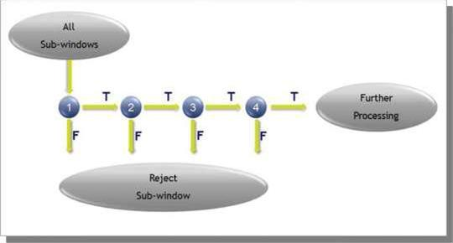
Figure.3.2 Cascade of classifiers

While the evaluation of the robust classifiers generated during the learning phase can be executed relatively swiftly, it still falls short of meeting real-time processing demands. Consequently, a cascading arrangement is implemented, structured in ascending order of complexity. Each subsequent classifier undergoes training exclusively with the sub-windows selected and approved by the preceding classifiers. In any instance along the cascade, if a classifier rejects the examined sub-window, no further processing is triggered, and the search progresses to the next sub-window.
To identify the regions of the eyes and mouth, it is imperative to initially locate the facial area. However, this initial step has the potential to compromise the system's efficiency and speed due to its extensive coverage. The central objective of this project revolves around detecting signs of drowsiness, specifically focusing on the eyes and mouth. Thus, we have deliberately restricted the scope of detection to these areas, a strategic decision aimed at enhancing system performance. Presently, we are in the process of assessing the Cascade Object Detector algorithm using MATLAB® software to determine the regions for detection in the forthcoming system development. Thorough testing is indispensable to ensure that it aligns with the requisite parameters.

MATLAB:
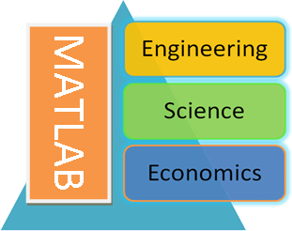
MATLAB is a versatile software suite designed for high-performance mathematical computations, data visualization, and programming tasks. This comprehensive tool offers an interactive environment replete with an extensive library of pre-built functions, catering to a wide range of technical computing, graphical, and animation needs. The acronym "MATLAB" itself stands for "Matrix Laboratory," originating from its original purpose, which was to implement a straightforward approach to matrix software inspired by the "LINPACK" (Linear system package) and "EISPACK" (Eigen system package) projects.
Figure.3.3 MATLAB Various Disciples

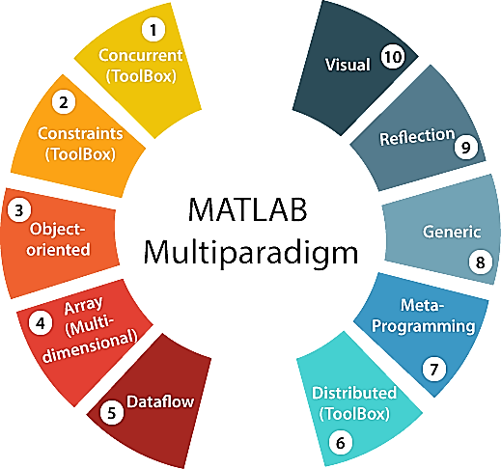
This cutting-edge programming language environment is not only modern but also multi-paradigm, boasting sophisticated data structures, integrated editing and debugging tools, and robust support for object-oriented programming. It's highly adaptable and can seamlessly accommodate various programming approaches, including Functional, Object-Oriented, and Visual, making it a versatile platform that goes beyond just being an environment—it is, in essence, a full-fledged programming language in its own right.

Figure 3.4 MATLAB Multiparadigm

True to its name, MATLAB primarily revolves around matrix-based computations and operations. Regardless of the variable type, be it integers, characters, or strings, MATLAB uniformly stores data in array formats.state-of-the-art algorithms. These are numerous functions for 2-D and 3-D graphics, as well as for animations.
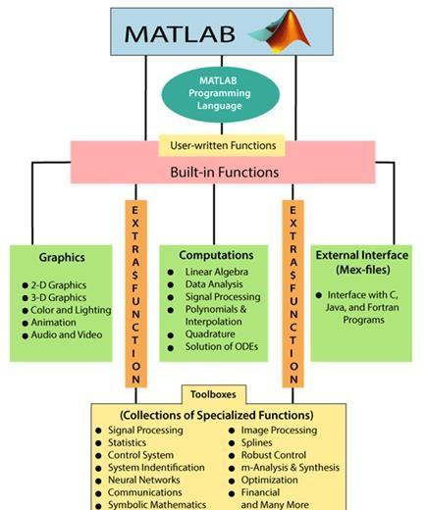
Figure 3.5 Schematic Diagram of Matlab Main Features

MATLAB goes a step further by providing an external interface that enables users to execute their programs seamlessly from within the MATLAB environment. This flexibility extends beyond the confines of built-in functions, allowing users to create custom functions using the MATLAB language. Additionally, a variety of optional "Toolboxes" are offered by MATLAB developers, each containing a suite of specialized functions tailored for specific applications like symbolic computations, image processing, statistics, control system design, and neural networks.
At the core of MATLAB's functionality are matrices, which serve as the essential building blocks. Arrays serve as the fundamental data type, and MATLAB expertly handles vectors, scalars, real matrices, and complex matrices as unique instances of this primary data type. In essence, MATLAB is deeply rooted in matrices and matrix functions, and its built-in functions are meticulously optimized to excel in vector-based operations.

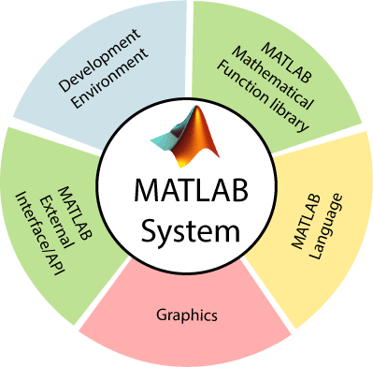
MATLAB System:

Figure 3.6 Elements of MATLAB system

CHAPTER 4

APPLICATIONS OF DROWSINESS DETECTION

The applications of a drowsiness detection and auto alerting system using image processing is to detect when a driver is becoming drowsy and alert them to prevent an accident. The drowsiness detection and auto alerting system using image processing can be useful in any situation where the safety of people is a concern. This technology can be used in various settings, such as:

Transportation:
This technology can be implemented in cars, buses, and trucks to ensure that the driver is alert while driving. If the system detects drowsiness, it can alert the driver to take a break or pull over to rest.

Workplace Safety:
Workers who operate machinery or perform safety critical tasks can benefit from a drowsiness detection system. This system can detect when the worker is getting drowsy and alert them or their supervisor to take a break or switch to a less safety critical task.

Medical Applications:
Drowsiness can be a symptom of many medical conditions, including sleep apnea, narcolepsy and other sleep disorders. A drowsiness detection system can help doctors monitor patients with these conditions and adjust their treatment accordingly.

Gaming Industry:
A drowsiness detection system can also be used in the gaming industry to alert players who are getting too tired and may need to take a break to avoid eye strain or other health problems associated with excessive screen time.

Educational Institutions:
Students who are studying or attending online classes for extended periods can benefit from this system. It can detect when they are getting drowsy and suggest them to take a break or switch to a different task.

CHAPTER 5

RESULTS
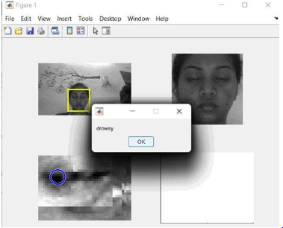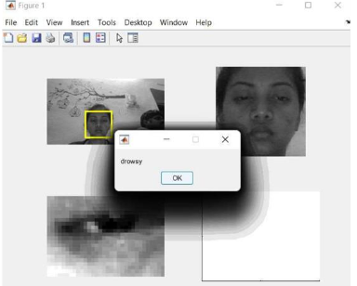
Figure 5.1 Drowsy Figure 5.2 Drowsy

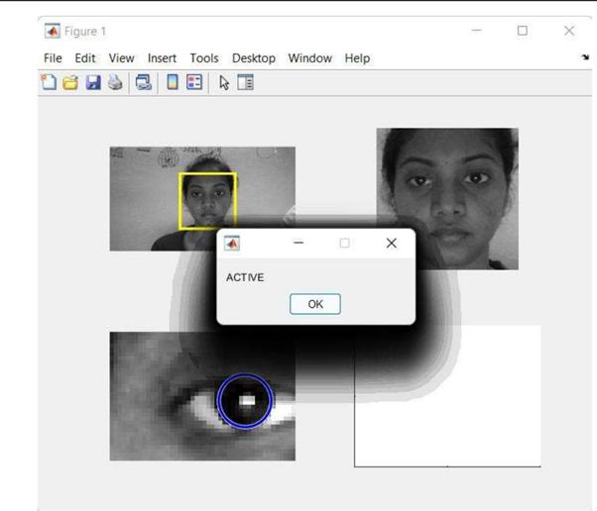
Figure 5.3 Active

CHAPTER 6

CONCLUSION AND FUTURE SCOPE

CONCLUSION:

Leveraging the MATLAB platform in conjunction with the Viola-Jones Algorithm, we have skillfully executed a robust drowsiness detection system. Following its development, our system underwent rigorous testing, illuminating both its accomplishments and limitations.

FUTURE SCOPE:

To ensure real-time drowsiness detection and prompt intervention, it is imperative to not merely rely on static threshold-based drowsiness detection. Instead, a continuous monitoring approach is necessary. By continuously monitoring drowsiness levels, the system can generate a signal to take direct control of the vehicle's brakes when the drowsiness level surpasses a predefined threshold, thereby actively slowing down the vehicle's speed.

BIBLIOGRAPHY

1.Z. Ahmad Noor Syukri, M. SitiAtiqah, L. Fauziana, and A. Abdul Rahmat, "MIROS crash investigation and reconstruction: annual statistical 2007-2010," 2012.

2.A. Picot, S. Charbonnier, and A. Caplier, "On-line automatic detection of driver drowsiness using a single electroencephalographic channel," in Engineering in Medicine and Biology Society, 2008. EMBS 2008. 30th Annual International Conference of the IEEE, 2008, pp. 3864- 3867.

3.G. Borghini, L. Astolfi, G. Vecchiato, D. Mattia, and F. Babiloni, "Measuring neurophysiological signals in aircraft pilots and car drivers for the assessment of mental workload, fatigue and drowsiness," Neuroscience &Biobehavioral Reviews, 2012.

4.B. T. Jap, S. Lal, P. Fischer, and E. Bekiaris, "Using EEG spectral components to assess algorithms for detecting fatigue," Expert Systems with Applications, vol. 36, pp. 2352-2359, 2009.

5.D. Liu, P. Sun, Y. Xiao, and Y. Yin, "Drowsiness Detection Based on Eyelid Movement," in Education [1]Technology and Computer Science (ETCS), 2010 Second International Workshop on, 2010, pp. 49-52.

6.H. Seifoory, D. Taherkhani, B. Arzhang, Z. Eftekhari, and H. Memari, "An Accurate Morphological Drowsy Detection," ed: IEEE, 2011.

7.D. J. McKnight, "Method and apparatus for displaying grey-scale or color images from binary images," ed: Google Patents, 1998.

8.T. Welsh, M. Ashikhmin, and K. Mueller, "Transferring color to greyscale images," ACM Transactions on Graphics, vol. 21, pp. 277-280, 2002.

9.I. Garcia, S. Bronte, L. Bergasa, N. Hernandez, B. Delgado, and M. Sevillano, "Vision-based drowsiness detector for a realistic driving simulator," in Intelligent Transportation Systems (ITSC), 2010 13th International IEEE Conference on, 2010, pp. 887-894.

- T. Danisman, I. M. Bilasco, C. Djeraba, and N. Ihaddadene, "Drowsy driver detection system using eye blink patterns," in Machine and Web Intelligence (ICMWI), 2010 International Conference on, 2010, pp. 230-233.

- S. T. Lin, Y. Y. Tan, P. Y. Chua, L. K. Tey, and C. H. Ang, "PERCLOS Threshold for Drowsiness Detection during Real Driving," Journal of Vision, vol. 12, pp. 546-546, 2012.

- R. Grace, V. E. Byrne, D. M. Bierman, J.-M. Legrand, D. Gricourt, B. Davis, et al., "A drowsy driver detection system for heavy vehicles," in Digital Avionics Systems Conference, 1998. Proceedings., 17th DASC. The AIAA/IEEE/SAE, 1998, pp. I36/1-I36/8 vol. 2.

- Q. Wang, J. Yang, M. Ren, and Y. Zheng, "Driver fatigue detection: a survey," in Intelligent Control and Automation, 2006. WCICA 2006. The Sixth World Congress on, 2006, pp. 8587- 8591.

14.M. Saradadevi and P. Bajaj, "Driver fatigue detection using mouth and yawning analysis," IJCSNS International Journal of Computer Science and Network Security, vol. 8, pp. 183-188, 2008.

15. Bereshpolova Y, Stoelzel CR, Zhuang J, Amitai Y, Alonso JM, Swadlow HA. (2011) "Getting drowsy? Alert/nonalert transitions and visual thalamocortical network dynamics". J Neurosci. 2011, 48: 17480-17487.

