Relation of TPB Model on Entrepreneurship Intention among Hospitality Management Graduates in Bangalore
*Vineeta Kumari, Assistant Professor **Sampath N,
Faculty of Hospitality Management and Student, MBA- HM
Catering Technology, Ramaiah University Faculty of Hospitality Management &
of Applied Sciences, Bengaluru Catering Technology, Ramaiah University
Email:- vkumari658@gmail.com of Applied Science, Bengaluru

ABSTRACT
The current research aims to undertake a study on the impact of the Theory of planned behavior on the entrepreneurial intentions among Hospitality Management graduate students in Bangalore, Karnataka. Based on the theoretical background, factors shape an individual to have entrepreneurial intentions such as personal and social factors (Bird,1988). This research aims to evaluate which variable has more impact on entrepreneurial intentions. The current research adopted a quantitative method by distributing a questionnaire among Hospitality Management graduate students. Data was gathered through a Google form and used JMP to find TPB’s impact on EI for data analysis. The finding shows that Perceived Attitude has more impact on entrepreneurial intention compared to subjective norms. This research concluded that Personal Attitude has more impact, after perceived Behavioral Control, and a weak and less impact from the subjective norm on entrepreneurial intentions. Using the above theoretical model this study offers detailed insights into how entrepreneurship intention is formed among the Hospitality Management graduate students

Keywords: Entrepreneurial Intentions, Theory of Planned Behavior (TPB)

I. INTRODUCTION

In recent times, there has been a renewed interest in entrepreneurs and their successes and motivation. Increasing societal approval and resounding success stories of some of the celebrity entrepreneurs coupled with volatile markets creating high risks have enabled individuals to source new opportunities in terms of funding, marketing, and advertising. At the same time, entrepreneurs face business innovation challenges and fast-changing consumer demands.
An entrepreneur is a person who undertakes a wealth-creating and value-adding process, through incubating ideas, assembling resources, and making things happen. While ‘making things happen’ entrepreneurs act as “engines of economic growth” and aid in stimulating the country’s economy and contribute significantly to the development of the country. Hence, entrepreneurship assumes great significance as one of the best economic development strategies that help to sustain the country's competitiveness in facing the impact of globalization.
Entrepreneurship is a major force in driving the economy of a country. Entrepreneurial intent is a fundamental section to the resolution of Indian development subject and future socio-political stability (Ngatse-Ipangui & Dassah, 2019). The occurrence of entrepreneurial factors varies across countries and cultures. Factors contributing to these differences are culture, the level of economic development of a country, and political-economic traditions (Barnir et al., 2011). Promoting entrepreneurial practice is an important topic among universities, governments, and researchers (Cobbinah & Chinyamurindi, 2018). However, it is also important to know the entrepreneurial intentions of students when educating them as future entrepreneurs.
In today’s context, there is a lot of encouragement from governments to promote entrepreneurship among the population. Initiatives such as “The startup India”, and “Stand up India” are expected to motivate the youth towards entrepreneurship. At this juncture, it becomes pertinent to study entrepreneurship intention among students which will help academicians, policy formulators, and administrators. In that direction, the present study aims at knowing the entrepreneurial intention currently prevailing among University students, particularly among postgraduate business administration students in India.
In this regard, the study of the behavior of entrepreneurs assumes great importance. The present study considers that venture creation by individuals is a planned behavior that is affected by various factors like attitude towards entrepreneurship, the importance of approval from important people in the individual’s life and environment along with self-efficacy of the individual. Entrepreneurial intentions form the dependent variable of the study and the elements of planned behavior are the independent variables. This study aims to investigate the entrepreneurial intentions (EI) of Hospitality. Management Graduate students specifically and to make recommendations for the creation of conditions fostering entrepreneurial intentions within the Bangalore region.
The study of entrepreneurial intentions opens arenas to theory-based research. Entrepreneurship intention has been studied from different perspectives by different authors. Authors have approached the subject using personality traits that can be associated with entrepreneurship to differentiate them from non-entrepreneurs (Bird, 1988)
(Mcclelland, 1985)has identified certain important personality traits such as Achievement orientation, Locus of control, Risk-taking propensity, Machiavellianism, etc as important characteristics to explain leadership behavior which is borrowed to explain entrepreneurial behavior also. Afterward, (Boyd & Vozikis, 1994) modified his theory using the concept of self-efficacy. Ajzen translated their ideas into a model called Theory of Planned Behavior (TPB).

A. THEORY OF PLANNED BEHAVIOUR
“The theory of planned behavior” was derived from the “Theory of Reasoned Action” (Ajzen Icek, 1975). The “Theory of Planned Behaviour” (TPB) is essentially an extension of the “Theory of Reasoned Action” (TRA) which includes belief about “perceived behavioral control” as an additional construct (Armitage & Conner, 2001).
The process of entrepreneurship is not happening all of a sudden but the result of an evolutionary process and the decision to become an entrepreneur is consciously taken after finding opportunities, evaluating their merits, selecting the best course of action, mobilizing the required resources, and designing mechanisms to exploit the identified opportunities (Shane et al., 2003). Thus entrepreneurial activity is a well-planned one and hence the TPB offers a better explanation of this intentional action relationship. According to TPB Model, intention towards a particular action is influenced by attitude towards that activity PAT, SSNO, and PBE. The following diagram shows the structural representation of the model.
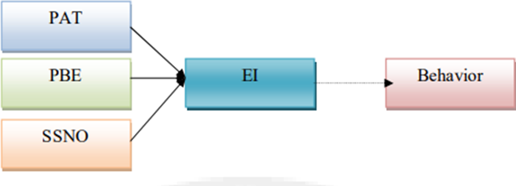
Fig 1.1: TPB model
The central aspect in this theory is the intention of an individual to perform a particular action, to become an entrepreneur in this case. TPB Model postulates three independent factors influencing intention. First one is Personal Attitude towards Entrepreneurship (behavior) PAT. This is nothing but

the degree of personal evaluation (either favorable or unfavorable) towards a particular action in question (entrepreneurship in the present case). The second one is subjective social norms. SSNO refers to the perceived social pressure the individual experiences towards carrying out the particular action (of becoming an entrepreneur in this case).
The third factor is the PBE. PBE refers to the perceived ease or hardship in the performance of a particular (entrepreneurial) action. PBE is the result of self-efficacy which in turn is the result of a perceived Locus of Control. According to (Ajzen, n.d.) the relative importance of attitude, SSNO, and PBE in the prediction of intention vary depending upon variations in behavior and context. Researchers have relied on the TPB model in their attempt to predict intention in varied situations like search for a job, leisure activities, voting choice in elections, weight reduction, etc. The main purpose of this research paper is to analyze the Relation of the TPB Model to Entrepreneurship Intention among Hospitality Management Graduates. To achieve the main purpose of this paper objective was to analyze career intention among Hospitality management students. Investigating motivational factors affecting hospitality students’ entrepreneurial intentions. And analyzing the relation of personal attitude, subjective social norms, and perceived behavioral control toward Entrepreneurship Intention.

II. LITERATURE REVIEW

Karimi, S et al. assessed the influence of entrepreneurship education programs as a compulsory subject and as an elective subject on Iranian students’ EI using an ex-ante and ex-post experimental design adopting the TPB model. They identified that an entrepreneurship education program as an elective significantly increased entrepreneurship intention and the increase was found to be not significant in the case of compulsory subjects. They also found that both types of programs significantly impacted in positive way subjective social norms and perceived behavior control. Hence entrepreneurship education programs become more meaningful and effective when it is offered to students who seek such a program rather than offering it as a compulsory subject to all. In most business schools, EE is offered as a core (compulsory) subject only and not as an optional elective subject that needs to be considered for course development (Karimi et al., 2014)
(Sahban et al., 2016) studied the factors contributing to students’ entrepreneurship intention using a survey among 650 undergraduate students from Asian countries. They investigated three groups of factors personality characteristics (NAC and self-efficacy) environmental aspects (proximity to information, opportunities to mobilize to capital and community network), and demographic factors. They found that students’ EI and determining factors vary from country to country highlighting the role of unique cultural and social backgrounds in creating EI among students. In general self-efficacy, environmental factors, age, and gender had a significant impact on EI of students in all the Asian countries studied. These again prove that the EI intentions of countries vary and the same cannot be universalized. Hence the need for such a study in the Indian context, a country with a unique cultural and social background (Sahban et al., 2016)
Henley, A., et al modified the TPB in the light of social cognitive theory to study the impact of “social capital” and “leadership skill” on students’ entrepreneurship intention formation. The study was conducted among 322 students of a Columbian Business School. They found leadership skills strongly and significantly impact EI via the mediating effect of TPB dimensions (perceived desirability, perceived feasibility, and subjective social norms). Significant evidence was found for the association between “perceived feasibility” and “social acceptability” of entrepreneurship. No strong evidence was found to explain the intentions in terms of family entrepreneurship background. The present study explores the impact of motivational drive needs through the mediating effect of TPB constructs in the Indian context (Henley et al., 2017)
A. PERSONAL ATTITUDE TOWARDS ENTREPRENEURSHIP
Usman,B. in a study among international students studying in Turkey using structural equation modeling for analysis found that PAT, and SSNO both showed high mean scores and PBE showed neither high nor low mean scores. It was found that PAT and PBE statistically performed significant and positive direct effects on EI. It was also noticed that subjective norms not making a statistically significant contribution to the variation in entrepreneurial intention (Usman & Yennita, 2019)
(Sarri Stavroula Laspita Anastasios Panopoulos et al., 2018) conducted a study during a prolonged economic turbulent period in Greece using 419 university students sample from the whole of Greece and found that entrepreneurship intention was low in spite of the fact that attitude towards entrepreneurship perceived desirability was high. They found that economic barriers, public policy-related barriers, and business risk barriers are highly important in the same way as personal risk barriers. Interestingly during such a period of economic crisis male and female students were quite similar in their interest and motivation to become entrepreneurs. The point to note here is that the mere presence of a positive attitude towards entrepreneurship and interest in the form of desirability will not guarantee intention into action unless the above-cited barriers are removed.

B. SUBJECTIVE SOCIAL NORMS
Subjective social norms the concept introduced by (Ajzen, n.d.) in his TPB refers to what extent the referent individuals approve or disapprove of the performance of certain behavior and to what extent the concerned individual wants to comply with such referent individual’s wishes.
(Ngoc Khuong & Huu An, 2016) examined the effects of personal traits, previous experience, external environment factors, social norms, and perceived feasibility in the formation of entrepreneurship intention among Vietnam National University students ( sample size 401), analyzing with statistical tools such as factor analysis, multiple regression, and path analysis found that all the surveyed factors except subjective social norms having a significant impact on students entrepreneurship intention.

C. PERCEIVED BEHAVIORAL CONTROL
“Perceived behavioral control refers to people’s perception of the ease or difficulty of performing the behavior of interest” – (Ajzen, n.d. 1991). “Perceived behavioral control” is an important aspect of TPB. This aspect differentiates TPB from TRA. This concept of PBE is having some similarities with (Nabavi, 2011)concept of “self-efficacy”. According to (Ajzen, n.d.), PBE and self-efficacy can be used interchangeably.
(Rodriguez-Gutierrez et al., 2020) made a study on the entrepreneurship intention of final year students of a Spanish university ( sample size 654) using Partial Least Square Structural Equation Modeling analysis and found that attitudes towards entrepreneurship play an important moderator role since the direct effect of perceived behavioral control increases as the attitudes increase. They also found the positive effects that the learning process and subjective social norms have on perceived behavior control. (Ladd et al., 2019)using survey data from 1658 graduate students studied the impact of two sub-dimensions of self-efficacy (perceived behavioral control) searching for new opportunities and mobilizing resources and found that the mediation effect of these two traits between entrepreneurship orientation and entrepreneurship intention.
D. SUMMARY OF LITERATURE
Studies have found a positive impact of EE on EI and, the intention is stronger in the students pursuing entrepreneurship courses. Studies have also revealed that Social Support positively influences Entrepreneur Intention. Studies were also focused on a few factors like the need for achievement, affiliation, independence, and Attitude influencing EI. Studies have found that Risk taking attitude is also impacting entrepreneurship intention. They also found significant differences in entrepreneurial attitudes between students pursuing business courses and others in the US.

III. SCOPE OF THE STUDY
Global Entrepreneurship Monitor says “One-third of the variations in economic developments of countries are due to variations in entrepreneurial activities of the countries”. Entrepreneurship is considered an important component of a country’s economic development. The critical role of entrepreneurship in nation-building is widely acknowledged now. India still remains as a developing country with population and unemployment being critical issues. Experts feel that the problem of unemployment can be solved to a great extent by developing entrepreneurship in the country because entrepreneurs not only create employment for themselves but for multitudes of others. Apart from solving the unemployment issue, entrepreneurship can contribute towards GDP by creating more products and services for the consumption of society. Entrepreneurship influences countries’ economic development through innovation in creating new products, and new methods of the production process and bringing them to markets thereby boosting competition and productivity ( Kritikos,2014)

IV. RESEARCH QUESTIONS

    - What are the perceptions of students about entrepreneurship?
    - What is the attitude of students towards Entrepreneurship as a career choice?
    - What are the social norms of Hospitality Management students to choose Entrepreneurship as a career?
    - What are the Entrepreneurial Intentions among Hospitality management graduates

V. HYPOTHESIS

- H1: Career Intention among students (CI) has a significant influence on EI

- H01: Career Intention among students (CI) has no significant influence on EI

- H2: Motivation among students (M) has a significant influence on EI

- H02: Motivation among students (M) has no significant influence on EI

- H3: The data confirm the functioning of the TPB model.

- H3a: Personal attitude toward entrepreneurial behaviour has a positive and significant impact on entrepreneurial intentions.
- H03a: Personal attitude toward entrepreneurial behaviour has no positive and significant impact on entrepreneurial intentions.
- H3b: Subjective norms have a positive and significant impact on entrepreneurial intentions.
- H03b: Subjective norms have no positive and significant impact on entrepreneurial intentions
- H3c: Perception of behavioral control has a positive and significant impact on entrepreneurial intentions.
- H03c: Perception of behavioral control has no positive and significant impact on entrepreneurial intentions

VI. METHODS AND METHODOLOGY

In this study, the researcher used a questionnaire to collect primary data. The questionnaire was divided into three parts. Part-I: Career Intention of the Hospitality Management students after their graduation if they want to take up jobs in the hospitality sector or if they want to start their own business. Part-II: Motivation, what motivates students to take up the job or start their own business. Part-III: TPB Variables (locus of control, need for achievement, self-efficacy, instrumental readiness) based on the variables how their entrepreneurial intention is formed among the students of Hospitality management graduates, all these variables were measured on a 5-point Likert scale (Strongly agree to Strongly disagree). For data analysis, JMP software is used.

A. SAMPLING
The research participants for this study were students pursuing Hospitality Management courses at the universities of Bangalore city. Bangalore, which is considered a “Start-up capital” is having many colleges offering MBA programs in Hospitality Management course. Among them, the study was conducted in colleges randomly selected namely M.S. Ramaiah University of applied sciences, and Christ university. Responses were obtained from 275 of these colleges. After removing responses with incomplete data 262 workable responses were taken for analysis. Such a promising response rate (around 95 %) was possible because of the cooperation of the faculty involved in the respective institutes.

B. DESCRIPTIVE STATISTICS
Descriptive Statistics are an important part of any social research and it is useful in explaining the basic features of the data under study. Central tendency and dispersion are used to describe quantitative data measures. Among the Motivational Drives and TPB variables considered Motivation is found to have an average maximum mean value of 3.7 with an SD value of 1 and TPB Variables like Personal Attitude, social norms, and Perceived Behaviour Control mediating the role of personal attitude towards entrepreneurship to be stronger, the mediating role of subjective social norms to be partial and the mediating role of perceived behavioral control to be weaker. Also found those students who scored more in TPB were found to be engaged in entrepreneurial career positions than those students who scored less.
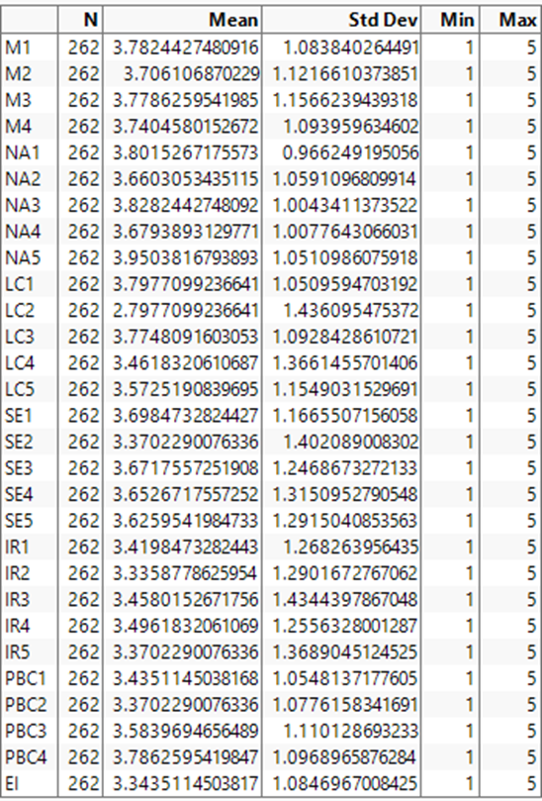
Fig 1: Descriptive statistics

CONCEPTUAL MODEL /FRAMEWORK/ SIMULATION
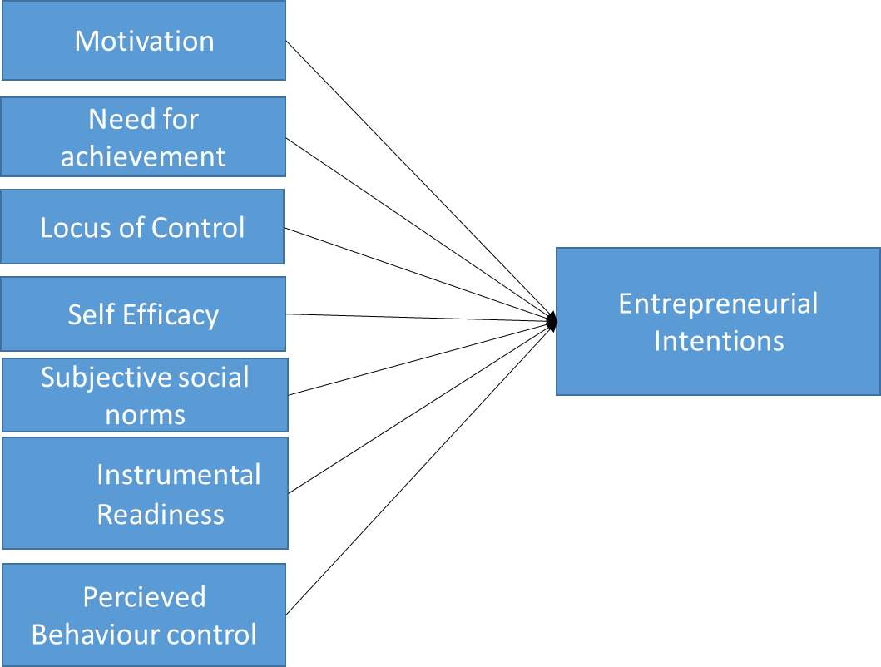

Fig 2: Conceptual Model

VII. ANALYSIS & RESULTS

Objective 1 - To Analyse career intention among Hospitality Management students

Most Hospitality Management graduates choose to start their own business as their Career Choice with a count of
151 among 262 students, 39 students opted to join the hotel industry as their career choice, 26 students chose to
join the tourism industry as their career choice with the least students joining other Hospitality industries.
Fig 3: Graph
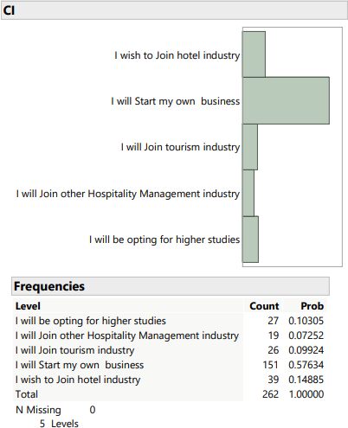

Objective 2 - To Investigate the motivational drives in influencing Entrepreneurial Intention among

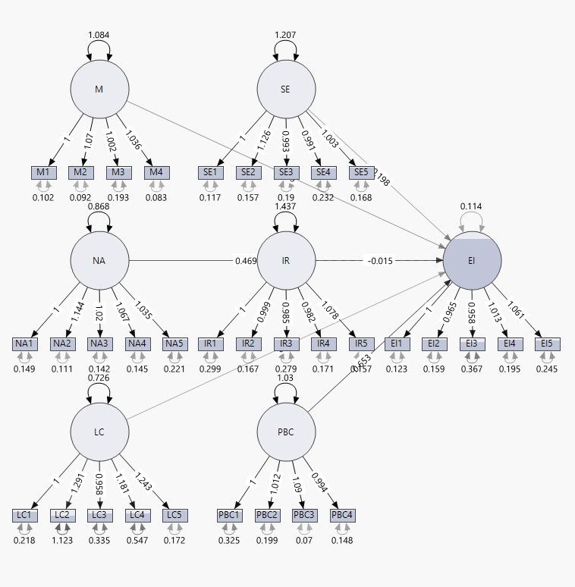
Hospitality Management students

Fig 4: Factor analysis

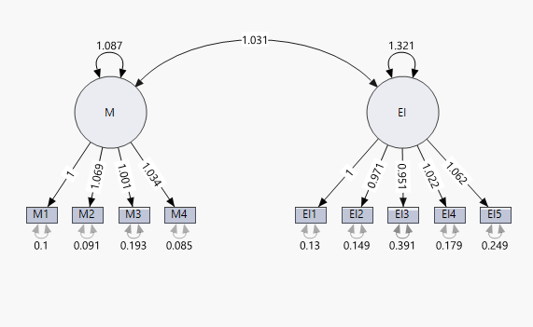
Fig 5: Two-factor diagram

Name | Index
CFI | 0.9622825
GFI | 0.9545962
TLI | 0.9545816
RMSEA | 0.0508885
SRMR | 0.0390108

Table 6: Two-factor analysis

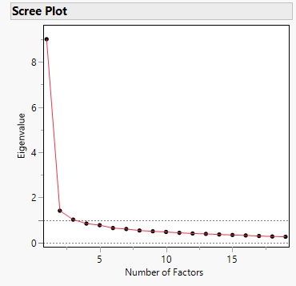
Fig 7: Scree Plot

Relationships |  |  | Beta estimates | SE | CR | Pvalue | Result
EI |  | NAC | 0.644 | 0.197 | 3.266 | 0.001 | Significant
EI |  | NP | 0.295 | 0.099 | 2.980 | 0.003 | Significant
EI |  | NAF | 0.216 | 0.103 | 2.096 | 0.036 | Significant
EI |  | NIA | -0.250 | 0.180 | -1.390 | 0.164 | Not Significant
Table 8: Result
It has been observed that “there is a positive and significant relationship” between NAC and EI. Findings also indicate “a positive and significant relationship” between NP and EI, “a positive and significant relationship” between NAF and EI. Except in the case of need for autonomy it has been observed that there is “no significant relationship” between “need for autonomy” and “entrepreneurship intention”.
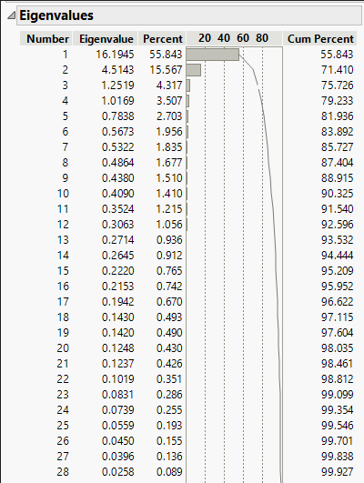
Figure 9: Eigenvalues

Objective 3 – To analyses the relationship of personal attitude, subjective social norms, and

Perceived Behavioural control towards Entrepreneurship Intention

Relationships |  |  | Beta estimates | SE | CR | P-value | Result
SSNO |  | NP | 0.351 | 0.122 | 2.867 | 0.004 | Significant
SSNO |  | NAF | 0.581 | 0.137 | 4.250 | 0.000** | Significant
SSNO |  | NAC | 0.147 | 0.127 | 0.676 | 0.499 | Not significant
SSNO |  | NIA | -0.526 | 0.206 | -2.554 | 0.011 | Significant
PBE |  | NIA | -0.233 | 0.108 | -2.063 | 0.039 | Significant
PBE |  | NAF | 0.235 | 0.068 | 3.344 | 0.000** | Significant
PBE |  | NAC | 0.491 | 0.123 | 3.981 | 0.000** | Significant
PBE |  | NP | 0.252 | 0.065 | 3.903 | 0.000** | Significant
PAT |  | NAC | 0.461 | 0.128 | 3.600 | 0.000** | Significant
PAT |  | NP | 0.228 | 0.068 | 3.344 | 0.000** | Significant
PAT |  | NAF | 0.135 | 0.070 | 1.945 | 0.052 | Not significant
PAT |  | NIA | -0.045 | 0.112 | -0.402 | 0.688 | Not significant
Table 10: EI & TPB Relation

It is observed that except in three instances (1) Need for achievement and subjective social norms,
(2) Need for affiliation and personal attitude towards entrepreneurship and (3) Need for autonomy and personal attitude towards entrepreneurship, where there is no significant relationship and the null hypothesis is accepted in all other instances the null hypothesis is rejected and a significant relationship is found between motivational drives and other dimensions of TPB model.
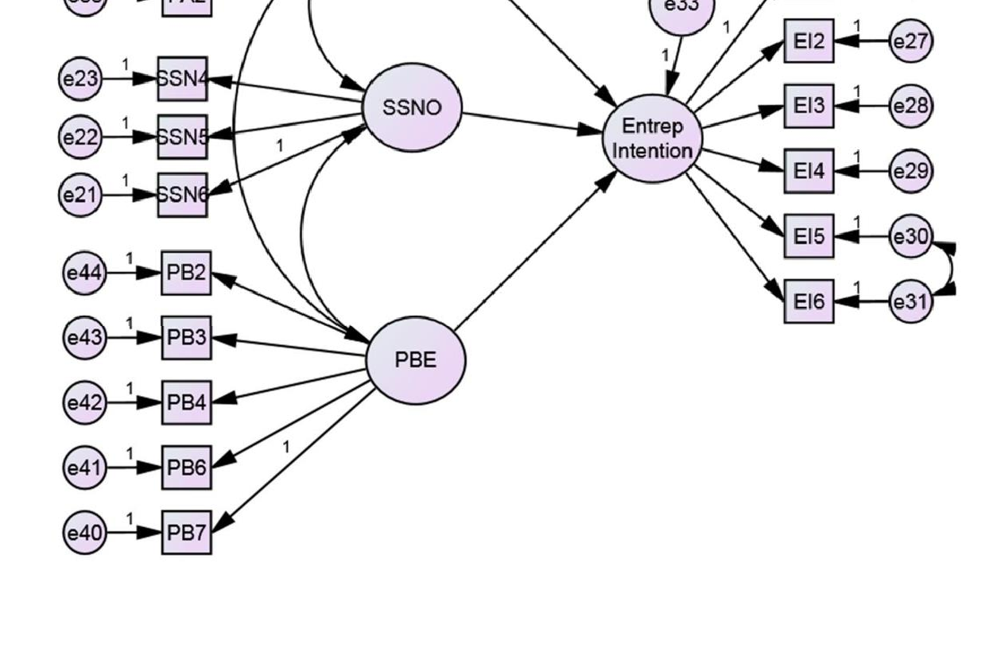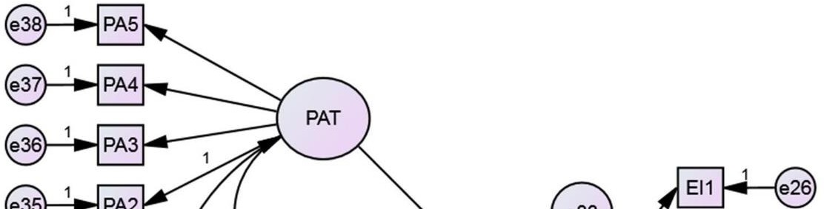
Fig 11: Relationship between PAT, SSNO, PBE and EI

VIII. FINDINGS AND CONTRIBUTION
The findings are summarized as follows:
- Most of the Hospitality students choose to start their own businesses rather than join paid jobs.

- Motivational drives like Achievement, power, and affiliation needs positively influence entrepreneurship intention among students.

IX. CONCLUSIONS
This study offers a theoretical model based on the TPB model theory thus ensuring an academically sound process. By quantitative analysis, this study provides empirical evidence for such an approach. Using the above theoretical model this study offers detailed insights of how entrepreneurship intention is formed among the postgraduate students of business administration belonging to the business community and non-business community which is the major research question in this study.
The study identifies that among the four motivational drives (independent variables) considered “need for achievement”, “need for power” and “need for affiliation” are showing a significant positive influence on entrepreneurship intention ( dependent variable pine that one of the important reasons for self-employment is that people want to do their own business instead of working in some other’s organization. But in the present study, the need for autonomy is found not to be significantly related to entrepreneurship intention. In order to develop entrepreneurship intention among students academicians impact their need for achievement and need for power by including competitive spirit in the curriculum in the form of management games, role play, etc. Also, the need for affiliation can be impacted by developing team spirit among them.
The relationship between personal attitude towards entrepreneurship intention and the relationship between perceived behavioral control and entrepreneurship intention is found to be significant in this study. The relationship 116 between subjective social norms and entrepreneurship intention is not found to be significant in this study. Hence it is suggested to take more steps to influence the student’s attitude towards entrepreneurship in a positive way as well as enhance their perceived behavioral control by improving their self-efficacy.

XI. SUGGESTIONS FOR FUTURE WORK

This study was conducted only in Bangalore city, if a study is done on an all-India basis in the future including other parts of the country it may give a clearer picture regarding the questions raised in this study. This study has been done using a cross-sectional design, hence in order to investigate further whether the intention actually results in behavior a longitudinal study is required involving more years of observation. This in fact may serve as a scope for further research in this area.

XII. REFERENCES
Ajzen, I. (n.d.). The Theory of Planned Behavior.
Armitage, C. J., & Conner, M. (2001). E Y cacy of the Theory of Planned Behaviour: A meta-analytic review. In British Journal of Social Psychology (Vol. 40).
Barnir, A., Watson, W. E., & Hutchins, H. M. (2011). Mediation and Moderated Mediation in the Relationship Among Role Models, Self-Efficacy, Entrepreneurial Career Intention, and Gender.
Bird, B. (1988). Implementing Entrepreneurial Ideas; The Case for Intention. In Academy o/Management Review (Vol. 13, Issue 3).
Boyd, N. G., & Vozikis, G. S. (1994). Self-Efficacy on the Development of Entrepreneurial Intentions and Actions (Vol. 1).
Cobbinah, C., & Chinyamurindi, W. T. (2018). Motivational factors for engaging in dirty work entrepreneurship among a sample of African immigrant entrepreneurs in South Africa. SA Journal of Human Resource Management, 16. https://doi.org/10.4102/sajhrm.v16i0.1025
Henley, A., Contreras, F., Espinosa, J. C., & Barbosa, D. (2017). Entrepreneurial intentions of Colombian business students: Planned behaviour, leadership skills and social capital. International Journal of Entrepreneurial Behaviour and Research, 23(6), 1017–1032. https://doi.org/10.1108/IJEBR-01-2017-0031
Karimi, S., Biemans, H. J. A., Lans, T., Chizari, M., & Mulder, M. (2014). Effects of role models and gender on students’ entrepreneurial intentions. European Journal of Training and Development, 38(8), 694–727. https://doi.org/10.1108/EJTD-03-2013-0036
Ladd, T., Hind, P., & Lawrence, J. (2019). Entrepreneurial orientation, Waynesian self-efficacy for searching and marshaling, and intention across gender and region of origin. Journal of Small Business and Entrepreneurship, 31(5), 391–411. https://doi.org/10.1080/08276331.2018.1459016
Mcclelland, D. C. (1985). How Motives, Skills, and Values Determine What People Do.
Nabavi, R. T. (2011). Bandura’s Social Learning Theory & Social Cognitive Learning Theory Title: Bandura’s Social Learning Theory & Social Cognitive Learning Theory. https://www.researchgate.net/publication/267750204
Ngatse-Ipangui, R., & Dassah, M. O. (2019). Impact of social entrepreneurs on community development in the Cape Town Metropolitan Municipality area, South Africa. The Journal for Transdisciplinary Research in Southern Africa, 15(1). https://doi.org/10.4102/td.v15i1.474
Ngoc Khuong, M., & Huu An, N. (2016). The Factors Affecting Entrepreneurial Intention of the Students of Vietnam National University — A Mediation Analysis of Perception toward Entrepreneurship. Journal of Economics, Business and Management, 4(2), 104–111. https://doi.org/10.7763/joebm.2016.v4.375
Rodriguez-Gutierrez, P., Cabeza-Ramírez, L. J., & Muñoz-Fernández, G. A. (2020). University students’ behaviour towards entrepreneurial intention in ecuador: Testing for the influence of gender. International Journal of Environmental Research and Public Health, 17(22), 1–19. https://doi.org/10.3390/ijerph17228475
Sahban, M. A., Ramalu, S. S., & Syahputra, R. (2016). The Influence of Social Support on Entrepreneurial Inclination among Business Students in Indonesia. Information Management and Business Review, 8(3), 32–46. https://doi.org/10.22610/imbr.v8i3.1330
Sarri Stavroula Laspita Anastasios Panopoulos, A., Author, C., & Panopoulos, A. (2018). DRIVERS AND BARRIERS OF ENTREPRENEURIAL INTENTIONS IN TIMES OF ECONOMIC CRISIS: THE GENDER DIMENSION. In Europe Journal of Economics (Vol. 2).
Shane, S., Locke, E. A., & Collins, C. J. (2003). Entrepreneurial motivation. Human Resource Management Review, 13(2), 257–279. https://doi.org/10.1016/S1053-4822(03)00017-2
Usman, B., & Yennita. (2019). Understanding the entrepreneurial intention among international students in Turkey. Journal of Global Entrepreneurship Research, 9(1). https://doi.org/10.1186/s40497-018-0136-0
Ajzen Icek. (1975). Belief, Attitude, intention and behavior: An introduction to theory and research.

