Harmonic Fusion – The Art of Mixing Music

Pratheek Acharya
Student, Audio Life-School of Sound Engineering, Bengaluru, Karnataka, India,
email: flutepratheek@gmail.com

Dr. Sridhar S,
Professor, Audio Life-School of Sound Engineering, Bengaluru, Karnataka, India.Email: email: s.sridhar957@gmail.com

Ramakrishna C H
Student, Audio Life-School of Sound Engineering,
Bengaluru, Karnataka, India.
email: ramakrishna530chinta@gmail.com

ABSTRACT

Whether you are new to music or a seasoned pro, there is something for you to discover the secrets of tweaking audio levels, creating a sense of space in your music and making each instrument and voice shine brilliantly. It islike a magician who brings out the best in every sound. This chapter is indispensable for everyone who wants to master the art of mixing and transform their musical visions into reality. Thus, you can master the captivating realm of music mixing with Harmonic Fusion.

Keywords—Harmonic fusion, Mixing music, Studio, Tracks, Spatialization.

INTRODUCTION

The Journey of a Mixing Engineer, is a path covering:
- Reflections on the art and evolution of music mixing
- Embracing creativity and constant learning in the field
- Constant learning, a pilgrimage of sound
- A rhythmic voyage through melodies, old and new

The mixing engineer, embarks on a constant cycle of learning, refinement and innovation. As artists constantly explore new techniques, the pursuit of excellent sound is boundless. The mixing engineer understands that he is always a student of sound, always ready to explore new areas of sound and develop the craft.

METHODOLOGY

The Basics of Audio Mixing

The basics of audio mixing are the following:
- Understanding audio frequencies, levels, and panning
- Introducing the mixing console and its components
- Signal flow and routing in a mix

Understanding these things is like learning the basic colours before becoming a professional painter. The header introduces the mixing console which guides to adjusting different sounds.
Next, is the signal flow and channel, which are considered as hidden channels of mixing. This plays an important role like a conductor directing sounds from one instrument to another, creating rhythmic harmonics.
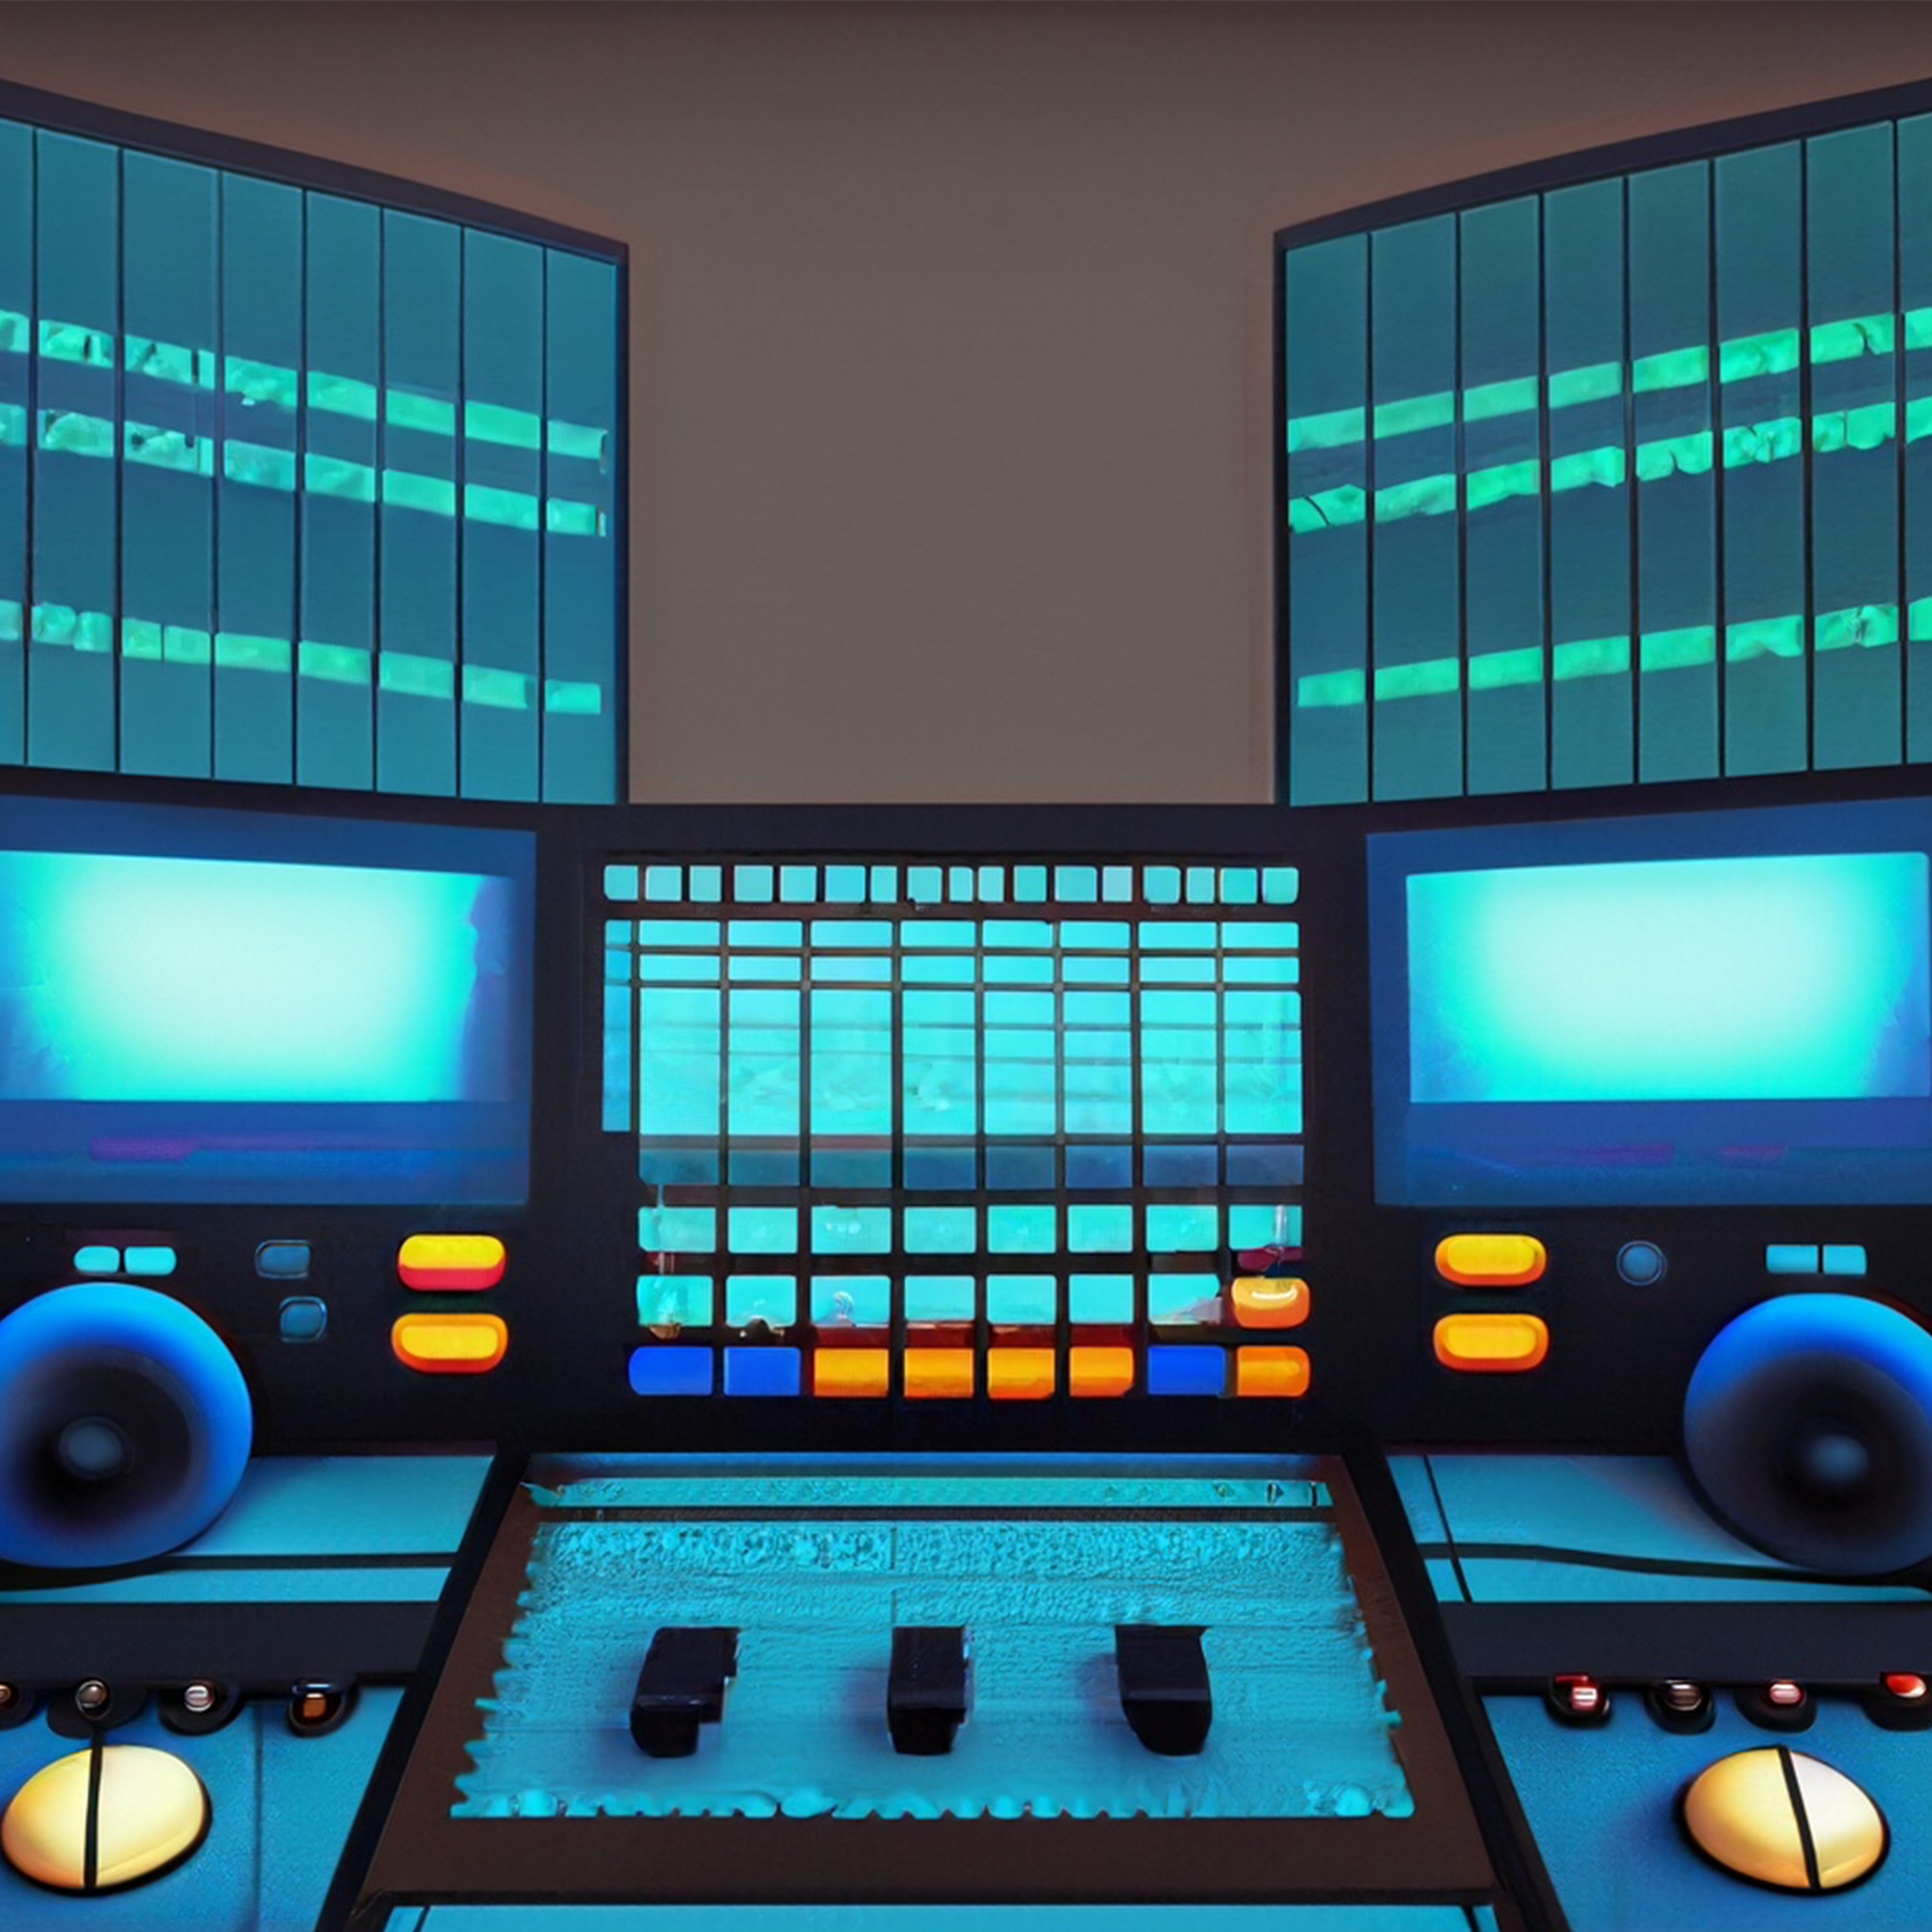

Fig. 1. Mixing basics

Setting Up Your Studio

The basics of setting up a studio are the following:
- Acoustic treatment and its importance
- Choosing the right monitors and headphones
- Optimal studio layout for an efficient workflow

Here, the main spot light is the studio. A studio layout similar to the stage is to be scrutinized. Effective organization of this is important because it improves productivity, and allows creativity to flow easily. Studio is considered as very important in simplifying the complexity of shapes and sounds. This enables us to create a neutral environment that allows us to hear the music as it is. A monitor and headphones are necessary to understand their nature and how they define the sound.

Preparing Tracks for Mixing

Here, the basics are the following:
- Pre-production and organization of audio files
- Editing and comping to create the best source material
- Utilizing effects during recording to enhance the mix

Once the studio is setup, the process of preparing the music before mixing, is the next step. Here, prerecorded audio files and programming play an important role just like a chef combining fresh ingredients before cooking. You learn how to compose music ensuring mixing process. Editing and comping will be our crafting tools, honing audio tracks to perfection. A well-crafted and well-assembled audio track is the foundation for a well defined and impressive mix. The idea of effects when recording is just what is required for a good presentation.

The Role of EQ in Mixing

The basics are the following:
- Understanding equalization and its impact on the mix
- Techniques for surgical and creative EQing
- Using high-pass and low-pass filters effectively

Equalization or EQ is a revolutionary tool in mixing. This precisely tunes the sound. EQing techniques are important in fine tuning and we can learn how to carefully create individual frequencies and craft space in the mix. EQ is a revolutionary tool in expressing emotions, textures and energy. Technical knowledge of EQ is very important to express the artistic approach of using it effectively.

Sculpting with Dynamics and Compression

The basics are the following:
- Comprehending dynamics and compression principles
- Different types of compressors and their applications
- Side chain compression and parallel processing

This goes beyond energy and inspiration. This adds life and emotion to the mix. Compression takes care of these details. Compressors range from classical analog models to the modern digital ones. Each compressor is different in contributing to the texture and quality of mix. The art of side chain pressing is a powerful way to make things rhythmically connect, just like a dancer reacting to the rhythm of the music. Navigation and compression are not just technical features but they are the tools to incorporate the mix.

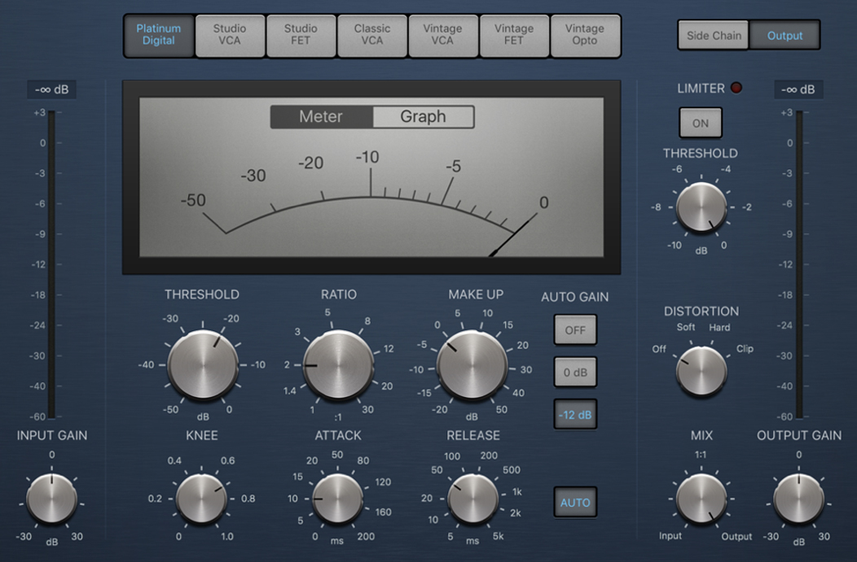

Fig.2. Compression dynamics

Balancing and Spatialization

This process involves the following:
- Achieving a balanced mix with proper level adjustments
- Utilizing panning and stereo imaging for depth and width
- Creative use of reverb and delay to create space

This process is a challenge for finding the perfect balance in the mix. Balancing the instruments is the sonic equivalent of forming an orchestra, ensuring each instrument has its place in the sonic orchestra. In this, the Equalizer becomes the primary tool. From this we can learn the art of harmony and ensuring no one element overpowers the others. We learn about blending not just as layers but also as space. Panning and stereo imaging, spatialization brushes allow us to place instruments in a three-dimensional sound stage. Echo and delay are the tools for crafting depth and immersion which transforms the mix to a multi-dimensional sound. By learning this, not only we become a good mixer but also a sonic architect creating space and time to create interesting sounds.

The art of Mixing Vocals

This includes the following:
- Achieving a balanced mix with proper level adjustments
- Utilizing panning and stereo imaging for depth and width
- Creative use of reverb and delay to create space

Here, the voice is put in the forefront of the mix. The voice is the highlight , conveying emotion and song to the audience. Here, we learn the art behind voice control, from bass to background. We learn the strategies for dealing with sibilance, plosives and vocal resonance. We also learn, how to fine-tune our voice for a polished professional sound. Doubling and harmonizing voices adds depth and emotional effects. Much like harmonizing voices in an orchestra. Here, we not only learn mixing voices, but through the human voice, we tap into the very soul of the music. Our mix becomes the very process of communicating music, songs and emotions that deeply resonate with the audience.

Blending the instruments and Arranging the Mix

This includes the following:
- Handling various instruments and their sonic interactions
- Arrangement tips to create an engaging mix
- Introducing automation for dynamic changes

This process explores the art of mixing harmonized instruments, such as composing various pieces in an orchestra, each contributing to a greater harmony. Here, the instruments and their vocal interactions are the main focus. The choreographer plans movements, adjusts voices and frequencies to sync. The guidelines of structural principles are to be followed, ensuring that the music flows seamlessly from beginning to end. Just like changing lightning and intensity during a stage performance, here automation is the tool for injecting life into the mix. By learning this, we not only become good mixer, also a musical arranger to create dynamic sounds that are captivating and impressive.

Advanced Mixing Techniques

This includes the following:
- Parallel processing and multiband compression
- Mid/side processing for enhanced control
- Exploring advanced mixing plugins and tools

This encompasses advanced techniques that fuels the creativity. Parallel processing is the secret ingredient, allowing us to layer effects and textures with finesse. Multi-band compression provides granular control of dynamics, such as adjusting shadows to the nuances of an image. The centre/ side function reveals new control concepts, and allows us to precisely suit the stereo field. This comprises of exploring advanced mixing plugins into the realm of innovative technology, enhancing the sonic combination. By completing this process, we become not just a mixer, but a ready-made artist with an extended toolkit. Our mix goes beyond the ordinary, embracing the innovation and exciting creativity in listeners’ ears.

Mixing in different Genres

This includes the following:
- Tailoring mixing techniques to specific musical styles
- Case studies of mixing various genres (rock, pop, electronic, etc.)

This gives us the skills to adapt mixing techniques to different genres. This forms the basics of exploration of art forms, just like an artist experimenting with different works of art. Here, song specific mixes play an important role, whether diving into rock territory or exploring subtle elements of pop or diving into electronic realm. By learning this, and from case studies, we discover unique characteristics that define each genre’s sonic identity.
By completing this, we become not only a good mixer, but also a genre chameleon, adept at adapting techniques to any situation in music

The final touches and Mastering

This includes the following:
- Preparing the mix for mastering
- Understanding the role of the mastering engineer
- Tips for delivering a polished, professional-sounding mix

This brings the end of our blending effort into the forefront. Here, we prepare our mix for the grand unveiling- the mastering stage. At this stage, make sure that, our sound creations are polished to perfection. We learn the art of preparing the mix for mastery. The tips for achieving a polished and professional sound is not only following the guidelines, but making our mix sound great and standing out in the crowded music. By completing this, we become a sonic architect, carefully crafting and preparing sounds that capture, move and inspire the audience.

Collaborating and Communicating with Artists

This includes the following:
- Navigating artistic differences and preferences
- Effective communication for successful collaborations

Lastly, the focus shifts to collaboration, which is the essence of creativity. In this process, we work with musicians and artists to explore the delicate art that brings our visions into reality. Effective communication is necessary in understanding artists’ aspirations and translating their ideas into reality. Navigating artists differences is like finding harmony in two pieces of music, where individual forces come together in creating a masterpiece. By completing this, we become a collaborator, mediator and creative channel. Our ability to communicate and collaborate elevates the mixes from purely technical creations to artistic collaborations that deeply resonate with performers and audiences together.

CONCLUSION

Harmonic Fusion aims to be an essential guide for aspiring and experienced mixing engineers alike, empowering them to bring their musical visions to life through the magic of audio mixing.

REFERENCES

- G. Eason, B. Noble F.Alton Everest, Ken Pohimann, Master Handbook of Acoustics, 5th Edition, 2015.
- "Mixing Secrets for the Small Studio" by Mike Senior
- "The Mixing Engineer's Handbook" by Bobby Owsinski
- "Mixing Audio: Concepts, Practices, and Tools" by Roey Izhaki
- "Mixing Music" by Russ Hepworth-Sawyer and Jay Hodgson

