COMPARISON OF INKJET PRINTED, LASER PRINTED AND PHOTOCOPIED DOCUMENTS
Gomathi P
Assistant Professor
Department of Forensic Science Technology
School of Allied Health Sciences
Vinayaka Mission’s Research Foundation (Deemed to be University)
AVMC & H Campus, Puducherry
pgomathipurushoth@gmail.com

ABSTRACT
In recent years, forensic document technology which primarily focuses on tracing a document's origin or identifying forgeries has advanced quickly. Commodity scanners and a computer are used in this technology to carry out the required evaluations. Printer, forgery, and scanner identification have been the main topics of recent document forensics research.
The requirement for printer inspection in questioned document examination has arisen in the modern period as a result of the growing use of printers in document generation as opposed to handwritten documents and the counterfeiting of documents produced by different printers.
Inkjet printers, laser printers, and photocopiers—three frequently used document creation devices were studied under a microscope to determine how they differ from one another. Based on characteristics seen in the characters in the papers, the suggested approach can distinguish between documents created by various sources. Thus, it can also be used to identify documents that have been altered and come from a combination of various sources.

Key words: Questioned documents, printed documents, photocopied documents, comparison of documents, inkjet printed, laser printed
I.INTRODUCTION
Forensic science is the profession of using scientific theories and knowledge to address legal matters and criminal investigations. Numerous scientific fields are included in it, including anthropology, chemistry, medicine, physics, engineering, genetics, pathology, psychology, toxicology, etc. Since its start, forensic science has been essential to investigating crimes. It enables the investigators to respond to queries that would not otherwise be possible. The discipline of 'Questioned Document Examination' is one of many sub-branches that forensic science has made known that deals with various parts of an inquiry. Early this century, the field of forensics known as "questionable document examination," or QDE, was created as a technique for document authentication or forgery detection. A document whose provenance or authenticity is questioned or disputed is deemed to have a questioned signature, handwriting, typewritten mark, or other mark. petitions, threatening letters, suicide notes, driver's licenses, contracts, wills, voter registration applications, passports, etc. are some examples. In instances of fraud, forgery, mail fraud, kidnapping, embezzlement, etc., QDE is used. In recent decades, printing has grown in popularity; today, nearly every workplace and home has a printer that is both accessible and affordable. Some of the most frequently found evidence in QDE is printed material. People are now more knowledgeable about the many methods utilized to solve crimes. People are now aware of how distinctive handwriting is and how it can be quickly identified and matched to the original writer, particularly in the context of QDE. Therefore, criminals consider employing other techniques that do not need them to use their handwriting, such as using printed documents, in order to avoid being caught. To reduce his chances of being detected, a criminal will write and print a letter of threat rather than writing it by hand. Additionally, formal documents like bank statements, cheques, and other legal documents like contracts, wills, and passports are susceptible to forgery because printed text is the most common target. As a result, printed documents are crucial for forensic purposes, and further study is needed in this area.
II.INKJET PRINTERS AND ITS PRINTING PROCESS
Ink is effectively sprayed onto the paper by an inkjet print head, which travels back and forth as the paper passes through the carriage. On the surface, liquid ink is sprayed. It is used for printing in large sizes, printing on unique media, and printing images that need enhanced colour fidelity (such HD images). The printhead, transport, and advance mechanisms make up the three primary parts of an inkjet printer. The ink cartridge's associated print head sprays ink onto the paper as it oscillates back and forth in the scan direction [1].
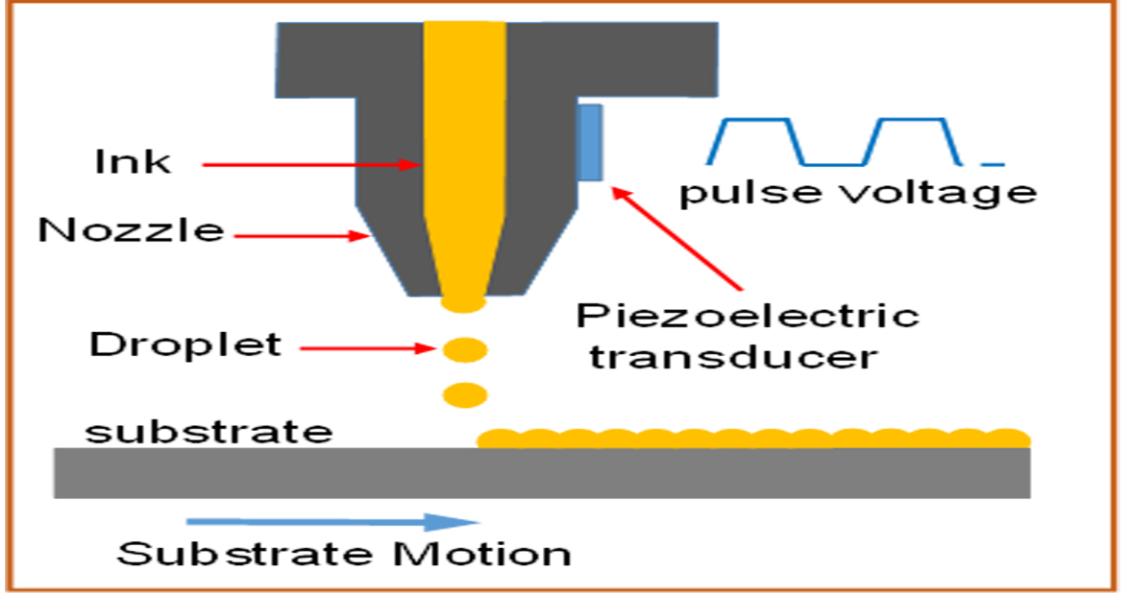
Fig 1. Inkjet printer

III. PRINTING PROCESS OF PRINTING AND ITS LASER PRINTERS

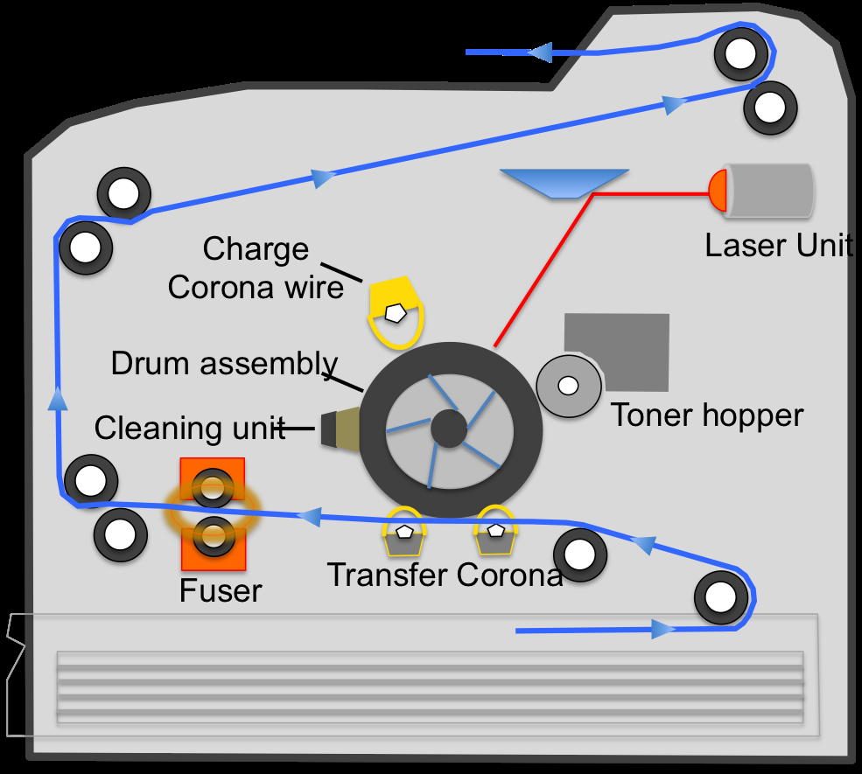
Fig 2. Laser printer
High-quality test photos and graphics can be produced with laser printers that use electrostatic digital printing, in addition to medium-quality images. To permanently fuse text and/or images, the technique involves passing a laser beam back and forth across a negatively charged cylinder known as the "drum," which subsequently picks up and collects the charged toner powder and transfers the image to the paper. A laser printer is used to perform xerographic printing. The laser scanner first develops the image before using it to produce a beam that shines through the glass pane to reproduce the image, below, in the laser printer. This picture is reflected by the printer's mirror and focused by a lens ^{[1]}.
Laser printing, however, differs from traditional copiers. Images are produced by scanning material through the printer's optical sensor directly in laser printers. Laser printers can now replicate images more quickly than conventional copiers. In offices, laser printers are preferable because they are faster, quieter, and have a cheaper cost per copy than laser printers.
IV. PHOTOCOPIER
Copier technology is based on electrical and photoconductive principles. The machine contains a light-sensitive optical sensor that draws ink particles to plain paper and then transfers them there to create a duplicate of the document.
- Photocopier working principle
A photocopier operates on two fundamental tenets: the law of attraction between opposite charges and the propensity for particular materials to become more conductive after absorbing electromagnetic radiation, such as ultraviolet, infrared, visible light, etc. (optical conductivity). The majority of contemporary photocopiers are built on the xerography technology, which is essentially a dry copy method. It involves attracting and then placing ink particles onto a piece of paper using charged particles.
- Parts of a photocopier
A typical photocopier (also casually known as a ‘xerox machine’) consists of the following components:
A photoreceptor drum (or belt), which is covered by a layer of a semiconductor material, such as selenium, silicon or germanium. This is arguably the most critical part of the machine.
A toner, which is basically just pigmented liquid. Sometimes referred to as ‘dry ink’, a toner is a dry mixture of fine, negatively-charged plastic particles and colouring agents that create the duplicate image on a piece of paper.
Corona wires, which when subjected to a high voltage, transfer a field of positive charge to the surface of the photoreceptor drum and the copy paper.
A light source and a few lenses, which shine a bright beam of light on the original document and focus a copy of the image onto a specific place, respectively.
A fuser can be considered the ‘final’ main component of a photocopier, as a fuser unit melts and presses the toner image onto the copy paper and imparts the final touches to the duplicate image just before it’s ejected from the machine.
- Working
The master copy is put face down on the glass of the copier's top cover, where a powerful laser beam scans the entire paper, to start the copying process. On the paper, the white portions reflect more light while the black areas barely or barely reflect any. On the photoconductor, a shadow (or picture) of the primary copy is created. The conveyor belt, which has a photoconductive layer, carries the bulb as it travels. Ink particles with negative charges adhere to the bulb, leaving an ink print of the original on the conveyer belt. From the opposite side, a blank sheet of paper is fed into the copier, which steadily advances in the direction of the photoconductive belt. It receives a significant positive charge as it goes along the conveyor belt. Pure paper's strong positive charge draws negatively charged ink particles to it. On the blank sheet of paper, a duplicate image of the original copy is created. Finally, a fuser (a pair of hot rollers) applies pressure and heat shortly before the paper is released to permanently fuse the ink particles to the paper. A freshly ejected duplicate is therefore fairly warm to the touch.
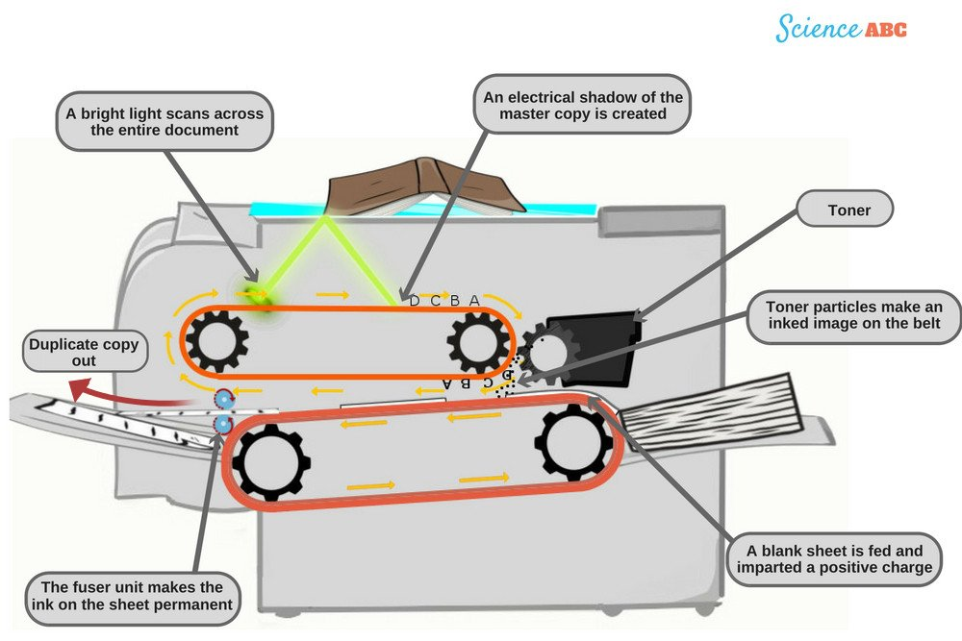

Fig 3. Photocopier

V.COMPARISON OF INKJET PRINTED, LASER PRINTED AND PHOTOCOPIED DOCUMENTS

Table 1. Comparison of inkjet printed, laser printed and photocopied documents
S.NO | CHARACTERS | INKJET | LASER | PHOTOCOPY
1. | Resolution | Low | High | Low
2. | Edge Contrast | Lower contrast and appearance of smudging | High contrast | Better contrast
3. | Edge roughness | Letters are uneven and rough | Letters are sharp and refined | Better edge roughness
4. | Ink flow and uniformity of printed character | Non-uniform | Uniform | Non-uniform
5. | Satellites | Few satellites | Lesser satellites | -------

Inkjet printer document
Resolution: The resolution and clarity of the letters written on inkjet printers are lower.
Edge contrast: The letters' edges have a reduced contrast, and the edges appear to be smudged.
Letter edges are uneven and scratchy, and at greater magnifications, the edges appeared deteriorated.
Spur Marks: When the print head of an inkjet printer moves, ink drops are discharged onto the paper. The ink drop forms tails or satellites on the page, and the printed characters have uneven, up-and-down shapes as a result. The inkjet letters had spur marks that varied in pitch and proximity to one another.
flow of the ink and character consistency
Flow of the ink and character consistency: Blotting of the ink on the paper indicates that the ink has been spayed ^{[4].}
The ink on the paper is not distributed evenly because certain lettering areas contain more ink than others. Due to uneven inking, there were certain instances where dark spotting was visible.
Laser printer document
Resolution: The letters printed on a laser printer have a better resolution and look sharper and more defined.
Edge roughness: Edges of the letters are sharper and refined.
Edge roughness: The edge of the letters has better contrast than that of the inkjet printer and photocopier samples.
Edge contrast: Compared to letters from inkjet samples, the letters exhibited a better edge contrast.
Ink flow and uniformity of the printed character: Ink depositions in the letters are uniform giving it a smooth border, thereby possessing thickness due to more ink spray. ^{[4]}
Photocopier Document
Resolution: The letters printed from the photocopier has a lower resolution than that of the laser printer.
Edge roughness: The edge of the letters has better contrast than that of the inkjet samples and lesser than that of the laser printer.
Edge contrast: The edge contrast of the letters was higher than that of a laser printer but lower than that of an inkjet printer.
Ink flow and uniformity of printed character: Ink deposition in the letters is non-uniform
Due to the damage brought on by scanning a printed document, their quality is not as good as that of laser printed characters. ^{[4]}
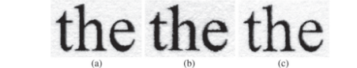
Fig 4. Showing words printed by laser, inkjet and photocopier
CONCLUSION
Law enforcement agencies can track the origin of forged papers to the suspected printer, which will ultimately point to the owner and/or suspect(s), thanks to the basis for printer identification. This can therefore serve as corroborating evidence in criminal investigations. First off, since most passports and other security papers are generated using laser printers, the findings can be used in secured document analysis to check for forgeries. In addition to the other passport-related examinations, a microscopic inspection of the creation of letters can help the investigators arrive at a more precise and thorough conclusion. Second, Banknotes & Checks also use a particular printing method for their text. The questioned documents can be closely studied to determine whether the letter formation matches or deviates from the standards, and their authenticity can be verified by comparing them under a microscope to the standards.
This can also be used to look at changes and additions to contested printed documents. By adding changes, additions, or deletions to the text of an official document, it is frequently possible to fake the document. If there is a question about the authenticity of a document, the words of the document that are allegedly altered can be compared to the text of the original document to see if the printing methods were the same. The unique traits of similar letters can be compared if the printing methods are the same. Thus, it can also be used to identify documents that have been altered and come from a combination of various sources. Additionally, this allows you to focus your search for the probable printer's kind.

REFERENCES
- Noronha SJ, Basheer SZ, Vijay MN, Alnajjar A, Sharma BK, and Singh N (2017) - A Comparative Study of Different Printed Documents to Estimate the Type of Printer Used. Published date: April 28, 2017
- Jagjeet Singh Saroa, Komal Saini (2013) - Physical examination of Photocopied documents
- M. Uma Devi, C. Raghvendra Rao, M. Jayaram (2014) - Statistical Measures for Differentiation of Photocopy from Print technology Forensic perspective
- Bhoopesh Kumar Sharma, Mandeep Kaur Purba (2021) - A Study of Certain Characteristic Features of Various Printed Documents to Determine the Type Printer Used in Forensic Investigations
- C.L. Gilmour (1994) - A Comparison of Laser Printed and Photocopied Documents can they be Distinguished?
- Shize Shang, Nasir Memon and Xiangwei Kong (2014) - Detecting documents forged by printing and copying
- Jaime H. Bohórquez, Brian P. Canfield, Kenneth J. Courian, Frank Drogo, Corrina A.E. Hall, Clayton L. Holstun, Aneesa R. Scandalis, and Michele E. Shepard (1994) - Laser-Comparable Inkjet Text Printing.
- Raj Kumar, Avantika Samkaria, Vishal Sharma (2020) - On the spectroscopic cum chemometric approach for differentiation and classification of inkjet, laser and photocopier printed documents
- Madhusudan Singh, Hanna M. Haverinen, Parul Dhagat, and Ghassan E. Jabbour (2010) - Inkjet Printing—Process and Its Applications

