Morphology of Galaxies
Amit Kumar Tamrakar
St. Thomas College, Ruabandha, Bhilai
stcphy.amit@gmail.com

Abstract

Sky gazing at night is a very natural activity for a curious mind. Curious people used to keep records of what they were observing. Exploring the sky beyond the eye’s limit became possible after the invention of the telescope by Galileo in the year 1600. Such observations open a new window to observe the extended objects. Galaxies are, in general, considered the fundamental building blocks of the large scale structure of the universe. We all live in a spiral galaxy, named as the Milky way galaxy. There are also a large variety of galaxies in the universe. The classification of galaxies is very important to understand how these galaxies are evolved and we can seek for the secrets of the overall structures and features of the visible and observable universe. Nature has provided us with different windows to observe the observable universe using different bands in the electromagnetic waves. Studying about the galaxies using multibands are very useful tools to study the morphologies and their associated properties.

- Introduction
Sky at night has always fascinated mankind since their childhood. What we see in the sky is lots of stars (nowadays in the cities, hardly we can see a few stars) belonging to our own galaxy, the Milky Way. After the invention of the telescope by Galileo in the year 1600, it became possible to explore the sky beyond the healthy eye’s limit. Telescopic observations opened a new window to observe the mysterious beauty of the universe. One of the biggest revolutions arose in observational astronomy in the year of the 20th century when the use of photographic films was replaced by the invention of the Charge Coupled Device (CCD), (which can store images digitally). The CCD images allows us to do a lot of image processing stuff to get more detailed images and hence the information about any celestial object. The large-scale structure of the Universe indicates that the galaxies act as basic building blocks of the Universe. In general, Galaxies are huge collections of 10⁶ to 10¹² stars, dust, gas, and dark matter. Galaxies are generally classified as Elliptical galaxies, Spiral galaxies, barred spiral galaxies and Irregular galaxies.

- Types of galaxies and their classification
The early galaxy morphology is primarily based on optical observations. Edwin Hubble (1926), created an arrangement of galaxies in increasing order of their ellipticity (ε ≡ 1 − b/a) to classify in a famous Tuning Fork diagram. The ellipticity may range from ε = 0 to 0.7, but not flatter (Schechter, 1987). Indeed, the ellipticity of any galaxy depends on the intrinsic shape of the galaxy as well as the unknown viewing angle. Hubble believed this arrangement was an evolutionary sequence of galaxies from the left end side to the right end of the tuning fork. He also believed that the younger galaxies might have progressed to the right as they became evolved galaxies. He, therefore, named elliptical and lenticular galaxies as early-type galaxies and the spiral galaxies, as late-type galaxies. However, it is not proven to be true, the nomenclature and the classification scheme are in some way related to Hubble’s sequence, which is still a starting point to introduce Galactic astronomy. A reproduction of Hubble’s tuning fork diagram is shown in Figure 1.
Indeed, this scheme was based on only a small portion of the electromagnetic spectrum. His classification scheme divides galaxies into three main categories based on morphology: the handle part contains the elliptical galaxies, the middle place is captured by the lenticular galaxies, and the upper and lower forks are dividing the spiral galaxies by the presence and absence of bar. Later, this scheme was updated by adding another class of galaxies called irregular galaxies (not shown in the figure) which did not fit into the main classification scheme, because of no specific shape or structure. Sometimes, galaxies do interact with other galaxies and the resulting gravitational dance deforms the galaxy morphology. These galaxies have a much more complicated structure than elliptical galaxies.
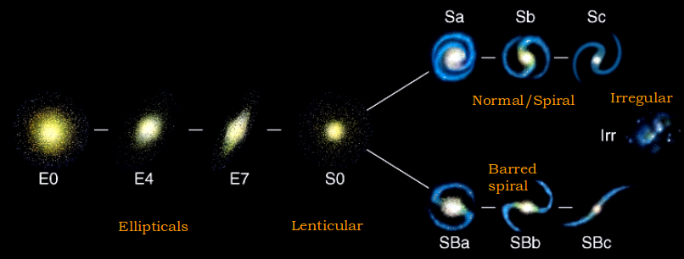

Figure 1: Hubble’s tuning fork diagram to classify galaxies. Astronomers often use this classic diagram to show how the galaxies are classified. Elliptical galaxies are on the left side, from type E0 (circular/spheroidal) to E7 (Flattened elliptical/ellipsoidal). The following image is of a Lenticular ( lens-like shape) galaxy (type S0) which is considered a transition object which is having properties similar to both spiral and elliptical galaxies. On the top, the three images of spiral galaxies from Sa to Sb to Sc, the arms open wider and on the bottom three images of barred spiral galaxies from Sa to Sb to Sc, have open wider arms and less prominent central bulges. Another class of galaxies, irregular galaxies is shown in the extreme right of the figure which is not a part of the tuning fork.
The basic branches of the tuning fork diagram include:
- Elliptical Galaxies (E): The elliptical galaxies vary in shape from round to progressively flatten profile. These galaxies are denoted by a round or elliptical shape. They are classified by their degree of ellipticity, ranging from E0 (nearly spherical) to E7 (highly elongated).
- Spiral Galaxies (S): Spiral galaxies are characterised by a central bulge surrounded by spiral arms. They are further divided into two subtypes:
a. Barred Spiral Galaxies (SB): These galaxies have a central bar-like structure that extends from the nucleus, with spiral arms emanating from the ends of the bar (SBa, SBb, SBc).
b. Non-Barred Spiral Galaxies (S): Spiral galaxies without a central bar are classified into different subtypes based on the openness and winding of their spiral arms (Sa, Sb, Sc).
- Lenticular Galaxies (S0): Lenticular galaxies are intermediate between elliptical and spiral galaxies. They have a central bulge but lack well-defined spiral arms.
- Irregular Galaxies (Irr): Irregular galaxies do not fit neatly into the above categories and have irregular and chaotic shapes.
 | 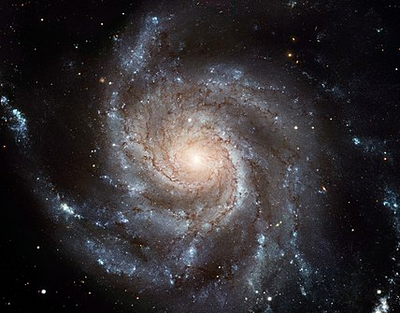 | 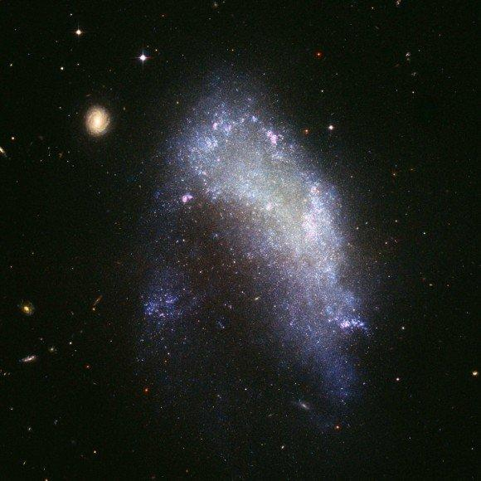
Figure 2: Example of Elliptical galaxies type E1 (M49), type E3 (M84), a lenticular galaxy type S0 (NGC 1201), a barred spiral galaxy type SB0 (NGC 2859) and a spiral galaxy (M 101 or NGC 5457)
Keep in mind that the tuning fork diagram is a simplified representation of galaxy morphology and doesn't enclose all the complexities that can be observed in real galaxies. Additionally, advancements in observational techniques and the understanding of galaxy evolution might lead to further refinements or modifications to the diagram in the future. As the technologies are continuously getting upgraded and more data is collected from different telescopes in all the possible wave-bands. The tuning fork diagram and its representation of galaxy morphology in a multiwavelength universe may undergo further refinements and expansions to accommodate new findings and discoveries.

3. A Multiwavelength view of galaxies

If someone looks at a galaxy with different windows of electromagnetic waves, different features appear. There are various telescopes around the globe and in space, mounted with sensitive instruments to capture light at different wavebands. Through this, we can have a multiwavelength view of the universe. The multiwavelength view of galaxies refers to the observational study of galaxies using a wide range of entire electromagnetic wavelengths, which includes Radio waves, Infrared, Visible light, Ultraviolet, X-rays, and Gamma-rays. Due to various physical processes and phenomena occurring in the galaxy, they emit radiation at all possible wavelengths. By multiwavelength data analysis, one can learn a comprehensive and detailed understanding of the galaxies about their shape, structure, composition, and many other astrophysical processes taking place in the galaxy. Each wavelength of electromagnetic waves provides a piece of unique information about the galaxy, by which astronomers analyse the data and make a complete picture of a galaxy. Let us see some key wavelengths (arranged in increasing order of frequency) in a Broadway and the information they reveal about galaxies:

A. Radio Waves: Radio waves are accessible from the surface of the Earth. There are many large radio telescopes pointing at the sky in all weather conditions to catch the radio waves coming from various celestial objects. Neutral hydrogen gas available in the galaxies, emits low-frequency radio waves which are detected by radio telescopes. Radio waves reveal the presence of active galactic nuclei (AGN) by powerful radio jets. The range of a radio telescope refers to the electromagnetic radiation in the radio frequency (RF) spectrum, including frequencies ranging from about 3 kilohertz (kHz) to several hundred gigahertz (GHz).

B. Infrared: To study the dusty regions in galaxies, Infrared waves are used to observe. Not only the dusty regions but cold molecular clouds, the formation of young stars, and hidden AGNs which are not visible in other wavebands can be studied using infrared observation. The range of infrared telescopes typically covers 0.7 micrometres (μm) to 1 millimetre (mm).

C. Visible or optical wavelength: The components of white light i.e. VIBGYOR typical range is from 400 nanometers (nm) to 700 nm allowing us to study the overall shape, and morphology of galaxies and the stellar distribution within them. This waveband provides detailed images of stars cluster, higher concentration regions of dust and gases. Studying the data in the visible band is essential to understand the overall appearance, shape and dynamics of the galaxy.

D. Ultraviolet: Ultraviolet (UV) wavelength helps to study the presence of hot, young stars, the most massive stars in the galaxy. Studying the UV emission light from a galaxy enables us to explore the regions associated with ongoing star-formation activities. It can help us to identify young stellar populations, and reveal the history of starburst events. UV radiation has shorter than visible wavelengths and spans approximately 10 nm to 400 nm.

E. X-rays: X-ray emissions are produced in regions of extremely hot gas thus indicative of high-energy processes., for example, supernova remnants, black hole accretion and hot gas in galaxy clusters. Galaxies in X-ray view provide insight into the galaxy's central supermassive black hole and its activity. X-rays span approximately 0.01 nm to 10 nm.

F. Gamma-rays: Looking through a Gamma-ray waveband reveals the most energetic processes in galaxies like gamma-ray bursts (GRBs). It also enables us to explore sources of high-energy particles within galaxies. The Gamma rays typically cover energies above 100 keV (kilo-electron volts).

We can take example of How galaxy’s appearance changes in different wavelength can be seen through an example of images of M81 (NGC 3031). We can observe a significant difference by comparing multiwavelength images of galaxies,
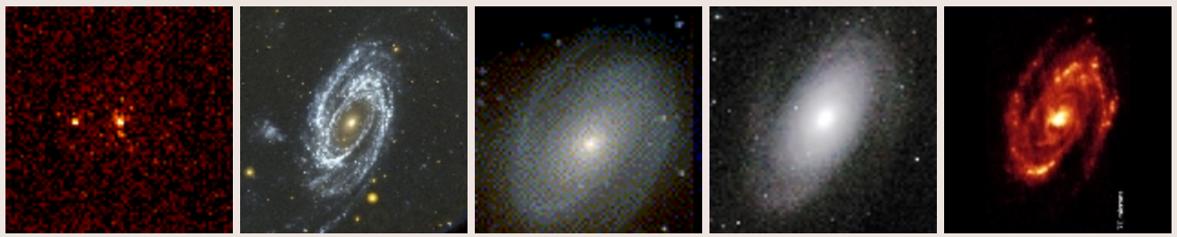
Figure 3: A multiwavelength view of M81 (NGC 3031) in X-ray, UV, Visible, near IR, and Far-IR image. Credit: https://pages.astronomy.ua.edu/keel/galaxies/classify.html

A more complete understanding of the galaxy’s overall physical properties can be obtained by combining data from multiple wavelengths. The galaxy’s overall structure, evolutionary processes, interactions with neighbouring galaxies or galaxy clusters, the presence of AGNs in it and the distribution of dark matter can be inferred by the multiwavelength view. Then only it becomes possible to classify the galaxies in more detailed morphological classes. This approach allows researchers to unveil the hidden aspects of galaxies that would be difficult or impossible to study with observations limited to a single wavelength band. So, such a multiwavelength view can provide valuable insights into the complex nature of galaxies and the universe as a whole.
The de Vaucouleurs system is an extension to the Hubble’s classification system and argued that the rings and lenses are the important structure of the galaxies which can adequately describe observed galaxy morphologies. The modified versions of the Hubble’s tuning fork diagram known as Hubble - De Vaucouleurs diagram (De Vaucouleurs, G. (1959)) (figure 4) and there are other morphological classification schemes such as in the Infrared region (figure 5).

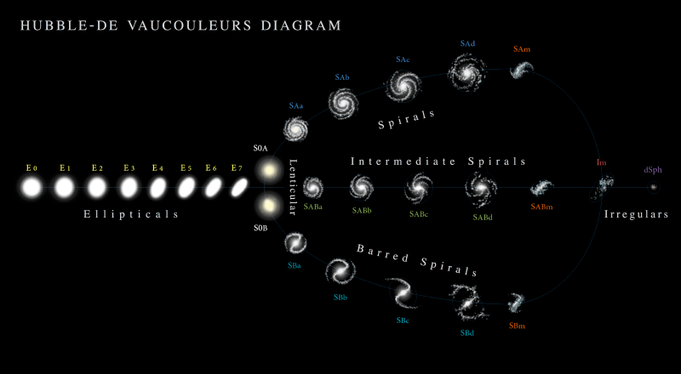
Figure 4: Hubble-De Vaucouleurs diagram, a more detailed view of the galaxy types. Credit: https://en.wikipedia.org/
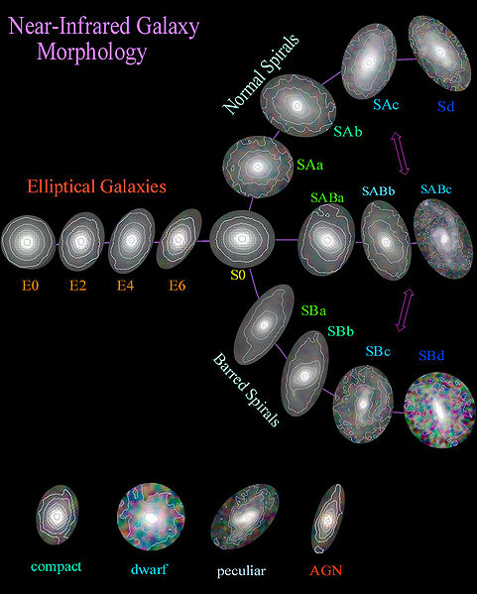

Figure 5: A Near-Infrared morphology of galaxies. Other type of galaxies such as compact galaxies, dwarf galaxies, peculier galaxies and AGNs are also shown under the tuning fork diagram which are not the part of it. Credit: https://en.wikipedia.org/

4. What can we learn from galaxy morphology?
The study of galaxy morphology provides valuable insights into the structure, evolution, and physical processes occurring within galaxies. By examining the visual appearance and shapes of galaxies, one can learn a wide range of information from the study of galaxy morphology, including:

A. Galaxy Classification: Morphology allows us to classify different types of galaxies, based on their visual appearance. The most common classification scheme is the tuning fork diagram which we have seen in figure 1. It helps us to organise and study the diverse population of galaxies in the universe.
B. Galactic Evolution: Galaxy morphology is closely related to the evolutionary history of galaxies. By observing the distribution of different galaxy types at various cosmic epochs, astronomers can infer how galaxies have evolved over time. For example, the prevalence of spiral galaxies in the nearby universe suggests that they are more common in the present epoch compared to the early universe.
C. Star Formation History: The presence of spiral arms and active star-forming regions in galaxies can provide valuable information about their star formation history. Spiral galaxies often contain young, massive, and blue stars in their arms, indicating ongoing star formation. Whereas elliptical galaxies generally have lower recent star formation activity and contains mostly older stellar populations.
D. Galactic Interactions and Mergers: We may find many distorted or irregular shape galaxies, which can be signs of recent interactions or merging of other galaxies. These galactic interactions play a crucial role in shaping galaxy structures and it can trigger the star formation activity and it may lead to the formation of new structures, such as tidal tails, bridges and influence the growth of supermassive black holes at their center.
E. Supermassive Black Holes: Observations of galaxies at their central regions can help us to understand the presence and growth of supermassive black. The morphology of the galaxy and the properties of the central bulge can be linked to the activity of the central black hole.
F. Dark Matter Distribution: The observed morphology of galaxies is influenced not only by the visible matter but also by the presence of dark matter. The gravitational influence of dark matter affects the overall shape and structure of galaxies. Observing how galaxies rotate and how their mass is distributed can help astronomers infer the distribution of dark matter within them.
G. Environmental Effects: Galaxy morphology is influenced by the environment in which galaxies located, such as galaxy clusters or voids. The distribution and types of galaxies in different environments can help us to understand the environmental effect in the galaxy evolution. Dressler (1980) established that the local environmental density is strongly related to galaxy morphology.
H. Cosmological Studies: Observing the morphology of distant galaxies allows us to study the evolution of the cosmic web, large-scale structures, and distribution of galaxies at large-scale, which is crucial to understand the structure of the universe.

5. Conclusion

Overall, galaxy morphology plays a fundamental role in our understanding of galaxy formation, large-scale structure and its evolution over time. It remains an essential tool in modern astrophysics and provides a basis for further investigations using a wide range of observational and theoretical approaches. Analysing galaxy clusters may also provide an understanding of the merger mechanism between galaxies, which often leave their footprints on the morphological properties of the merging galaxies and their coevolution.

References

- Hubble E. P., 1926, ApJ, 64, 321
- Schechter P. L., 1987, in de Zeeuw P. T., ed., Vol. 127, Structure and Dynamics of Elliptical Galaxies. pp 217–228, doi:10.1007/978-94-009-3971-4_18
- Dressler A., 1980, ApJ, 236, 351
- De Vaucouleurs, G. (1959). "Classification and Morphology of External Galaxies". Handbuch der Physik. Handbuch der Physik / Encyclopedia of Physics. 53: 275–310. Bibcode:1959HDP....53..275D. doi:10.1007/978-3-642-45932-0_7. ISBN 978-3-642-45934-4.
- Ambartsumian, Viktor Amazaspovich, Complete Dictionary of Scientific Biography. Encyclopedia.com. 3 Dec. 2019

