A strategy of Polyamines roles as plant growth promoter on regeneration in Sargassum tenerrimum (Fucales, Phaeophyta)

Babita kumari
¹Department of Botany, University of Dellhi, Delhi-110001
²Department of Environmental Science
CASAR, Best Innovation University, Gorantla, A.P.-515231

Abstract

In the present research work, the explants of Sargassum tenerrimun cultured in different concentrations of polyamines. The first regeneration was observed in 10⁻⁶M spermine supplemented PES medium after 3 days of inoculation. Some filamentous outgrowths were shown to develop several primary and secondary lateral branches with receptacles measuring 6.5cm in length grown successfully in 10⁻⁶M spermine supplemented PES medium. The nature of in vitro plants resembles the natural plants.
Introduction
Polyamines plays a significant role for the regeneration and growth and development in higher Plants (Smith 1985, Torrigiani et al. 1987, Gerats et al. 1988, Evans and Malmberg, 1986). A literature survey showed the physiological role of polyamine in both lower and higher plants (Schubert et al., 1983 ; Roberts et al., 1986 ; Kaur-Sawhney and Applewhite, 1993). Since a decade, the experimental work has had a positive impact on polyamines research has increased for agronomic and horticulture crops (Rajam 1997).. In the field of in vitro culture in marine algae, polyamines show tremendous effect within different algal groups ( Hamana and Matsuzaki, 1982) and their involvement in cell division (Cohen et al., 1984). Hence, the objective of this work was to study the positive impact of polyamines supplemented media on growth, regeneration and development of Sargassum tenerrimum . This study has help to increase the overall productivity and economic prospects of India, by developing in vitro tissue culture techniquies which is based on maco- clonal propagation in choosing fast growing strains
Material and method
Collection and preparation of Sample for in vitro culture studies
The thallus of Sargassum species (Fucales, Phaeophyceae) was collected from the coast of Gulf of Kacch, Gujarat on 2nd October 2012. The whole thallus was cleaned with seawater several times in the field, wrapped in moistened cotton cloth and brought in a cool ice-box to the laboratory. Healthy thalli, preferably with few branches with microscopic organisms reduced by manual brushing.. Now explants were cut into small fragments (.5mm-1cm) and inoculated in both liquid and solid medium supplemented with enriched spermine, spermidine and putrescine. In each petriplates, there was five explants inoculated. The cultured were maintained at 20⁰C in 12 : 12 light and dark photoperiod. Observations were made weekly.
Results and conclusions
Amongst media (PES, ESW and F2), the strongest effect of growth, regeneration and callus formation was observed in spermine enriched PES medium. Interestingly, the first regeneration of explant was reported after 72 hours in 10⁻⁶M and 10⁻⁸M spermine enriched PES medium in liquid culture. However, regeneration alongwith callus formation was observed in solid culture after 7 days of inoculation. The quantitative data of rate of regeneration of leaves in both solid and liquid culture shown in Figure 1a,b and c). However the solid culture summarized in Figure 2 a, b and c. Interestingly, the first regeneration was seen in 10⁻⁶M spermine enriched PES medium within 72 hours of inoculation. During regeneration, some new outgrowths were observed at the cut ends of explants that subsequently developed into young thallus when cultured in polyamines enriched media. Although regeneration occurred in all media, polyamines enriched media show better rate of regeneration than normal media. Further explants cultured in 10⁻⁶M spermine enriched PES medium induced 60 primary leaves (.5mm-1cm) alongwith short vegetative branches from the stipe portion of explant after 21 days of inoculation . The cut end of midrib portion of leaf produced several elongated stipes (1.4cm-4.3cm) when cultured in 10⁻⁶M enriched PES medium alongwith minute leaves . Subsequently, 10⁻⁶M putrescine enriched PES medium stimulated a single stipe (1.2cm) alongwith 12 primary leaves from the midrib portion of explant of leaf. While in ESW, two elongated stipes (4.5 & 5.5cm) alongwith primary leaves were observed from the explant of holdfast cultured in 10⁻⁸M spermine.

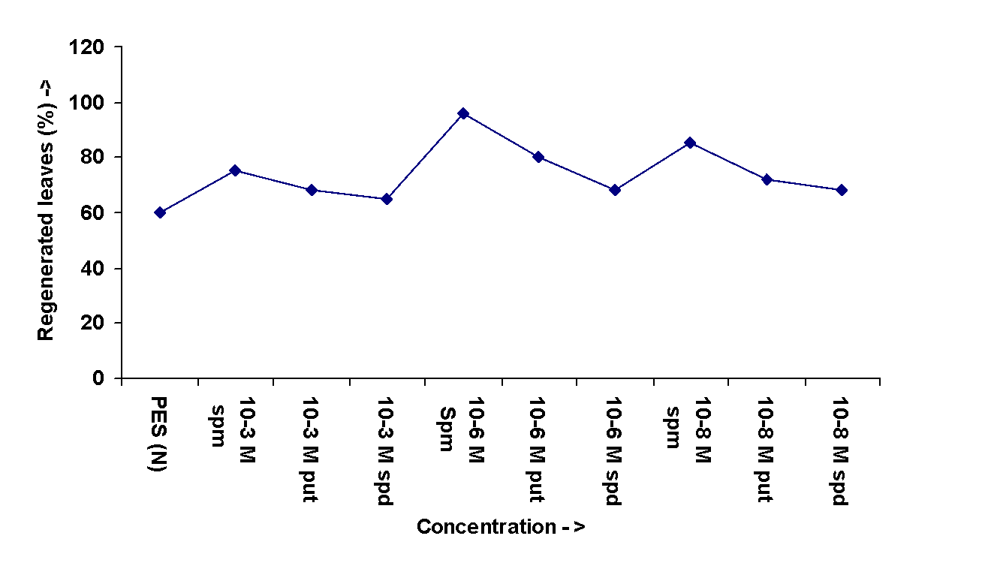
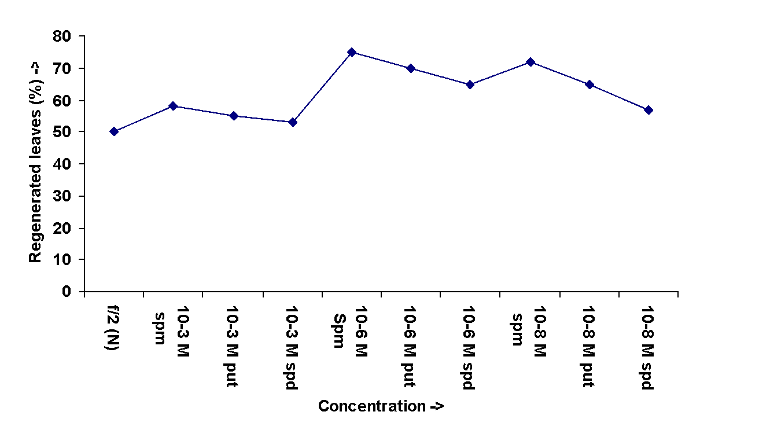

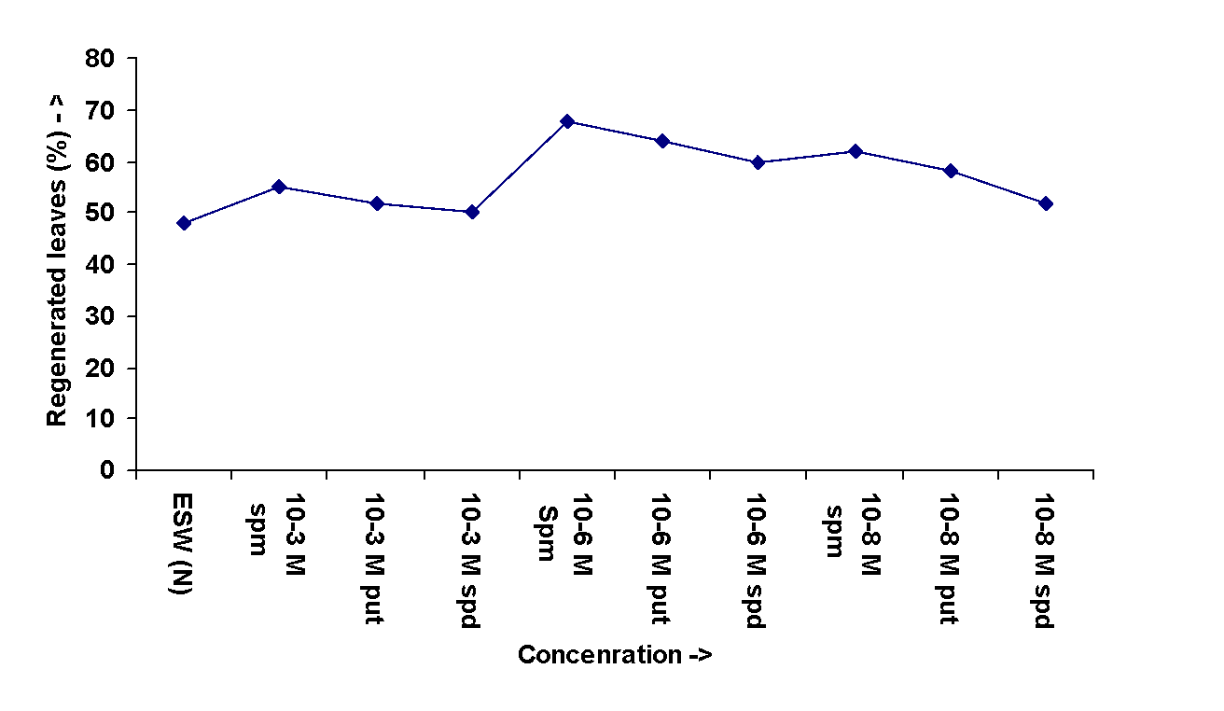
Fig 1a, b and c: Effect of Polyamines (spermine, putrecine & spermidine) enriched cultured media (A. PES B. f/2 & C. ESW) show percentage of regenerated leaves from different part of explants (hold fast, stipe and leaves) after 21 days of inoculation.

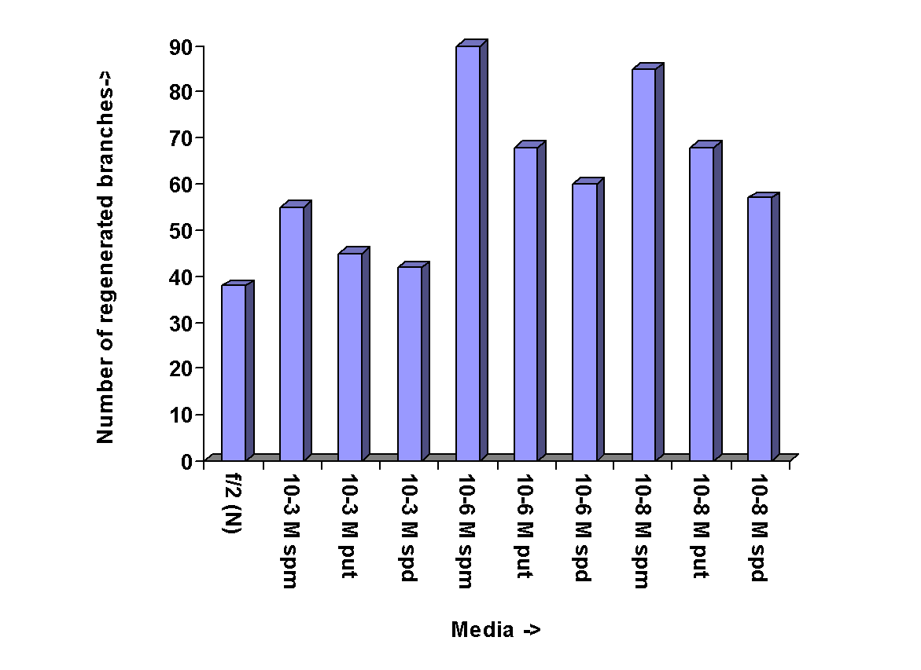
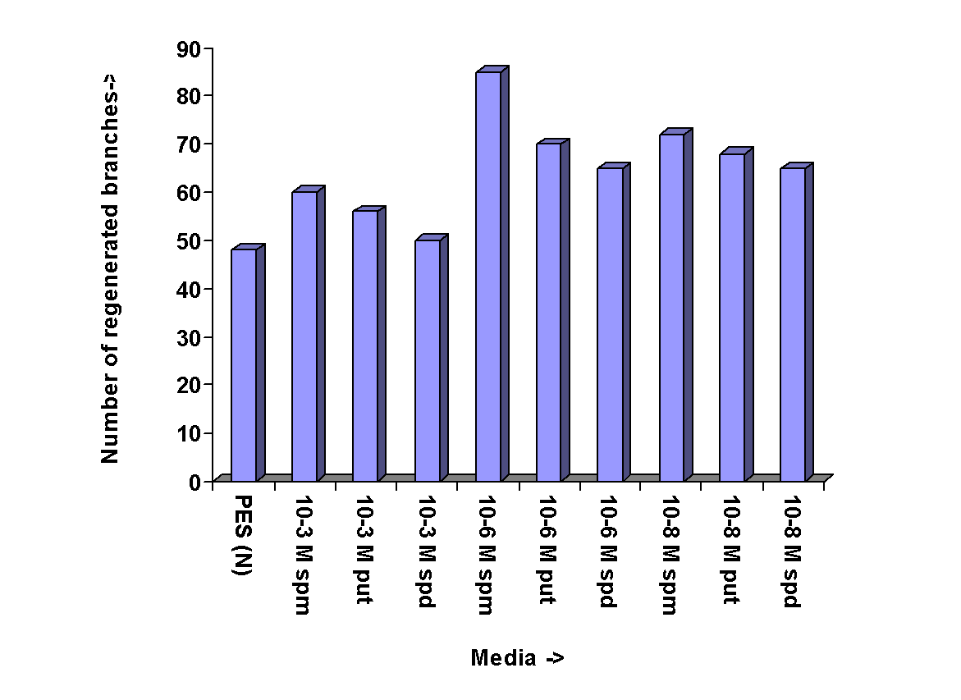
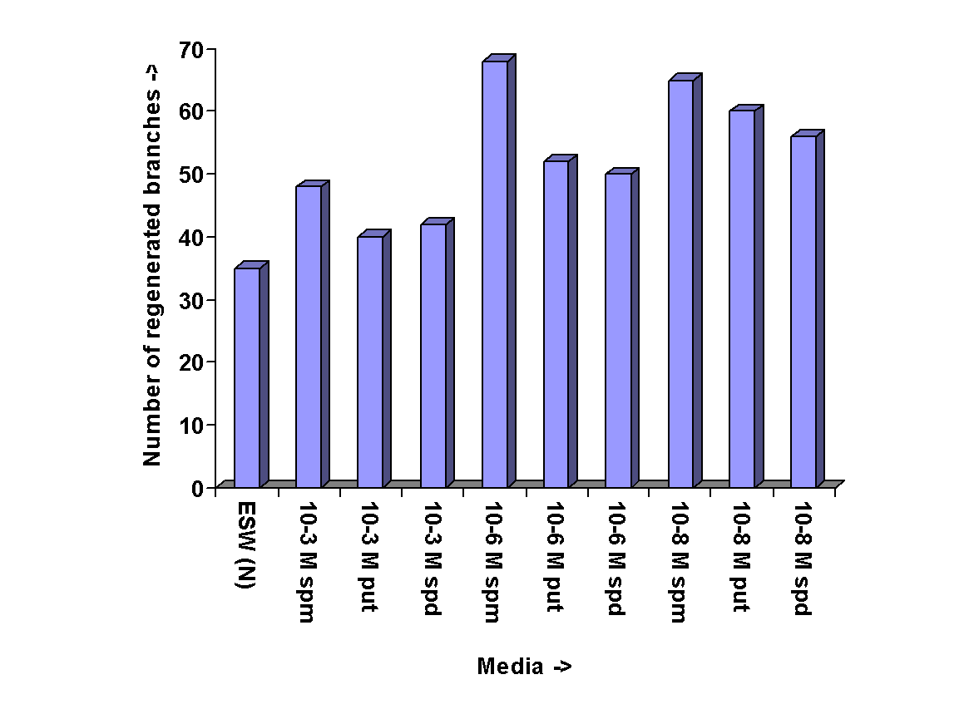

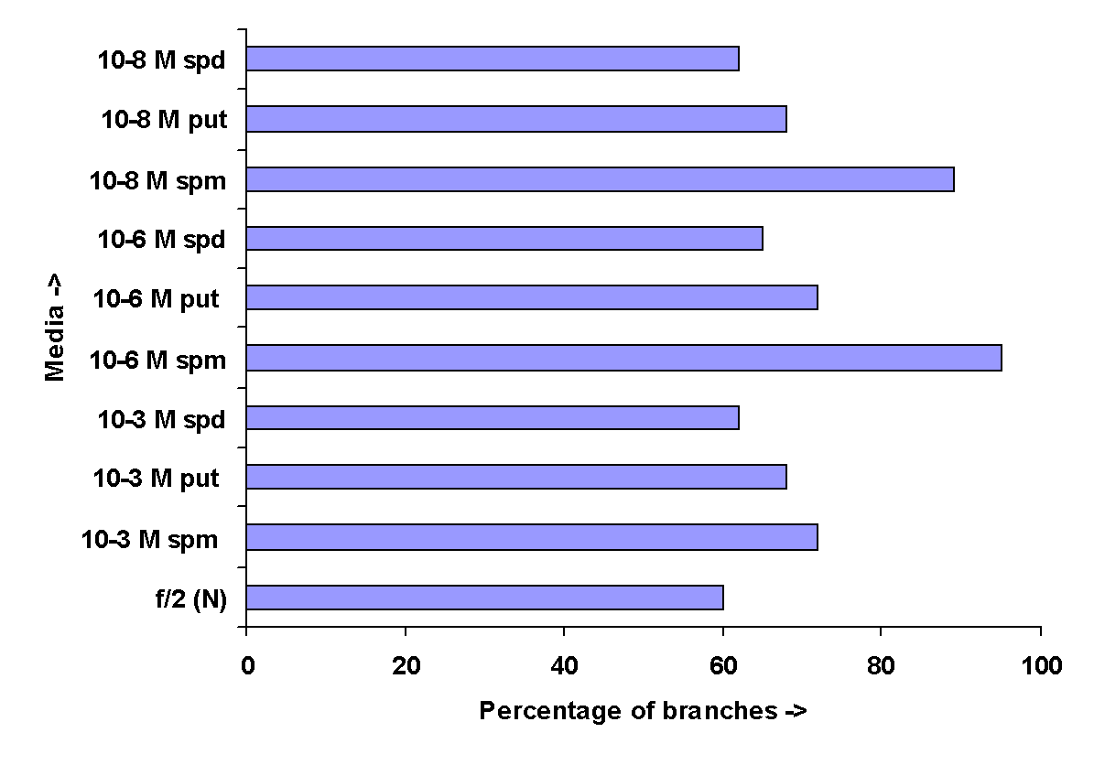
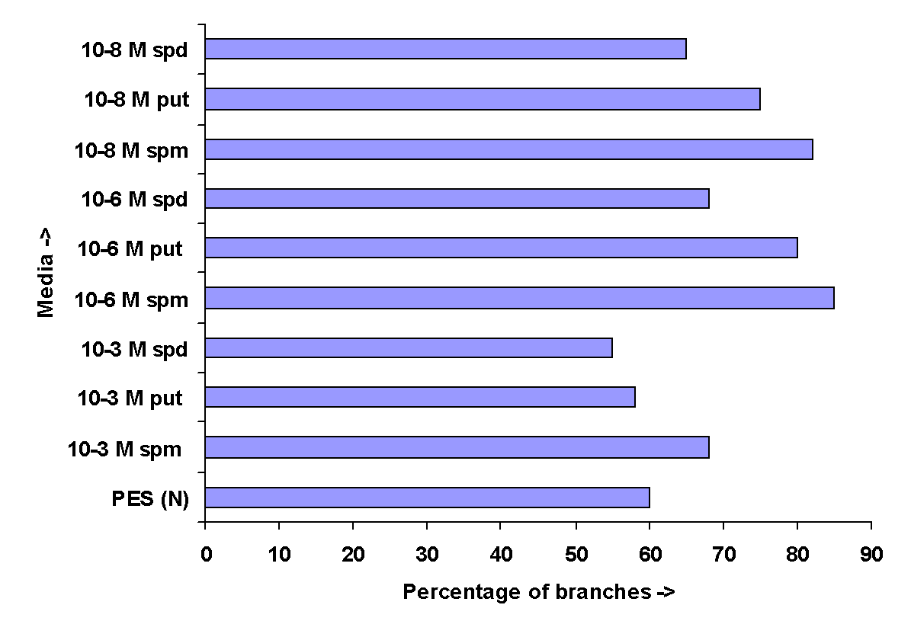

Fig2 a, b and c : Effect of Polyamines (spermine, putrecine & spermidine) enriched cultured media (A. PES B. f/2 & C. ESW) show number of regenerated branches from explants after 21 days of inoculation.
The surface of regenerated stipes was found to be smooth and primary leaves were developed in a regular spiral sequences. Moreover, Spermidine 10⁻⁶M enriched PES promoted several primary leaves alongwith short branches. Interestingly, one of the primary leaves grew rapidly from the basal portion and become broad in shape after 21 days (Figure). However, explants cultured in f/2 media promoted maximum rate of regeneration in spermine compared to spermidine and putrescine. Spermine 10⁻⁶M f/2 medium promoted maximum percentage of leaves from the stipe portion of explant. Several primary vegetative branches alongwith leaves developed from the cut ends of stipe cultured in 10⁻⁶ M supplemented media. The enhancement of growth of explants cultured in spermidine and putrescine was found to be slow. In spermidine 10⁻⁸M enriched f/2 medium enhanced the regeneration of primary leaves from the cut end of midrib portion of explant of leaf. Further inoculation of explants in putrescine enriched f/2 medium also promoted regeneration of leaves alongwith primary branches. However, explants cultured in spermine enriched medium produced two elongated stipes measuring 4.5 & 5.0cm in length along with secondary leaves. The surface of stipes was smooth and leaves were developed laterally in a regular sequences.
In solid medium (1.5% agar plus culture medium), 75 % of regeneration of leaves observed whereas only 25 % of callus induced after 7 days of inoculation of explants in 10⁻⁶M spermine enriched PES and f/2 medium. The speed of regeneration was found to rapid compared to callus formation. The length of leaves measuring upto .8mm-1cm while length of callus was found 12 μm after 21 days of subculture (Figure 2a, b and c ). The color of the callus was pale yellow.

DISCUSSION

Many report surveyed the positive impact of polyamines to promote the growth and regeneration algae (Hommersand and Fredericq, 1995; Guzman-Uriostegui, 2002; Garcia-Jimenez et al., 1998; Guzman-Uriostegui et al., 2002; Baldini et al., 1994; Garcia-Jimenez et al., 1998; Kaczyna and Megnet, 1993; Lee, 1998; Marian et al., 2000; Sacramento et al., 2004). In the present study supplementation of polyamines in different culture media were found to have significant stimulatory effect on Sargassum tenerrimum. The simultaneous formation of leaves, branches, receptacles and callus formation in Sargassum tenerrimum is reported for the first time in axenic tissue culture in different concentrations of polyamines enriched media.
Amongst all Polyamines, spermine seems to enhance tremendous results on growth, regeneration and callus formation in Sargassum tenerrimum. Regeneration of different organs occurred from all types of explants i.e from holdfast, stipe and leaves cultured in three different media supplemented with polyamines. Although the regeneration was found in normal media, growth was better in polyamines supplemented media (Present study). Fagerberg and Dawes (1976) reported that mitosis occurred at the active portion of the surface cell of stipes in Sargassum filipendula after 3rd day of inoculation. Similar results were observed from the stipe and leaves of explant in Sargassum tenerrimum when cultured in 10⁻⁶M spermine of PES medium after 3rd day of inoculation. However in prehe speed of regeneration of vegetative branches occurred more from the explant of holdfast compared to stipe and leaves in Sargassum tenerrimum. Regeneration of receptacles increases alongwith lateral branches observed in 10⁻⁶M spermine enriched PES medium (Present study). These receptacles undergo further development alongwith several vegetative branches and produced a young thallus.
Conclusion
From the above study, it was found that polyamines have significant positive impact on growth of callus formation and plant regeneration. However, more studies and experiments are needed to understand the role and effects of polyamines in Sargassum tenerrimum. This study may also lead to micropropagation and seed stock in brown algae such as Sargassum tenerrimum.

REFERENCES
Badini L., Pitocchi R. and Bagni N. 1994. Polyamine transport in the seaweed Ulva rigida (Chlorophyta). J. Phycol. 30: 599-605.

Cohen E., (Malis) Arad S., Heimer Y.M. and Mizrahi Y. 1983. Polyamine biosynthetic enzymes in chlorella : characterization of ornithine and arginine decarboxylase. Plant Cell Physiol. 24: 1003–10.
Evans P.T. and Malmberg R.L. 1989. Do polyamines have a role in plant development ? Ann. Rev. Physiol. Plant Mol. Biol. 40: 235–269.
Fagerberg W.R. and Dawes C.J. 1977. Studies on Sargassum II. Quantitative ultrastructure changes in differentiated stipe cells during wound regeneration and regrowth. Protoplasma. 92: 211-227.

Garcia- Jimenez P., Rodrigo M. and Robaina R.R. 1998. Influence of plant growth regulators, polyamines and glycerol interaction on growth and morphogenesis of carposporelings of Grateloupia cultured in vitro. J. Appl. Phycol. 10: 95–100.
Gerats A.G.M., Keye C., Collins C. and Malmberg R.L. 1988. Polyamines level in Petunia genotypes with normal and abnormal floral morphogenesis. Plant Physiol. 86: 390–3.
Hamana K. and Matsuzaki S. 1982. Widespread occurrence of norspermidine and norspermine in eukaryotic algae. J. Biochem. 91: 1321–8.
Hommersand M.H. and Fredericq S. 1995. Sexual reproduction and cystocarp development. In cole, K.M. & Sheath, R.G. (Eds.) Biology of the red algae. Cambridge University Press, New York. pp. 305–45.
Jimenez-Garcia P., Rodrigo M. and Robaina R.R. 1998. Influence of plant growth regulators, polyamines and glycerol interaction on growth and morphogenesis of Grateloupia cultured in vitro. J. Appl. Phycol. 10: 95–100.
Kaczyna F. and Megnet R. 1993. The effects of glycerol and plant growth regulators on Gracilaria verrucosa (Gigartinales, Rhodophyceae). Hydrobiologia. 268: 57–64.
Marian D. F., Jimenez-Garcia P. and Robaina R.R. 2000. Polyamines in marine macroalgae : Levels of putrescine, spermidine and spermine in the thalli and changes in their concentration during glycerol-induced cell growth in vitro. Physiol. Plantarum. 110: 530–534.

Sacramento T.A., Jimenez-Garcia P., Alcazar R., Tiburcio F.A., and Robaina R. 2004. Influence of polyamines on the sporulation of Grateloupia (Halimeniacea, Rhodophyta). Phycol. 40: 887-894.
Scoccianti V. and Bagni N. 1992. In vitro interactions between polyamines and isolated Porphyridium sp. Polysaccharide. Plant Physiol. Biochem. 30 (2): 135–138.
Smith T.A. 1985. Polyamines. Ann. Rev. Plant Physiol. 36: 117–143.
Uriostegui-Guzman A., Marian F., Jimenez-Garcia P., Robledo D. and Robaina R. 2002. Polyamines influence maturation in reproductive
structures of Gracilaria cornea (Gracilariales, Rhodophyta). J. Phycol. 38: 1169–1175.

