CHALLENGES, SOLUTIONS AND OPPORTUNITIES OF RENEWABLE ENERGY

INTRODUCTION:
The developing consideration to natural problems is driving execution of modern source models according to non-conventional energy sources. Usually modifying the course of action of energy administration and instilling novel issues that are fair modestly understood on. Non-conventional energy sources teach changes because an expanded ask to renewable power resources for balance customer demands at brief take note. To extend the best utilization of minimum-carbon resources, those changes should be understood and powerled. Breakthroughs in arrange plan, exchange, and capacity strategies, also as financial firm are basic. This conveyed behavior renewable power generation negates this conventional energy systems with expansive, centralized generations. The inconsistency clears the talk whether a unused essential plan is fundamental. This chapter appears and examines comes about source models such are created, also utilized at the founded for Renewable and Economic Power Schemes. Challenges and opportunities of diverse schemes hardness are talked about and given into a hypothetical system. Distinguish a trade-off among innovative and political challenges depending on the examined scope and schemes capacities.
The past thought on this subject is wide and we center on a few viewpoints which are analyze the techno-economic opportunities for renewable incorporation in distributed power schemes. A few studies analyze the longer-term points of view for capacity innovations. The nation scope respects the addition of the expanding sum of varying renewable energy as a nationwide challenge. One specialized incorporation degree, which can set up freely exclusive of worldwide assertions, is large-scale energy capacity. Expanding the schemes measure leads us from person homes to smaller scale networks.
Essentially the energy sources are two sorts; they are routine energy sources like coal, petroleum, common gas etc. & non-conventional energy sources like solar cells, fuel cells, thermo-electric generator, thermionic converter, solar generation, wind Power generation, geo-thermal energy generation, tidal Power generation etc.
Diverse Renewable strategies of Energy generation & efficiencies:
S.NO | SCHEME | EFFICIENCY
 |  | PRESENT | UPCOMING
1 | MHD | 50% | 60%
2 | Thermo-electric | 3% | 13%
3 | Thermionic converters | 15% | 40%
4 | Fuel cell | 50% | 60%
5 | Solar | 30% | 50%
6 | Wind | 30% | ----
7 | Geo-thermal | 15% | ----

Few Challenges facing by the Grid from Wind and Solar:
Here's the five issues facing by the Schemes from Variable Renewable Energy (VRE):
1) Inconstancy: This could be the most noteworthy and most frustrating.
Power generating plants can run on fuel (adjacent to hydro and geothermal) can be adjusted up and down on power. They are “distributed". But VRE sources make Power because it was when the wind is driving, or the sun is shining. Organize chairmen don't Power VRE, they oblige it, which needs many agilities.
This figure shows up why, utilizing wind Power as an layout:
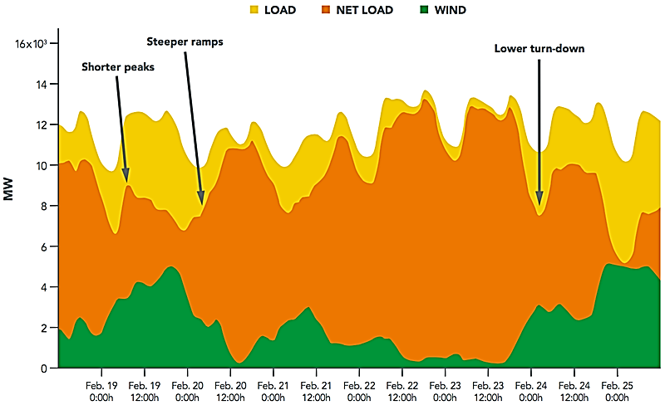

This appears one week of power supply and request (points of interest and area not especially vital). The green at the foot is energy received in through wind. The yellow at the beat is add up to request. The orange within the center is the hole between the two, the sum that must be provided by ordinary generating plants.
On the map over, "shorter crests" alludes to times when ordinary plants are providing the day's "crest load," which is when energy is most important. VRE diminishes or "shaves" the top, hence attaching it to the financial matters of standard plants. "More extreme inclines" alludes to times when routine plants need to increment or diminish their outcome rapidly in reaction to variances in VRE — frequently more rapidly than they are proposed or powerled for. And "reduce turn-down" implies that in speeds of tall VRE supply, routine plants will have to be run at the most reduced outcome they are competent of, i.e., "smallest load."
Every impact of inconstancy posture challenges the rules and financial matters that oversee existing power systems.
1) Vulnerability: The outcome of VRE plants cannot be anticipated with idealized precision in day-early and day-of estimates, so network administrators need to have abundance save running fair in case.
2) Site-specificity: Solar and wind are more grounded (and in this way more temperate) in a few places than in others — and not continuously in locations that have the essential transmission foundation to urge the energy to where it's required.
3) Nonsynchronous generation: Customary generators give voltage support and recurrence Power to the schemes. VRE generators can as well, possibly, but it's an extra capital speculation.
4) Low capacity calculates: VRE plants as it were run when sun or wind coordinates. Since of the Low capacity calculate of VRE, routine plants are required to require up the slack, but because of the tall outcome of VRE in crest periods, customary plants some of the time do not get to run as frequently as required to recuperate costs.
So those are the challenges. There are arrangements for joining solar and wind into the schemes.
1) Enhancement of planning and coordination: Usually the primary step, making beyond any doubt that VRE is coordinated up with suitably adaptable dispatchable plants and transmission get to so that energy can be shared more fluidly inside and between grid locales.
2) Adaptable rules and markets: Most grids are physically competent of more adaptability than they show. Changes to the rules and markets that oversee how plants are planned and dispatched, how unwavering quality is guaranteed, and how clients are charged.
3) Adaptable request and capacity: To a few degree, request can be overseen like supply. "Request reaction" programs total clients willing to let their stack be sloped up and down or moved in time. The result is comparable, from the network operator's viewpoint, to dispatchable supply.
4) Adaptable routine generation: Although more seasoned coal and atomic plants are reasonably resolute, with amplified shut-down, cool-off, and ramp-up times, parcels of more current and retrofitted routine plants are more agile — and can be made more so by a combination of innovation and made strides hones. Schemes organizers can favor more adaptable non-VRE choices like normal gas and small-scale Combined Warm and Power (CWP) plants.
5) Interconnected transmission systems: This one's lovely straightforward. Wind and solar resources become less variable in case totaled over a broader locale. The greater the geological region connected by Power lines, the more likely it is that the sun is sparkling, or the wind is blowing some place inside that zone.
But numerous of those arrangements have a few financial restrictions.
Smart Grid:
Smart Grid encourages well-organized and reliable continuous mental two-way conveyance organize from source to sink through integration of renewable power sources, Smart transmission, and conveyance. In this way Smart Network innovation might carry productivity and maintainability in assembly the developing power request with consistency and reliability of the condition.
Smart Grid too empowers genuine time observing and Power of power systems also makes a difference in diminishment of AT&C losses, request reaction and request side administration, quality of power administration, blackout administration, smart domestic source schemes etc. Smart Network will show as a spine foundation to empower new business models like smart city, electric vehicles, Smart communities separated from much strong and effective source schemes and tariff schemes.
Green Energy:
Green Energy is power that's delivered from non-conventional energy sources such as solar, wind, geothermal, biomass, and low-impact hydro offices. Ordinary power generation, based on the combustion of fossil powers, is the nation's single biggest mechanical source of discuss contamination. The developing accessibility of green Power empowers power clients to quicken establishment of non-conventional energy procedures. As more green Power sources are created - uprooting ordinary generation - the by and large natural impacts associated with power generation will be altogether decreased.
Energy Sources:
Green Power with Zero emanation is delivered from non-conventional energy sources without making discuss contamination.
Solar | Radiation from the sun that comes to Earth's exterior can create power in a few ways. Photovoltaic schemes utilize semiconductors to change light to power. Solar concentrators warm water into steam, which drives turbines to produce electric power.
Wind | The dynamic wind source can be loaded to produce power using wind turbines of numerous distinctive capacities.
Hydro | Streaming water could be coordinated using hydro-energy turbines to create power.
Geothermal | In a commonplace geothermal office, temperature from interior the ground warms water to create steam, which pivots turbines to create electrical Power.
Tidal | Tidal energy plants work by centering the tides' day by day cycles of development into power generator.
Wave | In a wave power energy, a water column pushes up and down to run the turbine to create power.
Ocean | The warm energy of the sea could be saddled to create power. Closed-cycle schemes utilize the ocean's warm surface water to steam a working liquid, that point extends and turns a turbine. Open-cycle schemes bubble ocean water to create steam for utilize in a turbine.

A few others delivered through non-conventional energy sources whereas producing a few discuss contamination.
Biomass | In a commonplace biomass office, squander wood is burned to warm water to make vapor, which turns turbines to produce power. Biomass offices radiate discuss contamination but utilize a renewable fuel source.
Landfill Gas | Landfills generates capable nursery gases like methane, which can be described and utilized to create power. In a normal landfill gas office, the combustion of these gases is utilized to make steam, which turns turbines to produce power. Landfill gas offices emanate discuss contamination, counting nitrogen oxides, but utilize a squander gas fuel source that would something else contribute to worldwide climate alter.
Municipal Waste | Ina ordinary metropolitan squander incinerator office, squander from numerous sources (counting development, Residential and trade junk) is burned, making steam to turn producing turbines. All waste-to-energy incinerators carry discuss licenses directing the sums of discuss contamination they transmit, and all decrease the volume of fabric entering landfills.

Another Energy Selections at Domestic:
Here are numerous ways simply can make another energy selections right at domestic. The 2 most prevalent ways are introducing solar PV panels or a wind turbine at our homes.
Solar PV panels:
Solar PV panels are gadgets that change over radiation into power. Numerous property holders are presenting the selection to introduce solar PV panels on their home (ordinarily on the top of home) to decrease their consumption bills and to diminish their carbon impression. The cost for PV panels shifts essentially. In any case, a survey organized by the National Renewable Energy Lab in 2010 assessed that the national normal cost of solar PV (photovoltaic) schemes was $7.62 per watt. Hence, a commonplace 5-Kw scheme would fetch around $38,000. Any neighborhood or state discounts would decrease this fetched, as would the 30% solar tariff credit.
Buyers’ ought to be beyond any doubt that here are three various sorts of solar PV panel schemes. The primary sort is the on-grid battery schemes. Clearly, these schemes are associated to the schemes but moreover comprise batteries that can accumulate abundance power created. They can still drive a few included energies out to the grid. On-grid organize exclusive of a battery are straightforward and cheap to introduce, but the organize will closed on the off chance that Power goes out in your region. At long last, there is an off-grid solar PV power scheme. Homes that utilize such schemes are not bound to the power grid and create all their energy autonomously. This choice isn't ordinarily prescribed without you living in a farther range.
Wind Turbines:
Wind energy may be a non-conventional source of energy that's rapidly getting to be an acknowledged frame of power all present the world. Wind energy is delivered by saddling wind from the utilization of a wind turbine. Numerous wind turbines are enormous and are developed in inaccessible ranges that are greatly breezy. It is conceivable for house owners to buy small-scale turbines and put them in their house to produce energy for their domestic. In any case, since wind energy is conflicting in many regions of the world, many individuals can’t create sufficient Power to freely Power their domestic. However a one wind turbine can ease the grid-drawn energy of domestic employments and minimal utility bills. Regularly, individuals that dwell in regions with normal maintained wind velocities of more than 07 miles per hour are the finest candidates for wind turbines.
The starting price of acquiring and introducing a turbine at domestic is frequently very tall. Turbine rates changed impressively conditional on the show, maker, and the locale in which you're remaining. It can cost anywhere from $4,000 to $55,000 to buy and introduce a little turbine. The American Wind Energy Affiliation gauges that a ordinary domestic wind schemes prices around $33,000. The price may be a main disadvantage for numerous house owners since the currency you spare on utility bills will not be counterbalanced the fetched of the gadget, indeed over numerous a long time. In any case, the preferences of acquiring a wind turbine incorporate cutting utility bills and being in Power of how your energy is generated. Another advantage is the charge breaks. The government gives a 30% assess credit (for the complete cost of the turbine) for house owners who purchase one.
Performance model of Wind Turbine Generating Unit (WTGU):
Based on the rotational velocity WTGUs can be generally classified into two sorts to be specific settled velocity WTGU and alter velocity WTGU. Settled velocity WTGU comprises of coordinate schemes coupled acceptance generator. In alter velocity WTGU course, a wind turbine and an acceptance generator are associated with grid through back-to-back voltage source converter. Generally variable speed WTGU is utilized in which genuine Power output changes wind speed. For a commonplace WTGU, the output electrical Power generation is given by equation (1),
(1)
Here, v_{cin}, v_{cout}, v_{N} are cut-in velocity, cut-out velocity and ostensible velocity of wind turbine, separately; v_{w} is the normal wind velocity and P_{rated} is the appraised outcome Power of turbine and can be spoken to as equation (2),
(2)
Where, A is the cleared region of rotor, ρ is the thickness of wind and C_{p} is the Power co-efficient.
Clarification:
Faultfinders of renewable energy regularly cite the reality that innovations like wind and PV solar deliver power when the wind is blowing, or the sun is sparkling. They contend that we can’t viably utilize renewable energy until fitting energy capacity innovation is created. Whereas the reality that wind and solar don’t create energy around the clock is certainly a major drawback, I discover that the issues related with the irregular nature of numerous renewables are frequently overstated, and once in a while examined from a viable viewpoint. With this post, I’ll present some of the most challenges postured by discontinuous energy sources, and after that talk about three conceivable arrangements.
The Challenges of Renewable Energy:
The trouble related with coordination variable sources of power stations from the reality that the Power grid was outlined around the concept of huge, Powerlable electric generators. Nowadays, the network administrator uses a three-phase arranging process to guarantee Power stations produce the correct sum of power at the proper time to meet electric request reliably and dependably. Since the grid has greatly little capacity capability, the adjust between electrical Power supply and stack request must be kept up at all the times to maintain a strategic distance from a shutdown or any other cascading trouble.
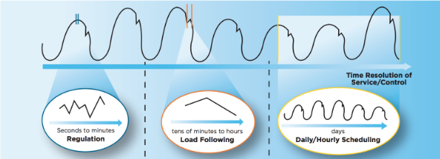

Discontinuous renewables are challenging since they disturb the ordinary policies for placing the day-by-day process of the electric network. Their energy varies over different time skylines, driving the grid administrator to alter its day-ahead, hour-ahead, and real-time working strategies.
Take the case of solar panels. Solar-PV energy is intrinsically accessible amid sunshine hours, so the grid administrator must alter the day-ahead arrangement to incorporate generators that can rapidly alter their energy outcome to compensate for the rise and drop in solar generation. In addition, electrical Power stations that normally produce electrical Power all through the day each and each day might instep be inquired to turn off amid the center of the day subsequently that the Power produced from solar can be utilized in lieu of fossil power.
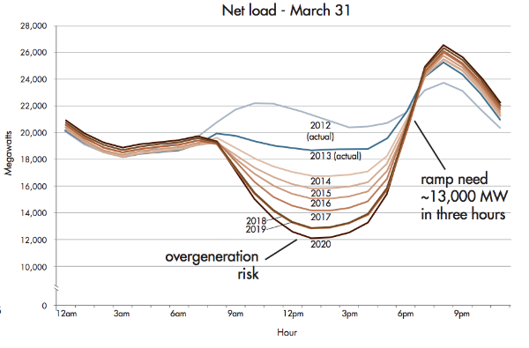
In expansion today by day vacillations caused by dawn and dusk, the output from solar panels can also alter abruptly due to clouds. Changeability caused by clouds can make it more troublesome for the schemes administrator to anticipate how much extra electric generation will be required amid the following hour of the day, so it gets to be troublesome to calculate precisely what the output of each generator ought to be to achieve the load-following stage recognized within the to begin with realistic over.
Quick vacillations in output from wind or solar energy don’t disturb the hourly load-following stage of schemes arranging, but too the second-to-second adjust between add up to electric supply and request. Nowadays, the schemes administrator sends a flag to power plants roughly every four seconds to guarantee the overall sum of Power infused into the network reliably breaks even with the whole Power pulled back. Since solar and wind enhance the sum of unforeseen electrical power generation shortages or abundances, the operation of the grid requires extra store Power prepared to reply at a moment’s watch to create beyond any doubt the network remains adjusted.
Whereas renewable disturbs the grid’s operation in several ways, it isn't incomprehensible to compensate for the extra intermittency and vulnerability. In reality, numerous techniques to overcome renewable variability are easier than you might realize. The taking after areas survey techniques that can be utilized to coordinate renewable energy without the requirement for expensive energy capacity.
A Economical Electric Grid of long Term:
While the challenges posed by the rotating nature of a few non-conventional energy sources unquestionably upgrade the trouble of effectively working the grid, they are distant absent from inconceivable. In a few ways, they pale in comparison to the colossal challenges that were overcome to initially string all the wires, construct all the electrical Power stations, and execute all of the Powers that make up the display schemes. Decreasing the costs related to non-conventional changeability will be a primary challenge of the up and coming a long time and decades.
Standards of Smart Renewable Energy Approach:
We portray Smart non-conventional energy technique as the set of approach, rules and government measures that direct to an progressed share of non-conventional energy sources in entire electrical Power utilization in line with a country’s advancement destinations. Smart non-conventional energy procedure energizes Residential speculation, accomplishes its points in a cost-effective way, advances steady advancement and is planned through straightforward, responsible and participatory forms.
Smart Renewable Energy Arrangement on the Ground:
Fruitful approaches to renewable energy approach and back shift by nation, but there are a few common topics and proposals rising from the encounters made in case consider nations analyzed in this chapter. Universal bolster can bring the lessons from these encounters to more nations and scale up existing victories. The lessons learned from the case thinks about are as takes after:
Arranging and creating a technique:
- Official renewable energy targets are a significant to begin with step.
- Planning can develop more advanced as sending grows; for genuine scaling up of renewable energy, long-term arranging will be fundamental.
- Preparation choices require to be based on a sensible and straightforward estimation of the complete fetched of distinctive alternatives.
- The arranging handle benefits from straightforwardness, responsibility, and partner cooperation.
Application Challenges/Opportunities for Research:
Wind Energy Challenges:
- Cost lessening for a zero-incentive circumstance
- Improving Efficiency
- Mechanical stack weakening
- Large-scale schemes incorporation and infiltration
- Extreme climate conditions
- Offshore wind turbines
- Airborne wind energy schemes
SOLAR ENERGY
Sun powered vitality can be made more calm by reducing theory and working costs and by growing sun powered plant execution. The sun-based field talks to the greatest share of the fetched of any CSP plant. Depending on the innovation, this brought might alter from around 43% for tower and Fresnel advancement to about 60% for symbolic trough and dish Stirling CSP plants. The preeminent critical decrease in fetched is likely to come from advancements in sun powered field arrange, which may bring down the Levelized Taken a toll of Vitality (LCOE) by 15% to 28%, depending on the advancement.
The entirety of daylight that strikes the earth's surface in an hour and a half is adequate to handle the total world's vitality utilization for a full year. Sun powered advancements alter daylight into electrical vitality either through Photovoltaic (PV) boards or through mirrors that concentrate solar radiation. This vitality can be utilized to form power or be put absent in batteries or warm capacity.
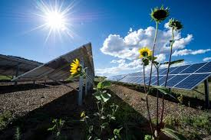

Solar Energy
Solar radiation is radiation – moreover named as light or electromagnetic radiation – that's transmitted through the sun. Whereas each area on earth gets a few sun lights throughout annum, the sum of sun radiation which comes to any location on the earth’s surface changes. Solar innovations collect this radiation and convert into valuable shapes of power.
Solar radiation, frequently called the solar source or just sunlight, may be a common term for the electromagnetic radiation radiated by the sun. Solar radiation can be captured and turned into useful shapes of energy, such as warm and power, employing an assortment of advances. Be that as it may, the specialized achievability and temperate operation of these innovations at a particular area depends on the accessible solar source.
Essential Standards
Each area on Earth gets sunlight at the slightest portion of an year. The sum of sun radiation which comes to any location on the earth's surface shifts agreeing to:
- Topographical area
- Day time
- Time
- Limited scene
- Confined climate.
Since this earth is circular, the radiation hits the surface at distinctive points, extending from 0° (fair over the skyline) up to 90° (straightforwardly overhead). As the sun beam comes vertical, this earth's surface receives all the power conceivable. The high inclined the sun beam is, longer they travel through the environment, getting to be more scattered and diffuse. Because the Earth is circular, the bone chilling polar districts never get a tall sun, because of the tilted pivot of revolution, these areas have no sun at all amid portions.
The earth rotates about the sun in an curved circle and is closer to the sun amid portion of the year. When the sun is nearer to earth, the Earth's surface gets smaller and has high solar power. The earth is nearer to sun in summer on the southern area of the equator and winter within the northern side of the equator. However, the nearness of endless seas moderates the hotter summers and colder winters one would anticipate seeing within the southern half of the globe because of this variation.
The 23.5° angle inside the earth's pivot of turn may be a high basic calculation in choosing the whole of daylight hitting the soil at a particular region. Angling comes approximately in lengthier days inside the northern half of the globe from the spring equinox to the drop (gather time) equinox and lingering days inside the southern side of the equator during the remaining 6 months. Days and nights are both absolutely 12 hours long on the equinoxes, this happen every year on or around walk 23 and September 22.
Nations like the Joined together states, which lie inside the center scopes, get more sun powered vitality inside the summer not because it was since days are lengthier, but since the sun is approximately overhead. The sun's bars are removed high angled during the small days of the winter months. Places like Denver, Colorado, (near 40° angled) get almost three times high sun-based vitality in June over in December.
The turn of the Soil in addition competent for hourly varieties in daylight. Inside the early morning and late evening, the sun is High inside the sky. Its pillars travel progresses through the discuss than at twelve, when the sun is at its most vital point. On a clear day, the foremost conspicuous whole of sun-oriented vitality comes to a sun powered collector around sun based twelve.

SPREAD AND COORDINATE SUN RADIATION
When daylight passes through, few of ingested, scattered, and reflected by:
- Wind particles
- Vapor
- Clouds
- Dust
- Pollutants
- Forest fires
- Volcanoes.
This is regularly termed as diffuse sun powered radiation. The sun powered radiation that comes to the earth's surface without being diffused is named as arrange column sun-based radiation. The total diffuse and facilitate sun-based radiation is called around the world sun-based radiation. Discuss conditions can diminish facilitating column radiation by 10% on clear, dry days and by 100% during thick, cloudy days.
ESTIMATION
Researchers’ degree the sum of solar light reaching on areas at diverse times of the annum. They at that point assess the sum of sunlight falling on districts at the same scope with comparative climates. Estimations of solar energy are ordinarily communicated as add up to radiation on an even surface, or as add up to radiation on a surface following the sun.
Radiation data for solar electric (photovoltaic) schemes are regularly spoken to as kilowatt-hours per square meter (kWh/m2). Coordinate gauges of solar energy may too be communicated as watts per square meter (W/m2).
Radiation information for solar water warming and space warming schemes are as a rule spoken to in British warm units per square foot (Btu/ft2).
DISTRIBUTION
The sun powered source over the is abundant for Photo-Voltaic (PV) plants since they utilize both facilitate and distributed daylight. Remaining propels might be high restricted. Be that because it may, the entirety of Power created by any sun-based development at a specific area depends on how much of the sun's vitality comes to it. Consequently, sun powered advancements work most productively inside the southwestern United States, which gets the foremost critical whole of sun-oriented vitality.
There are two primary sorts of solar energy technologies photovoltaics (PV) and concentrating Solar Thermal Power (CSTP).
Photovoltaics Basics
You're likely most commonplace with PV, which is utilized in solar panels. When the sun sparkles onto a solar panel, energy from the sunlight is absorbed by the PV cells within the panel. This energy makes electrical charges that move in reaction to an inner electrical field within the cell, causing electricity to stream.
Concentrating Solar-Thermal Power Essentials
What is concentrating solar-thermal power (CSTP) innovation and how does it work? CSTP innovations utilize mirrors to reflect and concentrate sunlight onto a recipient. The energy from the concentrated sunlight warms a tall temperature liquid within the recipient.
This warm - too known as warm energy - can be utilized to turn a turbine or Power an motor to create power. It can moreover be utilized in assortment of mechanical applications, like water desalination, improved oil recuperation, food processing, chemical generation, and mineral preparing.
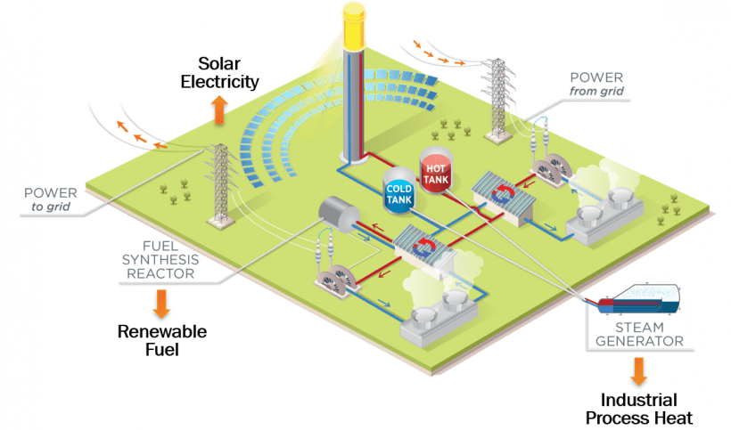
Concentrating solar-thermal power systems are for the most part utilized for utility-scale ventures. These utility-scale CSTP plants can be designed in several ways. Power tower schemes orchestrate mirrors around a central tower that acts as the recipient. Direct schemes have lines of mirrors that concentrate the sunlight onto parallel tube collectors situated over them.
Littler CSTP schemes can be found specifically where Power is required. For illustration, single dish/engine schemes can deliver 5 to 25 kilowatts of Power per dish and be utilized in conveyed applications.
Straight Concentrator Schemes Fixed Solar-Thermal Energy Basics
Direct Fixed Solar Thermal Energy (FSTE) collectors collects the solar power using huge panels which reflect and center the radiation onto a direct collecting tube. The collector includes a liquid which warmed by the solar light and after that utilized to warm a conventional energy cycle that turns a turbine that rotates a generator to deliver power. Then again, steam can be produced straightforwardly within the solar field, that disposes of the requirement for exorbitant warm exchangers.
Direct fixed collector areas comprise of a huge number of receivers in parallel columns that are ordinarily adjusted in a south-north introduction to enhance yearly and summer power receiving. Through a single-axis solar-tracking scheme, this setup empowers the panels to trace the sun from east to west amid the day, this guarantees that the solar reflects ceaselessly onto the collector tubes.
Direct schemes may join warm capacity. In these schemes, the collector field is larger than usual to heat a capacity scheme amid the day so the extra steam it creates can be utilized to deliver power within the evening or amid cloudy climate. These plants can moreover be planned as cross breeds, meaning that they utilize fossil fuel to supplement the solar output amid periods of Low solar radiation. In such a plan, a common gas-fired radiator or gas-steam boiler/reheater is used. Within the future, direct systems may be coordinates with existing or unused combined-cycle natural-gas- and coal-fired plants.
ILLUSTRATIVE TROUGH SCHEMES
The foremost common CSTP schemes within the Joined together States may be a direct concentrator that employments illustrative trough collectors. In such a system, the collector tube is positioned along the central line of each parabola-shaped reflector. The tube is settled to the reflect structure and the warm exchange liquid streams through and out of the field of solar mirrors to where it is utilized to form steam (or, within the period of a water/steam recipient, it is directed straightforwardly to the turbine).
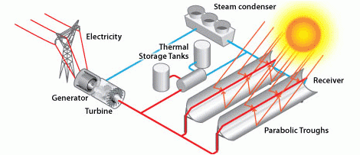

STRAIGHT FRESNEL REFLECTOR SCHEMES
A moment straight concentrator innovation is the direct Fresnel reflector schemes. Level or somewhat bent panels located on tracers on the earth are designed to reflect solar light onto a recipient tube settled in location over the panels. A little allegorical reflect is some of the time included on the recipient to encourage center the sunlight.
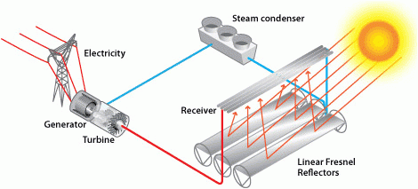
Warm Capacity Schemes Concentrating Fixed Solar-Thermal Energy Essentials
One task confronting the wide utilize of sun-based vitality is diminished or reduced vitality generation when the sunsets or is covered wsith clouds. Warm vitality capacity gives a workable course of action to this challenge.
In a Fixed Solar Powered Energy (FSTE) plants, the sun's bars are reflected onto a beneficiary, which makes warm that's utilized to deliver power that can be utilized rapidly or put absent for a while later utilize. This engages CSP plants to be versatile, or dispatchable, options for giving clean, renewable vitality.
Some practical warm vitality capacity developments have been attempted and actualized from 1985. These consolidate the two-tank arrange plants, two-tank circuitous plants, and single-tank thermocline plants.
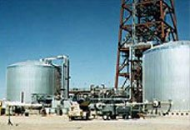
DIRECT TWO-TANK SYSTEM
Sun powered warm vitality in these plants is put absent inside the same fluid utilized to accumulate it. The fluid is put absent in two tanks—one at tall temperature and the other at High temperature. Fluid from the low-temperature tank streams through the sun powered collector or collector, where sun-oriented vitality warms it to a tall temperature, and it at that point streams to the huge-temperature tank for capacity. Liquid from the huge-temperature tank streams along with a warm exchanger, where it produces steam for power generation. The liquid comes out from warm exchanger at a high temperature and returns to the low-temperature tank.
Two-tank coordinate capacity was utilized in early illustrative trough Power plants (such as Solar Electric Producing Station I) and at the Solar Two Power tower in California. The trough plants utilized mineral oil as the heat-transfer and capacity liquid; Solar Two utilized liquid salt.
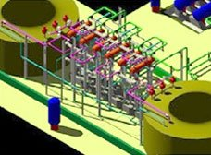
INDIRECT TWO-TANK SYSTEM
Circuitous two-tank plants work inside the same way as two-tank facilitate plants, but differing fluids are utilized as the heat-transfer and capacity fluids. This conspire is utilized in plants in which the heat-transfer fluid is as well exorbitant or not suited for utilize as the capacity fluid.
The capacity fluid from the low-temperature tank streams through an extra warm exchanger, where it is warmed by the high-temperature heat-transfer fluid. The high-temperature capacity fluid at that point streams back to the high-temperature capacity tank. The liquid comes out from this warm exchanger at a high temperature and returns to the sun-based receiver or beneficiary, where it is warmed back to a tall temperature. Capacity liquid from the huge-temperature tank is utilized to form steam inside the same way as the two-tank facilitate plants. The underhanded plants require an extra warm exchanger, which incorporates taken a toll to the plants.
These plants would be utilized in various of the illustrative Power plants in Spain and has too been projected for many U.S. metaphorical plants. The plants would utilize characteristic oil as the heat-exchanger liquid and fluid salt as the capacity liquid.
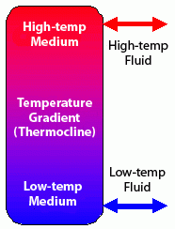
THERMOCLINE SINGLE-TANK SYSTEM
Thermocline single-tank plants accumulation warm vitality in a solid medium, most commonly, sand silica sited in a single tank. During operation, tis medium divides at high temperature, and a allocate is at high temperature. The cold and hot temperature areas are divided by a temperature gradient or thermocline. A huge temperature heat exchanger liquid streams into the beat of the thermocline and comes out from the foot at huge temperature. This plan changes the thermocline slipping and incorporates warm vitality to the plants for capacity. Exchanging the stream transfers the thermocline upward and ejects warm vitality from the plants to deliver steam and power. Flexibility impacts make warm stratification of the liquid interior the tank, this makes a distinction to steady and keep up the thermocline.
Employing a strong capacity medium and as it were requiring one tank diminishes the fetched of these schemes’ comparative to two-tank schemes. This scheme was illustrated at the solar single power tower, where steam was utilized as the heat transfer liquid and mineral oil was utilized as the capacity liquid.
Schemes Integration Basics
Sun oriented vitality development doesn’t conclude with power generation by PV or CSP plants. These sun-based vitality plants must be facilitated into homes, businesses, and existing electrical plants with moving mixes of ordinary and other renewable vitality sources.
Solar Schemes Integration Essentials
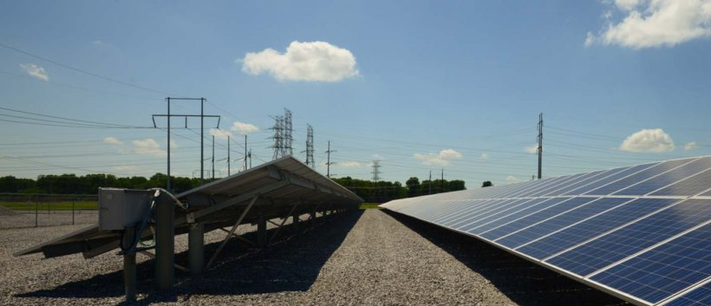
What is solar schemes integration and how does it work? Solar schemes integration includes creating advances and instruments that permit solar energy onto the power grid, whereas keeping up network unwavering quality, security, and proficiency.
THE ELECTRICAL GRID
For most of the past 100 a long time, electrical networks included large-scale, centralized energy generation found distant from customers. Cutting edge electrical networks are much more complex. In expansion to expansive utility-scale plants, cutting edge schemes moreover include variable energy sources like solar and wind, energy capacity schemes, Power electronic gadgets like inverters, and small-scale energy generation schemes like housetop establishments and microgrids. These smaller-scale and scattered energy sources are for the most part known as conveyed energy sources (CES).
The electrical schemes is isolated into transmission and Distribution Grids. The transmission grid is the arrange of high-voltage Power lines that carry power from centralized generation sources like expansive Power plants. These tall voltages permit Power to be transported long separations without intemperate misfortune. The conveyance schemes alludes to low-voltage lines that inevitably reach homes and businesses. Substations and transformers change over Power between tall and Low voltage. Customarily, power as it were required to stream one way through these schemes: from the central generation source to the shopper. In any case, schemes like housetop solar presently require the network to handle two-way power stream, as these schemes can infuse the abundance Power that they create back into the network.
POWER ELECTRONICS
Expanded solar and CES on the electrical network implies joining more Power electronic gadgets, which change over energy from one shape to another. This might incorporate changing over between tall and Low voltage, directing the sum of Power stream, or changing over between coordinate current (DC) and substituting current (AC) power, depending on where the power is going and how it'll be utilized. By 2030, as much as 80% of power might stream through Power electronic gadgets. One sort of power electronic gadget that's especially vital for solar energy integration is the inverter. Inverters change over DC power, this is solar PV units produces, into AC power.
SOLAR FURTHERMORE CAPACITY
Since solar energy can as it were be produced when the sun is sparkling, the capacity to store solar energy for afterward utilize is vital: It makes a difference to keep the adjust between power generation and request. This implies that creating batteries or warm capacity is key to including more solar.
GRID FLEXIBILITY AND QUALITY
The electrical network must be able to dependably give Power, so it’s critical for utilities and other power systems administrators to have real-time data almost how much power solar schemes are creating. Expanding sums of solar and DER on the schemes lead to both openings and challenges for grid unwavering quality. Complex cutting edge schemes with a blend of conventional generation and DER can make reacting to anomalous circumstances like storms or power outages more troublesome. However, power gadgets have the potential to gather real-time data on the grid and help Power grid operations. In truth, uncommon “grid-forming” inverters might utilize solar energy to restart the grid within the occasion of a power outage.
Solar Incorporation: Inverters and GRID Administrations Essentials
WHAT ARE INVERTERS?
Inverters are the first crucial parts of apparatus in sun powered vitality plants. It’s a contraption that changes DC power, which is what a sun-oriented board produces, to AC power, which is the electrical network maintenances. In DC, power will keep up at unfaltering voltage in one heading. In AC, power streams in all orientations inside the network when the voltage shifts from +ve to -ve. Inverters are reasonable one case of a course of contraptions named power equipment that Power the stream of electric power.
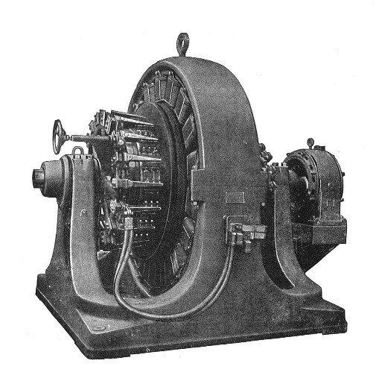
A 1909 500-kilowatt Westinghouse “rotary converter,” an early sort of inverter.

Solar Delicate Costs Essentials
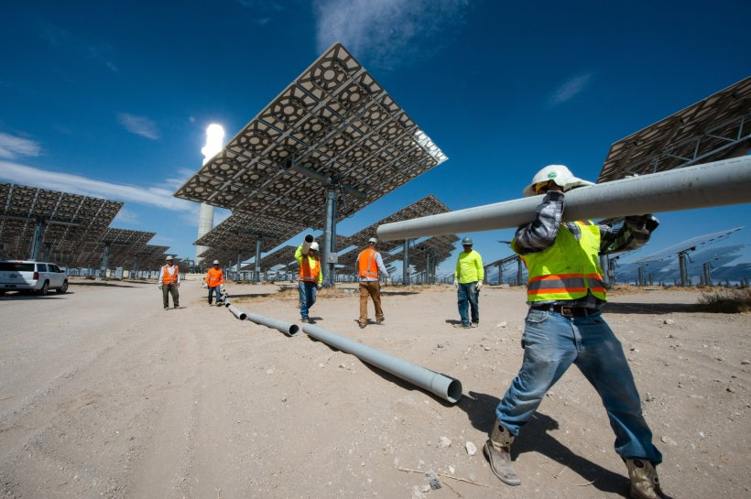
What is solar energy delicate costs and why do they matter? Delicate costs are the non-hardware costs related to going solar. These costs incorporate allowing, financing, and introducing solar, as well as the costs solar companies cause to procure unused clients, pay providers, and cover their foot line. These delicate costs have become a parcel of the by and large cost a client pays for a solar energy scheme. Whereas solar equipment costs have fallen in later a long time, delicate costs speak to a developing share of add up to solar schemes costs. Since there are so numerous contributing components, these costs can be difficult to pinpoint and require a assortment of arrangements.
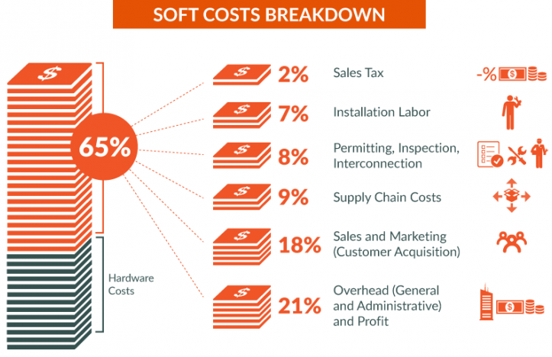
ROADBLOACKSS TO GOING SOLAR
Delicate costs are driven up when forms for going solar are moderate or wasteful. There isn't a single prepare or schemes to urge solar clients online since there are numerous purviews, utilities, and contrasting state and neighborhood laws included. As a result, clients encounter a slack time between when they purchase a solar scheme and when it really gets installed—a disappointing involvement that moreover includes costs.
RED TAPE
State and neighborhood governments that are unused to solar or are developing solar appropriation forms for the primary time can have tall costs due to wasteful aspects in allowing, review, and network interconnection, among other things—also known as “red tape.” Specialized help programs can offer help to extend proficiency and diminish these costs by engaging experienced solar experts to supply administering bodies the information and instruments they got to begin their claim programs.

SOLAR COMPANIES AND INDUSTRY EXPERTS
Streamlining the solar appropriation prepare for solar companies moreover impacts delicate costs. Program changes can offer assistance solar companies’ spare cash by moving forward deals leads, way better overseeing their portfolios, and making financing more open. These investment funds can at that point be passed along to clients. In expansion, solar companies can’t develop without exceedingly gifted laborers. Minimizing preparing crevices permits solar companies to effortlessly select unused enlists and expand at their possess pace, which minimizes labor costs.
Solar too impacts experts working in neighboring industries—such as genuine bequest operators, code authorities, and firefighters—who got to get it how solar energy influences their day-to-day employments. Teaching these experts brings down costs by moving forward solar deals exchanges and speeding up establishments.
REASONABLE, AVAILABLE SOLAR ENERGY
Expanding get to reasonable solar energy for clients moreover plays a part in delicate costs. A few components restrain certain clients from receiving solar, counting the tall cost and up-front cost of solar schemes, the need of competitive intrigued rates, Low credit scores, and the failure of tariff-exempt businesses and certain Low- and moderate-income populaces to utilize the Solar Speculation Assess Credit. One methodology for tending to these boundaries is community solar, where numerous members subscribe to a single solar energy scheme. Empowering neighborhood monetary educate, such as community banks, credit unions, and community improvement budgetary educate, to finance solar ventures in their nearby ranges can increment get to to reasonable solar energy for businesses and people in Low- and moderate-income communities.
Interface the Specks: Advancements in Residential Solar
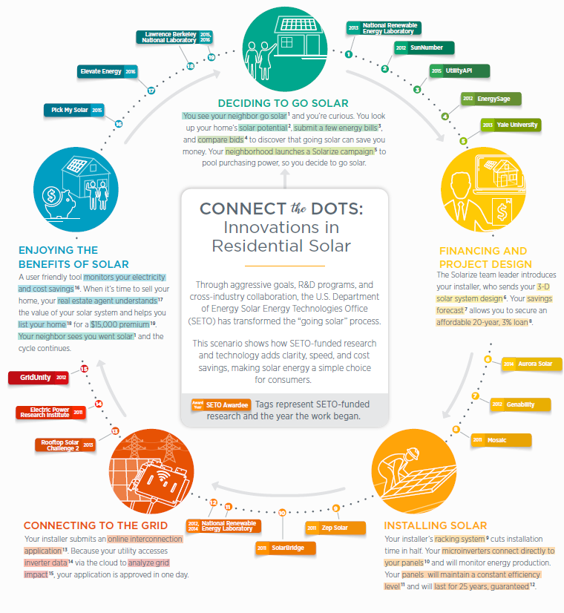

Performance model of PV cluster
Solar radiation and encompassing temperature are the most governors for measuring of PV module. PV modules cannot create bulk sum of electrical Power. So, huge numbers of PV modules are associated in arrangement and parallel to plan PV cluster. Arrangement and parallel association of PV modules boost up voltage and current to tailor PV cluster output. For a PV cluster comprise of N_{S} x N_{P} PV modules, greatest output Power can be calculated as equation (3),
(3)
Here, P_{md} is the most extreme electrical Power created by PV module which is defined as equation (4),
(4)
Where V_{OC}, I_{SC} and FF are the open circuit voltage, brief circuit current and fill figure of PV module. V_{OC}, I_{SC} and FF are the work of solar irradiance and PV module temperature; and these are gotten as conditions (5), (6) and (7),
(5)
(6)
(7)
Where, G_{N} and G_{a} are the ostensible and genuine solar irradiance on module, T_{N} and T_{a} are ostensible and genuine module temperature, V_{NOC} and I_{NSC} are ostensible the open circuit voltage and brief circuit current of PV module, R_{S} is the arrangement resistance of module, c₁, c₂ and c₃ are the three distinctive steady which are presented to appear non-linear relationship between solar irradiance, photo-current and cell temperature. n is thickness calculate, T is the PV module temperature (in Kelvin), K is the Boltzman steady (1.38 x 10-23 J/K) and q is the charge of electron (1.6 x 10-19 C).
Exceedingly created Power can help minimize running costs and increase solar plant execution. The major Power challenges are:
- Most favorable solid Power strategies able to maintain the working temperature as near to ideal as conceivable despite unsettling influences such as changes in solar irradiance level (caused by clouds), reflect reflectivity, and other working conditions.
- Optimal and cross breed Power calculations that decide ideal working focuses and modes and take into consideration the generation commitments, anticipated solar radiation, state of energy capacity, and power duties.
- Modes and strategies for determining solar radiation utilizing heterogeneous data (cameras, satellites, climate figures).
- Algorithms to gauge fundamental handle factors and parameters from heterogeneous and conveyed estimations (oil temperature and solar radiation at diverse parts of the field, reflect reflectivity, warm losses).
- Automatic reflect cleaning gadgets. The most calculated debasing the optical execution of concentrating mirrors is amassing of earth on the reflect surface. Cleaning mirrors speaks to a impressive cost in labor and water, ordinarily a scarce resource where solar plants are found. Programmed gadgets ought to be developed that minimize the utilize of water and degradation of the intelligent surface.
- Heliostat self-calibration components. Heliostats ought to be returned occasionally since of blunders within the sun show, scope and longitude of the location, heliostat position within the field, mechanical blunders, optical mistakes, and the like. Heliostat recalibration may speak to an vital fetched in labor and time when done physically. Strategies are required for quick, programmed, online recalibration of heliostats.
- Fault acknowledgment and division in solar stations. Calculations are required to sense and partitioned faults and breakdowns in electrical Power stations, such as acknowledgment of hot spots.
Conclusion:
Many national energy procedures around the world objective at guaranteeing an energy gather that bolsters a cleaner environment and more grounded advertise which fortifies national security by giving a unfaltering, assorted, household energy supply. Clean energy could be a worldwide and critical basis. Renewable generation, particularly from wind and solar and Smart Grid concepts are noteworthy procedures required to address worldwide warming and related issues. The major challenge is to play down the cost of non-conventional energies to sensible levels. Power and related methods will be essential for tackling these troublesome inconveniences.
The utilization of non-conventional energy sources is making a novel energy advertise where it is of the most noteworthy centrality to be in stateto anticipate patterns and necessities from clients and makers to play down wasteful aspects in energy administration and optimize generation. The up-and-coming change of the customary inactive conveyance schemes into a commonsense one needs the usage of an energy organize where generation and electrical Power variances can be productively overseen. In specific, Power vacillations have the most grounded effect on markets and on short-time energy-continuity prerequisites.

