POCUS: An Emerging Bedside Tool

AUTHORS

Dr Sushrut Ingawale (MD, DNB, FCPS, MNAMS)
Former Assistant Professor
Department of General Medicine
Seth G.S. Medical College and KEM Hospital
Mumbai, India
sushrutingawale2012@kem.edu

Dr Hema Hotchandani (MBBS)
Medical Intern
Lokmanya Tilak Municipal Medical College and General Hospital
Mumbai, India
hemahotchandani1113@gmail.com

Dr Vineet Upadhyaya (MBBS)
3rd year MBBS Medical Student
Terna Medical College and Hospital
Navi Mumbai, India
vrualt@gmail.com

ABSTRACT:

Point-of-care ultrasound (POCUS) has emerged as a revolutionary tool transforming the landscape of modern medical practice, offering real-time diagnostic imaging at the patient's bedside. This abstract explores the multifaceted significance of POCUS, detailing its fundamental principles, diverse clinical applications, training implications, and future potential. POCUS leverages basic ultrasound physics and portable transducer technology, enabling rapid and accurate imaging acquisition across medical disciplines. From cardiac assessments encompassing function, valve anomalies, and volume status to lung evaluations detecting pleural effusions, pneumothorax, and lung edema, POCUS empowers healthcare professionals with immediate diagnostic insights, impacting critical decision-making. Its role extends to procedural guidance, enhancing the accuracy of interventions such as vascular access, central line placement, and needle insertions. POCUS finds paramount utility in emergency medicine, facilitating trauma assessments, and augmenting resuscitative efforts. While training remains crucial, POCUS programs have been established to ensure proficiency among medical practitioners, overcoming challenges associated with their educational integration. Looking forward, the integration of artificial intelligence presents new horizons for POCUS, promising automated image analysis and enhanced diagnostic accuracy. In conclusion, POCUS's portable real-time imaging capabilities render it an indispensable asset, bridging diagnostic gaps, improving patient outcomes, and redefining the dynamic between diagnosis and treatment at the point of care. As its potential continues to unfold, POCUS undoubtedly emerges as a transformative and essential component of contemporary clinical practice.

- INTRODUCTION:

The discovery of ultrasonic (US) waves dates back to the late 1700s and their use by bats for navigation. Later, physicists applied this phenomenon to various military and industrial projects during the First and Second World Wars [1]. It wasn’t until the mid-1900s that this technology paved its way into medicine and revolutionized the diagnostic aspects of clinical medicine. The earliest works in the field of medicine were done by the Dussik brothers, Karl Dussik (neurologist) and Friedrich Dussik (physicist), who used ultrasonic transmission through the head and recorded the results on photographic plates that they called a “hyperphonogram” [2]. They attempted to study the abnormalities in the ventricular shapes in the brain and published their data in 1942 and 1947, which were images of the attenuated ultrasound waves by the skull [2]. Around the 1950s, pulse-echo ultrasound technology was applied to measure the thickness of excised tissue by a surgeon, John Wild [3]. His findings that echoes from tumor-invaded tissue can be distinguished from normal tissue led to a breakthrough in cancer detection, especially breast cancer [3, 4]. Wild and Jack Reid (an engineering graduate) built a B-mode scanner, a two-dimensional real-time ultrasound of the breast with a more precise location estimation compared to the single-dimensional A-mode scanner [4]. The diagnostic applications kept on evolving, and George Ludwig detected gallstones in animals using Ultrasonography (USG) [5]. Motion (M)-mode or time-mode could detect the real-time motion of tissues, which enabled the visualization of heart walls and valves. Since then, ultrasonography (USG) has been refined and extensively used as a tool to aid in diagnosis [2, 6]. The Doppler Effect, which had been known for many years, was soon applied to ultrasound waves for underwater applications and experiments in the US Navy [7]. Initially, continuous beams of ultrasound waves were used for vascular studies; eventually, pulse waves and color overlay came into the picture and further polished the operation of Doppler USG [2]. Recent advances include three-dimensional (3D) and four-dimensional (4D) USG. They offer meticulous visualization of the anatomy and better spatial guidance for various interventional procedures and surgeries. 4D-USG has an additional crucial factor of time, allowing real-time measurement of volume status [8]. USG has proven to be an efficient, cost-effective, and time-saving tool for confirming suspicion during life-threatening emergencies. This unique property was picked out and transformed into a Focused Assessment with Sonography (FAST) for trauma, which is used in emergency rooms as a screening test to identify active bleeding. This was modified to Extended Focused Assessment with Sonography for Trauma (E-FAST). Later on, USG was brought to the bedside of patients in need of timely diagnosis, prompt initiation of treatment, and assistance with certain procedures, which led to the development of POCUS.
Point of Care Ultrasound (POCUS) is an ultrasonography performed either at the bedside, in the outpatient clinic, or in ambulatory services. It serves as an affordable, time-saving, portable, and effective tool in the assessment of several chronic as well as acute, life-threatening conditions. POCUS has tremendous capabilities to transform healthcare delivery. Ultrasonography provides quick and definitive information and helps in clinically correlating pathological findings. This opens up an array of possibilities for its implementation in patient management. A paradigm shift has taken place in patient management with the invention of ultrasonography, and radiologists have played a pivotal role. Allowing it to reach the bedside will not only streamline patient care but also make it comprehensive and coordinated. Although the potential of POCUS is well known, there is still a lag in its widespread integration into healthcare models and training curricula.

- PRINCIPLES

A: BASIC ULTRASOUND PHYSICS AND IMAGING PRINCIPLES

Ultrasonography (USG) works by generating ultrasonic (US) waves with a frequency of 1 MHz to 10 MHz using the ‘Piezoelectric effect’. The Piezoelectric Effect is the ability of certain materials to generate an electric charge in response to applied mechanical stress. Lead zirconate titanate (PZT) is the most commonly used piezoelectric material in ultrasound transducers. The transducer probe has these piezoelectric crystals that vibrate and generate ultrasonic waves. These waves are transmitted to the body and then reflected from the soft tissues. The receiver detects these signals, amplifies the weaker waves, and forms an image on the display [9].

B: TRANSDUCER TYPES AND THEIR APPLICATIONS

The transducer probes have piezoelectric crystals on the tip, which create ultrasound waves. There are three types of probes that emit waves of different frequencies. The higher the frequency, the shorter the wavelength of the wave; wavelength is indirectly proportional to penetrance. This means longer-wavelength probes are used for visualizing tissues at a greater depth [9]. The frequency of the wave is directly proportional to the resolution. Thus, the three probes available have the following properties and are used for different purposes:
- Phased array (1–4 MHz): Has lowest resolution and highest penetrance. It is used for visualization of the heart, the inferior vena cava (IVC), lungs, and pleura.
- Curvilinear (2–5 MHz): Has good resolution and good penetrance. It is used for visualization of abdominal viscera.
- Linear (5–10 MHz): Has highest resolution and lowest penetrance. It is used for visualization of arteries, veins, and eyes during procedures such as central venous catheterization, lumbar puncture, and inserting an arterial line for blood pressure monitoring.

C. IMAGE ACQUISITION AND INTERPRETATION TECHNIQUES

The sound waves that are transmitted to the body travel at different velocities in different mediums. They get deflected as they change mediums. This generates artifacts on the display image. The transmitted waves get reflected, and the maximum reflecting materials are bone and air, which are perceived as white or bright (hyperechoic). Similarly, air and bone have the highest absorption of sound waves. Hence, the ultrasound waves cannot pass through air or bone, which causes a shadowing artifact [10].
Echogenicity is the term used to describe and interpret visualized images [9]. The images generated are categorized as follows:
- ‘Isoechoic’ refers to when the two tissues have similar textures in comparison.
- ‘Anechoic’ refers to when there is no reflection of waves, and it occurs in fluids.
- ‘Hyperechoic’ refers to when the structure appears brighter or whiter in comparison to the surroundings, suggesting greater reflection of the waves.
- ‘Hypoechoic’ refers to when the structures appear darker in comparison to the surroundings, suggesting a weaker reflection of the waves.

D. ADVANTAGES OF POCUS

Point-of-Care Ultrasound (POCUS) is a valuable medical tool that offers several advantages in various clinical settings. These include:

- Rapid Diagnosis: POCUS allows for real-time imaging and visualization of internal structures, enabling rapid assessment and diagnosis at the patient's bedside. This can be especially beneficial in emergency situations.

- Portability: POCUS machines are relatively compact and portable compared to traditional ultrasound machines, making them suitable for use in a variety of settings, including emergency rooms, ambulances, and remote areas.

- Reduced Radiation Exposure: Unlike certain imaging modalities like X-rays and CT scans, POCUS does not use ionizing radiation, making it a safer option for both patients and healthcare providers.

- Guidance for Procedures: POCUS can be used to guide various medical procedures, such as needle insertions for central line placements, thoracentesis, paracentesis, and nerve blocks. This improves the accuracy and safety of these procedures.

- Dynamic Assessment: POCUS allows for dynamic assessment of structures such as heart valves, blood flow, and muscle contractions. This can provide insights into functional abnormalities that might not be evident in static images.

- Bedside Monitoring: POCUS can be used for ongoing monitoring of patients in critical care settings, enabling clinicians to assess changes in real-time and make necessary adjustments to treatment plans [11].

- Cost effectiveness in low-resource settings: Given the low implementation and maintenance costs of POCUS, they can be readily made available in rural settings, unlike CT and MRI machines [13].

E. LIMITATIONS OF POCUS

Despite its rapid and increasing implementation in bedside medicine, POCUS also has its own limitations. These include:

- Operator Dependence: The quality of POCUS images and interpretations can vary based on the operator's skill and experience. Inaccurate or misinterpreted images can lead to diagnostic errors.

- Limited Depth and Penetration: POCUS may not penetrate deep tissues as effectively as traditional ultrasound machines, limiting its usefulness in certain cases, such as patients with high body mass index or when imaging structures located deep within the body. Small handheld POCUS devices cannot replicate the image quality of a standard ultrasound machine [13].

- Limited Field of View: POCUS often provides a smaller field of view compared to full-size ultrasound machines, which can make it challenging to visualize larger structures or get a comprehensive view of complex anatomy.

- Lack of Standardization: Unlike formal ultrasound exams, there may be a lack of standardization in POCUS imaging protocols and interpretations. This can lead to inconsistencies in diagnosis and management.

- Limited Diagnostic Scope: While POCUS is excellent for certain applications, it may not provide the same level of detail and comprehensive assessment as more advanced imaging modalities like MRI or CT scans.

- Risk of Overdiagnosis or Underdiagnosis: Depending solely on POCUS results without considering other clinical information could lead to either overdiagnosis (identifying minor abnormalities as clinically significant) or underdiagnosis (missing important pathologies).

- Inability to Replace Comprehensive Exams: POCUS is a supplementary tool and should not replace comprehensive ultrasound exams performed by trained sonographers. Some conditions may require more detailed assessments that POCUS might not provide.

- Provider Compensation: The provider compensation for the use of POCUS is also lower than compared to additional imaging modalities, mainly in Relative Value Unit (RVU)-based compensation systems. This financial loss is a barrier to the adoption of POCUS in private clinics [12].

III. CLINICAL APPLICATIONS OF POCUS

A. CARDIAC ASSESSMENT

Currently, auscultation using a stethoscope is the primary screening modality for cardiac valvular dysfunction. Those patients with anomalies heard on auscultation are usually sent for an echocardiogram. POCUS could be used as a stronger supplementary tool to assess cardiac valvular function in bedside medicine in addition to a stethoscope. However, it cannot act as a substitute for an echocardiogram, which requires better-quality imaging and a doctor (a cardiologist) with the necessary expertise to interpret the scan. The five basic cardiac ultrasound views (Cardiac Windows) of the heart are:
- Parasternal Long Axis
- Parasternal Short Axis
- Apical 4 Chambers (Figure 1)
- Subxiphoid (Subcostal), and
- IVC Views.
While POCUS is good at evaluating regional wall motion abnormality and left ventricular function, it is not as accurate as an echocardiogram in diagnosing valvular heart problems such as aortic stenosis, mitral regurgitation, etc. It has been successfully used to rapidly diagnose life-threatening pericardial effusions and has emerged as an effective screening modality for diseases such as hypertrophic cardiomyopathy, which are known to cause sudden cardiac death in athletes [12].
Fluid administration in patients with acute circulatory shock is a life-saving treatment that needs to be monitored to prevent fluid overload. Initial fluid therapy increases stroke volume and thereby increases cardiac output, but this rise is not linear and depends on cardiac contractility. Inferior vena cava (IVC) collapsibility with respiration assessment (Figure 2) has been found useful to evaluate fluid responsiveness [13, 14]. Following the termination of the expiration phase, it is common to observe an inferior vena cava (IVC) measurement below 10mm in situations of reduced blood volume. This indicates a greater likelihood of eliciting a response. Conversely, an IVC diameter exceeding 25mm is often encountered in scenarios involving elevated blood volume, indicating a diminished likelihood of fluid responsiveness. These observations have been highlighted in various studies [15–17]. In the case of M-mode ultrasonography (depicted in Figure 2), the dimensions of the inferior vena cava (IVC) are assessed in two distinct phases: first during calm and passive respiration, and subsequently during a swift inspiratory action, often referred to as a "sniff." The degree of fluctuation in dimensions, expressed as the percentage reduction in IVC diameter, is quantified as the collapsibility index of the inferior vena cava (IVCCI). This index is calculated using the formula: [(Maximum IVC diameter – Minimum IVC diameter)/Maximum IVC diameter] × 100. To facilitate the interpretation of IVC observations, Table 1 presents a straightforward and applicable guide. [16].

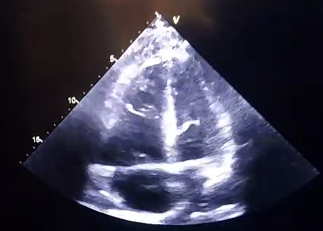
FIGURE 1: Four-chamber Apical view of the heart on POCUS

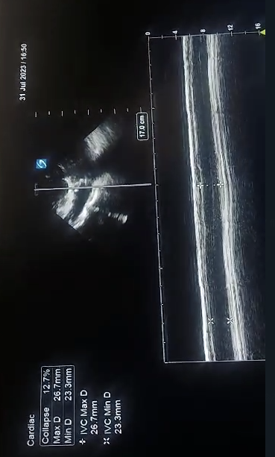
FIGURE 2: POCUS M-Mode for assessment of IVC collapsibility with respiration

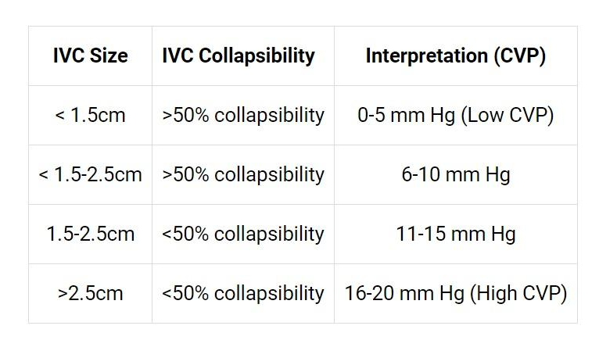
Table 1: Interpretation of IVC findings on POCUS, adapted from Kircher, B.J., et al.

B. LUNG ASSESSMENT

POCUS can be used to accurately diagnose lung pathologies with equal or greater accuracy than laboratory markers in certain conditions [11]. In the case of finding pulmonary B lines, POCUS is more sensitive and specific than pro-BNP levels in diagnosing acute heart failure [11]. POCUS has been found to be as good as a CT scan in diagnosing causes of respiratory failure [18]. It has been found to be as reliable as echocardiography in detecting lung ultrasound comets, which are seen in cases of pulmonary edema. In the COVID-19 outbreak, lung ultrasound was 97% sensitive, had a negative predictive value of 98% in finding patterns suggestive of lung involvement, and was successfully used in patients who had negative RT-PCR tests [18]. The BLUE (Bedside Lung Ultrasound in Emergency) protocol uses POCUS to diagnose acute respiratory distress [18]. Lung pathologies like pulmonary edema, pneumonia, pneumothorax, and pulmonary embolism can be diagnosed by the Blue Protocol. Additionally, lung abscesses (Figure 3) can be visualized.
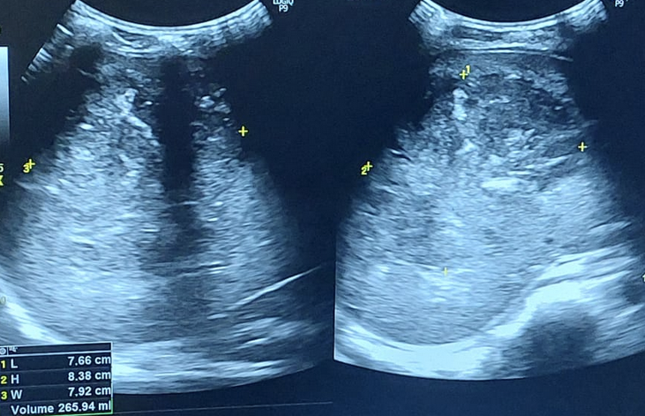
FIGURE 3: POCUS demonstrating a Lung abscess

C. ABDOMINAL ASSESSMENT

POCUS can be useful in the evaluation of acute abdominal pain and can be used to detect free intraperitoneal air, free fluid, and intestinal obstruction. Some common clinical presentations that require rapid and precise diagnosis are acute appendicitis, intestinal obstruction, perforation of the abdominal viscera, abdominal aortic aneurysm, and Crohn’s disease.

1. Detection of abdominal free air and fluid:
POCUS is superior to X-Ray in detecting free intraperitoneal air due to a hollow viscus perforation [19, 20]. Gas in the bowel is enclosed and should be differentiated from free air. The waves traveling back through the air run back and forth, creating reverberation artifacts that are equidistant. Focal air collections produce ring-down artifacts.
Free peritoneal fluid can be due to trauma, urine leaks, ascites, or a ruptured ectopic pregnancy. Free fluid as low as 10 ml can be detected on POCUS [19, 21]. Fluid appears anechoic (black) on USG images as it does not reflect the sound waves. The perihepatic space (Morrison’s pouch), the perisplenic space (Koller’s pouch), and the pelvis (the pouch of Douglas) are the spaces where intraperitoneal free fluid is collected first and visualized on ultrasound [19].
Limitations: The types of fluids (blood, ascites, bile, and urine) cannot be differentiated. Clotted blood may appear hyperechoic, leading to failure of diagnosis

2. Evaluation of hepatobiliary and renal pathology:
Gallstones are radiolucent, hence not easily detected on an x-ray. Ultrasonography is the gold standard for the detection of cholelithiasis and cholecystitis. Gallstones present as a hyperechoic focus with a posterior acoustic shadow on USG.
The outcomes of the investigation, encompassing 1690 individuals experiencing abdominal discomfort, indicated that point-of-care ultrasound (POCUS) exhibited a sensitivity of 88%, specificity of 87%, positive predictive value of 91%, and negative predictive value of 83% when employed for detecting gallstones [22]. Renal stones (Figure 4) can be detected on POCUS, and additional features of complications caused by them can also be visualized. POCUS is also helpful in confirming/excluding the presence of urinary tract obstruction and renal calculus. Hydronephrosis, which is one of the complications of kidney stones, can also be detected on POCUS with high sensitivity and specificity [23, 24]. Moreover, the grade of hydronephrosis can also be determined by ultrasound. With the help of POCUS, gross abnormalities such as the size of the kidney, parenchymal characteristics, and cysts can be determined (Figure 5).
Limitations: POCUS has low sensitivity for detecting renal stones. It cannot detect stones in the retroperitoneal ureter, which is located between the kidney and bladder [23].

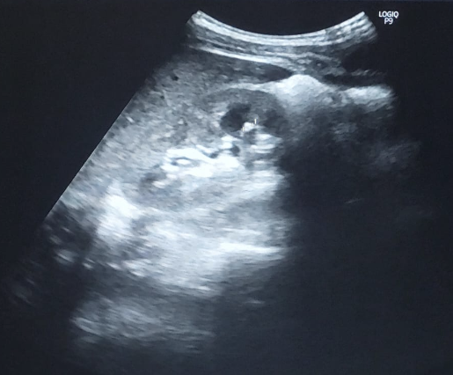
FIGURE 4: POCUS exam demonstrating the presence of Renal calculi

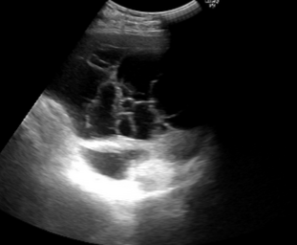
FIGURE 5: POCUS exam demonstrating a polycystic kidney

3. Assessment of an abdominal aortic aneurysm:
An abdominal aortic aneurysm (AAA) is often clinically silent, and a ruptured aortic aneurysm is a life-threatening emergency condition that is almost fatal. Hence, screening in high-risk populations is essential. Ultrasound is highly specific (98% to 100%) and sensitive (94% to 99%) in diagnosing AAA and is the gold standard imaging modality used for screening and follow-up in AAA patients [25]. The abdominal aorta is scanned both longitudinally and transversely [19]. Color Doppler helps in determining the flow within the aneurysm, and a bi-directional or swirling flow is seen within the aneurysm known as the Yin-Yang sign (Figure 6). An intimal tear suggesting dissection and free intraperitoneal fluid suggesting aneurysm rupture are the features seen on USG. Hence, POCUS is a great tool in a primary care setting to screen for and detect AAA.
Limitations: Difficult to diagnose in obese patients. High false positivity of 21.4% when performed by general practitioners [26].

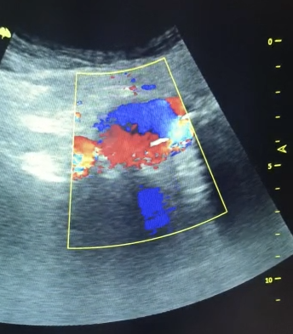
FIGURE 6: POCUS exam demonstrating the ‘Yin-Yang’ sign seen in Aortic aneurysm

D. VASCULAR ACCESS AND GUIDANCE FOR INVASIVE PROCEDURES

POCUS serves as an excellent tool for guiding various procedures such as inserting a central venous catheter, accessing difficult peripheral venous and arterial lines, thoracocentesis, paracentesis, lumbar puncture, regional anesthesia, arthrocentesis, and airway management [27]. POCUS can help access the patency of the vessel lumen, thus aiding in the diagnosis of vascular thrombosis (Figure 7) as well as guiding catheterization (Figure 8). Using POCUS as guidance for procedures increases the success rate and reduces complications [28]. It is also considered the standard of care for central venous catheter insertion [29].
Point-of-care ultrasound (POCUS) is being harnessed to enhance the safety and efficiency of cannulation in hemodialysis patients. Within this patient group, POCUS serves various purposes, including evaluating the development of arteriovenous fistulas (AVF) for optimal readiness, pinpointing anatomical points of reference and irregularities, appraising alternative sites for cannulation, facilitating initial AVF cannulation, managing challenging cannulation scenarios, refining cannulation precision, conducting cannulation through stents, and delivering training for patients to perform self-cannulation [30].

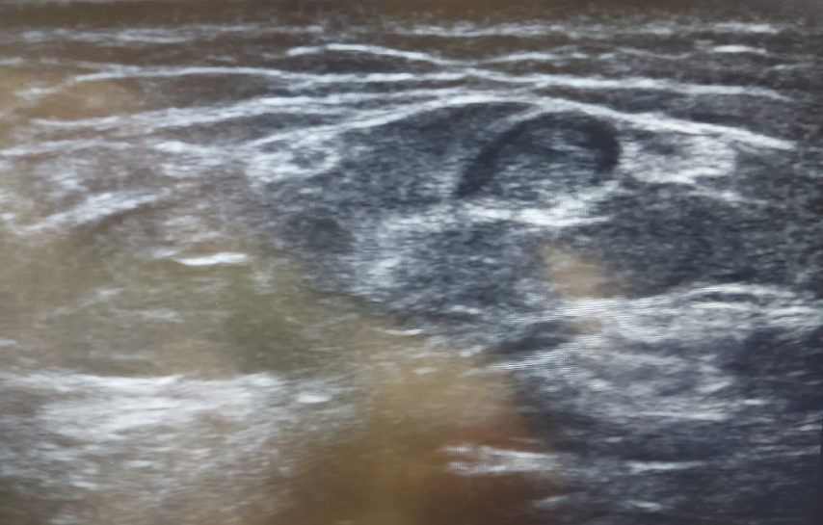
FIGURE 7: POCUS exam demonstrating Venous thrombosis

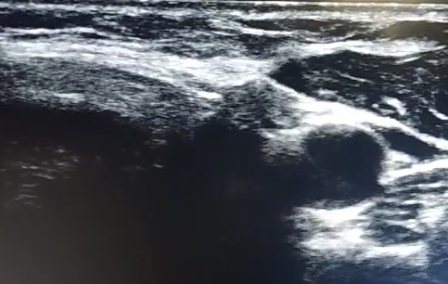
FIGURE 8: POCUS exam demonstrating Radial artery for Arterial Line catheterization

E. MUSCULOSKELETAL ASSESSMENT

In the realm of musculoskeletal diseases, POCUS can be used to detect abscesses and other soft tissue infections, foreign bodies in soft tissues, fractures, bone dislocations (such as shoulder dislocations), joint fluid, pediatric hip effusions, etc. [11]. CT scans are currently the preferred imaging modality for diagnosing skull fractures and traumatic brain injuries. POCUS has been found to have high sensitivity, specificity, and positive and negative predictive values in a study conducted on children with head trauma [31].
When it comes to joint effusions, POCUS is useful for their localization and the evaluation of their size. It can be used to determine whether or not early antibiotic treatment should be initiated or not, and it is also useful for aspirating large joint effusions [32]. In the case of skin and soft tissue infections, when ultrasound is not available, blind needle aspiration is often performed to determine whether or not an abscess is present. POCUS makes it simple to differentiate between simple cellulitis and an abscess that needs drainage, thus influencing the management of patients and potentially saving them from unnecessary needle pricks [33].

F. PELVIC (OBSTETRIC AND GYNECOLOGICAL) ASSESSMENT

Ultrasound is widely used in the field of Obstetrics and Gynecology for confirming pregnancy, estimating the age of the fetus, determining the location of the pregnancy (intrauterine or ectopic), assessing fetal viability, etc. The ‘tubal ring’ sign and the ‘ring of fire’ sign (Figure 9) are seen in cases of ectopic pregnancy. Locating a gestational sac with a fetal pole and fetal heart rate outside of the uterus confirms the diagnosis of an ectopic pregnancy. Corpus luteum cysts may also be seen on Doppler USG with the ‘ring of fire’ sign. The well-known ‘snowstorm appearance’ is pathognomonic of a molar pregnancy. The fetal presentation (the part of the fetus that overlies the maternal pelvic inlet), lie (the relation of the fetal long axis to the long axis of the mother), etc. can also be determined by bedside POCUS. It is also used to determine the location and condition of the placenta. This is exceedingly important in diagnosing conditions such as placenta previa, placenta accreta spectrum, and placental abruption, which can possibly be life-threatening to both the mother and the fetus [34].

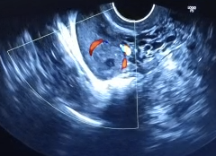
FIGURE 9: POCUS exam demonstrating the ‘Ring of Fire’ sign seen in an ectopic pregnancy

IV. THE ROLE OF POCUS IN EMERGENCY MEDICINE

A. POCUS IN TRAUMA ASSESSMENT AND TRIAGE

Blunt abdominal and thoracic trauma patients are in need of urgent care, and E-FAST reduces the time-to-diagnosis in such cases. Ultrasound is superior to X-ray in blunt abdominal and thoracic trauma for diagnosing pneumothorax/hemothorax and has also replaced peritoneal lavage [49-51]. Although a CT has more predictive value, E-FAST serves the purpose of providing a rapid diagnosis [49].
Limitation: A negative result in a hemodynamically stable patient does not rule out injury.

B. POINT OF CARE ULTRASOUND IN RESUSCITATION AND CARDIOPULMONARY RESUSCITATION:

Echocardiography is useful in cardiac arrest and is performed during the brief pulse checks done in between chest compressions [27]. POCUS can be beneficial to detect cardiac activity. The absence of cardiac contractility is a strong indicator of poor survival and non-favorable outcomes with CPR [35]. The presence of cardiac contractile activity without a palpable pulse can be detected on sonography [27]. Ultrasonography done during cardiopulmonary resuscitation also serves the purpose of identifying reversible causes of cardiac arrest such as cardiac tamponade, pulmonary embolism causing right heart failure, or profound hypovolemia [36].

C. POCUS-GUIDED PROCEDURES AND INTERVENTIONS
POCUS-guided procedures significantly reduce complications and ensure a successful attempt. POCUS provides the additional advantage of reduced procedural time and increases confidence in the physician carrying out the procedure. Various interventions can be performed with the aid of ultrasound at the point of patient care, some of which are described below:
- Paracentesis: Means the aspiration of the peritoneal fluid and is a therapeutic or diagnostic procedure. In patients with a positive FAST, POCUS-guided paracentesis can help distinguish the type of fluid accumulated in the peritoneal cavity, which further assists in management [37].
- Thoracocentesis: Accuracy, a lower complication rate, and better diagnostic reliability are achieved with POCUS-guided aspiration of pleural effusion. Consolidation and effusion are close differentials and can be ruled out on ultrasound [38].
- Pericardiocentesis: Emergency aspiration of pericardial fluid is indicated in cardiac tamponade or pericardial effusion causing hemodynamic instability. POCUS helps in the recognition of these conditions and allows for prompt treatment [39].
- Abscess evaluation: In most cases, it is difficult to distinguish an abscess from cellulitis. The treatment can be further diversified based on the abscess size and depth. Breast abscesses (<3 cm) can be managed with USG-guided aspiration and irrigation rather than surgical drainage [40].
- Arthrocentesis: Various pathologies can be diagnosed, such as abscess, bursitis, joint effusion, or cellulitis. Furthermore, it is a less painful procedure compared to conventional techniques [41].
- Central venous catheter insertion: Central line insertion is traditionally performed using the landmark technique. Using ultrasound-guided procedure reduces the complications of bleeding, pneumothorax, nerve injury, and airway compromise. It helps to target the vessel and surrounding structures as well as guide the needle tip through the vessel. However, catheter contamination and catheter-related infections increase with the use of ultrasonography.

V. TRAINING AND COMPETENCE IN POCUS

The aforementioned benefits of POCUS can be reaped only if the physicians are well-trained and qualified to perform the ultrasonography. There is a need to inculcate POCUS in the curriculum of medical students and residents. In the United States, emergency medicine residents are required by the Accreditation Council for Graduate Medical Education (ACGME) to complete a designated point-of-care ultrasound (POCUS) course. To gauge the proficiency of these trainees, established evaluation tools such as the Rapid Assessment of Competency in Echocardiography (RACE) or the Assessment of Competency in Thoracic Sonography (ACTS) have been formulated. These assessments predominantly concentrate on evaluating technical aptitude. Further evaluations based on the knowledge and application of POCUS in clinical settings are essential. The inclusion of a similar curriculum in the Indian medical education system is the need of the hour. A study conducted in the Emergency Medicine department in India states that the main learning source for POCUS was a mentor and that necessary guidelines and focused teaching are necessary for establishing competency [43]. Findings from a survey carried out within neonatal intensive care units in India revealed that 72% of these units were able to have access to point-of-care ultrasound (POCUS), while merely 26% had uninterrupted access to pediatric cardiology services and 40% to pediatric radiology services [44]. The primary factor contributing to the limited availability of POCUS was attributed to the absence of adequately trained staff, compounded by the rigid adherence to the Pre-conception and Prenatal Diagnostic Techniques (PC-PNDT) Act of 1994 [44, 45].

VI. FUTURE DIRECTIONS AND EMERGING TECHNOLOGIES

There has been an increased interest of late in the application of artificial intelligence (AI) in POCUS technology. AI could be used in the future to guide relatively untrained healthcare providers in probe placement and organ identification. This would be of assistance in emergencies, allowing doctors to quickly obtain imaging and make a more informed decision on further management. AI can help reduce the expertise required to diagnose conditions using ultrasound. This would be useful for the military and people residing in resource-poor areas who are in need of an accurate diagnosis [46].
Pocket or handheld ultrasound probes have recently become available that are connected to the internet. This allows for remote teaching, image review, and supervision by the provider. They can function with not only Windows but also MacOS, Android, iOS, etc. These devices contain preset profiles that have an optimized frequency for various scans. Additional changes to the image, such as gain, depth, and time gain compensation, can be made by the user as per their needs. Many POCUS probes also have M mode, color flow Doppler, etc built in. They can be used to make linear measurements, save images and upload them to the cloud, label anatomic structures, etc. [47].

While POCUS has proven itself to be an incredibly useful diagnostic tool, the inclusion of POCUS training in medical education is not uniform and structured, if at all it is present. It is therefore of great importance to implement a well-made formal curriculum that provides the necessary training to properly and effectively use POCUS for the future generation of doctors. It has been recommended that POCUS training start early in medical school to allow students adequate time to build up their proficiency. It should be taught longitudinally so that students may achieve long-term retention of skills. However, there are various barriers to the widespread inclusion of POCUS training in medical education, such as the lack of availability of handheld ultrasound machines in all hospitals and the unavailability of many properly qualified instructors as it is mainly used only in the emergency department [48]. POCUS will likely become an invaluable tool in the diagnostic arsenal of the future physician, aiding them in completing the clinical picture alongside the traditional history and physical examination.

VII. CONCLUSION

The applications of point-of-care ultrasound are quickly increasing in the medical field. It can be used to help diagnose a multitude of conditions in the realms of cardiology, pulmonology, gastroenterology, obstetrics, gynecology, etc. It is most commonly used in the emergency department to make rapid and more accurate decisions about patient management. From detecting cardiac valvular pathologies and COVID-19 to detecting fractures and abscesses, POCUS proves to be an invaluable tool in the arsenal of the modern-day physician. POCUS has a smaller learning curve, thus allowing relatively less skilled providers to reach a diagnosis without the need to consult a radiologist and transfer the patient to the ultrasound room. It is a low-cost alternative to a full-sized ultrasound machine that can suffice for many situations. However, the establishment of internationally recognized training programs and the inclusion of POCUS in the undergraduate and postgraduate medical curriculum are the needs of the hour to teach future doctors to effectively and safely use this technology. Further research regarding patient outcomes with POCUS as compared to traditional imaging modalities is required.

REFERENCES:

[1] Fraser AG, Monaghan MJ, van der Steen AF, Sutherland GR. A concise history of echocardiography: timeline, pioneers, and landmark publications European Heart Journal-Cardiovascular Imaging. 2022 Sep 1;23(9):1130-43.
‌
[2] Dietrich CF, Bolondi L, Duck F, Evans DH, Ewertsen C, Fraser AG, et al. History of Ultrasound in Medicine from its birth to date (2022), on occasion of the 50 Years Anniversary of EFSUMB. A publication of the European Federation of Societies for Ultrasound In Medicine and Biology (EFSUMB), designed to record the historical development of medical ultrasound. Medical Ultrasonography [Internet].2022Dec 21 [cited 2023 Jul 11];24(4):434–50.

‌[3] WILD J. USE OF HIGH-FREQUENCY ULTRASONIC WAVES FOR DETECTING CHANGES OF TEXTURE IN LIVING TISSUES. The Lancet. 1951 Mar;257(6656):655–7.
‌
[4] Wild JJ, Reid JM. Further pilot echographic studies on the histologic structure of tumors of the living intact human breast. The American journal of pathology. 1952 Oct;28(5):839.
‌
[5] Ludwig GD. Considerations underlying the use of ultrasound to detect gallstones and foreign bodies in tissue. Naval Medical Research Institute; 1949.

[6] Lutz H. Ultraschalldiagnostik (B-scan) in der inneren Medizin: Lehrbuch und Atlas. Springer-Verlag; 2013 Jul 2.

[7] OFFICE OF SCIENTIFIC RESEARCH AND DEVELOPMENT WASHINGTON DC. METHODS AND DEVICES DEVELOPED FOR THE SELECTION AND TRAINING OF SONAR PERSONNEL. 1946.
‌
[8] Kim SH, Choi BI. Three-dimensional and Four-dimensional Ultrasound: Techniques and Abdominal Applications. Journal of Medical Ultrasound. 2007;15(4):228–42.
‌
[9] Edelman SK. Understanding ultrasound physics. 4th ed. Woodlands, Tex.: Esp; 2012.
‌
[10] Steel R, Poepping TL, Thompson RS, Macaskill C. Origins of the edge shadowing artefact in medical ultrasound imaging. Ultrasound in Medicine & Biology. 2004 Sep;30(9):1153–62.
‌
[11] Hashim A, Tahir MJ, Ullah I, Asghar MS, Siddiqi H, Yousaf Z. The utility of point of care ultrasonography (POCUS). Ann Med Surg (Lond). 2021 Nov 2;71:102982. doi: 10.1016/j.amsu.2021.102982. PMID: 34840746; PMCID: PMC8606703.

[12] Hammadah M, Ponce C, Sorajja P, Cavalcante JL, Garcia S, Gössl M. Point-of-care ultrasound: Closing guideline gaps in screening for valvular heart disease. Clin Cardiol. 2020 Dec;43(12):1368-1375. doi: 10.1002/clc.23499. Epub 2020 Nov 11. PMID: 33174635; PMCID: PMC7724242

[13] Levitov A, Frankel HL, Blaivas M, Kirkpatrick AW, Su E, Evans D, Summerfield DT, Slonim A, Breitkreutz R, Price S, McLaughlin M. Guidelines for the appropriate use of bedside general and cardiac ultrasonography in the evaluation of critically ill patients—part II: cardiac ultrasonography. Critical care medicine. 2016 Jun 1;44(6):1206-27.

[14] Cecconi M, De Backer D, Antonelli M, Beale R, Bakker J, Hofer C, Jaeschke R, Mebazaa A, Pinsky MR, Teboul JL, Vincent JL. Consensus on circulatory shock and hemodynamic monitoring. Task force of the European Society of Intensive Care Medicine. Intensive care medicine. 2014 Dec;40:1795-815.

[15] Orde S, Slama M, Hilton A, Yastrebov K, McLean A. Pearls and pitfalls in comprehensive critical care echocardiography. Critical Care. 2017 Dec;21(1):1-0.

[16] Kircher BJ, Himelman RB, Schiller NB. Noninvasive estimation of right atrial pressure from the inspiratory collapse of the inferior vena cava. Am J Cardiol. 1990 Aug 15;66(4):493-6. doi: 10.1016/0002-9149(90)90711-9. PMID: 2386120.

[17] Lee CW, Kory PD, Arntfield RT. Development of a fluid resuscitation protocol using inferior vena cava and lung ultrasound. Journal of Critical Care. 2016 Feb 1;31(1):96-100.

[18] Ramgobin D, Gupta V, Mittal R, Su L, Patel MA, Shaheen N, Gupta S, Jain R. POCUS in Internal Medicine Curriculum: Quest for the Holy-Grail of Modern Medicine. J Community Hosp Intern Med Perspect. 2022 Sep 9;12(5):36-42. doi: 10.55729/2000-9666.1112. PMID: 36262489; PMCID: PMC9529654.

[19] Abu-Zidan F, B. Khan M. Point-of-care ultrasound for the acute abdomen in the primary health care. Turkish Journal of Emergency Medicine. 2020;20(1):1.

[20] Chen SC, Yen ZS, Wang HP, Lin FY, Hsu CY, Chen WJ. Ultrasonography is superior to plain radiography in the diagnosis of pneumoperitoneum. Journal of British Surgery. 2002 Mar;89(3):351-4.

‌[21] Abu-Zidan FM, Hefny AF. Point-of-care ultrasound in critically ill patients. Acute Care Surgery Handbook: Volume 1 General Aspects, Non-gastrointestinal and Critical Care Emergencies. 2017:335-60.

[22] Radonjić T, Popović M, Zdravković M, Jovanović I, Popadić V, Crnokrak B, et al. Point-of-Care Abdominal Ultrasonography (POCUS) on the Way to the Right and Rapid Diagnosis. Diagnostics. 2022 Aug 24;12(9):2052.

[23] Radonjić T, Popović M, Zdravković M, Jovanović I, Popadić V, Crnokrak B, et al. Point-of-Care Abdominal Ultrasonography (POCUS) on the Way to the Right and Rapid Diagnosis. Diagnostics. 2022 Aug 24;12(9):2052.
‌
[24] Wong C, Teitge B, Ross M, Young P, Robertson HL, Lang E. The accuracy and prognostic value of point‐of‐care ultrasound for nephrolithiasis in the emergency department: a systematic review and meta‐analysis. Academic Emergency Medicine. 2018 Jun;25(6):684-98.

[25] Radonjić T, Popović M, Zdravković M, Jovanović I, Popadić V, Crnokrak B, et al. Point-of-Care Abdominal Ultrasonography (POCUS) on the Way to the Right and Rapid Diagnosis. Diagnostics. 2022 Aug 24;12(9):2052.

[26] Abu-Zidan F, B. Khan M. Point-of-care ultrasound for the acute abdomen in the primary health care. Turkish Journal of Emergency Medicine. 2020;20(1):1.
‌
[27] Whitson MR, Mayo PH. Ultrasonography in the emergency department. Critical Care. 2016 Dec;20:1-8.

[28] Barr L, Hatch N, Roque PJ, Wu TS. Basic ultrasound-guided procedures. Critical Care Clinics. 2014 Apr 1;30(2):275-304.
‌
[29] Practice Guidelines for Central Venous Access. Anesthesiology. 2012 Mar;116(3):539–73.

[30] Schoch M, Bennett PN, Currey J, Hutchinson AM. Point-of-care ultrasound use for vascular access assessment and cannulation in hemodialysis: A scoping review. Semin Dial. 2020 Sep;33(5):355-368. doi: 10.1111/sdi.12909. Epub 2020 Aug 3. PMID: 32744355; PMCID: PMC7496621.

[31] Alexandridis G, Verschuuren EW, Rosendaal AV, et al
Evidence base for point-of-care ultrasound (POCUS) for diagnosis of skull fractures in children: a systematic review and meta-analysis
Emergency Medicine Journal 2022;39:30-36.

[32] Scheier E, Levick N, Ujirauli N, Raviv O, Balla U. Point-of-Care Ultrasound-Guided Drainage of Joint Effusions in the Pediatric Emergency Setting: A Case Series. J Ultrasound Med. 2022 May;41(5):1285-1293. doi: 10.1002/jum.15795. Epub 2021 Jul 28. PMID: 34318953.

[33] Skin and Soft Tissue Infections: A PoCUS Guided Approach | Department of Emergency Medicine | Saint John [Internet]. Available from: https://sjrhem.ca/skin-and-soft-tissue-infections-a-pocus-guided-approach/
‌
[34] Obstetric/OB Ultrasound Made Easy: Step-By-Step Guide [Internet]. POCUS 101. Available from: https://www.pocus101.com/obstetric-ob-ultrasound-made-easy-step-by-step-guide/
‌
[35] Blyth L, Atkinson P, Gadd K, Lang E. Bedside focused echocardiography as predictor of survival in cardiac arrest patients: a systematic review. Acad Emerg Med. 2012;19(10):1119–26.

[36] Gaspari R, Weekes A, Adhikari S, Noble V, Nomura JT, Theodoro D, et al. A retrospective study of pulseless electrical activity, bedside ultrasound identifies interventions during resuscitation associated with improved survival to hospital admission. A REASON Study. Resuscitation. 2017 Nov;120:103–7.

[37] Paracentesis [Internet]. www.acep.org. [cited 2023 Jul 28]. Available from: https://www.acep.org/sonoguide/procedures/paracentesis/

[38] Thoracentesis [Internet]. www.acep.org. Available from: https://www.acep.org/sonoguide/procedures/thoracentesis
‌
[39] Pericardiocentesis [Internet]. www.acep.org. [cited 2023 Jul 28]. Available from: https://www.acep.org/sonoguide/procedures/pericardiocentesis
‌
[40] Abscess Evaluation [Internet]. www.acep.org. [cited 2023 Jul 28]. Available from: https://www.acep.org/sonoguide/procedures/abscess-evaluation
‌
[41] Arthrocentesis [Internet]. www.acep.org. Available from: https://www.acep.org/sonoguide/procedures/arthrocentesis

[42] Lamperti M, Bodenham AR, Pittiruti M, Blaivas M, Augoustides JG, Elbarbary M, Pirotte T, Karakitsos D, LeDonne J, Doniger S, Scoppettuolo G. International evidence-based recommendations on ultrasound-guided vascular access. Intensive care medicine. 2012 Jul;38:1105-17.

[43] Thomas VK, Abraham SV, Balakrishnan JM, Krishnan S V, Amalakat A, Palatty BU. Point-of-care ultrasound training in Indian emergency medicine programs: A resident's perspective. Int J Acad Med 2017;3:263-7

[44] .Rath C, Nagpal R, Suryawanshi P. Point-of-Care Ultrasound in Neonatology in India: The Way Forward. Indian Pediatrics [Internet]. 2023 Feb 20 [cited 2023 Jul 30];60(5):351–7. Available from: https://www.indianpediatrics.net/epub022023/PERSP-00494.pdf
‌
[45] Deshpande S, Suryawanshi P, Sharma N, et al. Survey of Point-of-Care Ultrasound Uptake in Indian Neonatal Intensive Care Units: Results and Recommendations. Journal of Neonatology. 2019;33(1-4):13-21. doi:10.1177/0973217919897855

[46] Carbone M. Artificial Intelligence—Putting the POC in POCUS [Internet]. Point-of-Care Ultrasound Certification Academy. 2019 [cited 2023 Jul 28]. Available from: https://www.pocus.org/artificial-intelligence-putting-the-poc-in-pocus/
‌
[47] Baribeau Y, Sharkey A, Chaudhary O, Krumm S, Fatima H, Mahmood F, Matyal R. Handheld Point-of-Care Ultrasound Probes: The New Generation of POCUS. J Cardiothorac Vasc Anesth. 2020 Nov;34(11):3139-3145. doi: 10.1053/j.jvca.2020.07.004. Epub 2020 Jul 7. PMID: 32736998; PMCID: PMC7340048.

[48] Weill S, Picard DA, Kim DJ, Woo MY. Recommendations for POCUS Curriculum in Canadian Undergraduate Medical Education: Consensus from the Inaugural Seguin Canadian POCUS Education Conference. POCUS J. 2023 Apr 26;8(1):13-18. doi: 10.24908/pocus.v8i1.16153. PMID: 37152342; PMCID: PMC10155727.

[49] Faruqi I, Siddiqi M, Buhumaid R. Point-of-Care Ultrasound in the Emergency Department. InEssentials of Accident and Emergency Medicine 2018 Feb 13. IntechOpen.

[50] Ma OJ, Mateer JR. Trauma ultrasound examination versus chest radiography in the detection of hemothorax. Annals of emergency medicine. 1997 Mar 1;29(3):312-6.

[51] Kirkpatrick AW, Sirois M, Laupland KB, Liu D, Rowan K, Ball CG, Hameed SM, Brown R, Simons R, Dulchavsky SA, Hamiilton DR. Hand-held thoracic sonography for detecting post-traumatic pneumothoraces: the Extended Focused Assessment with Sonography for Trauma (EFAST). Journal of Trauma and Acute Care Surgery. 2004 Aug 1;57(2):288-95.

