BIODEGRADATION OF HEAVY METALS BY MICROORGANISMS
*Priyam Kumari, Vishal Kumar Singh, Rupa Verma
MSc Biotechnology, University Department of Botany, Ranchi University Ranchi, Jharkhand, India.
Corresponding author: idealpriyamsinha@gmail.com*,
ABSTRACT
Heavy metal pollution of soil and water, which may lead to cancer and impede plant development, has significantly increased in recent years. Examples of such heavy metals include arsenic, mercury, lead, chromium, nickel, etc. Bioremediation of heavy metals depends on microbes. Through genetic engineering, it is possible to produce microbes that have been genetically altered to potentially reduce numerous types of polycyclic hydrocarbons (PAHs). Flavobacterium, Pseudomonas, Bacillus, Arthrobacter, Corynebacterium, Mycobacterium, Methanogens, Aspergillus niger, are some microbial species that help in bioremediation of heavy metals, which is quite effective and promotes sustainable development. In addition to these, microbes aid in bioaugmentation, and some can raise soil fertility. Through a process called bioremediation, harmful polymers are converted into less harmful ones by microorganisms using them as a source of energy. Because of the Earth's fast degradation, an emergency scenario exists. One of these problems is contamination from heavy metals. The success of their strategy also depends on its effectiveness as a tool for the cleanup of polluted soils. The process of using microbiological methods to convert complicated polymers into less dangerous structures is known as biodegradation, and it is used by them as a source of energy. Bioremediation technology is still in its infancy and has to draw a distinction between what it claims to do and what really occurs. As a consequence of the aging processes, dead biomass can equally be obtained from contemporary sources.
KEYWORDS: - Bioremediation, Bioaugmentation, Flavobacterium, Pseudomonas, Arthrobacter, Corynebacterium, Mycobacterium, Methanogens, Aspergillus niger.

INTRODUCTION
Soil is the sole habitat that can sustain a variety of microflora and fauna, and it also offers higher plants mechanical and nutritional assistance. Heavy metals are widely used in a variety of industries, such as textile, leather, paper, electroplating, chrome plating, petroleum refinery, paint, and fabrication. These businesses seriously contaminate the environment by discharging significant amounts of hazardous waste and untreated effluents. Soil, water, and air are contaminated as a result of the organic pollutants that are present, deposited, and persistent in the environment.[1]
Metals released into water bodies undergo chemical change, which has a more negative human health and environmental impact. A significant threat to the ecology, heavy metal soil contamination is a critical environment problem. Heavy metals are not only non-biodegradable, but also bioaccumulated in tissues and biomagnified with the trophic levels. As a result of volcanic eruptions and bedrock deterioration, heavy metals can escape into the ecosystem. The kind of heavy metals released from the rock substrate depends on its composition as well as other factors such as the temperatures, the natural properties of the soil, the chemistry of the soil, and other human activities taking place in the region.[2]
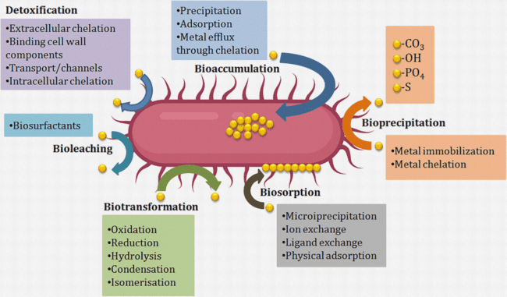

Figure 1: The main causes, consequences, and trophic levels of heavy metal exposure.[52]
Heavy metals are a threat to human health since they are found in soil and are known to go up the food chain through plants. Numerous heavy metals, such as mercury, cadmium, nickel, chromium, lead, and arsenic, are released into the environment as a result of human activities. These heavy metals are toxic to plants and animals in even minute concentrations. Ingenious solutions are being developed nowadays that focus on removing pollutants rather than employing the conventional technique of disposal. Numerous types of heavy metal sources are shown in figure 2.
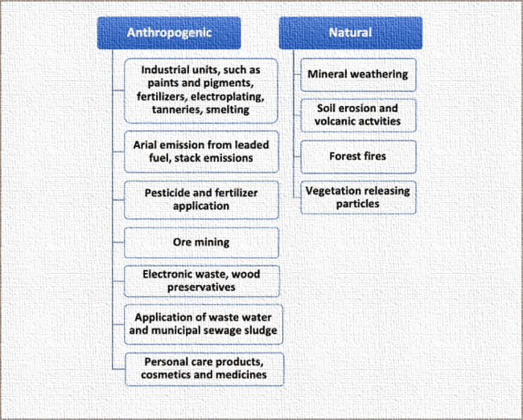Figure 2: Resources of heavy metals.[2]
To shift the concentration of dangerous substances in wastewater from a higher to lower level, a number of wastewater technologies were implemented on a target scale. Through physical, chemical, photochemical, and microbiological degrading processes, the polluted soil has been cleaned up. These procedures don’t totally eliminate soil hydrocarbon contamination and are more harmful to the ecosystem. Biological treatment, which employs the soil’s natural bacteria to transform the heavy metals into innocuous chemicals, is one of the finest techniques for cleansing soil that has been contaminated with heavy metals. Chemical, physical, and biological methods can be used to remove metal contamination from soil.
HEAVY METAL REMEDIATION
In recent years, a range of technologies and approaches have been used for heavy metal remediation in contaminated ecosystems, such as soil and water. The latter can be further separated into in-situ and ex-situ bioremediation. These approaches include physicochemical and biological ones.
A. Physicochemical Methods
Physicochemical procedures include methods for removing heavy metals from contaminated environments. As metal or metal-containing particle debris, they are useful. Physical and chemical methods such as ion exchange, precipitation, reverse osmosis, evaporative recovery, solvent extraction, filtration, chemical oxidation, chemical leaching, electrokinetics, landfilling, electrochemical treatment, electrodialysis, ultrafiltration, solvent extraction, chemical precipitation, chemical reduction, and isolation(mechanical) separation of metals can be used to carry out this remediation. These techniques do, however, need a lot of solvents and might result in inadequate metal removal as well as the formation of hazardous waste. In addition to being laborious and expensive, they also typically damage the soil and have harmful environmental effects. Consequently, these approaches are constrained by their high prices, high energy needs, poor performance, erratic metal ion removal, and production of hazardous sludge. [3-7]

B. Biological Methods
Heavy metals can be eliminated or broken down by biological activity via a number of methods. Biological remediation, often known as biodegradation, is the aggregate name for these processes. Both aerobic and anaerobic biological processes can be used to eliminate heavy metals. Under specific conditions, the polluted environment undergoes biodegradation to quantities that are below the regulatory bodies’ established limits. [8-12]
*Figure 3, provides a quick summary of the various bioremediation approaches for various pollutants.
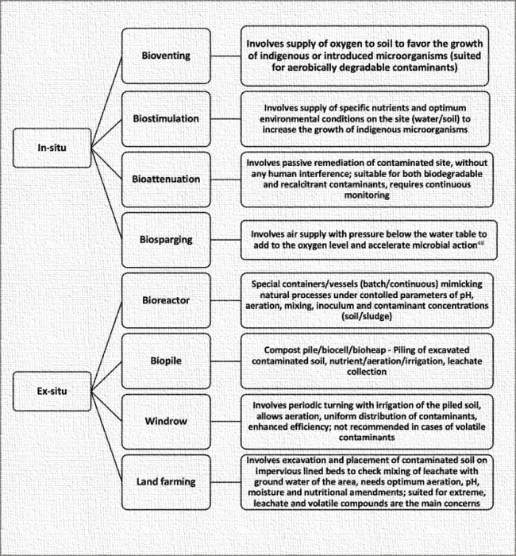Figure 3: Methods for different pollutants using different types of bioremediations.[13]

Table 1: Types of bioremediations.[14]
STRATEGY | DEGRADATION | ORGANISM
In situ bioremediation | Biotransformation | Bacterioremediation
Bioventing
Biosparging
Biostimulation
Bioaugmentation
Phytoremediation
Ex-situ bioremediation | Biodegradation | Mycoremediation
Land Farming
Composting
Biopiles
Bioreactors
Others | Mineralization | Phytoremediation  Compost bioremediation

IN SITU BIOREMEDIATION
In situ bioremediation techniques treat the contamination while the soil is still at the site. The use of these particular approaches is dependent on a number of factors, such as the degree of pollution, the properties of the chemicals involved, the quantity of pollutants present, and the amount of time required to complete the bioremediation. This method is frequently suggested because to its affordability and the necessity for fewer objects to be transferred. Two varieties of in situ bioremediation are occasionally used to classify it: intrinsic and planned in situ bioremediation. There are many different forms, but the most common ones include phytoremediation, bioventing, sparging, biostimulation, and bioaugmentation. [15-18]
Bioventing - The most popular in situ approach is called "venting," which involves supplying filthy soil with air and nutrients to encourage the growth of bacteria. Pollutants must biodegrade before they may be vented into the atmosphere, which necessitates a small airflow and low oxygen levels. Simple hydrocarbons in the soil can be biodegraded in-situ, which suggests that the pollution is pervasive below the soil’s surface. The efficiency of venting is limited by the inability to aerate surface pollution and the challenge of providing oxygen to contaminated soil.[19]
Biosparging - By “sparging,” high pressure air is injected below the water table to raise the oxygen content of the groundwater and hasten the bacterial bioremediation of contaminants. Both venting and bio-sparging techniques have been utilized simultaneously in order to guarantee the efficient removal of soil contaminants regardless of any unfavourable conditions. Using biosparging, the amount of dissolved oil components in groundwater may be reduced by mixing soil with groundwater, as well as soil beneath the water table and inside the capillary fringe. It is a straightforward, inexpensive procedure that offers a lot of adaptability.
Biostimulation - The first step in the bioremediation process is biostimulation, which encourages bacterial growth. Improved nutrients and essential chemicals are first applied to the polluted soil to encourage microbial activity and hasten the conversion of pollutants or harmful substances into carbon sources of nitrogen and phosphorus. Bacteria and fungus are two types of microorganism that recycle materials in nature at an early stage. The capacity of microorganisms to convert chemical waste into valuable resources and energy points to significant biological processes that are more effective and ecologically friendly.
Bioaugmentation - Wherever microorganisms are used in bioaugmentation, it is at those exact sites that the contaminants need to be removed. They are able to outcompete native microorganisms, which allows them to swiftly clean up the area. It has been shown that bioaugmentation may remove dangerous compounds from ecosystems, such as soil and water. It has also been noticed that there are certain limitations. When exogenous bacteria are introduced to a polluted environment, it has been discovered that both biotic and abiotic stresses reduce the quantity of foreign germs present. They arise as a result of competition between imported and native microbes, insufficient growth resources such substrates, temperature swings, and pH, and these factors together.[20]
Phytoremediation - Utilizing plants to remove contaminants from soil and water is a new technique known as phytoremediation. It could be a practical choice in the future and might be useful for the biodegradation of organic contaminants. Sites with shallow pollution are good candidates for this technique. In spite of this, several studies have highlighted a number of this technology’s disadvantages, including pollution concentration, toxicity, bioavailability, plant type, and stress tolerance.
EX SITU BIOREMEDIATION
Ex situ bioremediation is the act of treating and removing soil from its original location before re-introducing it. It is often quicker to disinfect the area when hazardous material is removed since it may either be treated on-site or off-site. Solid phase systems and slurry phase systems are the two different kinds of ex-situ bioremediation. Among the most important techniques are land farming, heaps, bioreactors, and composting.
Land farming – Land farming is a simple process that involves digging dirty soil over a planned plot with occasional tilling until contaminants are eliminated by microorganisms. The technique is only used to remediate a small area of soil. The method is straightforward and extremely effective, especially when applied to soil that has been contaminated with petroleum. Only a modest (10-35cm) area of top soil may be treated with this method. [21]
Composting – In order to promote the development of many microorganisms at higher temperatures (40-65c), composting involves combining polluted soil with non- hazardous organic agriculture wastes. The procedure is used to a mixture of excavated soil and biosolids (wood chips, animal waste, and vegetal waste) that have been contaminated with organic chemicals (pesticides and petroleum hydrocarbons). [21]
Biopiles – The use of biopiles combines traditional farming with composting. In the enriched ecosystems produced by biopiles, several microorganisms (both aerobic and anaerobic) can flourish. A contaminated environment is treated ex-situ by the aqueous reactors, which are pumped up from a particular location. It involves using specially created technology to bioremediated an unhealthy environment. Engineered cells are made to manage the physical losses of the pollutants through leaching, which is then followed by volatilization, for the treatment of surface contaminants. Biopilling is thought of as a useful, affordable solution for contaminated soils.
Bioreactors – Once an external environment has been tuned and a biological reaction has taken place there, the container is known as a bioreactor. The system may incorporate enzymes, tissues, bacteria, and animal and plant cells to create a high output of bioremediation. Biodegradation is frequently greater in bioreactor systems because the target environment is easier to control, monitor, and forecast in bioreactor systems than in other systems. Despite the advantages of reactor systems, it has been shown that in order for a bioreactor to manage a pollutant from a contaminated environment (such as soil) physical extraction of the contamination is necessary. [15]
BIOSORPTION AND BIOACCUMULATION
The use of biosorption and bioaccumulation as heavy metal cleanup procedures alternatives seems promising. The phrase "bioaccumulation" describes the uptake of contaminants by living biomass or cells, including the active/metabolism-dependent uptake of heavy metals. Using living biomass for cleanup may not be a viable option due to the extremely toxic metals that can accumulate in cells and interfere with metabolic processes, resulting in cell death. Dead biomass (biosorption) is flexible to changing environmental conditions and does not require a growth or nutritional medium, yet it is not impacted by toxicity. Up until equilibrium is reached, heavy metals are adsorbed passively (without requiring any energy expenditure; independent of metabolism) on the surface. Therefore, biosorption is preferable to active absorption or bioaccumulation since it is metabolism independent; nonetheless, it is highly reliant on the kind of biomass or biosorbent and pollutants involved. Microbial biomasses of fungus, algae, or yeast have been used for in-situ procedures to bioremediate because of these benefits. There have also been reports of heavy metal bioremediation using genetically engineered microbes and heavy metal nanoparticles produced by bacteria.Intracellular sequestration is the term for the accumulation of metal ions inside the cells of microorganisms. Because of surface interactions, heavy metal ions become complex and are then carried inside of the cell. Extracellular sequestration is defined as the concentration of metal ions in the periplasm or their complexation into insoluble precipitates. Cadmium precipitation in Klebsiella planticola and Pseudomonas aeruginosa has been documented. [22-28,33]
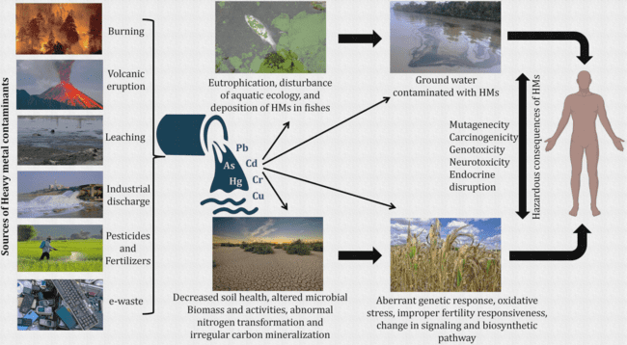

Figure 4: Environmental cleanup of heavy metals using microbes.[52]
Since microbes are nature's original recyclers, many different species can be employed for bioremediation. They may also convert chemicals into energy sources and raw materials for their own growth, creating a biological process that is both inexpensive and environmentally beneficial. Heavy metals are becoming a serious global environmental issue as a result of their extensive industrial use. Due to industrial activity and fuel consumption, toxic heavy metals accumulate via the food chain, posing a threat to the environment and human health. Mercury, silver, lead, cadmium, and arsenic are some examples of heavy metals that have hazardous effects on living cells. Many different kinds of bacteria have genes in their DNA that make them resistant to various cations and oxyanions of heavy metals. In order to deal with the absorption of heavy metal ions, bacteria go through a variety of different methods. These processes include complexation, biosorption, trapping, efflux, reduction, and precipitation. As a result, microorganisms might be a potential, limitless source for brand-new environmental biotechnologies. In bioremediation, harmful compounds to the environment or human health are detoxified or degraded using naturally occurring microbes. The microorganisms can either be separated from other resources at the contaminated location or utilized locally. The following examples are only a few of the microorganisms that are engaged in biodegradation as stated in Table 2: It includes Acinetobacter, Actinobacterium, Alcaligenes, Arthrobacter, Bacillins, Beijerinckia, Flavobacterium, Methylosinus, Mycobacterium, Mycococcus, Nitrosomonas, Nocardia, Xanthobacter, Penicillium, Phanerochaete, Pseudomonas, Rhizoctonia, Trametes, and Serratia. While the majority of bioremediation processes take place in aerobic settings, running a system in anaerobic ones could encourage microorganisms to break down otherwise refractory materials. During the process of growing, aerobic organisms require oxygen. Cellular respiration refers to these ongoing processes that employ oxygen to oxidize energy-producing substances like fatty acids from oil. Pseudomonas, Sphingomonas, Rhodococcus, Alcaligenes, and Mycobacterium are a few examples of aerobic degradative bacteria. In addition to hydrocarbon compounds, microorganisms may be employed to break down hazardous substances like insecticides. Numerous bacteria use the pollutant as a source of carbon and energy for their metabolism. In contrast to aerobic bacteria, anaerobic bacteria have a metabolism that is not dependent on oxygen. Additionally, biphenyls, chloroform, and dechlorination have all been bioremediation using anaerobic bacteria. Additionally, fungi may be able to degrade a broad range of dangerous or enduring environmental pollutants. Substrates come in a wide variety of varieties, including maize cobs, straws, and dust. The methane-using aerobic bacteria that proliferate by utilising it as a source of carbon and energy. Methane monooxygenase is used to initiate this aerobic breakdown, which will be efficient against a wide range of substances. [29-51]
Table 2: Heavy metal distribution in environment and microorganisms involved in biodegradation.[14]
Heavy metal | Distribution | Microorganism | Reference
As | Soil, volcanic eruption | Sporosarcina ginsengisoli | [31-32]
Cd | Soil, sedimentary rocks, water | Bacillus sp.  Klebsiella planticola | [33-35]
Cr | All environments | Bacillus cereus strain XMCr-6  Bacillus cereus  Pseudomonas putida  Enterobacter cloacae B2-DHA  Bacillus subtilis | [36-39]
Pb | Soil | Rhodobacter sphaeroides  Leclercia adecarboxylata  Kocuria flava | [40]
Hg | Water, soil, and air | Bacillus sp. strain CSB_B078  Klebsiella pneumoniae isolate  Enterobacter sp. strain 08  Acinetobacterseohaensis strain | [41]
Cu | Earth's crust, oceans, lakes, and rivers | Kocuria flava | [42]
Zn | Surface water, soil, and rock | Pseudomonas putida | [43-44]
Ni | Air, soil, sediments, and water | Desulfovibrio desulfuricans  Bacillus licheniformis | [45-46]
Co | Air, soil, and water | Bacillus sp.  Rhodopseudomonas palustris | [34, 47,48]
As: arsenic; Cd: cadmium; Cr: chromium; Pb: lead; Hg: mercury; Cu: copper; Zn: zinc; Ni: nickel; Co: cobalt.
WHAT AFFECTS BIOREMEDIATION?
Microorganisms might have natural and monetary limits with regards to weighty metal evacuation. The decision of a suitable bioremediation ought to consider various boundaries. The level of biodegradation relies fundamentally upon various elements. Most notably, nutrients including nitrogen, phosphate, sulfur, iron, and potassium can promote and sustain active microbial growth, cell digestion, and microbial expansion in the sullied environment. These supplements act as the structure blocks of life and help in the development of the compounds expected by microorganisms to corrupt poisons. Second, it's conceivable that the expense of remediation will be essential to the continuation of bioremediation, consequently it ought to be reasonable to be attainable monetarily. Thirdly, the sort of contaminations — whether they are dangerous or harmless, natural or inorganic, weighty metals, polycyclic sweet-smelling hydrocarbons, pesticides, or chlorinated solvents — may affect the cycle. Strong, semisolid, fluid, or unpredictable poisons, for instance, could unfavourably affect the interaction. Taking into account that it might affect the adequacy of bioremediation, the sort of debased district is additionally urgent. Fourth, the bioremediation interaction is impacted by physicochemical factors like pH, temperature, and others. Since it influences microbial development and, thusly, the evacuation of toxins, picking all that scope of these boundaries can likewise essentially affect the speed and measure of biodegradation. Five, natural development and powerful bioremediation are both exceptionally subject to dampness content (water). Sixth, various microorganisms that can biodegrade any sort of foreign substance, including E. crassipes and L. Hofmeister, as well as chloroflexota, corynebacterium, acinetobacter, mycobacteria, streptomyces, bacilli, and other amphibian plants, can likewise separate turbidity and compound homegrown wastewater. Seventh, both high-impact and anaerobic bioremediation might utilize oxygen, which is generally utilized for the early decay of hydrocarbons in dirtied areas. [ 15-18]
ADVANTAGES AND LIMITATIONS
Many scientists employ bioremediation, a straightforward procedure, to remediate waste from polluted areas like soil. The bacteria that break down the pollutant multiply and produce harmless byproducts. Usually innocuous compounds like carbon dioxide, water, and cell biomass make up the treatment's leftovers. When compared to other techniques for getting rid of hazardous waste, bioremediation requires a lot less work, is less expensive, and requires less manpower. Additionally helpful for the total eradication of a wide range of toxins, bioremediation is also environmentally benign, sustainable, and quite simple to execute. It is possible to turn many dangerous substances into safe goods. Furthermore, bioremediation may be carried out right at the contaminated site itself without significantly interfering with daily operations. Large amounts of garbage don't need to be transported off-site, the environment is safe and public health has no risk. Many drawbacks of bioremediation stem from the fact that it takes longer to complete than other solutions like excavation and pollutant removal from the site. Bioremediation also has trouble dealing with inorganic pollutants and determining whether or not contaminants have been eliminated. Additionally, highly chlorinated materials take a long time to biodegrade and produce byproducts that are more hazardous or cancer-causing [65, 66]. In addition, the byproducts of biodegradation might occasionally turn out to be far more harmful than the initial substance. Its biological functions are likewise quite specialized. Microbial populations, growth circumstances, and the amount of contaminants and nutrients are a few examples of effective site variables. [15,49-51]
CONCLUSION
Application of bioremediation technology, which is still a useful, organic, and environmentally acceptable method, results in the organic destruction of the polluted environment. Microorganisms have a significant role in the removal of heavy metal pollutants. Heavy metals such as arsenic, mercury, lead, cadmium, and silver have damaging effects on living cells. Aerobic bacteria that break down organic materials include Pseudomonas, Alcaligenes, Sphingomonas, Rhodococcus, and Mycobacterium, to name a few. Anaerobic bacteria have been successfully used for bioremediation of biphenyls, dichlorination, and chloroform. Numerous dangerous environmental toxins can be effectively reduced by fungus microorganisms. Using plants to purge polluted soil, water, and other environmental regions is a novel technique called phytoremediation. Bioremediation is inexpensive, labour -intensive, ecologically friendly, sustainable, and frequently easy to implement. It also needs very little work. The bulk of the disadvantages of bioremediation are caused by its sluggishness and time requirements. In some cases, the metabolites of biodegradation might even be more dangerous than the initial chemical. Unpredictability and irregularity may hinder bioremediation. Performance evaluation may also be difficult because there is no quantifiable objective for bioremediation. Further study is needed to develop a bioremediation approach and to uncover new biological treatments for the bioremediation of heavy metal contamination from diverse environmental systems.
REFERENCES
[1] P. Meenambigai1, R. Vijayaraghavan2, R. Shyamala Gowri1, P.Rajarajeswari 1 and P. Prabhavathi3 * Biodegradation of Heavy Metals – A Review International Journal of Current Microbiology and Applied Sciences ISSN: 2319-7706 Volume 5 Number 4 (2016) pp. 375-383 Journal homepage: http://www.ijcmas.com
[2] Meena Kapahi ^{1,2} and Sarita Sachdeva¹ , Bioremediation Options for Heavy Metal Pollution, J Health Pollut. 2019 Dec; 9(24): 191203.Published online 2019 Nov 27. doi: 10.5696/2156-9614-9.24.191203
[3] Asgari Lajayer B., Ghorbanpour M., Nikabadi S. Heavy metals in contaminated environment: destiny of secondary metabolite biosynthesis, oxidative status and phytoextraction in medicinal plants. Ecotoxicology and Environmental Safety 2017; 145:377–390. doi: 10.1016/j.ecoenv.2017.07.035. [PubMed] [CrossRef] [Google Scholar]
[4] Lasat M. Phytoextraction of metals from contaminated soil: a review of plant/soil/metal interaction and assessment of pertinent agronomic issues. Journal of Hazardous Substance Research .1999;2(1):1–25. doi: 10.4148/1090-7025.1015. [CrossRef] [Google Scholar]
[5] Tang C. Y., Fu Q. S., Criddle C. S., Leckie J. O. Effect of flux (transmembrane pressure) and membrane properties on fouling and rejection of reverse osmosis and nanofiltration membranes treating perfluorooctane sulfonate containing wastewater. Environmental Science & Technology 2007;41(6):2008–2014. doi: 10.1021/es062052f. [PubMed] [CrossRef] [Google Scholar]
[6] Xia Y., Liyuan C. Study of gelatinous supports for immobilizing inactivated cells of Rhizopus oligosporus to prepare biosorbent for lead ions. The International Journal of Environmental Studies .2002;5:1–6. [Google Scholar]
[7] Gardeatorresdey J., Peraltavidea J., Delarosa G., Parsons J. Phytoremediation of heavy metals and study of the metal coordination by X-ray absorption spectroscopy. Coordination Chemistry Reviews 2005;249(17-18):1797- 1810.doi; 10.1016/j.ccr.2005.01.001. [CrossRef] [Google Scholar]
[8] Pilon-Smits E. Phytoremediation. Annual Review of Plant Biology 2005;56(1):15-39.doi;10.1146/annurev.arplant.56.032604.144214.[PubMed] [CrossRef] [Google Scholar]
[9] Pilon-Smits E. A., LeDuc D. L. Phytoremediation of selenium using transgenic plants. Current Opinion in Biotechnology 2009;20(2):207–212. doi: 10.1016/j.copbio.2009.02.001. [PubMed] [CrossRef] [Google Scholar]
[10] Mani D., Sharma B., Kumar C., Balak S. Depth-wise distribution, mobility and naturally occurring glutathione based phytoaccumulation of cadmium and zinc in sewage-irrigated soil profiles. International journal of Environmental Science and Technology 2013;10(6):1167–1180. doi: 10.1007/s13762-012-0121-z. [CrossRef] [Google Scholar]
[11] Juwarkar A. A., Singh S. K. Microbe-assisted phytoremediation approach for ecological restoration of zinc mine spoil dump. International Journal of Environment and Pollution 2010;43(1/2/3):236–250. doi: 10.1504/IJEP.2010.035927. [CrossRef] [Google Scholar]
[12] Audet P. Examining the ecological paradox of the ‘mycorrhizal-metal-hyperaccumulators’ Archives of Agronomy and Soil Science 2013;59(4):549–558. doi: 10.1080/03650340.2012.658378. [CrossRef] [Google Scholar]
[13] Azubuike CC, Chikere CB, Okpokwasili GC. Bioremediation techniques-classification based on site of application: principles, advantages, limitations and prospects. World J Microbiol Biotechnol [Internet] 2016 Nov;32(11):18. doi: 10.1007/s11274-016-2137-x. [cited 2019 Aug 21] Article 180 [ p.]. Available from: [PMC free article] [PubMed] [CrossRef] [Google Scholar]
[14] Ali Sayqal ¹ and Omar B. Ahmed ²Advances in Heavy Metal Bioremediation: An Overview
Appl Bionics Biomech. 2021; 2021: 1609149.
Published online 2021 Nov 11. doi: 10.1155/2021/1609149
[15] Vidali M. Bioremediation. An overview. Pure and Applied Chemistry 2001;73(7):1163–1172. doi: 10.1351/pac200173071163. [CrossRef] [Google Scholar]
[16] Atagan H. I., Hayne R., Wallis F. Optimization of soil physical and chemical conditions for the bioremediation of creosote-contaminated soil. Biodegradation 2003;14(4):297–307. [PubMed] [Google Scholar]
[17] Mangunwardoyo W., Sudjarwo T., Patria M. P. Bioremediation of effluent wastewater treatment plant Bojongsoang Bandung Indonesia using consortium aquatic plants and animals. International Journal of Research and Reviews in Applied Sciences. 2013;14(1):150–160. [Google Scholar]
[18] Thapa B., Kc A. K., Ghimire A. A review on bioremediation of petroleum hydrocarbon contaminants in soil. Kathmandu University Journal of Science, Engineering and Technology 2012;8(1):164–170. doi: 10.3126/kusetv8i1.6056. [CrossRef] [Google Scholar]
[19] Azubuike C. C., Chikere C. B., Okpokwasili G. C. Bioremediation techniques–classification based on site of application: principles, advantages, limitations and prospects. World Journal of Microbiology and Biotechnology 2016;32(11):1–18. doi: 10.1007/s11274-016-2137-x. [PMC free article] [PubMed] [CrossRef] [Google Scholar]
[20] Stroo H. F., Leeson A., Ward Eds C. H. Bioaugmentation for Groundwater Remediation New York: Springer; 2013. [Google Scholar]
[21] Sivakumar D., Kandaswamy A., Gomathi V., Rajeshwaran R., Murugan N. Bioremediation studies on reduction of heavy metals toxicity. Pollution Research 2014;33(3):553–558. [Google Scholar]
[22] Igiri BE, Okoduwa SI, Idoko GO, Akabuogu EP, Adeyi AO, Ejiogu IK. Toxicity and bioremediation of heavy metals contaminated ecosystem from tannery wastewater: a review. J Toxicol [Internet] 2018;2018:16. doi: 10.1155/2018/2568038. [cited 2019 Aug 22] Article 2568038 [ p.]. Available from: [PMC free article] [PubMed] [CrossRef] [Google Scholar]
[23] Velasquez L, Dussan J. Biosorption and bioaccumulation of heavy metals on dead and living biomass of Bacillus sphaericus. J Hazard Mater [Internet] 2009 Aug 15;167(1–3):713–6. doi: 10.1016/j.jhazmat.2009.01.044. [cited 2019 Aug 22] Available from: Subscription required to view. [PubMed] [CrossRef] [Google Scholar]
[24] Ahluwalia SS, Goyal D. Microbial and plant derived biomass for removal of heavy metals from wastewater. Bioresour Technol [Internet] 2007 Sep;98(12):2243–57. doi: 10.1016/j.biortech.2005.12.006. [cited 2019 Aug 22] Available from: Subscription required to view. [PubMed] [CrossRef] [Google Scholar]
[25] Klaus-Joerger T, Joerger R, Olsson E, Granqvist C. Bacteria as workers in the living factory: metalaccumulating bacteria and their potential for materials science. Trends Biotechnol [Internet] 2001 Jan;19(1):15–20. doi: 10.1016/S0167-7799(00)01514-6. [cited 2019 Aug 22] Available from: Subscription required to view. [PubMed] [CrossRef] [Google Scholar]
[26] Poirier I, Hammann P, Kuhn L, Bertrand M. Strategies developed by the marine bacterium Pseudomonas fluorescens BA3SM1 to resist metals: a proteome analysis. Aquat Toxicol [Internet] 2013 Mar 15;128–129:215–32. doi: 10.1016/j.aquatox.2012.12.006. [cited 2019 Aug 22] Available from: Subscription required to view. [PubMed] [CrossRef] [Google Scholar]
[27] Paliwal V, Puranik S, Purohit HJ. Integrated perspective for effective bioremediation. Appl Biochem Biotechnol [Internet] 2012 Feb;166(4):903–24. doi: 10.1007/s12010-011-9479-5. [cited 2019 Aug 22] Available from: Subscription required to view. [PubMed] [CrossRef] [Google Scholar]
[28] Wang CL, Ozuna SC, Clark DS, Keasling JD. A deep-sea hydrothermal vent isolate, Pseudomonas aeruginosa CW961, requires thiosulfate for Cd ²⁺ tolerance and precipitation. Biotechnol Lett [Internet] 2002 Apr;24(8):637–41. doi: 10.1023/A:1015043324584. [cited 2019 Aug 22] Available from: Subscription required to view. [PMC free article] [PubMed] [CrossRef] [Google Scholar]
[29] Singh R. Microorganism as a tool of bioremediation technology for cleaning environment: a review. Proceedings of the International Academy of Ecology and Environmental Sciences 2014;4(1)p1. [Google Scholar]
[30] Adenipekun C., Fasidi I. Bioremediation of oil-polluted soil by Lentinus subnudus, a Nigerian white-rot fungus. African Journal of Biotechnology 2005;4(8):796–798. [Google Scholar]
[31] Tanmoy P., Nimai C. Environmental arsenic and selenium contamination and approaches towards its bioremediation through the exploration of microbial adaptations: a review. Pedosphere .2019;29(5):554–568. doi: 10.1016/S1002-0160(19)60829-5. [CrossRef] [Google Scholar]
[32] Ojuederie O. B., Babalola O. O. Microbial and plant-assisted bioremediation of heavy metal polluted environments: a review. International Journal of Environmental Research and Public Health 2017;14(12)p 1504. doi: 10.3390/ijerph14121504. [PMC free article] [PubMed] [CrossRef] [Google Scholar]
[33] Sharma P. K., Balkwill D. L., Frenkel A., Vairavamurthy M. A. A new Klebsiella planticola strain (Cd-1) grows anaerobically at high cadmium concentrations and precipitates cadmium sulfide. Applied and Environmental Microbiology .2000;66(7):3083–3087. doi: 10.1128/AEM.66.7.3083-3087.2000. [PMC free article] [PubMed] [CrossRef] [Google Scholar]
[34] Rani M. J., Hemambika B., Hemapriya J., Kannan V. R. Comparative assessment of heavy metal removal by immobilized and dead bacterial cells: a biosorption approach. Global Journal of Environmental Research 2010;4(2):23–30. [Google Scholar]
[35] Kapahi M., Sachdeva S. Bioremediation options for heavy metal pollution. Journal of Health and Pollution. 2019;9(24, article 191203) [PMC free article] [PubMed] [Google Scholar]
[36] Dong G., Wang Y., Gong L., et al. Formation of soluble Cr(III) end-products and nanoparticles during Cr(VI) reduction by _Bacillus cereus_ strain XMCr-6. Biochemical Engineering Journal 2013;70(15):166–172. doi: 10.1016/j.bej.2012.11.002. [CrossRef] [Google Scholar]
[37] Kanmani P., Aravind J., Preston D. Remediation of chromium contaminants using bacteria. International journal of Environmental Science and Technology .2012;9(1):183–193. doi: 10.1007/s13762-011-0013-7. [CrossRef] [Google Scholar]
[38] Balamurugan D., Udayasooriyan C., Kamaladevi B. Chromium (VI) reduction by Pseudomonas putida and Bacillus subtilis isolated from contaminated soils. International Journal of Environmental Science and Technology. 2014;5(3): p. 522. [Google Scholar]
[39] Rahman A., Nahar N., Nawani N. N., et al. Bioremediation of hexavalent chromium (VI) by a soil-borne bacterium,Enterobacter cloacaeB2-DHA. Journal of Environmental Science and Health-Part A . 2015;50(11):1136–1147. doi: 10.1080/10934529.2015.1047670. [PubMed] [CrossRef] [Google Scholar]
[40] Rigoletto M., Calza P., Gaggero E., Malandrino M., Fabbri D. Bioremediation methods for the recovery of lead-contaminated soils: a review. Applied Sciences. 2020;10(10):p3528. doi: 10.3390/app10103528. [CrossRef] [Google Scholar]
[41] Pushkar B., Sevak P., Singh A. Bioremediation treatment process through mercury-resistant bacteria isolated from Mithi river. Applied Water Science. 2019;9(4): p. 117. doi: 10.1007/s13201-019-0998-5. [CrossRef] [Google Scholar]
[42] Coelho L. M., Rezende H. C., Coelho L. M., de Sousa P. A. R., Melo D. F. O., Coelho N. M. M. Bioremediation of polluted waters using microorganisms. In: Shiomi N., editor. Advances in Bioremediation of Wastewater and Polluted Soil Shanghai, China: InTech; 2015. [CrossRef] [Google Scholar]
[43] Pardo R., Herguedas M., Barrado E., Vega M. Biosorption of cadmium, copper, lead and zinc by inactive biomass of Pseudomonas putida. Analytical and Bioanalytical Chemistry 2003;376(1):26–32. doi: 10.1007/s00216-003-1843-z. [PubMed] [CrossRef] [Google Scholar]
[44] Chen X. C., Wang Y. P., Lin Q., Shi J. Y., Wu W. X., Chen Y. X. Biosorption of copper (II) and zinc (II) from aqueous solution by _Pseudomonas putida_ CZ1. Colloids and Surfaces. B, Biointerfaces . 2005;46(2):101–107. doi: 10.1016/j.colsurfb.2005.10.003. [PubMed] [CrossRef] [Google Scholar]
[45] Kim I. H., Choi J. H., Joo J. O., Kim Y. K., Choi J. W., Oh B. K. Development of a microbe-zeolite carrier for the effective elimination of heavy metals from seawater. Journal of Microbiology and Biotechnology 2015;25(9):1542–1546. doi: 10.4014/jmb.1504.04067. [PubMed] [CrossRef] [Google Scholar]
[46] Zhou M., Liu Y., Zeng G., Li X., Xu W., Fan T. Kinetic and equilibrium studies of Cr (VI) biosorption by dead Bacillus licheniformis biomass. World Journal of Microbiology and Biotechnology. 2007;23(1):43–48. doi: 10.1007/s11274-006-9191-8. [CrossRef] [Google Scholar]
[47] Gao R., Wang Y., Zhang Y., Tong J., Dai W. Cobalt (II) bioaccumulation and distribution in Rhodopseudomonas palustris. Biotechnology and Biotechnological Equipment. 2017;31(3):527–534. doi: 10.1080/13102818.2017.1292148. [CrossRef] [Google Scholar]
[48] Mani D., Kumar C. Biotechnological advances in bioremediation of heavy metals contaminated ecosystems: an overview with special reference to phytoremediation. International journal of Environmental Science and Technology 2014;11(3):843–872. doi: 10.1007/s13762-013-0299-8. [CrossRef] [Google Scholar]
[49] Broda P. Using microorganisms for bioremediation - the barriers to implementation. Trends in Biotechnology 1992;10(9):303–304. [PubMed] [Google Scholar]
[50] Zeyaullah M., Atif M., Islam B., et al. Bioremediation: a tool for environmental cleaning. African Journal of Microbiology Research 2009;3(6):310–314. [Google Scholar]
[51] Dhokpande S. R., Kaware J. P. Biological methods for heavy metal removal- a review. International Journal of Engineering Science and Innovative Technology 2013;2(5):304–309. [Google Scholar]
[52] Veni Pande^{1,2} Satish Chandra Pandey¹ Diksha Sati^{1,3} Pankaj Bhatt^{4*} Mukesh Samant^{1*}Microbial Interventions in Bioremediation of Heavy Metal Contaminants in Agroecosystem, Front. Microbial., 06 May 2022
Sec.Microbiotechnology Volume 13 - 2022 | https://doi.org/10.3389/fmicb.2022.824084

