Strain Improvement by natural variant selection and acclimatization
Sulagna Roy
R and D Microbiologist,
Vadodara, India

ABSTRACT
Microbial strains used as producers during industrial fermentations need to be developed in a manner that results into high product titres. While genetic manipulation continues to be the gold standard in this regard due to its ability to produce precisely the desired outcome, classical approaches like selection of natural variants and acclimatization can also help in giving high yielding strains.

Keywords – strain improvement, strain selection, natural variants, natural isolates, acclimatization, acclimation, fermentation
- INTRODUCTION
Natural isolates normally produce commercially important products at very low concentrations and thus continuous efforts need to be undertaken to improve the productivity of the chosen strain. The approach used for this usually involves continuous genetic modification of the culture followed by culture medium optimization. Microbial producer cultures are likely to turn heterogenous as they undergo spontaneous genetic changes with every cell division cycle. From such heterogenous populations, variants have been isolated that fare much better in terms of product yield. This is quite frequently encountered in the initial stages of new product development. Thus, it is worthwhile to plate out the producing strain at regular intervals and screen a portion of the progeny for productivity. An added benefit of this approach is that the operator becomes aware of the specific morphological traits associated with high productivity and typical colonies of natural variants can be selected to achieve consistent results [1].
Acclimatization is a process where continuous exposure of a microbial population to a chemical result in a more rapid transformation (biodegradation) of the chemical than initially observed. It is the ability of an organism to adjust its phenotype to new environmental conditions over the course of its lifetime given its genotype. Acclimatization that occurs in a controlled, experimental setting such as a laboratory is referred to as acclimation. Such acclimation approaches thus allow the development of strains that can speed up the transformation of specific components and facilitate their bioavailability in the immediate microenvironment [2].

- NATURAL VARIANT SELECTION
A.Streptogramins
Streptogramins are a family of antibiotics predominantly produced by Streptomyces species. The two structurally different antibiotics in this family act synergistically and show potent bactericidal activity toward Gram-positive bacteria with few incidences of resistant strains. The type A compounds in the Streptogramin family are cyclic polyunsaturated macrolactones that include pristinamycin II, synergistin A, vernamycin A and virginiamycin M (VM), whereas the type B compounds are cyclic hexa- or hepta-depsipeptides that include pristinamycin I, synergistin B, vernamycin B and virginiamycin S (VS). Both type A and type B compounds are individually bacteriostatic, but in combination they show a strong synergistic effect against a wide variety of pathogenic bacteria: they inhibit protein synthesis by binding to the peptidyltransferase domain (P site) of the 50S ribosomal subunit at different sites (Di Giambattista et al., 1989). Type A compounds inhibit elongation of the polypeptide chain by preventing the binding of amino acyl-tRNA to the ribosome, while type B compounds stimulate the release of the peptidyl tRNA. During binding of type A compounds, the ribosome is likely to be transformed into a different conformation, enhancing the binding affinity of type B compounds to the ribosome (Contreras and Vazquez, 1977). Thus, the combination of type A and type B compounds results in 100-fold higher activity compared to treatment with either compound alone. Chemical modification of virginiamycins (pristinamycin IA and IIA) has led to the design of water-soluble derivatives such as quinupristin and dalfopristin for treating infections associated with vancomycin-resistant Enterococcus faecium and other Gram-positive bacteria, and thus the importance of the Streptogramin family has increased [3].
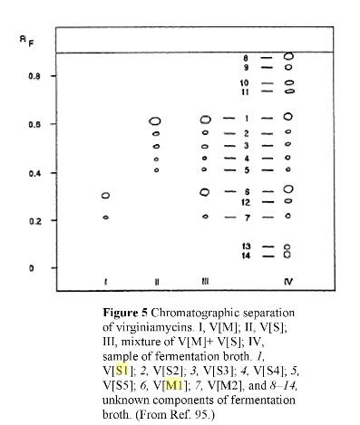

Figure 1: Chromatographic separation of streptogramin antibiotic – Virginiamycin. I, V[M]; II, V[S]; III, mixture of V[M + V[S]; IV, sample of fermentation broth, 1, V[S1]; 2, V[S2]; 3, V[S3]; 4, V[S4]; 5, V[S5]; 6, V[M1]; 7, V[M2] and 8 –14, unknown components of fermentation broth

B. Selection of Natural Variants Producing Streptogramins
On plating out the Gram +ve, filamentous actinomycete, Streptomyces virginiae on yeast extract-malt extract agar plates and incubating the same at 28–30-degree Celsius for 4 to 6 days, 5 different colony morphologies were obtained as described in Table 1.

Table 1: Different colony morphologies of S. virginiae as observed on yeast extract-malt extract agar plates upon incubation at 28-30 degree Celcius for 4 to 6 days
Colony number | Colony morphology
1 | Round, white, smooth
2 | Polygonal, white, smooth
3 | Round or polygonal, lavender or pink, smooth, camphor-like odour
4 | Round to polygonal, 2-4mm diameter, lavender or pink, with grooves radiating from centre of colony and dividing the surface into 2, 3, 4 or more sectors, central tiny depression, camphor-like odour
5 | Round to polygonal, lavender or pink, with central large depression, camphor-like odour

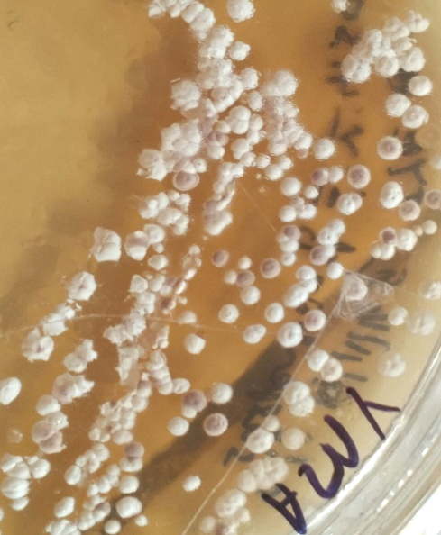
Figure 2: Different colony morphologies as seen on yeast extract-malt extract agar plates

C. Growth, Production and Extraction
The spore suspensions of the 5 different types of colonies were inoculated into 25ml growth or seed medium in 250ml Erlenmeyer flasks (soyabean meal – 15g/L, peanut meal – 20g/L, yeast extract – 5g/L, soluble starch – 20g/L, D-glucose – 30g/L, CaCO₃ – 3g/L, heated up to 90-degree Celsius for 20 minutes, pH 7, sterilized at 10psi for 20 minutes) and incubated at 28-30-degree Celsius, 120-140rpm for 24 hours.

Table 2: Seed Parameters at Maturity
pH | 6 – 6.5
Packed Mycelial Volume (PMV) | 30-40%
Microscopy | Dense growth of thick, branched, filaments
Colour | Very faint pink tint

17% i.e., 10ml of the mature seed was aseptically added to 60ml of production medium in 500ml Erlenmeyer flasks (soluble starch – 1.5g/L, soyabean meal – 0.3g/L, yeast extract – 0.2g/L, D-glucose – 1g/L, Linseed oil – 0.4g/L, K₂HPO₄ – 0.04g/L, FeSO₄ – 0.004g/L, (NH4)2SO4 – 0.1g/L, CaCO3 – 3g/L, HP21 – 20g/L, heated up to 90-degree Celsius for 20 minutes, pH 7.2, sterilized at 10 psi for 20 minutes) and incubated at 28-30-degree Celsius, 160-170rpm for 96 to 120 hours. Feedings of 0.6g/L sodium propionate and 0.7g/L L-threonine were carried out aseptically at 48-50 and 50-52 hours respectively.
At regular intervals, broth samples were collected, centrifuged at 6000rpm for10 minutes and the volume of pellet obtained was noted down. A volume of ethyl acetate equal to the pellet volume was added, the pellet was suspended into ethyl acetate by vigorous vortexing for 30 minutes. The ethyl acetate layer was removed, and an equal volume of acetonitrile (ACN) was added, the pellet was once again suspended by vigorous vortexing for 30 minutes. The acetonitrile fraction was collected by centrifugation or filtration using Whatman filter paper 1 or muslin cloth. The pellet was further given 2-3 such washes with acetonitrile, all fractions were collected and pooled together. The pooled fractions were concentrated (by distillation) and used for Thin Layer Chromatographic (TLC) analysis and High-Pressure Liquid Chromatographic (HPLC) analysis.

D. TLC and HPLC Analysis
Pre-washing or blank development of the silica plates (60-F-254 0.2mm) was carried out in the TLC tank containing chloroform and methanol in a ratio of 1:1. The direction of blank development was marked on the plate and the same direction was used during chromatographic separation of the samples. 20ul of the acetonitrile extracts were spotted on the pre-washed silica plates while a mobile phase comprising of chloroform: methanol in a ratio of 92: 8 was used. The plates were observed under UV light at 235nm.

Figure 3: TLC of Acetonitrile extracts from 96h samples from production flasks inoculated with 5 different colony morphologies. Colony 4 shows production of the desired compound

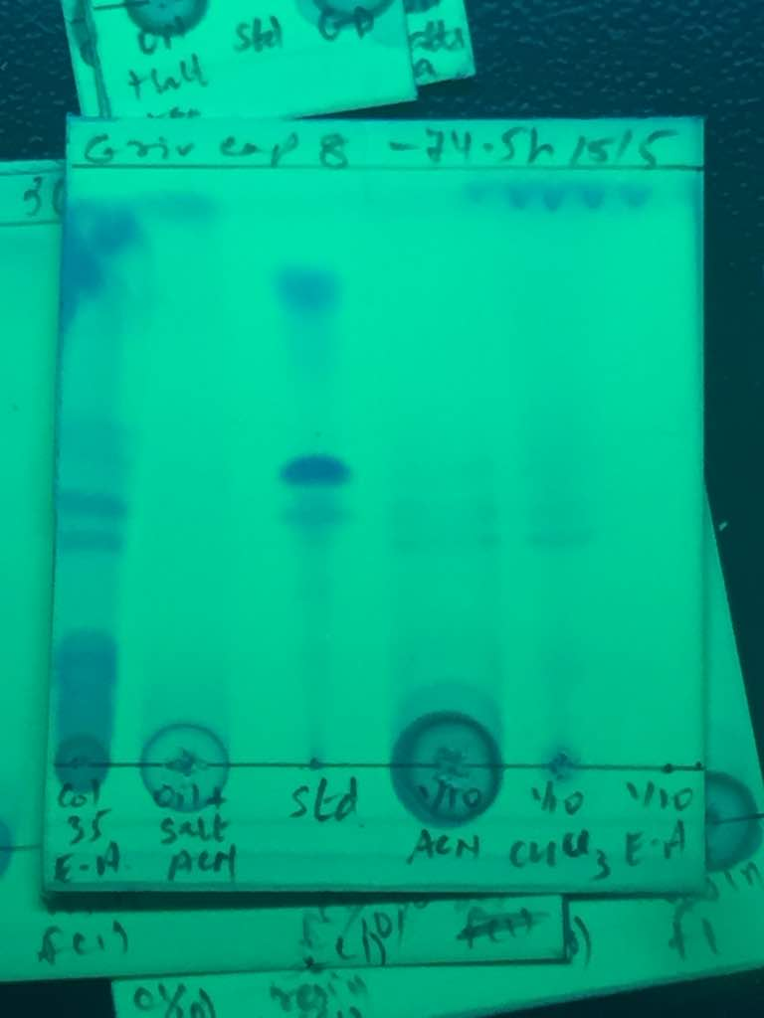

Figure 4: TLC of Acetonitrile extracts from 77.5h samples from production flasks inoculated with colony 31 and from 74.5h samples from production flasks inoculated with colony 35. (with both colonies having morphology similar to colony 4). Both colonies show production of the desired compound at an earlier age

HPLC analysis was carried out after combining and concentrating all the acetonitrile extracts that showed production of the desired compound as visible on TLC plates. Column used was Supelco LC-18 DB Column, 15cm length, 4.6mm i.d., 5um, particle size. Flow rate of 1.0mL/min and gradient elution system was used. A wavelength of 230nm was used for detection.
Table 3: Gradient Elution System for HPLC
Time (min) | Solvent A (%) | Solvent B (%)
0.2 | 94 | 6
30.0 | 15 | 85
35.0 | 15 | 85
40.0 | 94 | 6
45.0 | 94 | 6
Where Solvent A – 0.01M phosphoric acid, Solvent B - Acetonitrile

Figure 5: Desired compound standard HPLC with peak at 16.921 minutes

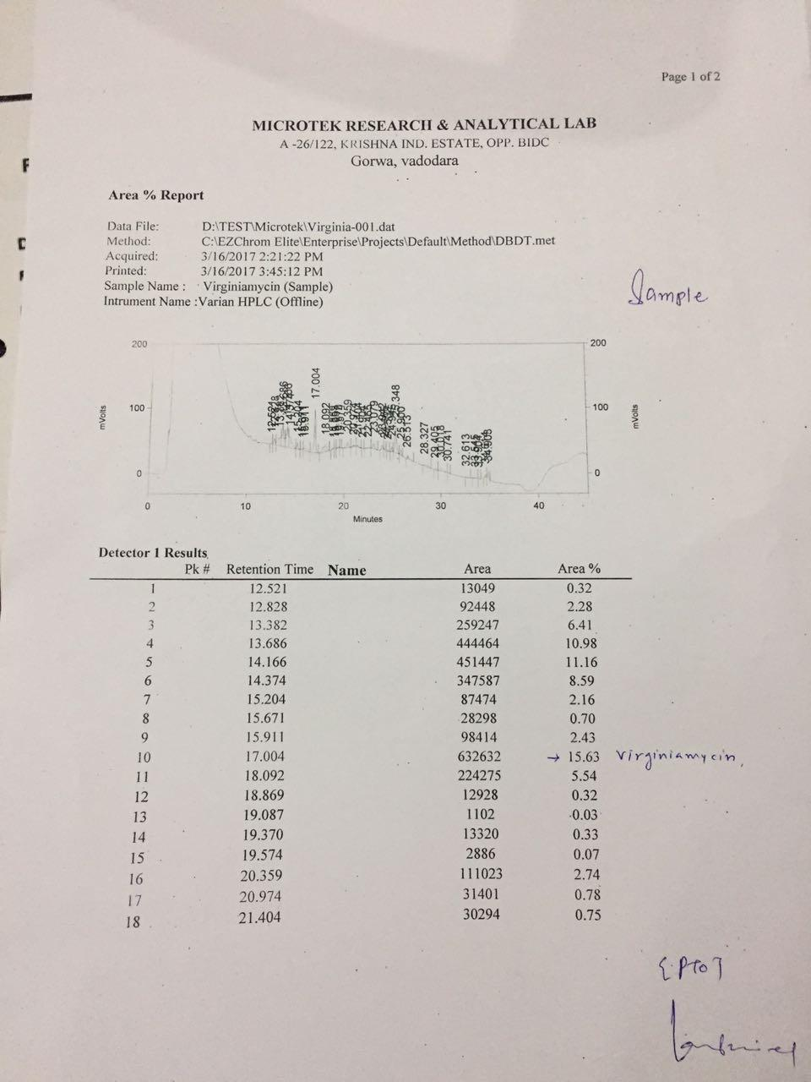
Figure 6: Acetonitrile fraction HPLC showing peak corresponding to desired compound at 17.004 minutes
E. Inference
Based on the above approach, it could be inferred that only round to polygonal colonies with 2-4mm diameter, lavender or pink, with grooves radiating from centre of colony and dividing the surface into 2, 3, 4 or more sectors, central tiny depression, camphor-like odour would give rise to the desired compound if used for production.
- ACCLIMATIZATION
A. Phosphate Solubilization
Phosphorus is one of the 17 essential elements for plant growth. Phosphate solubilizing microorganisms including bacteria and fungi, can mobilize phosphate complexes in the soil and thus help in increasing the availability of fixed phosphates for plant growth. Phosphate solubilizing bacteria (PSB) are common in the rhizosphere and secretion of organic acids and phosphatase enzyme are common methods of facilitating the conversion of insoluble forms of P to plant-available forms. The solubilization of P in the rhizosphere is a common mode of action implicated in PGPR that increases nutrient availability to host plants. Phosphate solubilizing microorganisms mainly belong to Bacillus and Pseudomonas among the bacteria.

B. Growth, Acclimation and Screening
Microbial strains showing ability to solubilize phosphate were exposed to gradually increasing concentrations of tricalcium phosphate to further improve or enhance their phosphate solubilization ability. The strains selected were: BME101, BPO101, BPU301, PF501.
Isolated colonies of the selected strains were inoculated into Nutrient broth and incubated upto 24-48hours. These cultures in turn were used to inoculate fresh Nutrient broth (100ml medium in 500ml flask). After an incubation of 24 hours at 30 degree Celcius,120rpm, the cells of each strain were collected by centrifugation at 5000rpm for 10 minutes and resuspended into 500ml flasks having 80ml Nutrient broth and 20ml of Pikovskaya's broth (recommended for detection of phosphate solubilizing microorganisms). Again after an incubation of another 24 hours at 30 degree Celcius,120rpm, the cells of each strain were collected by centrifugation at 5000rpm for 10 minutes and resuspended into 500ml flasks having 60ml Nutrient broth and 40ml of Pikovskaya’s broth. This was continued with 500ml flasks having 40ml Nutrient broth and 60ml of Pikovskaya's broth, followed by 500ml flasks having 20ml of Nutrient broth and 80 ml of Pikovskaya's broth and finally 500ml flasks having 100ml of Pikovskaya's broth. At regular intervals, cultures of each of the selected strains were inoculated into 8mm wells on Pikovskaya's agar plates to determine phosphate solubilization. After incubation in 100ml of Pikovskaya's broth, the cells of each strain were collected by centrifugation at 5000 rpm for 10 minutes, washed with sterile water to remove excess salts and were then inoculated into 8mm wells on Pikovskaya's agar plates to determine phosphate utilization. These cultures were also streaked onto Pikovskaya's agar plates and slants and CFU (colony forming units) were also determined.

Table 4: pH, biomass, initial zone on Pikovskaya plates with increasing volume of Pikovskaya broth during acclimation
Age | Volume of Pikovskaya broth (ml) | pH | Biomass after centrifugation (g) | Initial Zone size on Pikovskaya plate
1st day | 0 | 7 (for all four strains) | BME101- 2.5  BPO101 - 2.3  BPU301 - 1.66  PF501 - 1.56 | BME101 - only growth, no zone  BPO101- only growth, no zone  BPU301- 8.3mm zone after 48hrs  PF501 - 8mm zone after 24hrs
2nd day | 20 | 7 (for all four strains) | BME101 - 1.45  BPO101 - 1.82  BPU301 - 1.43  PF501 - 1.81 | -
3rd day | 40 | BME101 - 7.5  BPO101 - 6  BPU301 -7  PF501 - 7 | BME101 - 2  BPO101 - 2.27  BPU301 - 2.05  PF501 - 1.62 | BME101 - only growth, no zone  BPO101 - only growth, no zone  BPU301 - 3.7mm zone after 24hrs  PF501 - 8.8mm zone after 24hrs
4th day | 60 | BME101 - 7  BPO101 - 6  BPU301 - 7  PF501 - 6.5 | BME101 - 2.25  BPO101 - 2.19  BPU301 - 2.65  PF501 - 2.88 | -
5th day | 80 | BME101 - 6.5  BPO101 - 6  BPU301 -7  PF501 - 5 | BME101 - 3.36  BPO101 - 2.85  BPU301 - 3.36  PF501 - 2.91 | -
7th day | 100 (observations after 48hrs) | BME101 - 5  BPO101 - 4  BPU301 - 5  PF501 - 4 | BME101 - 3.3  BPO101 - 4.26  BPU301 - 4.12  PF501 - 4.43 | BME101 - 3.2mm zone after 24 hrs  BPO101 - only growth, no zone  BPU301 - 3.5mm zone after 24hrs  PF501 - 4.45mm zone after 24 hrs

Table 5: Zone size around 8mm well on Pikovskaya's agar plates under incubation till 14 days (336 hrs)
 | BME101 | BPO101 | BPU301 | PF501
NB100ml, Pikovskaya's broth 0ml | 24hrs - only growth, no zone | 24hrs - only growth, no zone | 24hrs - only growth, no zone | 24 hrs - 8mm zone
NB100ml, Pikovskaya's broth 0ml | 48 hrs - only growth, no zone | 48 hrs - only growth, no zone | 48 hrs - 8.3mm zone | 48 hrs - 8mm zone
NB100ml, Pikovskaya's broth 0ml | 144 hrs - only growth, no zone | 144 hrs - only growth, no zone | 144 hrs -12mm zone | 144 hrs - 8mm zone
NB100ml, Pikovskaya's broth 0ml | 192 hrs - only growth, no zone | 192 hrs - only growth, no zone | 192 hrs -12mm zone | 192 hrs -11mm zone
NB100ml, Pikovskaya's broth 0ml | 264 hrs - only growth, no zone | 264 hrs - only growth, no zone | 264 hrs -16.3mm zone | 264 hrs -13mm zone
NB100ml, Pikovskaya's broth 0ml | 336 hrs – only growth, no zone | 336 hrs – only growth, no zone | 336 hrs – 17mm zone | 336 hrs – 13mm zone
NB 60ml, Pikovskaya's broth 40ml | 24 hrs - only growth, no zone | 24 hrs - only growth, no zone | 24 hrs - 3.7mm zone | 24 hrs 8.8mm zone
NB 60ml, Pikovskaya's broth 40ml | 96 hrs - only growth, no zone | 96 hrs - only growth, no zone | 96 hrs - 6mm zone | 96 hrs - 10mm zone
NB 60ml, Pikovskaya's broth 40ml | 144 hrs - only growth, no zone | 144 hrs - only growth, no zone | 144 hrs - 9mm zone (individual colony zone - 10.8mm) | 144 hrs - 12mm zone
NB 60ml, Pikovskaya's broth 40ml | 216 hrs - only growth, no zone | 216 hrs - only growth, no zone | 216 hrs - 19.5mm zone (individual colony zone 12.2mm) | 216 hrs - 18mm zone
NB 60ml, Pikovskaya's broth 40ml | 336 hrs - only growth, no zone | 336 hrs - only growth, no zone | 336 hrs – 20mm zone (individual colony zone 12.5mm) | 336 hrs - 18mm zone
NB 0ml, Pikovskaya's broth 100ml | 24 hrs - 3.2mm zone | 24 hrs - only growth, no zone | 24 hrs - 3.5mm zone | 24 hrs - 4.45mm zone
NB 0ml, Pikovskaya's broth 100ml | 48 hrs - 7.4mm zone | 48 hrs - only growth, no zone | 48 hrs - 5.6mm zone | 48 hrs - 6mm zone
NB 0ml, Pikovskaya's broth 100ml | 120 hrs - 11mm zone (individual colony zone - 2mm) | 120hrs - only growth, no zone | 120 hrs - 10.3mm zone (individual colony zone - 8.1mm) | 120 hrs - 9mm zone (individual colony zone - 6.3mm)
NB 0ml, Pikovskaya's broth 100ml | 336 hrs - 12mm zone (individual colony zone - 4.5mm) | 336 hrs- only growth, no zone | 336 hrs - 13mm zone (individual colony zone -11mm) | 336 hrs - 10mm zone (individual colony zone -7mm)
Final count on Pikovskaya plates | 10*11 (with zone) | 10*10 (no zone) | 10*11 (with zone) | 10*10 (with zone)

C. Inference:
With increasing phosphate concentrations in the form of Pikovskaya’s broth, the pH of the growth medium gradually decreases indicating rapid utilization of sugars to produce organic acids. This in turn can be associated with higher phosphate solubilization. While total mass of pellet after centrifugation is found to increase progressively, it could be the combined mass of cells as well as salts and not the biomass alone.
Three strains,viz., BME101, BPU301 and PF501 show phosphate solubilization through the cork-borer/ well plate method. While BPU301 and PF501 have shown such solubilization even without any Pikovskaya’s broth, BME101 started showing this activity only when 100 per cent Pikovskaya’s broth was used. 40ml of Pikovskaya’s broth in medium has been effective in improving phosphate solubilization in case of PF501 and BPU301 as evident through larger zones produced by both strains and earlier zone formation in case of BPU301. 100ml of Pikovskaya’s broth in medium has been mainly effective in improving phosphate solubilization in case of BME101 while it has not shown any significant enhancement in activity in case of PF501 and BPU301. So 40ml of Pikovskaya’s broth in medium is suitable for PF501 and BPU301 while 100ml of Pikovskaya’s broth in medium is well suited for BME101.
Acclimatized strains such as above need to be preserved under the same conditions as were used during acclimatization,i.e., in presence of tricalcium phosphate or Pikovskaya’s medium so that their acclimatized state is not lost. Such phosphate acclimatized as well as sporulating strains like those of Bacillus can be more efficient in phosphate solubilization over a longer period of time and under varied conditions as compared with non-sporulating strains like those of Pseudomonas.
IV. CONCLUSION
The selection of right strain of microorganism for synthesis of specific product or desired compound and strain improvement strategies like acclimatization can have crucial impact on the overall process of fermentation technology and can pave the way for the subsequent steps like stock culture preparation, mass production (of the right strain) and product separation and purification from the spent medium.

REFERENCES
[1] Peter F. Stanbury, Alan Whitaker. “The Isolation, Preservation and Improvement of Industrial Micro-organisms :The Improvement of Industrial Micro-organisms". Principles of Fermentation Technology, Pergamon International Library, 1984, 33.
[2] Elsevier ScienceDirect, 2014, Acclimatization, 27/08/2023, <https://www.sciencedirect.com/topics/earth-and-planetary-sciences/acclimatization>
[3] Pulsawat. N, Kitani. S, Nihira. T. “Characterization of biosynthetic gene cluster for the production of virginiamycin M, a streptogramin type A antibiotic, in Streptomyces virginiae”. Gene393 (2007) 31 – 42, doi: 10.1016/j.gene.2006.12.035.

